1. What is the definition and conception about quote, order and request in SnapTracker?
2. What is the procurement system?
3. 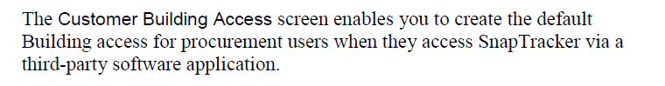

What is the third-party software application.

1. What is difference between the customers and the users in SnapTracker.
2. What is the meaning of catalog in SnapTracker?
3. What is the SIF file?

Got it. It is a way to interchange information between different system.

1. What is difference between Standard and Standard Class?
2. What is the Item? It is the instance of one standard?