1. Game View

Can set resolution manually.

Can play one frame for accurate test.

1. Hierarchy

Type search:{ t:type}

1. Profiler

It help developer know the time of every part in every frame

1. Prefab

It can be a model of instance. We can make it and then use it to create instance.

1. Tag

Tag can use to identify specific item in code.

1. Layer

Layer can indicate a specific functionality, like ignoring raycast, ignoring camera (the property cull mask which under camera, choose a layer).

We also can show/hide specific layer in the scene view.

**Extending Editor**

1. Custom Inspector

Create script under Assert/Editor.

The class in script inherits from Editor.

Add attribute CustomEditor which indicate the object this script want to show.

Override the function OnInspectorGUI().

Use EditorGUILayout.IntField to show the properties of the script which we want to show in inspector.

1. Add a button to a custom inspector.

Use GUILayout.Button under the function OnInspectorGUI().

1. DrawDefaultInspector()

If set a script editor to a script, invoking this function under the OnInspectorGUI() will show the default setting of the inspector. If not, the default property setting will gone.

1. Custom Menu

Can custom any type menu and context menu using c# attributes like:

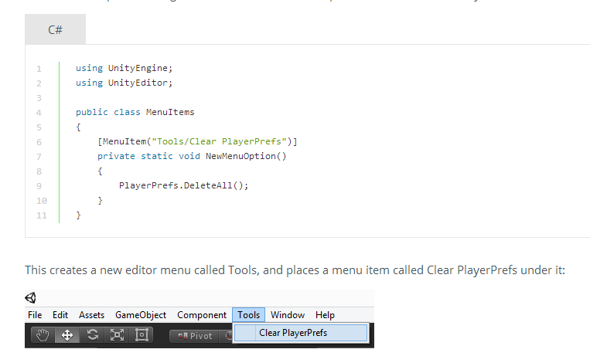

**Sciprt.**

1. Awake and Start

Awake before start. Both of them only call once. If script is not enabled, only call Awake.

1. Linear interpolation

float result = [Mathf.Lerp](http://docs.unity3d.com/Documentation/ScriptReference/Mathf.Lerp.html) (3f, 5f, 0.5f);

Vector3 from = new Vector3 (1f, 2f, 3f);

Vector3 to = new Vector3 (5f, 6f, 7f);

// Here result = (4, 5, 6)

Vector3 result = [Vector3.Lerp](http://docs.unity3d.com/Documentation/ScriptReference/Vector3.Lerp.html) (from, to, 0.75f);

1. Instantiate

Instantiate

Destroy

AddForce

1. Destroy

It can destroy game object and the component of the object.

1. GetButton and GetKey

GetButton/Down/Up

1. GetAxis

It is used for joystick control, or virtual directional keypad.

1. OnMouseDown (mouse click)

It can be detected via a collider or a GUI text element.

1. GetComponent

It is a way to access another script and another object’s component.

It take much time, so it suit be called in Awake or Start.

1. Invoke and InvokeRepeat

Call a function in a delay. Only can call the function which has void return value and void parameter.

void Start()

{

Invoke ("SpawnObject", 2);

}

void SpawnObject()

{

Instantiate(target, new Vector3(0, 2, 0), Quaternion.identity);

}

1. Properties

Can has default implement properties, just has set; or get;.