QA CASE STUDY: EXCELSIOR GENETICS REBUILD
Ensuring System Reliability through Rigorous Testing of SMTP Integrations and Data Validation Logic

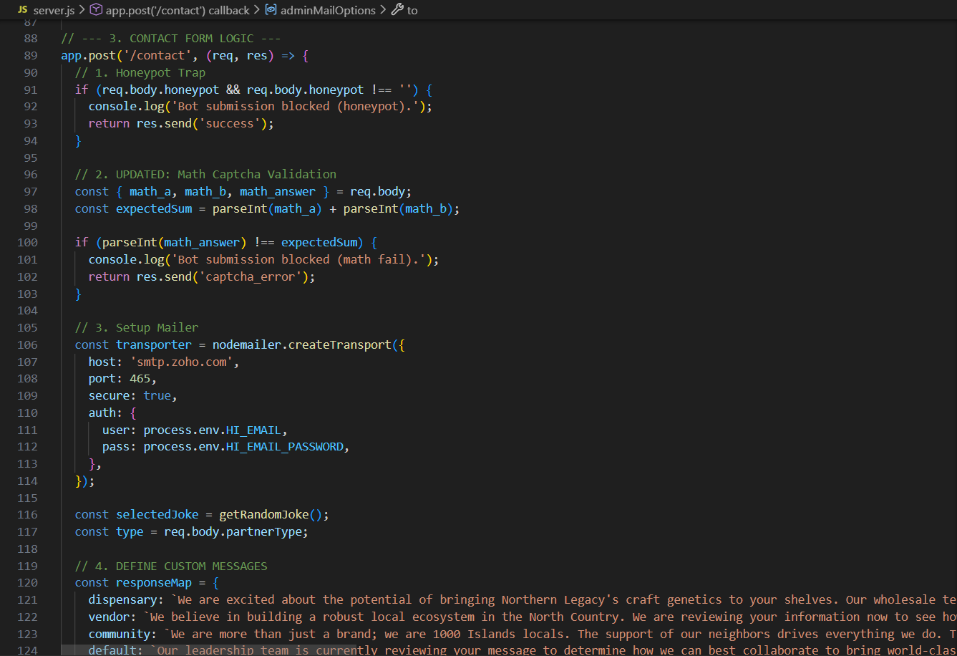

Prepared by: Gregory Farrell
Role: Lead Developer & QA
Tech Stack: Node.js, Express, EJS, SMTP
Date: February 2026

TECHNICAL QA CASE STUDY: PARTNERSHIP PORTAL AND LEAD CAPTURE
Scope: Lead Developer & Quality Assurance | Environment: Node.js, Express, EJS, SMTP Integration
1. QA Strategy & Objectives
The primary objective of the QA cycle for the Excelsior Genetics rebuild was to ensure the integrity of the Partnership Portal and the reliability of Automated Communication Channels. Given the regulatory nature of the industry, zero-failure in lead capture and verification was a non-negotiable requirement.
2. Feature Focus: Partnership Portal & Lead Capture
The portal utilizes a custom-built lead capture form that triggers an automated workflow. Testing focused on data validation and the successful handoff between the server and the SMTP relay.
Test Case ID: TC-001 | Automated Response Validation
- Test Objective: Verify that a successful form submission triggers a "Thank You" email within 60 seconds.
- Pre-conditions: SMTP relay configured; User is on the /partnership route.
- Test Steps:
  - Enter valid alphanumeric data into all required fields.
  - Submit form.
  - Monitor target inbox for incoming response.
- Expected Result: Server returns a 200 OK status; User receives formatted EJS-templated email.
- Actual Result: PASS.
Test Case ID: TC-002 | Input Sanitization & Error Handling
- Test Objective: Ensure the system rejects invalid email formats and prevents empty submissions.
- Test Steps: 1. Leave "Email" field blank. 2. Input a malformed email (e.g., "test@@test.com").
- Expected Result: Frontend validation blocks submission; User receives a specific error toast/message.
- Actual Result: PASS.
3. Resolved Defect Log (Bug Report)
During development, a high-severity security and functional failure was identified and resolved.
Defect ID: BUG-001
Title: SMTP Handshake Failure / Unsecured Credential Exposure
Severity: High (Blocked automated communications)
Description: The application failed to establish a secure connection with the SMTP server, resulting in authentication timeouts and exposed credentials in the source code.
Root Cause: The application was configured for non-secure port connections, and authentication credentials were hardcoded in the primary source file.
Resolution:
- Protocol Alignment: Reconfigured the transport layer to utilize Port 465 with SSL/TLS to meet security requirements.
- Security Hardening: Migrated sensitive credentials to protected environment variables (.env) to prevent exposure.
Status: RESOLVED / VERIFIED

