'WƆN -TAƆNG -MA 'GÜ 'SËËDHƐ
Ü faan dɔ ü –dewo draan- -sü -bha

-Pamɛamɛ ‘ö -kë kwaa- naɔ -ma ‘gü ‘sëëdhɛ ‘ka bha, -a -bɛn zë -mɛ -nu yi ka faan -dɔ, -Gblüdë -a ‘në -nu kö ‘ka ka faan dɔ -a -wo pö -sü -bha -dedewo. Kwa -dega -a ‘wɔn -së -mü. Yi- -dhɛ ka -gɔ kö ‘ka ka -de ‘kun ‘mɛ -nu ‘ö ‘waa mɛ -nu faan dɔ ‘wɔn ‘bha -bha, -a -nu -gɔ. Kö ‘ka ma ‘ka =gwëë bha ‘aa -yö -oo ?

̈

Kwaa- =danwo pö "sɛ 'gü -wɔn

￹￹
"Maadhö : -Zaanwoplöö

-A ‘dhɛ ya ‘wɔn -së do ‘ö -kë -Zlaanwoplöö “Maadhö yö -mü.
Kwaa- ‘sëëdhɛ ‘ö -kë -Zlaawo ‘sëëdhɛ ‘ka “kɛɛ -mlɛɛ -dee ‘sëëdhɛ ‘ka bha, ‘yö kwaa- ‘në ‘gbɛ ‘bha -nu ‘wo- -wo pö. Yë ö “dhʋ̈ bha, -a zü -yö kë -bho “su ‘ö -kë -gblɛdhe ‘ka ‘ö “kwi -zë ‘ö- -dhɛ ‘mɛ- bha, -a -bha -dhɛkpaɔyi -kaɔng =plɛ ö ga “saɔdo (26) ‘ka, ‘yö- “dhiʋ̈ ‘dhö ta “su ‘dhɛ ‘ö dɔ- “piʋ̈, ‘ö -kë “plɛɛ, (‘zuɛn-) ‘ka, -a -bha -dhɛkpaɔyi -kaɔng do ö ga “saɔdo (16) ‘ka. -Zlaan ‘saa- ‘gü, yë bha -a “dhiʋ̈ kë -ta -së. -Dhɛng -nu ‘ö ‘wo kë nu yë bha- kë-, -wo kë -go Gaangdha “sɛ ‘gü. -Kwɛ -nu ‘ö ‘wo nu sië bha, padhɛɛ ‘ö kwaa kwa “tʋ ‘to- -bha -wo -dho nu- -nu ‘ka. Mɛ ‘gbɛ -dede -wo kë -go “Lʋgwaadhö, “Sanggwinng, “Maadhö, Gbiaangwinng -dhɛ -nu ‘gü ‘ö ‘wo ‘sëëdhɛ bha- -wo pö. “Kɛɛ ‘mɛ -nu ‘ö ‘wo kë to ‘mü “tʋ̈ng =gban ‘gü wo -mü : Baba =Tiëmɔko Sebasiɛn ‘ö go -Tɛɛdhö =në gun -kwɛɛgbö ‘kpii- ‘ka. ‘Yö mɛ -kpɛa -nu ‘wo gun Gɔɔn Izakö (-Dakwɛɛpöö), =Kesɩ =Dhuëng Giyɔngmë (-Giaplö), Tɔnga Lazaa (“Bhlɔɔdhö), =Kesɩ Dhifɔnngsü, -nu ‘ka. Kwa dheebhang ‘ö go ‘Dannëngdhö ‘wo- -dhɛ ‘Lo Zafe, ‘ö yö =në yë bha -a -gɔ ‘ö -gban -bha -dedewo bha ‘ö gun mü.
-Kwa “Zɛ Emanuɛlë nuwɛɛ -bho -dedewo. Yö =në gun -dhɛng -nu “dhiʋ̈ -ziö wo -mɛ ‘ka. Pasitëë Zonasü ‘ö gun mü “tʋ̈ng bha- ‘gü, -kwaa nuwɛɛ bho ‘gbɛ. -Yö -gun yi faan dɔ sië -kpɛawo waa- Pasitëë ‘Klisi =Ya n ‘Dhɔ ‘ö -tun -Zlaan -wo =klang- “dhiʋ bha- ‘dhö.

L’orthographe DAN
Voici ce que nous pouvons utiliser pour savoir lire et écrire en langue dan.  Les consonnes et les voyelles que vous ne voyez pas ici sont les mêmes qu' en français.  Attention:  1. c, h, j, qu et x n'existent pas en dan.  2. r ne se trouve jamais au début d'un mot.  Voici le reste de l' alphabet :  Lettres Exemple Traduction  Aa "kaa gale  An "gan tirer  Aan saan cadeau  aɔ kaɔ perdrix  aɔn ‘daɔn- araignée  bh -bho cabris  dh dhe mère  ee =wee sel  ɛ "pɛ déchirer  ɛɛ =wɛɛ moquerie  ɛn -gɛn pied  ɛɛn =gblɛɛn long  ë pë chose | ëë "këë daba  ën 'kën rassasier  ëën =klëën entourer  ɛa "kpɛa sec  ɛan gɛan" scorpion  gw -gwë caillou  in "bin fleur  iin "iin ou  ɩ "wɩ parler  ɩɩ "gbɩɩ- fort  kw =kwaa main gauche  ng gbeng nuit  oo -zoo chenille  ɔ 'pɔ credit  ɔn "yɔn huile  ɔɔn =yɔɔn sang  ö pö dire  öö töö panier  u "su lune  un bun tombeau  uun =yuun asticot | ü 'gü intérieur  üü "güü amère  ün =blün miette  üün glüün rouler  ϋ "gϋ brûler  ϋϋ "bhϋϋ tarir  ʋ "tʋ oreille  ʋʋ "tʋʋ sauce  -Wo 'dho -kɔ ( Les tons )  très haut "dhü arbre  haut 'kɔ maison  moyen dë père  bas =zɛ termite  très bas -dhɔ amour  très haut + très bas "klang- singe  haut + très bas 'yënng- soleil  moyen + très bas saa- savon  bas + très bas =göö- iroko  moyen + très haut gɛan" scorpion  moyen + haut kpuu' souche

Kwaa- "Kɔdivuaa -sɛ 'gü -wɔn

'Wɔn 'ö -gban =klang- -nu -bha

Dhioo 'ö

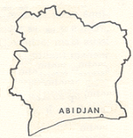

-Kwaa “Kɔdivua -sɛ ‘gü -wɔn

“Bhang -bha =wɛnng ‘ö- wo mɛ -ta ‘Biya

“Kwi -a “su ‘ö -kë ‘zuɛn- ‘ka “kɛɛ ‘ö mɛ tii -nu -zë ‘kwa- -dhɛ -gblɔdhe bha, -a -bha -dhɛkpaɔyi -kaɔng =plɛ ‘ö ga “saaga ‘ö gun “Maadhɔɔyi do ‘ka bha, dha ‘ö ban ‘Biya, -yö kë -wɔ ‘gü “yaan -dedewo ‘ö -dhɛ ga “puu ‘ö =kpaɔ ‘ka. Kaatie ‘kpii- do ‘bha -yö ‘Biya, ‘wo- -dhɛ Kokodi. –Dhɛ bha- ‘gü, goo ‘gü -dhɛ -nu ‘gbɛ -wo kaatie bha- ‘gü ‘pö, ‘ö “flɛɛ -mɛ -nu ‘gbɛ ‘wo woo- “dhü ga -kɔ -nu dɔ -sü ‘ka -a -nu ‘gü. -Dhɛ ‘bha bha- ‘gü, =naɔmɛ do -bha “kwanngdhɛ -yö -ya -sü ‘ka goo -ta “dhuʋ̈- ‘ö “bhang =gblɛɛn ‘ö dho “dhuʋ̈- ‘ö =klëën -sü ‘ka -a -bha “kwanngdhɛ ‘ö “dhʋ̈ bha- -zü. -Kaaga, dha bha ban ‘o- wo “Maadhɔɔyi bha- ‘ka bha, ‘yö “sɛ ‘dhö -kë “plëë -plëë. -Bhuuɛɛ, “bhang bha =ya ‘go “sɛɛ =ya =wɛnng ‘mɛ -nu ‘wo goo ‘gü bha, -a -nu -bha ‘kɔ -nu -ta. ‘Wɔn bha -yö -gun ‘ya- -dedewo. Mɛ “saɔplɛ =në ‘ö “bhang bha ‘ö- -nu zë. Gbiöödhe do, ‘në ‘sɛɛnnë -yaaga gɔɔn- do waa- ‘në dhebë =plɛ. ‘Yö mɛ -kaɔng do ö ga -yaaga ‘wo =gii -dedewo.
-Pamɛamɛ -ya -dhɛ -Zlaan -gɔ kö ‘mɛ -nu ‘wo -wëë ‘gü, -a -nu -bha mɛ -nu ‘wo ga “dhʋ̈ bha, -ya -nu -zo -gban.

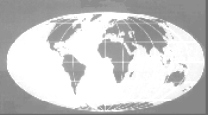
"Kpʋngtaadhɛ -wɔn -bha
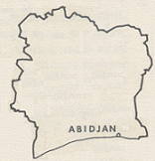

Mɛ do ‘ö “kpʋngtaa -mɛ -nu ‘kpiidhɛ ‘wo- ‘tɔ -së pö -sü ‘ka

Kwaa- mɛtii “sɛ -nu bha, mɛ wë =ya kë ‘yënng -wo -zian ‘ka, -a ‘dhɛ -nu ‘ö ‘wo -ya -sü ‘ka “sia- =yën bha, mɛ do -ya do ‘gü ‘ö ‘wo- -dhɛ Nɛlsɔnö Mangdela. -A yi =ya =gwëë, -yö kë mɛ tii -nu -ta -ko -zë “sɛ bha- ‘gü kö “kwi “puu -nu -wa -nu -wëëdhɛ bho sië -dedewo. -A -wɔn ‘gü “kwi -nu bha -wo kë- -da -kaso ‘gü ‘ö dha “yi -kwɛ -kaɔng =plɛ ö ga “saɔplɛ waa- ö ‘gbu -kë -kaso ‘gü ‘gbaandhö. =Dhɛ ‘ö go -kaso bha- ‘gü, -yö kë -dho ‘ö -ya “sɛ bha- -gɔ “dhiʋ̈ -kwɛ “sɔɔdhu ‘ka. =Dhɛ -kwɛ “sɔɔdhu bha ‘ö yö ‘ko “dhiʋ̈, ‘yö -kë yöö -dede ‘gü -së kö ‘ö -duɛɛ bha- nu mɛ “wɛɛ -dhɛ. ‘Mɛ ‘ö- nu- -dhɛ bha, -wa -dhɛ Tabo N Beki. Maangdela bha, -a -kwɛ =ya kë =dɛɛ -kaɔng “suesiö (90). -A -kwɛ -yö ‘ko “dhiʋ̈ ‘fɛtö, -yö kë -kë “su ö -kë “plɛ (‘zuɛn-) ‘ka bha, -a -bha “dhɔɔgɔ totaamasü ‘gü “kwi -naa “sɛ ‘ö -kë ‘Glɛ- “sɛ ‘ka, ‘wo- Angglötɛɛ -kë bha, -a ‘pö- ‘kpii- ‘ö -kë ‘Lɔnngdrë ‘ka ‘bha- ‘gü. -Gblüdëdhe ‘wo- -dhɛ Elizabɛtö ‘döö- bha- wëëdhö. Mɛ “gblü -kaɔng “sɔɔdhu (50.000) -wo kë -nu mü. Mɛ “gblü ‘gbɛ ‘wo bha, -a -nu -bha ‘wëëga ‘wo- bho kö ‘wo -da ‘ka ‘kɔɔdhö bha, Mangdela -ya -pö ‘wëëga bha -yö ‘sü kö -wo “yuamɛ -nu ‘dhɛ kë- ‘ka. –Kwaa ‘gü ma ‘ka =dhɛ Mangdela bha
-a suu yö -dhɛ =ya kë ‘ya- =dɛɛ “kpʋngtaa.
.

Mɛ =slɔɔ -pë -nu -wɔn
‘Wɔn ‘ö -gban ‘zü -dhöö ta -wɔn -bha

N dheebhang, n dë -nu, -a ‘dhɛ ‘ö ya -Pamɛamɛ -yaa -blɛɛsü pö, ‘yö ‘go sië ‘mü ‘yö- ‘bha pö sië ya.
“Tʋ̈ng ‘ö ‘kwa dɔ- ‘gü ya mɛ ‘yaa mɛ “tʋ̈ng kë ta -pë doseng ta -sü ‘gü. Yö =në ‘kwa- -kë, “iin ‘ö kwa dë -nu ‘wo- -kë ‘yö “kaflɩɩ waa- =kakao -nu bha -ö -waa wo ya, -tosɛa =ya kë kwa -bha “gbɩɩ- -dedewo kwaa- “pɛɛn -nu -ta bha. -A -wɔn ‘gü, ‘mɛ ‘kö pë ta -dhɛ -zë, -a ‘bha ‘dhö ü -gɔ, kö -bhö ü ‘gü dɔ “gbɩɩ- kö ‘ü -dhöö -dhü ta. =Trɔɔn ‘ö- ‘gü, -a dhiang ‘yaa zë -dedewo. -A -gɛn -mü =dhɛ kö -yö yö- -bha, ü- “yi -bho “dhɔɔgɔ doseng ‘ka =plɛ. Dɔ ‘ö ‘kwa wo =dɛɛ ya, ‘Biya “pɛɛn -ta, yö =në mɛ ‘gbɛ ‘dhö- ta -sü ‘ka. -A ‘pö- -mɛ -nu oo-, -a ‘mɛ -nu ‘wo “kwi =plöö oo-, -wa ta -sü ‘gü -ziisü.

=Ya ‘go yö -zë ‘gü, ka -mɔɔ- -bha ‘pö ‘ö ‘ka -mlü -bhlaa “gblʋ̈gblʋ̈ -nu kpɔ ‘ö ‘ka- -mlü “dhɔɔ -nu dɔ. ‘Kwa ‘ke- kë -kwaa -mlü -nu ‘kun -së. ‘Kwa- ‘dho pë -nu -kpa ‘ö- -kpɛa -nu -wo to ‘ö ‘kwa- -nu =wɛnng.
Pë see- “tʋ̈ng ‘yaa mü ‘ö ‘kwa dɔ- ‘ka ya.

Kö ‘kwa- ‘gü ma kö ‘kwa =gwëë bha ‘aa -yö kë -oo?

'Wɔn 'ö -gban -potaasü -wɔn -bha.

-Dhɛ ‘ö “yi ‘pɔnngpö waa- -klɔng ‘waa- -bha

‘Pö- -mɛ -nu ‘gbɛ =në ‘ö ‘wo mü, ‘ö -waa pö woo ‘dho ‘bhlaadhɛ -nu ‘gü, ‘waa “yi ‘sü ‘pɔnngpö “iin -klɔng ‘gü kö ‘wo- 'dho- ‘ka. -A -gɛn -mü =dhɛ mɛ ‘bha -nu -wa -pö =dhɛ ziaan ‘ö dho- -nu -gɔ ‘bhlaadhɛ -nu ‘gü bha -yö =gblɛɛn “yi ‘sü -sü -bha. ‘Yö mɛ ‘bha -nu ‘wo- pö =dhɛ “yi ‘ö- -nu -gɔ mü bha -a din -yö -së ‘ö -zian ‘ka ‘pɔnngpö “yi -ta.
Mɛ “pɛpɛ ‘ö ‘wo dhiang zë bha, tɛawɔn (“Maa -mɛ -nu -wa -pö gaadee) -ya -nu “piϋ. “Kɛɛ ‘wɔn ‘ö- -nu -zo -yö bhɔ- ‘ka, yö -mü =dhɛ “yi -nu ‘wo ‘bhlaadhɛ -nu ‘gü bha bhië’’ 'në (bhöö’’) -nu -wa ‘gbɛ -dhɛ ‘gü. -A -wɔn ‘gü ‘në -nu -waa mü bhië’’ -yua -ya -nu -kë.
-A -kë “dhϋ -sü bha- ‘gü, ‘wɔn ‘ö- -dhɛ ‘dhö- -bha kö -wa kë, yö -mü =dhɛ -waa pö woo ‘dho ‘bhlaadhɛ -nu ‘gü, -wo sɔ ‘ö ‘yaa -dhiisi ‘ö “zu -sü ‘ka -së ‘ka, -a ‘kun wo -kɔ “piϋ. =Ya kë =dhɛ -waa pö woo “yi -nu ‘ö ‘wo “dhϋ bha- mü kö -wa ziö ‘gü =kö -blɛɛsü =dhɛ -kɔ ‘ö =Mɔyan ‘dhö- kë sië- ‘ka ‘sëëdhɛ -ta ya- ‘dhö.
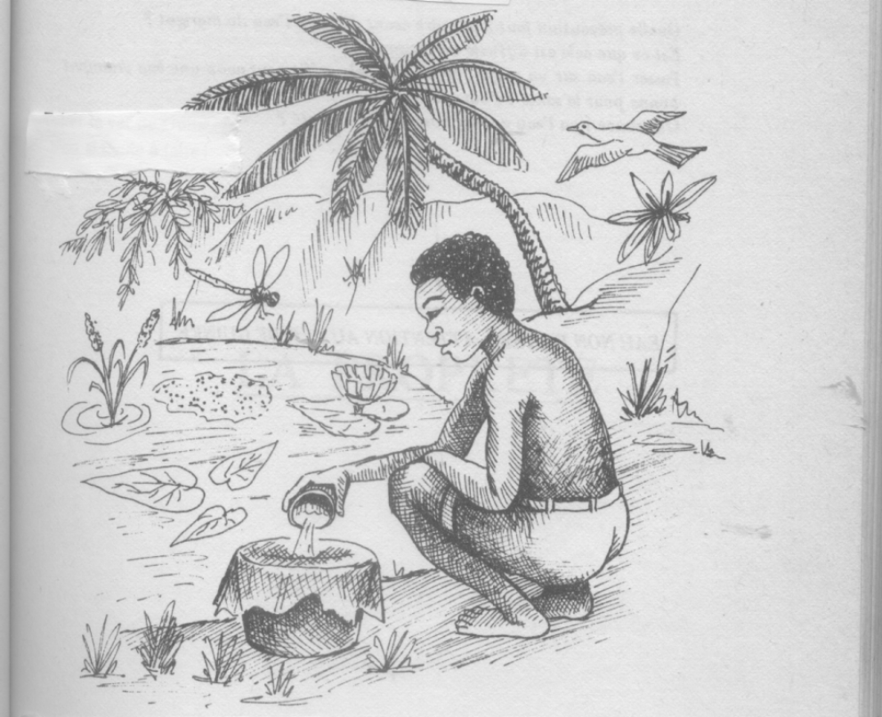
=Ya kë “dhϋ ‘në -nu ‘wii ‘dho bhië" 'në (bhöö’’ 'në) =slɔɔ-.

.

'Wɔn 'ö -gban troo -nu -bha mɛ wɔkɔ -nu 'gü

=Badhong ‘kpii- ‘ö -ziö Ɛsipayö -sɛ waa- “Dhima -sɛ -nu =zinng ‘gü.

“Su do ‘ö -kë “plɛ (‘zuɛn-) ‘ka bha, ‘yö “sɛgɔ =plɛ ‘wo bha ‘wo ‘kupö -ziö ‘ka -a -dhɛkpaɔyi -kaɔng =plɛ ö ga “suesiö (29) bha ‘ka “kwi -pö ‘kpii- do ‘wo- -dhɛ ‘Viɛnö Otrisië -sɛ ‘gü bha- ‘gü, ‘yö -dhöö kpö ‘dhö -ma ‘kwëë- -dhɛ bha- ‘gü -dedewo.
=dhɛ -waa -zuö “dhʋ̈ kö ‘wii kë ‘dho =kö wo “tɛɛ pa-, ‘yö =Ɛsipayö ‘ö ‘bii- do -da. ‘Wo go wo “tɛɛ pa- -dhɛ ‘gü, “tʋ̈ng “wɛɛ ‘bha ‘yii =slɔɔ “Dhima -nu -gɔ “wɛɛ ‘bha bho kö -wa bho tongtongdhö. -Yö kë -to -a -nu -gaɔ ‘ö to- ‘ka “dhʋ̈ ‘ö =badhong “dhiʋ̈ -yö ta.
‘Mɛ ‘ö kë ‘bii- bha- -da, -wa -dhɛ Fɛɛlanngdo ‘Tɔɔ-. -A -kwɛ -yö -kaɔng =plɛ ö ga -yiisiö (24). Ɛsipayö bha -a -bha ‘kupö bha, -a ‘sü -kɔ =plɛ -naa =në ‘ö kwɛɛ ya. ‘Wo- -blɛɛsü sü -a dha “yi -kwɛ ya kë -kaɔng -yiisiö ö ga -yiisiö. “Dhima -nu -zë, =wa gun -waa ‘sü ‘nu -yiisiö.
=Ya kë “dhʋ̈ kö Ɛsipayö bha -yö -dɔ ‘Glɛkö -nu =në -a -nu “piʋ̈ kwɛɛ. -A -gɛn -mü =dhɛ ‘Glɛkö -nu ‘wo- sü -a -kwɛ -yiisiö -naa =në ‘ö kwɛɛ (2008).

"Yɩɩ -wɔn
Gɔndënë do ‘ö =dua ö -dea =geebë -gɔ

“Kɔdivua ‘në do =në ‘ö dho =klang- kë- Moritani
‘Në bha -wa dhɛ Benoa. “Sɛ bha ‘gü -mɛ -nu dhiang zë -kɔ waa- kwa -bha ‘yaa do.-Dhɛkpaɔyi -blɛɛsü bha, =dhɛ -wa -da =klang- ‘kɔɔdhö, ‘yö ‘mɛtrë ‘ö -ya mɛ -nu -dhɛ -sü -bha kö ‘mɛ ‘yii nu =klang- “dhiϋ ‘ö- -mɛ dɔ.
‘Mɛ ‘dhɛ -yaa ‘tɔ pö, ‘yö- -mɛ -yaa pö : =misiee.
‘Yö- zü bho ‘ö- pö : ‘Piɛɛ-, =misiee. ‘Pɔlë, =misiee. Bɛɛtinö, =misiee. ‘Bɛnë oitö, -suaa. Mɛ ‘bhaa “wɩ. ‘Yö dho mɛ -dhɛ-sü ‘ka “dhiϋ. ‘Zan-, =misiee. ‘Yö dho- ‘ka “dhϋ, “dhϋ, “dhϋ. =Dhɛ ‘ö ö bo, ‘yö ‘Kɔdivua ‘në bha ‘ö ö -kɔ “dhiϋ =wlüü, ‘ö- pö : << =Misiee, ‘mii n ‘tɔ ma -wa ! >> ‘yö -gɔmɛdë ‘dhö- pö -dhɛ -wo ü -dhɛ =dhɛ ? ‘yö- pö: -wo n -dhɛ Benoa. ‘Yö- pö, kö ‘ma- pö ‘nu. Bhi =në ‘wo ü -dhɛ Bɛnë Oitö bha.
=Bangba ‘Bakadhi

“Gwënng
«’Mɛ ‘ö wɛɛ =loo, -a -mɛ -kɔ “dhɛ ‘yaa =dhɛng -Zlaan -gɔ.» -kɔ do bha- ‘gü, ‘mɛ ‘ö -Pamɛamɛ -wɔn kun “gbɩɩ-, -Zlaan -yö -dho “ta- -mɛ -dhɛ.

Pë -Wlangda -sü

Kwaa- ‘sëëdhɛ do -yö yö -sü ‘ka "kpɛnng ‘ö -kë =dhɔtrɔɔ ‘sëëdhɛ ‘ka ‘wo- -dhɛ ‘Pë ‘ö Nu Yua ‘ka. -A "dhɔɔ -bha -Yö "Maadhö Pasitëë Iba Andre "piʋ̈ UEESO. ‘Yö ‘bha ‘dhö Ibɛɛ -gɔ. -A -bha "nimlɔɔ =nɛ: 06107157

‘Wɔn yaa kë -sü =ya sɔ =dɛɛ -dedewo

‘Në dhebë ‘në ya, -a -kwɛ -yö kaɔng do ö ga do, ‘yö dho ö dhuëë- =keng- ‘yö- dhuëë bha ‘ö ‘gu dɔ- -bha.
‘Ka ka bo ‘sëëdhɛ ya- -wo pö -sü ‘ka, ‘wɔn ‘bha =ya kë ka -gɔ kö ‘ka pö yi -dhɛ, -ka ‘sëëdhɛ kë kö ‘ka bɔ. Yii- ‘drɛsü -mü 08 BP 857 Abidjan 08 ‘ka. Tel. 08 18 08 88 / 06 39 04 88
‘Mɛ -nu ‘ö ‘wo ‘sëëdhɛ ‘ö ya- -kë, wo -mü =Sai Zoziasü , "Dhɔɔgbö Zafe, =Kesɩ Mɔyan Dhifɔngsü, Valangtɛn Vidrinö waa- Edhɛna Pɛdhɛkwalösökaya ‘ö- -nu =gban =plɛ ‘wo go Dhusi ‘ö -da “Anɛsü ‘ö go ‘Suisü , -a -nu ‘ka.

