Week 10 Assignment
Repository Link:
https://github.com/Hughes-Tyler/AnalyticsCapstone
Report Link:
https://github.com/Hughes-Tyler/AnalyticsCapstone/blob/main/notebooks/main.ipynb

1. Background
Our goal is to predict whether a startup ends up operating, acquired, closed, or IPO from its funding history, timing, location, and industry, so an investor or analyst can decide which companies deserve a closer look. After cleaning, the dataset has 49,638 companies, split 60/20/20 (stratified, seed 42) into 29,782 training, 9,928 validation, and 9,928 test companies. The outcome is very imbalanced (81.7% operating, 8.3% acquired, 8.0% closed, 2.0% IPO), so we judge models on macro F1 and per-class recall and precision rather than accuracy.
In Week 9 we picked Gradient Boosting V2 (learning rate 0.10, maximum depth 6, 200 iterations, balanced class weights) as our best model, with a validation macro F1 of 0.4345 and a test macro F1 of 0.4312. All three model families leveled off at about the same validation score, which suggested that the data and features were holding us back more than the choice of model. So, this week we kept the model fixed and worked on the data instead. We studied the model’s worst mistakes (Section 2), made three data improvements based on what we found (Section 3), retrained the same model on the updated data and compared it with the Week 9 model (Section 4), and ran the final model on the test set (Section 5). Section 6 covers what we took away from it.

2. Error Analysis
We ran the Week 9 model on the 9,928 validation companies. It got 3,356 of them wrong, which is an error rate of 33.8%. Its validation accuracy was 0.662 and its macro F1 was 0.4345. Our target has four classes, so there aren’t numeric residuals to sort. Instead, each validation company got a per-row log loss, −log(p_true), where p_true is the probability the model gave to the company’s real status. A high value means the model was confidently wrong, and we used it to rank the worst errors. The test set wasn’t used for any of this.
True status | Predicted as | Errors | Share of all errors
Operating | Closed | 1,244 | 37.1%
Operating | Acquired | 925 | 27.6%
Closed | Operating | 271 | 8.1%
Operating | IPO | 270 | 8.0%
Acquired | Operating | 180 | 5.4%
All other combinations |  | 466 | 13.9%
Table 1. Most common validation errors for the Week 9 model
Most of the errors (2,439, or 72.7%) are operating companies predicted as something else, mostly closed or acquired. This is the trade we made with balanced class weights, which push the model toward the rare classes and bring operating recall down to 0.70. Even so, the rare classes are still missed more often. The error rate is 30.1% for operating companies, 43.6% for acquired, 56.7% for closed, and 54.0% for IPO. Precision is low for the rare classes too (0.29 for acquired, 0.20 for closed, 0.21 for IPO), since so many operating companies get labeled as one of them.
The 30 worst errors had per-row losses between 5.2 and 7.9, which means the model gave the true class a probability close to zero. Several IPO companies were predicted as operating with high confidence, including Vodis Pharmaceuticals, Pushpay, Animoca Brands, and TerraForm Energy. Four of the 30 had 8 or more funding rounds, and three of those were at our cap of 10. A few might be label problems, such as JinkoSolar Holding, which is labeled closed. Mislabeled records can’t be proven from the data alone, so we treat these as candidates for a manual check rather than errors to fix.

Categorizing the errors
We flagged every validation company for possible data problems: numeric outliers (outside the 1st to 99th percentile of the training data, or 10 or more rounds), missing values (imputed funding, unknown country, unknown category), companies funded before their founding date, young companies founded in 2013 or later whose outcome may not have happened yet, and companies with only one funding round. All thresholds came from the training rows. For each flag we compared the error rate of flagged and unflagged companies. The ratio of the two, the lift, tells us whether a flag actually raises the error rate or is just common.
Flag | % of validation | Error rate (flagged) | Error rate (unflagged) | Lift
Country unknown | 7.5% | 0.516 | 0.324 | 1.59
Category unknown | 2.6% | 0.431 | 0.336 | 1.29
Numeric outlier | 6.2% | 0.396 | 0.334 | 1.19
One funding round | 59.3% | 0.354 | 0.315 | 1.12
Funded before founding | 7.3% | 0.369 | 0.336 | 1.10
Funding missing (imputed) | 17.8% | 0.293 | 0.348 | 0.84
Young company (2013+) | 25.3% | 0.168 | 0.395 | 0.43
Table 2. Error rate of flagged vs. unflagged validation companies
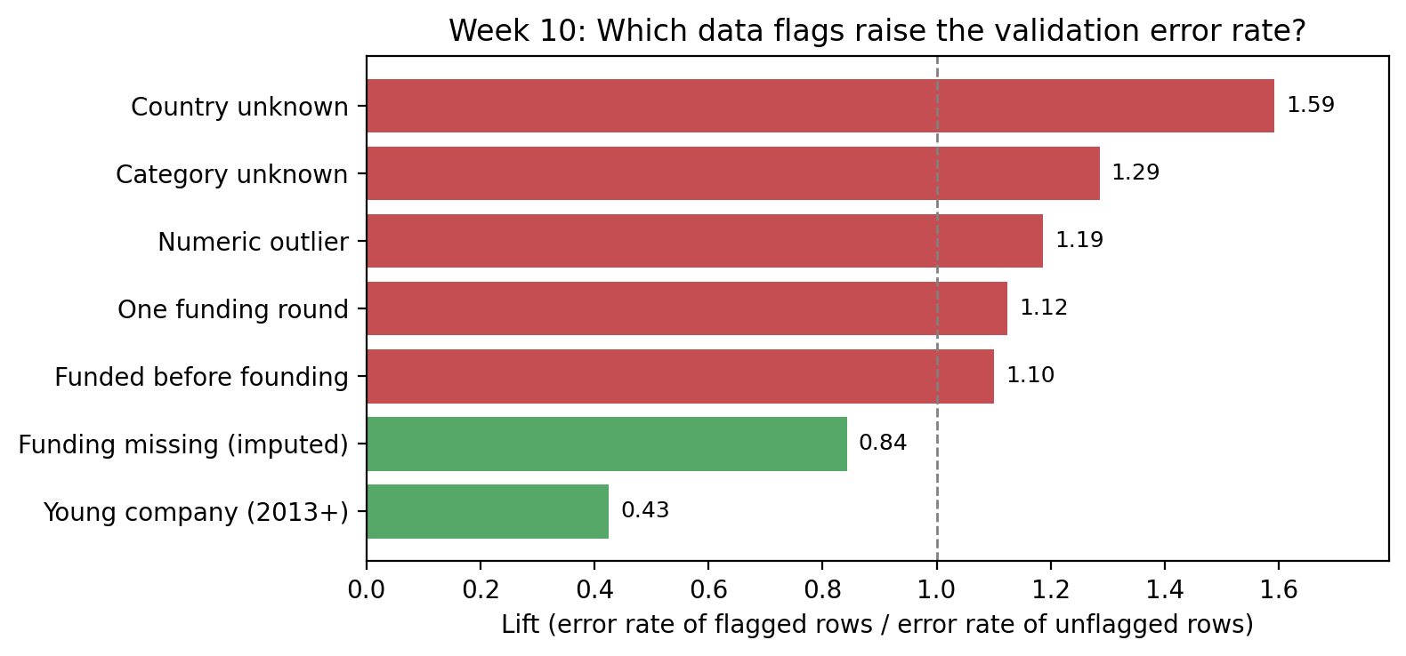
Figure 1. Lift for each data flag (above 1 means the flag raises the error rate)

Why the model struggled
- Missing country and category are read as “closed.” Closed companies are missing these fields more often, so the model learned that pattern and now over-applies it. 55% of operating companies with an unknown country, and 44% with an unknown category, are predicted as closed. The country can’t be recovered either, since region, city, and state are also empty for those rows.
- The features carry little usable detail. When we shuffled each feature and measured the drop in macro F1, PC5 (0.11) and PC1 (0.10) did most of the work, and 16 of the 51 features weren’t distinguishable from noise. PC5 is mostly founded year and days to first funding, so the strongest signal is closer to company age than to funding velocity.
- Single-round companies give the model little to work with. They make up 59% of validation companies and 62% of the errors, since a company with one round has no funding span or cadence to measure.
- No single data defect explains the errors. The highest lift is 1.6 and most flags are between 1.1 and 1.3, so we expected fixes to give modest gains at best.
- The young-company idea wasn’t supported. Young companies have a much lower error rate, probably because the model learned that a recent founding year usually means still operating. Imputed funding also had a lower error rate than the rest (lift 0.84).

3. Data Improvements
Based on these error categories we made three changes to the data. Each one was tested on its own first. For every version, the scaler and PCA were refit on the training rows only, and Gradient Boosting V2 was retrained with its Week 9 settings on the same split. Each version was compared with an identical retrain on the original data, which reproduces the Week 9 validation macro F1 of 0.4345.

Improvement 1: Capping numeric outliers
Before. In Week 4 we log-transformed the heavy-tailed numeric columns, which fixed their shape but left the most extreme companies far from everyone else. Numeric outliers had a lift of 1.19, the third highest of our flags, and extreme values can pull the standardized PCA components toward a handful of companies.
Change. We clipped the five continuous columns (log funding total, log days to first funding, log funding span, log average funding per round, and log rounds per year) at the 1st and 99th percentiles of the training rows. Every company stays in the data, and between 492 and 1,047 values per column were moved to the nearest bound. Week 4 showed that these extremes are real companies rather than entry errors, so the goal was to limit their influence and not to remove them.
After. The skew of the affected columns dropped (for example, log rounds per year went from −1.57 to −1.35), but validation macro F1 fell to 0.4255 (−0.009). On the 618 flagged outlier companies themselves, it fell from 0.437 to 0.405. One likely reason is that the extreme values carry real information, such as very large funding totals, so capping them took away signal instead of noise.

Improvement 2: Filling missing funding by country group
Before. In Week 4 we filled the 8,935 companies (18.0%) with missing or unrealistic funding totals with one global median of about $1.8M. Every one of those companies ended up with the exact same value, which created a spike in the funding distribution right before the PCA step.
Change. We filled each missing value with the median of the company’s country group (the top 10 countries, Unknown, or Other), using training rows only and falling back to the global median for any group with fewer than 50 training companies. The medians differ a lot, from $386K for Unknown to $2.8M for the US and $14.7M for China.
After. The largest group of identical filled values dropped from 8,935 companies to 4,797 (the US group), so the spike is much smaller. Validation macro F1 fell to 0.4278 (−0.007). Looking back at the error analysis, companies with imputed funding already had a lower error rate than the rest (lift 0.84), so this wasn’t an area where the model was struggling.

Improvement 3: Adding new features
Before. Single-round companies make up 62% of the errors. Since Week 5 replaced all seven continuous columns with five PCA components, the trees also couldn’t split directly on founded year or funding size. In Week 4 we dropped homepage_url and region, and we never counted how many industry tags a company listed.
Change. We added six features: has_homepage (whether the company listed a website), in_top_vc_hub (region is SF Bay Area, New York City, Boston, or London), num_categories (number of industry tags, added to the PCA step), is_single_round (exactly one funding round), and unrotated copies of founded year and log funding total kept outside the PCA.
Status | Has homepage | In top VC hub | Single round | Number of tags
Operating | 94.6% | 26.5% | 60.3% | 2.56
Acquired | 93.8% | 46.5% | 41.6% | 2.48
Closed | 95.3% | 25.9% | 72.0% | 2.41
IPO | 99.2% | 30.3% | 32.9% | 2.11
Table 3. New features by outcome (all companies)
After. Being in a top VC hub separates acquired companies (46.5%) from the other outcomes (26% to 30%), and closed companies are much more likely to have only one round (72.0%). Having a homepage barely differs across outcomes (94% to 99%). Validation macro F1 fell to 0.4306 (−0.004), the smallest drop of the three. On the single-round companies, macro F1 rose a little from 0.407 to 0.414, so this was the only fix that helped the group it was aimed at.

Merging the three improvements
The three changes were combined in an order that avoids leakage. We started with the country-group funding fill and recomputed log funding total and log average funding per round, then clipped the five numeric columns at new 1st and 99th percentile bounds from the training rows, then added the new features, and finally refit the scaler and PCA on the training rows. The updated dataset has 49,638 rows and 56 features, has no missing values, and keeps the same row index and split as the Week 9 data.
Data version | Validation macro F1 | Change vs. original data
Original data (Week 9) | 0.4345 | n/a
Improvement 1: capping outliers | 0.4255 | −0.0090
Improvement 2: country-group funding fill | 0.4278 | −0.0067
Improvement 3: new features | 0.4306 | −0.0039
All three combined | 0.4256 | −0.0089
Table 4. Validation macro F1 for each data version (same model and settings)
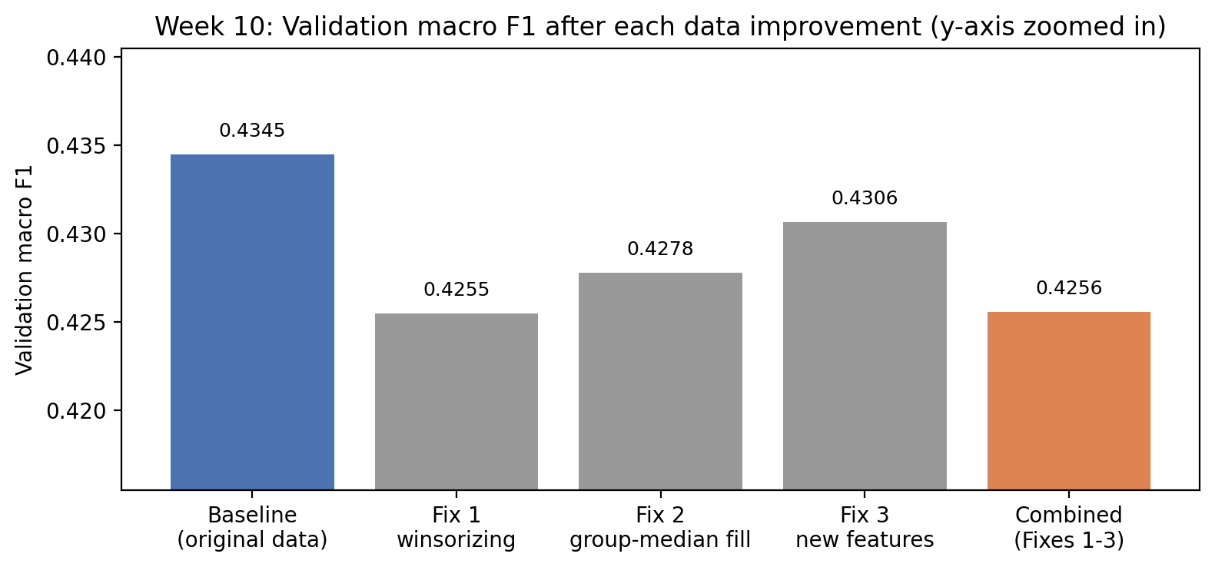
Figure 2. Validation macro F1 after each data improvement (y-axis zoomed in)

4. Retraining and Validation Comparison
We retrained Gradient Boosting V2 on the updated dataset with the same architecture and hyperparameters (learning rate 0.10, maximum depth 6, 200 iterations, balanced class weights, seed 42) and the same training rows. Both models were scored with the same scoring function from Week 9 on the same 9,928 validation companies, so the only difference between them is the data.
Validation metric | Week 9 model (original data) | Week 10 model (updated data)
Macro F1 | 0.4345 | 0.4256
Accuracy | 0.6620 | 0.6710
Macro precision | 0.4044 | 0.3969
Macro recall | 0.5391 | 0.5148
Log loss | 0.8121 | 0.7865
ROC-AUC (one-vs-rest) | 0.7979 | 0.8017
Training macro F1 | 0.6676 | 0.6944
Table 5. Week 9 model vs. retrained Week 10 model on validation
The Week 9 model has the higher validation macro F1 (0.4345 vs. 0.4256), so it is still our final model. The updated data didn’t help the classes that we care about the most. The Week 10 model finds more operating companies (recall 0.70 to 0.72), but it finds fewer of every rare outcome. Acquired recall falls from 0.56 to 0.52, closed from 0.43 to 0.40, and IPO from 0.46 to 0.42, while precision for those classes stays about the same (0.20 to 0.29 for both models). So the Week 10 model isn’t more accurate when it flags a rare outcome. It just flags fewer of them.
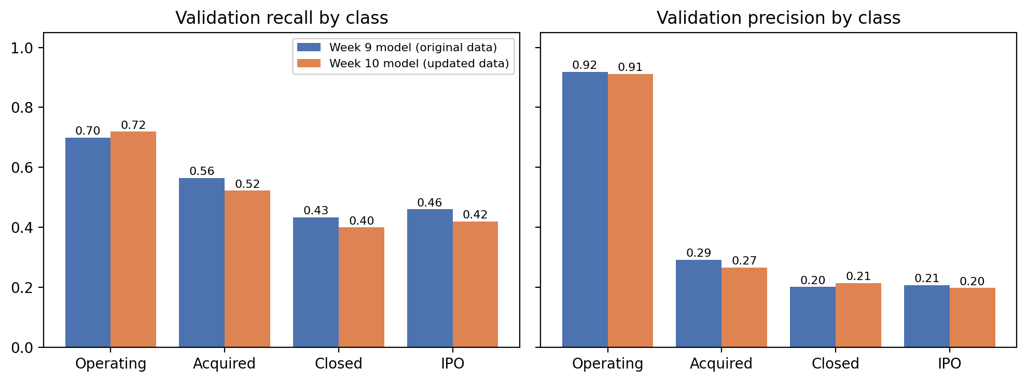
Figure 3. Validation recall and precision by class for the two models
The Week 10 model does have a slightly better log loss (0.787 vs. 0.812) and ROC-AUC (0.802 vs. 0.798), and higher accuracy. Its probabilities lean a little more toward operating, which helps on a validation set that’s 82% operating. We saw the same pattern with RF V3 in Week 9, so we kept macro F1 as the deciding metric.
The difference is small. To check whether it’s bigger than what we’d expect from which companies happen to be in the validation set, we resampled the 9,928 validation companies 1,000 times and scored both models on each resample. The 95% interval for the change in macro F1 runs from −0.021 to +0.004, which includes zero, and the Week 10 model only came out ahead in 7.9% of the resamples. The two models also label 2,169 companies (22%) differently, even though their overall scores are close. So the fair reading is that the updated data didn’t improve the model, not that it clearly made it worse. The Week 10 model also fits the training rows more closely (training macro F1 0.694 vs. 0.668), which widens the train-validation gap from 0.233 to 0.269. With results this close, we kept the original pipeline, which has fewer features and fewer processing steps.

5. Final Model on the Test Set
The winner was locked on validation before the test set was touched. Since the Week 9 model won, this is the same model we scored on the test set in Week 9, so no decision here was based on test results. The Week 10 model was never scored on the test set.
Split | Accuracy | Macro F1 | Macro precision | Macro recall | Log loss
Train | 0.7772 | 0.6676 | 0.5837 | 0.8908 | 0.5790
Validation | 0.6620 | 0.4345 | 0.4044 | 0.5391 | 0.8121
Test | 0.6610 | 0.4312 | 0.4013 | 0.5375 | 0.8001
Table 6. Final model (Gradient Boosting V2, original data) on train, validation, and test
The big drop is between training and validation, where macro F1 falls by 0.233 and accuracy by 0.115. That’s the overfitting we saw in the Week 9 bias-variance chart: the model fits the companies it trained on much better than new ones, and its training macro recall of 0.89 shows how well it learned the rare classes in those rows.
From validation to test the change is tiny. Macro F1 moves from 0.4345 to 0.4312 (−0.003), accuracy from 0.662 to 0.661, and test log loss is even a little lower than validation (0.800 vs. 0.812). So picking this model on validation didn’t make it look better than it really is, and the validation results are a fair estimate of how it does on companies it hasn’t seen.
Class | Precision | Recall | F1 | Companies
Operating | 0.919 | 0.699 | 0.794 | 8,111
Acquired | 0.269 | 0.518 | 0.354 | 826
Closed | 0.219 | 0.471 | 0.299 | 794
IPO | 0.199 | 0.462 | 0.278 | 197
Macro average | 0.401 | 0.538 | 0.431 | 9,928
Table 7. Final model on the test set by class
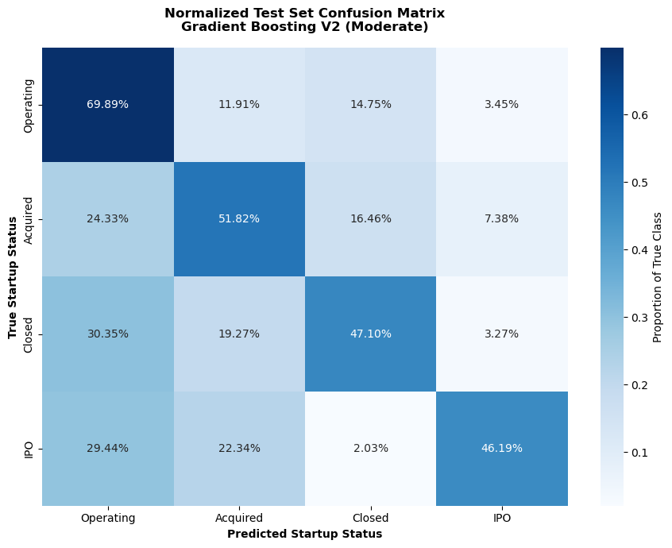
Figure 4. Normalized test confusion matrix for the final model (from Week 9, Section 9.3)
On the test set the model finds about half of the rare outcomes: 52% of acquisitions, 47% of closures, and 46% of IPOs. The confusion matrix shows where the rest go. About 30% of closed and 29% of IPO companies are predicted as operating, and 22% of IPOs are predicted as acquired. Both of those are exits, so the model has a harder time telling them apart. Among operating companies, 15% are predicted as closed and 12% as acquired, which is where most of the false alarms come from.

6. Insights and Conclusion
None of our three data improvements raised validation macro F1, and the model retrained on the combined dataset scored slightly lower than the Week 9 model, by an amount that’s within the noise of the validation sample. This supports what we found in Week 9, that the task is mostly limited by the information in the features. Capping outliers and changing how missing funding is filled only rearrange values the model already had. The new features helped a little on single-round companies, but most of what they say about a company overlaps with country, category, and funding, which the model already uses.
The error analysis was still useful, since it showed us where the model goes wrong and why. It labels operating companies as closed when their country or category is missing, it relies on company age more than funding speed, and it has very little to go on for the 59% of companies with one funding round. It also reminded us that our labels are a snapshot. An operating company isn’t necessarily a success, and many may still be acquired, close, or IPO later, so some of the “errors” on young operating companies may not be errors at all.
For an investor, the final model works best as a screening tool. It finds about half of the acquisitions, closures, and IPOs in companies it hasn’t seen, which the all-operating rule can’t do at all. But with precision of 0.20 to 0.27 for those classes, roughly three to four out of every five companies it flags won’t have the predicted outcome. The model can point to which companies deserve a closer look, but the investor still makes the decision.
If we kept improving the data, we’d focus on adding new information rather than cleaning what we have:
- Investor information, such as who led each round, which could separate strong single-round companies from weak ones.
- A better way to handle the operating label, such as treating recent operating companies as unfinished (the survival analysis idea from our project plan) instead of as a final outcome.
- A manual check of the most confident errors, like JinkoSolar Holding, to see whether some labels are actually wrong.
- A separate look at companies with an unknown country, since that group has the highest error rate and the model is reading the missing value itself as a sign of closing.

Appendix

A. Model settings
Both models in Section 4 use scikit-learn’s HistGradientBoostingClassifier with learning_rate 0.10, max_depth 6, max_iter 200, class_weight “balanced”, max_leaf_nodes None, early_stopping False, and random_state 42. Both use the same Week 5 split (train 29,782, validation 9,928, test 9,928). The scaler and PCA (5 components) are fit on the training rows only for every data version.

B. Reproducibility note
Gradient boosting results can change slightly with the scikit-learn version. The numbers in this report come from scikit-learn 1.7.2, which reproduces the Week 9 results exactly (validation macro F1 0.4345, test 0.4312). Running the same notebook with scikit-learn 1.9 gives a validation macro F1 of 0.4307 for the Week 9 model, but every data version still scored below the original data, so the conclusions don’t change.

