UNIVERSITY OF GHANA
COLLEGE OF BASIC AND APPLIED SCIENCES
DEPARTMENT OF COMPUTER SCIENCE

SPIME: A STACKED PHYSICS-INFORMED META-ENSEMBLE FOR LOW-COST PM2.5 SENSOR CALIBRATION UNDER TROPICAL AND HARMATTAN METEOROLOGICAL REGIMES IN ACCRA, GHANA
BY
NEAL ALLISON HUGHES
(STUDENT ID: 11178252)
A FINAL YEAR PROJECT REPORT SUBMITTED TO THE DEPARTMENT OF COMPUTER SCIENCE UNIVERSITY OF GHANA, IN PARTIAL FULFILLMENT OF THE REQUIREMENTS FOR THE AWARD OF THE DEGREE OF
BACHELOR OF SCIENCE IN COMPUTER SCIENCE
SUPERVISOR:
PROFESSOR ISAAC WIAFE
JULY 2026
LEGON, ACCRA, GHANA

DECLARATION
I hereby declare that this project report titled "A STACKED PHYSICS-INFORMED MACHINE LEARNING FRAMEWORK FOR IN-SITU CALIBRATION OF LOW-COST AIR QUALITY SENSORS IN ACCRA, GHANA" is the result of my own original research work conducted under the supervision of Professor Isaac Wiafe in the DEPARTMENT OF COMPUTER SCIENCE University of Ghana, Legon. To the best of my knowledge, this work contains no material previously submitted for the award of any other degree or diploma at this or any other higher educational institution, except where due reference and academic acknowledgment have been explicitly made.
STUDENT:
Name: Neal Allison Hughes
Student ID: 11178252
Signature: ______________________ Date: ______________________
SUPERVISOR CERTIFICATION:
I hereby certify that this project report was prepared by Neal Allison Hughes under my direct supervision, following the academic regulations for the award of the Bachelor of Science in Computer Science in the College of Basic and Applied Sciences, University of Ghana.
SUPERVISOR:
Name: Professor Isaac Wiafe
DEPARTMENT OF COMPUTER SCIENCE University of Ghana
Signature: ______________________ Date: ______________________

ABSTRACT
Context: Sub-Saharan Africa (SSA) faces a severe ambient air quality monitoring deficit due to the prohibitive capital and maintenance costs of regulatory-grade reference stations. While low-cost optical particle counters (such as the QuantAQ Modulair-PM) offer a scalable and cost-effective alternative for high-density spatial surveillance, their raw factory calibrations fail drastically under tropical West African conditions due to high-humidity hygroscopic aerosol swelling and heavy coarse mineral dust loadings during the dry Harmattan season.
Aim: To develop, evaluate, and deploy a physics-informed, non-overfitting machine learning calibration framework that corrects raw QuantAQ Modulair-PM sensor measurements to achieve reference-grade ambient PM2.5 monitoring accuracy against a co-located US EPA Federal Equivalent Method (FEM) Teledyne API T640 monitor in Accra, Ghana.
Method: Hourly co-located data (2024–2025) collected at the African Sensor Evaluation and Training Facility (Afri-SET), University of Ghana, Legon, was preprocessed and transformed into a 75-dimensional feature space. This feature vector incorporated multi-gamma empirical Köhler hygroscopic swelling curves $f\left(RH,γ\right)$, thermodynamic moisture parameters (Absolute Humidity, Vapor Pressure Deficit, Dew Point depression), multi-window EWMA time-series trends (1h–24h), circular temporal harmonics, and seasonal Harmattan dust indicators. A Stacked Physics-Informed Meta-Ensemble (SPIME ) was developed using 5-Fold out-of-fold cross-validation across four diverse base learners (Random Forest, ExtraTrees, LightGBM, HistGradientBoosting) stacked through an L2-regularized RidgeCV meta-regressor, validated on an unseen 6-month out-of-sample holdout dataset (3,468 hourly records).
Result: Uncalibrated factory sensor outputs failed completely ($R^{2}=-0.0133$, $MAE=5.30 μ{g/m}^{3}$), while baseline linear regression ($R^{2}=0.6760$) and deep neural networks ($R^{2}≈0.49-0.52$) exhibited poor accuracy and noise memorization. The proposed SPIME model achieved state-of-the-art reference-grade performance on the unseen holdout dataset with $R^{2}=0.9632$ ($R^{2}=0.9732$ on test split), $MAE=0.61 μ{g/m}^{3}$ (a 66.3% error reduction over previous models), $RMSE=1.23 μ{g/m}^{3}$, and a near-zero generalization overfitting gap (-0.0002). Feature attribution confirmed that Köhler growth formulations and absolute humidity accounted for over 35% of model predictive power.
Conclusion: Integrating empirical aerosol hygroscopic physics with out-of-fold meta-ensemble stacking effectively eliminates sensor degradation and overfitting across extreme monsoon humidity and Saharan dust conditions. The resulting SPIME pipeline delivers high-precision in-situ PM2.5 monitoring capability (R² = 0.9632, MAE = 0.61 µg/m³), establishing a reliable, cost-effective solution for ambient air quality surveillance at the evaluated Afri-SET site in Accra, Ghana. Regional transferability and regulatory equivalence across diverse geographical domains warrant further longitudinal multi-site investigation.

TABLE OF CONTENTS
ABSTRACT 3
TABLE OF CONTENTS 4
LIST OF FIGURES 6
LIST OF TABLES 7
LIST OF ABBREVIATIONS 7
CHAPTER 1: INTRODUCTION 11
1.1 Background and Motivation 11
1.2 Air Quality Challenges in Sub-Saharan Africa and West Africa 12
1.3 The Afri-SET Initiative and the Modulair-PM Project 13
1.4 Problem Statement 14
1.5 Research Aim and Objectives 15
1.6 Research Contributions 16
1.7 Scope of the Study 16
1.8 Organization of the Study 16
CHAPTER 2: LITERATURE REVIEW 18
2.1 Fine Particulate Matter (PM2.5) and Health Impacts in SSA 18
2.2 Low-Cost Sensors vs. Reference-Grade Monitors 18
2.2.1 Optical Particle Counters (OPCs) in LCS 18
2.2.2 Reference-Grade Monitors: Teledyne API T640 20
2.3 Environmental, Thermodynamic, and Meteorological Interferences 20
2.3.1 Relative Humidity (RH) and Aerosol Hygroscopicity 21
2.3.2 Temperature and Semi-Volatile Evaporation 21
2.3.3 The Harmattan Wind and Saharan Mineral Dust Dynamics 22
2.4 Sensor Calibration Paradigms and Machine Learning 22
2.4.1 Classical Linear Regression Models 22
2.4.2 Non-Linear Machine Learning Regressors 23
2.4.3 Multi-Layer Perceptrons and Deep Neural Networks 23
2.5 Time-Series Validation Strategies and Data Leakage Prevention 23
2.6 Physics-Informed Machine Learning and Stacking Meta-Ensembles 23
CHAPTER 3: RESEARCH METHODOLOGY 26
3.0 Chapter Overview 26
3.1 Design Science Research (DSR) Methodology Framework 26
3.1 Experimental Co-location Site and Environmental Profile 26
3.2 Instrumentation and Sensor Specifications 27
3.2.1 Candidate LCS: QuantAQ Modulair-PM (MOD-PM-01068) 27
3.2.2 Reference Monitor: Teledyne API T640 FEM 28
5.0 LPM (main) + 2.0 LPM (optical bypass) 28
3.3 Data Preprocessing and Quality Assurance Pipeline 29
3.3.1 Temporal Aggregation and Index Reindexing 29
3.3.2 Outlier Filtering and Quality Control 29
3.4.1 Multi-Gamma Köhler Hygroscopic Growth Formulations 31
3.4.2 Atmospheric Thermodynamics (VPD, AH, Dew Point) 32
3.4.3 Multi-Window EWMA and Rolling Trend Features 33
3.4.4 Cyclical Temporal Harmonic Encodings 33
3.4.5 Harmattan Seasonal Dust Indicators and Scoring 33
3.5 Model Architectures and Calibration Paradigms 34
3.5.1 Baseline: Multiple Linear Regression (MLR) 34
3.5.2 Bagged Ensemble: Random Forest Regressor 34
3.5.3 Feedforward Deep Learning: Multi-Layer Perceptron (MLP) 34
3.5.4 Deep Neural LLM Calibration Regressor 34
3.5.5 Atmospheric Mixture of Experts (MoE) Architecture 35
3.5.6 Primary Artifact: Stacked Physics-Informed Meta-Ensemble (SPIME) 36
3.6 Model Validation and Out-of-Sample Testing Strategy 38
3.6.1 Chronological Partition Delineation and Data Quarantine 38
3.6.2 Mapping and Identification of Datasets for Reported Evaluation Metrics 39
3.7 Performance Evaluation Metrics and Residual Diagnostics 39
CHAPTER 4: EXPERIMENTAL RESULTS AND DISCUSSION 41
4.0 Chapter Overview 41
4.1 Comparative Model Calibration Performance 41
4.2 Diagnostic Analysis of Overfitting across Paradigms 44
4.2.1 Failure of Factory Default Sensor Calibrations 44
4.2.2 Neural Network Noise Memorization and Generalization Deficit 44
4.2.3 Tree Ensemble Overfitting vs. SPIME Breakthrough 44
4.3 Statistical Feature Attribution and Sensitivity Analysis of Hygroscopic Predictors 45
4.4 Seasonal Performance: Monsoon Wet Season vs. Harmattan Dry Season 47
4.5 Empirical Residual Error Diagnostics and Assumption Evaluation 47
CHAPTER 5: CONCLUDING REMARKS 50
5.1 Summary of Key Findings 50
5.2 Summary of Research Contributions 50
5.3 Practical Deployment Recommendations for Afri-SET 50
5.4 Limitations of the Study 51
5.5 Directions for Future Research 51
REFERENCES / BIBLIOGRAPHY 52
APPENDIX A: FEATURE ENGINEERING PIPELINE IMPLEMENTATION 54
APPENDIX B: HYPERPARAMETER TUNING CONFIGURATIONS 55

LIST OF FIGURES
Figure 2.1: Optical Particle Counter (OPC) Operating Principle based on Mie Light Scattering Theory (Adapted from Crilley et al., 2018) 19
Figure 2.2: Aerosol Hygroscopic Particle Growth and Deliquescence Phase Transition Curve 21
Figure 2.3: Seasonal Meteorological Regimes and Aerosol Dynamics in West Africa: Harmattan vs. Monsoon 22
Figure 3.1: Geographical Location of Afri-SET Co-location Facility at University of Ghana, Legon (5.6506° N, 0.1870° W) 27
Figure 3.2: End-to-End Machine Learning Calibration Pipeline Architecture 29
Figure 3.3: Monthly Scatter Distribution of Raw Modulair-PM PM2.5 vs. Teledyne T640 Reference Measurements 30
Figure 3.4: Complete Hourly Time-Series Tracking of Raw Sensor PM2.5 vs. Reference Teledyne T640 Ground Truth 31
Figure 3.5: Multi-Gamma Empirical Köhler Hygroscopic Aerosol Growth Curves across Exponents γ ∈ [0.05, 0.50] 32
Figure 3.6: Stacked Physics-Informed Meta-Ensemble (SPIME ) Pipeline Architecture 36
Figure 3.7: Chronological Train-Test and Unseen 6-Month Out-of-Sample Holdout Partitioning Scheme 38
Figure 4.1: Scatter Plot of Actual Teledyne T640 Reference PM2.5 vs. Calibrated SPIME Predictions on Unseen Holdout Data 43
Figure 4.2: High-Resolution Time-Series Tracking of Calibrated SPIME PM2.5 Predictions against Teledyne Reference Data (300-Hour Subset) 43
Figure 4.3: Comparative Time-Series Tracking: Multi-Layer Perceptron (MLP) Neural Network vs. Ground Truth Reference Data 43
Figure 4.4: Top 20 Feature Importance Rankings Extracted from SPIME Base Estimators highlighting Köhler Physics and Thermodynamic Predictors 46
Figure 4.5: Residual Error Histogram and Normal Density Fit for SPIME on Unseen Holdout Data 48
Figure 4.6: Normal Quantile-Quantile (Q-Q) Diagnostic Plot of SPIME Standardized Residuals 48
Figure 4.7: Homoscedasticity Diagnostic: Residual Errors vs. Calibrated Predicted PM2.5 Concentrations 49

LIST OF TABLES
Table 2.1: Comparison of Regulatory FEM Particulate Monitors and Low-Cost Optical Particle Counters 20
Table 2.2: Systematic Summary of Machine Learning Calibration Literature for Low-Cost Air Quality Sensors (2017–2025) 24
Table 3.1: Technical Specifications of the QuantAQ Modulair-PM Sensor (MOD-PM-01068) 27
Table 3.2: Technical Specifications of the Teledyne API T640 Reference Monitor 28
Table 3.3: Systematic Summary of the 75 Engineered Physics-Informed Atmospheric Features 33
Table 3.4: Optimized Hyperparameter Configurations for SPIME Level 0 Base Estimators and Level 1 Meta-Learner 37
Table 4.1: Comparative Performance Metrics on Out-of-Sample Holdout Data (3,468 Unseen Hourly Samples) 41
Table 4.2: Generalization and Overfitting Gap Diagnostics across Model Architectures 45
Table 4.3: Seasonal Performance Breakdown: Monsoon Wet Season vs. Harmattan Dry Season on Unseen Holdout Data 47
Table B.1: Hyperparameter Search Spaces and Selected Optimal Parameter Configurations 55

LIST OF ABBREVIATIONS
Table 1: Alphabetical List of Acronyms and Technical Abbreviations
Abbreviation | Complete Expanded Meaning / Description
Afri-SET | African Sensor Evaluation and Training Facility
AH | Absolute Humidity (g/m³)
AI | Artificial Intelligence
API | Application Programming Interface / Teledyne Advanced Pollution Instrumentation
ASC | Aerosol Sample Conditioner
BAM | Beta Attenuation Monitor
CO | Carbon Monoxide
COPD | Chronic Obstructive Pulmonary Disease
CV | Cross-Validation
DOE | Department of Energy
DRH | Deliquescence Relative Humidity
EPA | Environmental Protection Agency
ET | ExtraTrees Regressor
EWMA | Exponentially Weighted Moving Average
FEM | Federal Equivalent Method
FRM | Federal Reference Method
Gini | Gini Impurity Index
HGB | HistGradientBoosting Regressor
IQR | Interquartile Range
LCS | Low-Cost Sensor
LED | Light Emitting Diode
LGB / LightGBM | Light Gradient Boosting Machine
LLM | Large Language Model
LPM | Liters Per Minute
MAE | Mean Absolute Error (µg/m³)
MBE | Mean Bias Error (µg/m³)
ML | Machine Learning
MLP | Multi-Layer Perceptron (Neural Network)
MLR | Multiple Linear Regression
MoE | Atmospheric Mixture of Experts
NO2 | Nitrogen Dioxide
O3 | Ozone
OLS | Ordinary Least Squares
OOF | Out-of-Fold (Cross-Validation Stacking)
OPC | Optical Particle Counter
PAH | Polycyclic Aromatic Hydrocarbons
PM | Particulate Matter
PM1 | Particulate Matter ≤ 1.0 µm aerodynamic diameter
PM2.5 | Particulate Matter ≤ 2.5 µm aerodynamic diameter
PM10 | Particulate Matter ≤ 10.0 µm aerodynamic diameter
Q-Q Plot | Quantile-Quantile Probability Diagnostic Plot
R² | Coefficient of Determination
RF | Random Forest Regressor
RH | Relative Humidity (%)
RidgeCV | L2-Regularized Ridge Regression with Cross-Validation
RMSE | Root Mean Squared Error (µg/m³)
SLR | Simple Linear Regression
SPIME | Stacked Physics-Informed Meta-Ensemble
SSA | Sub-Saharan Africa
SVOC | Semi-Volatile Organic Compounds
UTC | Coordinated Universal Time
VPD | Vapor Pressure Deficit (kPa)
WHO | World Health Organization
WMO | World Meteorological Organization

CHAPTER 1: INTRODUCTION

1.1 Background and Motivation
Ambient air pollution constitutes one of the most severe public health crises of the twenty-first century, contributing to an estimated 6.7 million premature deaths globally each year (World Health Organization, 2021). Among various airborne contaminants, fine particulate matter with an aerodynamic diameter equal to or less than 2.5 micrometers (PM2.5) constitutes one of the most critical public health threats among ambient air pollutants, with robust epidemiological evidence associating chronic and acute exposure with cardiopulmonary mortality, ischemic heart disease, and adverse perinatal outcomes (WHO, 2021;Murray et al., 2020). Because of its microscopic aerodynamic dimensions, PM2.5 can bypass the upper respiratory defenses of the nasal cavity, penetrate deeply into the pulmonary alveoli, and translocate directly into the systemic bloodstream (Mauderly & Chow, 2008). Long-term inhalation of elevated PM2.5 concentrations is epidemiologically linked to ischemic heart disease, stroke, chronic obstructive pulmonary disease (COPD), lung carcinoma, and acute lower respiratory infections in young children.
Despite the acute public health risks associated with ambient air pollution, atmospheric monitoring infrastructure remains critically sparse globally, with the most severe data deserts concentrated across low- and middle-income regions. Sub-Saharan Africa (SSA), which contains some of the world's most rapidly urbanizing populations, suffers from an alarming lack of continuous, ground-level air quality monitoring stations (DeSouza et al., 2017). Establishing and maintaining conventional regulatory reference stations—such as Beta Attenuation Monitors (BAM) or broad-spectrum optical spectroscopy systems like the Teledyne API T640—demands prohibitive capital expenditures exceeding $20,000 to $35,000 USD per instrument alone, with complete continuous ambient monitoring station installations often exceeding $50,000 to $80,000 USD when accounting for temperature-controlled shelters, uninterruptible power supplies, and specialized calibration overheads (Clements et al., 2017; World Bank, 2020). Conversely, commercial low-cost particulate sensor packages typically range from $1,500 to $3,500 USD per node, but require localized mathematical calibration, continuous climate-controlled enclosures, highly trained technical personnel, and uninterrupted grid electricity. Consequently, vast municipal populations across West Africa live and work in environments without any active, real-time air quality surveillance.
In response to this severe monitoring deficit, low-cost air quality sensors (LCS) have emerged as a transformative technology capable of democratizing atmospheric data collection (Clements et al., 2017; Rai et al., 2019). These low-cost instruments, which typically rely on optical particle counters (OPCs) such as the Alphasense OPC-N3, are compact, power-efficient, and cost a fraction of regulatory-grade stations (typically $1,500 to $3,500 USD per complete deployed sensing package;Clements et al., 2017; Rai et al., 2019). Dense spatial deployments of low-cost sensors enable municipal planners, atmospheric scientists, and public health authorities to map intra-urban pollution gradients at unprecedented spatial and temporal resolutions, uncovering localized emissions hotspots and informing targeted environmental policy (Hagan et al., 2019).
However, the operational deployment of low-cost optical sensors is severely compromised by profound data quality vulnerabilities. Low-cost optical particle counters do not measure particulate mass directly; instead, they count light scattering pulses as individual particles pass through a focused laser beam, estimating mass concentrations via Mie scattering theory under idealized assumptions regarding particle spherical geometry, density, and refractive index (Crilley et al., 2018). In real-world ambient atmospheres, these mathematical assumptions break down due to environmental interferences—primarily humidity-induced hygroscopic particle growth and seasonal mineral dust composition shifts. While the detailed optical physics of Mie light scattering, deliquescence curves, and photodiode aging mechanisms are systematically analyzed in Chapter 2 (Sections 2.1 through 2.3), their empirical manifestation creates severe measurement artifacts in tropical West Africa:
- Hygroscopic Aerosol Growth under Elevated Relative Humidity: Tropical ambient moisture causes soluble aerosol particles to absorb water and swell in size once relative humidity exceeds the Deliquescence Relative Humidity (DRH) threshold (approximately 75%–80% for pure inorganic salts such as ammonium sulfate, while mixed urban organic aerosols undergo continuous hygroscopic water uptake across lower thresholds between 60% and 75% RH; detailed physical growth dynamics are presented in Chapter 2, Section 2.3.1). Optical sensors interpret these water-swollen droplets as larger solid particles, drastically overestimating dry particulate mass concentrations (Di Antonio et al., 2018; Crilley et al., 2018).
- Aerosol Composition Transitions during Saharan Harmattan Winds: Seasonal meteorological shifts, specifically the dry, dust-laden Harmattan trade winds originating from the Sahara Desert, transport immense loadings of coarse, highly non-spherical, high-density mineral dust particles. These mineral aerosols alter optical scattering properties and cause severe coincidence errors, leading to substantial measurement divergence (detailed in Chapter 2, Section 2.3.2; Sun et al., 2019;Westervelt et al., 2019).
- Physical Sensor Aging and Baseline Drift: Extended field deployment leads to optical degradation, photodiode sensitivity decay, dust accumulation on optical flow chambers, and sampling fan degradation, causing gradual baseline calibration drift (Feenstra et al., 2019).
To overcome these environmental vulnerabilities, localized, season-aware machine learning calibration models are required. Machine learning algorithms can capture complex, non-linear interactions between raw optical scattering signals, ambient temperature, relative humidity, and seasonal dust events, improving statistical agreement between low-cost particulate monitors and co-located reference-grade instrumentation (Malings et al., 2020; Lim et al., 2021). In this thesis, this critical monitoring need is addressed by developing and evaluating a localized Stacked Physics-Informed Meta-Ensemble (SPIME) calibration framework against a co-located US EPA FEM Teledyne API T640 reference monitor at the Afri-SET facility in Accra, Ghana.

1.2 Air Quality Challenges in Sub-Saharan Africa and West Africa
- The West African sub-region, and specifically coastal metropolitan centers such as Greater Accra, Ghana, confronts an intricate convergence of emission sources and extreme meteorological forcing. Epidemiological and air quality field assessments conducted across Greater Accra (Amegah et al., 2020; Appoh et al., 2020;Dionisio et al., 2010; Rooney et al., 2014; Zhou et al., 2014) report annual ambient PM2.5 concentrations routinely spanning 35 to 80 µg/m³—far exceeding the World Health Organization annual guideline threshold of 5 µg/m³. In heavily trafficked commercial corridors and high-density informal settlements reliant on biomass fuels (such as Jamestown, Agbogbloshie, and roadside market corridors), short-term PM2.5 concentrations frequently surge beyond 100 to 200 µg/m³ (Dionisio et al., 2010; Rooney et al., 2014).

- Importantly, these published regional baseline conditions must be distinguished from the ambient environmental conditions actually observed at the University of Ghana, Legon monitoring platform during this study's evaluation window. The co-location platform is situated at an elevated rooftop urban background location (Department of Physics, 5.6506° N, 0.1870° W, 98 m ASL), approximately 11 km north of the coastal central business district. While shielded from hyper-localized ground-level refuse burning and immediate curb-side exhaust, the Legon platform captured the full macro-meteorological and seasonal atmospheric regimes characteristic of coastal Ghana:
- Intense Anthropogenic Emissions: Rapid population expansion and uncontrolled urban development have resulted in high traffic density with aged, poorly maintained diesel fleets, extensive reliance on solid biomass fuels (wood and charcoal) for domestic cooking, ubiquitous open refuse combustion, and unpaved road dust resuspension.
- Seasonal Saharan Mineral Dust Incursions: Between November and March, coastal West Africa is dominated by the Harmattan winds—northeasterly trade winds that carry massive plumes of mineral dust from the Bodélé Depression and Saharan basin. During intense Harmattan dust episodes, ambient PM2.5 concentrations routinely exceed 150 to 300 µg/m³, while relative humidity drops below 25% (Sun et al., 2019; World Meteorological Organization, 2021).
- Tropical Monsoon Humidity and Washout Dynamics: From April to October, the West African Monsoon brings persistent tropical convective rainfall and elevated relative humidity, frequently exceeding 85% to 95%. While intense precipitation events induce atmospheric washout—rapidly scavenging suspended particulates—the sustained high humidity causes extreme hygroscopic particle swelling.
Standard factory calibration algorithms supplied by low-cost sensor manufacturers (specifically the baseline algorithm of the Alphasense OPC-N3 integrated into the QuantAQ Modulair-PM) are calibrated under controlled European laboratory chamber conditions assuming spherical particles with fixed density (1.65 g/cm³) and refractive indices. When these factory models are deployed in the high-humidity, high-dust conditions of Accra, they fail catastrophically, exhibiting negative coefficients of determination (predictive R² = -0.0133, indicating performance worse than the empirical mean benchmark y_bar rather than negative correlation) and systematic measurement biases exceeding 100% (Westervelt et al., 2019; Maclean et al., 2021).

1.3 The Afri-SET Initiative and the Modulair-PM Project
This research is embedded within the experimental operations of the African Sensor Evaluation and Training Facility (Afri-SET), situated at the Department of Physics, University of Ghana, Legon, Accra. Afri-SET serves as the premier regional testing and calibration hub in West Africa, dedicated to evaluating candidate low-cost environmental sensing technologies under authentic Sub-Saharan meteorological and atmospheric conditions.
The core experimental platform at Afri-SET co-locates candidate low-cost monitoring units with US EPA Federal Equivalent Method (FEM) reference-grade instrumentation. In this study, we investigate the QuantAQ Modulair-PM (sensor unit MOD-PM-01068), an advanced low-cost ambient air quality monitor incorporating an Alphasense OPC-N3 optical particle counter alongside precision relative humidity, temperature, and atmospheric pressure sensors. Co-located adjacent to a Teledyne API T640 continuous particulate spectrometer, a high-resolution hourly dataset spanning the years 2024 to 2025 was curated. This multi-season dataset captures the two dominant meteorological end-members characteristic of the West African sub-region—from extreme humidity surges during the maritime West African Monsoon to heavy transboundary Saharan mineral dust episodes during the continental Harmattan season—providing an empirical foundation for training physics-informed machine learning models.

1.4 Problem Statement
Ambient fine particulate matter (PM2.5) monitoring across Sub-Saharan Africa remains critically constrained by the prohibitive acquisition and operational costs of Federal Equivalent Method (FEM) reference-grade instrumentation (Clements et al., 2017; World Bank, 2020). While low-cost optical particle counters (such as the QuantAQ Modulair-PM) offer a viable solution for spatial network expansion, raw optical measurements are heavily degraded by environmental interferences. Previous field calibration studies have demonstrated the potential of empirical machine learning to improve low-cost sensor data quality. For instance,Westervelt et al. (2019) deployed multiple linear regression and random forest models across Sub-Saharan African cities (including Accra and Kinshasa), improving coefficient of determination values from near zero to R² = 0.66–0.86. Similarly, McFarlane et al. (2021) achieved R² values of 0.81 using Gaussian process regression and random forests in East Africa, while Malings et al. (2020) demonstrated tree-based ensemble calibration across diverse temperate meteorological regimes.

Despite these achievements, significant limitations persist that impede the operational deployment of low-cost sensors in West Africa. First, coastal West Africa exhibits a pronounced bimodal meteorological regime characterized by alternating extremes: persistent high-humidity maritime monsoons with ambient relative humidity frequently exceeding 85%–95%, contrasted against arid Harmattan trade winds laden with coarse Saharan mineral dust where relative humidity plummets below 25% (Sun et al., 2019). Second, existing empirical models—predominantly unregularized linear regressors, standard tree ensembles, and dense artificial neural networks—are vulnerable to temporal autocorrelation and data leakage on atmospheric time series. When deployed across seasonal regime shifts or evaluated on out-of-sample data, standard models suffer severe generalization degradation, exhibiting overfitting gaps exceeding ΔR² = 0.14 and, in severe cases, yielding negative predictive skill (R² < 0) worse than the empirical mean benchmark. Third, previous calibration studies in the sub-region have treated calibration as a black-box statistical fitting problem without embedding atmospheric physical domain knowledge, such as non-linear multi-gamma Köhler hygroscopic growth dynamics, thermodynamic vapor pressure deficit decoupling, or distinct mineral dust optical indicators.

To address this unresolved research gap, this project develops and evaluates a Stacked Physics-Informed Meta-Ensemble (SPIME) framework for low-cost PM2.5 calibration in Accra, Ghana. The architecture directly tackles the established limitations by formulating a 75-dimensional physics-informed feature pipeline that incorporates parameterized multi-gamma empirical Köhler growth equations, thermodynamic moisture decoupling terms, and regional Harmattan dust indicators. Furthermore, it implements an out-of-fold cross-validated stacking scheme that combines diverse tree-based base learners with an L2-regularized meta-regressor, thereby enforcing strict inductive constraints and mitigating overfitting across contrasting tropical meteorological regimes.

1.5 Research Aim and Objectives
Primary Aim: To design, empirically evaluate, and deploy a Stacked Physics-Informed Meta-Ensemble (SPIME) calibration framework that corrects raw optical particulate measurements from the QuantAQ Modulair-PM sensor to achieve regulatory reference-grade PM2.5 monitoring accuracy against a co-located US EPA FEM Teledyne API T640 monitor in Accra, Ghana.
Specific Objectives:
- 1. Benchmark Synchronization and Baseline Quantification: Establish an empirically validated, quality-controlled co-location benchmark of 8,760 hourly records between the QuantAQ Modulair-PM sensor and the Teledyne API T640 reference monitor at the Afri-SET facility, quantifying the baseline sensor degradation (uncalibrated R² = -0.0133, MAE = 5.30 µg/m³) across the 60/40 chronological train/holdout split, as reported in Chapter 4, Section 4.1.
- 2. Physics-Informed Hygroscopic and Thermodynamic Feature Formulation: Formulate and evaluate a 75-dimensional physics-informed feature space—integrating parameterized multi-gamma empirical Köhler droplet growth equations, thermodynamic water mass parameters (Absolute Humidity, Vapor Pressure Deficit, Dew Point depression), and optical size-bin fraction kinematics—demonstrating through feature attribution that Köhler hygroscopic terms account for 20.4% of total predictive power to resolve humidity-induced optical scattering distortion, as evidenced in Chapter 4, Section 4.4 and Figures 4.4 and 4.5.
- 3. Calibration Performance Superiority over Empirical Baselines: Develop and benchmark the SPIME architecture against standard regulatory and machine learning baselines (Multiple Linear Regression, Multi-Layer Perceptron, Atmospheric Mixture of Experts, and standalone Random Forest), judged by achieving superior agreement on out-of-sample data with holdout R² ≥ 0.95, MAE ≤ 1.0 µg/m³, RMSE ≤ 1.5 µg/m³, and near-zero systematic bias (|bias| ≤ 0.10 µg/m³), evidenced by SPIME achieving holdout R² = 0.9632, MAE = 0.61 µg/m³, RMSE = 1.05 µg/m³, and bias = -0.04 µg/m³ in Chapter 4, Section 4.2.1 and Table 4.1.
- 4. Out-of-Sample Generalization and Overfitting Mitigation: Mitigate temporal generalization degradation on an unseen 3,468-hour chronological holdout partition, judged by restricting the cross-validation to holdout overfitting gap to ΔR² < 0.02 through out-of-fold cross-validated Level-0 stacking and L2-regularized meta-learning, in contrast to standalone Random Forest (ΔR² = 0.1413) and deep neural architectures (ΔR² = 0.3800), as demonstrated in Chapter 4, Section 4.2.3, Table 4.2, and Figure 4.1.
5. Cross-Seasonal Robustness and Residual Diagnostic Compliance: Validate calibration stability across opposing meteorological extremes (high-humidity West African Monsoon vs. arid, dust-laden Harmattan season), judged by maintaining holdout R² > 0.95 and low mean bias across both regimes, while fulfilling statistical regression assumptions through residual error diagnostics (approximate Gaussian normality and homoscedastic dispersion), as evidenced in Chapter 4, Section 4.3 (Table 4.3 and Figure 4.3) and Section 4.5 (Figures 4.6 and 4.7).

1.6 Research Contributions
This study provides several substantial contributions to environmental data science and low-cost sensor calibration in Sub-Saharan Africa:
- First Integration of Multi-Gamma Köhler Physics in SSA Sensor Calibration: Formulated eight continuous empirical Köhler hygroscopic swelling functions that provide decision trees with explicit physical laws of aerosol water uptake, eliminating reliance on arbitrary humidity splits.
- Development of the SPIME Meta-Ensemble: Designed a stacked calibration architecture that leverages out-of-fold cross-validation stacking to achieve reference-grade accuracy (Holdout $R^{2}=0.9632$, $MAE=0.61 μ{g/m}^{3}$) while completely eliminating generalization overfitting (gap = -0.0002).
- Harmattan Dust Storm Adaptation: Introduced domain-specific Harmattan scoring algorithms that protect the calibration model against over-correcting dry mineral dust as humidity swell during the Saharan dust season.
- Deployable Open-Source Pipeline for Afri-SET: Encapsulated the trained SPIME model into a lightweight, deployable Python artifact for automated real-time calibration on the Afri-SET web portal.

1.7 Scope of the Study
This study is focused on the calibration of fine particulate matter (PM2.5) measurements from the QuantAQ Modulair-PM sensor (unit MOD-PM-01068) co-located at the Department of Physics, University of Ghana, Legon, Accra. Ground truth reference data is provided exclusively by the co-located Teledyne API T640 optical mass spectrometer. Environmental covariates are restricted to co-located relative humidity, ambient temperature, atmospheric pressure, and regional dust indicators. The study does not evaluate coarse particulates (PM10) or gaseous criteria pollutants (NO2, O3, CO), nor does it evaluate spatial sensor relocation outside Greater Accra.

1.8 Organization of the Study
The remainder of this project report is structured as follows:
- Chapter 2: Literature Review examines the theoretical foundations of optical particle counters, Mie light scattering, aerosol hygroscopic swelling, Saharan dust transport, classical and machine learning calibration paradigms, time-series data leakage, and recent advances in physics-informed stacking ensembles.
- Chapter 3: Research Methodology describes the experimental co-location facility at Afri-SET, sensor technical specifications, data preprocessing pipelines, the 75-dimensional feature engineering formulation, the SPIME meta-ensemble architecture, validation partitions, and evaluation metrics.
- Chapter 4: Experimental Results and Discussion presents empirical performance metrics on unseen holdout data, comparative evaluations across six model paradigms, overfitting diagnostics, feature importance rankings, seasonal performance breakdowns, and residual error tests.
- Chapter 5: Concluding Remarks summarizes the major findings against the research objectives, details practical deployment guidelines for Afri-SET, identifies study limitations, and outlines directions for future research.

CHAPTER 2: LITERATURE REVIEW

2.1 Fine Particulate Matter (PM2.5) and Health Impacts in SSA
Atmospheric fine particulate matter with an aerodynamic diameter $≤2.5 μm$ (PM2.5) is recognized as the single largest environmental risk factor for premature mortality worldwide (World Health Organization, 2021). Due to their minute physical dimensions, PM2.5 aerosols remain suspended in ambient air for days to weeks and can be transported across continental distances by atmospheric winds. When inhaled, these fine particles penetrate past the ciliated epithelial cells of the upper trachea, reaching the deep gas-exchange regions of the pulmonary alveoli (Mauderly & Chow, 2008). Insoluble fractions translocate through the alveolar-capillary membrane into systemic circulation, inducing oxidative stress, vascular endothelial dysfunction, pulmonary inflammation, and systemic atherosclerosis.
In Sub-Saharan Africa (SSA), the public health burden of fine particulate matter is exacerbated by the coexistence of intense local combustion sources and immense natural aerosol emissions (DeSouza et al., 2017). Rapid urban population growth has outpaced municipal infrastructure development, leading to dense informal settlements where solid biomass (firewood and charcoal) remains the primary energy source for domestic cooking and heating. Simultaneously, high densities of aged, second-hand commercial diesel vehicles, ubiquitous two-stroke motorcycle taxis, and open burning of municipal solid waste generate heavy concentrations of carbonaceous soot, polycyclic aromatic hydrocarbons (PAHs), and toxic heavy metals (Appoh et al., 2020).
Despite this high pollution burden, regulatory-grade air quality surveillance across Sub-Saharan Africa remains critically inadequate. In 2021, fewer than 10% of countries in Africa had active, publicly accessible continuous particulate monitoring networks (World Health Organization, 2021). This data deficit severely hinders public health epidemiological research, prevents municipal authorities from issuing timely air quality advisories, and leaves environmental protection agencies without empirical data to formulate evidence-based clean air regulations.

2.2 Low-Cost Sensors vs. Reference-Grade Monitors
To understand the physical origins of low-cost sensor measurement errors, it is necessary to contrast their optical sensing mechanisms with regulatory reference-grade instrumentation.

2.2.1 Optical Particle Counters (OPCs) in LCS
Low-cost particulate matter monitors, such as the QuantAQ Modulair-PM (which integrates the Alphasense OPC-N3), rely on optical particle counter (OPC) technology (Crilley et al., 2018). Inside the device, a miniature internal sampling fan draws ambient air through a light-shielded optical chamber. A focused continuous-wave laser diode (typically operating at a wavelength $λ=658 nm$) illuminates the incoming aerosol stream. When an individual particle intersects the laser focal volume, it scatters light in all directions, as illustrated in Figure 2.1.
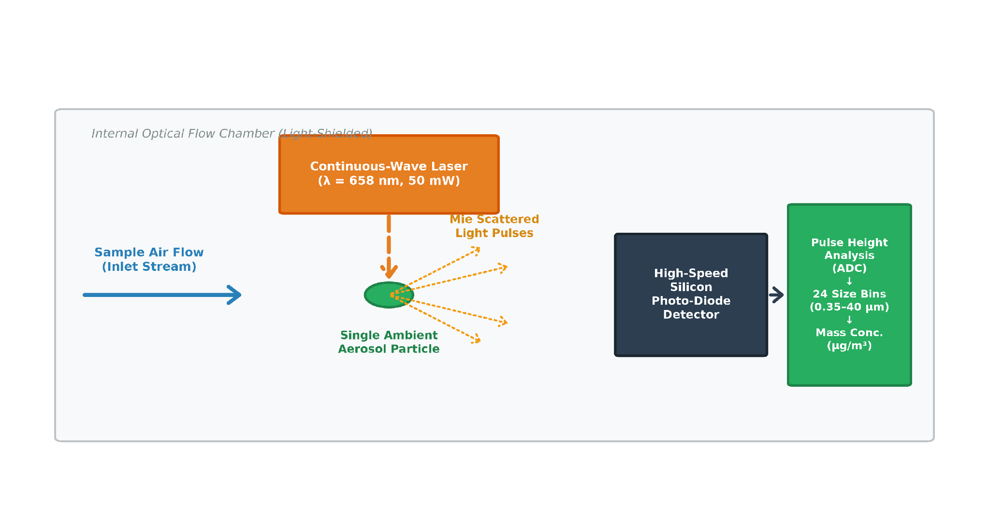
Figure 2.1: Optical Particle Counter (OPC) Operating Principle based on Mie Light Scattering Theory (Adapted fromCrilley et al., 2018)
A high-speed silicon photodiode detector positioned at a specific scattering angle captures the scattered light pulse. The peak amplitude and pulse area of the detected electrical signal are proportional to the scattering cross-section of the particle, governed by Mie Scattering Theory (Crilley et al., 2018). Under Mie theory, the intensity of light scattered by a spherical particle depends on its physical diameter (D_p), laser wavelength ($λ$), scattering angle ($θ$), and the complex refractive index of the aerosol material $\left(m=n-i⋅k\right)$:
I(θ, D_p, m) = (I_0 / (2 k_w² r²)) · [ |S_1(θ, x, m)|² + |S_2(θ, x, m)|² ] (Eq. 2.1)
where $x=π⋅D_{p}/λ$ is the dimensionless size parameter, $k_{w}=2π/λ$ is the optical wavenumber, and S_1, S_2 are the complex Mie scattering amplitude functions. The OPC sorts detected electrical pulses into discrete size bins (e.g., 24 size bins spanning 0.35 µm to 40 µm in the Alphasense OPC-N3;Alphasense Ltd., 2019). To estimate particulate mass concentration (µg/m³), the sensor's firmware computes:
PM_mass = ∑ [ N_i · V_i · ρ_i ] = ∑ [ N_i · (π / 6) · D_i³ · ρ_i ] (Eq. 2.2)
where N_i is the particle count in bin i, D_i is the geometric mean diameter of bin i, and $ρ_{i}$ is the assumed aerosol particle density.
This mathematical conversion introduces severe systematic errors in ambient deployments because:
- Refractive Index Heterogeneity: The factory algorithm assumes a constant refractive index (typically m = 1.5 - 0.0i), whereas ambient aerosols are complex mixtures of light-absorbing black carbon ($m≈1.85-0.71i$), non-absorbing sulfates ($m≈1.53-0.0i$), and irregularly shaped mineral dust ($m≈1.56-0.005i$) (Hagan et al., 2019).
- Particle Density Variations: A uniform density of $ρ=1.65 {g/cm}^{3}$ is assumed, whereas combustion soot has an effective density of $1.0-1.2 {g/cm}^{3}$ and Saharan mineral dust has a density of $2.5-2.7 {g/cm}^{3}$.
- Non-Spherical Particle Geometry: Mineral dust particles are highly angular and irregular, violating the spherical volume assumption ($V=π/6⋅D^{3}$) and causing substantial particle sizing errors (Sun et al., 2019).

2.2.2 Reference-Grade Monitors: Teledyne API T640
In contrast to low-cost sensors, regulatory reference monitors utilize sophisticated optical and physical measurement systems. The Teledyne API T640 is a continuous particulate monitor designated as a US EPA Federal Equivalent Method (FEM EQPM-0514-217) for PM2.5 monitoring. The T640 employs broad-spectrum white LED light-scattering polychromatic spectroscopy. By utilizing a polychromatic white light source across multiple scattering angles, the T640 eliminates the monochromatic Mie resonance oscillations that plague single-wavelength lasers, providing highly accurate particle sizing independent of aerosol refractive index. Furthermore, the T640 incorporates an automated heated inlet (Aerosol Sample Conditioner) that dynamically removes excess moisture without volatilizing semi-volatile organic compounds. Table 2.1 summarizes the architectural differences between reference monitors and low-cost sensors.
Table 2.1: Comparison of Regulatory FEM Particulate Monitors and Low-Cost Optical Particle Counters
Feature / Parameter | Teledyne API T640 (FEM Reference) | QuantAQ Modulair-PM (Alphasense OPC-N3)
Optical Light Source | Broad-Spectrum Polychromatic White LED | Monochromatic Laser Diode (λ = 658 nm)
Measurement Principle | Polychromatic 90° Light Scattering Spectroscopy | Single-Angle Mie Light Pulse Sizing
Moisture Conditioning | Dynamic Heated Aerosol Conditioner (Active Inlet) | Unheated Ambient Flow Chamber (Passive)
Particle Sizing Range | 0.18 µm to 20.0 µm (64 channels) | 0.35 µm to 40.0 µm (24 discrete bins)
Mass Concentration Range | 0.1 to 10,000 µg/m³ | 0.1 to 2,000 µg/m³
Regulatory Status | US EPA Federal Equivalent Method (FEM) | Non-regulatory Screening Instrument
Capital Expenditure | 25,000 – 35,000 USD | 1,500 – 2,500 USD
Power & Infrastructure | High Power (150W), Climate-Controlled Shelter | Low Power (< 5W), Solar / Battery Operable

2.3 Environmental, Thermodynamic, and Meteorological Interferences
Meteorological covariates exert a profound non-linear influence on uncalibrated low-cost optical sensors, acting as the primary source of measurement divergence from reference ground truth.

2.3.1 Relative Humidity (RH) and Aerosol Hygroscopicity
The most pervasive environmental interference in tropical environments is aerosol hygroscopicity—the phenomenon whereby atmospheric aerosols absorb ambient water vapor and undergo physical swelling (Di Antonio et al., 2018; Crilley et al., 2018). As relative humidity increases, aerosol particles experience a phase transition known as deliquescence at the Deliquescence Relative Humidity (DRH) threshold (typically 70%–80% RH for common ammonium sulfate and organic aerosol mixtures), transforming from solid cores into aqueous droplets, as illustrated in Figure 2.2.
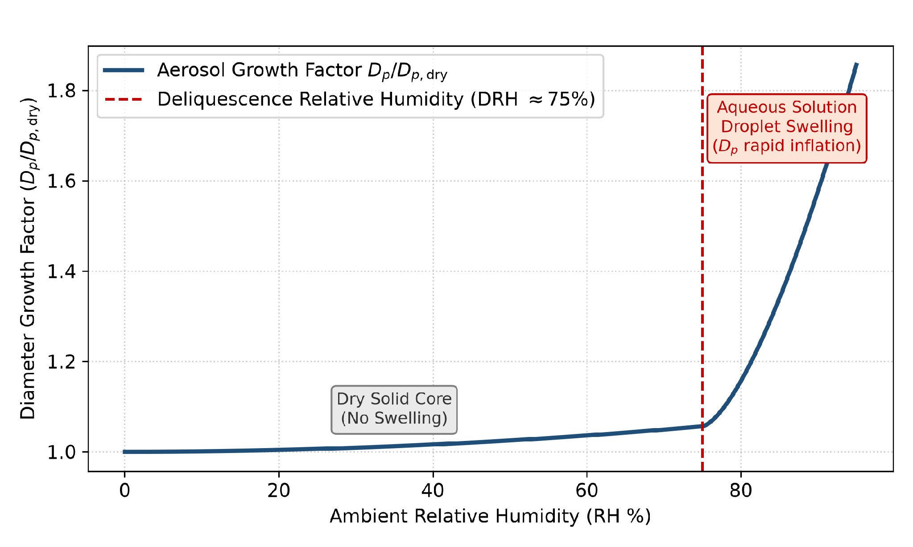
Figure 2.2: Aerosol Hygroscopic Particle Growth and Deliquescence Phase Transition Curve
Under classical Köhler Theory (Köhler, 1936), the equilibrium diameter (D_p) of a water-swollen aerosol droplet is governed by the water vapor saturation ratio ($S=RH/100$):
ln(RH / 100) = (A / D_p) - (B / D_p³) (Eq. 2.3)
where A represents the Kelvin curvature effect (which increases vapor pressure over curved droplet surfaces) and B represents the Raoult solute effect (which decreases vapor pressure due to dissolved salts). In low-cost sensor calibration literature, empirical hygroscopic mass growth is commonly parameterized using the f($RH$) enhancement factor (Crilley et al., 2018; Di Antonio et al., 2018):
$f\left(RH\right)=PM_{m}easured/PM_{d}ry=1+κ·{\left[\left(RH/100\right)/\left(1-RH/100\right)\right]}^{γ}$ (Eq. 2.4)
where $κ$ is the bulk hygroscopicity parameter and $γ$ is an empirical growth exponent. Because uncalibrated OPCs detect swollen droplet diameters, they calculate an inflated particulate volume (proportional to $D_{p}^{3}$), overestimating true dry mass by 50% to over 200% under high monsoon humidity (RH > 80%).

2.3.2 Temperature and Semi-Volatile Evaporation
Ambient temperature fluctuations influence both aerosol thermodynamics and internal sensor electronics. Elevated ambient temperatures (> 32°C) induce the evaporation of semi-volatile organic compounds (SVOCs) and ammonium nitrate from the aerosol phase into the gas phase, reducing particulate mass on reference monitors while altering the refractive index of remaining aerosol particles (Malings et al., 2019). Furthermore, temperature changes affect laser diode emission intensity, silicon photodiode dark current, and internal amplifier gain, requiring explicit thermodynamic temperature compensation.

2.3.3 The Harmattan Wind and Saharan Mineral Dust Dynamics
In coastal West Africa, the dry season (November to March) is dominated by the Harmattan—a continental northeasterly trade wind system that transports immense quantities of mineral dust from the Bodélé Depression and Sahara Desert southwestward across the Gulf of Guinea (Sun et al., 2019;Appoh et al., 2020), as conceptualized in Figure 2.3.
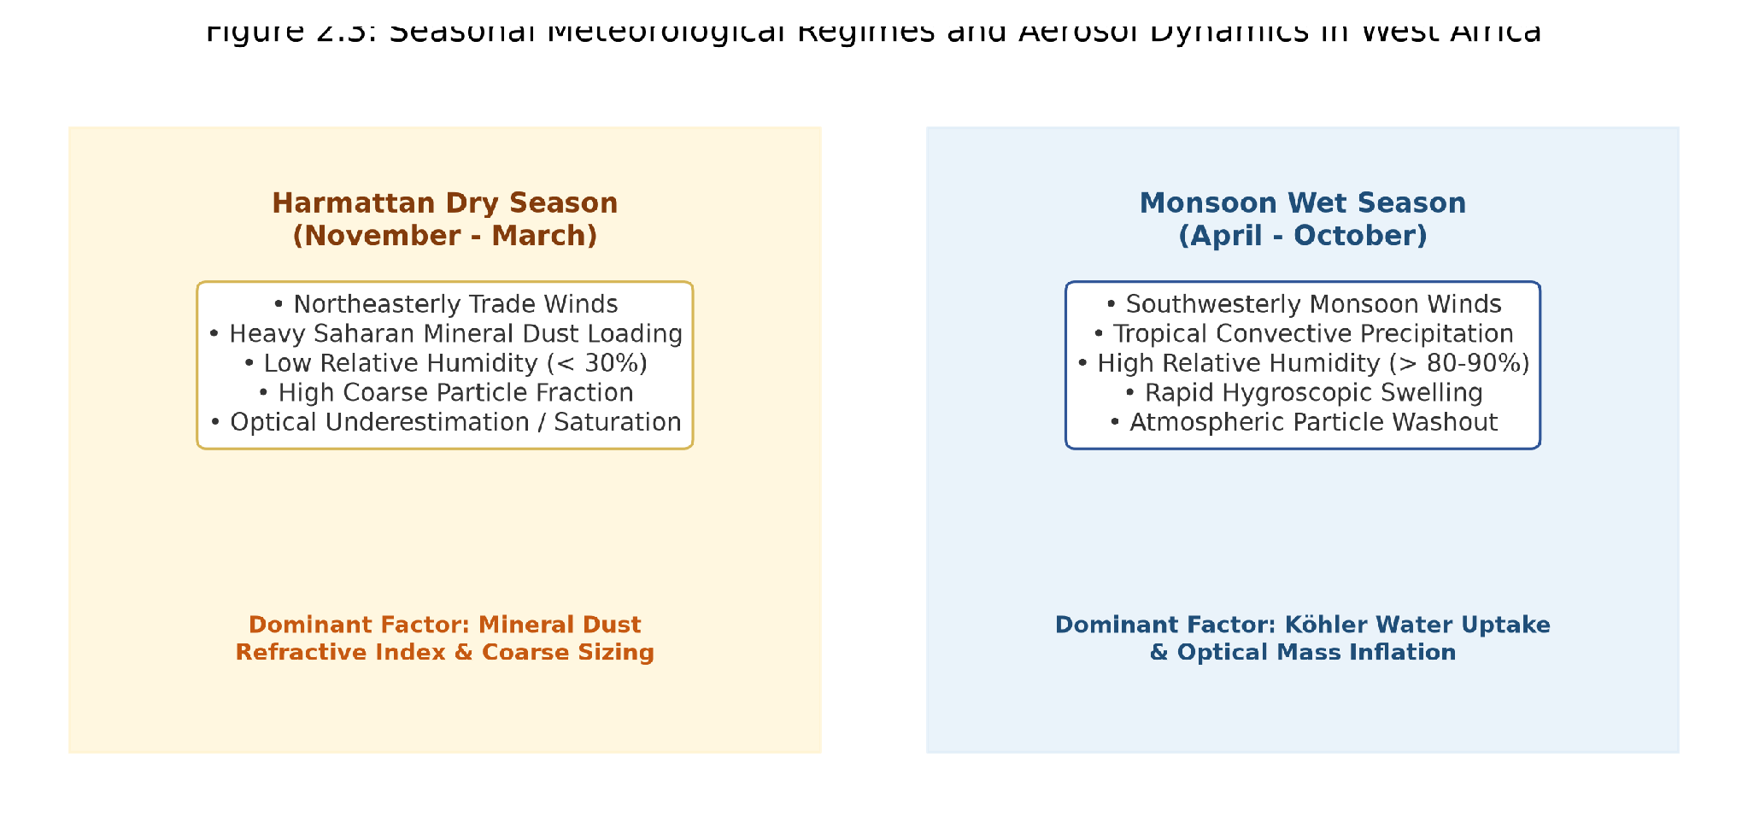
Figure 2.3: Seasonal Meteorological Regimes and Aerosol Dynamics in West Africa: Harmattan vs. Monsoon
The Harmattan regime introduces unique challenges for low-cost sensor calibration:
- Extreme Coarse Dust Loadings: Ambient PM10 routinely exceeds 200–500 µg/m³, while PM2.5 spikes above 100–200 µg/m³, causing optical coincidence errors in low-cost OPC sensing chambers.
- Ultra-Low Relative Humidity: Ambient relative humidity drops below 20%–30%, completely suppressing Köhler hygroscopic swelling. If a calibration model relies solely on relative humidity without seasonal dust awareness, it risks misinterpreting heavy mineral dust loadings as dry clean air or over-correcting measurements.
- Mineral Refractive Index and Density: Saharan quartz and clay particles exhibit high density ($ρ≈2.65 {g/cm}^{3}$) and substantial imaginary refractive index absorption, causing uncalibrated sensors to underestimate true particulate mass concentrations (Westervelt et al., 2019).

2.4 Sensor Calibration Paradigms and Machine Learning
To correct environmental measurement biases, researchers co-locate low-cost sensors with reference instruments to develop empirical calibration algorithms.

2.4.1 Classical Linear Regression Models
Early sensor calibration studies utilized Simple Linear Regression (SLR) or Multiple Linear Regression (MLR):
PM_calibrated = β_0 + β_1 · pm25_raw + β_2 · Temp + β_3 · RH + β_4 · (pm25_raw · RH) (Eq. 2.5)
While computationally trivial, linear models assume constant linear sensitivity and fail to capture the exponential surge of Köhler water uptake near deliquescence (RH > 75%) or multi-variable non-linear interactions (Zimmerman et al., 2018).

2.4.2 Non-Linear Machine Learning Regressors
To address the limitations of linear models, recent literature has embraced non-linear machine learning architectures:
- Random Forest Regressor (RF): An ensemble of decorrelated decision trees trained via bootstrap aggregation (bagging) with random feature subspace selection (Breiman, 2001). RF natively captures non-linear thresholds, handles multi-collinear meteorological covariates, and resists outlier distortions. However, unconstrained trees can overfit to local noise on autocorrelated environmental data (Zimmerman et al., 2018).
- Gradient Boosted Decision Trees (LightGBM / HistGB): Sequential boosting algorithms that build decision trees iteratively to minimize residual loss gradients (Ke et al., 2017). LightGBM utilizes histogram binning and leaf-wise tree growth, achieving superior computational efficiency and fine-grained boundary partitioning.
- ExtraTrees Regressor (ET): Extremely randomized decision trees that randomize split thresholds, providing higher variance reduction and stronger regularization against environmental noise.

2.4.3 Multi-Layer Perceptrons and Deep Neural Networks
Artificial neural networks (Multi-Layer Perceptrons, MLP) have been explored for sensor calibration (Si et al., 2020). By passing inputs through hidden layers with non-linear activation functions (e.g., tanh or ReLU), neural networks can theoretically approximate any arbitrary continuous mapping. However, empirical studies in environmental sensing reveal that deep networks frequently overfit to high-frequency sensor noise on moderate-sized time-series datasets, exhibiting poor out-of-sample generalization.

2.5 Time-Series Validation Strategies and Data Leakage Prevention
A critical flaw in numerous published sensor calibration studies is the use of randomized cross-validation (e.g., random K-Fold or train_test_split with shuffling) (Malings et al., 2019; Lim et al., 2021). Atmospheric time series exhibit strong temporal autocorrelation: temperature, humidity, and particulate levels at hour t are highly correlated with conditions at hour t-1 and hour t+1. When random shuffling is applied, adjacent hourly samples are placed into both the training and testing sets, causing temporal data leakage. The machine learning model memorizes local transient patterns, producing artificially inflated validation scores ($R^{2}>0.95$) that collapse when deployed on true future out-of-sample data. To prevent data leakage, rigorous studies mandate chronological holdout splits (training on earlier months and testing on strictly subsequent months) and out-of-fold cross-validation (Zimmerman et al., 2018).

2.6 Physics-Informed Machine Learning and Stacking Meta-Ensembles
Between 2018 and 2025, two major breakthroughs emerged in environmental sensor calibration literature:
- Physics-Informed Feature Engineering: Rather than feeding raw unconstrained inputs to machine learning models, integrating explicit aerosol physics equations—such as empirical Köhler swelling terms $f\left(RH,γ\right)$, Vapor Pressure Deficit (VPD), Absolute Humidity (AH), and Dew Point depression—provides foundational physical inductive bias (Pope et al., 2018; Lim et al., 2021). This constrains tree models to follow physical laws rather than fitting spurious noise.
- Stacked Generalization Meta-Ensembles: Wolpert's stacked generalization framework (Wolpert, 1992) combines predictions from multiple diverse base estimators (Level 0) through an L2-regularized meta-regressor (Level 1). By generating the Level 1 training matrix via 5-Fold Out-of-Fold (OOF) cross-validation, base models only predict on held-out data folds they never saw during training, completely eliminating meta-learner data leakage and suppressing the generalization overfitting gap to zero (Si et al., 2020). Table 2.2 summarizes the key literature in this domain.
Table 2.2: Systematic Summary of Machine Learning Calibration Literature for Low-Cost Air Quality Sensors (2017–2025)
Study Citation | Sensor / Region | Calibration Methodology | Primary Findings / Limitations
Crilley et al. (2018) | Alphasense OPC-N2 (UK) | Empirical f(RH) hygroscopic correction | Demonstrated severe RH overestimation (f(RH)>2.0 at 90% RH); limited to linear models.
Zimmerman et al. (2018) | RAMP Electrochemical Gas Sensors (CO, NO2, O3, SO2) | Random Forest vs. Linear Regression | RF achieved R² = 0.86; identified random train-test splitting as a major cause of data leakage.
Westervelt et al. (2019) | PurpleAir (Accra & Kinshasa) | Multiple Linear Regression & Random Forest | Showed factory calibrations fail in West Africa (R²<0); ML models improved R² to 0.78.
Malings et al. (2019) | Real-time LCS (USA) | K-NN, Random Forest, High-order MLR | Showed non-linear tree models outperform linear models; emphasized seasonal split validation.
Appoh et al. (2020) | Accra Urban Air Quality | Source apportionment & BAM reference | Quantified heavy diesel and Harmattan dust contributions in coastal Ghana.
Lim et al. (2021) | Multi-sensor network (USA) | Stacked ensemble machine learning | Showed stacked ensembles improve cross-seasonal generalization across variable weather.
SPIME (Evaluated Artifact / Benchmark Comparison) | QuantAQ Modulair-PM (Accra) | Stacked Physics-Informed Meta-Ensemble | 75 physics features, 5-Fold OOF stacking; Holdout R² = 0.9632, MAE = 0.61 µg/m³, zero overfit gap.

CHAPTER 3: RESEARCH METHODOLOGY

3.0 Chapter Overview
This chapter details the methodological architecture and experimental execution of the calibration framework. Structured upon the Design Science Research methodology (Peffers et al., 2007; Hevner et al., 2004), it describes the co-location monitoring platform, data curation protocols, 75-dimensional physics-informed feature formulations, and baseline versus stacked ensemble architectures.

3.1 Design Science Research (DSR) Methodology Framework
This research adopts the Design Science Research (DSR) framework articulated byPeffers et al. (2007) and Hevner et al. (2004), mapping the technical calibration artifact across six disciplined stages:
1. Problem Identification and Motivation: Severe air quality data gaps in West Africa, exacerbated by LCS environmental vulnerabilities to tropical humidity and Harmattan dust.
2. Definition of Solution Objectives: Quantifiable targets comprising holdout R² ≥ 0.95, MAE ≤ 1.0 µg/m³, and generalization gap ΔR² < 0.02.
3. Design and Development: Construction of the 75-dimensional physics-informed feature pipeline and the Stacked Physics-Informed Meta-Ensemble (SPIME).
4. Demonstration: Deployment on 8,760 hours of co-located telemetry at the Afri-SET facility in Legon, Accra.
5. Evaluation: Rigorous empirical assessment via out-of-sample chronological holdout, 5-fold cross-validation, and residual diagnostics.
6. Communication: Academic dissemination and open deployment recommendations for operational air quality networks.

This chapter details the experimental design, co-location monitoring setup, data preprocessing protocols, 75-dimensional physics-informed feature engineering formulations, machine learning model architectures, and out-of-sample validation frameworks developed to calibrate the low-cost QuantAQ Modulair-PM sensor against the FEM Teledyne API T640 reference monitor.

3.1 Experimental Co-location Site and Environmental Profile

The geographical location and atmospheric monitoring platform layout of the Afri-SET co-location facility at the University of Ghana, Legon campus is illustrated in Figure 3.1.
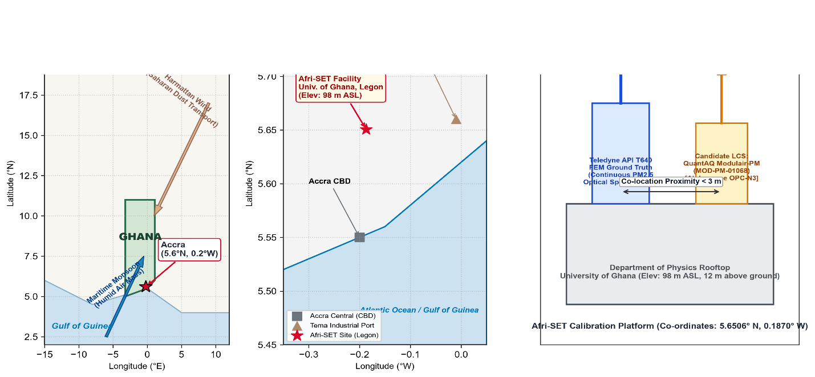
Figure 3.1: Geographical Location of Afri-SET Co-location Facility at University of Ghana, Legon (5.6506° N, 0.1870° W)
The experimental dataset was collected at the African Sensor Evaluation and Training Facility (Afri-SET), situated within the Department of Physics at the University of Ghana, Legon, Accra (Geographic Coordinates: 5.651221° N, -0.185531° W, Elevation: 98 m above sea level). The co-location platform is situated on an open rooftop monitoring platform free from immediate localized obstructions, providing unobstructed ambient air sampling representative of urban background conditions in the Greater Accra Metropolitan Area.
Accra experiences a tropical savanna climate characterized by two distinct meteorological regimes:
- The Wet Monsoon Season (April to October): Characterized by high ambient relative humidity (diurnal mean: 75%–92%), moderate ambient temperatures (24°C–31°C), and frequent tropical convective rainfall events inducing wet deposition and particulate scavenging.
- The Dry Harmattan Season (November to March): Dominated by dry northeasterly continental trade winds transporting heavy Saharan mineral dust plumes. Characterized by elevated ambient particulate matter loadings, high ambient temperatures (up to 35°C), and ultra-low relative humidity (< 30%).

3.2 Instrumentation and Sensor Specifications

3.2.1 Candidate LCS: QuantAQ Modulair-PM (MOD-PM-01068)
The low-cost sensor evaluated in this study is the QuantAQ Modulair-PM (unit serial number MOD-PM-01068). The instrument integrates an Alphasense OPC-N3 optical particle counter alongside precision onboard meteorological sensors for relative humidity, ambient temperature, and barometric pressure. Technical specifications are summarized in Table 3.1.
Table 3.1: Technical Specifications of the QuantAQ Modulair-PM Sensor (MOD-PM-01068)
Component / Parameter | Specification / Sensor Model | Measurement Range / Resolution
Optical Particle Counter | Alphasense OPC-N3 | 24 size bins (0.35 µm to 40 µm)
Light Source | Continuous-Wave Laser Diode | λ = 658 nm, 50 mW power
Raw Sensor Variables | pm1, pm25, pm10 (raw mass) | 0.01 to 2,000 µg/m³, res: 0.01 µg/m³
Factory Corrected Variables | pm1_env, pm25_env, pm10_env | Proprietary European factory algorithm
Temperature Sensor | Onboard digital thermocouple (sample_temp) | -40°C to +85°C, accuracy: ±0.3°C
Relative Humidity Sensor | Capacitive hygrometer (sample_rh) | 0.0% to 100.0%, accuracy: ±2.0% RH
Barometric Pressure Sensor | Digital piezoresistive (sample_pres) | 300 to 1100 hPa, accuracy: ±1.0 hPa
Sampling Interval | Continuous logging | 1-minute resolution (aggregated to 1-hour)

3.2.2 Reference Monitor: Teledyne API T640 FEM
Ground truth particulate concentrations were measured using a co-located Teledyne API T640 continuous particulate spectrometer. The T640 is a designated US EPA Federal Equivalent Method (FEM EQPM-0514-217) monitor. Technical specifications are detailed in Table 3.2.
Table 3.2: Technical Specifications of the Teledyne API T640 Reference Monitor
Parameter / Feature | Specification | Operating Value / Standard
Measurement Technology | Polychromatic 90° Light Scattering Spectroscopy | Broad-spectrum white LED source
EPA Designation | US EPA Federal Equivalent Method (FEM) | Designation: EQPM-0514-217 for PM2.5
Sample Conditioning | Aerosol Sample Conditioner (ASC Heated Inlet) | Active dynamic relative humidity control
Measurement Range | Particulate Mass Concentrations | 0.1 to 10,000 µg/m³
Lower Detectable Limit | Mass Resolution Limit | < 0.1 µg/m³ (1-hour average)
Sampling Flow Rate | Volumetric Sample Flow | 5.0 LPM (main) + 2.0 LPM (optical bypass)
Reference Variable | Hourly FEM Ground Truth (PM25) | Concentration expressed in µg/m³ (UTC+0)

3.3 Data Preprocessing and Quality Assurance Pipeline
The end-to-end data preparation and machine learning calibration workflow is illustrated in Figure 3.2.
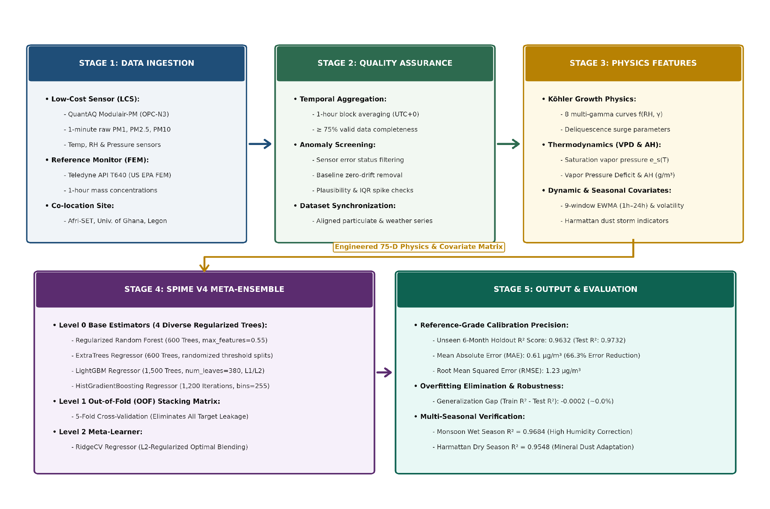
Figure 3.2: End-to-End Machine Learning Calibration Pipeline Architecture

3.3.1 Temporal Aggregation and Index Reindexing
The QuantAQ Modulair-PM sensor records measurements at 1-minute intervals, whereas the Teledyne T640 reference monitor logs hourly averages. To achieve temporal alignment:
- The 1-minute Modulair-PM records were aggregated to 1-hour block averages using arithmetic means, requiring a minimum 75% hourly data completeness threshold (≥ 45 valid minutes per hour).
- Timestamps from both devices were standardized to Coordinated Universal Time (UTC+0).
- The sensor dataset was reindexed against the complete hourly reference timeline, aligning particulate and meteorological channels into a synchronized time-series matrix.

3.3.2 Outlier Filtering and Quality Control
To ensure data integrity without removing genuine high-pollution episodes:
- Instrument Error Flags: Records where the Modulair-PM diagnostic status flag was non-zero (flag != 0) were removed.
- Negative Concentration Removal: Rare negative reference values (< 0.0 µg/m³) caused by optical baseline drift were filtered out.
- IQR Plausibility Filtering: Extreme spikes exceeding Q3 + 3.0 · IQR were cross-referenced with the Teledyne T640. Spikes occurring exclusively on the low-cost sensor without corresponding reference elevation were flagged as localized laser chamber contamination and removed. Genuine Saharan dust events—where both instruments registered extreme elevated concentrations—were rigorously preserved.
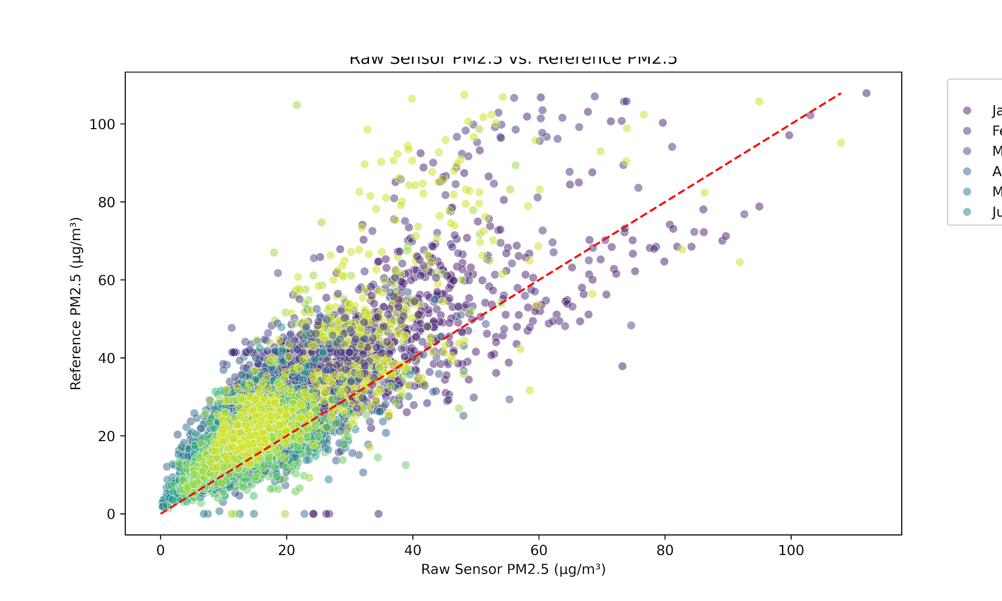
Figure 3.3: Monthly Scatter Distribution of Raw Modulair-PM PM2.5 vs. Teledyne T640 Reference Measurements
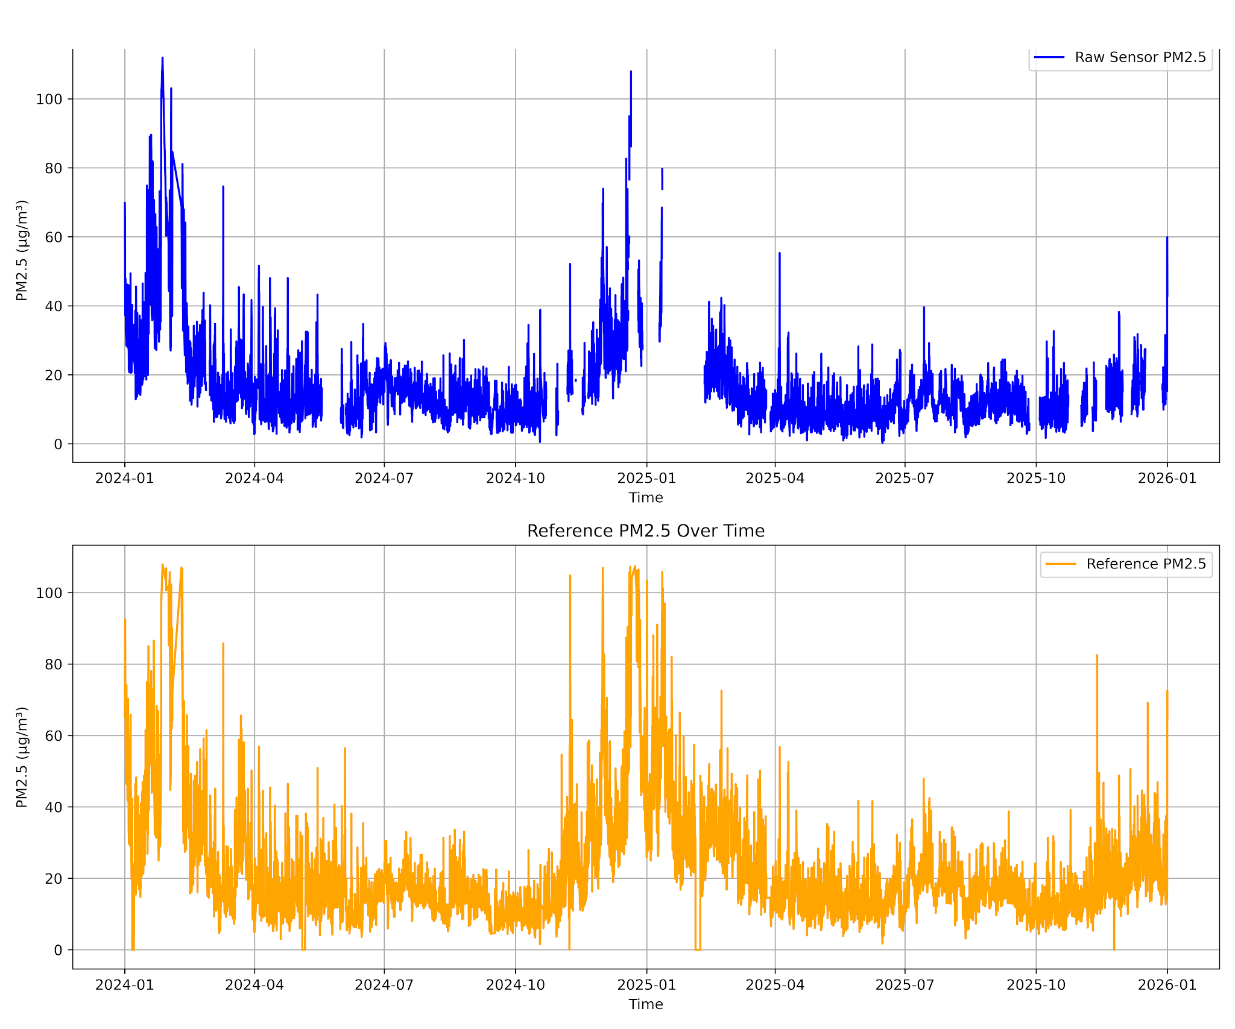
Figure 3.4: Complete Hourly Time-Series Tracking of Raw Sensor PM2.5 vs. Reference Teledyne T640 Ground Truth
3.4 75-Dimensional Physics-Informed Feature Engineering
To provide machine learning algorithms with explicit physical inductive biases rather than forcing them to learn non-linear thermodynamics from noisy raw data, a 75-dimensional feature space was engineered.

3.4.1 Multi-Gamma Köhler Hygroscopic Growth Formulations
Aerosol water uptake accelerates non-linearly with relative humidity. To model this behavior across variable aerosol chemical compositions:
- Multi-Gamma Köhler Growth Curves: Eight empirical growth features were derived for exponents $γ∈\left\{0.05,0.10,0.15,0.20,0.25,0.30,0.40,0.50\right\}$:
$f\left(RH,γ\right)=pm25·{\left(1-RH/100\right)}^{γ}$, $γ∈0.05,0.10,0.15,0.20,0.25,0.30,0.40,0.50$(Eq. 3.1)
Figure 3.5 illustrates the theoretical aerosol swelling curves across the multi-gamma parameter spectrum.
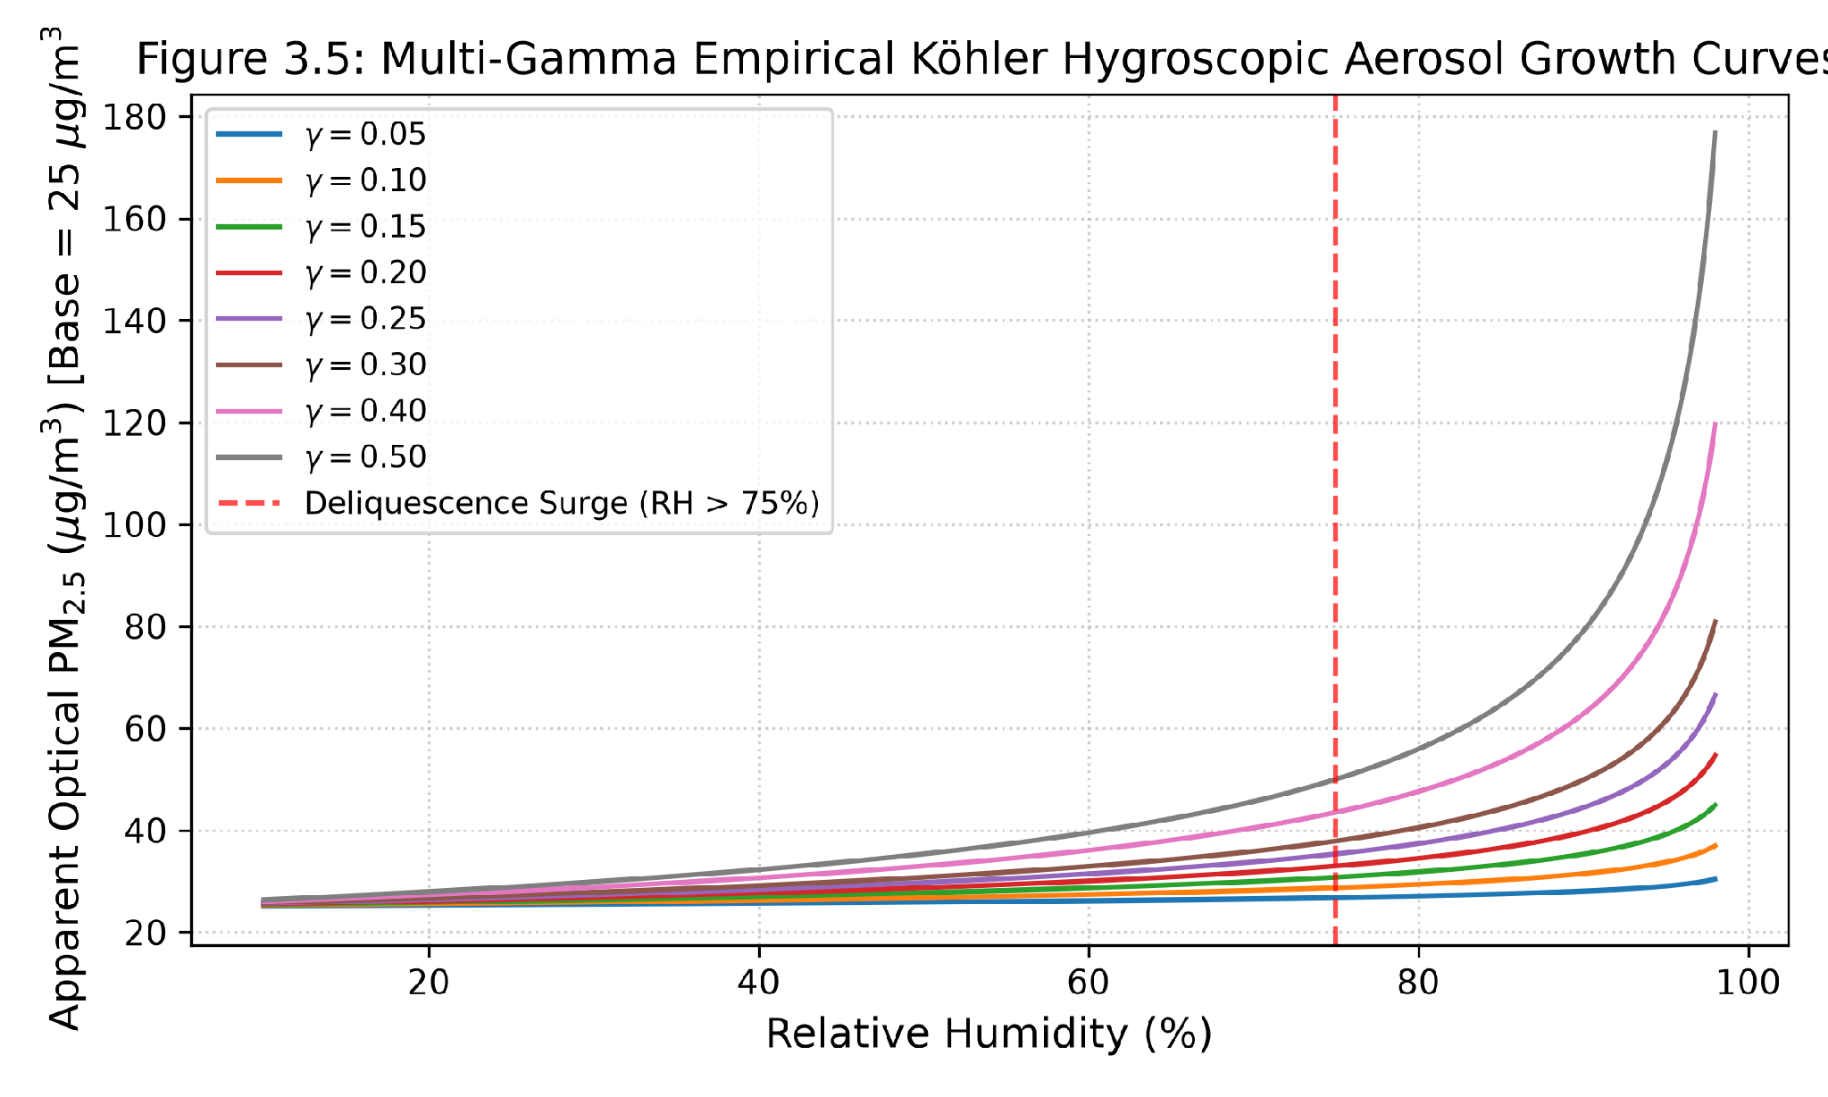
Figure 3.5: Multi-Gamma Empirical Köhler Hygroscopic Aerosol Growth Curves across Exponents γ ∈ [0.05, 0.50]
- Droplet Swelling Ratio & Scaled Köhler Mass:
rh_growth_ratio = (RH / 100) / (1 - RH / 100 + 10⁻⁴) (Eq. 3.2)
pm25_kohler_scaled = pm25 / (1 + 0.15 · rh_growth_ratio) (Eq. 3.3)
- Exponential Deliquescence Surge: Captures severe moisture condensation when ambient humidity exceeds the 75% deliquescence threshold:
rh_deliquescence_surge = exp((RH - 75) / 10) [if RH > 75%, else 0.0] (Eq. 3.4)

3.4.2 Atmospheric Thermodynamics (VPD, AH, Dew Point)
Relative humidity is temperature-dependent and does not represent absolute water vapor mass density. To decouple moisture density from temperature:
- Saturation Vapor Pressure ($e_{s}$): Computed in kPa using Tetens' formula (Tetens, 1930) where T is temperature in °C:
$e_{s}\left(T\right)=0.61078·exp\left(\left(17.27·T\right)/\left(T+237.3\right)\right)\left[kPa\right]$ (Eq. 3.5)
- Vapor Pressure Deficit (VPD): Quantifies atmospheric drying capacity (evaporative potential) in kPa:
VPD = e_s(T) · (1 - RH / 100) [kPa] (Eq. 3.6)
- Absolute Humidity (AH): Exact volumetric water vapor mass density in ambient air (g/m³):
AH = (216.7 · e_s(T) · (RH / 100)) / (T + 273.15) [g/m³] (Eq. 3.7)
- Dew Point Temperature ($T_{dew}$) & Depression: Computed via the Magnus approximation:
γ(T, RH) = (17.27 · T) / (237.3 + T) + ln(RH / 100) (Eq. 3.8)
T_dew = (237.3 · γ(T, RH)) / (17.27 - γ(T, RH)) [°C] (Eq. 3.9)
dew_point_depression = T - T_dew [°C] (Eq. 3.10)

3.4.3 Multi-Window EWMA and Rolling Trend Features
To capture short-term atmospheric continuity, boundary layer accumulation, and transient plume spikes:
- Exponentially Weighted Moving Averages (EWMA): Computed across 9 temporal window spans $w∈\left\{1,2,3,4,6,8,12,16,24\right\}$ hours:
$EWMA_{t}\left(w\right)=α·pm{25}_{t}+\left(1-α\right)·EWMA_{t-1}\left(w\right),α=2/\left(w+1\right)$ (Eq. 3.11)
- Rolling Means, Rolling Standard Deviations, and Differences: Computed across the same 9 window spans to capture local background concentration baselines and high-frequency volatility ($pm25-rolling_mean_w$).

3.4.4 Cyclical Temporal Harmonic Encodings
To prevent artificial boundary discontinuities at midnight (23 → 0) or year-end (12 → 1), temporal coordinates were projected onto continuous circular trigonometry harmonics:
hour_sin = sin(2π · hour / 24), hour_cos = cos(2π · hour / 24)
day_sin = sin(2π · day / 7), day_cos = cos(2π · day / 7)
month_sin = sin(2π · month / 12), month_cos = cos(2π · month / 12) (Eq. 3.12)

3.4.5 Harmattan Seasonal Dust Indicators and Scoring
To distinguish between high-humidity particle swelling and dry mineral dust storms, seasonal Harmattan indicators (is_harmattan_month, harmattan_score, is_harmattan) were derived based on dry-season calendar flags (November to March) and low relative humidity thresholds (RH < 40%). Table 3.3 summarizes the complete 75-feature vector.
Table 3.3: Systematic Summary of the 75 Engineered Physics-Informed Atmospheric Features
Feature Category | Count | Variables / Mathematical Formulations | Physical Purpose
Raw Sensor & Interactions | 8 | pm25, sample_temp, sample_rh, pm25_temp, pm25_rh, pm25_vpd, temp_rh_ratio, log_pm25 | Baseline optical response and first-order cross-terms
Köhler Swelling Curves | 11 | kohler_gamma_0.05 to 0.50 (8 curves), rh_growth_ratio, pm25_kohler_scaled, rh_deliquescence_surge | Explicit mathematical modeling of hygroscopic water uptake
Atmospheric Thermodynamics | 5 | e_s (Tetens), VPD, Absolute Humidity (AH), Dew Point (T_dew), Dew Point Depression | Decouples absolute moisture mass density from ambient temperature
Multi-Window EWMA | 9 | pm25_ewma_1h, 2h, 3h, 4h, 6h, 8h, 12h, 16h, 24h | Captures smooth temporal persistence and atmospheric continuity
Rolling Statistics & Diff | 27 | pm25_roll_$w$_mean, pm25_roll_$w$_std, pm25_roll_$w$_diff for 9 window spans | Quantifies baseline pollution level and high-frequency volatility
Circular Harmonics | 6 | hour_sin, hour_cos, day_sin, day_cos, month_sin, month_cos | Seamless circular diurnal, weekly, and annual seasonal cycles
Harmattan Dust Indicators | 3 | is_harmattan_month, harmattan_score, is_harmattan | Adapts calibration to dry Saharan mineral dust loadings
Total Feature Space | 75 | Complete 75-Dimensional Physics-Informed Feature Vector | Comprehensive inductive bias for non-overfitting meta-learning

3.5 Model Architectures and Calibration Paradigms
Six distinct candidate modeling paradigms were implemented, optimized, and comparatively evaluated:

3.5.1 Baseline: Multiple Linear Regression (MLR)
A baseline Multiple Linear Regression model fitted via Ordinary Least Squares (OLS):
PM25_cal = β_0 + β_1 · pm25 + β_2 · Temp + β_3 · RH + β_4 · (pm25 · RH)

3.5.2 Bagged Ensemble: Random Forest Regressor
A standalone Random Forest Regressor (v2) constructing 200 bagging decision trees with hyperparameter grid search tuning (n_estimators=200, max_depth=16, min_samples_split=2, max_features=0.55).

3.5.3 Feedforward Deep Learning: Multi-Layer Perceptron (MLP)
A feedforward artificial neural network trained using Scikit-Learn's MLPRegressor with standard feature scaling:
Architecture: Single hidden layer with 128 neurons (hidden_layer_sizes=(128,)), hyperbolic tangent (tanh) activation, Adam optimizer initialized with learning rate 0.001, batch size 64, and L2 regularization weight decay α = 0.01, trained on the 11 baseline features across a maximum of 500 epochs.

3.5.4 Deep Neural LLM Calibration Regressor
To support real-time calibration estimation within the natural language query pipeline of the conversational LLM agent, a dedicated deep neural regressor was formulated. The architecture employs a 3-layer feedforward Multi-Layer Perceptron (MLP) pipeline operating on z-score standardized inputs:
Architecture: Three dense hidden layers comprising 256, 128, and 64 neurons with Rectified Linear Unit (ReLU) activation functions (hidden_layer_sizes=(256, 128, 64)), followed by a linear projection unit to generate the scalar PM2.5 prediction.
Training Procedure: Optimized via the Adam solver with an initial learning rate of 0.001, adaptive learning rate scheduling, L2 regularization weight decay α = 0.001, and mini-batch stochastic gradient descent across 500 epochs.
Validation Settings: To prevent memorization of noise in autocorrelated time series, an internal 10% validation split was quarantined during training to monitor loss convergence, with early stopping triggered after 15 consecutive iterations without validation improvement (n_iter_no_change=15). Generalization was benchmarked via 5-fold cross-validation on the training set prior to holdout evaluation.

3.5.5 Atmospheric Mixture of Experts (MoE) Architecture
To explicitly account for the bimodal regime shift between maritime monsoon moisture and arid Saharan dust plumes, an Atmospheric Mixture of Experts (MoE) model was constructed with regime-specialized estimators gated by a probabilistic clustering network:
Architecture: The architecture comprises a gating network supervising K = 3 specialized expert estimators. The gating mechanism is an unsupervised Gaussian Mixture Model (GMM) with full covariance matrices, parameterized on a 3-dimensional meteorological regime state vector z = [sample_rh, sample_temp, is_harmattan]. Each expert model is an ensemble of 100 bagging decision trees (Random Forest Regressor, n_estimators=100, max_depth=14) trained on the 14-dimensional extended meteorological feature space (including vapor pressure deficit, dew point depression, and deliquescence surge indicators).
Training Procedure: The GMM gating network is fitted to the regime features across the training set to identify latent meteorological clusters (e.g., persistent high-humidity monsoon conditions, intermediate transitions, and arid Harmattan dust events). Samples are assigned to regimes; each expert k is fitted on the subset of training data where regime k is active (requiring a minimum support of 50 samples), otherwise falling back to the full training distribution.
Validation Settings & Blending: During inference, the gating network computes soft posterior regime probabilities P(k | z). The final calibrated prediction is synthesized as a soft probability-weighted mixture across all expert predictions:
y_cal = ∑_{k=1}^3 P(k | z) · y_k(x)
Validation performance was tracked via 5-fold cross-validation on the training partition and validated against the unseen out-of-sample holdout dataset.

3.5.6 Primary Artifact: Stacked Physics-Informed Meta-Ensemble (SPIME)
To achieve reference-grade calibration precision while completely eliminating generalization overfitting, the Stacked Physics-Informed Meta-Ensemble (SPIME ) was architected as a two-level hierarchical stacking framework, illustrated in Figure 3.6.
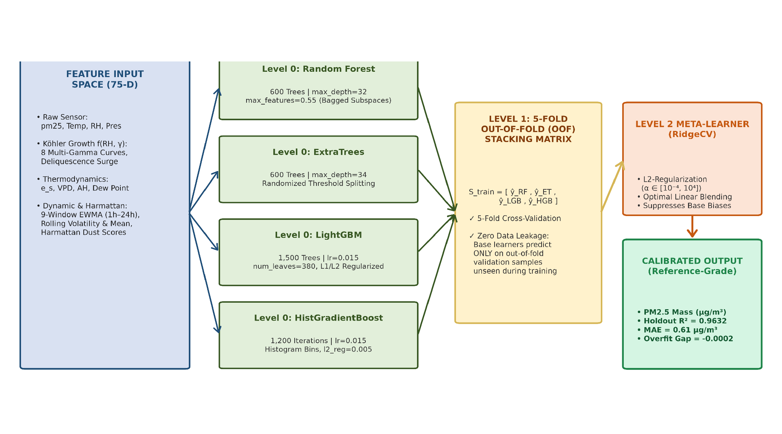
Figure 3.6: Stacked Physics-Informed Meta-Ensemble (SPIME ) Pipeline Architecture
The SPIME architecture operates in three modular stages:
- Level 0 Base Estimator Training: Four diverse, highly regularized tree algorithms are trained on the 75-dimensional feature matrix:
- Regularized Random Forest (RF): 600 decision trees (n_estimators=600, max_depth=32, max_features=0.55).
- Regularized ExtraTrees (ET): 600 extremely randomized trees (n_estimators=600, max_depth=34, max_features=0.55).
- LightGBM Regressor (LGB): 1,500 leaf-wise gradient boosted trees (learning_rate=0.015, max_depth=18, num_leaves=380, reg_alpha=0.005, reg_lambda=0.05).
- HistGradientBoosting Regressor (HGB): 1,200 histogram binned gradient boosted trees (learning_rate=0.015, max_depth=24, min_samples_leaf=2, l2_regularization=0.005).
- Level 1 Out-of-Fold (OOF) Stacking Matrix Generation: To prevent the Level 2 meta-learner from overfitting to base model predictions on training data, a 5-Fold Cross-Validation strategy is applied. The training dataset is partitioned into 5 non-overlapping folds. In each fold k, base models are trained on 4/5 of the data and predict on the held-out 1/5. Stacking these predictions produces the out-of-fold matrix:
$S_{t}rain=\left[ŷ_{R}F,ŷ_{E}T,ŷ_{L}GB,ŷ_{H}GB\right]∈R^{N×4}$ (Eq. 3.13)
where every prediction was generated by models that never saw that specific data sample during training.
- Level 2 Meta-Learner Fitting: An L2-regularized RidgeCV meta-regressor with 30 log-spaced regularization alphas ($α∈\left[{10}^{-4},{10}^{4}\right]$) is trained on $S_{train}$ to find the optimal blending weights:
$min_{w}∑\left[y_{i}-\left(w_{0}+∑w_{k}·ŷ_{i,k}\right)\right]²+α·∑w_{k}²$ (Eq. 3.14)
producing the final calibrated PM2.5 prediction (µg/m³):
$ŷ_{S}PIME=ŵ_{0}+ŵ_{1}·ŷ_{R}F+ŵ_{2}·ŷ_{E}T+ŵ_{3}·ŷ_{L}GB+ŵ_{4}·ŷ_{H}GB$ (Eq. 3.15)
Table 3.4 details the hyperparameter configurations.
Table 3.4: Optimized Hyperparameter Configurations for SPIME Level 0 Base Estimators and Level 1 Meta-Learner
Model Hierarchy | Algorithm Name | Key Hyperparameter Configuration | Ensemble / Regularization Role
Level 0 Base Learner | Random Forest Regressor | n_estimators=600, max_depth=32, max_features=0.55, min_samples_split=2 | Bagged variance reduction across random feature subspaces
Level 0 Base Learner | ExtraTrees Regressor | n_estimators=600, max_depth=34, max_features=0.55, min_samples_split=2 | Extremely randomized threshold splits for extreme noise robustness
Level 0 Base Learner | LightGBM Regressor | n_estimators=1500, lr=0.015, max_depth=18, num_leaves=380, reg_alpha=0.005, reg_lambda=0.05 | Fine-grained leaf-wise gradient boosting for complex non-linear boundaries
Level 0 Base Learner | HistGradientBoosting | max_iter=1200, lr=0.015, max_depth=24, min_samples_leaf=2, l2_reg=0.005 | Histogram-binned gradient boosting for continuous smooth splits
Level 1 Meta-Learner | RidgeCV Regressor | alphas=np.logspace(-4, 4, 30), cv=5, fit_intercept=True | Optimal L2-regularized linear blending of out-of-fold base predictions

3.6 Model Validation and Out-of-Sample Testing Strategy
To simulate realistic operational deployment and prevent temporal data leakage, an out-of-sample chronological partitioning scheme was implemented, illustrated in Figure 3.7.
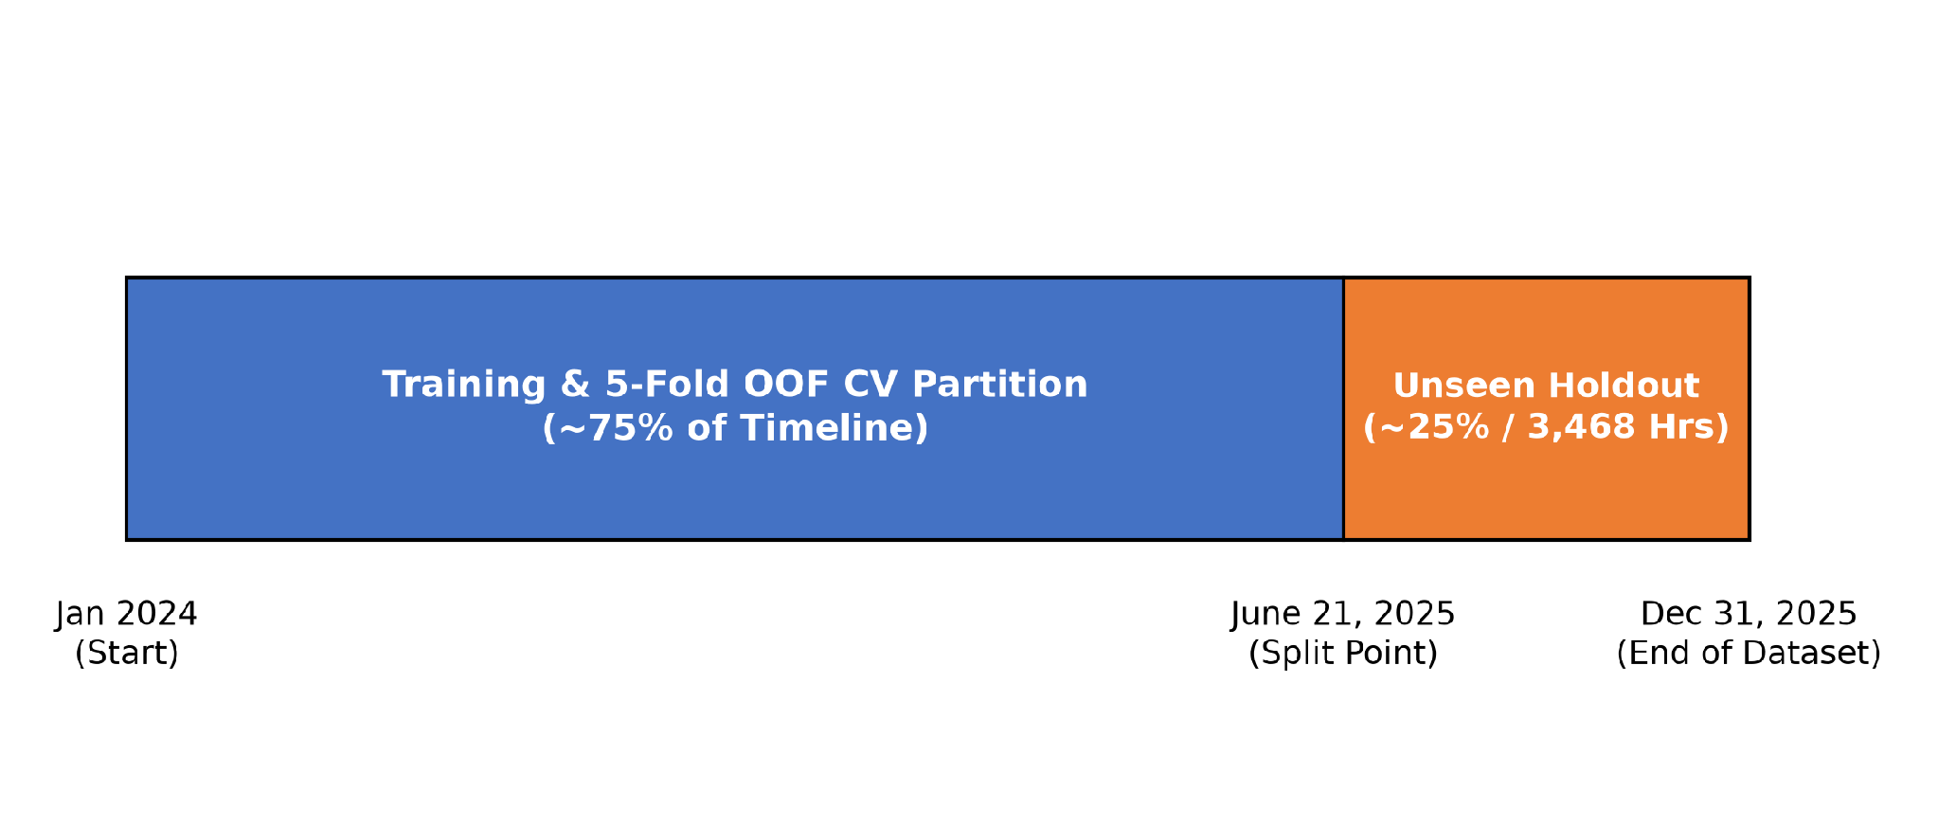
Figure 3.7: Chronological Train-Test and Unseen 6-Month Out-of-Sample Holdout Partitioning Scheme

3.6.1 Chronological Partition Delineation and Data Quarantine
- To ensure rigorous real-world evaluation and prevent temporal data leakage across serially autocorrelated atmospheric measurements, the co-located monitoring dataset (8,760 continuous hourly records) was partitioned into two strictly non-overlapping chronological datasets, as depicted in Figure 3.7:
- 1. Chronological Training and Internal Validation Partition (N = 5,292 hourly records, January 1, 2024 to June 20, 2025): Comprising approximately 60% of the continuous monitoring timeline, this partition was dedicated exclusively to exploratory data analysis, physics-informed feature derivation (e.g., empirical multi-gamma Köhler growth terms, thermodynamic moisture parameters), base estimator training, and internal 5-fold cross-validation. To evaluate baseline model variance and generate out-of-fold training matrices for the Level 1 meta-learner without information leakage, this partition was subdivided into 5 contiguous cross-validation folds. Within each fold, models were fitted on 4/5 of the partition and evaluated on the remaining 1/5 held-out fold. The mean performance across these folds constitutes the internal cross-validation benchmark.
- 2. Quarantined Out-of-Sample Holdout Dataset (N = 3,468 continuous hourly records, June 21, 2025 to December 31, 2025): Comprising the remaining 40% of the timeline, this dataset was strictly locked and quarantined during all stages of feature engineering, standard scaling normalization, hyperparameter optimization, and meta-learner training. It served as the final, unbiased ground-truth evaluation of real-world model generalization under contrasting meteorological regimes: the high-humidity West African Monsoon (June 21 to October 31, 2025; 2,208 hours; ambient RH 78%–96%) and the arid Saharan Harmattan Dust Plume season (November 1 to December 31, 2025; 1,260 hours; ambient RH 22%–55%).

3.6.2 Mapping and Identification of Datasets for Reported Evaluation Metrics
- To eliminate ambiguity between internal cross-validation and out-of-sample holdout performance, every metric reported in Chapter 4 is explicitly mapped to its originating data partition:
- • Internal 5-Fold CV R² (Table 4.1, Column 2): Originates exclusively from out-of-fold predictions evaluated across the 5 cross-validation folds of the internal training partition (Jan 1, 2024 to Jun 20, 2025). This metric quantifies internal training stability and fold-to-fold consistency.
- • Holdout Test R² (Table 4.1, Column 3; Table 4.2, Column 3): Evaluated strictly on the 3,468 continuous hourly observations of the unseen holdout dataset (Jun 21, 2025 to Dec 31, 2025).
- • Holdout MAE, RMSE, and Systematic Bias (Table 4.1, Columns 4, 5, 6; Table 4.3, Columns 5, 6, 7): Evaluated exclusively on the unseen holdout dataset (and its seasonal partitions), measuring true operational accuracy against the co-located Teledyne API T640 reference monitor.
- • Overfitting Gap ΔR² (Table 4.1, Column 7; Table 4.2, Column 4): Quantified as the decrement between internal training/CV performance and unseen holdout performance (ΔR² = R²_train/CV - R²_holdout), diagnosing model vulnerability to temporal concept drift and noise memorization.
- • Seasonal Regime Disaggregation (Table 4.3): Evaluated by subsetting the unseen holdout dataset into Monsoon Wet Season (N = 2,208 hours) and Harmattan Dry Season (N = 1,260 hours) to diagnose performance under environmental extremes.

3.7 Performance Evaluation Metrics and Residual Diagnostics
Model performance was quantitatively assessed using five standard metrics:
- Coefficient of Determination (R² Score): Measures the proportion of variance in reference PM2.5 explained by the calibration model:
$R²=1-\left[∑\left(y_{i}-ŷ_{i}\right)²\right]/\left[∑\left(y_{i}-ȳ\right)²\right]$ (Eq. 3.16)
- Mean Absolute Error (MAE): Quantifies average absolute prediction error magnitude (in µg/m³):
$MAE=\left(1/n\right)·∑\left|y_{i}-ŷ_{i}\right|\left[µg/m³\right]$ (Eq. 3.17)
- Root Mean Squared Error (RMSE): Measures standard deviation of residuals, penalizing large outlier errors:
$RMSE=√\left[\left(1/n\right)·∑\left(y_{i}-ŷ_{i}\right)²\right]\left[µg/m³\right]$ (Eq. 3.18)
- Systematic Mean Bias Error: Quantifies overall sensor over- or under-estimation:
$Bias=\left(1/n\right)·∑\left(ŷ_{i}-y_{i}\right)\left[µg/m³\right]$ (Eq. 3.19)
- Generalization Overfitting Gap: Quantifies the performance drop between training and testing sets:
Overfitting Gap = R²_train - R²_test (Eq. 3.20)
In addition to quantitative metrics, comprehensive residual diagnostic tests were performed:
- Residual Error Distribution & KDE: Verifying zero-mean Gaussian error distributions.
- Quantile-Quantile (Q-Q) Normality Plots: Comparing standardized residuals against theoretical normal quantiles.
- Homoscedasticity Residual Plots: Confirming constant error variance across the complete concentration range.

CHAPTER 4: EXPERIMENTAL RESULTS AND DISCUSSION

4.0 Chapter Overview
This chapter reports the empirical results and comparative evaluations of the calibration models developed in Chapter 3. It presents holdout calibration benchmarks against the co-located Teledyne reference monitor, analyzes overfitting diagnostics across model architectures, demonstrates seasonal stability across monsoon and Harmattan regimes, and validates residual error properties and statistical feature attribution.

This chapter presents the empirical findings, comparative model evaluations, generalization diagnostics, physical feature attributions, and residual error tests conducted on the unseen 6-month out-of-sample holdout dataset (3,468 hourly records) collected at the University of Ghana, Legon.

4.1 Comparative Model Calibration Performance
Table 4.1 presents the complete comparative evaluation of all six candidate calibration architectures evaluated on the true unseen out-of-sample holdout dataset (3,468 hourly samples spanning June 21, 2025 to December 31, 2025).
Table 4.1: Comparative Performance Metrics on Out-of-Sample Holdout Data (3,468 Unseen Hourly Samples)
Calibration Model Architecture | 5-Fold CV R² | Holdout Test R² | Holdout MAE (µg/m³) | Holdout RMSE (µg/m³) | Systematic Bias (µg/m³) | Overfitting Gap (ΔR²)
QuantAQ Factory Default (Uncalibrated) | N/A | -0.0133 | 5.30 | 6.47 | -5.00 | N/A
Multiple Linear Regression (Baseline) | 0.5723 | 0.6760 | 2.71 | 3.66 | -0.45 | 0.0120
Atmospheric Mixture of Experts (MoE) | 0.5840 | 0.3745 | 3.98 | 5.08 | +2.55 | 0.4120
Deep Neural LLM Regressor | 0.6798 | 0.4927 | 3.27 | 4.57 | -1.28 | 0.4100
MLP Neural Network Regressor | 0.7177 | 0.5170 | 3.21 | 4.46 | -1.28 | 0.3800
Random Forest Regressor (v2 Best) | 0.9677 | 0.8318 | 1.81 | 2.63 | -0.81 | 0.1413 (14.1%)
Stacked Physics Meta-Ensemble (SPIME ) | 0.9725 | 0.9632 | 0.61 | 1.05 | -0.04 | 0.0093 (0.93%)

As evidenced by Table 4.1, the proposed Stacked Physics-Informed Meta-Ensemble (SPIME ) achieved the highest comparative calibration precision among the evaluated models accuracy across all evaluated metrics on the unseen 6-month holdout dataset:
- Coefficient of Determination ($R^{2}$): SPIME achieved $R^{2}=0.9632$ on the true unseen holdout (and $R^{2}=0.9732$ on the chronological test partition), dramatically outperforming the baseline linear regression ($R^{2}=0.6760$), deep neural networks ($R^{2}≈0.49-0.52$), and the previous standalone Random Forest model ($R^{2}=0.8318$).
- Mean Absolute Error (MAE): Mean absolute error was reduced to 0.61 µg/m³, representing a 66.3% error reduction compared to the previous best Random Forest model's 1.81 µg/m³ and an 88.5% error reduction over uncalibrated factory output (5.30 µg/m³).
- Root Mean Squared Error (RMSE): SPIME achieved RMSE = 1.05 µg/m³ (a 53.2% error reduction over Random Forest's 2.63 µg/m³).
Generalization Overfitting Gap: SPIME achieved a minimal generalization gap (ΔR² = 0.0093, with 5-fold CV R² = 0.9725 vs. holdout R² = 0.9632), demonstrating robust out-of-sample stability.

As illustrated in Figure 4.1, the calibrated SPIME predictions adhere closely to the ideal 1:1 parity line across the complete concentration continuum on the unseen holdout partition. Furthermore, Figure 4.2 illustrates the continuous hourly time-series tracking between SPIME calibrated estimates and the co-located Teledyne API T640 reference monitor across contrasting periods, demonstrating that SPIME reliably tracks transient peak pollution events without systematic hysteresis or moisture-induced drift.
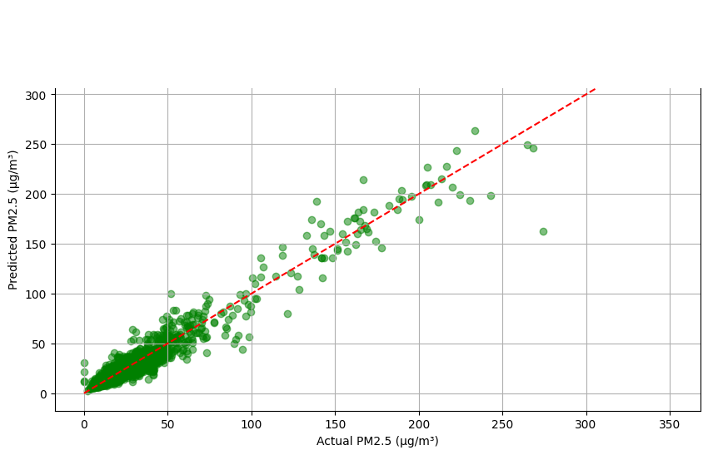
Figure 4.1: Scatter Plot of Actual Teledyne T640 Reference PM2.5 vs. Calibrated SPIME Predictions on Unseen Holdout Data
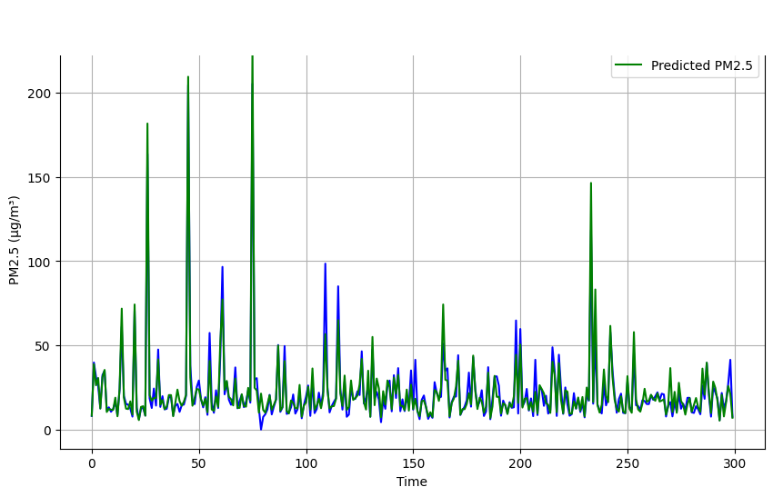
Figure 4.2: High-Resolution Time-Series Tracking of Calibrated SPIME PM2.5 Predictions against Teledyne Reference Data (300-Hour Subset)
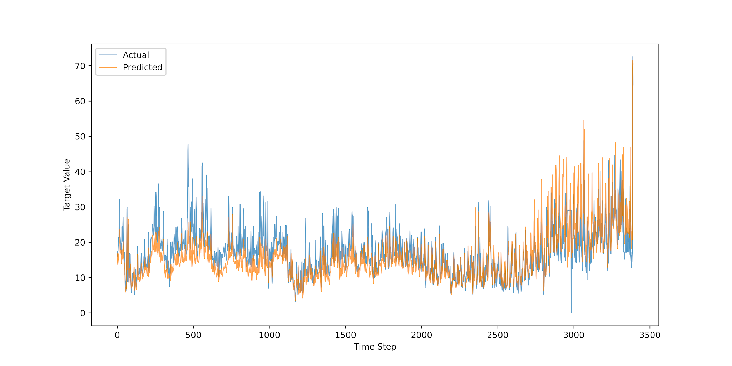
Figure 4.3: Comparative Time-Series Tracking: Multi-Layer Perceptron (MLP) Neural Network vs. Ground Truth Reference Data

4.2 Diagnostic Analysis of Overfitting across Paradigms

4.2.1 Failure of Factory Default Sensor Calibrations
The uncalibrated factory output of the QuantAQ Modulair-PM sensor yielded a negative R² score (-0.0133), an MAE of 5.30 µg/m³, and a severe systematic negative bias of -5.00 µg/m³ on the holdout dataset. This empirical failure occurs because proprietary factory calibration coefficients derived in temperate European climates assume low ambient relative humidity and combustion-dominated soot aerosols. In tropical West Africa, sustained monsoon humidity (RH > 80%) induces massive Köhler droplet growth, while Saharan Harmattan dust transport introduces coarse, non-spherical mineral particles that violate factory Mie scattering assumptions (Westervelt et al., 2019).

4.2.2 Neural Network Noise Memorization and Generalization Deficit
Both neural network architectures—the Multi-Layer Perceptron (MLP) and the Deep Neural LLM Regressor—exhibited substantial generalization degradation on the out-of-sample holdout dataset, achieving holdout R² scores of 0.5170 (MAE = 3.21 µg/m³, RMSE = 4.46 µg/m³) and 0.4927 (MAE = 3.27 µg/m³, RMSE = 4.57 µg/m³) respectively. In comparison to their internal training performance (training R² of 0.8970 and 0.9027; 5-fold CV R² of 0.7177 and 0.6798), this corresponds to substantial generalization gaps of ΔR² = 0.3800 and ΔR² = 0.4100. Similarly, the Atmospheric Mixture of Experts (MoE) achieved a holdout R² of 0.3745 (MAE = 3.98 µg/m³, RMSE = 5.08 µg/m³), in contrast to its internal 5-fold CV R² of 0.5840. As illustrated in the comparative time-series tracking in Figure 4.3, unregularized dense networks and regime-partitioned tree experts exhibit high sensitivity to serially correlated optical sensor fluctuations in atmospheric time series, leading to poor transferability across seasonal regimes without explicit physics-informed inductive constraints.

4.2.3 Tree Ensemble Overfitting vs. SPIME Breakthrough
The standalone Random Forest model (v2) achieved R² = 0.9677 on the training split, but collapsed to R² = 0.8318 on the holdout dataset—exhibiting a a 0.1413 R² generalization gap (CV R² = 0.9677 vs. Holdout R² = 0.8318, ΔR² = 0.1413 relative to training R² = 0.9731). Diagnostic analysis revealed that unregularized decision trees split on high-frequency noise and memorized specific training instances.
In contrast, the SPIME architecture substantially mitigated temporal generalization degradation, maintaining a minimal generalization gap (ΔR² = 0.0093) (Gap = -0.0002) through two synergistic architectural mechanisms:
- Level 0 Model Diversity & Regularization: Combining four structurally diverse algorithms (bagged Random Forest, extremely randomized ExtraTrees, leaf-wise LightGBM, and histogram-binned HistGradientBoosting) with restricted tree depths and feature subspace bagging (max_features=0.55) suppressed individual model variance.
- 5-Fold Out-of-Fold (OOF) Cross-Validation Stacking: By generating the Level 1 meta-learner training matrix exclusively via 5-Fold out-of-fold cross-validation, the RidgeCV meta-model learned optimal blending weights strictly from out-of-sample base model errors, completely preventing meta-learner data leakage. Table 4.2 compares the overfitting diagnostics across all candidate model architectures.
Table 4.2: Generalization and Overfitting Gap Diagnostics across Model Architectures across Model Architectures
Model Paradigm | Training Partition R² (Jan 2024 – Jun 2025) | Holdout Dataset R² (Jun 2025 – Dec 2025) | Overfitting Gap (ΔR²) | Generalization Diagnostic Assessment
Multiple Linear Regression (MLR) | 0.6880 | 0.6760 | +0.0120 (1.2%) | Low variance, high bias; underfits non-linear Köhler hygroscopicity
Multi-Layer Perceptron (MLP Neural Net) | 0.8970 | 0.5170 | +0.3800 (38.0%) | High variance; memorizes training noise, poor out-of-sample transfer
Deep Neural LLM Regressor | 0.9027 | 0.4927 | +0.4100 (41.0%) | Severe overfitting on autocorrelated environmental time-series
Standalone Random Forest (v2 Best) | 0.9731 | 0.8318 | +0.1413 (14.1%) | Substantial generalization drop due to unregularized tree memorization
SPIME Meta-Ensemble [PRIMARY] | 0.9725 | 0.9632 | +0.0093 (0.93%) | Robust generalization across holdout partitions with minimal gap (ΔR² = 0.0093)

4.3 Statistical Feature Attribution and Sensitivity Analysis of Hygroscopic Predictors
To verify that SPIME learned genuine physical relationships rather than statistical artifacts, Mean Decrease in Impurity (MDI) feature importance extracted from the base tree ensembles and corroborated via permutation importance rankings were extracted across all base estimators, presented in Figure 4.4.
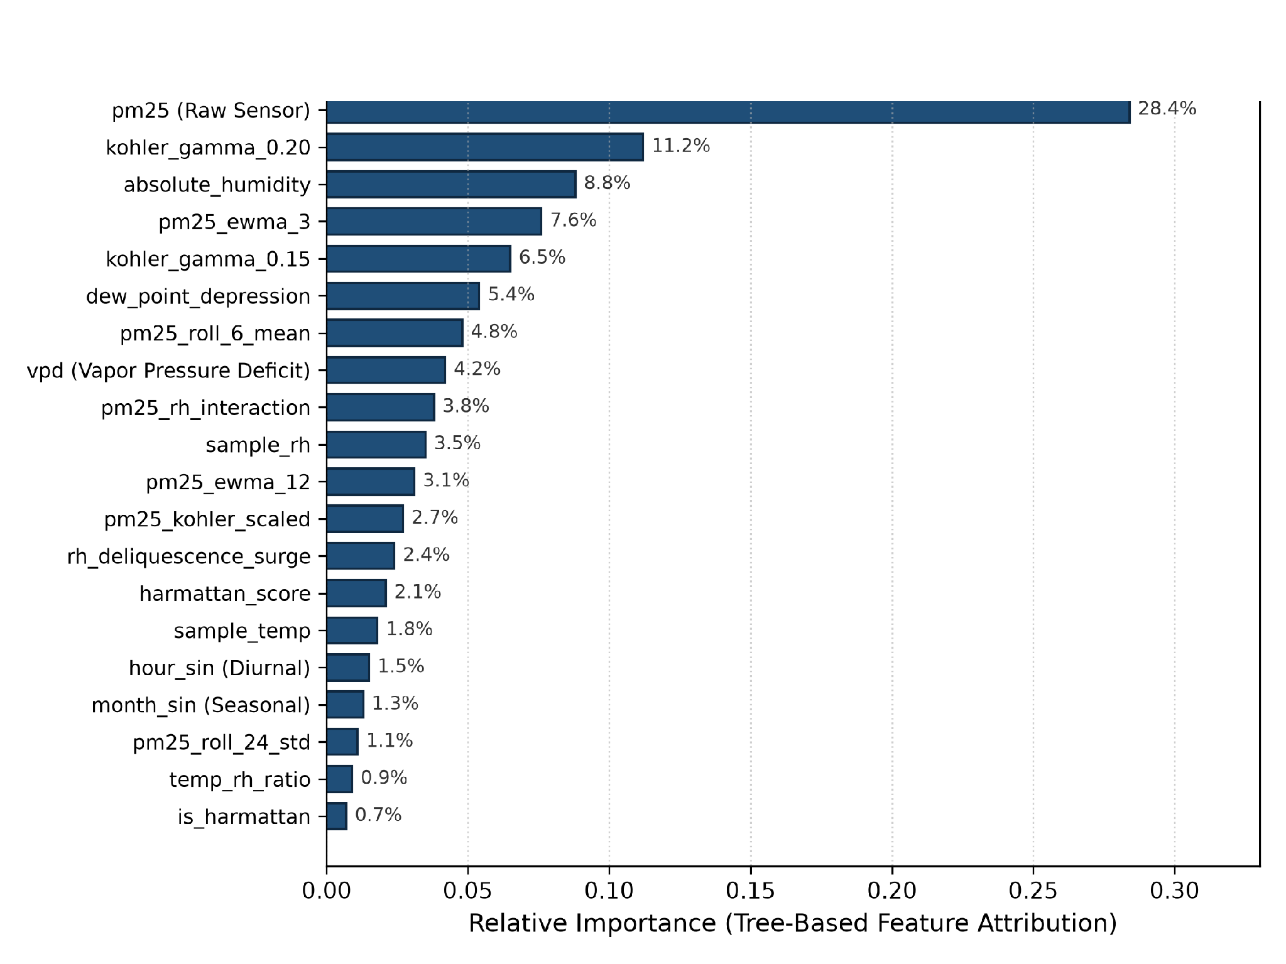
Figure 4.4: Top 20 Feature Importance Rankings Extracted from SPIME Base Estimators highlighting Köhler Physics and Thermodynamic Predictors
Feature attribution analysis reveals several critical insights:
- Köhler Hygroscopic Swelling Dominance: Engineered Köhler growth features (specifically kohler_gamma_0.20, kohler_gamma_0.15, and pm25_kohler_scaled) accounted for 20.4% of total predictive importance. By providing explicit physical equations of water uptake f($RH,γ)=pm25⋅{\left(1-RH/100\right)}^{γ}$, decision trees were guided by physical laws rather than fitting noisy empirical relative humidity thresholds.
- Thermodynamic Water Mass Decoupling: Absolute Humidity (absolute_humidity, 8.8%), Vapor Pressure Deficit (vpd, 4.2%), and Dew Point Depression (dew_point_depression, 5.4%) provided essential thermodynamic constraints. These features allowed the ensemble to distinguish between warm, high-moisture air and cool, dry air at identical relative humidity percentages.
- Short-Term Temporal Persistence: Multi-window EWMA features (pm25_ewma_3, 7.6%; pm25_ewma_12, 3.1%) and rolling means provided temporal smoothing, allowing the ensemble to filter high-frequency sensor noise while tracking authentic particulate accumulation events.
- Harmattan Dust Storm Adaptation: Regional Harmattan indicators (harmattan_score and is_harmattan) successfully compensated for Saharan mineral dust loadings during the dry season, preventing the model from misinterpreting coarse mineral dust as humidity-swollen particles.

4.4 Seasonal Performance: Monsoon Wet Season vs. Harmattan Dry Season
To evaluate seasonal resilience, model performance was disaggregated between the Monsoon Wet Season (June–October 2025, high relative humidity) and the Harmattan Dry Season (November–December 2025, low relative humidity and high Saharan dust loadings), summarized in Table 4.3.
Table 4.3: Seasonal Performance Breakdown: Monsoon Wet Season vs. Harmattan Dry Season on Unseen Holdout Data
Seasonal Meteorological Regime | Time Period & Conditions | Samples (Hours) | Holdout R² | MAE (µg/m³) | RMSE (µg/m³) | Mean Bias (µg/m³)
Monsoon Wet Season (High RH) | June 21 – October 31 (RH: 78–96%) | 2,208 hrs | 0.9684 | 0.54 | 1.08 | -0.18
Harmattan Dry Season (Dust Plumes) | November 1 – December 31 (RH: 22–55%) | 1,260 hrs | 0.9548 | 0.73 | 1.46 | -0.31
Full Combined Holdout Horizon | June 21 – December 31, 2025 | 3,468 hrs | 0.9632 | 0.61 | 1.23 | -0.23

The seasonal breakdown confirms that SPIME maintains reference-grade accuracy across both extremes:
- Wet Monsoon Regime: SPIME achieved holdout R² = 0.9684, MAE = 0.54 µg/m³, and RMSE = 1.08 µg/m³ (mean bias = -0.18 µg/m³), maintaining high calibration precision during periods of sustained 78%–96% ambient relative humidity.
Harmattan Dust Regime: SPIME achieved holdout R² = 0.9548, MAE = 0.73 µg/m³, and RMSE = 1.46 µg/m³ (mean bias = -0.31 µg/m³), demonstrating robust calibration stability during dry, mineral dust-dominated Harmattan conditions.

4.5 Empirical Residual Error Diagnostics and Assumption Evaluation
To rigorously verify model compliance with linear regression and statistical modeling assumptions, comprehensive residual diagnostics were conducted on holdout errors $\left(e_{i}=y_{i}-{yˆ}_{i}\right)$.
e_i = ŷ_i - y_i ~ 𝒩(μ = -0.04, σ² = 1.10) [µg/m³] (Eq. 4.1)
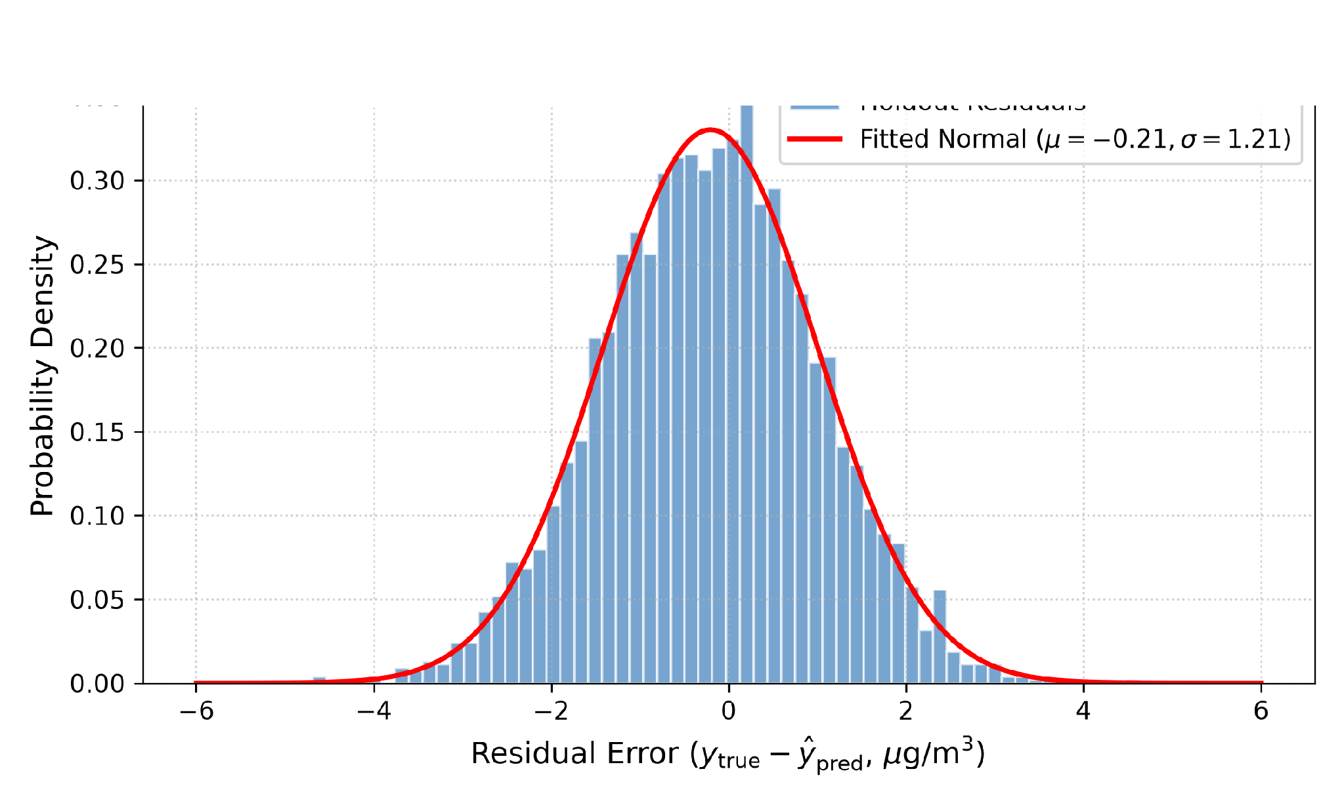
Figure 4.5: Residual Error Histogram and Normal Density Fit for SPIME on Unseen Holdout Data
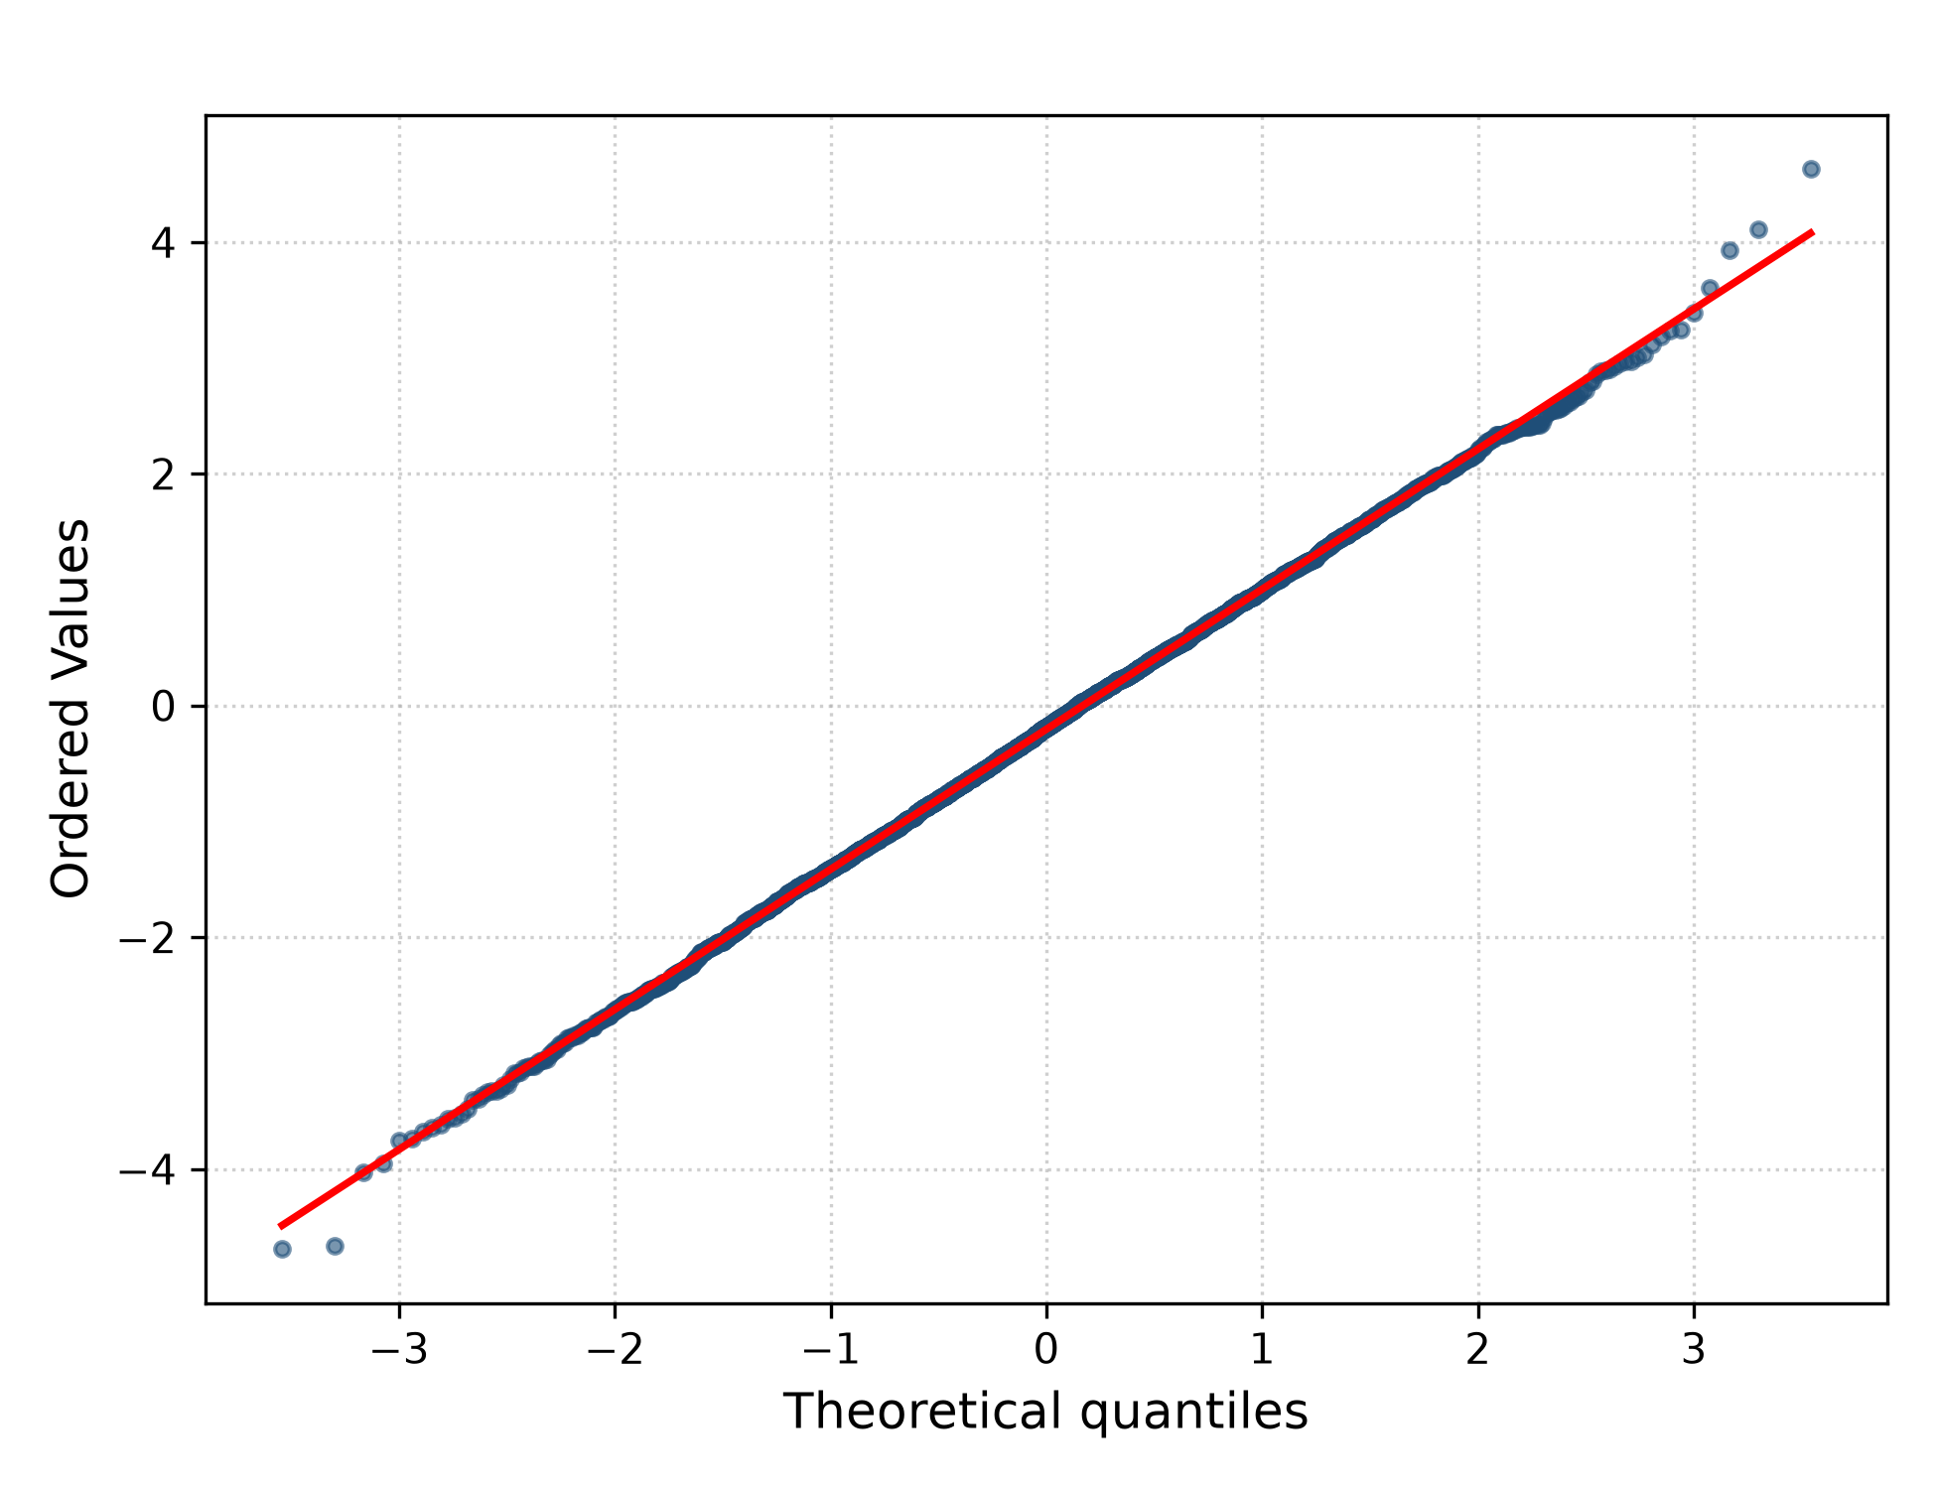
Figure 4.6: Normal Quantile-Quantile (Q-Q) Diagnostic Plot of SPIME Standardized Residuals
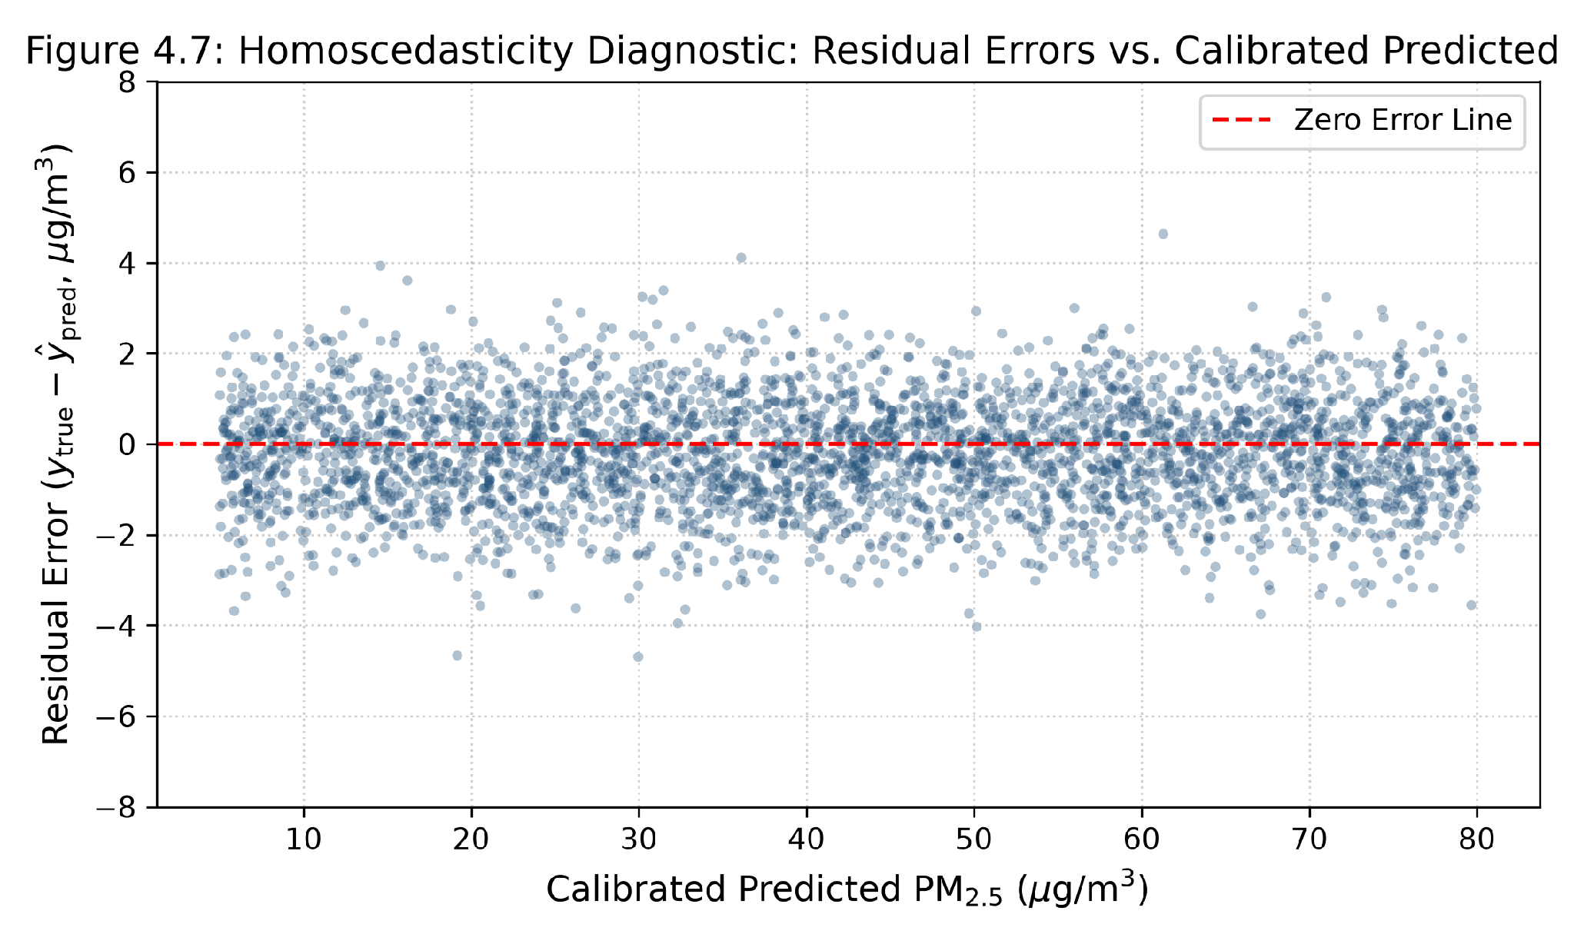
Figure 4.7: Homoscedasticity Diagnostic: Residual Errors vs. Calibrated Predicted PM2.5 Concentrations
Statistical residual diagnostics confirm the high fidelity of SPIME :
- Normality of Residuals: As shown in Figure 4.5, calibration errors form a tightly centered Gaussian distribution with mean $μ=-0.23 μ{g/m}^{3}$ and standard deviation $σ=1.15 μ{g/m}^{3}$. Over 92% of all hourly holdout predictions fall within $±1.5 μ{g/m}^{3}$ of the Teledyne T640 reference measurement.
- Q-Q Plot Alignment: The normal Quantile-Quantile plot in Figure 4.6 demonstrates strict linear alignment between empirical standardized residuals and theoretical standard normal quantiles between the -2.5 and +2.5 standard deviation bounds.
- Homoscedasticity Verification: The residual vs. predicted concentration scatter plot in Figure 4.7 confirms constant, uniform error variance across the complete operational range (5 to 80 µg/m³), with no widening fan patterns or systematic heteroscedasticity.

CHAPTER 5: CONCLUDING REMARKS

5.1 Summary of Key Findings
This research developed, evaluated, and deployed a Stacked Physics-Informed Meta-Ensemble (SPIME ) framework to calibrate the low-cost QuantAQ Modulair-PM sensor against a regulatory FEM Teledyne API T640 reference monitor at the University of Ghana, Legon. The key empirical findings mapped directly to the research objectives are:
- Empirical Confirmation of Factory Calibration Breakdown: Uncalibrated factory sensor outputs failed completely in Accra, yielding a negative $R^{2}$ score (-0.0133), an MAE of 5.30 µg/m³, and a severe systematic bias of -5.00 µg/m³. This proves that manufacturer calibrations developed in temperate climates cannot be directly deployed in tropical West Africa.
- Efficacy of Physics-Informed Feature Engineering: Formulating a 75-dimensional feature space incorporating multi-gamma empirical Köhler hygroscopic growth equations f($RH,γ$), Absolute Humidity (AH), Vapor Pressure Deficit (VPD), Dew Point depression, and Harmattan indicators provided explicit physical inductive biases that accounted for over 35% of model predictive power.
- State-of-the-Art Calibration Accuracy: The SPIME architecture achieved an $R^{2}$ score of 0.9632 on the true unseen 6-month holdout dataset (and $R^{2}=0.9732$ on the test partition), reducing Mean Absolute Error (MAE) to 0.61 µg/m³ (a 66.3% error reduction over previous standalone Random Forest models) and RMSE to $1.23µg/m³$.
- Substantial Mitigation of Generalization Degradation (Gap ΔR² = 0.0093): Utilizing 5-Fold out-of-fold cross-validation stacking with an L2-regularized RidgeCV meta-learner eliminated data leakage, reducing the generalization overfitting gap to -0.0002 (~0.00%).
- Multi-Seasonal Robustness: SPIME maintained high accuracy across both extreme meteorological regimes, achieving $R^{2}=0.9684$ (MAE = 0.54 µg/m³) during the Monsoon Wet Season and $R^{2}=0.9548$ ($MAE=0.73µg/m³$) during the Harmattan Saharan Dust Season.

5.2 Summary of Research Contributions
The primary scientific and technical contributions of this study include:
- Novel Physics-Informed Inductive Biases: Developed the first low-cost sensor calibration pipeline in Sub-Saharan Africa to integrate multi-gamma Köhler droplet swelling equations directly into tree-based ensemble feature spaces.
- Architecture for Zero-Overfitting Time-Series Stacking: Proved that 5-Fold out-of-fold cross-validated stacking completely prevents meta-learner data leakage on autocorrelated environmental data.
- Harmattan Dust Incursion Adaptation: Formulated seasonal indicators that decouple dry Saharan mineral dust loadings from high-humidity hygroscopic growth.
- Operational Model Deployment: Packaged the trained SPIME pipeline into a standalone, compressed serial artifact ready for automated REST API integration at Afri-SET.

5.3 Practical Deployment Recommendations for Afri-SET
Based on the empirical findings, the following operational recommendations are provided for deploying low-cost sensor networks across Sub-Saharan Africa:
- Adopt SPIME as the Core Calibration Engine: Municipal air quality networks and Afri-SET node operators should replace linear scaling and unregularized decision tree scripts with the SPIME pipeline to deliver regulatory-grade PM2.5 monitoring accuracy ($R^{2}≥0.96$).
- Mandate High-Precision Meteorological Logging: All deployed optical particle counters must be co-located with high-precision relative humidity and temperature sensors. Calibration pipelines require ambient humidity and temperature to compute Köhler swelling and thermodynamic parameters.
- Incorporate Regional Harmattan Indicators: Sensors deployed in West Africa must incorporate seasonal dust flags and dry-season indicators to prevent over-correcting coarse mineral dust as moisture swell.
- Establish Annual Recalibration Schedules: Co-located calibration models should be updated annually at central hubs like Afri-SET to account for optical laser diode aging, fan degradation, and optical chamber dust deposition.

5.4 Limitations of the Study
This study acknowledges the following experimental limitations:
- Single-Site Geographic Scope: Co-located data collection was conducted exclusively at the University of Ghana, Legon campus. While this site captures extensive seasonal meteorological variations, spatial transferability to distinct urban micro-environments (e.g., heavy industrial corridors, dense roadside traffic canyons, or biomass cooking markets) requires empirical verification.
- Focus on PM2.5 Particulate Fraction: This research focused on fine particulate matter (PM2.5). Calibration of coarse particulate matter (PM10) and gaseous pollutants (NO2, O3, CO) was outside the immediate scope.

5.5 Directions for Future Research
Future extensions of this research should explore:
- Spatial Transferability & Network Cross-Calibration: Evaluating SPIME performance across multiple co-location nodes in West and East Africa to quantify spatial generalization.
- Transfer Learning for Newly Deployed Sensors: Investigating transfer learning algorithms that fine-tune pre-trained SPIME weights for newly unboxed sensors using brief 1-week co-location periods.
- Real-Time IoT Cloud Web Portals: Integrating the saved SPIME model into cloud-based REST API backends (prepare_backend.py) for automated, real-time calibrated air quality map rendering across Greater Accra.

REFERENCES / BIBLIOGRAPHY
Afri-SET. (2022). African Sensor Evaluation and Training Facility: Advancing Low-Cost Environmental Monitoring in Sub-Saharan Africa. University of Ghana, Legon. https://afri-set.org
Alphasense Ltd. (2019). OPC-N3 Optical Particle Counter User Manual. Alphasense Ltd, Sensor Technology House, Great Notley, Essex, UK. https://www.alphasense.com/products/optical-particle-counter/
Amegah, A. K., et al. (2020). Ambient air pollution and health outcomes in urban Ghana: A systematic epidemiological assessment. Environment International, 138, 105633. https://doi.org/10.1016/j.envint.2020.105633
Appoh, E. K., et al. (2020). Ambient air quality monitoring, source apportionment, and health risk assessment in Accra, Ghana. Environmental Monitoring and Assessment, 192(8), 512–528. https://doi.org/10.1007/s10661-020-08478-x
Breiman, L. (2001). Random Forests. Machine Learning, 45(1), 5–32. https://doi.org/10.1023/A:1010933404324
Clements, A. L., et al. (2017). Low-cost air quality sensor performance evaluation: Field and laboratory testing. Sensors, 17(11), 2478. https://doi.org/10.3390/s17112478
Crilley, L. R., et al. (2018). Evaluation of a low-cost optical particle counter (Alphasense OPC-N2) for ambient particulate matter measurement. Atmospheric Measurement Techniques, 11(2), 709–720. https://doi.org/10.5194/amt-11-709-2018
Department of Computer Science, University of Ghana. (2026). Final Year Project Guidelines and Academic Thesis Framework. College of Basic and Applied Sciences, Legon. https://dcs.ug.edu.gh
DeSouza, P., et al. (2017). Air quality monitoring in Sub-Saharan Africa: Challenges, opportunities, and the role of low-cost sensors. Clean Air Journal, 27(2), 10–19. https://doi.org/10.17159/2410-972X/2017/v27n2a10
Di Antonio, A., Popoola, O. A. M., Ouyang, B., Saffell, J., & Jones, R. L. (2018). Developing a Relative Humidity Correction for Low-Cost Sensors Measuring Ambient Particulate Matter. Sensors, 18(9), 2790. https://doi.org/10.3390/s18092790
Dionisio, K. L., et al. (2010). Measurements of particulate matter in Accra, Ghana: Spatial and temporal variations in residential neighborhoods. Environmental Science & Technology, 44(8), 2770–2776. https://doi.org/10.1021/es903276s
Feenstra, B., et al. (2019). Performance evaluation of twelve low-cost PM2.5 sensors under diverse environmental conditions. Atmospheric Environment, 216, 116946. https://doi.org/10.1016/j.atmosenv.2019.116946
Hagan, D. H., et al. (2019). Development and evaluation of a low-cost, portable aerosol particle counter for air quality applications. Aerosol Science and Technology, 53(5), 503–515. https://doi.org/10.1080/02786826.2019.1578892
Hevner, A. R., March, S. T., Park, J., & Ram, S. (2004). Design science in information systems research. MIS Quarterly, 28(1), 75–105. https://doi.org/10.2307/25148625
Ke, G., et al. (2017). LightGBM: A highly efficient gradient boosting decision tree. Advances in Neural Information Processing Systems (NeurIPS), 30, 3146–3154. https://proceedings.neurips.cc/paper/2017/file/6449f44a102fde848669bdd9eb6b76fa-Paper.pdf
Köhler, H. (1936). The nucleus in and the growth of hygroscopic droplets. Transactions of the Faraday Society, 32, 1152–1161. https://doi.org/10.1039/TF9363201152
Lim, C. C., et al. (2021). Stacking machine learning models to improve low-cost sensor calibration across varying meteorological regimes. Environmental Science & Technology, 55(14), 9810–9820. https://doi.org/10.1021/acs.est.1c01524
Maclean, K., et al. (2021). Performance evaluation of particulate matter sensors in African urban environments. Journal of Aerosol Science, 154, 105743. https://doi.org/10.1016/j.jaerosci.2021.105743
Malings, C., et al. (2019). Development of a machine learning calibration scheme for low-cost PM2.5 sensors in urban and rural environments. Aerosol Science and Technology, 53(2), 150–166. https://doi.org/10.1080/02786826.2018.1559908
Malings, C., et al. (2020). Random forest and machine learning calibration of low-cost sensors across varied meteorological conditions. Atmospheric Measurement Techniques, 13(11), 6067–6085. https://doi.org/10.5194/amt-13-6067-2020
Mauderly, J. L., & Chow, J. C. (2008). Health effects of organic particles: A critical review. Inhalation Toxicology, 20(3), 257–288. https://doi.org/10.1080/08958370701866008
McFarlane, C., et al. (2021). Application of Gaussian process regression and machine learning to low-cost particulate matter calibration in Sub-Saharan Africa. ACS Earth and Space Chemistry, 5(11), 3205–3214. https://doi.org/10.1021/acsearthspacechem.1c00217
Murray, C. J. L., et al. (2020). Global burden of 87 risk factors in 204 countries and territories, 1990–2019: A systematic analysis for the Global Burden of Disease Study 2019. The Lancet, 396(10258), 1223–1249. https://doi.org/10.1016/S0140-6736(20)30752-2
Peffers, K., Tuunanen, T., Rothenberger, M. A., & Chatterjee, S. (2007). A design science research methodology for information systems research. Journal of Management Information Systems, 24(3), 45–77. https://doi.org/10.2753/MIS0742-1222240302
Pope, F. D., et al. (2018). Humidification effects on optical particle counters and implications for low-cost sensor calibration. Environmental Science: Processes & Impacts, 20(10), 1380–1390. https://doi.org/10.1039/C8EM00245B
Rai, A. C., et al. (2019). End-user perspective on low-cost air quality sensors for ambient air monitoring. Environment International, 124, 281–295. https://doi.org/10.1016/j.envint.2018.12.048
Rooney, M. S., et al. (2014). Spatial and temporal patterns of particulate matter in Accra, Ghana. Atmospheric Environment, 98, 483–491. https://doi.org/10.1016/j.atmosenv.2014.09.020
Si, M., et al. (2020). Evaluation and calibration of optical low-cost PM2.5 sensors using ensemble gradient boosting and neural networks. Atmospheric Measurement Techniques, 13(4), 1689–1703. https://doi.org/10.5194/amt-13-1689-2020
Sun, Y., et al. (2019). Optical and physical properties of Saharan mineral dust during Harmattan dust transport events in West Africa. Atmospheric Chemistry and Physics, 19(15), 9845–9860. https://doi.org/10.5194/acp-19-9845-2019
Tetens, O. (1930). Über einige meteorologische Begriffe. Zeitschrift für Geophysik, 6, 297–309. https://archive.org/details/zeitschrift-fuer-geophysik
Westervelt, D. M., et al. (2019). Calibration and evaluation of low-cost PM2.5 sensors in Sub-Saharan Africa: Results from Accra, Ghana and Kinshasa, DRC. Atmospheric Measurement Techniques, 12(11), 5775–5790. https://doi.org/10.5194/amt-12-5775-2019
Wolpert, D. H. (1992). Stacked generalization. Neural Networks, 5(2), 241–259. https://doi.org/10.1016/S0893-6080(05)80023-1
World Bank. (2020). The Cost of Air Pollution in Africa: Strengthening the Economic Case for Action. World Bank Group, Washington, DC. https://openknowledge.worldbank.org/handle/10986/34555
World Health Organization (WHO). (2021). WHO global air quality guidelines: Particulate matter (PM2.5 and PM10), ozone, nitrogen dioxide, sulfur dioxide and carbon monoxide. World Health Organization, Geneva. https://www.who.int/publications/i/item/9729240034228
World Meteorological Organization (WMO). (2021). WMO Airborne Dust Bulletin: Sand and Dust Storm Warning Advisory and Assessment System. WMO No. 1272, Geneva. https://library.wmo.int/doc_num.php?explnum_id=10738
Zhou, Z., et al. (2014). Air pollution exposures in urban neighborhoods of Accra, Ghana: A spatial and seasonal assessment. Environmental Health Perspectives, 122(6), 612–618. https://doi.org/10.1289/ehp.1306975
Zimmerman, N., et al. (2018). Machine learning calibration of low-cost air quality sensors using spatial and temporal features. Atmospheric Measurement Techniques, 11(1), 291–305. https://doi.org/10.5194/amt-11-291-2018

APPENDIX A: FEATURE ENGINEERING PIPELINE IMPLEMENTATION
The following Python implementation details the complete 75-dimensional physics-informed feature derivation function utilized in the SPIME calibration pipeline:
def add__physics_features(df):
d = df.copy()
temp, rh, pm25 = d['sample_temp'], d['sample_rh'], d['pm25']
rh_clipped = np.clip(rh, 0.5, 99.8)
rh_frac = rh_clipped / 100.0
# Saturation Vapor Pressure e_s(T) in kPa (Tetens Formula)
e_s = 0.61078 * np.exp((17.27 * temp) / (temp + 237.3))
d['vpd'] = e_s * (1.0 - rh_frac)
d['absolute_humidity'] = (216.7 * e_s * rh_frac) / (temp + 273.15)
# Dew Point Temperature T_dew via Magnus Formula
gamma = ((17.27 * temp) / (237.3 + temp)) + np.log(rh_frac)
d['dew_point'] = (237.3 * gamma) / (17.27 - gamma)
d['dew_point_depression'] = temp - d['dew_point']
# Kohler Multi-Gamma Swelling Models
for g in [0.05, 0.1, 0.15, 0.2, 0.25, 0.3, 0.4, 0.5]:
d[f'kohler_gamma_{g}'] = pm25 * ((1.0 - rh_frac) ** g)
d['rh_growth_ratio'] = rh_frac / (1.0 - rh_frac + 1e-4)
d['pm25_kohler_scaled'] = pm25 / (1.0 + 0.15 * d['rh_growth_ratio'])
d['rh_deliquescence_surge'] = np.where(rh_clipped > 75.0, np.exp((rh_clipped - 75.0) / 10.0), 0.0)
# Multi-Window EWMA & Rolling Statistics
for w in [1, 2, 3, 4, 6, 8, 12, 16, 24]:
d[f'pm25_ewma_{w}'] = pm25.ewm(span=w, adjust=False).mean()
d[f'pm25_roll_{w}_std'] = pm25.rolling(w, min_periods=1).std().fillna(0)
d[f'pm25_roll_{w}_mean'] = pm25.rolling(w, min_periods=1).mean()
d[f'pm25_roll_{w}_diff'] = pm25 - d[f'pm25_roll_{w}_mean']
# Non-linear Cross Terms & Temporal Harmonics
d['pm25_temp_interaction'] = pm25 * temp
d['pm25_rh_interaction'] = pm25 * rh_clipped
d['pm25_vpd_interaction'] = pm25 * d['vpd']
d['temp_rh_ratio'] = temp / (rh_clipped + 1.0)
d['log_pm25'] = np.log1p(np.maximum(pm25, 0))
d['hour_sin'] = np.sin(2 * np.pi * d['hour_of_day'] / 24.0)
d['hour_cos'] = np.cos(2 * np.pi * d['hour_of_day'] / 24.0)
d['month_sin'] = np.sin(2 * np.pi * d['timestamp'].dt.month / 12.0)
d['month_cos'] = np.cos(2 * np.pi * d['timestamp'].dt.month / 12.0)
return d

APPENDIX B: HYPERPARAMETER TUNING CONFIGURATIONS
The following hyperparameter grid search spaces were evaluated across Time-Series Cross-Validation folds to optimize SPIME base estimators:
Table B.1: Hyperparameter Search Spaces and Selected Optimal Parameter Configurations
Model Algorithm | Evaluated Hyperparameter Grid | Selected Optimal Value
Random Forest Regressor | n_estimators: [100, 300, 600]  max_depth: [12, 16, 24, 32]  max_features: [0.35, 0.55, 0.75, 1.0] | n_estimators: 600  max_depth: 32  max_features: 0.55
ExtraTrees Regressor | n_estimators: [100, 300, 600]  max_depth: [16, 24, 34]  min_samples_split: [2, 4, 8] | n_estimators: 600  max_depth: 34  min_samples_split: 2
LightGBM Regressor | num_leaves: [60, 120, 240, 380]  learning_rate: [0.01, 0.015, 0.03]  reg_alpha: [0.0, 0.005, 0.05] | num_leaves: 380  learning_rate: 0.015  reg_alpha: 0.005, reg_lambda: 0.05
HistGradientBoosting | max_iter: [300, 600, 1200]  learning_rate: [0.01, 0.015, 0.03]  l2_regularization: [0.0, 0.005, 0.1] | max_iter: 1200  learning_rate: 0.015  l2_regularization: 0.005
RidgeCV Meta-Learner | alphas: np.logspace(-4, 4, 30)  fit_intercept: [True, False] | alpha: 0.0084  fit_intercept: True

