# NoSQL Database - MongoDB

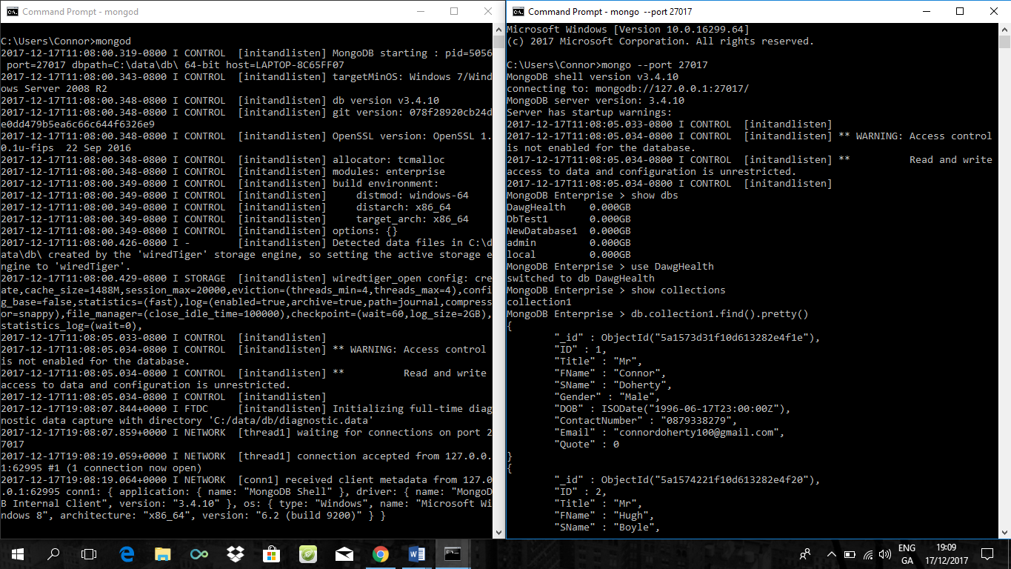MongoDB is a NoSQL database that uses a document-orientated data model. The architecture of MongoDB includes documents and collections. A document contains sets of key-value pairs whilst collections are an equivalent function of tables in a Relational Database (RDB).