**Family Caregiver Module (30 minutes online)**

I’m not sure if the following items “Learning Outcomes” and “Performance Measures” will need to be included yet. Still waiting for confirmation from the client. In the event that they are, they will just be text before you start the pre-test.

**Learning Outcomes**

Family caregivers will:

1. Define each caregiver type.

2. Describe family communication patterns for caregivers.

3. Respond appropriately to different health events tailored to different caregiver types.

**Performance Measures**

Students will complete a pre- and post-test measuring affective, cognitive, and behavioral learning regarding each learning outcome.

**Banner?**

COMFORT COMMUNICATION for Healthcare Professionals

Module F: Family Caregivers

*This will be a banner image that is constant throughout the entire test.*

**Module Plan/Storyboard**

**Section 1: Pretest**

Before you begin this module on family caregivers, complete this short pretest to assess your baseline knowledge:

[Insert the following text to appear upon completing the pretest]

Now that you have finished the pretest, let’s begin. This module will take about 30 minutes to complete. Once finished, you will take a post-test to assess your learning. If you are not satisfied with the results, feel free to go through the module again. You can do so as many times as you’d like to—until you are satisfied with your post-test results.

**Section 2: Introduction and Learning Outcomes**

Family caregivers can experience a great deal of anger, stress, denial, and burnout when caring for their loved ones. Watch this short video to hear some real stories family caregivers regarding their experiences. As you watch, jot down thoughts that come to your mind about challenges you might face when working with them as their health care provider and what you might say and do as you address those challenges.

<https://www.youtube.com/watch?v=XaonoH1XqNI>

[Perhaps you want to make this link into a hyperlink students find by clicking on the quotation by Karen Madewell.] [approximately 5 minutes long]



What challenges came to mind for you? Perhaps you mentioned wondering how to address their pain in working with a loved one who is no longer the person they once knew and loved, or how to manage this balancing this new role along with their other work and family obligations, or how to help them learn to ask for help, or how to help them let go as they watch their loved one gradually slip away.

As a health care professional, you play a critical role in facilitating communication among the patient, family members, and family caregivers. Unfortunately, many professional health care programs of study fail to include curricula that provide you with the tools needed for doing so effectively.

This module is one of several that is designed to meet that need. In it, we equip you with tools and strategies for communicating successfully with patients, family members, and family caregivers during these times of distress and uncertainty. After completing the module, you will be able to:

1. Describe family communication patterns for caregivers.

2. Identify and define each caregiver type (Manager, Carrier, Partner, Lone).

3. Respond appropriately when communicating with caregivers and their families.

Health care professionals do much more than treat patients. Communicating effectively with patients and their families is certainly a major part of the job. For example,

Consider this . . . .



*Imagine yourself at work. Lab reports for a patient you have been working with – a 43-year-old woman named Sheila – have come in. The results indicate that Sheila has pancreatic cancer. Pancreatic cancer is most frequently diagnosed in people 65-74 years of age, so this news will probably come as a shock to Sheila and her family. Not only that, only four percent of people diagnosed with pancreatic cancer live to reach the five year survival rate. Sheila and her husband, Nick, have two children. Allyson is 15 and Blake is 10. Shelia’s mom, Dorothy, who is 72 years old and lives with early-stage Alzheimer’s disease, has also been living with them since her husband died two years ago. They are all in the room with Sheila. As you review the results you wonder what you are going to say as you head to Sheila’s room.*

Unfortunately, this scenario is not unusual. In such instances, most medical professionals are able to present the facts, but few have been trained adequately in *how to communicate* with families experiencing bad news effectively. In this module, we walk through each of four caregiver types by (1) explaining the characteristics of the caregiver type, (2) identifying best practices approaches for you to communicate effectively with each of them, and (3) practicing communication based on case study scenarios. But first we lay the foundation by discussing different family communication patterns as they may influence the way families communicate during these times of distress and uncertainty. We hope that approaching family caregiver communication concepts and skills in this way will ultimately prepare you to communicate effectively when you must share bad news with families as they navigate what is, for them, quite possibly uncharted territory.

**Section 3: Family Communication Patterns**

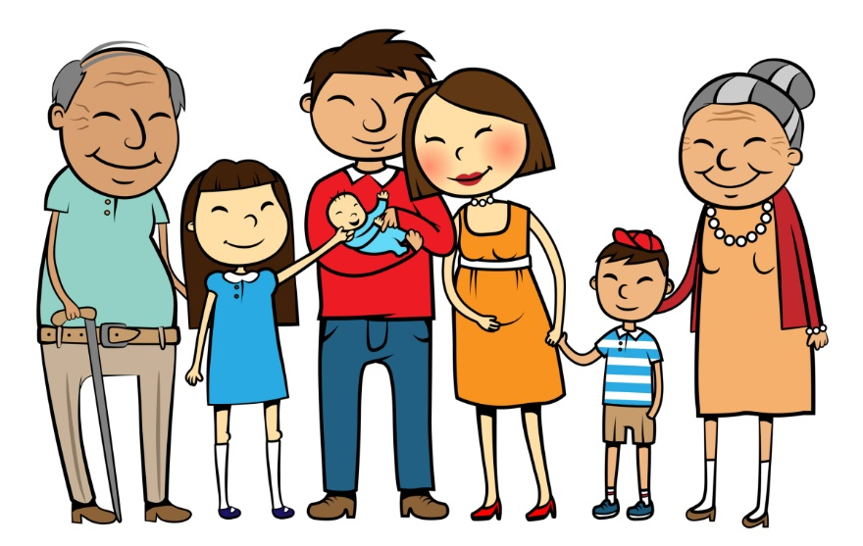

Every family develops its own communication pattern for dealing with the functions of family life. These patterns govern what they do (and don’t) talk about and the way they interact with one another. As a medical professional working with families during times of distress and uncertainty, we can be more effective in navigating discussion and achieving the outcomes we desire when we adapt our approach to their unique communication pattern. Family communication patterns can be organized around two themes:

Family Talk

* High Talk
* Low Talk

Family Obligation

* High Obligation
* Low Obligation

1. **Family Talk** has to do with (a) what topics a family finds appropriate (and inappropriate), (b) how much time the family spends communication, and (c) whether or not the family engages in communal or individual decision-making.
   1. Families that have very few restrictions on topic or time are described as **high family talk** families.
   2. Families that don’t spend much time talking with one another and consider very few topics to be appropriate for discussion are described as **low family talk** families.
2. **Family Obligation (a.k.a. Conformity)** has to do with (a) how much time a family spends together, (b) how they share (or don’t share resources), and (c) the degree to which they obey parents.
   1. **High obligation families** encourage harmony, avoid conflict, are interdependent, and obey parents.
   2. **Low obligation families** honor heterogeneous attitudes, individuality, uniqueness, and independence.

**To gain a better understanding of family communications patterns theory, watch this short Prezi prepared and posted by Aaron Strange, Pauline Zamora, Angelina Guo, and Jason Williams:**

**https://prezi.com/oiiu-o6g9c5d/family-communications-patterns-theory/#_=_**

1. **Reflection and Assessment:** [There will be freeform answer boxes for each question so the user can answer each. After they have answered all the questions, information from the instruction will be shown below each question.]

Take a moment to consider your family’s communication pattern.

* 1. Do you come from a **high family talk** or **low family talk** family? Why? Provide an example to support your assessment.
  2. Do you come from a **high obligation** or **low obligation** family? Why? Provide an example to support your assessment.
  3. What might be some communication challenges for you as a healthcare professional in interacting with each family type about issues facing one of their members?

**Still waiting on this from the client**

*[Elaine: Could you provide 3-5 sentences summarizing what you as the expert understand that health care providers experience as challenges in each type and how to manage those challenges? This should appear for students after they complete their personal reflection and assessment.]*

**Section 4: Preview of the Four Family Caregiver Types**

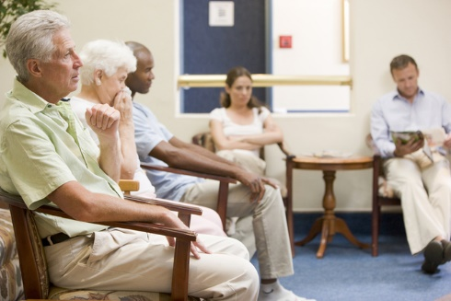

**One’s family communication pattern is shaped by collective family history. Based on these patterns, our research has revealed four prominent family caregiver types. These specific caregiver types are: manager, carrier, partner, and lone. Each of these caregiver types depicts unique communication characteristics. To be most effective, communication interventions and healthcare provider communication should be tailored to the needs and preferences of each caregiver type. Let’s look at each one more closely.**

**Section 5: The Manager Caregiver**

**Manager caregivers** are at the top of the family hierarchy and appoint themselves to be the family spokesperson. They may be the most formally educated of the family members generally and have the highest health literacy specifically. Managers deal with their own uncertainty by taking control of the communication within the family and with the health care providers. These manager caregivers act as an extension of the physician and dominate conversations about cancer by focusing on their own knowledge of it. As the self-appointed family spokesperson, the manager also makes the decisions and limits opportunities for other family members to ask or answer questions.



How to spot a manager caregiver: You can spot a manager because they are heavily prepared, have studied the research, use medical terminology to illustrate their health literacy, and often bring research material with them to the occasion. Managers often minimize the illness as a coping mechanism. Finally, managers focus on swift decision-making based on limited discussion. In other words, they privilege action over process.

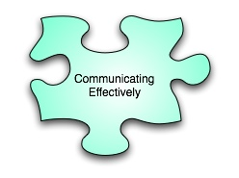

Communication Strategies: Remember that manager caregivers mean well. Honor the health literacy of the manager caregiver by using medical terminology when talking with them. Because manager caregivers tend to dominate the conversation and limit opportunities for other family members to engage in the discussion, you should moderate the communication exchange by inviting other family members to engage. For example, you can ask them directly what they are worried about and what questions/concerns they have. You should also conduct one-on-one meetings with other family members to provide them opportunities to process their experiences and ask questions without feeling hindered by the presence of the manager caregiver.



Let’s Try It! Watch this video and respond to these questions as you do so.

**Still waiting on link from client**

*[insert link to manager caregiver of Denice and Ellen here.] [5:15 minutes long]*

**Questions**

1. How would you describe the family patterns for these two sisters (high or low talk; high or low obligation) and why?

2. Identify some of the manager caregiver characteristics Denice displays in the video.

3. How do the healthcare providers attempt to include both Denice and Ellen in the conversation?

4. What else could the healthcare providers do to ensure decisions are made in ways that honor process over swift decision-making?

[The following are the instructor responses to each of the questions above. So once they have answered all the question and click the “I’ve answered all the questions” button, the following will show up under each question. These are what we are waiting for from the client on the previous section but to give you an idea of their length and format.]

**Instructor Response**

1. Both family talk and family obligation are high. Why? Both sisters are present for the family meeting and we see that Ellen supports Denice when she takes Denice’s hand when the physician asks how they are doing. Denice also offers a comment that they are a close family that talks all the time.

2. Denice is heavily prepared. She did research and brings materials in to the meeting with her. She demonstrates high health literacy and uses medical terminology. She also stresses action over process: “We just need a plan to move on.” And she minimizes the nurse’s suggestion for addressing Ellen’s concerns by taking control of the conversation to what she believes is best for her mother.

3. The nurse addresses Ellen specifically to invite her into the conversation. She asks Ellen what her concerns are. She suggests that food can be brought in for mother to smell and taste.

4. Because Denice dominates the conversation in ways that fail to regard Ellen’s concerns and in spite of the doctor’s and nurse’s attempt to moderate, they should create a one-on-one opportunity for Ellen to express her concerns and ask questions.

**Section 6: The Carrier Caregiver**

**Carrier caregivers** tend to surrender to the pressures of family authority and pressures to conform to the patient’s wishes over their own self-care needs. They typically come from a low-talk and high obligation family. Carrier caregivers shoulder the burden of responsibility as they shelter other family members from it. They are unlikely to disclose their needs to other family members and avoid discussions about death and dying. They seek affirmation from clinical staff about decision-making and caregiving. They welcome opportunities to self-disclose with the healthcare providers because they cannot do so with their families. They might say, for example,

*I don’t want to say anything to them [other family members] because I don’t want to stir up anything and have mom [the patient] get upset. So I just kind of gripe to my husband about it which don’t even like doing that. But at least he’ll listen.*

Carrier caregivers tend to suffer from burnout and depression as they attempt to shoulder the burden of responsibility for caring for the patient, not feeling much of a support network in the family, and neglecting to care for themselves in the process of caring for the patient.



How to spot a carrier caregiver: You can spot a carrier caregiver because they will usually ask lots of questions and rarely challenge the answers. They trust the decisions and suggestions of the healthcare professionals. They will self-disclose to the clinical staff and seek affirmation from them. They do not discuss death and dying or their own burdens with family members.



Communication Strategies: Address caregiver burden with the clinical team so all understand what the caregiver is experiencing and all can encourage the caregiver to share responsibilities with other family members, as well as stress the importance of self-care. Explain and advocate their use of support resources available to them. Provide affirmation and support to them for the decisions they are making and the care they are providing. Provide opportunities for them to self-disclose about their burdens, stresses, and concerns. Ask questions that remind them to care for themselves too: “What have you done for yourself today?”



Let’s Try It! Watch this video and respond to the questions as you do so.

[insert link to carrier caregiver video here] [3:40 minutes]

<https://www.youtube.com/watch?v=-tyRrEPATXk>

**Questions**

1. How would you describe the family patterns (high or low talk; high or low obligation) for this caregiver and why?

2. What carrier caregiver characteristics does she display?

3. What might you say and do if you were on the healthcare team for this caregiver?

**Instructor response**

1. [Waiting on client for this]

2. She has prior caregiving experience as she discloses about having cared for her mother. She also completes all of her caregiving tasks without complaining. She takes pride in shouldering all the burden of responsibility. Although she has four children, they do not participate in caregiving even though the caregiver hints at need help when her daughter calls and she says the “cupboard is bare” and she can’t go but groceries unless someone could be here with him while she does so. She also gets after her children to plan for their care. She takes on the responsibility for caring for all family members.

3. [Elaine: Can you provide your expert response here?]

**Section 7: The Partner Caregiver**

**Partner caregivers** are aware of and focus on caring for the whole patient. They benefit from a high talk family communication pattern where decisions about care have been discussed and determined in advance. The entire family (including the patient) is involved in discussing and decision-making about patient care. Partner caregivers emphasize education about the disease, placement option, and additional information that contributes to make an educated decision on behalf of the patient. Partner caregivers engage in open discussion with providers (rather than mere questions and answers), as well as with the family about death and dying. They delegate tasks, accept assistance, and discuss burden freely with the patient and other family members. The partner caregiver desires a partnership not only with care providers but also with family members as a team and support network. For example:

*My brother and I had another little mini meeting today and said we are going to have to give dad [patient] the message that we understand he’s bored, he wants his own food and he still thinks he can still try to go to the bathroom and he’s fighting that whole thing and he wants us to take care of him. Certainly we will bring him home during the day, all we have to do is put him in a wheelchair and walk around the corner, so I don’t know. I’m trying to be honest with him and it’s just weird. I heard mom say to dad [patient] yesterday when my brother and I were out of the room when we took her for a visit, I heard her say “the kids are in charge now honey and they are doing the best they can for us.”*



How to spot a partner caregiver: You will notice that different family members will be present at different times. Partner caregivers will offer to help the provider team and accept assistance from others. They will share the burden with various family members by engaging in open dialogue about death and dying, which may give rise to conflict. However, conflict results in productive outcomes.



Communication Strategies: In addition to providing information, be sure to include the caregiver in care planning and decision-making. Facilitate family meetings to discuss caregiving and support. Ask questions like “What do you need from the team?” and “How are you all holding up?”



Let’s Try It!

Let’s Try It! Watch this video and respond to the questions as you do so.

[insert link to partner caregiver video here]

This link may change to a different one…client is still deciding.

<https://www.youtube.com/watch?v=GQMjDE_7-Nw> 2:53 minutes

**Questions**

1. How would you describe the family patterns (high or low talk; high or low obligation) for this caregiver and why?

2. What partner caregiver characteristics does this caregiver display?

3. What might you say and do if you were on the healthcare team for this caregiver?

**Instructor Responses**

1. Waiting for client

2. Waiting for client

3. Waiting for client

So this section will need to add this text and video. This is the only section that has this extra text and video after the questions.

In summary, here is a short video that summarizes what to do to help partner caregivers and their families work together effectively in making decisions and providing care: <https://www.youtube.com/watch?v=zCaT0H6Tc1o>

[1:37 minutes]

**Section 8: The Lone Caregiver**

**Lone caregivers** are just that, alone in the task of caregiving, and recognize that they are. They have little or no support from family members for decision-making or caregiving. They come from low-talk and low-obligation families. They have limited communication and weak relationships with other family members and feel high stress, burden, anger, and resentment as a result. They also may be leery and even defensive. For example, this lone caregiver is the adult daughter with five brothers:

*That’s the part that hurts me the most is because my brothers….my mom has been living with me for six months. One of my brothers, that lives in [X], he’s been out here five times….my mom wanted to invite them all [my five brothers] for lunch on a Saturday so we did that and he [another brother] stopped by for 15 minutes and then had to go to [X]. And my other brother, who lives in [X], not that far away, he’s been here like 3 times in 6 months. So I have a lot of anger against them.*

Lone caregivers also tend to fixate on one aspect of care (e.g., hydration, diet, and upcoming procedure) related to the patient’s immediate physical needs. They don’t tend to self-disclose about anything other than the immediate caregiving tasks at hand. They also have a difficult time accepting the overall disease process or prognosis.



How to spot a lone caregiver: As a coping mechanism, lone caregivers often appear detached. There is little or no observable family interaction or evidence of shared caregiver burden. They are heavily invested in short-term biomedical solutions and fixate on the patient’s immediate physical needs. They avoid discussing death, dying, the disease, process and prognosis, caregiving plans, or quality of life issues. They may even become defensive when these subjects arise.



Communication Strategies: Use simple words and pictures to address low health literacy. Engage in one-on-one interactions rather than large team meetings, which may make the lone caregiver feel defensive. However, because this caregiver type is the most challenging, multiple interventions and interactions need to come from a variety of members of the healthcare team. You might affirm what they are doing as a lone caregiver to address their resentment and ask questions like “What gives you hope?”



Let’s Try It! Watch this video and respond to the questions as you do so.

[insert link to lone caregiver video here….or if you only have audio, link that here.]

**Questions**

1. How would you describe the family patterns (high or low talk; high or low obligation) for this caregiver and why?

2. What lone caregiver characteristics does this caregiver display?

3. What might you say and do if you were on the healthcare team for this caregiver?

**Instructor Responses**

1. Waiting for client

2. Waiting for client

3. Waiting for client

**Section 9: Post-Test Assessment and Evaluation**

Congratulations! You have now completed Module F (Family Caregivers) and are ready to assess your understanding by taking the post-test.

Test is same as pre-test.