**DrawItOrLoseIt Multi-Platform Edition**

**Hugo D Leyva**

**CS 230 Project 3 Software Design**

**Version 3.0**

**Table of Contents:**

**Document Revision History**

|  |  |  |  |
| --- | --- | --- | --- |
| **Version** | **Date** | **Author** | **Comments** |
| **3.0** | **12/10/23** | **Hugo D Leyva** | Characteristics of and techniques specific to various systems architectures |
| **2.0** | **11/26/23** | **Hugo D Leyva** | Enhanced the design to support multiple platforms and integrated client's expanded requirements. |
| **1.0** | **11/12/23** | **Hugo D Leyva** | Enhanced the design to support multiple platforms and integrated client's expanded requirements. |

**Executive Summary**

Creative Technology Solutions (CTS) is collaborating with The Gaming Room to evolve Draw It or Lose It into a multi-platform gaming experience. This version emphasizes a server-style configuration for web-based deployment, reaching players on Linux, Mac, Windows, iOS, and Android. The software design addresses client requirements and introduces considerations for platform-specific characteristics, advantages, and weaknesses, with a focus on leveraging Spring Boot for efficient development and deployment.

**Requirements:**

1. Web-based application deployment on Linux, Mac, Windows, iOS, and Android.
2. Server-side scalability for thousands of players.
3. Compatibility with various web browsers and mobile devices.
4. Utilization of Spring Boot for streamlined development.

**Domain Model**

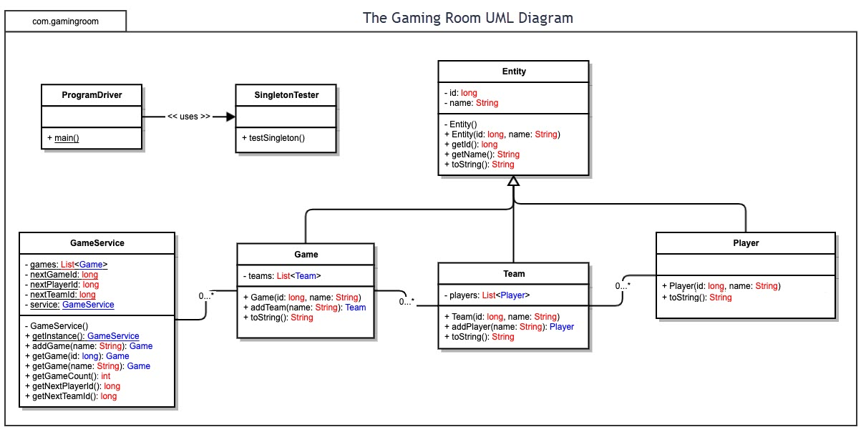

Domain Model:

The UML class diagram below illustrates the domain model for Draw It or Lose It. It includes classes for Game, Team, and Player, demonstrating a clear relationship between them. Object-oriented principles such as encapsulation and inheritance are applied, ensuring efficient fulfillment of software requirements.

**Evaluation**

**Development Requirements**

|  |  |  |  |  |
| --- | --- | --- | --- | --- |
| **Development Requirements** | **Mac** | **Linux** | **Windows** | **Mobile Devices** |
| **Server Side** | Robust support for web-based application hosting. Potential licensing costs may be higher. | Proven scalability and cost-effective hosting. Preferred for server-side deployment. | Viable server-based deployment, potential higher licensing costs. | Cloud-based solutions like AWS or Azure for seamless scaling. Costs vary based on usage. |
| **Client Side** | Cross-platform compatibility for Mac browsers and iOS devices. | Cross-platform compatibility for Linux browsers and Android devices. | Cross-platform compatibility for Windows browsers and Android devices. | Cross-platform compatibility for mobile browsers (iOS and Android). |
| **Development Tools** | Java, Spring Boot, IntelliJ IDEA , Unified development with Spring Boot reduces complexity. | Java, Spring Boot, Eclipse, Unified development with Spring Boot reduces complexity. | Java, Spring Boot, Visual Studio Code , Unified development with Spring Boot reduces complexity. | Java, Spring Boot, Android Studio , Unified development with Spring Boot reduces complexity. |

**Recommendations**

**Operating Platform:** Considering the diverse requirements of The Gaming Room and their desire to expand Draw It or Lose It to various computing environments, a cloud-based solution is recommended. Specifically, utilizing a Platform-as-a-Service (PaaS) model, such as Google Cloud Platform (GCP) or Microsoft Azure, would be advantageous. These platforms offer scalability, ease of deployment, and support for multiple operating systems, allowing seamless expansion to different environments.

**Operating Systems Architectures:** The chosen operating platform should embrace a microservices architecture. This architectural style, characterized by independent, modular components, aligns well with the goal of supporting multiple operating systems. Each microservice can encapsulate specific functionalities, enabling agility, scalability, and ease of maintenance across different environments.

**Storage Management:** For efficient storage management, a cloud-based storage solution, such as Amazon S3 or Google Cloud Storage, is recommended. These services provide scalable and durable storage, accommodating the growing data needs of Draw It or Lose It. Implementing a distributed file system architecture ensures data availability and reliability across various platforms.

**Memory Management:** The recommended operating platform, integrated with Spring Boot, can leverage Java's built-in memory management capabilities. The Java Virtual Machine (JVM) employs garbage collection to automatically manage memory, optimizing resource utilization. Additionally, utilizing caching mechanisms within Spring Boot can enhance the performance of Draw It or Lose It, ensuring smooth gameplay across different platforms.

**Distributed Systems and Networks:** Achieving communication between various platforms can be realized through a combination of RESTful APIs and message queues. Implementing a microservices architecture allows the different components of Draw It or Lose It to communicate asynchronously, promoting decoupling and flexibility. Utilizing a reliable message broker, such as Apache Kafka or RabbitMQ, can enhance communication efficiency, especially in the presence of network outages or fluctuations. Load balancing and redundancy measures should be implemented to ensure connectivity and minimize downtime.

**Security:** To uphold the security requirements of Draw It or Lose It, a multi-layered approach is recommended. The chosen cloud platform should provide robust security features, including encryption at rest and in transit, access controls, and regular security updates. Employing Spring Security within the application can enhance user protection, ensuring secure authentication and authorization mechanisms. Regular security audits and monitoring should be implemented to detect and address potential vulnerabilities promptly.

These recommendations aim to provide a foundation for an adaptable, secure, and high-performance architecture for Draw It or Lose It, enabling the game to seamlessly extend to various environments while prioritizing user protection and data security.