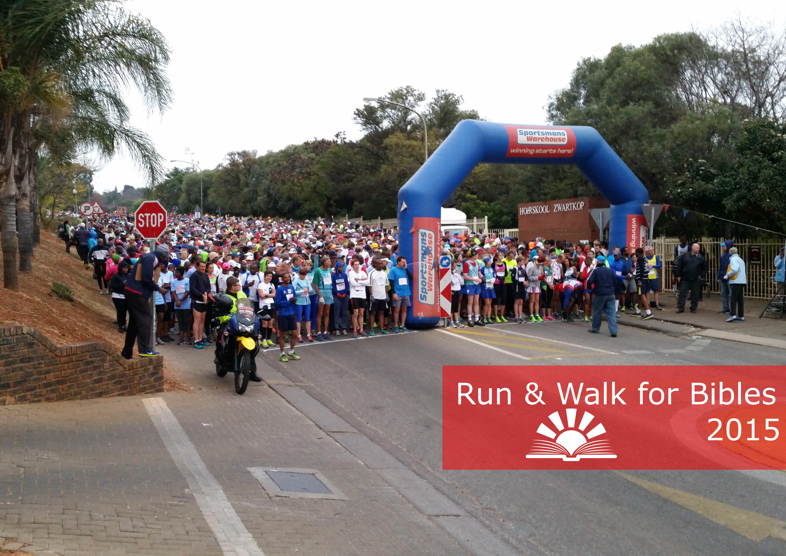

Runners

|  |  |  |  |
| --- | --- | --- | --- |
| **Women – 21 km** | | | |
| **Category** | **Name** | **Club** | **Time** |
| 1st Open | Andrea Steyn | TBC | 01:26:30 |
| 2nd Open | Thabile Mkhonza | SAPS Academy | 01:42:13 |
| 3rd Open | Karin Hillhouse | Runavation | 01:43:05 |
| 1st Veteran | Karin Hillhouse | Runavation | 01:43:05 |
| 1st Master | Ansie Breytenbach | Irene | 01:43:27 |
| 1st G. Master | Francis v Blerk | Nedbank | 01:50:49 |
| 1st GG Master | Debbie van Heerden | Nedbank | 02:08:22 |
| 80+ | - | - | - |
| 1st Junior | - | - | - |

|  |  |  |  |
| --- | --- | --- | --- |
| **Men – 21 km** | | | |
| **Category** | **Name** | **Club** | **Time** |
| 1st Open | Joel Madiba | TUT | 01:11:29 |
| 2nd Open | Martin Nkoe | TUT | 01:13:25 |
| 3rd Open | John Thipe | Nkangala | 01:13:38 |
| 1st Veteran | Peter Medupe | Nedbank | 01:15:47 |
| 1st Master | Ralph Mashabela | Cool Running | 01:37:59 |
| 1st G. Master | Francis Makuka | Phobians | 01:31:57 |
| 1st GG Master | Patrick Mafilika | Nedbank | 02:03:25 |
| 80+ | - | - | - |
| 1st Junior | - | - | - |

|  |  |  |  |
| --- | --- | --- | --- |
| **Women – 10 km** | | | |
| **Category** | **Name** | **Club** | **Time** |
| 1st Open | Thembi Baloyi | TUT | 00:40:34 |
| 2nd Open | Murendwa Dawana | TUT | 00:40:50 |
| 3rd Open | Jacqui vd Waals | Irene | 00:41:13 |
| 1st Veteran | Jacqui vd Waals | Irene | 00:41:13 |
| 1st Master | Linda vd Gryp | Krugersdorp | 00:47:54 |
| 1st G. Master | Mariet Louw | Irene | 01:10:39 |
| 1st GG Master | Mavis Stradler | Agape | 01:06:48 |
| 80+ | Deidre Larkin | Randburg | 01:03:03 |
| 1st Junior | Monique Geel | Tuks | 00:44:19 |

|  |  |  |  |
| --- | --- | --- | --- |
| **Men – 10 km** | | | |
| **Category** | **Name** | **Club** | **Time** |
| 1st Open | Anthony Timoteus | UWC | 00:32:59 |
| 2nd Open | Jonathan Brendenkamp | Tuks | 00:34:00 |
| 3rd Open | Walter Mzinama | Temp | 00:35:33 |
| 1st Veteran | Demetri Jansen | OMMC | 00:36:35 |
| 1st Master | Joseph Moloto | PMMC | 00:41:03 |
| 1st G. Master | Pieter Rossouw | Enduro | 00:53:52 |
| 1st GG Master | Andries vd Merwe | Transnet | 00:55:13 |
| 80+ | Ken Nurden | Agape | 00:55:08 |
| 1st Junior | Tomrin Vlok | H/S Zwartkops | 00:38:11 |

Walkers

|  |  |  |  |
| --- | --- | --- | --- |
| **Women – 21 km** | | | |
| **Category** | **Name** | **Club** | **Time** |
| 1st Open | Lesley v Buuren | Wanderers | 02:04:13 |
| 2nd Open | Sandra Steenkamp | Irene | 02:09:51 |
| 3rd Open | Elsa Meyer | Irene | 02:17:49 |
| 1st Veteran | Marinda Neethling | Berts Bricks | 02:46:10 |
| 1st Master | Lesley v Buuren | Wanderers | 02:04:13 |
| 1st G. Master | Elsa Meyer | Irene | 02:17:49 |
| 1st GG Master | - | - | - |
| 80+ | - | - | - |
| 1st Junior | - | - | - |

|  |  |  |  |
| --- | --- | --- | --- |
| **Men – 21 km** | | | |
| **Category** | **Name** | **Club** | **Time** |
| 1st Open | Jaap Willemse | Irene | 02:15:47 |
| 2nd Open | Stephen Msimanga | BNAC | 02:20:10 |
| 3rd Open | Gerhard vd Raad | Irene | 02:24:24 |
| 1st Veteran | - | - | - |
| 1st Master | Jaap Willemse | Irene | 02:15:47 |
| 1st G. Master | Hendrik Potgieter | VTM | 02:43:30 |
| 1st GG Master | Gerhard vd Raad | Irene | 02:24:24 |
| 80+ | - | - | - |
| 1st Junior | - | - | - |

|  |  |  |  |
| --- | --- | --- | --- |
| **Women – 10 km** | | | |
| **Category** | **Name** | **Club** | **Time** |
| 1st Open | Celeste Scheepers | PMWC | 01:06:15 |
| 2nd Open | Martie Homan | Carltonville | 01:13:15 |
| 3rd Open | Angela Pottinger | Irene | 01:15:59 |
| 1st Veteran | Chene Kruger | PMWC | 01:29:23 |
| 1st Master | Celeste Scheepers | PMWC | 01:06:15 |
| 1st G. Master | Susan Grabe | Affies | 01:19:40 |
| 1st GG Master | Kiebet Strauss | Agape | 01:21:50 |
| 80+ | - | - | - |
| 1st Junior | - | - | - |

|  |  |  |  |
| --- | --- | --- | --- |
| **Men – 10 km** | | | |
| **Category** | **Name** | **Club** | **Time** |
| 1st Open | Jeff Manamela | Temp | 01:01:09 |
| 2nd Open | Hudsie Hudsenberg | PMWC | 01:03:00 |
| 3rd Open | Aaron Letele | Temp | 01:05:10 |
| 1st Veteran | Hudsie Hudsenberg | PMWC | 01:03:00 |
| 1st Master | Alan Nemeti | Randburg | 01:08:43 |
| 1st G. Master | Wynand Breytenbach | Irene | 01:11:02 |
| 1st GG Master | - | - | - |
| 80+ | Frans Grobler | Transnet | 01:35:51 |
| 1st Junior | - | - | - |