1) Executer un programme C depuis le terminal de Contiki :

./hello-world.native

2)Make to Compile

make TARGET=sky

2)Code du blink.c
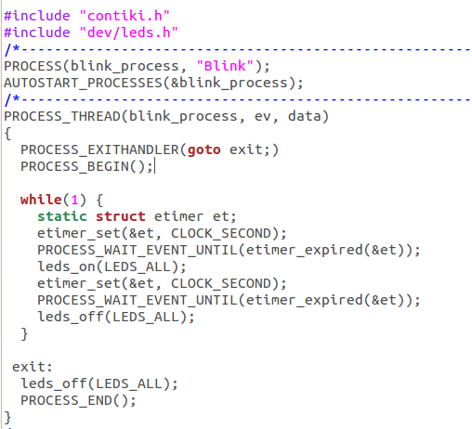
#include "contiki.h"
#include "dev/leds.h"
/*---------------------------------------------------------------------------*/
PROCESS(blink_process, "Blink");
AUTOSTART_PROCESSES(&blink_process);
/*---------------------------------------------------------------------------*/
PROCESS_THREAD(blink_process, ev, data)
{
PROCESS_EXITHANDLER(goto exit;)
PROCESS_BEGIN();

while(1) {
static struct etimer et;
etimer_set(&et, CLOCK_SECOND);
PROCESS_WAIT_EVENT_UNTIL(etimer_expired(&et));
leds_on(LEDS_ALL);
etimer_set(&et, CLOCK_SECOND);
PROCESS_WAIT_EVENT_UNTIL(etimer_expired(&et));
leds_off(LEDS_ALL);
}

exit:
leds_off(LEDS_ALL);
PROCESS_END();
}

//J’imagine que le code est utile sur des vrais motes pour faire clignoter leurs LEDS d’ou les leds_on et leds_off.

