Overview

Operation of the program

The software solution can be launched by clicking the “Open Program” file.

You will be presented with a screen that looks like this:

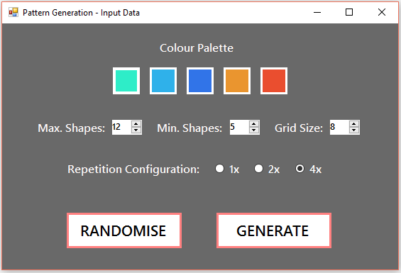

In this screen you can select the colours you would like to be used in the pattern, as well as the maximum and minimum number of shapes, grid size and repetition configuration. Pressing the “Randomise” button will automatically assign random values to each of these fields.

When you are happy with your choices, you can press “Generate” to launch the display window.

The display window will look like this with a new pattern: See example below.

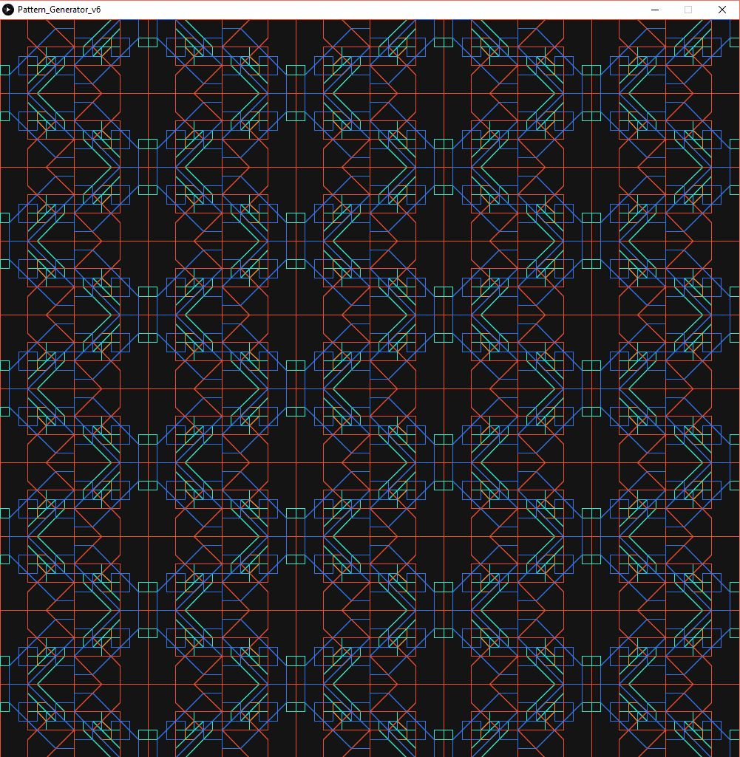

With the display window in focus, you can generate new patterns by pressing the **right arrow key** and go back to previously generated patterns with the **left arrow key**.

Pressing the **“x” key** will change the display mode so that the shapes are filled, rather than outlined and vice versa. If you would like to play with more options See **Advanced** documentation below.

If you find a pattern that you would like to save, pressing the **“s” key** will save the current pattern as a PDF. It can be found in the “saves” folder.

Advanced:

Pressing the **“c” key** will save a copy of the “seed” that the current pattern is being generated from to the “seeds.txt” file inside the “saves” folder.

Pressing the **“t” key** will switch the alternate the thickness setting:

If the setting is switched to **“on”**: new patterns will be generated with thickness = 1

If the setting is switched to **“off”**: new patterns will be generated with variable thickness between 1 and length of the shape divided by root 2.

Pressing the “b” key will switch between a white and black background.

Pressing the “g” key will switch between drawing a grid and not drawing a grid

Pressing the “a” key will lower the total tile count

Pressing the “d” key will increase the total tile count