**I. Pen-and-paper**

**Answer 1**

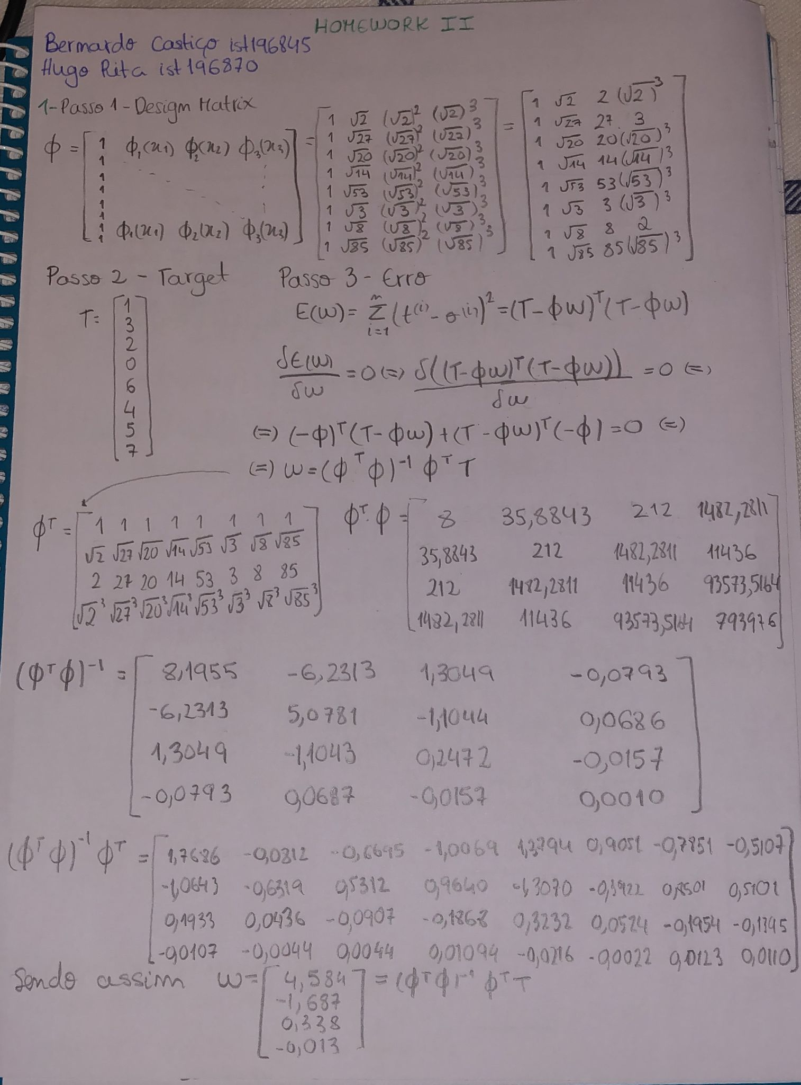

**Answer 2**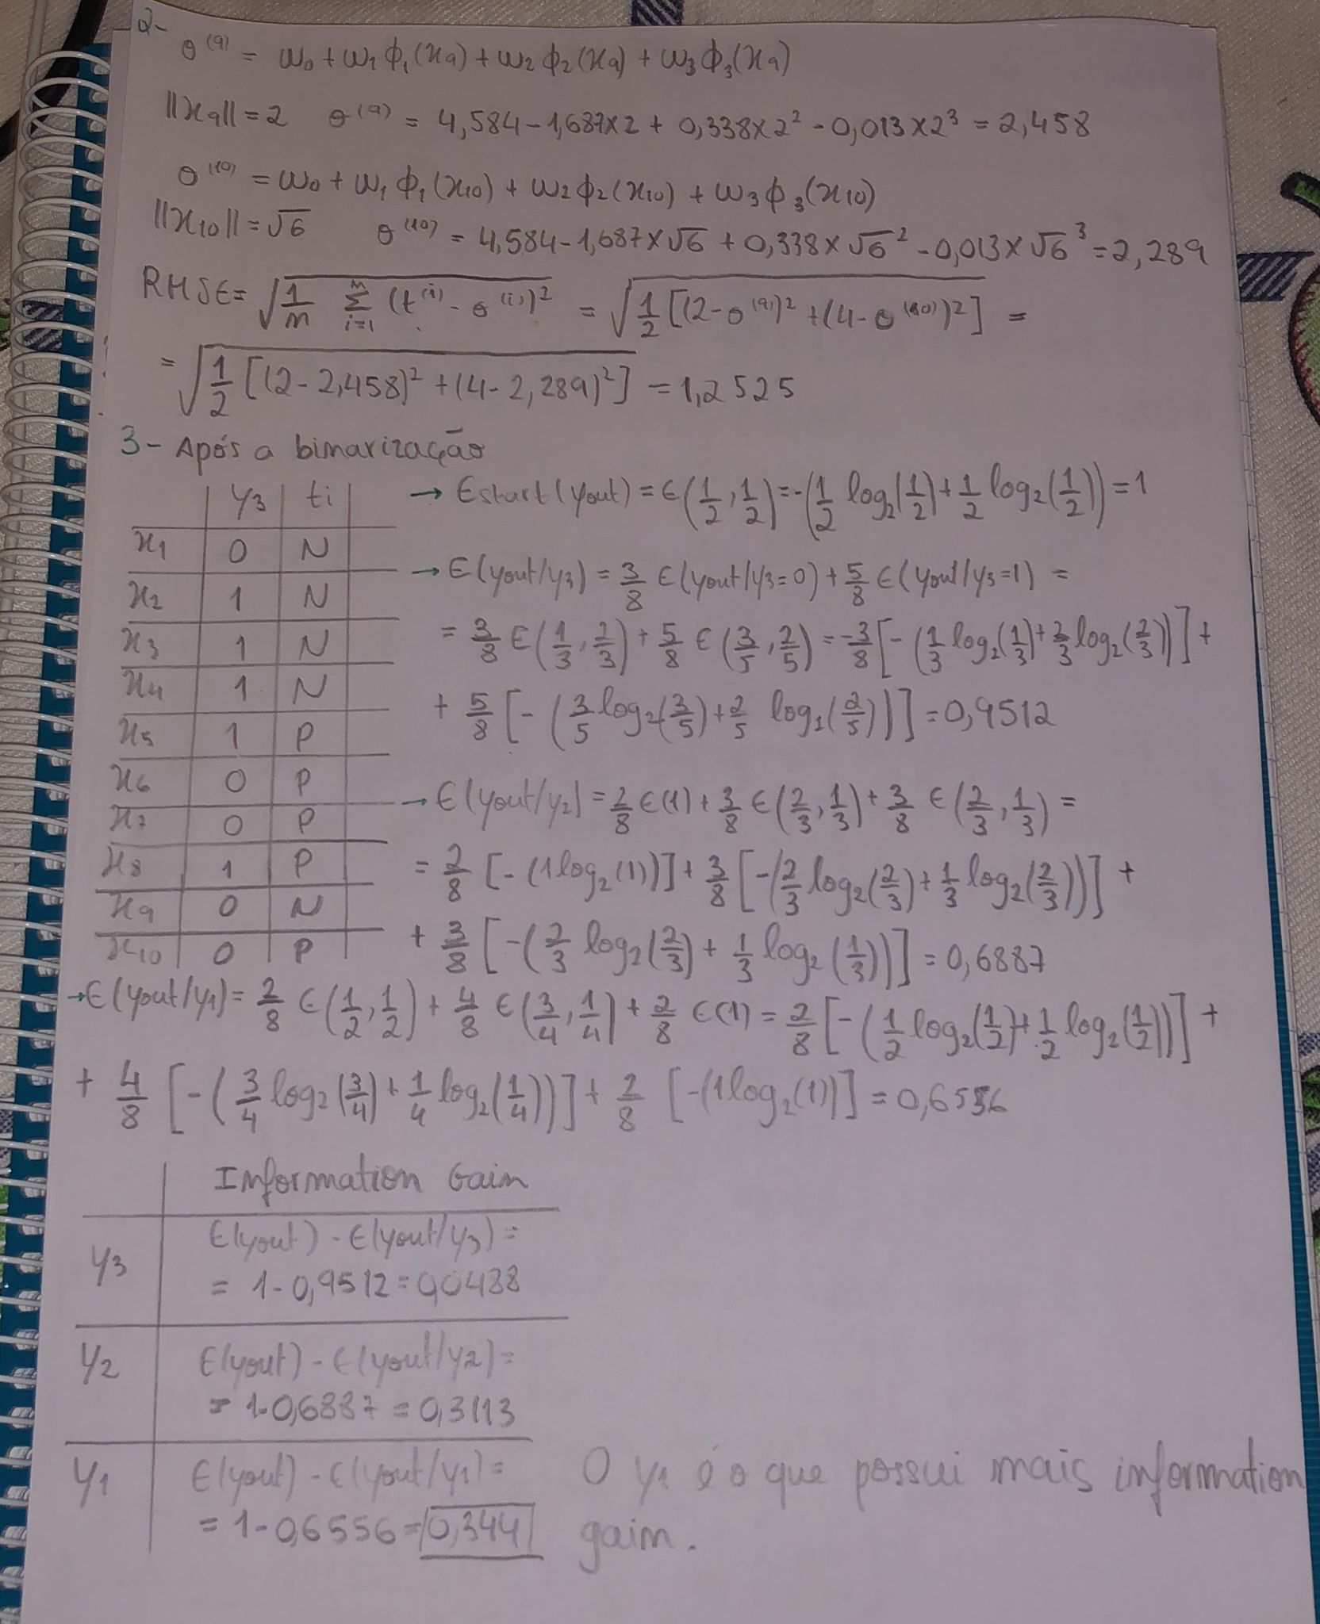

**Answer 3**

**Answer 3 - continuação**

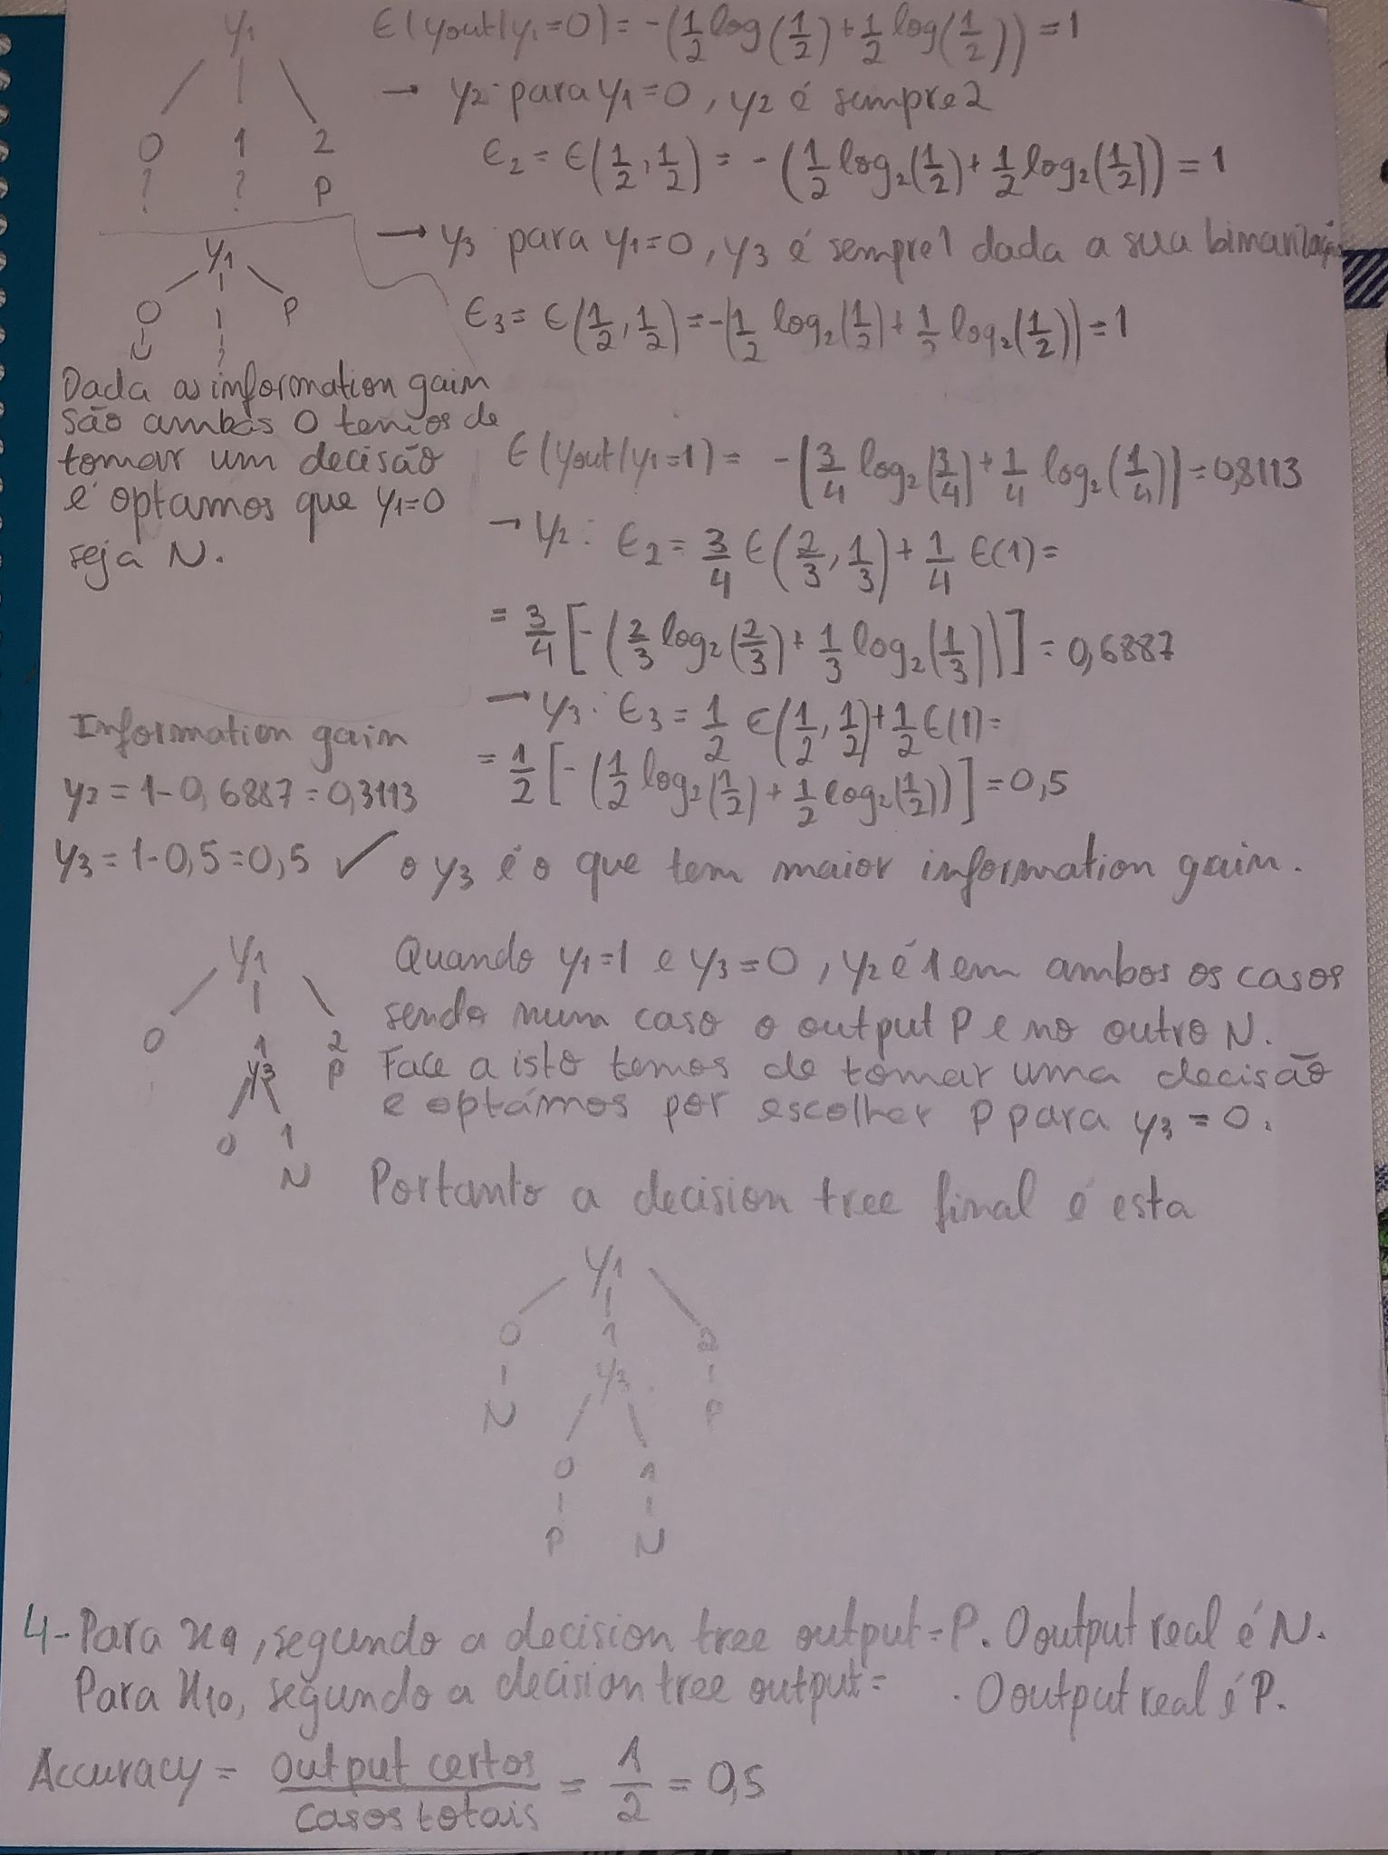

**Answer 4**



**II. Programming and critical analysis**

**Answer 5**

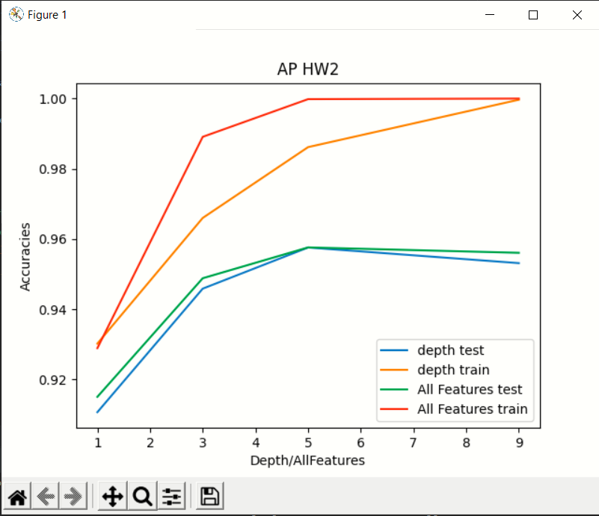

Para a obtenção deste gráfico começámos por separar a data do ficheiro fornecido usando um 10-fold cross validation. Posto isto, selecionámos as melhores features usando a função do python SelectKBest sendo o resultado desta função usado para a alínea i. Assim, para calcular as decision trees usamos a função DecisionTreeClassifier com os parâmetros default, excepto o max depth na alínea ii.

Por fim, fizemos fit da data e predict usando as decision trees para poder comparar resultados.

**Answer 6**

Uma das razões para a correlação observada deve-se ao facto de apesar de no caso i. se selecionar as max features e no caso ii. se selecionar a max depth. Pode-se verificar que ao selecionar max features = i Є [1,3,5,9] estamos a selecionar tambem uma max depth correspondente ao valor de i que selecionamos.

A outra razão passa pelo facto de ao limitarmos tanto a max depth como a max features com valores baixos, teremos pouca informação para testar a data, o que se reflete em accuracies mais baixas. O mesmo efeito acontece para valores altos como k = 9, sendo que nestes casos o facto de existir uma data bastante vasta também leva a uma ligeira diminuição na accuracy.

**Answer 7**

A depth que selecionamos é k = 5, uma vez que para uma tree com max depth igual a 5 ao testarmos a nossa test data é aí que se atinge um valor máximo, ocorrendo para valores superiores a 5 overfit.

**III. APPENDIX**

Paste your programming code here using Consolas 9pt or 10pt.

Use **highlighting** or colored text to facilitate the analysis by your faculty hosts.

# Grupo 117 Aprendizagem HomeWork 2

# Bernardo Castico ist196845

# Hugo Rita ist196870

from sklearn import tree

from sklearn.model_selection import KFold

from sklearn.feature_selection import SelectKBest

from sklearn.feature_selection import mutual_info_classif

import matplotlib.pyplot as plt

#Res = the 10-fold cross validation with our group number (117)

Res = KFold(n_splits=10, random_state=117, shuffle=True)

def getDataToMatrix(lines):

    realLines = []

    data = []

    toDelete = []

    for i in range(len(lines)):

        if i > 11:

            realLines += [lines[i]]

    for i in range(len(realLines)):

        for j in range(len(realLines[i])):

            if realLines[i][j] == "benign\n":

                realLines[i][j] = 1

            elif realLines[i][j] == "malignant\n":

                realLines[i][j] = 0

            elif realLines[i][j] == '?':

                toDelete += [i]

            else:

                realLines[i][j] = int(realLines[i][j])

    for i in range(len(realLines)):

        if i not in toDelete:

            data += [realLines[i]]

    return data

def splitData(list):

    a = []

    b = []

    for i in list:

        a.append(i[:-1])

        b.append(i[-1])

    return [a,b]

def main():

    depthTestX, finalAccuraciesAllFeatures, finalAccuraciesDepth, res , AllFeaturesTrainY, AllFeaturesTrainX = [],[],[],[],[],[]

    depthTestY , AllFeaturesTestY, AllFeaturesTestX, depthTrainY, depthTrainX = [],[],[],[],[]

    with open("HW2.txt") as f:

        lines = f.readlines()

    for line in lines:

        tmp = line.split(',')

        res.append(tmp)

    data = getDataToMatrix(res)

    for i in [1,3,5,9]:

        counter11, counter12, counter21, counter22 = 0,0,0,0

        accuraciesDepth, accuraciesAllFeatures = [],[]

        for train, test in Res.split(data):

            testData, trainData = [],[]

            accuracyAuxDepthTest, accuracyAuxDepthTrain = 0,0

            accuracyAuxAllFeaturesTest, accuracyAuxAllFeaturesTrain = 0,0

            for j in test:

                testData += [data[j]]

            for j in train:

                trainData += [data[j]]

            trainDataSplit = splitData(trainData)

            testDataSplit = splitData(testData)

            decision = SelectKBest(mutual_info_classif, k=i).fit(trainDataSplit[0], trainDataSplit[1])

            decisionTrainData = decision.transform(trainDataSplit[0])

            decisionTestData = decision.transform(testDataSplit[0])

            resultDepth = tree.DecisionTreeClassifier(max_depth=i, criterion="gini", max_features=None)

            resultAllFeatures = tree.DecisionTreeClassifier(max_depth=None, criterion="gini", max_features=None)

            resultDepth.fit(trainDataSplit[0], trainDataSplit[1])

            resultAllFeatures.fit(decisionTrainData, trainDataSplit[1])

            predictionsTest = resultDepth.predict(testDataSplit[0])

            predictionsTrain = resultDepth.predict(trainDataSplit[0])

            predictionsTestFeatures = resultAllFeatures.predict(decisionTestData)

            predictionsTrainFeatures = resultAllFeatures.predict(decisionTrainData)

            for j in range(len(predictionsTestFeatures)):

                if predictionsTestFeatures[j] == testDataSplit[1][j]:

                    accuracyAuxAllFeaturesTest += 1

                if predictionsTest[j] == testDataSplit[1][j]:

                    accuracyAuxDepthTest += 1

            for j in range(len(predictionsTrainFeatures)):

                if predictionsTrainFeatures[j] == trainDataSplit[1][j]:

                    accuracyAuxAllFeaturesTrain += 1

                if predictionsTrain[j] == trainDataSplit[1][j]:

                    accuracyAuxDepthTrain += 1

            accuraciesAllFeatures += [[accuracyAuxAllFeaturesTest/len(predictionsTestFeatures), accuracyAuxAllFeaturesTrain/len(predictionsTrainFeatures)]]

            accuraciesDepth += [[accuracyAuxDepthTest / len(predictionsTest), accuracyAuxDepthTrain / len(predictionsTrain)]]

        for k in range(len(accuraciesDepth)):

            counter11 += accuraciesDepth[k][0]

            counter12 += accuraciesDepth[k][1]

            counter21 += accuraciesAllFeatures[k][0]

            counter22 += accuraciesAllFeatures[k][1]

        finalAccuraciesDepth += [[counter11 / 10, counter12 / 10]]

        finalAccuraciesAllFeatures += [[counter21 / 10, counter22 / 10]]

    #Plot

    for i in range(4):

        depthTestX = [1,3,5,9]

        depthTestY += [finalAccuraciesDepth[i][0]]

        depthTrainX = [1, 3, 5, 9]

        depthTrainY += [finalAccuraciesDepth[i][1]]

        AllFeaturesTestX = [1,3,5,9]

        AllFeaturesTestY += [finalAccuraciesAllFeatures[i][0]]

        AllFeaturesTrainX = [1, 3, 5, 9]

        AllFeaturesTrainY += [finalAccuraciesAllFeatures[i][1]]

    plt.xlabel('Depth/AllFeatures')

    plt.ylabel('Accuracies')

    plt.title('AP HW2')

    plt.plot(depthTestX, depthTestY, label = "depth test")

    plt.plot(depthTrainX, depthTrainY, label = "depth train")

    plt.plot(AllFeaturesTestX, AllFeaturesTestY, label = "All Features test")

    plt.plot(AllFeaturesTrainX, AllFeaturesTrainY, label = "All Features train")

    plt.legend()

    plt.show()

main()

**END**