Multi-Scale Modelling within the CBI Simulator Framework
Hugo Cornelis, Allan D. Coop, Armando L. Rodriguez, Dave Beeman, James M. Bower.
1. Cornelis H. Department of Neurophysiology, Catholic University of Leuven, Leuven, 3000, Belgium
2. Coop A. D. Director of Flight Simulation, Merindah Energy.
3. Rodriguez A. L. Research Imaging Institute, University of Texas Health Science Center at San Antonio, San Antonio, TX, United States
4. Beeman D. Department of Electrical, Computer, and Energy Engineering, University of Colorado, Boulder, CO 80309
5. Bower J. M. Research Imaging Institute, University of Texas Health Science Center at San Antonio, San Antonio, TX, United States
E-mail: Corresponding Author Hugo.Cornelis@gmail.com
Contents

1 Introduction
The scientific understanding of problems involving the interaction between different temporal and spatial scales is very challenging, as well as being an important issue in computational neuroscience. In efforts to resolve this issue, over the last 30 years several schemas have been introduced. The earliest was proposed by Marr [13], who identified three independent levels: (a) computational theory–what does the system do or what problems does it solve? (b) representation and algorithm–how does the system solve the problem? and (c) hardware implementation–how is the system physically realized? More recently, Churchland and Sejnowski [3] have also proposed three levels: (1) level of analysis, which includes Marr’s three levels, (2) level of processing, for example the levels of processing in the visual pathway, and (3) level of structural organization, for which they proposed seven broad levels–systems, topographic maps, layers and columns, local networks, (e) neurons, (f) synapses, and (g) molecules.
Recently, we proposed a five step “ideal user workflow”, or user workflow, which can be employed to organize the sequence of steps typically necessary for the development and simulation of a computational model in neuroscience, including data generation and analysis. This workflow consists of the steps: construct model, design experiment, run simulation, analyze output, and iterate [10]. Such a workflow allows the object under investigation, the tools used to perform the investigation, and the operations performed during a simulation to be distinguished.
Here, we extend the workflow paradigm by introducing the organizing principle of a “cognitive workflow”. This workflow describes the process by which a mental model is transformed from an abstraction into an implementation. One cognitive workflow that facilitates such a path is given by the top row in Figure 1 (Biology Computer Simulation). In this figure, the column to the left gives the spatial scale and lists the level of structural organization of the biology (object under investigation), the column to the right lists the equivalent level of software and hardware (operations performed during the investigation), and the central column gives the mathematical implementation or algorithm (tools used to perform the investigation). The rows in each column give examples of simulator functionality appropriate for the given level.

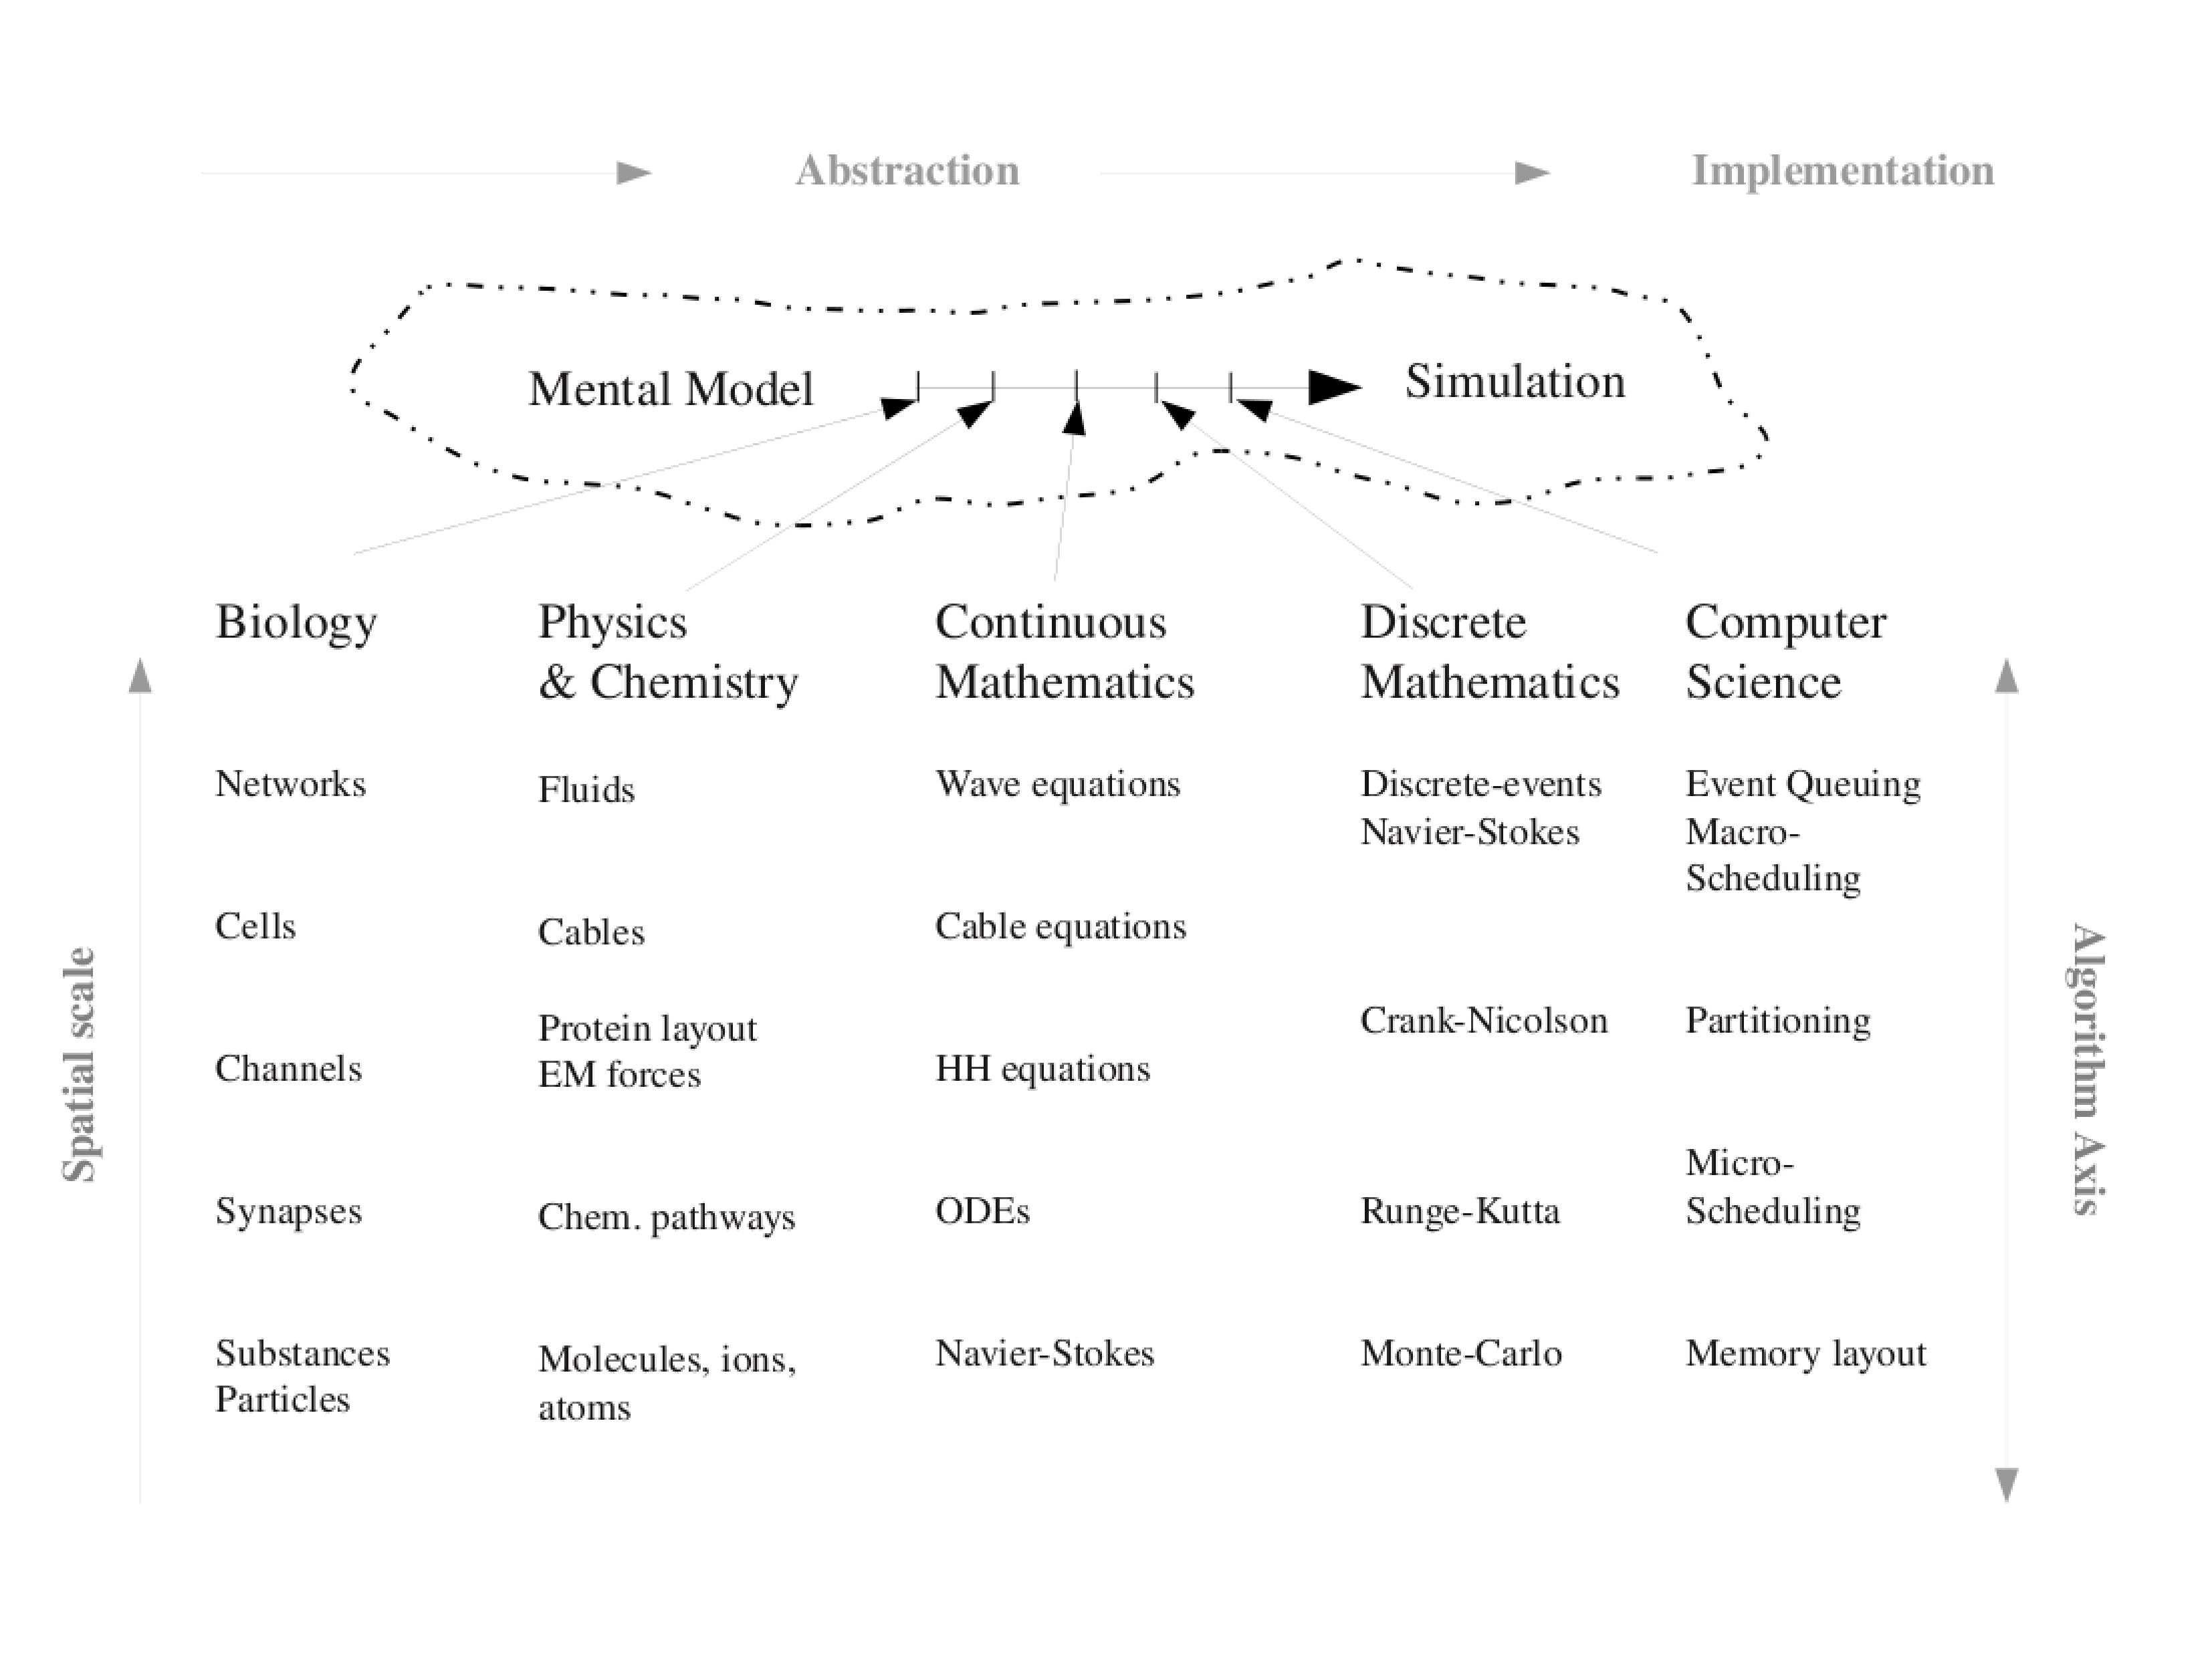
Figure 1: A Multi-Scale Path from Mental Model to Simulation.
The matrix implicit in Figure 1 reveals a relationship between the cognitive and user workflows and the schema outlined by Marr. Here, we use these relationships to develop a novel and simplifying approach to the simulation of multi-scale models.
If it is accepted that: (1) a scale specific approximation can be abstracted at each level of a system and disjointly partitioned from its environment, and (2) the biological structures listed in Figure 1 are plausible, then it is apparent that a realistic neuron model comprised of at least a soma and dendrites and that includes channels and synapses is a multi-level model simulated at multiple scales.
Initially, we describe features of the reconfigured GENESIS simulator (G-3), then by using scripting examples show how the primary components of the simulator transparently support multi-scale modelling from the molecular to the systems level.

2 Methods

2.1 Structural Overview of the CBI Architecture
The Computational Biology Initiative Federated Software Architecture (CBI architecture) is defined as a modular paradigm that places stand-alone software components into a set of logical relationships. In this sense it defines a modular framework that provides the necessary parts of a simulator.
A schema identified by separation of concerns (see [10] for details) is expanded in Figure 2 to give the modules that form the building blocks of the CBI architecture. It retains the four quadrants of simulator functionality identified by the separation of concerns, including the notions of low-level data for numerics and high-level representations for biology, as well as separation between data and control (Fig. 2: indicated by horizontal and vertical dashed lines, respectively).

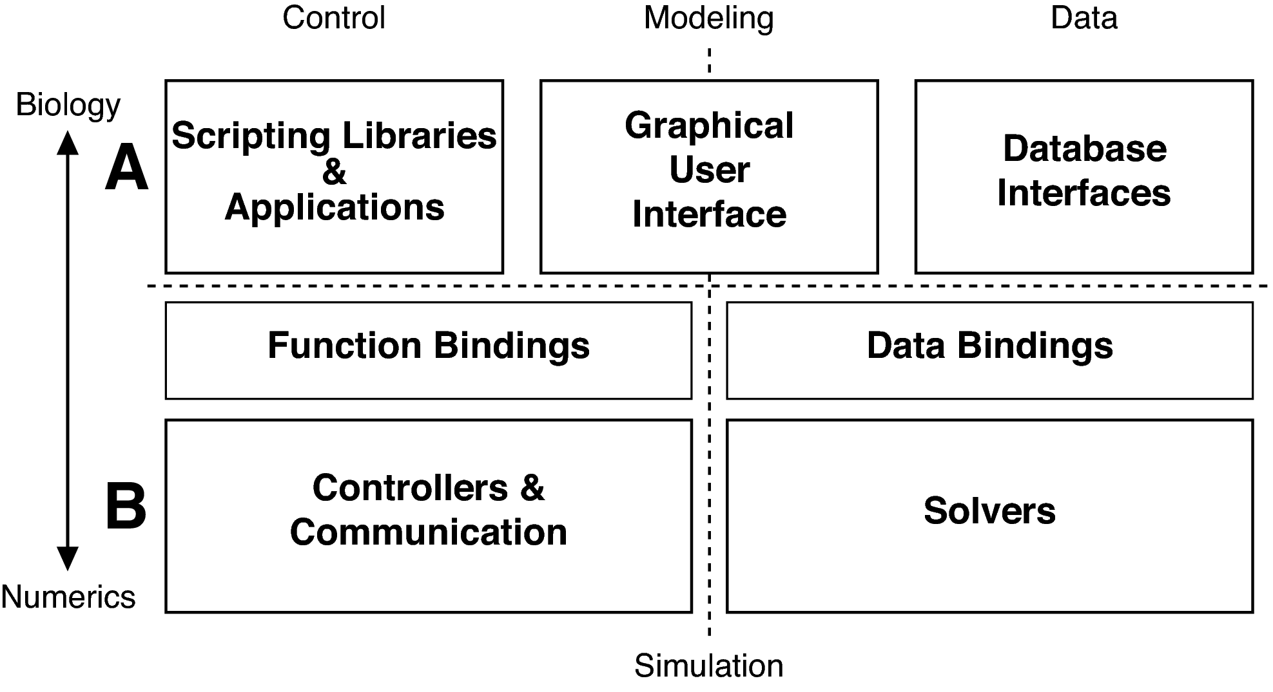
Figure 2: Overview of a federated software architecture: The primary functional modules defined for the CBI federated software architecture are illustrated. Control modules are given to the left and data modules to the right. A. The top layer contains conceptual data and controls representations of the biology of a model. B. The bottom layer contains representations that are numeric and thus close to the hardware. The middle or intermediate layer bridges between these ‘biological’ and ‘numerical’ layers in a CBI compliant simulator. Importantly, Control (Scripting Libraries & Applications) and Data (Database Interfaces) modules can interact either directly or via the Graphical User Interface.
We refer to the CBI architecture as being ‘federated’ as it extends the modular approach associated with the development of single applications to the functional integration of otherwise independent applications. Federation aims to provide a unified interface to diverse applications and mask from the user the differences, idiosyncrasies, and implementations of the underlying applications and data sources (see [9]). In doing so, federation provides transparency, heterogeneity, a high degree of function, autonomy for the underlying federated sources, extensibility, openness, and the possibility of highly optimized performance. Here, extensibility is defined as a system design principle where an implementation takes into consideration future developments. An extensible system is one that includes mechanisms for expanding or enhancing the system with new capabilities without having to make major changes to the system infrastructure. Ideally, federation makes the underlying applications look like a single system to the user.
Enhanced application interoperability is then available through the use of flexible high-level scripting languages to support diverse workflows, low-level application programmer interfaces (API)s, and application binary interfaces (ABI)s for performance (see [11]).
In summary, the CBI architecture provides a template for software development that, at its core, contains a simulator. Additionally, the modularity and layering of the architecture simplifies connection to independent applications related to model construction and instantiation and the display and analysis of simulation output.

2.1.1 Behavioural View of the CBI Architecture
Figure 3 provides an expanded view of Figure 2 and illustrates in more detail the structural relationships between the different modules and sub-modules that comprise the CBI architecture. Their functionality has previously been described in [10]. The behavior of the CBI architecture is defined by the functional and dynamic connectivity provided by these individual modules. Their behavior is now described within the context of a user workflow (for more details of this workflow see [10]).

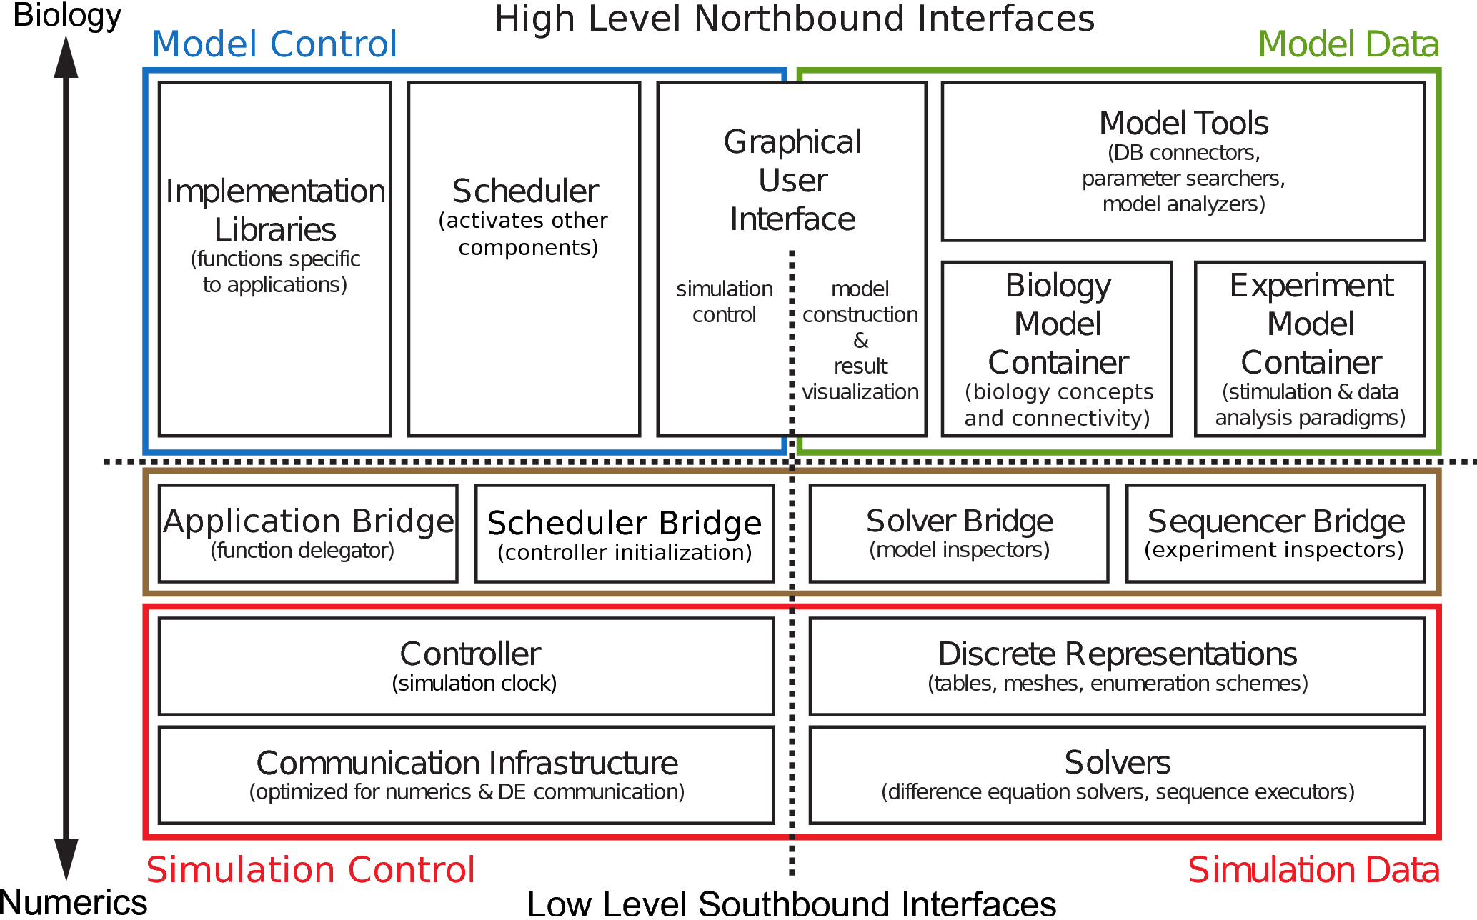
Figure 3: Detailed view of the Computational Biology Initiative federated software architecture. Relationships of sub-modules within each of the primary functional modules given in Figure 2 are illustrated. North bound interfaces group and conceptualize the details of the modules and interact with south bound interfaces of higher level modules. Steps 1–3 of the user workflow induce data cycling between the upper layers (blue and green boxes) and lower layers (red box). Ultimately, the two layers interact to implement a single simulation. By design, any type of model including multi-scale models will exhibit this data cycle. In contrast to previous versions of GENESIS and other neuronal simulation platforms, the design of G-3 is fundamentally modular, separating different functional components of the simulator into their own modules. Importantly, G-3 separates model descriptions from their mathematical representations. This simplifies the implementation of new solvers and other run-time software components. The communication infrastructure connects different solvers to simulate different parts of a model and can ‘upscale’ or ‘downscale’ numerical data as needed. Additional detail is given in [10].210
During the phase of model construction prior to simulation, users combine models from files and databases. When the simulation runs, the numerical Solvers perform the calculations of a simulation, and save the output back to files and databases. When these two steps are combined they imply a cyclic data flow from files and databases to the Solvers.
In more detail, as a result of Steps 1–3 of the user workflow (construct model, design experiment, run simulation), data flows both through and between software components that conform to a CBI architecture: the data cycles between databases and files, and back-end Solvers. Here, the cycle is described for a single neuron model. However, all scales of model will exhibit this data cycling.
Once Step 3 is completed, all data generated by dynamic states of the model are available through databases and files. Consequently, there is no requirement to query software components that deal with numerical data. This ultimately prevents the creation of a monolithic simulator.
In Step 4 of the user workflow (output), the availability of any model data from the Biology Model Container and the functionality of Scripting Libraries & Applications can be used to connect the CBI architecture to external tools, for example Matlab (to implement output analysis), while maintaining the integrity of the separation of concerns. At Step 5 (iterate), simulation output data and model parameters and structure available in the model containers can be combined, for example, to provide automated script generators for the creation of batch simulations. Importantly, at this stage of the workflow, the back-ends of the CBI architecture (indicated below the dotted horizontal line in Figures 2 and 3) are unavailable.

2.2 GENESIS 3.0
The software architecture developed for G-3 supports a new and unique capacity for federated and modular software development of multi-scale modelling. Furthermore, its structure also supports the direct interaction or embedding of models at different levels of scale. During model construction this is accomplished through the reconfiguration of the internal model storage format, while during simulation run-time it is accomplished through specific software modules that create intermediary representations of variables present at multiple scales (described in more detail below).
Several explicit features of G-3 allow new software components to be rapidly incorporated into the simulator: 1) the modular CBI structure allows the development of new solvers independently of other software components. This encourages full focus on the mathematical aspects of solvers and their implementation and leads to better optimization; 2) the G-3 Developer Package facilitates integration of new solvers into the build system of G-3 enabling immediate regression testing; 3) easy extension of the configuration of the internal model storage format to establish new declarative model tokens and parameters recognized by new solvers; 4) easy construction of an interface between the internal data storage format and the core of the new solvers, and finally 5) the specific development of a communication software component to create simulation run-time interfaces between solvers.
Solvers currently available in G-3, starting at the highest scale, include: DES, for discrete event queuing and distribution, Heccer, a single neuron solver, Chemesis-3, solves simple reaction-diffusion systems, and Experiment (not to be confused with the Experimentsl Model Container), provides current injections, time-tables, and output.

2.2.1 The Model Containers
Biology Model Container stores biological entities and end-user concepts and provides a solver-independent internal storage format for models. It also annotates the structures and concepts of a model with biological, physical, and mathematical quantities. By ‘containing’ the biological model, the Biology Model Container makes the implementation of the numerical core of a solver independent of software implementation.
Because all model components are an integrated part of a single model-container [10], existing and new G-3 solvers can be integrated to simulate different aspects of the same model. This scale-linking functionality of G-3 instantiates dedicated run-time software components that contain intermediary representations of solved variables that can pass both upscale and downscale values to solvers at different levels of scale.
Therefore, in principle, the Biology Model Container is capable of supporting the transparent construction of multi-scale models and simulations.
For completeness we note that the Experimental Model Container stores a model of a stimulus paradigm and desired output parameters and defines and stores a hierarchical sequence of stimulus-related actions (e.g. start and stop time of a current injection) and their dependencies.
Finally, we note that the model containers define models in a purely declarative, extensible language.
The Biology Model Container supports tokens for: Grid3D, Populations, and Networks; VolumeConnect, Individual Connections; Single Cells and Morphology; HH-Channels and Synaptic (NMDA / AMPA) Channels, and Reaction–Diffusion.

2.2.2 The Neurospaces Description Format
The model container’s Neurospaces Description Format (NDF) file format was originally designed as a file-based user-editable declarative interface to the hsolve method in GENESIS-2 [5]. Subsequently, its single neuron modeling functionality was expanded with network modelling capabilities.
The file format is indicated by the .ndf file name extension and integrates and extends the previous GENESIS .p and .g declarative file formats. NDF files are purely declarative and can be stored in a model database. In an NDF file, a model exists as a hierarchy of tokens, each representing a biological component. Each component is a physical process and can have parameters and shared variables.

2.2.3 Overview of an NDF File
An NDF file contains four sections. They are not necessarily filled, but must be present in the given order. Files have the following general form (described in more detail below).

#!/usr/local/bin/neurospacesparse
//-*- NEUROSPACES -*-

// default location for file comments

NEUROSPACES NDF

IMPORT
FILE <namespace> "<directorypath>/<filename.ndf>"
. . . <other files may be imported as required>
END IMPORT

PRIVATE_MODELS
ALIAS <namespace>::/<source label> <target label> END ALIAS
. . . <other aliases may be defined as required>
END PRIVATE_MODELS

PUBLIC_MODELS
CELL <morphology name>
SEGMENT_GROUP segments
. . . <morphological details>
END SEGMENT_GROUP
END CELL
END PUBLIC_MODELS

The header section must starts with the Unix interpreter sequence giving the system specific absolute path to the NMC executable (for example):

#!/usr/local/bin/neurospacesparse

This is followed by two declarations on separate lines.

//-*- NEUROSPACES -*-
NEUROSPACES NDF

The first (optional) declaration flags an appropriate major mode and keyword highlighting for Emacs and XEmacs (the Neurospaces Emacs major mode is bundled with the NMC package). The second declaration identifies the file type (here NDF).
The Import section uses the FILE keyword to declare dependencies on other NDF files, e.g.

IMPORT
FILE <namespace> "<path>/<fname>.ndf"
END IMPORT

To simplify model development, G-3 supports construction of NDF files that define different components of a model. These files may be thought of as library files. To expedite model development, all NDF files can be shared by being imported into other NDF files.
The Private Models section defines models that are private to a single NDF file. They may depend on imported public models of other files.
The Public Models section defines models that are visible to the NDF files into which they are imported. Typically, for example, a neuron morphology would be located here. Public models may depend on private models or be hard coded.
One important feature of an NDF file is that it can contain either a single model or a library of models that represent different levels of neuronal morphology and/or electrophysiological function. Models declared in an NDF file can be ‘private’ to that file, or ‘public’ and available to other NDF files. This mechanism prevents the use of certain (private) components, while allowing reuse of other (public) components. This supports the controlled and modular construction of a multi-scale model as a given NDF file can depend on other NDF files.

2.2.4 Physical Processes and Model Variables
Mathematical models can be used to describe physical processes that underly the functional activity of biological entities by associating the physical processes with parameters (fixed during a simulation) and variables (computed during a simulation).
As an example, a synaptic current is commonly modelled using a second-order differential equation (where in computational neuroscience the right-hand side of the equation corresponds to the level of synaptic activation delivered by spikes arriving at times ):

G''+αG'+βG=S (1)
where , , and L.
Assuming the initial values G(0)=0 and G'(0)=0, the solution to this equation is a dual-exponential equation:

(2)
This equation has two parameters TAU1 and TAU2, sometimes called the rise and decay time constants, respectively. Assigning values to these two parameters in an NDF file is done as follows:

PARAMETERS
PARAMETER ( TAU1 = 0.50e-3 ),
PARAMETER ( TAU2 = 1.20e-3 )
END PARAMETERS

Values are either constant, point to a parameter of another symbol, or have a function value. For example:

PARAMETERS
PARAMETER ( DIAMETER = 0.3 ),
PARAMETER ( LENGTH = ..->LENGTH ),
PARAMETER ( SEED = SERIAL () )
END PARAMETERS

Here, the DIAMETER parameter has a constant value, the LENGTH parameter is inherited from the parent component (the ’..’ notation is a reference to the parent symbol, and SEED has a value defined by the function SERIAL().
We note that the NDF file format supports both the ’..’, and notations to reference the parent symbol. (While non-technical people might prefer the notation, technical people will prefer the ’..’ notation.)
When one biological entity modulates the behavior of another, their physical processes share one or more variables. In the case of a synaptic channel the incoming spikes raise the neurotransmitter concentration level in the synaptic cleft, which then modulates total ionic conductance through channels in the post-synaptic membrane. The NDF file format expresses the neurotransmitter concentration level as activation and conductance as G. As these variables are shared they must be declared using the BINDABLES keyword:

BINDABLES
INPUT activation, OUTPUT G
END BINDABLES

Assuming a synapse is present under the label ../synapse, its activation level can be bound to the channel activation level using a BINDINGS clause:

BINDINGS
INPUT ../synapse->activation
END BINDINGS

Putting everything together using the EQUATION_EXPONENTIAL token to represent the dual-exponential equation, we get the NDF snippet that defines a model’s component with name exp2:

EQUATION_EXPONENTIAL exp2
BINDABLES
INPUT activation, OUTPUT G
END BINDABLES
BINDINGS
INPUT ../synapse->activation
END BINDINGS
PARAMETERS
PARAMETER ( TAU1 = 0.50e-3 ),
PARAMETER ( TAU2 = 1.20e-3 )
END PARAMETERS
END EQUATION_EXPONENTIAL

In this example, the order of the clauses of BINDABLES, BINDINGS, and PARAMETERS was chosen for readibility. Importantly, neither the NDF file format nor the model container make a syntactical distinction between the variables and parameters of a physical process.
The NDF file format supports an extensible set of tokens including SEGMENT, CHANNEL, CELL, POPULATION, PROJECTION, NETWORK and many more that allow the construction of models ranging from subcellular dynamics up to the network level.

2.2.5 A Single-Neuron Solver: Heccer
Heccer is a G-3 reimplementation of the compartmental solver (hsolve) of the GENESIS-2 simulator [4]. It employs the Crank-Nicolson solution to integrate the cable equation of a neuronal morphology and the Hodgkin-Huxley equations of their transmembrane currents [16, 1, 4]. Heccer also integrates exponentially decaying calcium concentrations and Nernst potentials but for more elaborate calcium models it must be interfaced with other solvers.

2.2.6 DES: Action Potential Propagation Abstraction
The Discrete Event System (DES) is used for abstract modeling of action potentials. This functionality is needed for running network simulations. Action potentials generated at the soma of one neuron are translated to a discrete event that is delivered to a post-synaptic target of a connected neuron.
DES can queue a single event and deliver it to many targets. It allows to associate ’secondary’ data with a connection, like weight, delay and other data specific for the model.
From the viewpoint of the software architecture, DES is a separate solver that simulates action potential propagation in an efficient way. Splitting this functionality from the rest of the simulator facilitates customization for the modeling of sophisticated learning rules, especially those related to STDP, diffusion, and spillover.
Internally, the discrete event system contains two subcomponents, one for event distribution that contains a connectivity matrix, the second for event queuing.

2.2.7 Chemesis-3
Chemesis-3 was adapted from a GENESIS-2 ‘add-on’ library of objects for modelling biochemical reactions, models of second messengers, and calcium dynamics [2].
The functions currently implemented in Chemesis-3 include: rxnpool–a concentration pool that interacts with reactions and diffuses to other pools; conservepool–a mass conservation based pool, it computes the difference between the total of all molecules (a model parameter, rest state) and diffused molecules, divided by compartment volume; reaction–provides standard forward/backward chemical reactions between pools of molecules; and diffusion–computes flux in molecules between two pools.

2.2.8 Schedulers and User Interfaces

SSP
Both the model containers and the mathematical solvers are stand-alone G-3 components. To be useful, they must be ‘glued’ together and activated correctly, such that they can coordinate during a single simulation. This is exactly what the Simple Scheduler in Perl (SSP) does. It is currently the standard scheduler for G-3. SSP exploits the sophistication of the Perl scripting language to load software components on demand, and activate them from a configuration file. It achieves this by loading dynamically those software components referenced in its configuration. Because the SSP scheduler does not have any computational load, its implementation is very simple and highly configurable. Other configurations can connect SSP to different modelling services or solvers.
In summary, SSP glues other software components together, synchronizes the activities of other components during a simulation, and Is configurable.

SSPY
G-3 is composed of several independent software components, each of which has a presence in Python. It is possible via the API of components such as the model containers and Heccer to script simulations via Python (see below). However this is not desirable as all simulations would be composed of code which contained their own control flow. Like GENESIS-2, this would often require a user to understand all the internals to be able to expand existing simulations. To avoid this, SSPy is designed similarly to SSP. It encapsulates the operations for loading and running a complete simulation while giving complete control of simulation parameters and simulator options to a declarative configuration file. It also provides an easy plugin framework so that new modelling services, experimental protocols, and solvers can be dynamically loaded from a plugin directory. This extends simulator functionality without the need to change any core code.

G-Shell
When running from a command line, after G-3 has completed its startup procedure, a command prompt (genesis >) appears in the terminal window. This indicates the existence of a G-3 shell environment (G-Shell), which runs an interactive G-3 session. To provide backward compatibility, the G-Shell interfaces with the GENESIS-2 Script Language Interpreter (SLI).

2.3 Interactive Query and Simulation
The G-Shell integrates other G-3 components and makes their functions available through an interactive environment available from a command line. Coded in Perl, the G-Shell is a communication abstraction layer for the Model Container, Heccer, SSP, DES and the Studio, after the G-Shell has been started from a system shell with:

genesis-g3

Integration of the G-Shell with the Model Container allows for real-time analysis of the quantitative and structural aspects of a neuronal morphology. The library of model components that is installed with the Model Container provides a definition of a model Purkinje cell in the file cells/purkinje/edsjb1994.ndf. The command:

ndf_load cells/purkinje/edsjb1994.ndf

makes this model Purkinje cell available for interactive analysis. Similar commands exist for backward-compatible loading of GENESIS-2 SLI scripts with sli_load or alternatively with pynn_load (to interface to the PyNN network modeling environment [8]).
If a dendritic segment contains a synaptic channel, it can be stimulated with a precomputed spike train stored in a file named, for example, event_data/events.yml:

set_runtime_parameter /Purkinje/segments/b1s06[182]/Purkinje_spine_0/head/par/synapse
EVENT_FILENAME ``event_data/events.yml''

Finally, following the addition of an output for the somatic membrane potential:

add_output /Purkinje/segments/soma Vm

a simulation can conveniently be started using:

run /Purkinje 0.1

This simulation produces the somatic response to the given dendritic stimulus in a file named, by default, /tmp/output.
To query the parameters of the stimulated compartment the model can then be analyzed using the graphical front-end of the Studio with the command:

explore

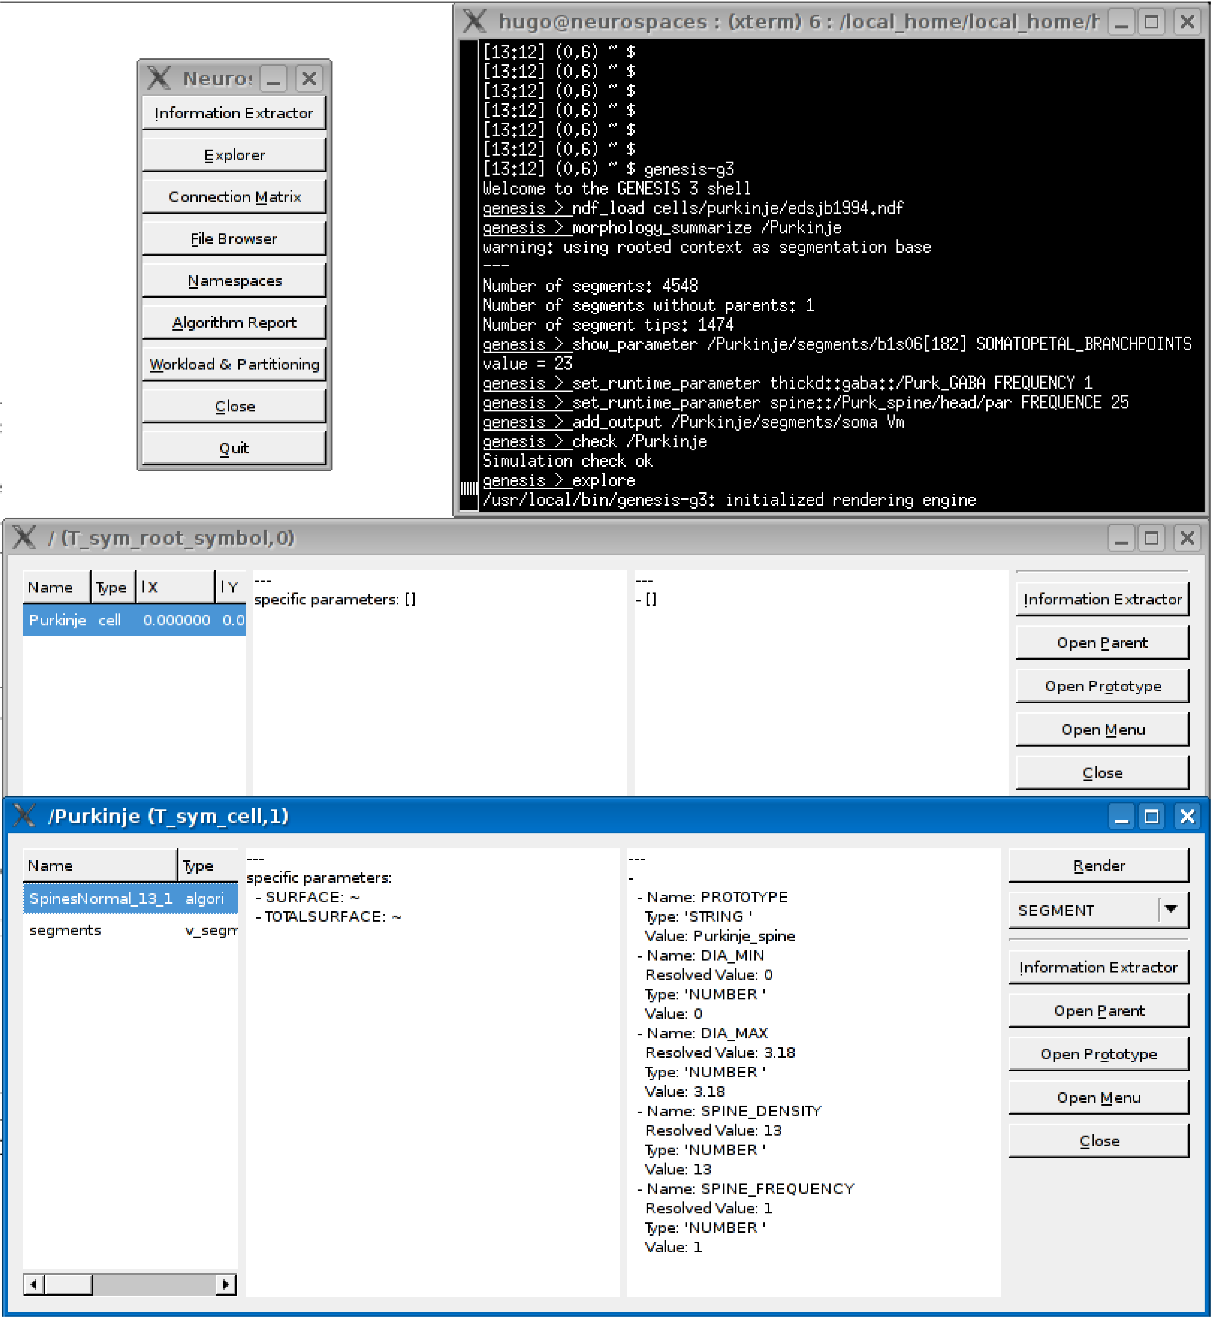
Figure 4: Querying a model in GENESIS 3.0. The Studio is a G-3 simulator component that can be used to query the parameters of individual compartments in a multi-compartment model neuron. The Studio also renders 3D morphology of dendrites and generates overviews of network models.
Figure 4 shows sample output of running this command. Other capabilities of the Studio include rendering morphologies in three dimensions and generating overviews of network models (not shown). In the next section we explore some of the more graphical capabilities of G-3.

2.4 Simple Scripting
Python is a high-level scripting language that uses modules to group related functions. G-3 employs Python’s module system to group the functions that provide an interface to each of the simulators software components. As an example, the G-3 Python module nmc contains functions to simplify the storage of neuron models in computer memory. The module is a simple front-end to the Model Container. Likewise, Heccer is a wrapper module for the Heccer component. Python bindings for DES that facilitate network modelling also exist.
Here we show a simple high-level Python script that runs a simulation of a single cylindrical segment. It is defined by standard values for the parameters of membrane resistance (RM), axial resistance (RA), and membrane capacitance (CM). (Note: This script is written for clarity of presentation rather than compactness or efficiency.) Parameters are given by their specific values (in SI units) as commonly reported in the literature, instead of their actual values scaled to the compartment surface area as used by a mathematical solver [6]. The script defines a Python function run_simulation that will load and run a model when invoked from a system command line on an appropriately configured computer. The script can also be imported into G-3 as a Python module, thus allowing access to this function. For convenience, we call this Python module example.

"""
Comment: Python script running a simple model with G-3.
"""
from g3.nmc import ModelContainer

def RunSimulation(simulationTime):
timeStep = 1e-5

#------------------------------------------------------------------------------
# Create a model container with a neuron cell and a dendritic segment
#------------------------------------------------------------------------------
my_nmc = ModelContainer()
my_cell = my_nmc.CreateCell("/cell")
my_segment = my_nmc.CreateSegment("/cell/soma")

my_segment.SetParameters(
{
"Vm_init": -0.0680,
"RM": 1.000,
"RA": 2.50,
"CM": 0.0164,
"ELEAK": -0.0800,
"DIA": 2e-05,
"LENGTH": 4.47e-05,
}
)

# Apply current injection to the soma
my_segment.SetParameter("INJECT", 1e-9)

#------------------------------------------------------------------------------
# Create a Heccer for computing the neuron model stored by the model container.
#------------------------------------------------------------------------------
from g3.heccer import Heccer
my_heccer = Heccer(name="/cell", model=my_nmc)
my_heccer.CompileAll()

#-----------------------------------------------------------------------------
# Create an output object.
#------------------------------------------------------------------------------
from g3.experiment.output import Output
my_output = Output("/tmp/output")

#-----------------------------------------------------------------------------
# Link the output object to the address of the computed variable of interest.
#------------------------------------------------------------------------------
my_output.AddOutput("output", my_heccer.GetAddress("/cell/soma", "Vm"))

#-----------------------------------------------------------------------------
# Create an array of the objects that participate in the simulation.
#------------------------------------------------------------------------------
schedulees = []

# schedule heccer
schedulees.append(my_heccer)
schedulees.append(my_output)

#-----------------------------------------------------------------------------
# Advance all the particpating objects for the duration of the simulation.
#------------------------------------------------------------------------------
currentTime = 0.0
while currentTime < simulationTime:
currentTime += timeStep

for schedulee in schedulees:
schedulee.Advance(currentTime)

my_heccer.Finish()
my_output.Finish()

#------------------------------------------------------------------------------
# Main program executes a simulation of 0.5 seconds.
# The if statement allows use of this file as an executable or as a library.
#------------------------------------------------------------------------------

if __name__ == '__main__':
RunSimulation(0.5)

2.5 Scripting Chemesis-3
In this section we show how to implement two of the G-2 Chemesis tutorial examples in G-3.
The example script cal1.g creates a single compartment with interaction between calcium and a buffer, cal2.g creates a two compartment model with a dendrite and soma with an additional diffusion object for diffusion between the compartments.
The G-3 representation of cal1.ndf follows:

#!neurospacesparse
// -*- NEUROSPACES -*-
NEUROSPACES NDF
// VERSION 0.1
PUBLIC_MODELS
KINETICS cal1
PARAMETERS
PARAMETER ( DIA = 24e-4 ),
PARAMETER ( LENGTH = 24e-4 ),
END PARAMETERS
POOL somaCa
BINDABLES
OUTPUT concen
END BINDABLES
PARAMETERS
PARAMETER ( concen_init = 0.001 ),
PARAMETER ( DIA = ..->DIA ),
PARAMETER ( LENGTH = ..->LENGTH ),
PARAMETER ( "UNITS" = 1e-3 ),
END PARAMETERS
END POOL
POOL somaCabuf
BINDABLES
OUTPUT concen
END BINDABLES
PARAMETERS
PARAMETER ( concen_init = 0.003 ),
PARAMETER ( DIA = ..->DIA ),
PARAMETER ( LENGTH = ..->LENGTH ),
PARAMETER ( "UNITS" = 1e-3 ),
END PARAMETERS
END POOL
POOL somabuf
BINDABLES
OUTPUT concen
END BINDABLES
BINDINGS
INPUT ../somaCabuf->concen,
END BINDINGS
PARAMETERS
PARAMETER ( concen_init = 0.153 ),
PARAMETER ( concen_total = 0.153 ),
PARAMETER ( DIA = ..->DIA ),
PARAMETER ( LENGTH = ..->LENGTH ),
END PARAMETERS
END POOL
REACTION somacabufrxn
BINDABLES
INPUT concen, OUTPUT concen
END BINDABLES
BINDINGS
INPUT ("substrate") ../somaCa->concen,
INPUT ("substrate") ../somabuf->concen,
INPUT ("product") ../somaCabuf->concen,
END BINDINGS
PARAMETERS
PARAMETER ( FORWARD_RATE = 1e2 ),
PARAMETER ( BACKWARD_RATE = 0.5 ),
END PARAMETERS
END REACTION
END KINETICS
END PUBLIC_MODELS

Finally, the following commands illustrate how the G-Shell and the G-3 Studio (model explorer) is used to load cal1.ndf into the Model Container and explore the model:

\$ genesis-g3
Welcome to the GENESIS 3 shell
genesis > ndf_load /usr/local/neurospaces/models/library/chemesis/cal1.ndf
genesis > explore

while, the G-Shell command to run cal1.ndf and send output to a file is:

genesis > run /cal1 2

3 Results

3.1 Multi-Scale Scripting
In a typical multi-scale model different numerical solution methods are required to solve the different types of mathematical equations associated with the different scales of the model. In G-3 the cable equation and ion currents are numerically solved with implicit Crank-Nicolson integration using Heccer. Calcium models are numerically solved with Chemesis-3. The association between a given model and its solver can be configured by the user. For example to associate the model named “/purkinje” with the solver “heccer”, one issues the command:

genesis > solverset "/purkinje => heccer"

Biochemical pathways in neuronal modeling are complex networks of interacting ion concentration pools. The G-3 implementation for simulation of biochemical pathways is called Chemesis-3 and has a dedicated optimized implementation to represent networks parameterized with biochemical pathways. To simulate a complex network model of biochemical pathways, in this example called cal1, a user would typically type from the G-3 shell:

genesis > solverset "/cal1 => chemesis3"

In the case where a network of biochemical pathways is defined inside a single neuron model, a user would have to type two commands with wildcards that associate the correct solver with each component of the model, for example:

genesis > solverset "/**/cal1 => chemesis3"
genesis > solverset "/traub94/**[!cal1] => heccer"

In later versions of G-3 these rules will be built in but still allow the user to select a different method of solution for different components of a model.

3.2 Multi-Scale Network Modeling
See tests/perl/spiker4.
Network modelling was previously already possible with G-2. In G-3 multi-scale network modelling of individual neurons is also solved by different Heccer instances. For example, their projections are solved by DES where the G-Shell syntax is:

genesis > solverset "/network/target1 => heccer"
genesis > solverset "/network/target2 => heccer"
genesis > solverset "/network/receiver => heccer"
genesis > solverset "/network/projection => des"

Alternatively, in SSP the syntax is:

{
modelname => "/network/target1",
solverclass => "heccer",
},
{
modelname => "/network/target2",
solverclass => "heccer",
},
{
modelname => "/network/receiver",
solverclass => "heccer",
},
{
modelname => "/network/projection1",
solverclass => "des",
},

4 Discusion
Simulation provides a framework to organize our understanding of biological systems. Historically, the development of neuronal simulation software for the construction of morphologically detailed neuron models and small networks has been instigated by research projects that specifically addressed complementary technical and scientific questions [15]. These software systems have been both highly successful and continued to grow in complexity through cycles of research project extension. However, more than twenty years of extending their functionality, usually by the direct incorporation of source code into the core of the simulator, has led to code structures so complicated that it has become increasingly difficult, if not impossible, to easily continue this process. Ultimately, the resulting stand-alone applications have become ‘monolithic’. That is, it has become increasingly difficult for users and developers to maintain and extend them, with the logical consequence that user workflows are often similarly degraded. A significant consequence of this process is that the development of an optimized simulation can be a considerable challenge for a neuroscientist unfamiliar with the necessary mathematical and computational theory.
One significant reason for this situation is that no distinction is made between biological data, numerical data, and control operations. In practice, the result is that the complexity and monolithic nature of the software results in a non-scalable software architecture [7].
The CBI architecture was designed and developed in an effort to resolve the complexities associated with continual addition of functionality to simulators. As illustrated in Figure 2, the relationships between simulator control and data modules in such a federated architecture are symbolizedby the relationship between high level biological concepts and their mathematical implementation. Diagonal interactions are forbidden as they foster the mixing of functionality across different levels that ultimately leads to the creation of monolithic software applications.
According to principles of systems theoretic analysis (see [17, 12]), it is clear there are numerous phenomenological approaches to the development of multi-scale models suited to the transformation of a mental model into a computational simulation. Figure 1 illustrates a selection of some of the possible steps, levels, and components of this process. Interestingly, two possible multi-scale models have been in widespread use but not generally recognized for their multi-scale characteristics: (1) Biologically inspired, e.g. a model is specified as a network and a population of detailed channel models, and (2) Mathematically inspired, e.g. use continuous cable equations to model a neuron, discrete event models for axonal propagation, and Hodgkin-Huxley equations for the channels.
Many so-called secondgeneration simulators remain primarily focused on the biological and mathematical aspects of multi-scale modelling. It is likely that because they do not respect all three of Marr’s levels, the complexity of multi-scale simulation is greatly increased. Following the recent reconfiguration of the GENESIS simulator it is now possible to incorporate Marr’s third level of ‘hardware’, as software functionality, to give a comprehensive multi-scale simulator. In this approach, it is the implementation of a model for simulation or otherwise, that is contained by a single software entity (in this case a single ‘model-container’) and that employs the solvers necessary to implement different mathematical tools that communicate with each other at run-time using a communication infrastructure provided by the CBI architecture that solves the problem of creating a software platform that efficiently supports the simulation of multi-scale models.
That this is the case is evident when the matrix given in Figure 1 is compared with the structural level matrix illustrated in Figure 5.

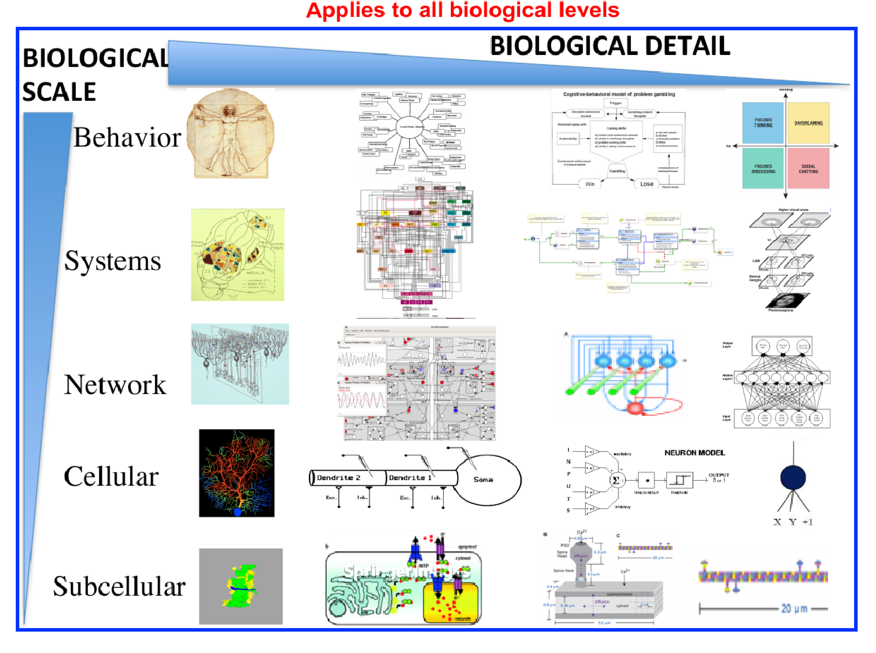
Figure 5: A Multi-Scale Structural Taxonomy.
From a technical point of view, the incorporation of simulation modules that specifically involve spatial dimensions is, in principle, much more difficult than the integration of biochemical kinetic models. In fact the accurate representation of space and time for multi-scale simulations is an open research area. However, the explicit provision of software modules for the intermediary representation of solved variables allows the comparison and evaluation of different methods of scale-linking, for instance by comparing different resolutions of a fixed grid with adaptive grid intermediary representations [14]. In effect, this will allow the use of multi-scale G-3 models as a framework to compare different technical strategies.
G-3 supports the construction of very large scale network and system models based on more abstracted neuronal components. In support of this function, the G-3 Biology Model Container applies specific algorithms to instantiate systems level connectivity models and convert them to mathematical representations. This relieves the mathematical solvers from the algorithmic pressures typical for rich heterogeneous model structures. At the same time, intermediate simulation system modules, already described as the mechanism used to link Chemesis-3 and linear cable solvers, will also be used to share values and functions between larger scale network simulations and lower scale models.
The definition of multi-scale modelling arrived at in this paper enables the generation of a taxonomy of models in computational neurobiology based on both the biological scale of a model and the level of detail it aims to represent.
References
[1] Hodgkin A and Huxley A. A quantitative description of membrane current and its application to conduction and excitation in nerve. Journal of Physiology, 117:500–544, 1952.
[2] K.T. Blackwell. Evidence for a distinct light-induced calcium-dependent potassium current in hermissenda crassicornis. Journal of Computational Neuroscience, 9(2):149–170, September 2000.
[3] PS Churchland and TJ Sejnowski. The Computational Brain. Bradford Books: Cambridge MA, 1992.
[4] Hugo Cornelis and Erik De Schutter. Tutorial : Simulations with Genesis using Hsolve. Course material, November 2002. Available from http://genesis-sim.org/filemanager/active? fid=95, accessed 2011 Dec 11.
[5] Hugo Cornelis and Erik De Schutter. Neurospaces: Separating modeling and simulation. Neurocomputing, 52–54:227–231, 2003.
[6] Hugo Cornelis and Erik De Schutter. Neurospaces parameter handling. Neurocomputing, 58–60:1079–1084, 2004.
[7] Jaeger D. Accurate reconstruction of neuronal morphology. In Erik De Schutter, editor, Computational Neuroscience, Realistic Modeling for Experimentalists, chapter 6. CRC Press: New York, 2002.
[8] AP Davison, D Brüderle, J Eppler, J Kremkow, E Muller, D Pecevski, L Perrinet, and P Yger. PyNN: A common interface for neuronal network simulators. Frontiers in Neuroinformatics, 2:11, 2008.
[9] Lin E and Haas L. IBM federated database technology. www-128.ibm.com/developerworks/db2/library/techarticle/0203haas/0203haas.html, March 2002.
[10] Cornelis H, Coop AD, and JM Bower. A federated design for a neurobiological simulation engine: The CBI framework for GENESIS 3.0. PLoS ONE, 7(1):e28956, 01 2012.
[11] Cornelis H, Rodriguez AL, Coop AD, and Bower JM. Python as a federation tool for GENESIS 3.0. PLoS ONE, In press, 2011.
[12] F Heylighen, P Cilliers, and C Gershenson. Complexity and philosophy. arXiv:, page cs/0604072v1, 2006.
[13] D Marr. Vision: A Computational Investigation into the Human Representation and Processing of Visual Information. W. H. Freeman & Co Ltd, 1982.
[14] Bernabeu MO, Bordas R, Pathmanathan P, Pitt-Francis J, Cooper J, Garny A, Gavaghan DJ, Rodriguez B, Southern JA, and Whiteley JP. CHASTE: Incorporating a novel multi-scale spatial and temporal algorithm into a large-scale open source library. Philosophical Transactions of the Royal Society A, 367:1907–1930, 2009.
[15] J W Moore. A personal view of the early development of computational neuroscience in the USA. Frontiers in Computational Neuroscience, 4:20, 2010.
[16] I. Segev, J. Rinzel, and G. H. Shepherd, editors. The Theoretical Foundation of Dendritic Function : Selected Papers by Wilfrid Rall with Commentaries. MIT Press, Cambridge, MA, 1995.
[17] L von Bertalanffy. General System Theory. George Braziller: New York, (Revised Edition) edition, 1973.

