Development of a graphic user interface for enhanced publication of scientific communication.

5.5 Content of the Research Plan

5.5.1 NA This is not a resubmission or a revision.

5.5.2 Specific Aims

This proposal requests support for the development of a new set of computational tools to support the evaluation, understanding, and sharing of computational models of the nervous system. In effect, the project described in this proposal is intended to lay the ground work for making models, rather than as at present, the written descriptions of models, the base for scientific publication in computational neuroscience and potentially neuroscience as a whole. The project will be organized around ongoing research and development of the GENESIS (GEneral NEural SImulation System) modeling system, however, the tools and Graphic User Interface (GUI) proposed here will be developed as plug-ins for an existing agnostic software infrastructure, that we refer to as the CBI federated architecture.
Specific Aim 1: Develop and implement a comprehensive user modifiable GUI for the control, analysis, comparison, and peer reviewed electronic publication of computational models and simulation results in computational biology. Development of such a GUI will enable access to multiple databases (e.g. experiment, morphology, model) and also account for the micro-evolution of a model by making it part of a publication record. The publication records are maintained in a model publication database.
Specific Aim 2: The model publication database is proposed to comprise a project record that contains (i) a structured narrative (Introduction, Methods, Results, Discussion), (ii) a framework for the exploration of a model or tutorial, and (iii) a complete record of all changes made to a model during a research project, including the dead-ends. This leads to an operational workflow that includes: model development, model simulation, and results analysis where modifications to a model creates a graph of ancestry during the life time of the model.
Specific Aim 3: The GUI will facilitate and support the development of the structured narrative and will also automatically create a project record by tracking all models, simulation configurations, and results of a given research project.
Specific Aim 4: A user will then be able to select the interesting parts of the project record to become part of the project publication. Operationally, the GUI will contain a library of frames of reference, e.g. a reference frame for the membrane channels of a given model that illustrates the quantitative validation of the channel kinetics. These frames are populated by the researcher with reference to model history, and new results and observations.
Specific Aim 5: Manuscript submission will push the complete graph of ancestry that includes the dead ends and frames of reference to an external database. This electronic submission will then be available for review. In this publication paradigm, a reviewer will primarily focus on the frames of reference that validate the computational model as a precursor to the novel aspects of a project that includes the narrative.
Specific Aim 6: Once published, the system will support a wiki-like interactive discussion of the model and its results, and will also make the model available for modification and expansion and track its macro-evolution and lineage across publications.

Once developed even in prototype form, the P.I. is well positioned to discuss incorporation of this system as part of existing journals (the Journal of Computational Neuroscience which he founded; Frontiers in Neuroscience, whose chief editor Idan Segev was also a founding member of JCNS as well as co-founder and director of the European Methods in Computational Neuroscience Course) or if appropriate, to establish a new publication. These conversations are premature, however, until the infrastructure is established and demonstrated. It is important to point out from the outset, that we are proposing to develop this model-based publication system, we are not proposing at this time to develop a new publication in computational neuroscience.
5.5.3 Research Strategy

5.5.3.1 Significance

At its core, the proposed publication infrastructure is designed to facilitate sharing of scientific data and biophysical computational models and their annotations and by so doing provide a quantitative mechanism for the further development of computational neuroscience and our understanding of neurobiological systems as a whole. This proposal is specifically written around the generation of what are commonly referred to as “realistic models”, whose anatomical and biophysical structures are derived from the brain itself (see Bower, 1999 for discussion). While clearly an ambitious undertaking, we believe that the time has come to design a mechanism for the ordered evaluation, sharing, and evolution of what we will refer to here as ”Community Models” of components and parts of the nervous system. As outlined below, there is already early de facto movement in this direction as several models have already migrated from single laboratories to multiple and even competing laboratories. One of these models, a cerebellar Purkinje cell model, will serve as the initial test case for the system we propose to develop. However, while the technology of modeling has slowly been gaining acceptance in the field, like experimental science before it, this new approach requires the development of new technology to maximize its potential and value. It is our view that the transition from purely descriptive experimental science, to investigations increasingly related to models, is, in essence, the first stage in establishing the first real quantitative theoretical base for understanding structure/function relationships in the nervous system. Models themselves, properly constructed, in effect, represent our current understanding about what is functionally important in the structure of the brain and its components, as well as a tool to organize future experimental and modeling efforts to move that understanding forward (Bower, 1999). However, this kind of success for modeling will require the development of new tools for the comparison and publication of models. The purpose of this proposal is to develop such a framework to link to existing tools and develop new tools that will be critical to that process.

5.5.3.2 Innovation

The Need and Opportunity. The core historical premise for this project is that, for most of its history, the greatest part of our efforts to communicate new neurobiological results has been based fundamentally on narrative story telling in the form of scientific journal articles (Gibson et al., 1960). Accordingly, the usual first stage in constructing a publication is to develop a series of graphical figures around which a narrative story is then constructed. It is common practice to construct these figures from “best case” results, which tell the story most convincingly, or at least in a manner that will raise the least reviewer concerns. The short-term evaluation of the veracity of the new story is then performed by experts through the peer review process where the new story is aligned with existing and previously published stories, and often, in practice, most especially with the beliefs of the reviewers. Although publication of a methods section, in principle, allows the possibility for the actual experimental replication of a new result, it is generally understood that methods descriptions are inadequate to replicate experiments, and with a strong emphasis on ‘new’ stories, publication of pure replications is difficult or impossible.
In principle, model-based research provides a mechanism to overcome a number of these limitations and approach publishing, scientific communication, and even collaboration in a new way, because the models themselves can be published. First, new stories generated by models can, at least in principle, be referred directly to mathematical structures from which the story was constructed. At least some of these structures, such as for example basic biophysical parameters like membrane capacitance or resistance, can, in principle, be evaluated automatically as the first stage of publication of a new model, making some part of the review process more rigorous and objective. Such an automatic evaluation process can also alert reviewers (as well as authors) to parameters that are well out of the norm. Second, again in principle, instead of being handpicked from best-case data, figures can be constructed directly from the published model itself. Thus a reviewer or reader would know exactly the conditions under which a particular figure or result was generated. In effect, on-demand figure generation is a form of result replication. Finally, and perhaps most importantly, the model itself potentially becomes a forum to establish and structure an ongoing dialog, as well as a basis for the development of new modeling components. Models, used in this way, provide a common representation of what is known about a particular component of the nervous system, as well as a means for further elaboration and exploration of that component. Such models would, in effect become “Community Models” to which many could contribute. They can also provide the structure of a common basis for training new researchers, educating students, including, for example, medical students, as well as a mechanism to clearly identify outstanding issues, for example the need for better or new experimental data. Models used in this way would greatly clarify communication (which should be a principle objective of scientific publication) and could also become a means to quantitatively identify and resolve scientific conflicts. To do so, however, it will be necessary to construct a publication system that publishes models rather than textual description of models, as is currently the case.

The Current State. While, in principle, model-based research has the potential to provide this kind of foundation for current and future neurobiological science, in fact, the majority of modeling studies today are based on models that remain unshared, or un-sharable, and which are built and associated with single laboratories. As an example, at last year’s International Computational Neuroscience meeting in Berlin, results were presented from 12 different hippocampal network models from 12 different independent laboratories. No effort has yet been made to integrate these models together into one common model. This is typical for most (but not all, see below) computational models.
While there are clear sociological factors involved in this state of affairs (see discussion in later sections), we believe that the current form of scientific publication is also an important impediment. For example, perhaps even more than is the case for the publication of experimental results, traditional methods sections are wholly inadequate in providing enough information to replicate a complex realistic model or its results. While there have been important efforts to develop repositories for published models, with Model-DB at the Yale Sense lab being perhaps the most visible and successful example (Hines et al 2004), models are added after the fact, and are not explicitly linked to the publication of the text or figures. Models deposited as an after-thought have been notoriously difficult to extract and make sense of once made available. It is also well known, for example, that the relationship between the model deposited and the model that generated the results or figures in a particular paper is often tenuous, and, in fact, Model-DB only suggests that the deposited model replicates at least one of the published figures. Deposited models also lack any documentation with respect to the execution of the model itself, its origins or antecedents. It is the nature of the modeling process to generate multiple variations which, in the absence of a formal system for model versioning, can become very difficult to track. It is the premise of this proposal that constructing a tool that integrates the modeling and publication process will produce a technical basis for the development of both higher fidelity publications, and the kind of community models that physics, for example, has depended on for several centuries.
While the current state of modeling is more disparate than organized, there is clear evidence that community models are beginning to emerge. Perhaps the best current example is based on a model of the cerebellar Purkinje cell, initially published in 1994 as a passive electrical model by Rapp and Yarom (1994). This model was then subsequently extended to include active conductances by our own research group (De Schutter and Bower, 1994a,b,c.) and made available to the public through the GENESIS data-bases (URL: http://www.modelersworkspace.org/). Over the last nine years, four variations of this model have been published by four independent research groups (Chono et al 2003; Coop & Reeke 2001; Miyasho et al 2001, Steuber et al 2007). In addition, numerous variations have been published by former members of the Bower laboratory now running their own research groups (De Schutter & Steuber 2009; Kreiner & Jaeger 2004, Solinas et al., 2006). The Purkinje cell model was also the first full model of a neuron to be translated between the NEURON simulator (Hines & Carnevale 1997) and GENESIS (Steuber et al 2007) and has served as the basis for a funded collaboration between five different research groups in three different countries (Steuber et al 2007). The model has also now been incorporated into a network model of cerebellar cortex and, importantly, has been cited in a relatively large number of purely experimental studies (cf. Cavelier et al 2002; Ogasawara et al 2007; Pouille et al 2000; Widmer et al 2003; Williams et al 2002; Willoughby & Schwiening 2002).
While the Purkinje cell model is well on the way to becoming one of the first “Community Models” in neuroscience, the lack of model-based publication is even an issue for this model. Like all models, the original continues to undergo a process of evolution that is more or less explicit. While the original model was based on a neuron morphology of a passive model developed by Rapp (1994), other models have used different morphologies, but applied the same channel distribution and characteristics. Other versions of the model have used different values for conductance parameters (Chono et al 2003). While these model differences were explicitly called out in the corresponding publications, closer examination of the other published versions of this model also reveal sometimes subtle and sometimes not so subtle variations. While this is potentially a concern in itself, the larger issue is that it is not at all clear how much of the original performance of the first model is preserved in subsequent models. For example, the original model showed significant dendritic amplification of excitatory post-synaptic signals (De Schutter & Bower 1994), while a more recent version shows that this same mechanism can also amplify inhibitory post-synaptic signals (Solinas et al., 2006). However, the updated channel characteristics in the latter model make it difficult to quantitatively compare the reported dendritic amplification characteristics of inhibitory and excitatory signals. This is an important issue because, in the current process of publication, it is often assumed that the current model has ‘inherited’ the demonstrated characteristics of the original model. No modern journal would accept the re-publication of 20 years worth of figures demonstrating that this is the case – but the question of whether the new version can still replicate the performance of the old version is a critical experimental and theoretical question that is currently simply not addressed. The inability to replicate could either indicate that the old result was wrong or misinterpreted, or that the new version of the model has drifted away from the biological realism established in early modeling stages. It will be necessary to develop new tools and a new publication system to address this important issue.
While in some sense, the Purkinje cell model represents one of the best current examples of a “Community Model”, as just described, but it suffers, as do all modeling efforts, from the lack of particular tools for understanding and evaluating different models. These include the following:

Current lack of model comparison tools: With the exceptions of using Bayesian methods for evaluating compartmental models of neurons (Baldi et al., 1998) and the analysis of the structure of a model (Hines et al., 2007), there are few, if any, whole model comparison tools available. While individual researchers are developing specialized tools that examine one or another feature of models (Cannon & D'Alessandro 2006; Druckmann et al 2007), there is as yet no infrastructure or software system to integrate these tools into a working whole. None of these tools obviously have been included into the review process for publication of modeling results.

Current lack of model lineage inspection tools: With the exception of tracing model lineage by hand from source publications, we know of no formal methodology or computational tools for identifying and/or tracking model lineage in computational neuroscience and biology. In these disciplines it is still difficult if not impossible to track either the micro-evolution of incremental changes made to a model during a single publication or the macro-evolution of a model across multiple publications. This is a particularly relevant concern as it relates to the question of attribution, which is, in turn tied to evaluations for funding, promotion, and tenure. In principle, tracking model lineage could provide a more quantitative and rigorous method for evaluating the impact of a particular researcher on the community, as well as understanding the antecedants of a new model. In principle, combining model comparison tools with lineage tracking, one could also formally ask the question “what has this new model contributed?” or “how does it differ from an older model?”

Current lack of model verification: Due to its micro-evolution, even with full access to the code of a given model, confirming that it was indeed the one used to produce the figures in a paper is not always possible. This greatly complicates model verification.

Current difficulty of result replication: Because the validity of a model cannot currently be easily verified, replication of results (one of the corner stones of the scientific method) is greatly complicated. This is particularly a problem with models, like the Purkinje cell model, which have evolved through several generations. As already described, it will be important to know which of the previously published features of the model still hold true as the model parameters are modified with additional experimental data.

5.5.3.3 Approach

Our qualifications to manage such an effort. Before considering the specific approach we will take to address these issues, it is important to provide some evidence that our research group is capable and well positioned to take on this ambitious task. Providing a rather substantial experience base for this effort, for 25 years the P.I. has been managing the development and extension of the GENESIS simulation platform, which during that time has been responsible for many core innovations in the field of computational neuroscience. GENESIS, and its version for parallel and networked computers (PGENESIS) was the first broad scale modeling system in neurophysiology to encourage modelers to develop and share model features and components. The GENESIS group established the first standards for comparisons between simulation systems, the Rallpacks (Bhalla et al., 1992). This effort in particular can be viewed as the first step in the direction of quantitative model comparison. The GENESIS development team was one of the first to recognize the importance of standards for model sharing, which led to the initial development of the NeuroML standard for model exchange (Crook et al., 2007; Goddard et al., 2001), PGENESIS was the first 'realistic' neural simulator run on supercomputers, and has itself spawned the development of middle-ware projects for simulator interoperability such as the Systems Biology Workbench (Hucka et al 2002), the Neosim parallelization framework, and the Neurospaces project for the development of independent software components for simulators. The GENESIS group also published the first tools for automatic parameter estimation (Vanier & Bower 1999) as well as the first Bayesian formulation for model comparisons (Baldi et al 1998).
Although this project is not specific to the GENESIS simulation system, the GENESIS users group will provide a core foundation for the development and testing of these tools. Since its release for general use in 1988, GENESIS has provided one of the foundations for the ongoing course in Methods in Computational Neuroscience at Woods Hole MA, as well as courses offered in the European Union, Mexico, Brazil, India, and in more than 100 universities around the world where it has been used both as an instructional tool in realistic modeling of the nervous system and as a simulation based tool for neurobiological education in general. For over 25 years, the GENESIS simulator has been used for research simulations with over 400 peer-reviewed papers to date published using the system. Additional information on GENESIS can be found at genesis-sim.org/.

5.5.3.3.1 Preliminary Studies

The CBI Federated Software Architecture. The GUI and technology development here will be a component of the larger CBI Federated software architecture which has been developed to provide a modern modular framework for simulator technology. The CBI architecture is organized around the principle that a natural distinction can be drawn between data and algorithms. In the context of computational research, the distinction between data and algorithms leads to a separation between model (data) and simulation control (control of data flows). The relationship between simulator control and data components for the CBI architecture are symbolized by the horizontal arrows in the following figure, where the highest level layer captures biological representations and the lower level layers are related to the mathematical implementation. The vertical dashed line indicates the separation of control and data within a simulator.
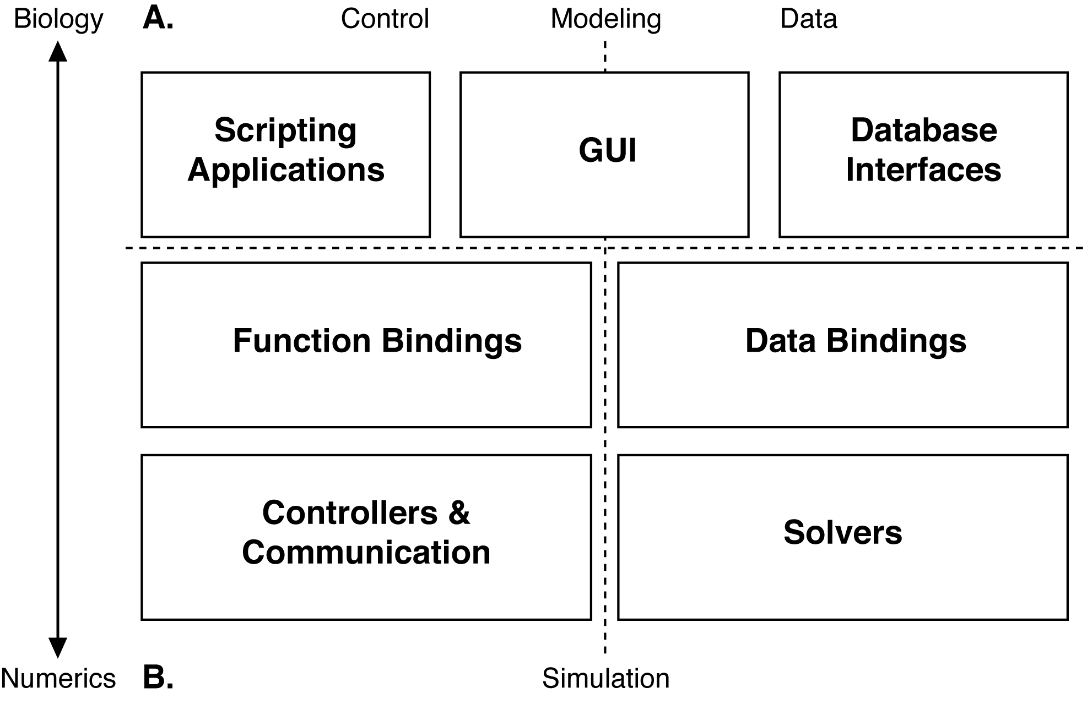
This highly modular approach to the development of simulator software allows for independent stand-alone software components that integrate on a just-in-time basis. Importantly for the current project, this modularity also allows different simulation systems or analysis modules to be plugged into the entire system. These different modules can contribute functionality to the workflow of model development, model exploration and analysis, model simulation, and (ultimately) data analysis and model publication. This structure also allows for the addition of new modules and functions for model description as well as publication. A key innovation in the CBI architecture is the separation of the stimulus protocols from a given model cell and its numerical implementation. This is an innovation that allows both a model and a stimulation paradigm to be combined dynamically at run time for a given simulation and simplifies the generation of batch files for multiple simulations. Importantly, this separation also allows any simulation to be run with any model, a feature that greatly facilitates iterative model development and comparison. The isolation of a cell model from a given simulation configuration also enables convenient exploration and quantification of properties of the biological model. For example, no special functions or scripting are required to quantify properties of a single cell model such as total or partial volumes or surface areas, the number of dendritic branches or branch points per dendritic tip, or the average somatopetal to dendritic tip distance. This new implementation gives fast and easy access to all the quantities that describe a model and its constituents giving the user (or publisher) tight control over the processes of model verification and validation.

New Browser-based GUI. While the CBI architecture makes the publication system we are proposing to develop independent of any particular simulator, this project will benefit from new software systems and features constructed as a result of our independent work to release a new version of the GENESIS simulation system (G-3) which is scheduled for open release in July 2010.

Control and command for G-3 is implemented through a browser-based series of components which will also be available for use by these projects. (a) Project-Browser is a contributed component providing a working prototype of a web server and database which allows different projects to be browsed and simulation results inspected and compared via a web browser. The Project-Browser allows the data from a single project to be distributed and synchronized over multiple computers. (b) The Studio is a contributed component used to visualize a model stored by the Model-Container and allows a model to be queried in the G-Shell. (c) The G-Tube can be evoked from either a Unix terminal prompt or the G-Shell, and ultimately will be available as an icon on the desktop.

Perhaps the most important consequence of the CBI federated architecture for the GUI is that the higher level interfaces present high-level biological concepts instead of mathematical ones, it is now possible to considerably enhance the functionality of the GUI independent of the simulator itself. This modular architecture has the advantage that it facilitates integration with existing infrastructures and internet based technologies. As an example, we have developed prototype code that interfaces the Model-Container with the neuromorpho.org morphology internet database. This code downloads a cell morphology from the database and generates both passive and active models according to a given configuration. A second example is a new database of computational stimulation protocols (e.g. stochastic afferent synaptic activation, current, and voltage clamp) that allow models to be automatically validated. This project will add additional new components to this overall system.

New Documentation System. As part of the G-3 development project, we have also designed and implemented a new documentation system, which will also be employed in the development of the new project. In fact, our experience with this documentation system will strongly inform the development of the publication system itself. Documentation will be key to the use of the technologies to be developed as part of this grant. The Documentation System provides user and developer documentation at seven levels: Level 1: Introductory material, Level 2: User guides and documentation, Level 3: Automated regression testing and use cases, Level 4: Technical guide specification, Level 5: Algorithm documentation, Level 6: API documentation, and Level 7: Inline source code documentation. This documentation ranges from introductory background material and tutorials for users, to Doxygenized APIs and HTMLified browsable source code for developers. It is currently available from the GENESIS web site and will be made available as context dependent help in the new GUI development. With the exception of Level 1 and 2, documentation is automatically generated directly from regression tests and source code or integrated from external public sources. Level 3-7 documentation provides a guide to writing the Level 1 and 2 documentation covering specific functionality. The documentation will be integrated into the new publication system via a YAML-tagged flat file system maintained in a server repository under control of a distributed version control system (currently monotone). Tags define whether documentation is maintained locally and visible only to authorized members of a given project or is exposed to the world by web publication. The tags can also be used to define “complementary flows” through a set of documents. These complementary flows can be dynamically generated. The documentation system is fully automated and currently rebuilds itself every eight hours, such that any changes or new files are quickly and automatically incorporated into the system.

5.5.3.2.2. Research Design and Methods

5.5.3.2.2.1 System contents
G-TUBE. Traditional scientific publications come in the form of Introduction, Methods, Results, and Discussion. The proposed Publication System will be organized along similar lines, if for no other reason than this provides a familiar framework for the researcher or student. The specific context for the GUI development will be via the G-Tube, which will provide a browser-based and browsable menu of bullet points/narrative components that takes the place of the more traditional Abstract. The critical difference in using G-tube is that it will provide the interface to access the model, model configuration, stimulation protocol, and simulation configuration repositories, and combine selected records via a Perl scheduler (SSP) that defines a reproducible run of one or more simulations as well as the narrative for the research. Moving the focus of a publication from the narrative text to figures will allow a researcher to focus on the novel components, mechanisms, and/or behavior of a model first, and then delve into areas of specific interest second. It allows a publication to be explored in depth from four menu items in the GUI:
Menu item 1: Links to an introduction and other relevant publications.
Menu item 2: Explains the model in detail by supporting:
(i) The use of figures and tables to illustrate the functions and parameters of a neuron.
(ii) Browsing of the model lineage.
(iii) Browsing model structures including for example single neuron simulations exploring channel characteristics, and their distributions and kinetics.
(iv) Automated testing of the model, including structural analysis and validation simulations.
Menu item 3: Gives access to all the simulations that have been run, and enables automatic reproduction of the figures that are important to the publication. The G-Tube also allows manual figure production for figures that are not part of the publication.
Menu item 4: Links to a conclusion that links to the previous menu items and other publications.

Model Lineage: In principle one of the values of mathematical modeling is that each model should extend one or more pre-existing model(s) or parts of a model. Formally capturing and tracking the incremental steps of model development and exploration is fundamental to a comprehensive publication process. The structure of the NDF file format has been designed around lineage tracking of models and their constituents by keeping a formal record of a model's hierarchy and its modifications. These advanced features allows the history of both a model and the refinements made by different research groups who have worked on a model to be tracked. The multiple publications of the single Purkinje cell model already described, will be used to prototype and test this feature (Rapp and Yarom, 1994; De Schutter and Bower, 1994a,b,c; Chono et al 2003; Coop & Reeke 2001; Miyasho et al 2001, Steuber et al 2007; De Schutter & Steuber 2009; Kreiner & Jaeger 2004, Salanis et al., 2006).

The model lineage system and attribution: Perhaps one of the most important aspects of the model lineage system, is that it will allow a new form of attribution to be established, where one can track and quantify how much influence a previous modeler through their model or its components have had on a particular component or part of a newly published model. Related, the model lineage component will also allow readers to follow the progression of the work of a single investigator or lab. This feature will likely be important in encouraging investigator cooperation with the new system.

Model Comparisons: A very important component of this new form of publication will be the ability to quantitatively compare models. This applies both to the structural components of the model, as well as the parameters used to generate the reported modeling results. Because of the modularity of the CBI architecture, the system will be able to quickly identify what is the same and/or different between two models, both at the structural level, and also at the level of parameters. For example, a new Purkinje cell model might include a novel type of potassium channel, or might have significantly changed a parameter for a component common to two models. This kind of capability will allow readers to quickly identify and understand what is similar and different about models.

Experimental Data: It is not unusual for the same model to be used to explore different aspects of possible function, based on different types of data used or changes in the resolution (see for example, first three papers by De Schutter and Bower [1994a,b,c] on the Purkinje cell model). As an extension to model lineage we will also provide ways to include or link to the experimental data used to tune or test the model, thereby clearly distinguishing expected (tuned for) model behavior from emergent model behavior, and perhaps also starting to establish standard data sets for model validation. The modularity of the system will allow us to also link to the large and growing number of projects involving experimental data storage and access (Kaspirzhny et al 2002).

5.5.3.2.2.2. The Publication-Workflow

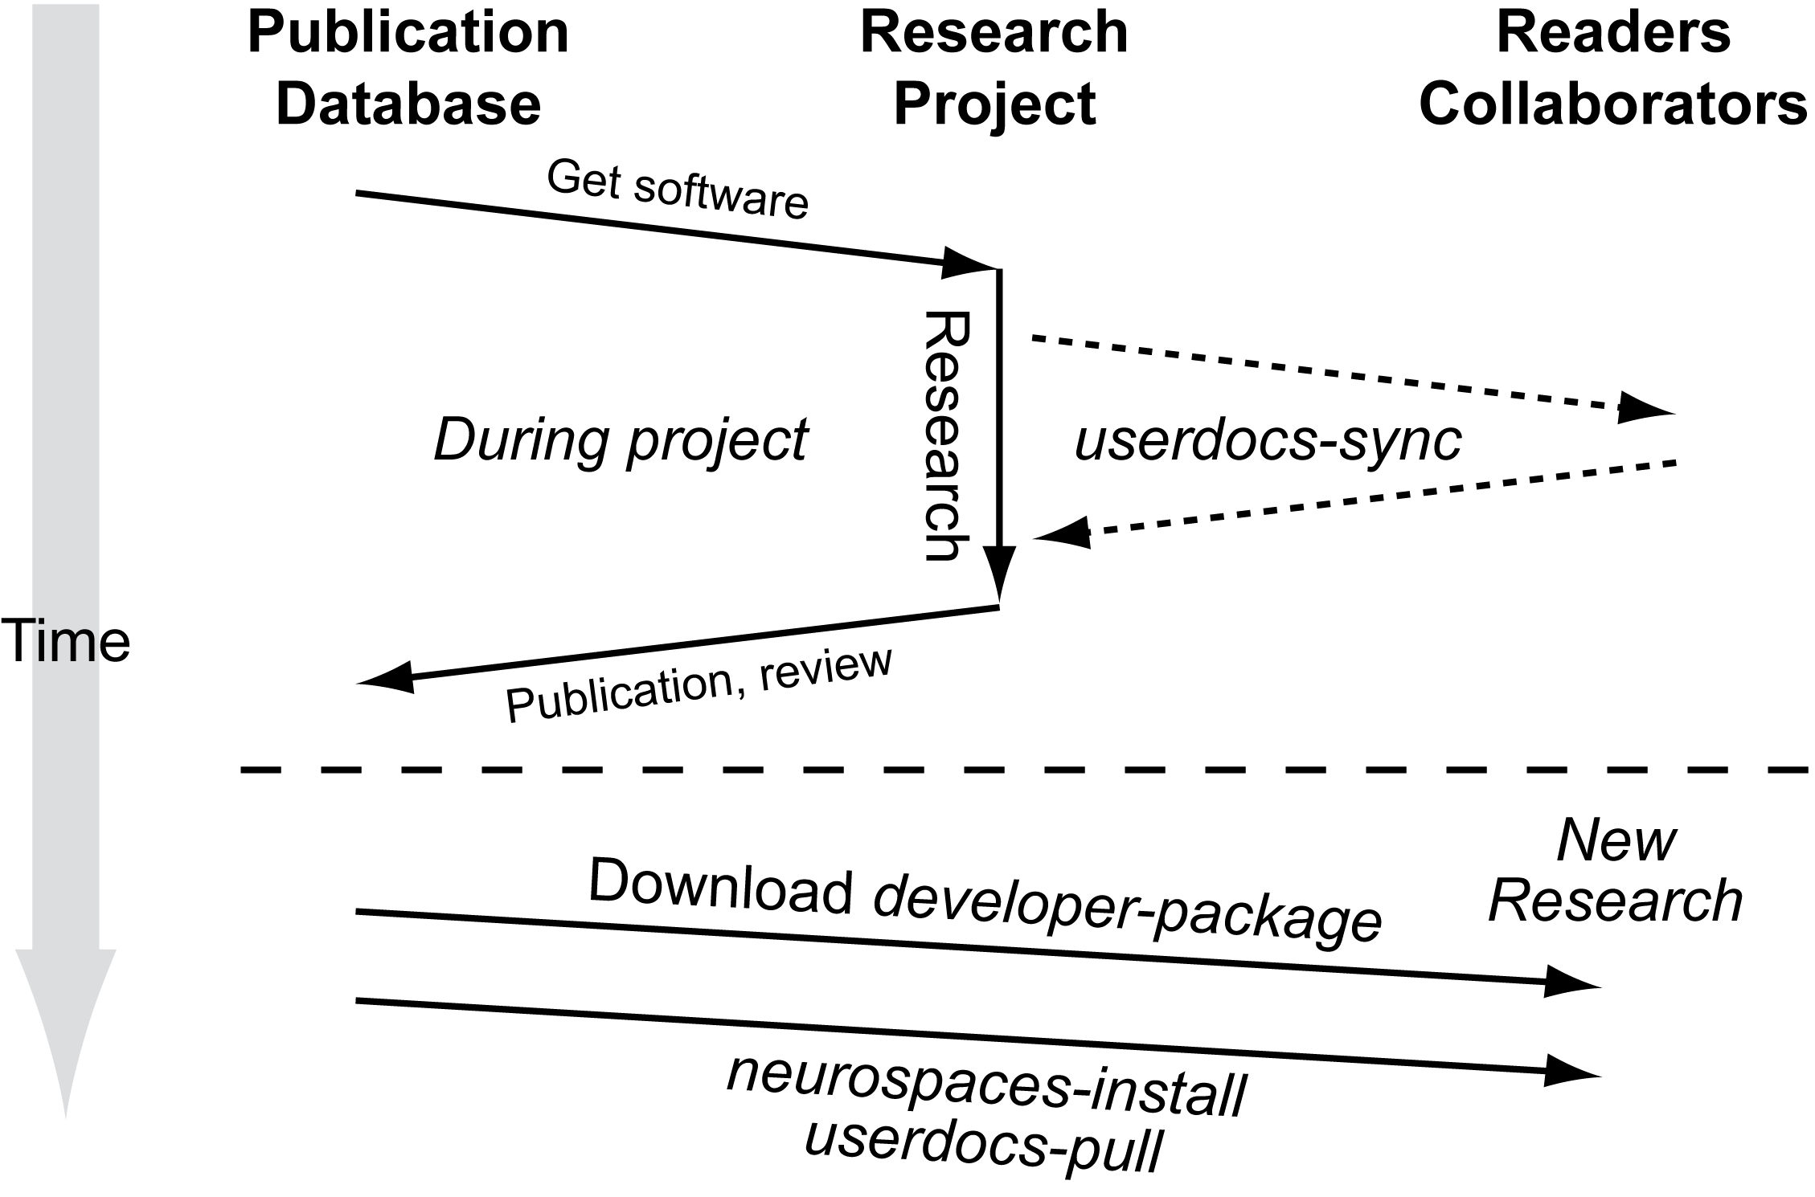
The above figure outlines the global data-flows and individual and other entities that organize and support the publication system. It encompasses two important workflows, the User-Workflow and the Publication-Workflow. Software to support the User-Workflow has been substantially implemented in association with the development of G-3, although, again the modular nature of the CBI architecture allows the system to be linked to any other component parts of simulators. The addition of a system for Publication-Workflow is the work to be funded by this proposal.
Because of their familiarity, the new publication system will be based on the traditional components of a scientific communication, i.e. Abstract, Introduction, Methods, Results, and Discussion. It is notable that in the proposed system, these components are partitioned in a way that more clearly distinguishes narrative and non-narrative components than is the case for traditional paper and electronic publications:

Generating a Publication.
Figures. Key to success of this project will be the development of tools to facilitate the annotation and organization of a model for publication. As with the current way in which publications are constructed, this new system will start with tools to construct and identify figures representing the behavior of the model. To facilitate this process, figures generated from the data of a specific model version and stimulus paradigm will be automatically tracked during the research phase of the project. At the completion of a project, the required figures can be manually selected and tagged for inclusion in the electronic publication. It will also be possible, for a particular type of model (single cell passive for example), to automatically generate “industry standard” figures describing basic functionality expected of any model of that type (dendrograms for example). We anticipate that this functionality alone may very well result in the development of a set of explicit standards against which any model of a particular type will be judged. This alone would make an important contribution to the field.
Figure Annotation. The structure of this new publication system will assume that most of the discussion about the model results and significance will take place around the generated figures. Accordingly, each figure will have four associated user-completed annotation panels (i) Figure caption and separate (ii) Results, (iii) Discussion, and (iv) Abstract annotations.
Summary Discussion and Conclusions. While we anticipate that much of the discussion will be constructed around the figures (i.e. directly related to model results), there will also be a facility provided to generate summary discussion and conclusions. This component will especially allow for references and discussions of models preceding in the lineage, or other models in the data base.
Discussion, Commentary and Feedback. An important new component of all parts of the electronic publication will be a facility to allow commentary, analysis, and cross linking with other modeling efforts. Conceived in the form of a wiki, this facility will allow for the ongoing discussion of issues related to the model, with the important distinction from a traditional wiki, that commentators will be able to actually run the model, change parameters, or the way figures are constructed to illustrate their concerns and points of view.

Publication Review
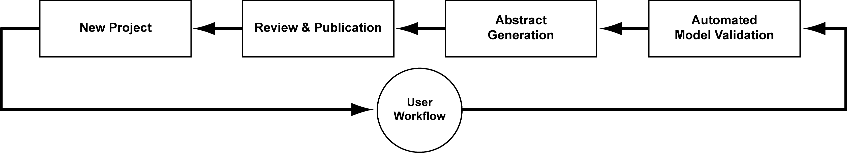
Current reviews of modeling papers are based entirely on reading text. In contrast the review process we propose will actually start with a first phase of automated model validation. This validation process will be exercised by the author themselves, and providing feedback to the author on possible concerns regarding their model. This facility will allow the author to either correct, or specifically provide arguments as to why the model is worthy of publication anyway. In effect this system will therefore iteratively develop a set of accepted basic standards for model publication, while providing an opportunity to argue for the extension or replacement of those standards. Once this level of automated review is passed, the model will be made available to reviewers, who can evaluate the authors arguments with respect to core features of the model, and then consider the additional capabilities of the model as demonstrated by the figures and their annotation. It is important to note that the modular nature of the core infrastructure for this project will allow us to take advantage of other approaches to model evaluation (Cannon & D'Alessandro 2006). The proposed process is illustrated in the preceding figure:
(a) Verify model: This step in the Publication-Workflow is to ensure that the lineage starting point of the model employed for simulations is a previously published source model. Model verification is performed on the morphology, cable discretization, equations for different membrane and synaptic channel types and their kinetics, model parameter values, and dynamic response to specific current injection and voltage clamp protocols.
(b) Validate model: In the absence of a pre-existing model, model validation is completed by the generation of tables and figures reporting model verification. These data are acquired from the Model-Container. If the model is based on a pre-existing published model, validation is completed by a comparison of the two models. Any differences between the two models are identified, characterized, quantified, and reported. This step can be performed by a user prior to submission to a publication data base.
(c) Parameter Space: The issue of parameter space analysis is important and complex and still very much an area of open research, especially for complex models (Baldi et al 1998; Vanier & Bower 1999). However, there are mechanisms available to examine the sensitivity of core modeling results to parameter variations. We anticipate that a model publication system is likely to accelerate the development of this aspect of model analysis and validation.

5.5.3.2.2.3. Implementation Details
Space does not allow a full description of the implementation details. Suffice it to say that the P.I.'s GENESIS development group has been involved in complex software implementations for many years. However, there are a few key components to the system that we will briefly describe:

Database Format: Each database supports system-specific, project-specific, and user-specific views. The system specific view abstracts system specific configurations such as the filesystem layout. The project view is a container for project specific data such as models and source code. The user view gives the user the flexibility to run simulations without initiating a new research project. The existing GENESIS repositories implement these views based on system process environment settings.
The database structure has three major features: (i) It complements the five steps of the User-Workflow, (ii) It provides a database of text, figures, and annotations, and (iii) Defines relationships between other objects in the database.
Based on the existing G-3 documentation system each database described below will initially be implemented as a YAML-tagged flat file system. This approach, also in use by popular databases in neuroscience (eg. www.neuromorpho.org) allows convenient storage of the highly heterogeneous data typical of neuroscience models using specially formatted text based files. Other advantages include easy manipulation, archiving, and synchronization between databases using the file distribution technology and replication technology developed for the Project-Browser.
The databases that will be developed to support the Publication-Workflow complement the databases of the G-3 User-Workflow:
i. Publication Narrative Component Repository: The database with the narrative components of a publication serves two purposes: the definition of collections of fragments of simulation configurations allows traditional-style publication figures to be reproduced. Secondly, inserting free-style text paragraphs and combining them with the figures allows for profound discussion sections. Also personal notes, reviewer comments, and computer generated annotations can be inserted.
ii. Publication Object Relationships Repository: The relationships between all the objects of a model publication are defined in this database. As an example, the main menu of a publication is defined as a narrative component, and is linked to its contents via a set of records in this database. Not only does this allow customization of the main menu to the contents of a model publication, but it also provides for the definition of secondary reader-flows through one or more publications. The implementation will be based on the YAML tags that were developed for the G-3 documentation system. For a typical model publication we envisage that at least the following flows will be defined: 'history', outlining the history of the model, 'present', giving an overview of related models, and 'tutorial', tutorializing the functions implemented by the published model. In addition to these narrative flows, we will also define flows that are specific to verification, validation, and review. As an example, every single-cell model should come with an automatically generated report that guarantees model parameters are within their physiological range.
The publication system described here greatly expands the current limitations of paper publication that are bound by a predefined and linear flow.
iii. Database Tools: We plan to develop additional interfaces for the sole purpose of examining, exploring, querying, and comparing the models in the database, including their micro- and macro-evolution [give examples]. As an extension of the automated benchmark test suite other software under development includes robots that validate the static structure of the models in the database, including parameter range testers, morphological constraint testers and robots that check for shared features in a model. Server side based, this framework needs further extension before it also becomes useful to researchers. We also plan to develop robots that detect database model similarities and propose actions to the user.
iv. Database Distribution and Replication Strategies: The Project-Browser distributes the data of a single research project over multiple computers. This creates a distributed database of a single research project. The data distribution mechanism also facilitates collaborations between labs that trust one another. The Project-Browser distribution policy replicates parts of the project database on different computers using a secure shell (SSH) as a transport mechanism. Research projects typically proceed by incrementally gathering result data from simulations, so we plan to evaluate other policies such as the rsync protocol.
Electronic publication submission replicates the research project database at the publisher's hardware infrastructure. Both automated and manual review processes generate new data that is stored in the database. These data can then be compiled into a review report that becomes a part of the electronic publication.
Accepted electronic publications can be replicated at a local computer of a reader using the same distribution policies. By default the most important components of a research project will be replicated, but options will be available to replicate all data in the research project, including meta-data that was produced during the review.
v. Integrity, Access Control and DRM
Digital rights management (DRM, also sometimes called Information Rights Management) is a generic term for access control to a database to protect confidential content. DRM will be implemented using cryptographic key pairs and checksums. Each account in the publication system will generate a public and private key. The private key is stored on a user PC while the public key can be duplicated and stored on many PCs (public/private key pairs can also belong to 'machine' accounts). Cryptographic checksums on the content of the files in the database are compared to authenticate requests and data. Optionally, these checksums can then be signed using an account's private key. This protects the system from unauthorized access and preserves data integrity.
Computing and comparing the cryptographic checksums after pulling data from an external database guarantees the origin and integrity of the pulled annotations, including reviewer comments and computer validation test results. This process can also provide a record of the scientific quality of a model that is considered for starting a research project. The result will be an infrastructure to maintain a distributed database of computational neuroscience models, their annotations, and narrative flows.
The DRM system designed for the G-3 publication system will integrate the distributed nature of a research project database and the different roles a user can have when reading and modifying an electronic publication. The design is similar to that of well-known service-driven websites such as Facebook (www.facebook.com) and Blogger (www.blogger.com).

5.5.3.2.2.2. Other forms of publication/ Communication:
While space does not allow a full discussion of the other opportunities provided by this form of electronic publication, we will mention three that we are already developing as part of G-3.

Tutorializing Research Projects: GENESIS has always placed considerable emphasis on the development of educational tutorials. In the past, this was an elaborate and time consuming task that followed the completion of a research project. Building G-Pub around the GENESIS database infrastructure defined by the User- and Publication-Workflows will automatically structure the project data such that it becomes easy to define educational user flows through the project via the YAML-based tagging mechanism. We think that during a research project this facility will already be useful as a preparation tool for progress reports and scientific presentations. The integration of specialized interfaces around, such as, an educational flow is a custom feature of current GUI frameworks (e.g. wxWidgets). The state of the windows in a GUI (such as position, size, and buttons and their actions) can easily be saved to define a simple educational tutorial. In effect, the difference between a scientific publication, a collaboration between laboratories, and the educational tutorial, becomes one of content rather than technology.

Web-Based Medical Education Tutorials: While our previous work has shown that enhanced interfacing to databases (e.g. www.neuromorpho.org) and hardware (e.g. RTXI dynamic clamp) can more easily be achieved through modularization of the underlying simulator software, the same modularization also provides for enhanced GUI integration. It is now much easier to enhance the GUI with plugins for interfacing to new simulator functionality and to connect it with databases as well as integrate with new internet Web 2.0 technologies such as Youtube (www.youtube.com) and Facebook (www.facebook.com). We have already developed a prototype Facebook application called 'Neurobook' that allows for a new range of educational tutorials to be developed and for more targeted recruitment of students and collaborators.

From Model Publication to Scientific Networking
The G-3 publication system defines multiple possible roles for a publication database reader (global administrator, chief editor, article editor, reviewer, PI, collaborator, external reader). By extension the publication system will allow 'readers' to comment on particular aspects of the model - this starts a dialog about the model. For example, an author could designate those who could comment on the model - or, comments could be restricted to those whose components are included in the model, or who have published other models in the same area. This becomes ultimately a new way to discourse about science and scientific results.

REFERENCES
Baldi P, Vanier M and Bower JM (1998) On the use of Bayesian methods for evaluating compartmental neural models. Journal of Computational Neuroscience. 5: 285-314.
Bhalla US, Bilitch DH, Bower JM. 1992. Rallpacks: a set of benchmarks for neuronal simulators. Trends Neurosci 15:453-8
Cannon RC, D'Alessandro G. 2006. The ion channel inverse problem: neuroinformatics meets biophysics. PLoS Comput Biol 2:e91
Cavelier P, Pouille F, Desplantez T, Beekenkamp H, Bossu JL. 2002. Control of the propagation of dendritic low-threshold Ca(2+) spikes in Purkinje cells from rat cerebellar slice cultures. J Physiol 540:57-72
Chono K, Takagi H, Koyama S, Suzuki H and Ito E. 2003. A cell model study of calcium influx mechanism regulated by calcium-dependent potassium channels in Purkinje cell dendrites. J Neurosci Methods 129:115-27
Coop AD and Reeke GJ (2001) The composite neuron: A realistic one-compartment Purkinje cell model suitable for large-scale neuronal network simulations. Journal of Computational Neuroscience. 10: 173–86.
Cornelis H, Edwards M, Coop AD, Bower JM (2008) The CBI architecture for computational simulation of realistic neurons and circuits in the GENESIS 3 software federation. BMC Neuroscience. 9: P88.
De Schutter E and Bower JM (1994a) An active membrane model of the cerebellar Purkinje cell I. Simulation of current clamps in slice. Journal of Neurophysiology, 71: 375–400, 1994.
De Schutter E and Bower JM (1994b) An active membrane model of the cerebellar Purkinje cell II. Simulation of synaptic responses. Journal of Neurophysiology. 71: 401-419.
De Schutter E and Bower JM (1994c) Simulated responses of cerebellar Purkinje cells are independent of the dendritic location of granule cell synaptic inputs. Proceedings of the National Academy of Sciences, USA. 91: 4736-4740.
Djurfeldt M and Lansner A (2006) 1st INCF Workshop on Large-scale Modeling of the Nervous System. Stockholm: International Neuroinformatics Coordinating Facility Secretariat.
Gibson I, Farrelly P, Harris E, Harris T, Iddon B, Key R, McWalter T, Murrison A, Smith G, Spink B and Turner D (2004) Scientific publications: Free for all? Science and Technology Committee Tenth Report, Annex 1. Session 2003-4. House of Commons, UK.
Hines ML (1984) Efficient computation of branched nerve equations. International Journal of Bio-Medical Computing. 15: 69-76.
Hines ML, Morse TM, and Carnevale, NT (2007) Model structure analysis in NEURON. In: CJ Crasto and NJ Totowa (eds.). Neuroinformatics. New Jersey: Humana Press. pp. 91-102.
Miyasho T, Takagi H, Suzuki H, Watanabe S, Inoue M, Kudo Y and Miyakawa H (2001) Low-threshold potassium channels and a low-threshold calcium channel regulate Ca2+ spike ﬁring in the dendrites of cerebellar Purkinje neurons: A modeling study. Brain Research 891: 106-115.
Rapp M, Segev I and Yarom Y (1994) Physiology, morphology, and detailed passive models of cerebellar Purkinje cells. Journal of Physiology (Lond.). 474: 101-118.
Solinas S, Maex R and De Schutter E (2006) Dendritic ampliﬁcation of inhibitory postsynaptic potentials in a model Purkinje cell. European Journal of Neuroscience, 23: 1207-1218.

Coop AD, Reeke GN, Jr. 2001. The composite neuron: a realistic one-compartment Purkinje cell model suitable for large-scale neuronal network simulations. J Comput Neurosci 10:173-86
De Schutter E, Bower JM. 1994. Simulated responses of cerebellar Purkinje cells are independent of the dendritic location of granule cell synaptic inputs. Proc Natl Acad Sci U S A 91:4736-40
De Schutter E, Steuber V. 2009. Patterns and pauses in Purkinje cell simple spike trains: experiments modeling and theory. Neuroscience 162:816-26
Druckmann S, Banitt Y, Gidon A, Schurmann F, Markram H, Segev I. 2007. A novel multiple objective optimization framework for constraining conductance-based neuron models by experimental data. Front Neurosci 1:7-18
Kreiner L, Jaeger D. 2004. Synaptic shunting by a baseline of synaptic conductances modulates responses to inhibitory input volleys in cerebellar Purkinje cells. Cerebellum 3:112-25
Miyasho T, Takagi H, Suzuki H, Watanabe S, Inoue M, et al. 2001. Low-threshold potassium channels and a low-threshold calcium channel regulate Ca2+ spike firing in the dendrites of cerebellar Purkinje neurons: a modeling study. Brain Res 891:106-15
Ogasawara H, Doi T, Doya K, Kawato M. 2007. Nitric oxide regulates input specificity of long-term depression and context dependence of cerebellar learning. PLoS Comput Biol 3:e179
Pouille F, Cavelier P, Desplantez T, Beekenkamp H, Craig PJ, et al. 2000. Dendro-somatic distribution of calcium-mediated electrogenesis in purkinje cells from rat cerebellar slice cultures. J Physiol 527 Pt 2:265-82
Solinas SMG, Maex R, De Schutter E. 2006. Dendritic amplification of inhibitory postsynaptic potentials in a model Purkinje cell. EUROPEAN JOURNAL OF NEUROSCIENCE 23:1207-18
Steuber V, Mittmann W, Hoebeek FE, Silver RA, De Zeeuw CI, et al. 2007. Cerebellar LTD and pattern recognition by Purkinje cells. Neuron 54:121-36
Vanier MC, Bower JM. 1999. A comparative survey of automated parameter-search methods for compartmental neural models. J Comput Neurosci 7:149-71
Widmer HA, Rowe IC, Shipston MJ. 2003. Conditional protein phosphorylation regulates BK channel activity in rat cerebellar Purkinje neurons. J Physiol 552:379-91
Williams SR, Christensen SR, Stuart GJ, Hausser M. 2002. Membrane potential bistability is controlled by the hyperpolarization-activated current I(H) in rat cerebellar Purkinje neurons in vitro. J Physiol 539:469-83
Willoughby D, Schwiening CJ. 2002. Electrically evoked dendritic pH transients in rat cerebellar Purkinje cells. J Physiol 544:487-99

Crook S, Gleeson P, Howell F, Svitak J, Silver RA. 2007. MorphML: level 1 of the NeuroML standards for neuronal morphology data and model specification. Neuroinformatics 5:96-104
Goddard NH, Hucka M, Howell F, Cornelis H, Shankar K, Beeman D. 2001. Towards NeuroML: model description methods for collaborative modelling in neuroscience. Philos Trans R Soc Lond B Biol Sci 356:1209-28
Hines ML, Carnevale NT. 1997. The NEURON simulation environment. Neural Comput 9:1179-209
Hines ML, Morse T, Migliore M, Carnevale NT, Shepherd GM. 2004. ModelDB: A Database to Support Computational Neuroscience. J Comput Neurosci 17:7-11
Hucka M, Finney A, Sauro HM, Bolouri H, Doyle J, Kitano H. 2002. The ERATO Systems Biology Workbench: enabling interaction and exchange between software tools for computational biology. Pac Symp Biocomput:450-61
Kaspirzhny AV, Gogan P, Horcholle-Bossavit G, Tyc-Dumont S. 2002. Neuronal morphology data bases: morphological noise and assesment of data quality. Network 13:357-80

