Development of a graphic user interface for enhanced publication of scientific communication.

1. Specific Aims
This proposal requests support for the development of new computational tools and technologies that will provide the GEneral NEural SImulation System (GENESIS) software platform with a comprehensive Graphic User Interface (GUI). The primary purpose of the GUI is to link users to a model publication database that supports an electronic publication system. This database can be defined as a structured set of narrative stories that contains everything that happens during a research project that leads to the publication of a mathematical model.
Specific Aim 1: Develop and implement a comprehensive user modifiable GUI for the control, analysis, comparison, and peer reviewed electronic publication of computational models and simulation results in computational biology. Development of such a GUI will enable access to multiple databases (e.g. experiment, morphology, model) and account for the micro-evolution of a model by making it part of the publication record maintained in the model publication database.
Specific Aim 2: The model publication database is proposed to comprise a project record that contains (i) a structured narrative (Introduction, Methods, Results, Discussion), (ii) a framework for the exploration of a model or tutorial, and (iii) a complete record of all changes made to a model during a research project, including the dead-ends. This leads to an operational workflow that includes: model development, model simulation, and results analysis where modifications to a model creates a graph of ancestry during the life time of a model.
Specific Aim 3: The GUI will automatically track all models, simulation configurations, and results of a given research project.
Specific Aim 4: A user will then be able to select the interesting parts of the project record to become part of the project publication. Operationally, the GUI will contain a library of frames of reference, e.g. a reference frame for the membrane channels of a given model that illustrates the quantitative validation of the channel kinetics. These frames are populated by the researcher with reference to model history and new results and observations.
Specific Aim 5: Manuscript submission will push the complete graph of ancestry that includes the dead ends and frames of reference to an external database. This electronic submission is then available for review. In this publication model, a reviewer will primarily focus on the frames of reference that validate the model as a precursor to the novel aspects of a project that include the narrative.
Specific Aim 6: Develop comprehensive documentation of the extended GUI functionality and publication system.
The features of such a publication system are that (i) a complete history of the research process is maintained, (ii) a more comprehensive review process becomes possible where the typical 'narrative-reading' review is enhanced by the addition of model exploration, (iii) there is no categorical distinction between a publication and a tutorial that is immediately available for educational purposes, (iv) in principle any compliant simulator can be used as long as the model scripts are available.
Such a publication system will (i) enhance web-based collaboration, i.e. multiple researchers can work on the same model, (ii) keep experimental data 'close' to computational data, and (iii) automate the verification of previously published components of a model thus freeing a reviewer or student to focus on the novel aspects of a publication or tutorial. This modifies traditional publication by emphasizing the model, its annotated data, and history, rather than the narrative story. It does so by focusing on the technical aspects of a publication. The result is a publication that is immediately available both as the basis of further research projects and as an educational tutorial.
The proposed publication infrastructure is designed to facilitate sharing of scientific data and computational models and their annotations in particular. The acceleration of scientific communication will result in accelerated advancements of scientific knowledge. While this type of technology will at first complement supplementary materials to online traditional style publications, we believe that model sharing and model metadata sharing will become more significant in the future and might even replace paper publications in the long term.

2. Background and Significance
2.1. Evidence of our success
GENESIS is a general purpose simulation platform that supports the simulation of neural systems ranging from sub-cellular components and biochemical reactions to complex models of single neurons, simulations of large networks, and systems-level models. Although the software can also model more abstract networks, other simulators are more suited for back-propagation and similar connectionist modeling paradigms.
GENESIS, and its version for parallel and networked computers (PGENESIS) was the first broad scale modeling system in computational biology to encourage modelers to develop and share model features and components. GENESIS has a history of contributions to simulator technology: the Rallpacks were developed by GENESIS users and are widely recognized as a standard for simulator performance. The GENESIS development team was one of the first to recognize the importance of standards for model sharing, which led to the initial development of the NeuroML standard for model exchange, PGENESIS was the first neural simulator run on supercomputers, and has initiated the development of middle-ware projects for simulator interoperability such as the Systems Biology Workbench, the Neosim parallelization framework, and the Neurospaces project for the development of independent software components for simulators.
Since its release for general use in 1988, GENESIS has provided one of the foundations for the ongoing course in Methods in Computational Neuroscience at Woods Hole MA, as well as courses offered in the European Union, Mexico, Brazil, India, and in more than 100 universities around the world where it has been used both as an instructional tool in realistic modeling of the nervous system and as a simulation based tool for neurobiological education in general. For over 20 years, the GENESIS simulator has been used for research simulations and over 400 peer-reviewed papers have been published using GENESIS modeling work.

2.2. Simulator development inhibited by non-scalable 'monolithic' software architectures
The core modules of GENESIS were written in the late 1980's in C and for computational efficacy they were tightly coupled. However, the recent history of GENESIS has shown a significant side-effect of this approach is increased difficulty in extending GENESIS by the addition of more modern graphical interfaces, alternate script parsers, and interfaces via the WWW. This prevents developers from a wide range of scientific disciplines contributing to simulator design and development. This was particularly the case for the source code which did not cleanly separate into its underlying components. The problems associated with such non-scalable software architectures are not unique to GENESIS. They result in experimentalists being denied the opportunity to more easily ground empirical observation within the formalism of a mathematical model. It is for these reasons that GENESIS has recently been reconfigured to adhere to the software design requirements specified by the Computational Biology Initiative (CBI) federated software architecture (Cornelis et al., 2008) and is now referred to as GENESIS 3.0 (G-3).

2.3. Testing, Validation, and Benchmarking
The importance of test suites and reproducibility of simulation results was recently underlined in the recommendations of the INCF report on large scale modeling of the nervous system (Djurfeldt and Lansner, 2006). We have implemented new test suites for GENESIS that validate the current and future software behavior. They have been tested on some of the most successful models available today, including the De Schutter and Bower cerebellar Purkinje cell model (1994a,b). Additionally, the test suites have been an equally important tool for contributing developers by enforcing consistency of new additions, and as a tool for technical documentation and communication about program behavior for complex applications like neuronal simulators.

2.4. Open problems in Neuroinformatics, Computational Modeling and Model Publication
Even if modeling would allow for complete reproduction of the results reported in traditional paper publications, it would still be impossible for a researcher to develop a full overview of the published models. As an example, we know of at least eight reported variants (De Schutter and Bower, 1994a,b,c; Rapp and Yoram, 1994; Coop and Reeke, 2001; Miyasho et al., 2001; Chono et al., 2003; Solinas et al., 2006) of the Purkinje neuron model that our laboratory first published in 1994. Some publications report small modifications to the model, such as updates of the synaptic properties with recent or more accurate data. While our model was based on a neuron morphology of a passive model developed by Rapp (1994), other models used a different morphology, but applied the same channel distribution and characteristics. It is currently unknown if the properties reported for the first model are unique features or are also present in these derived models. As an example, due to both the precise morphological structure and the transmembrane current characteristics, our model showed significant dendritic amplification of excitatory post-synaptic signals. Similarly, a more recent report shows that this same mechanism can also amplify inhibitory post-synaptic signals (Solinas et al., 2006). However, the updated channel characteristics in the latter model make it difficult to quantitatively compare the reported dendritic amplification characteristics of inhibitory and excitatory signals. Further, it is entirely unknown if other models that apply the same transmembrane currents to a different morphology show any of the reported dendritic amplification mechanisms. We think it is now the right time to start addressing these problems. The remainder of this section elaborates on these problems in more detail.
2.4.1. Current lack of model comparison tools: With the exceptions of using Bayesian methods for evaluating compartmental models of neurons (Baldi et al., 1998) and the analysis of the structure of a model (Hines et al., 2007), there are no known model comparison tools available.
2.4.2. Current lack of model lineage inspection tools: With the exception of tracing model lineage by hand from source publications, we know of no formal methodology or computational tools for identifying and/or tracking model lineage in computational neuroscience and biology. In these disciplines it is still difficult if not impossible to track either the micro-evolution of incremental changes made to a model made during a single publication or the macro-evolution of a model across multiple publications.
2.4.3. Current lack of model verification: Due to its micro-evolution, even with full access to the code of a given model, confirming that it was indeed the one used to produce the figures in a paper is not possible. This greatly complicates model verification.
2.4.4. Current difficulty of result replication: Because the validity of a model cannot currently be easily verified, replication of results (one of the corner stones of the scientific method) is greatly complicated.

2.5. Enhancing the value of electronic publication
The history of scientific paper publication shows that over several hundred years what was initially just a narrative story has slowly become more structured by the organization of a manuscript into different sections, e.g. 'Introduction', 'Methods', 'Results', and 'Discussion' (Gibson et al., 1960). This development has led to the narrative component being split from the more technical aspects of a publication. One beneficial consequence is a reduced workload for reviewers as it simplifies the process of checking the accuracy and completeness of methods and results. More recently, databases of publication data and annotated meta-data have become associated with the web publication of peer reviewed manuscripts. This has led to the development of web-based supplements to paper publications that often contain minimal narrative content. (Although, one advantage of such electronic publication is the possibility of extending search capabilities beyond individual manuscripts to their contents.) Neither the simplification of the process of review nor the extended search capabilities address the issues associated with model comparison, model lineage, model verification and result replication. With this proposal we request funding to start to solve these specific problems.

3. Preliminary Studies
Here we describe the motivating philosophy, components, and the current state of GENESIS development. The reconfiguration of GENESIS was in response to the fact the platform had evolved into a non-scalable 'monolithic' software architecture.
Initially, we introduce the modular approach to software development that is based on the CBI federated software architecture (described next). This approach exhibits several novel features, for example, the separation of stimulus protocols from a given model cell to partition a model from its numerical implementation. It is an innovation that allows both a model and a stimulation paradigm to be combined dynamically at run time for a given simulation and simplifies the generation of batch files for multiple simulations. Importantly, this separation allows any simulation to be run with any model, a feature that greatly facilitates iterative model development and comparison. The isolation of a cell model from a given simulation configuration also enables convenient exploration and quantification of properties of the biological model. For example, no special functions or scripting are required to quantify properties of a model cell such as total or partial volumes or surface areas, the number of dendritic branches or branch points per dendritic tip, or the average somatopetal to dendritic tip distance. This way the new implementation of the GENESIS simulator gives fast and easy access to all the quantities that describe a model and its constituents giving the user tight control over the processes of model verification and validation.
We now briefly describe the currently existing components of G-3 which provide a fully functional neuronal simulator and introduce the G-3 User-Workflow paradigm. This paradigm provides an organizing principle for simulator functionality. Note that the User-Workflow is functionally complete, whereas, the funding requested here will support the further development and implementation of the a complementary Publication-Workflow.

3.1. The CBI Federated Software Architecture
All software can be understood in terms of algorithms operating on input data to produce output data. For experimental research, the natural distinction between data and algorithms can be compared to the distinction between the biological system (data to be investigated) and the stimulation paradigm (tools supporting data investigation). For computational research, the distinction between data and algorithms leads to a separation between model (data) and simulation control (control of data flows). The relationship between simulator control and data components are symbolized by the horizontal arrows in the following figure.

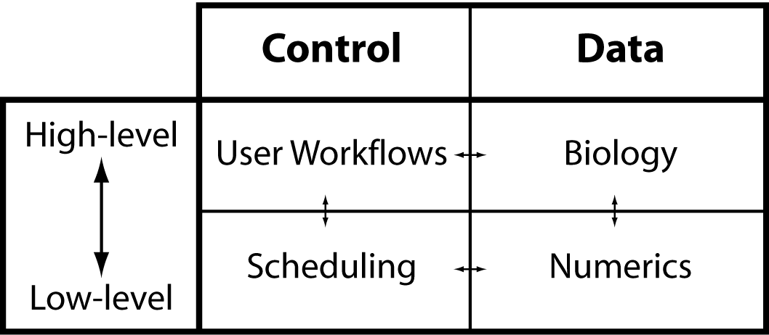
A separation of concerns has been used to identify the basic components of the G-3 simulator, as seen by a GENESIS user. In the following figure the horizontal dashed line separates A. High level layer of biological representation from B. Low level layers related to mathematical implementation. The vertical dashed line indicates the separation of control and data within a simulator.
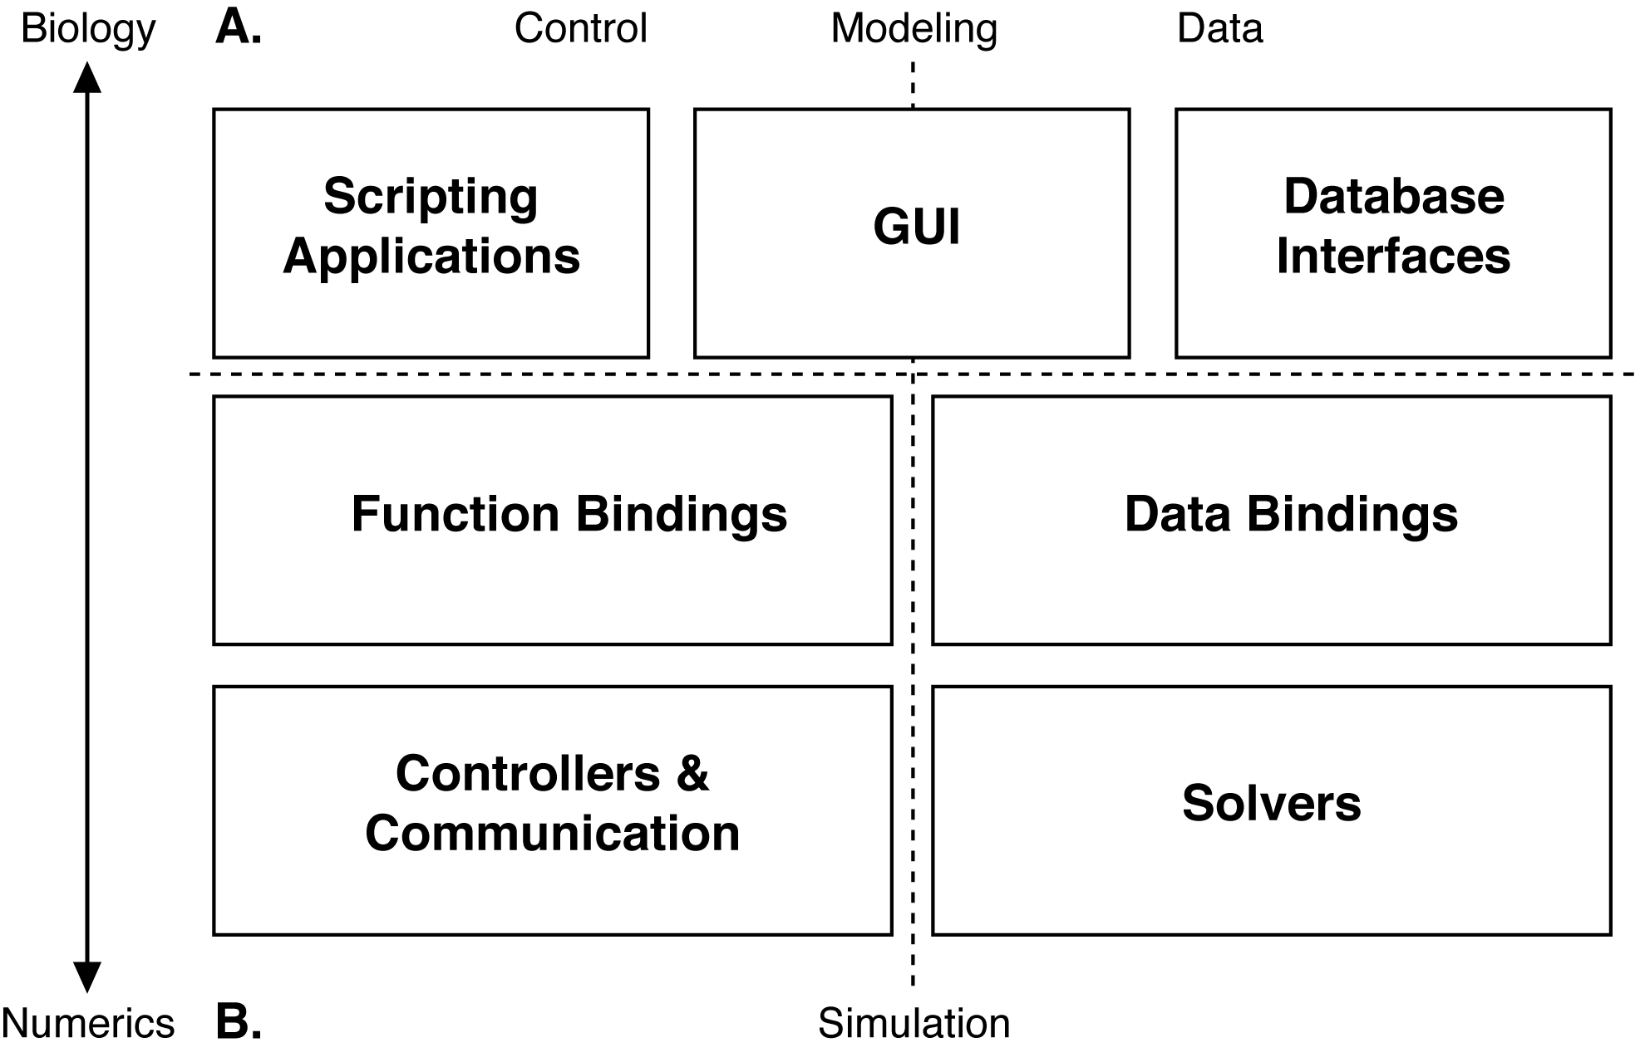
This highly modular approach to the development of simulator software leads to independent stand-alone software components that integrate on a just-in-time basis. Different modules contribute functionality to the workflow of model development, model exploration and analysis, model simulation, and (ultimately) data analysis and model publication.

3.2. G-3 Components
We have completed the implementation of the following major G-3 components which together form a fully function simulator:
3.2.1. Function binding: The G-3 interactive shell (G-Shell) provides a unified command line interface with Python and Perl that enables convenient interaction with other G-3 components.
3.2.2. Data binding: By “containing” a biological model, the Model-Container software component makes the implementation of numerical solvers independent of model representation. Giving different user views on the same model and its constituents the Model-Container also provides to the user a unique tool for model exploration.
3.2.3. Solver: Heccer is a highly optimized compartmental solver based on G-2 hsolve functionality.
3.2.4. Controller: The Simple Scheduler in Perl (SSP) provides a highly configurable scheduler that activates and synchronizes the Model-Container and Heccer to work together on a single simulation in a just-in-time manner. SSP also provides the necessary hooks to reconfigure the model to prepare it for connection with a stimulation protocol before the simulation starts.
3.2.5. GUI: (a) The Project-Browser is a contributed component. It provides a working prototype of a web server and database which allows different projects to be browsed and simulation results inspected and compared via a web browser such as Firefox. The Project-Browser allows the data of a single project to be distributed over multiple computers. (b) The Studio is a contributed component used to visualize a model stored by the Model-Container and allows a model to be queried in the G-Shell. (c) The G-Tube can be evoked from either a Unix terminal prompt or the G-Shell, and ultimately will be available as an icon on the desktop. Because the most important consequence of the CBI federated architecture for the GUI is that the higher level interfaces present high-level biological concepts instead of mathematical ones, it is now possible to considerably enhance the functionality of the G-3 GUI.

The modular architecture of G-3 has the advantage that it facilitates integration with existing infrastructures and internet based technologies. As a first example, we have developed prototype code that interfaces the Model-Container with the neuromorpho.org morphology internet database. This prototype downloads a cell morphology from the database and derives both passive and active models according to a given configuration. A second example is a new database of computational stimulation protocols (e.g. stochastic afferent synaptic activation, current, and voltage clamp) that allow models to be automatically validated. This code is part of the G-3 test suite and prevents regression of the core functionality of the simulator.

3.3. The GENESIS Documentation System
The GENESIS Documentation System provides user and developer documentation at seven levels: Level 1: Introductory material, Level 2: User guides and documentation, Level 3: Automated regression testing and use cases, Level 4: Technical guide specification, Level 5: Algorithm documentation, Level 6: API documentation, and Level 7: Inline source code documentation. This documentation ranges from introductory background material and tutorials for users, to Doxygenized APIs and HTMLified browsable source code for developers. It is currently available both from the GENESIS web site and will be made available as context dependent help in the new GENESIS GUI. With the exception of Level 1 and 2, documentation is automatically generated directly from regression tests and source code or integrated from external public sources. These sources provide guides for writing the Level 1 and 2 documentation covering specific GENESIS functionality. The documentation is integrated with the G-3 simulator via a YAML-tagged flat file system maintained in a server repository under control of a distributed version control system (currently monotone). Tags define whether documentation is maintained locally and visible only to authorized members of a given project or is exposed to the world by publication at the GENESIS web site. The tags can also be used to define 'complementary flows' through a set of documents. These complementary flows are dynamically generated. The documentation system is fully automated and rebuilds itself every 8 hours, such that any changes or new files are quickly and automatically incorporated into the system.

3.4. Data-Flows and Work-Flows in Research Projects
The relationship between experiment and simulation in computational neuroscience is illustrated in the following figure.

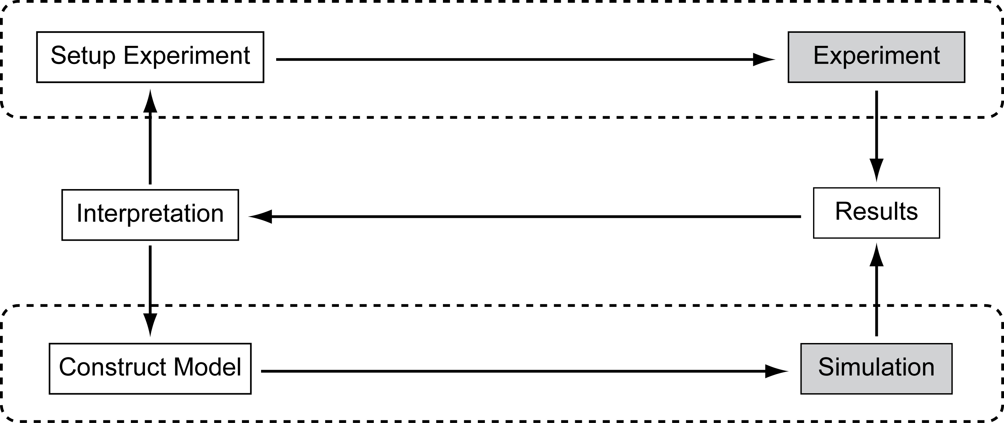
Conducting experiments and running simulations are two iterative processes connected by a feedback loop that uses interpretation of results to design new experimental setups and model constructions. From this perspective, simulations provide a framework to organize our understanding of biological systems. We have developed a number of workflows that provide an organizational basis for simulator functionality and the user experience. The GENESIS User-Workflow supports the lower loop (Results->Interpretation->Construct Model->Simulation) within the system as given above, while the GENESIS Publication-Workflow interfaces the User-Workflow with the flows of external scientific discourse. The G-3 User-Workflow is now illustrated and described.

3.5. The G-3 User-Workflow
More than 20 years of experience in the development and use of GENESIS has led to the identification of a workflow paradigm that can be employed to organize activities such as project development, GUI functionality, and user and developer documentation and tutorials. The User-Workflow provides the foundation of how G-3 can be employed to define and examine models, run simulations, and extract results using modern and backward compatible interfaces. The typical User-Workflow is composed of five basic steps, summarized in the following figure:

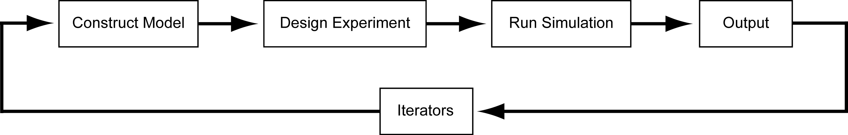
i. Construct Model: Create simple models directly within the G-Shell by entering commands. More complex models can be imported into the G-Shell from either the GENESIS model libraries or from other external model libraries. To enhance simulator interoperability, models specified in SWC, PyNN, Python, Perl, and XML formats can also be loaded. They can then be operated on in a seamless and integrated manner along with any G-2 SLI models that may be present to develop a new model. The new G-3 declarative file format (NDF) replaces and enhances those aspects of the GENESIS 2 Script Language Interpreter (G-2 SLI) that support model construction and exploration. The NDF file format has the advantage that it allows lineage tracking of models and their constituents. Once imported, a model can be explored, checked, and saved.
ii. Design Experiment: Set model parameter values specific to a given simulation, the stimulus parameters for a given simulation run or “experiment”, and/or the output variables to be stored for subsequent analysis. Experimental design primarily consists of specifying the inputs and outputs of a simulation. Inputs consist of how a model is activated, e.g. by current injection or synaptic activation. Alternatively, the Perfect Clamp utility provides a simple voltage clamp protocol to one or more specified compartment(s) of a neuronal morphology. Output can be specified for any compartments and can consist of any derived variables known to the mathematical solvers. For more controlled input, the voltage command, the current injection magnitude or the synaptic event times can be read from a data file.
iii. Run Simulation: Configure runtime options, check, run, reset simulation, and save model state. Prior to initiating a simulation, a variety of runtime options may be set, including, amongst others: the update time step and choice of simulator and simulation algorithm. An optional check can be performed to ensure, e.g. that the model and the experiment to be run during a simulation are syntactically correct, variables are not out of range, and solvers are correctly initialized. The state of a model can be saved at any time-step of a simulation. A simulation can then be (re)started from this saved state. Such functionality is particularly useful for eliminating redundant startup calculations. Output is flushed to raw result storage for subsequent data analysis.
iv. Process Output: Check simulation output and the validity of results to determine whether the output exists in the correct locations. Output can be explored both visually and quantitatively within G-3. Simulation output can also be piped to external applications such as Matlab, xmgrace, or Mathematica for post-processing and visualization.
v. Iterators: A G-3 modeling project is established by the introduction of iterators into the User-Workflow. The iterators achieve this by closing the loop between the output of results and model construction. They provide a crucial step in model development by matching simulation output to experimental data to aid the tuning of model parameters and thus model behavior. This proceeds either by brute force, as is typically the case with static parameter space searching with automatically generated batch files, or dynamically in real time by using, for example, dynamic clamp output.
The G-3 simulator guides a user through the User-Workflow during model construction and simulation configuration. The application of these different steps in the User-Workflow fills a research project database with configuration values, that allow the reproduction of all the simulation results that belong to a project, including model responses and any automatically generated electronic figures thereby facilitating model verification and result replication which are prerequisites for electronic model publication.

3.6. Databases Supported by the User-Workflow
3.6.1. GENESIS Model Repository: As the complexity and quantity of neurobiological data continues to increase, neuroscientists are being inundated with large amounts of data of unknown accuracy or relevance for the task of understanding brain function. Traditionally, modelers have typically obtained the information they need to construct models either from their own experiments or the published literature. To simplify and facilitate model development, GENESIS has been extended by enabling importation of quantitative specifications of neuronal geometries obtained from morphological databases, as well as related membrane and sub-cellular processes. For example, ChannelDB is a MySQL and Java-based GUI implementation of a database of ionic conductance models stored in simulator-independent NeuroML format (Beeman and Bower, 2004). A powerful addition to the functionality of GENESIS included in the architecture of G-3, is the ability to import a detailed neuronal morphology that a user can rapidly populate with realistic models of known ionic conductances from a database such as ChannelDB. Similarly, access to the DOQS (Database of Quantitative Cellular Signaling) gives the modeler the choice of importing XML based models of signaling pathways, including: reaction schemes, concentrations, and rate constants (Sivakumar et al., 2003).
3.6.2. GENESIS Model Configuration Repository: Many model publications report about a model of the biology that can have different mathematical expressions. As an example, when applying current injection to a single neuron model, spines are most conveniently represented in the mathematical model by recalculating the dendritic capacitance and membrane resistance to accommodate the spines surface. This requires a small technical change to the model for a single simulation run, but does not change the model of the biology. Combining the model repository and the model configuration repository allows representation of families of models. The advantage is that the core of the model is only stored once enabling tracking micro-evolutions of a model, model structure comparison, and ultimately also the macro-evolution of a model across many model publications.
3.6.3. GENESIS Stimulation Protocol Repository: The development of a stimulation protocol repository with configuration templates for current injection and voltage clamp simulations allows arbitrary combination of a model and different stimulation protocols. Examples include, action potential generation and the degree of spike frequency adaptation during a current injection to a model cell exhibiting calcium activated potassium channels. From a technical perspective this repository stores a description of the inputs to a simulation. Therefore one aspect of this proposal involves the development of a complementary repository with output of a simulation, to enable automatic model behavior verification and validation, via matching expected output in the repository with produced output of a model
3.6.4. GENESIS Simulation Configuration Repository: To guarantee a deterministic outcome for a given simulation, additional configuration data fixes technical aspects of a simulation such as numerical time step, spatial accuracy and output resolution. Although we expect that for most projects reasonable defaults can be used, a separate (small) database storing the non-default configuration of each software component will be required to guarantee reproducibility of the simulation results of a given research project.

To facilitate automated model validation we will also develop a database with categories of neural responses.
3.7. Additional External Connectivity of the G-3 Simulator
The external connectivity enabled by the modularity of the CBI architecture and its interfaces makes it possible to implement a comprehensive computational environment that supports neural modeling by interfacing model development with neuroscience databases. The following figure illustrates relationships between G-3 and these
external components.
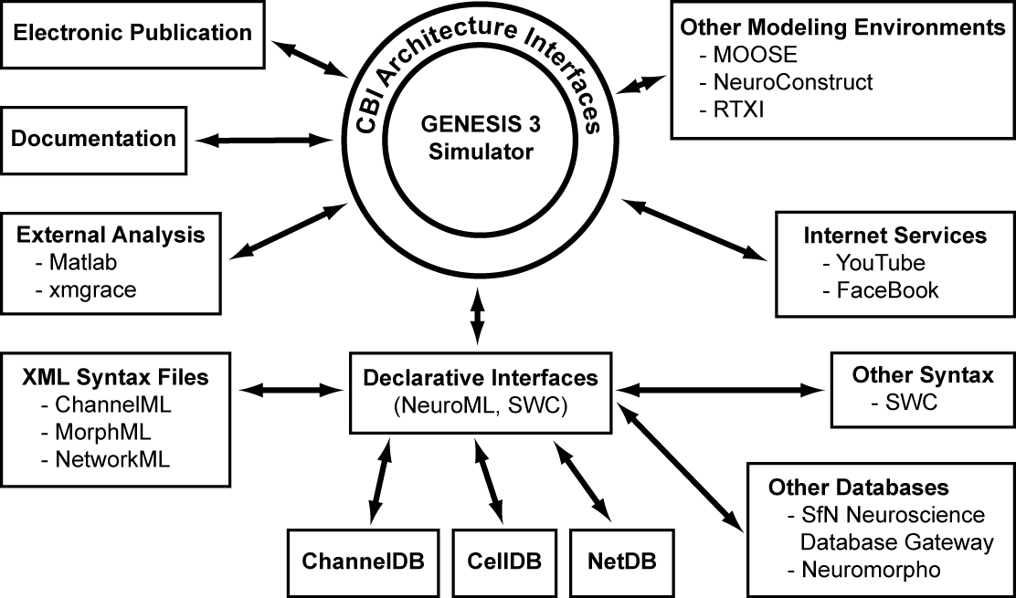
With the first implementation of the G-3 modular architecture completed, it is now possible to fully connect the simulator with internet databases and services. The information available from existing databases will (i) assist in model construction and design of computational experiments, and (ii) enable new knowledge produced by running simulations to be compared with and evaluated against information from databases storing data from real experiments. We propose that the best way to do this is by a full integration of a model with its publication. To this end we are developing and populating databases for each step of the User- and Publication-Workflows. These databases will be integrated with a user annotation infrastructure that contains scores and annotations about the models and their behavior (see below). The full content of data and annotations can then be shared with other users or laboratories by bringing it under control of the distribution technology of the documentation system and applying existing content distribution systems.
In this proposal we specifically ask for the funding to enhance the functionality of the GUI by implementing additional interfaces to allow easy comparison and model sharing, including electronic model publication backed up with multimedia data. To this end we ask the funding for the integration of the technology developed for the documentation system such as the database format and the automated web-content creation tools with the data distribution policies of the Project-Browser to accommodate the needs of electronic model publications.

4. Research Design and Methods
4.1. Contents of a Typical GENESIS 'Publication'
Traditional scientific publications come in the form of Introduction, Methods, Results, and Discussion. The GENESIS Publication System is organized along similar lines, if for no other reason than this provides a familiar framework for the researcher or student. The critical difference is that the text, figures, and tables are linked to the model via the G-3 interface. This approach allows the incorporation of novel functionality into an electronic publication.
A G-Tube publication has a browsable menu of bullet points/narrative components that takes the place of the more traditional Abstract. It allows a publication to be explored in depth from four menu items in the GUI:
(a) Menu item 1: Links to an introduction and other relevant publications.
(b) Menu item 2: Explains the model in detail by supporting:
(i) The use of figures and tables to illustrate the functions and parameters of a neuron.
(ii) Browsing of the model lineage.
(iii) Automated testing of the model, including structural analysis and validation simulations.
(c) Menu item 3: Gives access to all the simulations that have been run, and enables automatic reproduction of the figures that are important to the publication. The G-Tube also allows manual figure production for figures that are not part of the publication.
(d) Menu item 4: Links to a conclusion that links to the previous menu items and other publications.
4.1.1. Figures: In traditional paper publications it is not unusual for different figures to be produced by different versions of a model. The separation of a model (the biology) and its simulation (the mathematical implementation) in the CBI federated software architecture allows figures to be dynamically reproduced and explored. This moves the focus of a publication from the narrative to figures that illustrate the novel components, mechanisms, and/or behavior of a model.
A library of SSP schedules with different stimulation paradigms is available. The GUI instructs the SSP scheduler to load a schedule from the library and then run the simulation. This produces the output for one figure. Tables and channel kinetic plot reconstruction will employ similar mechanisms.
The SSP configuration library can be browsed using the show_library G-Shell command. Each configuration is shown using its description inside the YAML file. Most of the SSP configurations required for this functionality are already available from different locations in the source code (e.g. the regression tests). After initial creation of this library, the buttons that implement functions for model comparison implicitly select one or more SSP configuration files and run a simulation.
Manual figure reproduction should also be possible from the G-Tube menus. For this, the G-Tube needs an interface to access and load schedules from the SSP library. This interface is available from a menu that is part of the Publication-Workflow.
4.1.2. Channel Kinetics and Distribution: G-Tube shows a list with all the transmembrane currents/channels found in the model.
(a) Channel characteristics table: Shows the gate parameters and the reversal potential for each channel (for example, Table 1, De Schutter and Bower, 1994a).
(b) Channel distribution table: Shows the current densities (for example, Table 2, De Schutter and Bower, 1994a).
(c) Plot channel kinetics: Clicking a button in the table with channel characteristics generates a plot of the steady-state and time course of channel activation (and/or inactivation) against the membrane potential. This relationship is calculated by the mathematical solvers and made available to the G-Tube via the G-Shell 'tabulate' command.
(d) Visualize response to clamp stimulus: The cell response to voltage or current clamp can be visualized using a library of SSP schedules.
4.1.3. Model Lineage: In principle one of the values of model-based science is that each model should extend one or more pre-existing model(s) or parts of a model. This scheme has been fundamental to the development and extension of GENESIS since its inception. Formally capturing and tracking the incremental steps of model development and exploration is fundamental to a comprehensive publication process. We are developing a facility that will track the lineage of a new model - both its individual parts and the entire model. We employ the Purkinje cell model (de Schutter & Bower, 1994a,b) as a test case.
The structure of the NDF file format provides built-in support for lineage tracking of models and their constituents. This advanced feature allows the history of both a model and the refinements made by different research groups who have worked on a model to be tracked.

4.1.4. Linkage to a Body of Work: As an extension of the model lineage component, such a system will also allow readers to follow the progression of the work of a single investigator or lab. This raises all kinds of interesting issues - when, for example, does a lab substantially change a model? How long do they continue to study the same model, but with different levels of resolution or different kinds of data (see below)? There are also interesting branching issues within a laboratory tradition, for example, a postdoc leaves a lab, but continues to work on the same model.
4.1.5. Attribution: Once a lineage system is built into a publication, a new form of attribution can be established, where, for example, one can track and quantify how much influence a previous modeler has had on a particular component or part of the newly published model. Based on the publication atom, parameters of a complex model, and by assigning 'attribution scores' to each model component, the attribution of one or more contributors to a model can be fully quantified.
Likewise the 'local' past and current importance of a model component can be quantified by counting its usage from the lineage tree. In a centralized database with peer-reviewed publications the 'local importance' provides an overall measure of the significance of a model component. The algorithms to compute the importance of a model component shares principles with Google algorithms to attribute scores to Google search hits. They are also related to spanning tree and coverage calculations in graph networks.
The G-Shell's show_library command has extensions for file types such as 'ndf' files, 'g2' files, and so on. This command is already supported by the G-Tube. A new extension type 'cite' will list all the citations related to one model (channel, morphology, or other) and allows the model lineage to be browsed.
The G-Tube provides tracking of both who has contributed what to a model and the impact of each contribution. The fundamental building block of a publication is a “publication atom”. This parameter is defined in the Model-Container, points to an external file, and is an explicit component of a model (such as a channel or synapse instance). Each publication atom is contributed by an author. Publication atoms start with equal impact factors. The use-count of a publication atom determines its overall impact. This attribution model obviously gives high scores to Hodgkin and Huxley and to Wilfrid Rall. Upon request, the G-Tube will show a table of all the people who have contributed to a model, to which model component they have contributed, and the current impact factor of that component.
4.1.6. References to Other Models: While we all know about paper models, the model lineage and attribution system also is, in effect, a new form of reference for other models. Icons inserted into the text will let the reader know that there is another model in the publication system that is relevant to a given part of the publication.
4.1.7. Model Comparisons: Critical to this new form of publication will be the ability to quantitatively compare models. This applies both to the structural components of the model, as well as the parameters used to generate the reported modeling results. We will develop the capacity to quickly identify what is the same and/or different between two models, both at the structural level, and also at the level of parameters. For example, a new Purkinje cell model might include a novel type of potassium channel, or might have significantly changed a parameter for a component common to two models. This kind of capability will allow readers to quickly identify and understand what is similar and different about a model. Planned comparisons include:
i. Structural differences between models: The G-Tube shows multiple morphology, passive models, channel characteristics and channel distribution tables simultaneously. Both quantitative and structural differences can be visualized using different colors (green color: same parameters/structure, red color: differences in parameters/structure).
ii. Behavioral differences between models: Behavioral differences between models can be shown by running simulations that simulate common experimental protocols:
(a) Responses to current injection traces are shown for each model that is compared.
(b) Voltage clamp simulations after application of channel blockers.
A library of SSP schedules is used to configure the simulation required to produce these traces (see also below). The G-Tube allows the SSP library to be browsed and a schedule for running a single selected simulation.
iii. Functional differences between models: The response of the different models to synaptic stimulation under different physiological conditions can be compared.
Model parameters are automatically extracted from the Model-Container and placed into a table which provides: soma dimensions, electrotonic length of the longest and shortest compartments, total dendritic length, surface area and volume, number of branch points, average branch order of dendritic tips, R_{M}, C_{M}, R_{A}, E_{LEAK}, number of spines, number of compartments, and a list of transmembrane currents. These quantities can be computed by the Model-Container and are made available as YAML text files to the GUI from the standard I/O connection with the G-Shell.
4.1.8. Review: We need to think about ways in which this system could be used to augment human review - just the fact that all figures would need to be generated by the model, for example, is one level of review not possible with current publications. But there are potentially other ways to make reviews semi-automatic - by, for example, looking at how fragile parameters are, or testing to see if the new model is a significant change from existing models. This is potential a big area for development and technology.
4.1.9. Experimental Data: We will also want to construct some way to include or link to the experimental data used to tune or test the model. One way in which modeling publications can differ is in the experimental data being used to validate or test the model - even if the model is the same. Thus, it is not unusual for the same model to be used to explore different aspects of possible function, based on different types of data used or changes in the resolution (see for example, first 3 papers by Erik on the Purkinje cell model).
4.1.10. Parameter Space: Being able to understand parameter space dynamically provides considerable functional information. The ability to quantify where the model sits with respect to both its own parameters and those of other models would be very valuable - one could ask, for example, if the calcium conductance for the current model is close to those of other models, or quite different. There is also the issue of how robust model behavior is to particular parameters. In addition, it would be valuable to be able to designate which parameters are well constrained by data, and which are not. We usually write paragraphs about that in our discussion sections, although many don't.

4.2. The G-3 Publication-Workflow
A widespread and current Publication-Workflow starts with a reviewer reading the narrative of a paper publication. This is followed by inspection of some of the model parameters. This phase of review can be followed by an in depth (but often incomplete) search for full understanding of the results and their implications. In contrast with these contemporary practices, the Publication-Workflow we now propose starts from the details of the model, and builds on them using figures and associated narrative annotations that provide a basis for a narrative abstract that is automatically generated prior to project submission for review. This abstract provides a key to the publication database for a given model by allowing a reviewer or reader to “drill down” to obtain increasing detail about the composition of a model and new results.
The User-Workflow is complemented with additional steps in a Publication-Workflow to complete a full data flow in a research project. The Publication-Workflow can be initiated at any step of the User-Workflow. The following figure outlines the steps in the GENESIS Electronic Publication Paradigm (G-Pub).

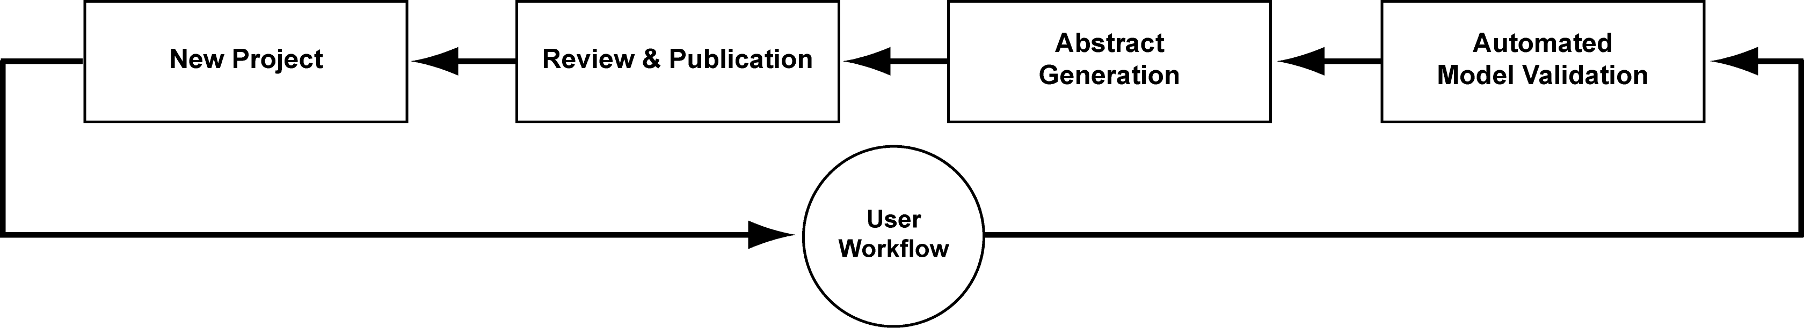
The individual steps in this figure are now described in more detail.
i. Automated model validation: Automated model validation replaces the majority of the traditional methods section of a publication. It is at this first step of the Publication-Workflow that core model components can be verified and validated. This step has two purposes:
(a) Verify model: This step in the Publication-Workflow is to ensure that the lineage starting point of the model employed for simulations is a previously published source model. Model verification is performed on the morphology, cable discretization, equations for different membrane and synaptic channel types and their kinetics, model parameter values, and dynamic response to specific current injection and voltage clamp protocols.
(b) Validate model: In the absence of a pre-existing model, model validation is completed by the generation of tables and figures reporting model verification. These data are acquired from the Model-Container. If the model is based on a pre-existing published model, validation is completed by a comparison of the two models. Any differences between the two models are identified, characterized, quantified, and reported. This step can be performed by a user prior to submission to the publication data base.
ii. Abstract generation:
(a) Manual figure selection and annotation: G-3 automatically tracks changes to both a model and the stimulus parameters employed during each simulation run. Figures generated from the data of a specific model version and stimulus paradigm are also automatically tracked during a project. At the completion of a project, the required figures can be manually selected and tagged for inclusion in a publication. Each figure has at least four associated user-completed annotation panels for a (i) Figure caption and separate (ii) Result, (iii) Discussion, and (iv) Abstract annotations.
Following figure selection and annotation, an abstract can automatically be generated by collecting the Abstract annotations. Contemporary publication practices are extended as the abstract provides a key to project results via the figures generated by the current model. It also provides links to result and discussion annotations.
(b) Manuscript submission: Once an abstract has been generated, a project can be pushed to an external database for review. For a publication to be accepted, it must successfully pass an automated validation step. If this step is failed, the submitter is notified as to where the failure occurred.
iii. Review and publication: Acceptance for publication is determined by whether a model passes the automated validation step that occurs at the time of submission. This greatly reduces the workload of reviewers and allows them to focus on the new contributions of a publication. A novel feature of the G-Pub process is that any new project is automatically embedded in both its own and the published model lineage. This means that, if necessary, a reviewer can rerun simulations to verify novel claims, check figures or generally explore the model and the stability and generality of reported results.
iv. G-3 User-workflow: A publication is the result of running many simulations. We envisage that at first the G-3 User-Workflow will be the most important iterator of the G-3 Publication-Workflow. Also other iterators are possible. As an example a model mining research project does not start with new model development but can equally lead to electronic publication.

4.3. G-3 Workflow Paradigm
The following figure outlines the global work- and data-flows that organize and support G-Pub. It encompasses two important workflows, the User-Workflow and the Publication-Workflow.

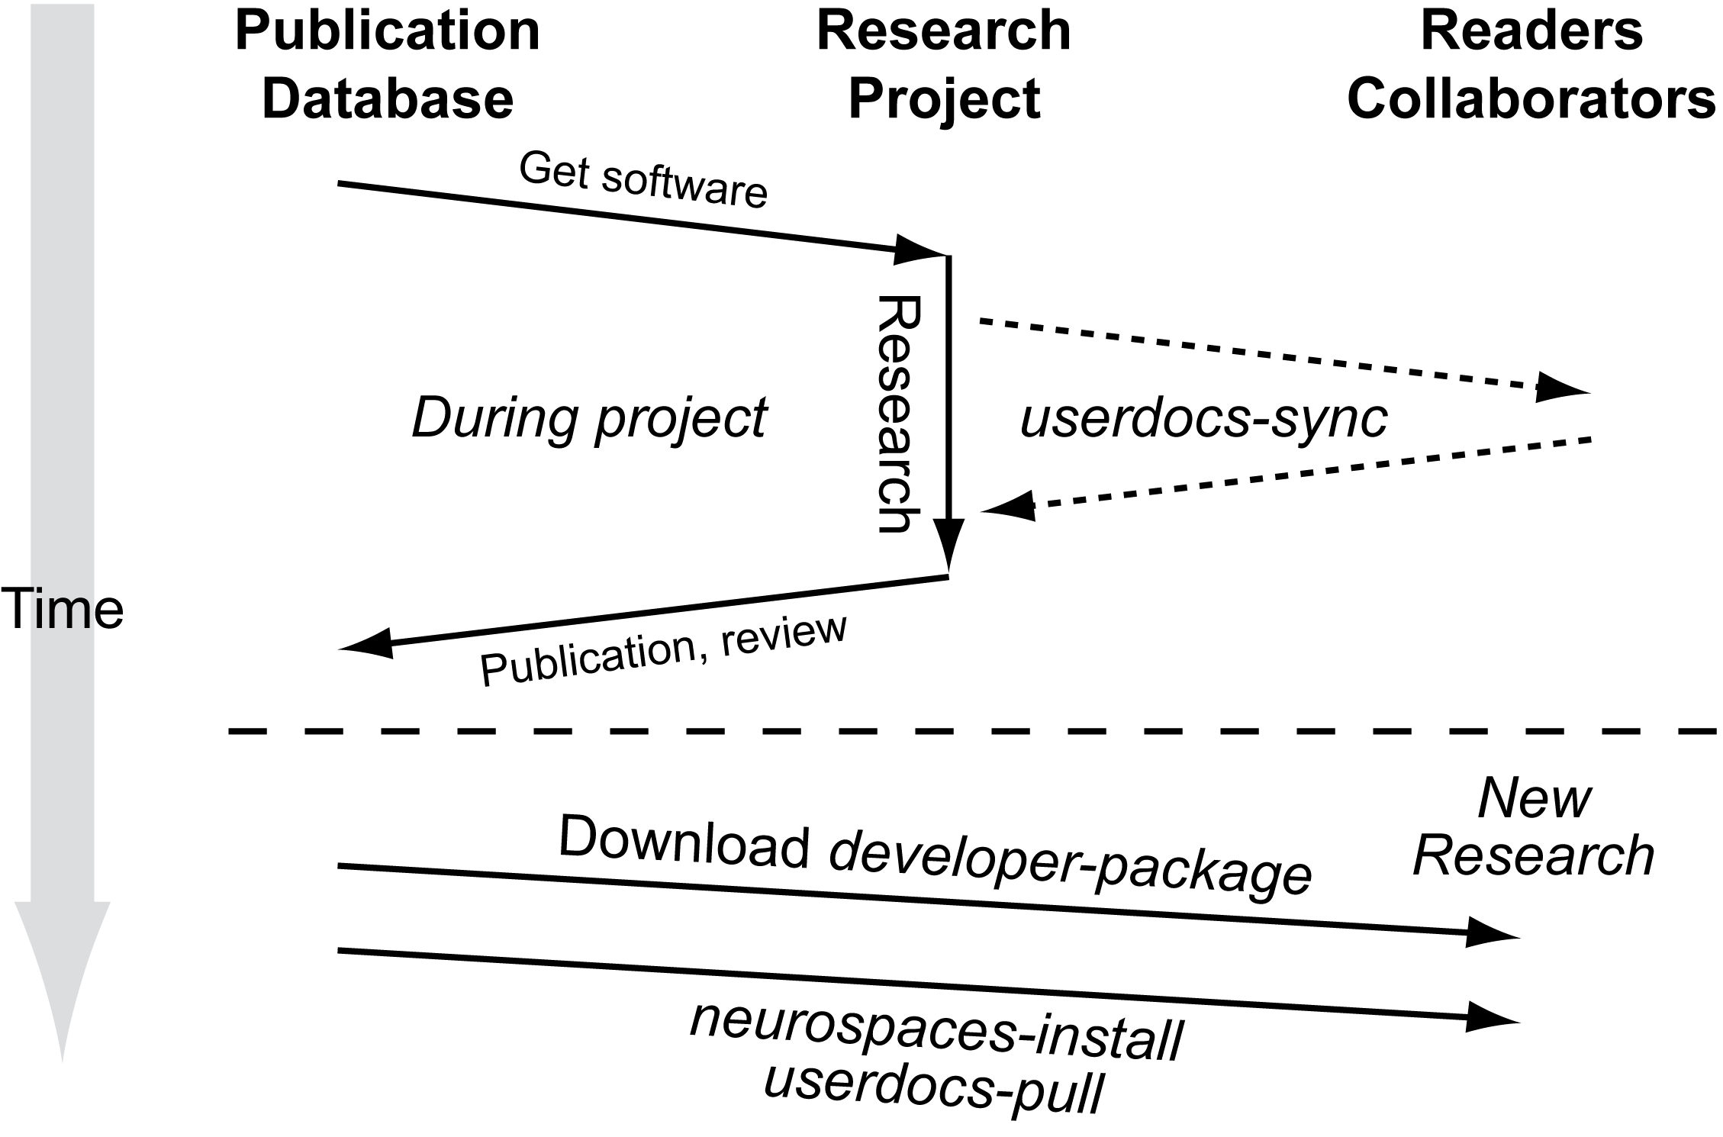
Software to support the User-Workflow has been substantially implemented, whereas, it is the software that supports the Publication-Workflow and which provides an organizing principle for G-3 functionality that is the work to be funded by this proposal.
Because of their familiarity, G-Pub is based on the traditional components of a scientific communication, i.e. Abstract, Introduction, Methods, Results, and Discussion. It is notable that in a G-Pub these components are partitioned in a way that more clearly distinguishes narrative and non-narrative components than is the case for traditional paper and electronic publications. The G-Tube (already under construction) is complemented by G-Pub to complete the full support of the G-3 Publication-Workflow.

4.4. Database Design and Development
The database development provides the foundation of the publication framework for which we request funding with this proposal. Each database format supports system-specific, project-specific and user-specific levels. The system specific level makes abstraction of system specific configuration such as filesystem layout. The project level is a container for project specific data such as models and source code. The user level provides the user the flexibility to run simulations without initiating a new research project.
4.4.1. Database Format: The documentation is integrated with the G-3 simulator via a YAML-tagged flat file system maintained in a server repository under control of a distributed version control system (currently monotone). Tags define whether documentation is maintained locally and visible only to authorized members of a given project or is exposed to the world by publication at the GENESIS web site. The tags can also be used to define 'complementary flows' through a set of documents. These complementary flows are dynamically generated. The documentation system is fully automated and rebuilds itself every 8 hours, such that any changes or new files are quickly and automatically incorporated into the system.
Based on the G-3 documentation system each database described below will be implemented as a YAML-tagged flat file system. This approach, also in use by popular databases in neuroscience (eg. www.neuromorpho.org). It allows convenient storage of the highly heterogeneous data typical of neuroscience models using specially formatted text based files. Other advantages include easy manipulation, archiving, and synchronization between databases. The database structure has three major features: (i) It follows the five steps of the User-workflow, (ii) It provides a database of text, figures, and annotations, and (iii) Defines relationships between other objects in the database.
The databases defined for support of the G-3 User-Workflow are complemented by the following databases to comprehensively support the Publication-Workflow.
i. Publication Narrative Component Repository: The database with the narrative components of a publication serves two purposes: the definition of collections of fragments of simulation results allows traditional-style publication figures to be reproduced. Secondly, inserting free-style text paragraphs and combining them with the figures allows for profound discussion sections. Also personal notes, reviewer comments, and computer generated annotations can be inserted.
ii. Publication Metadata Repository: We will provide the ability to define secondary reader-flows through one or more publications through the YAML tag-based document descriptors that were developed for the G-3 documentation system. It will also be possible to provide more than one flow for a given model, such as 'history', and 'present', overcoming the limitation of paper publications that have to stick with a predefined linear flow. We plan to predefine a number of validation and review flows. As an example, every single-cell model should come with an automatically generated report that guarantees that parameters are within their physiological range.
iii. Database Tools: Software under development includes robots that validate the static structure of the models in the database, including parameter range testers, morphological constrained testers and robots that test for shared features in a model. Server side based, this framework needs further extension before it also becomes useful to researchers. We also plan to develop robots that detect database model similarities and propose actions to the user.
The GENESIS development team is actively involved in the development of standards for model exchange such as NeuroML for neuronal model descriptions and the new INCF initiative for large-scale neuronal network model descriptions, the NineML standard.
4.4.2. Database Distribution and Replication Strategies: The Project-Browser distributes the data of a single research project over multiple computers. This creates a distributed database of a single research project. It is possible for relevant parts of the database to exist on one PC. This allows demanding simulations to be run on a cluster computer and then run the result analysis on a workstation. The data distribution mechanism also facilitates collaborations between labs that trust one another. The Project-Browser distribution policy replicates parts of the project database on different computers using the secure shell (SSH) as a transport mechanism. Research projects typically proceed by incrementally gathering result data from simulations, so other policies such the rsync protocol may be better suited to maintain the distributed project database.
Electronic publication submission replicates the research project database at the publisher's hardware infrastructure.
The review process generates new meta-data that is then compiled into a review report that ultimately leads to acceptance or rejection of the electronic publication.
Accepted electronic publications can be replicated at the local computer of a reader using the same distribution policies. By default the most important components of a research project will be replicated, but options will be available to replicate all data in the research project, including meta-data that was used for review purposes.
4.4.3. Tutorializing Research Projects: GENESIS has always placed considerable emphasis on the development of educational tutorials. In the past, this was an elaborate and time consuming task that followed the completion of a research project. Building G-Pub around the GENESIS database infrastructure defined by the user- and Publication-Workflows will automatically structure the project data such that it becomes easy to define educational user flows through the project via the YAML-based tagging mechanism provided by the documentation system. The integration of specialized interfaces around such as an educational flow is a custom feature of current GUI frameworks (such as wxWidgets). The state of the windows in a GUI (such as position, size and buttons and their actions) can easily be saved to define a simple educational tutorial. In effect, the difference between a scientific publication, a collaboration between laboratories, and the educational tutorial, becomes one of content rather than technology.
i. Web-Based Medical Education Tutorials: While our previous work has shown that enhanced interfacing to databases (e.g. www.neuromorpho.org) and hardware (e.g. RTXI dynamic clamp) can more easily be achieved through modularization of the underlying simulator software, the same modularization also provides for enhanced GUI integration. It is now much easier to enhance the GUI with plugins for interfacing to new simulator functionality and to connect it with databases as well as integrate with new internet Web 2.0 technologies such as Youtube (www.youtube.com) and Facebook (www.facebook.com). We have already developed a prototype Facebook application called 'Neurobook' that allows for a new range of educational tutorials to be developed and for more targeted recruitment of students and collaborators.
ii. GENESIS Project-Browser and Model Sharing: In the past, GENESIS tutorials were developed from existing simulation scripts by the addition of supplementary code to a published model. This has always been a laborious task. Within the framework of the G-3 publication system, tutorial definitions are pro-actively supported by correct application of special purpose YAML-tags to define tutorial reader flows through one or more electronic model publications. This brings the core processes of science and scientific eduction closer to one another.

4.5. From Model Publication to Scientific Networking
The G-3 publication system defines multiple possible roles for a publication database reader (global administrator, chief editor, article editor, reviewer, PI, collaborator, external reader). By extension the publication system will allow "readers" to comment on particular aspects of the model - this starts a dialog about the model. For example, an author could designate those who could comment on the model - or, comments could be restricted to those whose components are included in the model, or who have published other models in the same area. This becomes ultimately a new way to discourse about science and scientific results.

4.6. Integrity, Access Control and DRM
Digital rights management (DRM, nowadays also called information rights management) is a generic term for access control to a database to protect confidential content. DRM will be implemented using cryptographic key pairs and checksums. Each account in the publication system will generate a public and private key. The private key is stored on a user PC while the public key can be duplicated and stored on many PCs (public/private key pairs can also belong to 'machine' accounts). Cryptographic checksums on the content of the files in the database are compared to authenticate requests and data. Optionally, these checksums can then be signed using an account's private key. This protects the system from unauthorized access and preserves data integrity.
The DRM system designed for the G-3 publication system will integrate the distributed nature of a research project database and the different roles a reader can have when reading and modifying an electronic publication. Its design is similar to that of well-known websites such as Facebook (www.facebook.com) and Blogger (www.blogger.com).
Computing and comparing the cryptographic checksums after pulling data from an external database guarantees that the origin and integrity of the pulled annotations, including reviewer comments and computer validation test results. This process can also provide a record of the scientific quality of a model that is considered for starting a research project. The result will be an infrastructure to maintain a distributed database of computational neuroscience models, their annotations, and narrative flows.

4.7. Project Management Plan
4.7.1. Personnel
i. Documentation developer (Allan).
ii. Tutorial developer (Dave).
iii. GUI expert (Mando + new hiree).
iv. Infrastructure Developer (new hiree).
v. Database architect and standardization expert, system architect (Hugo).
vi. Supervision, PI (Jim).
4.7.2 Intellectual Property Rights: Need something here about how they will be dealt with.
The GENESIS source code repositories are publicly accessible. Both source code tar-balls and binary system-specific packages are available from public websites under GNU public license (GPL).
4.7.3. Milestones: See G-3 update to parent grant for Project-Browser milestones.
Even current state-of-the-art testing frameworks provide only limited support for automation of GUI testing. We have therefore already engaged in writing checklists of GUI features to be supported by the publication system. These checklists are used as target functions during implementation, and will be used by both alpha-testers and beta-testers. The current and latest versions of the checklists are always available as G-3 documentation.
1. Development of a GUI for GENESIS User-Workflow iterators.
2. Restructuring of existing projects that are already available in G-3 formats (mostly SLI, NDF).
3. Development of Database schema for models and simulations, consistent with the G-3 User-Workflow, performance evaluation of alternatives of checking local content consistency, (e.g. use of SHA checksums on content versus the use of dates).
4. Design of a system for annotation of models and other data. As an example of the advantages of using a separate Model-Container to keep annotations of versioned model, is its capability to associate 3D coordinates with annotations, such that it becomes possible to browse a model and its annotation in three dimensions. All the properties of annotation coordinates (such as correct transformations and rotations) are tracked automatically by the Model-Container for ultimate consistency.
5. Evaluation of synchronization algorithms: low-level data synchronization (based on rsync) versus low-level data copying (based on secure shell protocol, ssh) vs content copying (based on set synchronization protocols, based on distributed version control systems). In iterations with step 3, database schema and dependency tracking.
6. Development of scoring systems to measure the contribution of individuals based on the objective quantity and subjective (peer reviewed) quality of their contributions to the distributed database of models and annotations.
7. Evaluation of search engine implementation strategies (e.g. tagging based with indices versus pure html content based).
Mention GPU solver development, letter of support from G. Ascoli, Sharon Crook, Jaap Van Pelt, Erik De Schutter, Idan Segev.
4.7.4. Facilities: The facilities and equipment available are the Computational Biology Initiative computer hardware at the University of Texas at San Antonio, including a cluster with 30 times 4 nodes, multiple terabyte storage space, and over 25 desktop PCs. We also have informal commitments from many GENESIS users and volunteers to do alpha and beta testing.

REFERENCES
Baldi P, Vanier M and Bower JM (1998) On the use of Bayesian methods for evaluating compartmental neural models. Journal of Computational Neuroscience. 5: 285-314.
Chono K, Takagi H, Koyama S, Suzuki H and Ito E (2003) A cell model study of calcium inﬂux mechanism regulated by calcium-dependent potassium channels in Purkinje cell dendrites. Journal of Neuroscience Methods. 129:115-127.
Coop AD and Reeke GJ (2001) The composite neuron: A realistic one-compartment Purkinje cell model suitable for large-scale neuronal network simulations. Journal of Computational Neuroscience. 10: 173–86.
Cornelis H, Edwards M, Coop AD, Bower JM (2008) The CBI architecture for computational simulation of realistic neurons and circuits in the GENESIS 3 software federation. BMC Neuroscience 9: P88.
De Schutter E and Bower JM (1994a) An active membrane model of the cerebellar Purkinje cell I. Simulation of current clamps in slice. Journal of Neurophysiology, 71:375–400, 1994.
De Schutter E and Bower JM (1994b) An active membrane model of the cerebellar Purkinje cell II. Simulation of synaptic responses. Journal of Neurophysiology. 71: 401-419.
De Schutter E and Bower JM (1994c) Simulated responses of cerebellar Purkinje cells are independent of the dendritic location of granule cell synaptic inputs. Proceedings of the National Academy of Sciences, USA. 91: 4736-4740.
Gibson I, Farrelly P, Harris E, Harris T, Iddon B, Key R, McWalter T, Murrison A, Smith G, Spink B and Turner D (2004) Scientific publications: Free for all? Science and Technology Committee Tenth Report, Annex 1. Session 2003-4. House of Commons, UK.
Hines ML, Morse TM, and Carnevale, NT (2007) Model structure analysis in NEURON. In: CJ Crasto and NJ Totowa (eds.). Neuroinformatics. New Jersey: Humana Press. pp. 91-102.
Miyasho T, Takagi H, Suzuki H, Watanabe S, Inoue M, Kudo Y and Miyakawa H (2001) Low-threshold potassium channels and a low-threshold calcium channel regulate Ca2+ spike ﬁring in the dendrites of cerebellar Purkinje neurons: A modeling study. Brain Research 891:106-115.
Rapp M, Segev I and Yarom Y (1994) Physiology, morphology, and detailed passive models of cerebellar Purkinje cells. Journal of Physiology (Lond.). 474: 101-118.
Solinas S, Maex R and De Schutter E (2006) Dendritic ampliﬁcation of inhibitory postsynaptic potentials in a model Purkinje cell. European Journal of Neuroscience, 23:1207-1218.

