Development of a graphic user interface for enhanced publication of scientific communication.

1.0 Specific Aims
This proposal requests support for the development of new set of computational tools to support the evaluation, understanding, and sharing of computational models of the nervous system. In effect, the project described in this proposal is intended to lay the ground work for making models, rather than as at present, the written descriptions of models, the base for scientific publication in computational neuroscience and potentially neuroscience as a whole. The project will be organized around ongoing research and development of the GENESIS (GEneral NEural SImulation System) modeling system, however, the tools and Graphic User Interface (GUI) developed here will be agnostic with respect to a particular simulator.
Specific Aim 1: Develop and implement a comprehensive user modifiable GUI for the control, analysis, comparison, and peer reviewed electronic publication of computational models and simulation results in computational biology. Development of such a GUI will enable access to multiple databases (e.g. experiment, morphology, model) and also account for the micro-evolution of a model by making it part of the publication record maintained in the model publication database.
Specific Aim 2: The model publication database is proposed to comprise a project record that contains (i) a structured narrative (Introduction, Methods, Results, Discussion), (ii) a framework for the exploration of a model or tutorial, and (iii) a complete record of all changes made to a model during a research project, including the dead-ends. This leads to an operational workflow that includes: model development, model simulation, and results analysis where modifications to a model creates a graph of ancestry during the life time of a model.
Specific Aim 3: The GUI will facilitate and support the development of the structured narrative and will also automatically track all models, simulation configurations, and results of a given research project.
Specific Aim 4: A user will then be able to select the interesting parts of the project record to become part of the project publication. Operationally, the GUI will contain a library of frames of reference, e.g. a reference frame for the membrane channels of a given model that illustrates the quantitative validation of the channel kinetics. These frames are populated by the researcher with reference to model history and new results and observations.
Specific Aim 5: Manuscript submission will push the complete graph of ancestry that includes the dead ends and frames of reference to an external database. This electronic submission will then be available for review. In this publication model, a reviewer will primarily focus on the frames of reference that validate the model as a precursor to the novel aspects of a project that include the narrative.
Specific Aim 6: Once published, the system will support a wiki-like interactive discussion of the model and its results, and will also make the model available for modification and expansion. The system will automatically track the lineage of all new models, or model analysis, based on previously published models.

It is important to point out at the outset, that we are proposing to develop this model-based publication system, we are not proposing at this time to develop a new publication in computational neuroscience. Once developed even in prototype form, the P.I. is well positioned to discuss with incorporation of this system as part of existing journals (the Journal of Computational Neuroscience which he founded; Frontiers in Neuroscience, whose chief editor Idan Segev was also a founding member of JCNS as well as co-founder and director of the European Methods in Computational Neuroscience Course, etc). Of if appropriate to found a new publication. These conversations are premature, however, until the infrastructure is established and demonstrated.
2.0 Background and Significance
At its core, the proposed publication infrastructure is designed to facilitate sharing of scientific data and biophysical computational models and their annotations and by so doing provide a quantitative mechanism for the further development of computational neuroscience and our understanding of neurobiological systems as a whole. This proposal is specifically written around the generation of what are commonly referred to as “realistic models”, whose anatomical and biophysical structures are derived from the brain itself (see Bower, 1999 for discussion). While clearly an ambitious undertaking, we believe that the time has come to design a mechanism for the ordered evaluation, sharing, and evolution of what we will refer to here as ‘Community Models’ of components and parts of the nervous system. As outlined below, there is already early defacto movement in this direction as several models have already migrated from single laboratories to multiple and even competing laboratories. One of these models, the cerebellar Purkinje cell will serve as the initial test case for the system we propose to develop.

2.1 The Need
The core historical premise for this project is that, for most of its history, the greatest part of our efforts to communicate new neurobiological results has been based fundamentally on narrative story telling (Gibson et al., 1960). Accordingly, the usual first stage in constructing a publication is to develop a series of graphical figures around which a narrative story is then constructed. It is common practice to construct these figures around “best case” results, which tell the story most convincingly, or at least in a manner that will raise the least reviewer concerns. The short-term evaluation of the veracity of the new story is then performed by experts through the peer review process where the new story is aligned with existing and previously published stories, and often, in practice, most especially with the beliefs of the reviewers. Although publication of a methods section, in principle, allows the possibility for the actual experimental replication of a new result, it is generally understood that methods descriptions are inadequate to replicate experiments, and the emphasis of the publication process anyway is on ‘new’ stories making publication of replications difficult or impossible.
In principle, model-based research provides a mechanism to overcome a number of these limitations. First, new stories generated by models can, at least in principle, be referred directly to mathematical structures from which the story was constructed. At least some of these structures, like for example basic biophysical parameters like membrane capcitance or resistance, can, in principle, be evaluated automatically as the first stage of publication of a new model making some part of the review process more rigorous and objective. Such an automatic evaluation process can also alert reviewers (as well as authors) to parameters that are well out of the norm. Second, again in principle, instead of being handpicked from best-case data, figures can be reconstructed from the model itself. Thus a reviewer or reader would know exactly the conditions under which a particular figure or result was generated. In effect, live generating of figures is a form of replicating the results. Finally and perhaps most importantly, the model itself potentially becomes the basis to establish an ongoing dialog, as well as a basis for the development of new modeling components. Models, used in this way, in effect, provide a common representation of what is known about a particular component of the nervous system, as well as a mechanism for further elaboration and exploration of that component. Such models would, in effect become “community models” to which many contribute, but no one individual or group would “own”. Such a model can also become a common basis for training new researchers, as well as a mechanism to clearly identifying outstanding issues (including the need for new experimental data), as well as a means to quantitatively resolve scientific conflicts. Models used in this way would greatly clarify communication (which should be a principle objective of scientific publication) and would likely transform neuroscience. To do so, however, it will be necessary to construct a publication system that allows models, rather than text itself, to become the basis for narrative.

2.2 The Current State
While, in principle, model-based research has the potential to provide this kind of foundation for current and future neurobiological science, in fact, the majority of modeling studies today are based on models that remain unshared, or unsharable, and which are built and associated with single laboratories. As an example, at last year’s International Computational Neuroscience meeting in Berlin, results were presented from 12 different hippocampal network models from 12 different independent laboratories. No effort has yet been made to integrate these models together into one common model. This is common for most (but not all, see below) computational models.
While there are clear sociological factors involved in this state of affairs (see discussion in later sections), we believe that the current form of scientific publication is also an important factor. For example, perhaps even more than is the case for the publication of experimental results, traditional methods sections are wholely inadequate in providing enough information to replicate a model or its results. While there been important efforts to develop depositories for published models, with Model-DB at the Yale Sense lab being perhaps the most visible and successful example (refs), such deposits are made after the fact, and are not explicitly linked to the publication of the text or figures. Models deposited as an after thought have been notoriously difficult to extract and make sense of once deposited. It is also well known, for example, that the relationship between the model deposited and the model that generated the results or figures in a particular paper is often tenuous, and, in fact, Model-DB only requires that the deposited model replicate one of the published figures. Deposited models also lack any documentation with respect to the execution of the model itself, its origins or anticedants. It is the nature of the modeling process to generate variations which, in the absence of a formal system for model version tracking, for example, can become very difficult to track. It is the premise of this proposal that constructing a tool that integrates the modeling and publication process will produce a technical basis for the development of both higher fidelity publication, and the kind of community models that physics, for example, has depended on for 400 years.
While the current state of modeling is more disparate than organized, there is clear evidence that community models are beginning to emerge. Perhaps the best current example is based on a model of the cerebellar Purkinje cell, initially published in 1994 as a passive electrical model by Rapp and Yarom (1994). This model was then subsequently extended into a model with active conductances by our own research group (De Schutter and Bower, 1994a,b,c.) and made available to the public through the GENESIS data-bases (URL). Over the last 9 years, 4 variations of this model have been published by four independent research groups (Chono et al 2003; Coop & Reeke 2001; Miyasho et al 2001). In addition, numerous variations have been published by former members of the Bower laboratory now running their own research groups (De Schutter & Steuber 2009; Kreiner & Jaeger 2004; Solinas et al 2006). The Purkinje cell model was also the first full model of a neuron to be translated between GENESIS and NEURON (Steuber et al 2007) and has served as the basis for a funded collaboration between five different research groups in three different countries (Steuber et al 2007). The model has also now been incorporated into a network model of cerebellar cortex and, importantly, has been cited in a relatively large number of experimental studies (Cavelier et al 2002; Ogasawara et al 2007; Pouille et al 2000; Widmer et al 2003; Williams et al 2002; Willoughby & Schwiening 2002).
While the Purkinje cell model is well on the way to becoming one of the first “Community Models” in neuroscience, like all models, the original model continues to undergo a process of evolution that is more or less explicit. While the original model was based on a neuron morphology of a passive model developed by Rapp (1994), other models have used different morphologies, but applied the same channel distribution and characteristics (refs). Other versions of the model have used different values for conductance parameters (Chono et al 2003). However, while these model differences were explicitly called out in the corresponding publications, closer examination of the other published versions of this model also reveal sometimes subtle and sometimes not so subtle variations. While this is potentially a concern in itself, the larger issue is that it is not at all clear how much of the performance of the first model is preserved in subsequent models. For example, the original model showed significant dendritic amplification of excitatory post-synaptic signals (De Schutter & Bower 1994), while a more recent report shows that this same mechanism can also amplify inhibitory post-synaptic signals (Solinas et al., 2006). However, the updated channel characteristics in the latter model make it difficult to quantitatively compare the reported dendritic amplification characteristics of inhibitory and excitatory signals. This is an important issue because, in the current process of publication, it is often assumed that the current model has ‘inhereted’ the demonstrated characteristics of the original model. No modern journal would accept the re-publication of 20 years worth of figures demonstrating that this is the case – but the question of whether the new version can still replicate the performance of the old version is a critical experimental and theoretical question that is currently simply not addressed. The inability to replicate could either indicate that the old result was wrong or misinterpreted, or that the new version of the model has drifted away from the biological realism established in early modeling stages. It will be necessary to develop new tools and a new publication system to address this important issue.
While in some sense, the Purkinje cell model represents one of the best current examples of a ‘community model’, as just described, it suffers as do all modeling efforts by the lack of particular tools for understanding and evaluating different models. These include the following:
2.2.1. Current lack of model comparison tools: With the exceptions of using Bayesian methods for evaluating compartmental models of neurons (Baldi et al., 1998) and the analysis of the structure of a model (Hines et al., 2007), there are few, if any, whole model comparison tools available. While individual researchers are developing specialized tools that examine one or another feature of models (Cannon & D'Alessandro 2006; Druckmann et al 2007), there is as yet no system to incorporate these tools into a working whole.
2.2.2. Current lack of model lineage inspection tools: With the exception of tracing model lineage by hand from source publications, we know of no formal methodology or computational tools for identifying and/or tracking model lineage in computational neuroscience and biology. In these disciplines it is still difficult if not impossible to track either the micro-evolution of incremental changes made to a model made during a single publication or the macro-evolution of a model across multiple publications. This is a particular relevant concern because it relates to the question of attribution, which is, in turn tied to evaluations for funding, and promotion and tenure. In principle, tracking model lineage could provide a more quantitative and rigorous method for evaluating the impact of a particular researcher on the community.
2.2.3. Current lack of model verification: Due to its micro-evolution, even with full access to the code of a given model, confirming that it was indeed the one used to produce the figures in a paper is not possible. This greatly complicates model verification.
2.2.4. Current difficulty of result replication: Because the validity of a model cannot currently be easily verified, replication of results (one of the corner stones of the scientific method) is greatly complicated. This is particularly a problem with models, like the Purkinje cell model, which have evolved through several generations. As already described, it will be important to know which of the previously published features of the model still hold true as the models parameters are modified with additional experimental data.

2.4 Significance
We hope it is clear from the forgoing brief discussion, that the projects proposed in this grant are potentially highly significant with respect to the infrastructure for future studies in neuroscience. While the technology of modeling has slowly been gaining acceptance in the field, like experimental science before it, this new approach requires the development of new technology to maximize its potential and value. It is our view that the transition from purely descriptive experimental science, to investigations increasingly related to models, is a process of establish the first real quantitative theoretical base for understanding structure function relationships in the nervous system. Models themselves, properly constructed, in effect, represent our current understanding about what is functionally important in the structure of the brain and its components, as well as a tool to organize future experimental and modeling efforts to move that understanding forward (Bower, 1999). However, this kind of success for modeling will require the development of new tools for the comparison an publication of models. The purpose of this proposal is develop the framework to link to existing tools and develop new tools that will be critical to that process.

2.5. Our qualifications to manage such an effort
Before considering the specifics of this proposal, it is important to provide some evidence that our research group is capable and well positioned to take on this ambitious task. We are very aware that this is an ambitious undertaking, with significant implications and potential consequences for the field of neuroscience, and the practice of doing neurobiological research. We also believe that our research group is in an ideal position to take this task on. Specifically, for 25 years, the P.I. has been managing the development and extension of the GENESIS simulation platform, which has been responsible for many core innovations in the field of computational neuroscience. GENESIS, and its version for parallel and networked computers (PGENESIS) was the first broad scale modeling system in computational biology to encourage modelers to develop and share model features and components. The GENESIS group established the first standards for comparisons between simulation systems, the Rallpacks (Bhalla et al 1992) which is now widely recognized as a standard for simulator performance and can be viewed as the first step in the direction of quantitative model comparison. The GENESIS development team was one of the first to recognize the importance of standards for model sharing, which led to the initial development of the NeuroML standard for model exchange (refs), PGENESIS was the first neural simulator run on supercomputers (refs), and has itself spawned the development of middle-ware projects for simulator interoperability such as the Systems Biology Workbench (refs), the Neosim parallelization framework (refs), and the Neurospaces project for the development of independent software components for simulators (refs). The GENESIS group also published the first tools for automatic parameter estimation (Vanier & Bower 1999) as well as the first Bayesian formulation for model comparisons (Baldi et al 1998).
Although this project is not specific to the GENESIS simulation system, the GENESIS users committee will provide a core foundation for the development and testing of these tools. Since its release for general use in 1988, GENESIS has provided one of the foundations for the ongoing course in Methods in Computational Neuroscience at Woods Hole MA, as well as courses offered in the European Union, Mexico, Brazil, India, and in more than 100 universities around the world where it has been used both as an instructional tool in realistic modeling of the nervous system and as a simulation based tool for neurobiological education in general. For over 25 years, the GENESIS simulator has been used for research simulations with over 400 peer-reviewed papers to date published using the system. Additional information on GENESIS can be found at genesis-sim.org/.

3.0. Preliminary Studies
As already described, the GUI and technology development here will not be dependent on GENESIS, but will in fact be a component of the larger CBI Federated software architecture on which the new version of GENESIS (G-3) is being developed. However, the projects will be undertaken by the GENESIS development team and will be allowed by the considerable progress we have made in implementing a new framework for modeling systems. Initially, we will therefore introduce this modular approach to software development which is based on the CBI federated software architecture (described next). This approach includes several novel features for simulations that will be key for the success of these projects as well. For example, the new architecture seperates the stimulus protocols from a given model cell from its numerical implementation. This is an innovation that allows both a model and a stimulation paradigm to be combined dynamically at run time for a given simulation and simplifies the generation of batch files for multiple simulations. Importantly, this separation allows any simulation to be run with any model, a feature that greatly facilitates iterative model development and comparison. The isolation of a cell model from a given simulation configuration also enables convenient exploration and quantification of properties of the biological model. For example, no special functions or scripting are required to quantify properties of a model cell such as total or partial volumes or surface areas, the number of dendritic branches or branch points per dendritic tip, or the average somatopetal to dendritic tip distance. This new implementation gives fast and easy access to all the quantities that describe a model and its constituents giving the user tight control over the processes of model verification and validation.
In the following sections, we briefly introduce the CBI Federated Software Architecture, describe the currently existing components of G-3 which provide a fully functional neuronal simulator, and present the G-3 User-Workflow paradigm. This paradigm provides an organizing principle for simulator functionality but also provides the super structure for the development of the publication narrative. Note that the User-Workflow is functionally complete, whereas, the funding requested here will support the further development and implementation of a complementary Publication-Workflow (described in section 4.2).

3.1. The CBI Federated Software Architecture
All software can be understood in terms of algorithms operating on input data to produce output data. For experimental research, the natural distinction between data and algorithms can be compared to the distinction between the biological system (data to be investigated) and the stimulation paradigm (tools supporting data investigation). For computational research, the distinction between data and algorithms leads to a separation between model (data) and simulation control (control of data flows). The relationship between simulator control and data components are symbolized by the horizontal arrows in the following figure.
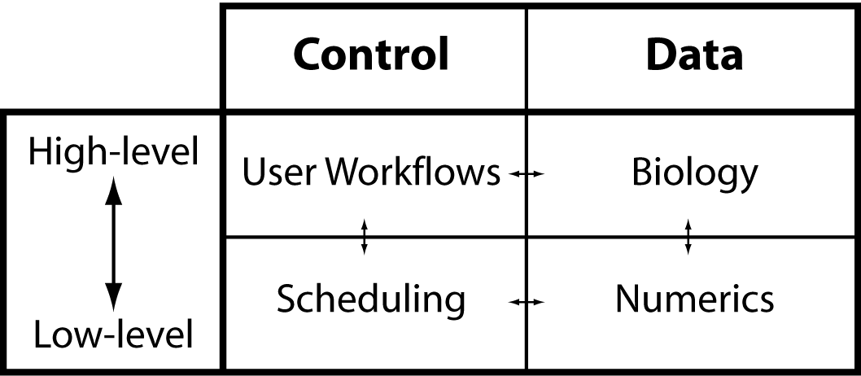
In the following figure the horizontal dashed line separates A. High level layer of biological representation from B. Low level layers related to mathematical implementation. The vertical dashed line indicates the separation of control and data within a simulator.

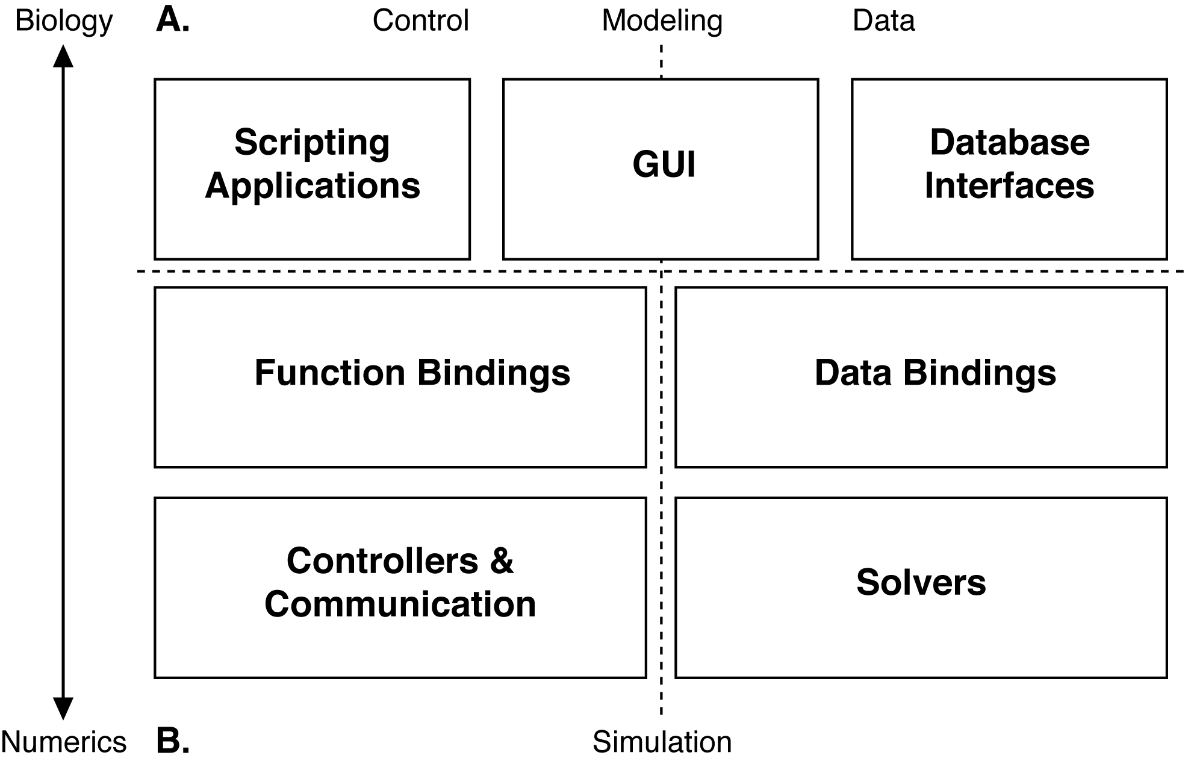
This highly modular approach to the development of simulator software leads to independent stand-alone software components that integrate on a just-in-time basis. Different modules contribute functionality to the workflow of model development, model exploration and analysis, model simulation, and (ultimately) data analysis and model publication. This structure also allows for the addition of new modules and functions for model description as well as publication.

3.2. G-3 Components
The projects in this proposal will be developed in the context of the new G-3 simulator, although again, the modular nature of the CBI architecture, in principle allows any simulator to use these tools. In oder to establish however, that G-3 is ready to serve as the development base for the work to be performed here, we will briefly describe the completed components of this new system:
3.2.1. Function binding: The G-3 interactive shell (G-Shell) provides a unified command line interface with Python and Perl that enables convenient interaction with other G-3 components.
3.2.2. Data binding: By “containing” a biological model, the Model-Container software component makes the implementation of numerical solvers independent of model representation. Giving different user views on the same model and its constituents the Model-Container also provides to the user a unique tool for model exploration.
3.2.3. Solver: Heccer is a highly optimized compartmental solver based on G-2 hsolve functionality (Hines, 1984).
3.2.4. Controller: The Simple Scheduler in Perl (SSP) provides a highly configurable scheduler that activates and synchronizes the Model-Container and Heccer to work together on a single simulation in a just-in-time manner. SSP also provides the necessary hooks to reconfigure the model to prepare it for connection with a stimulation protocol before the simulation starts.
3.2.5. GUI: (a) The Project-Browser is a contributed component. It provides a working prototype of a web server and database which allows different projects to be browsed and simulation results inspected and compared via a web browser such as Firefox. The Project-Browser allows the data of a single project to be distributed and synchronized over multiple computers. (b) The Studio is a contributed component used to visualize a model stored by the Model-Container and allows a model to be queried in the G-Shell. (c) The G-Tube can be evoked from either a Unix terminal prompt or the G-Shell, and ultimately will be available as an icon on the desktop. Because the most important consequence of the CBI federated architecture for the GUI is that the higher level interfaces present high-level biological concepts instead of mathematical ones, it is now possible to considerably enhance the functionality of the G-3 GUI.
The modular architecture of G-3 has the advantage that it facilitates integration with existing infrastructures and internet based technologies. As a first example, we have developed prototype code that interfaces the Model-Container with the neuromorpho.org morphology internet database. This code downloads a cell morphology from the database and generates both passive and active models according to a given configuration. A second example is a new database of computational stimulation protocols (e.g. stochastic afferent synaptic activation, current, and voltage clamp) that allow models to be automatically validated. This code is part of the G-3 test suite and prevents regression of the core functionality of the simulator.

3.3 Workflow Design
Before describing the structure of the publication system, it is important as the larger context for this project to understand that the system will be designed around modeling workflows informed by 25 years of simulator development and modeling studies. Specifically, the system support User-Workflow supports the lower loop (Results->Interpretation->Construct Model->Simulation). These are built into the G-3 system and are core to the way that the system tracks and interacts with models which will also be important for this project. The application of these different steps described below in the User-Workflow fills a research project database with configuration values, that allow the reproduction of all the simulation results that belong to a project, including model responses and any automatically generated electronic figures thereby facilitating model verification and result replication which are prerequisites for electronic model publication.
i. Construct Model: Create simple models directly within the G-Shell by entering commands. More complex models can be imported into the G-Shell from either the GENESIS model libraries or from other external model libraries. To enhance simulator interoperability and the ability for other modeling software to use this system, models specified in SWC, PyNN, Python, Perl, and XML formats can also be loaded. They can then be operated on in a seamless and integrated manner. We have implemented a new G-3 declarative file format (NDF) that has the advantage that it allows lineage tracking of models and their constituents. Once imported, a model can be explored, checked, and saved.
ii. Design Experiment: Set model parameter values specific to a given simulation, the stimulus parameters for a given simulation run or “experiment”, and/or the output variables to be stored for subsequent analysis. Experimental design primarily consists of specifying the inputs and outputs of a simulation. Inputs consist of how a model is activated, e.g. by current injection or synaptic activation. Alternatively, the Perfect Clamp utility provides a simple voltage clamp protocol to one or more specified compartment(s) of a neuronal morphology. Output can be specified for any compartments and can consist of any derived variables known to the mathematical solvers. For more controlled input, the voltage command, the current injection magnitude, or the synaptic event times can be read from a data file.
iii. Run Simulation: Configure runtime options, check, run, reset simulation, and save model state. Prior to initiating a simulation, a variety of runtime options may be set, including, amongst others: the update time step and choice of simulator and simulation algorithm. An optional check can be performed to ensure, e.g. that the model and the experiment to be run during a simulation are syntactically correct, variables are not out of range, and solvers are correctly initialized. The state of a model can be saved at any time-step of a simulation. A simulation can then be (re)started from this saved state. Such functionality is particularly useful for eliminating redundant startup calculations. Output is flushed to raw result storage for subsequent data analysis.
iv. Process Output: Check simulation output and the validity of results to determine whether the output exists in the correct locations. Output can be explored both visually and quantitatively within G-3. Simulation output can also be piped to external applications such as Matlab, xmgrace, or Mathematica for post-processing and visualization.
v. Iterators: A G-3 modeling project is established by the introduction of iterators into the User-Workflow. The iterators achieve this by closing the loop between the output of results and model construction. They provide a crucial step in model development by matching simulation output to experimental data to aid the tuning of model parameters and thus model behavior. This proceeds either by brute force, as is typically the case with static parameter space searching with automatically generated batch files, or dynamically in real time by using, for example, dynamic clamp output.

3.4. Documentation System
Documentation will be key to the use of the technologies to be developed as part of this grant. We have recently developed and implemented a new documentation system for G-3 which will also be used to document the new publication system. The Documentation System provides user and developer documentation at seven levels: Level 1: Introductory material, Level 2: User guides and documentation, Level 3: Automated regression testing and use cases, Level 4: Technical guide specification, Level 5: Algorithm documentation, Level 6: API documentation, and Level 7: Inline source code documentation. This documentation ranges from introductory background material and tutorials for users, to Doxygenized APIs and HTMLified browsable source code for developers. It is currently available from the GENESIS web site and will be made available as context dependent help in the new GUI development. With the exception of Level 1 and 2, documentation is automatically generated directly from regression tests and source code or integrated from external public sources. These sources provide guides for writing the Level 1 and 2 documentation covering specific functionality. The documentation will be integrated into the new publication system via a YAML-tagged flat file system maintained in a server repository under control of a distributed version control system (currently monotone). Tags define whether documentation is maintained locally and visible only to authorized members of a given project or is exposed to the world by web publication. The tags can also be used to define 'complementary flows' through a set of documents. These complementary flows are dynamically generated. The documentation system is fully automated and rebuilds itself every eight hours, such that any changes or new files are quickly and automatically incorporated into the system.

4. Research Design and Methods

4.1. System contents

Traditional scientific publications come in the form of Introduction, Methods, Results, and Discussion. This Publication System will be organized along similar lines, if for no other reason than this provides a familiar framework for the researcher or student. The critical difference is that the text, figures, and tables are linked to the model via the publication interface. This approach allows the incorporation of novel functionality into an electronic publication. The specific context for the GUI development will be G-Tube, a browsable menu of bullet points/narrative components that takes the place of the more traditional Abstract. It allows a publication to be explored in depth from four menu items in the GUI:
(a) Menu item 1: Links to an introduction and other relevant publications.
(b) Menu item 2: Explains the model in detail by supporting:
(i) The use of figures and tables to illustrate the functions and parameters of a neuron.
(ii) Browsing of the model lineage.
(iii) Automated testing of the model, including structural analysis and validation simulations.
(c) Menu item 3: Gives access to all the simulations that have been run, and enables automatic reproduction of the figures that are important to the publication. The G-Tube also allows manual figure production for figures that are not part of the publication.
(d) Menu item 4: Links to a conclusion that links to the previous menu items and other publications.

4.1.1. Figures: In traditional paper publications it is not unusual for different figures to be produced by different versions of a model. The separation of a model (the biology) and its simulation (the mathematical implementation) in the CBI federated software architecture allows figures to be dynamically reproduced and explored. Manual figure reproduction will also be possible from the G-Tube menus. For this, the G-Tube will be the interface to access the model, model configuration, stimulation protocol and simulation configuration repositories, and combine selected records to a SSP schedule that defines a reproducible run of one or more simulations. Moving the focus of a publication from the narrative text to figures will allow a researcher to focus on the novel components, mechanisms, and/or behavior of a model.

4.1.2. Channel Kinetics and Distribution: G-Tube shows a list containing all the transmembrane currents/channels found in the model.
(a) Channel characteristics table: The Model-Container exports the gate parameters and the reversal potential for each channel to the G-Tube (for example, Table 1, De Schutter and Bower, 1994a).
(b) Channel distribution table: The Model-Container exports the relationship between current densities and neuron morphology (for example, Table 2, De Schutter and Bower, 1994a).
(c) Plot channel kinetics: Clicking a button in the table containing channel characteristics will generate a plot of the steady-state and time course of channel activation (and/or inactivation) against the membrane potential. This relationship is calculated by the mathematical solvers and made available to the G-Tube from records in the simulation configuration repository.
(d) Visualize response to clamp stimulus: The cell response to voltage or current clamp configured from records in the GENESIS stimulation protocol repository.

4.1.3. Model Lineage: In principle one of the values of mathematical modeling is that each model should extend one or more pre-existing model(s) or parts of a model. Formally capturing and tracking the incremental steps of model development and exploration is fundamental to a comprehensive publication process. The structure of the NDF file format has been designed around lineage tracking of models and their constituents by keeping a formal record of a model's hierarchy and its modifications. These advanced features allows the history of both a model and the refinements made by different research groups who have worked on a model to be tracked. We employ the Purkinje cell model (de Schutter & Bower, 1994a,b) and its six derived models (refs?) that we know of as a test case during development.

4.1.4. Linkage to a Body of Work: As an extension of the model lineage component, this system will also allow readers to follow the progression of the work of a single investigator or lab. This raises many interesting issues - when, for example, does a lab substantially change a model? How long do they continue to study the same model, but with different levels of resolution or different kinds of data (see below)? There are also interesting branching issues within a laboratory tradition, for example, a researcher leaves a laboratory, but continues to work on the same model.

4.1.5. Attribution: Once a lineage system is built into a publication system, a new form of attribution can be established, where, for example, one can track and quantify how much influence a previous modeler has had on a particular component or part of a newly published model. For example, a component of a complex model can be assigned an 'attribution score' based on its use by other models in the database. This way the total attribution of one or more contributors to a model can be fully quantified.

4.1.6. References to Related Models and Publications: As an extension to the model lineage and attribution system also references to related models are allowed by inserting icons into the text will let the reader know that there is another model in the publication system that is relevant to a given part of the publication. Full support for traditional references will also be included.

4.1.7. Model Comparisons: Critical to this new form of publication will be the ability to quantitatively compare models. This applies both to the structural components of the model, as well as the parameters used to generate the reported modeling results. We will develop the capacity to quickly identify what is the same and/or different between two models, both at the structural level, and also at the level of parameters. For example, a new Purkinje cell model might include a novel type of potassium channel, or might have significantly changed a parameter for a component common to two models. This kind of capability will allow readers to quickly identify and understand what is similar and different about a model. Planned comparisons include:
i. Structural differences between models: The G-Tube shows multiple morphologies, passive models, channel characteristics and channel distribution tables simultaneously. Both quantitative and structural differences can be visualized using different colors (green color: same parameters/structure, red color: differences in parameters/structure). Model parameters are automatically extracted from the Model-Container and placed into a table which provides: soma dimensions, electrotonic length of the longest and shortest compartments, total dendritic length, surface area and volume, number of branch points, average branch order of dendritic tips, R_{M}, C_{M}, R_{A}, E_{LEAK}, number of spines, number of compartments, and a list of transmembrane currents. These quantities can be computed by the Model-Container and are made available as YAML text files to the GUI from the standard I/O connection with the G-Shell.
ii. Behavioral differences between models: Based on the functions for dynamic figure reproduction, the behavioral differences between models can be shown by running simulations that simulate common experimental protocols:
(a) Responses to current injection traces are shown for each model that is compared.
(b) Voltage clamp simulations after application of channel blockers.
iii. Functional differences between models: The response of the different models to synaptic stimulation under different physiological conditions can be compared. This is technically not different from the previous point, but we envisage that a user will prefer 'in-vivo' type simulations to be available under a different menu than 'in-vitro' type simulations.

4.1.8. Review: In this publication system the process of review will be augmented by the automated verification that all figures are generated by the model. The system will also implement other forms of semi-automatic testing, including determining the ‘normality” of the range of basic parameters, as well as an essessment of how fragile model parameters are or tests if the new model is a significant change from existing models. The modular nature of the core infrastructure for this project will allow us to take advantage of other research efforts in this area which are extensive (Cannon & D'Alessandro 2006). (probably want to fill some others in here)

4.1.9. Experimental Data: It is not unusual for the same model to be used to explore different aspects of possible function, based on different types of data used or changes in the resolution (see for example, first three papers by De Schutter and Bower [1994a,b,c] on the Purkinje cell model). As an extension to model lineage we will also provide ways to include or link to the experimental data used to tune or test the model, thereby clearly distinguishing expected (tuned for) model behavior from emergent model behavior. Again there are many existing projects involving data storage and access. (need some references here)

4.1.10. Parameter Space: Being able to understand parameter space dynamically provides considerable functional information (Baldi et al 1998; Vanier & Bower 1999). The ability to quantify where the model sits with respect to both its own parameters and those of other models would be very valuable - one could ask, for example, if the calcium conductance for the current model is close to those of other models, or quite different. There is also the issue of how robust model behavior is to particular parameters. In addition, it would be valuable to be able to designate which parameters are well constrained by experimental data, and which are not.

4.2. The Publication-Workflow
A widespread and current publication workflow starts with a reviewer reading the narrative of a paper publication. This is followed by inspection of some of the model parameters. This phase of review can be followed by an in depth (but often incomplete) search for full understanding of the results and their implications. In contrast with these contemporary practices, the Publication-Workflow we now propose starts from the details of the model, and builds on them using figures and associated narrative annotations that provide a basis for a narrative abstract that is automatically generated prior to project submission for review. This abstract provides a key to the publication database for a given model by allowing a reviewer or reader to “drill down” to obtain increasing detail about the composition of a model and new results.
The User-Workflow is complemented with additional steps in a Publication-Workflow to complete a full data flow in a research project. The Publication-Workflow can be initiated at any step of the User-Workflow. The following figure outlines the steps in the GENESIS Electronic Publication Paradigm (G-Pub).

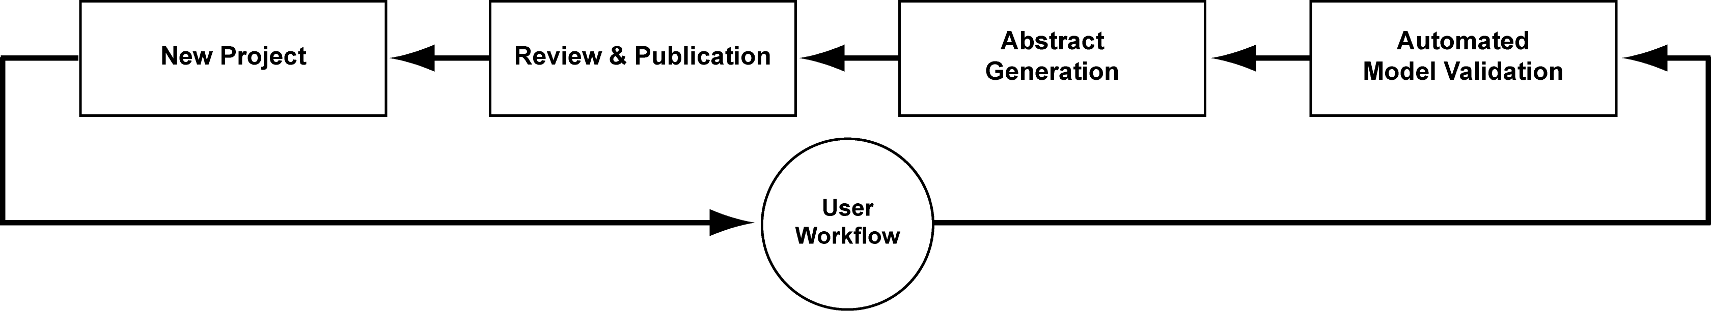
The individual steps in this figure are now described in more detail.
i. Automated model validation: Automated model validation replaces the majority of the traditional methods section of a publication. It is at this first step of the Publication-Workflow that core model components can be verified and validated. This step has two purposes:
(a) Verify model: This step in the Publication-Workflow is to ensure that the lineage starting point of the model employed for simulations is a previously published source model. Model verification is performed on the morphology, cable discretization, equations for different membrane and synaptic channel types and their kinetics, model parameter values, and dynamic response to specific current injection and voltage clamp protocols.
(b) Validate model: In the absence of a pre-existing model, model validation is completed by the generation of tables and figures reporting model verification. These data are acquired from the Model-Container. If the model is based on a pre-existing published model, validation is completed by a comparison of the two models. Any differences between the two models are identified, characterized, quantified, and reported. This step can be performed by a user prior to submission to the publication data base.
ii. Abstract generation:
(a) Manual figure selection and annotation: Figures generated from the data of a specific model version and stimulus paradigm are automatically tracked during a project. At the completion of a project, the required figures can be manually selected and tagged for inclusion in a publication. Each figure has at least four associated user-completed annotation panels for a (i) Figure caption and separate (ii) Result, (iii) Discussion, and (iv) Abstract annotations.
Following figure selection and annotation, an abstract can automatically be generated by collecting the Abstract annotations. Contemporary publication practices are extended as the abstract provides a key to project results via the figures generated by the current model. It also provides links to result and discussion annotations.
(b) Manuscript submission: Once an abstract has been generated, a project can be pushed to an external database for review. For a publication to be accepted, it must successfully pass an automated validation step. If this step is failed, the submitter is notified as to where the failure occurred.
iii. Review and publication: Possible acceptance for publication is determined by whether a model passes the automated validation step that occurs at the time of submission. This greatly reduces the workload of reviewers and allows them to focus on the new contributions of a publication. A novel feature of the G-Pub process is that any new project is automatically embedded in both its own and the published model lineage. This means that, if necessary, a reviewer can rerun simulations to verify novel claims, check figures or generally explore the model and the stability and generality of reported results.
iv. G-3 User-workflow: A publication is the result of running many simulations. We envisage that at first the G-3 User-Workflow will be the most important iterator of the G-3 Publication-Workflow. Also other iterators are possible. As an example, a model mining research project does not start with new model development but can equally lead to electronic publication.

4.3. G-3 Workflow Paradigm
The following figure outlines the global data-flows and individual and other entities that organize and support G-Pub. It encompasses two important workflows, the User-Workflow and the Publication-Workflow.
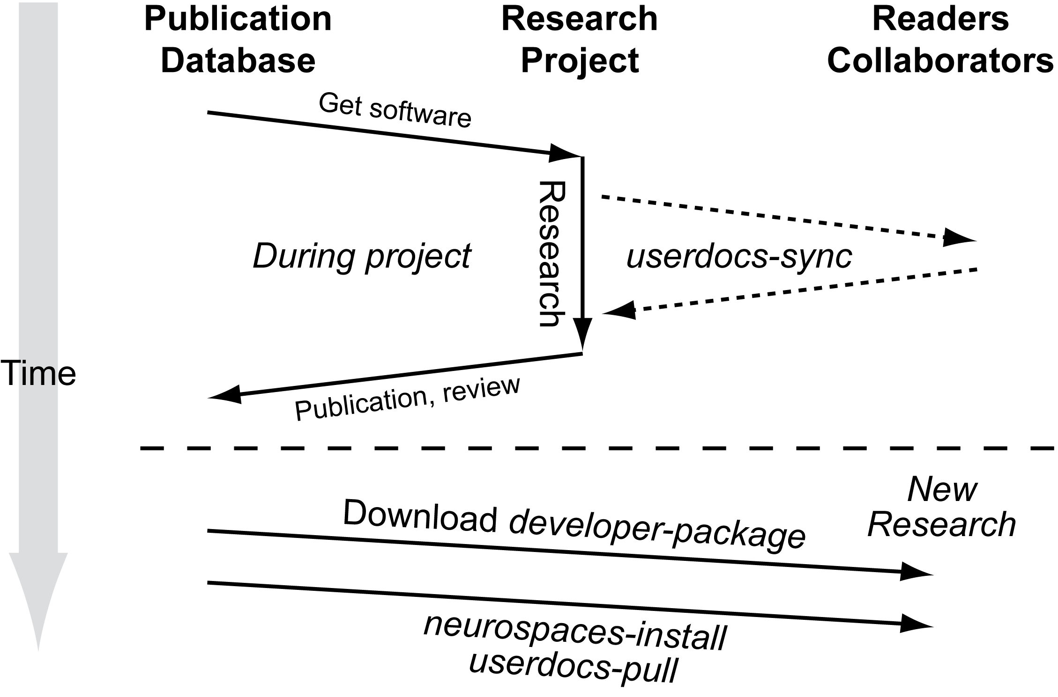
Software to support the User-Workflow has been substantially implemented, whereas, it is the software that supports the Publication-Workflow and which provides an organizing principle for G-Pub functionality that is the work to be funded by this proposal.
Because of their familiarity, G-Pub is based on the traditional components of a scientific communication, i.e. Abstract, Introduction, Methods, Results, and Discussion. It is notable that in a G-Pub these components are partitioned in a way that more clearly distinguishes narrative and non-narrative components than is the case for traditional paper and electronic publications. The G-Tube (already under construction) is complemented by G-Pub to complete the full support of the G-3 Publication-Workflow.

4.4. Database Design and Development
The database development explained below provides the foundation of the publication framework for which we request funding with this proposal.
4.4.1. Database Format: Each database supports system-specific, project-specific and user-specific views. The system specific view abstracts system specific configurations such as the filesystem layout. The project view is a container for project specific data such as models and source code. The user view gives the user the flexibility to run simulations without initiating a new research project. The existing GENESIS repositories implement these views based on system process environment settings.
The database structure has three major features: (i) It complements the five steps of the User-workflow, (ii) It provides a database of text, figures, and annotations, and (iii) Defines relationships between other objects in the database.
Based on the G-3 documentation system each database described below will initially be implemented as a YAML-tagged flat file system. This approach, also in use by popular databases in neuroscience (eg. www.neuromorpho.org) allows convenient storage of the highly heterogeneous data typical of neuroscience models using specially formatted text based files. Other advantages include easy manipulation, archiving, and synchronization between databases using the file distribution technology and replication technology developed for the Project-Browser.
The databases that will be developed to support the Publication-Workflow complement the databases of the G-3 User-Workflow:
i. Publication Narrative Component Repository: The database with the narrative components of a publication serves two purposes: the definition of collections of fragments of simulation configurations allows traditional-style publication figures to be reproduced. Secondly, inserting free-style text paragraphs and combining them with the figures allows for profound discussion sections. Also personal notes, reviewer comments, and computer generated annotations can be inserted.
ii. Publication Object Relationships Repository: The relationships between all the objects of a model publication are defined in this database. As an example, the main menu of a publication is defined as a narrative component, and is linked to its contents via a set of records in this database. Not only does this allow customization of the main menu to the contents of a model publication, but it also provides for the definition of secondary reader-flows through one or more publications. The implementation will be based on the YAML tags that were developed for the G-3 documentation system. For a typical model publication we envisage that at least the following flows will be defined: 'history', outlining the history of the model, 'present', giving an overview of related models, and 'tutorial', tutorializing the functions implemented by the published model. In addition to these narrative flows, we will also define flows that are specific to verification, validation and review. As an example, every single-cell model should come with an automatically generated report that guarantees model parameters are within their physiological range.
The publication system described here greatly expands the current limitation of paper publications that are bound by a predefined and linear flow.
iii. Database Tools: We plan to develop additional interfaces for the sole purpose of examining, exploring, querying and comparing the models in the database, including their micro- and macro-evolution [give examples].
As an extension of the automated benchmark test suite other software under development includes robots that validate the static structure of the models in the database, including parameter range testers, morphological constrained testers and robots that check for shared features in a model. Server side based, this framework needs further extension before it also becomes useful to researchers. We also plan to develop robots that detect database model similarities and propose actions to the user.
4.4.2. Database Distribution and Replication Strategies: The Project-Browser distributes the data of a single research project over multiple computers. This creates a distributed database of a single research project. The data distribution mechanism also facilitates collaborations between labs that trust one another. The Project-Browser distribution policy replicates parts of the project database on different computers using the secure shell (SSH) as a transport mechanism. Research projects typically proceed by incrementally gathering result data from simulations, so we plan to evaluate other policies such as the rsync protocol.
Electronic publication submission replicates the research project database at the publisher's hardware infrastructure. Both automated and manual review processes generate new data that is stored in the database. These data can then be compiled into a review report that becomes a part of the electronic publication.
Accepted electronic publications can be replicated at a local computer of a reader using the same distribution policies. By default the most important components of a research project will be replicated, but options will be available to replicate all data in the research project, including meta-data that was produced during the review.
4.4.3. Tutorializing Research Projects: GENESIS has always placed considerable emphasis on the development of educational tutorials. In the past, this was an elaborate and time consuming task that followed the completion of a research project. Building G-Pub around the GENESIS database infrastructure defined by the User- and Publication-Workflows will automatically structure the project data such that it becomes easy to define educational user flows through the project via the YAML-based tagging mechanism. We think that during a research project this facility will already be useful as a preparation tool for progress reports and scientific presentations. The integration of specialized interfaces around such as an educational flow is a custom feature of current GUI frameworks (such as wxWidgets). The state of the windows in a GUI (such as position, size and buttons and their actions) can easily be saved to define a simple educational tutorial. In effect, the difference between a scientific publication, a collaboration between laboratories, and the educational tutorial, becomes one of content rather than technology.
i. Web-Based Medical Education Tutorials: While our previous work has shown that enhanced interfacing to databases (e.g. www.neuromorpho.org) and hardware (e.g. RTXI dynamic clamp) can more easily be achieved through modularization of the underlying simulator software, the same modularization also provides for enhanced GUI integration. It is now much easier to enhance the GUI with plugins for interfacing to new simulator functionality and to connect it with databases as well as integrate with new internet Web 2.0 technologies such as Youtube (www.youtube.com) and Facebook (www.facebook.com). We have already developed a prototype Facebook application called 'Neurobook' that allows for a new range of educational tutorials to be developed and for more targeted recruitment of students and collaborators.

4.5. From Model Publication to Scientific Networking
The G-3 publication system defines multiple possible roles for a publication database reader (global administrator, chief editor, article editor, reviewer, PI, collaborator, external reader). By extension the publication system will allow "readers" to comment on particular aspects of the model - this starts a dialog about the model. For example, an author could designate those who could comment on the model - or, comments could be restricted to those whose components are included in the model, or who have published other models in the same area. This becomes ultimately a new way to discourse about science and scientific results.

4.6. Integrity, Access Control and DRM
Digital rights management (DRM, also sometimes called Information Rights Management) is a generic term for access control to a database to protect confidential content. DRM will be implemented using cryptographic key pairs and checksums. Each account in the publication system will generate a public and private key. The private key is stored on a user PC while the public key can be duplicated and stored on many PCs (public/private key pairs can also belong to 'machine' accounts). Cryptographic checksums on the content of the files in the database are compared to authenticate requests and data. Optionally, these checksums can then be signed using an account's private key. This protects the system from unauthorized access and preserves data integrity.
Computing and comparing the cryptographic checksums after pulling data from an external database guarantees the origin and integrity of the pulled annotations, including reviewer comments and computer validation test results. This process can also provide a record of the scientific quality of a model that is considered for starting a research project. The result will be an infrastructure to maintain a distributed database of computational neuroscience models, their annotations, and narrative flows.
The DRM system designed for the G-3 publication system will integrate the distributed nature of a research project database and the different roles a user can have when reading and modifying an electronic publication. The design is similar to that of well-known service-driven websites such as Facebook (www.facebook.com) and Blogger (www.blogger.com).

4.7. Project Management Plan
4.7.1. Personnel
i. Documentation developer (Allan).
ii. Tutorial developer (Dave).
iii. GUI expert (Mando + new hire).
iv. Infrastructure Developer (new hire).
v. Database architect and standardization expert, system architect (Hugo).
vi. Supervision, PI (Jim).
4.7.2 Intellectual Property Rights: Need something here about how they will be dealt with.
The GENESIS source code repositories are publicly accessible. Both source code tar-balls and binary system-specific packages are available from public websites under GNU public license (GPL).
4.7.3. Milestones: See G-3 update to parent grant for Project-Browser milestones.
Even current state-of-the-art testing frameworks provide only limited support for automation of GUI testing. We have therefore already engaged in writing checklists of GUI features to be supported by the publication system. These checklists are used as target functions during implementation, and will be used by both alpha-testers and beta-testers. The current and latest versions of the checklists are always available as G-3 documentation.
1. Development of database schema for models and annotations, complementary with the G-3 User-Workflow, performance evaluation of consistency checking alternatives and cryptographic signatures.
2. Development and initialization of databases with narrative components and object relationships. They will be initialized with data from the purkinje cell model.
3. Main menu GUI development, connections between GUI infrastructure and object relationship repository, implementation of flow-oriented GUI framework.
4. Evaluation of search engines and other database robots.
5. Testing, evaluation of alternate data distribution and replication algorithms.
6. Implementation of attribution algorithms for impact scores of models and model components.
7. Development of other GUI menus and tools: Figures, Channel Kinetics and Distribution, Abstract Generation.
8. Automated Verifiers and Validators for automated review.
9. Model lineage tracker GUI.
4.7.4. Facilities: The facilities and equipment available are the Computational Biology Initiative computer hardware at the University of Texas at San Antonio, including a cluster with 30 times 4 nodes, multiple terabyte storage space, and over 25 desktop PCs. We also have informal commitments from many GENESIS users and volunteers to do alpha and beta testing.

REFERENCES
Baldi P, Vanier M and Bower JM (1998) On the use of Bayesian methods for evaluating compartmental neural models. Journal of Computational Neuroscience. 5: 285-314.
Chono K, Takagi H, Koyama S, Suzuki H and Ito E (2003) A cell model study of calcium inﬂux mechanism regulated by calcium-dependent potassium channels in Purkinje cell dendrites. Journal of Neuroscience Methods. 129:115-127.
Coop AD and Reeke GJ (2001) The composite neuron: A realistic one-compartment Purkinje cell model suitable for large-scale neuronal network simulations. Journal of Computational Neuroscience. 10: 173–86.
Cornelis H, Edwards M, Coop AD, Bower JM (2008) The CBI architecture for computational simulation of realistic neurons and circuits in the GENESIS 3 software federation. BMC Neuroscience. 9: P88.
De Schutter E and Bower JM (1994a) An active membrane model of the cerebellar Purkinje cell I. Simulation of current clamps in slice. Journal of Neurophysiology, 71: 375–400, 1994.
De Schutter E and Bower JM (1994b) An active membrane model of the cerebellar Purkinje cell II. Simulation of synaptic responses. Journal of Neurophysiology. 71: 401-419.
De Schutter E and Bower JM (1994c) Simulated responses of cerebellar Purkinje cells are independent of the dendritic location of granule cell synaptic inputs. Proceedings of the National Academy of Sciences, USA. 91: 4736-4740.
Djurfeldt M and Lansner A (2006) 1st INCF Workshop on Large-scale Modeling of the Nervous System. Stockholm: International Neuroinformatics Coordinating Facility Secretariat.
Gibson I, Farrelly P, Harris E, Harris T, Iddon B, Key R, McWalter T, Murrison A, Smith G, Spink B and Turner D (2004) Scientific publications: Free for all? Science and Technology Committee Tenth Report, Annex 1. Session 2003-4. House of Commons, UK.
Hines ML (1984) Efficient computation of branched nerve equations. International Journal of Bio-Medical Computing. 15: 69-76.
Hines ML, Morse TM, and Carnevale, NT (2007) Model structure analysis in NEURON. In: CJ Crasto and NJ Totowa (eds.). Neuroinformatics. New Jersey: Humana Press. pp. 91-102.
Miyasho T, Takagi H, Suzuki H, Watanabe S, Inoue M, Kudo Y and Miyakawa H (2001) Low-threshold potassium channels and a low-threshold calcium channel regulate Ca2+ spike ﬁring in the dendrites of cerebellar Purkinje neurons: A modeling study. Brain Research 891: 106-115.
Rapp M, Segev I and Yarom Y (1994) Physiology, morphology, and detailed passive models of cerebellar Purkinje cells. Journal of Physiology (Lond.). 474: 101-118.
Solinas S, Maex R and De Schutter E (2006) Dendritic ampliﬁcation of inhibitory postsynaptic potentials in a model Purkinje cell. European Journal of Neuroscience, 23: 1207-1218.

Baldi P, Vanier MC, Bower JM. 1998. On the use of Bayesian methods for evaluating compartmental neural models. J Comput Neurosci 5:285-314
Bhalla US, Bilitch DH, Bower JM. 1992. Rallpacks: a set of benchmarks for neuronal simulators. Trends Neurosci 15:453-8
Cannon RC, D'Alessandro G. 2006. The ion channel inverse problem: neuroinformatics meets biophysics. PLoS Comput Biol 2:e91
Cavelier P, Pouille F, Desplantez T, Beekenkamp H, Bossu JL. 2002. Control of the propagation of dendritic low-threshold Ca(2+) spikes in Purkinje cells from rat cerebellar slice cultures. J Physiol 540:57-72
Chono K, Takagi H, Koyama S, Suzuki H, Ito E. 2003. A cell model study of calcium influx mechanism regulated by calcium-dependent potassium channels in Purkinje cell dendrites. J Neurosci Methods 129:115-27
Coop AD, Reeke GN, Jr. 2001. The composite neuron: a realistic one-compartment Purkinje cell model suitable for large-scale neuronal network simulations. J Comput Neurosci 10:173-86
De Schutter E, Bower JM. 1994. Simulated responses of cerebellar Purkinje cells are independent of the dendritic location of granule cell synaptic inputs. Proc Natl Acad Sci U S A 91:4736-40
De Schutter E, Steuber V. 2009. Patterns and pauses in Purkinje cell simple spike trains: experiments modeling and theory. Neuroscience 162:816-26
Druckmann S, Banitt Y, Gidon A, Schurmann F, Markram H, Segev I. 2007. A novel multiple objective optimization framework for constraining conductance-based neuron models by experimental data. Front Neurosci 1:7-18
Kreiner L, Jaeger D. 2004. Synaptic shunting by a baseline of synaptic conductances modulates responses to inhibitory input volleys in cerebellar Purkinje cells. Cerebellum 3:112-25
Miyasho T, Takagi H, Suzuki H, Watanabe S, Inoue M, et al. 2001. Low-threshold potassium channels and a low-threshold calcium channel regulate Ca2+ spike firing in the dendrites of cerebellar Purkinje neurons: a modeling study. Brain Res 891:106-15
Ogasawara H, Doi T, Doya K, Kawato M. 2007. Nitric oxide regulates input specificity of long-term depression and context dependence of cerebellar learning. PLoS Comput Biol 3:e179
Pouille F, Cavelier P, Desplantez T, Beekenkamp H, Craig PJ, et al. 2000. Dendro-somatic distribution of calcium-mediated electrogenesis in purkinje cells from rat cerebellar slice cultures. J Physiol 527 Pt 2:265-82
Solinas SMG, Maex R, De Schutter E. 2006. Dendritic amplification of inhibitory postsynaptic potentials in a model Purkinje cell. EUROPEAN JOURNAL OF NEUROSCIENCE 23:1207-18
Steuber V, Mittmann W, Hoebeek FE, Silver RA, De Zeeuw CI, et al. 2007. Cerebellar LTD and pattern recognition by Purkinje cells. Neuron 54:121-36
Vanier MC, Bower JM. 1999. A comparative survey of automated parameter-search methods for compartmental neural models. J Comput Neurosci 7:149-71
Widmer HA, Rowe IC, Shipston MJ. 2003. Conditional protein phosphorylation regulates BK channel activity in rat cerebellar Purkinje neurons. J Physiol 552:379-91
Williams SR, Christensen SR, Stuart GJ, Hausser M. 2002. Membrane potential bistability is controlled by the hyperpolarization-activated current I(H) in rat cerebellar Purkinje neurons in vitro. J Physiol 539:469-83
Willoughby D, Schwiening CJ. 2002. Electrically evoked dendritic pH transients in rat cerebellar Purkinje cells. J Physiol 544:487-99

