Figures

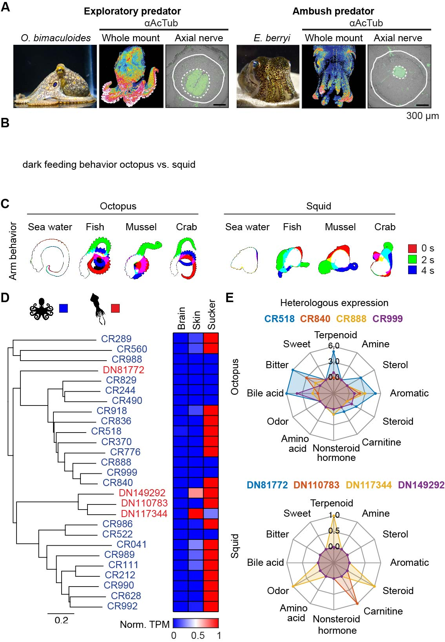

Fig. 1. Cephalopod chemotactile receptors have distinct molecular tuning
- Whole-mount neuronal immunostaining of tissue-cleared O. bimaculoides (right) hatchlings and E. berryi squid using an antibody against the marker α-acetylated tubulin (α-AcTub, center). Right, cross-section along the arm of an octopus and squid.
- Feeding behavior
- Autonomous behavior from amputated octopus (left) and squid (right) arms in response to fish, mussel and crab extracts. Sea water was used as negative control.
- Phylogenetic tree with O. bimaculoides (blue) and E. berryi (red) genes aligned to its expression pattern measured by bulk RNA-seq.
- CR activity in response to a panel of 80 molecules (100 µM). Web plots represent the number of molecules from a given category that activated the receptor. Responses were quantified by the increase in fluorescence of GCaMP6-expressing cells as an indicator of CR activity over basal (DMSO).
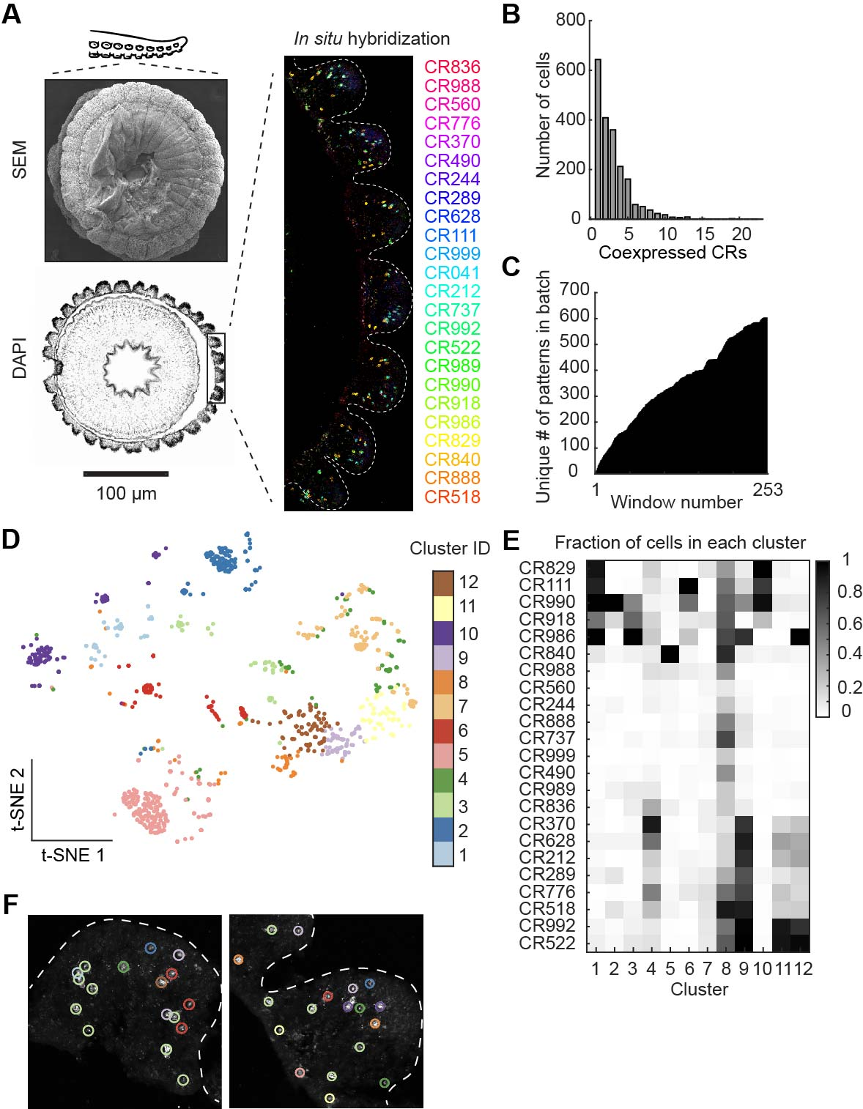

Fig. 2. Chemotactile receptors expression exhibits combinatorial patterns
- Left, scanning electron micrograph of an octopus sucker cup (top) and thin section of its sensory epithelium (bottom). Right, overlay of a multi in situ hybridization experiment for 24 O. bimaculoides CR genes.
- Histogram with number of coexpressed CR genes seen by in situ hybridization.
- Histogram with number of unique CR gene combinations observed across ~2000 cells.
- SNE space visualization of the first ten principal components obtained from the cell expression distribution. Cells were clustered using k-means.
- Matrix with fraction of cells expressing a given CR in each cluster.

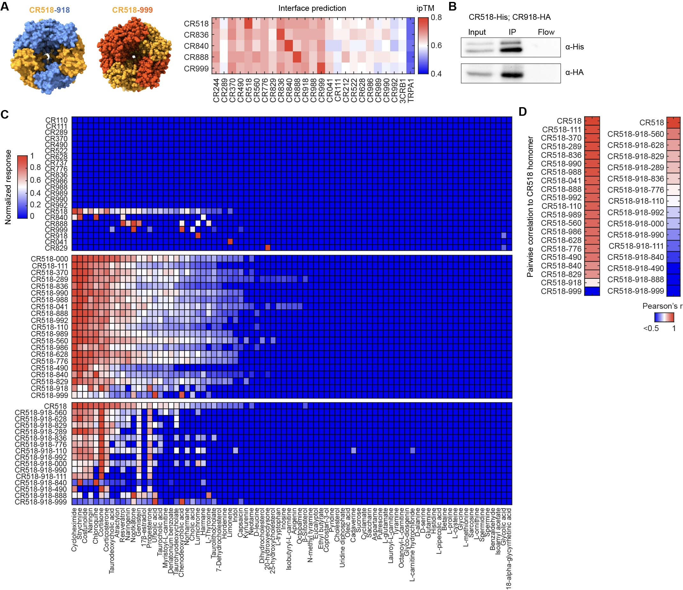

Fig. 3. CR coexpression modulates receptor selectivity to ligands
- Predicted AlphaFold3 structure of CR genes heteromerization. Heatmap of interface prediction values for CR gene pairs.
- CR518-918 complex pull-down. CR518-His was affinity purified using a nickel resin. Presence of CR918-HA was assessed in a western blot assay against the tag HA.
- Activity measurements in cell transfected with one, two or three CR genes in response to a panel of 80 molecules (100 µM) using GCaMP6 fluorescence as readout. Responses are normalized by receptor and ligands ranked by mean response across receptors. Each cell represents the maximal response to a given molecule. Color bar indicates normalized response.
- Pairwise Pearson’s correlation of receptor responses compared to CR518 response vector. Color bar indicates Pearson’s r value.

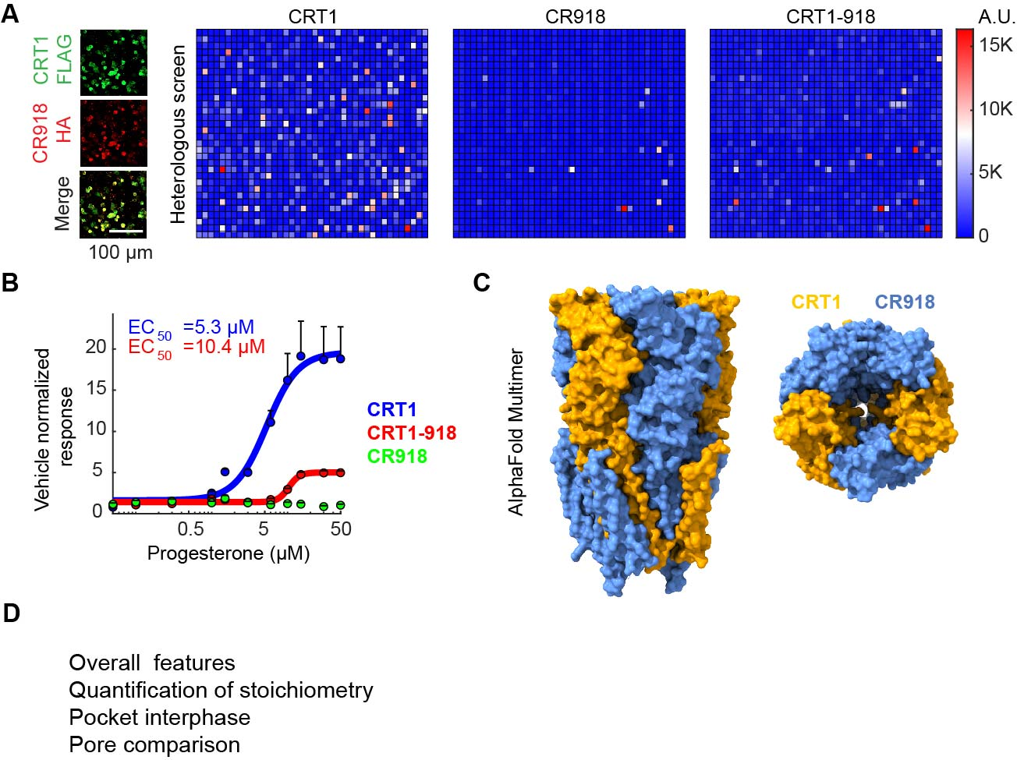

Fig. 4. CR genes coexpression leads to receptor heteromerization
- Activity measurements in cells expressing CRT1, CR918 and coexpressed with CRT1 increase in fluorescence of GCaMP6-expressing cells over basal. Each cell represents the top response to a single molecule. Color bar indicates fluorescence in arbitrary units. Gene expression was verified by the expression of the protein tags HA and FLAG (left).
- Dose-response activity relationships for progesterone and CRT1, CR918 and CRT1-918 expressing cells.
- Heteromer structure (Hao)
- Heteromer structure (Hao)

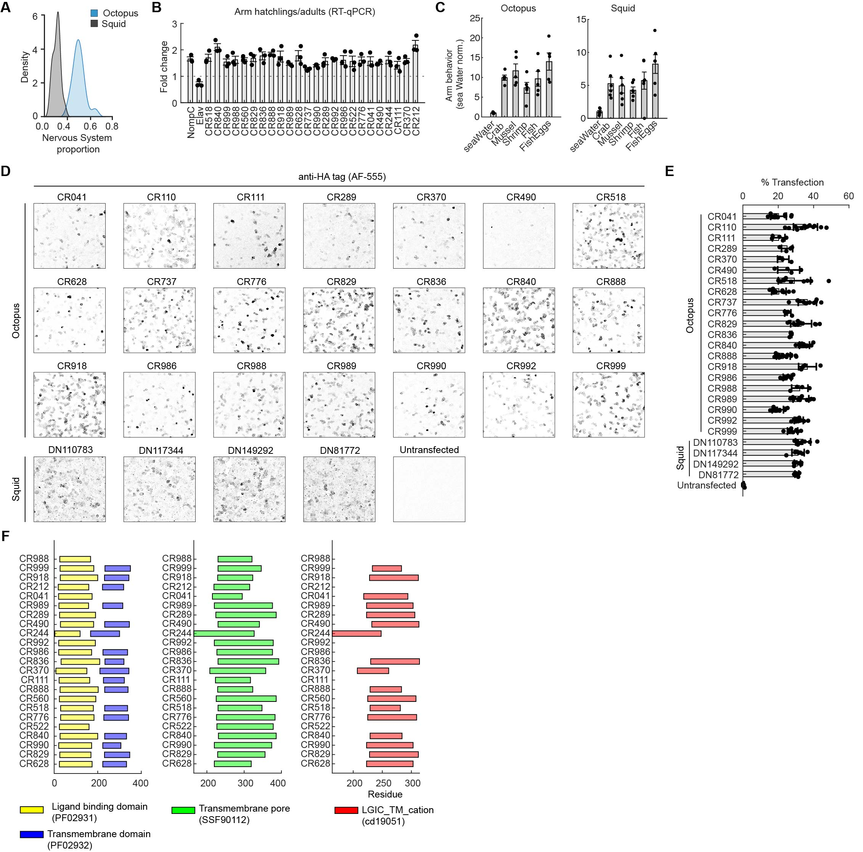

Fig. S1. In vitro expression of CR genes and ion channels protein domain prediction
- Ratio of axial nerve cord over arm section diameter for octopus (blue) and squid (gray).
- RT-qPCR quantification of CR genes in hatchling arms over adult octopus.
- Summary data for amputated arm behavioral responses to crab, mussel, shrimp, fish and fish eggs in octopus and squid from Fig. 1C. Octopus, n=; squid, n=. Statistical comparisons with sea water were calculated using one-way ANOVA with Kruskal-Wallis test. p< 0.005.
- Octopus and squid CRs were expressed in HEK293 cells together with the calcium sensor GCaMP6s to monitor receptor activity. Representative images of hemagglutinin (HA)-tagged CRs labeled using an anti HA-tag antibody to validate protein expression. Immunostaining was absent in untransfected cells.
- Successful transfection rates were estimated as the percentage of immunostained cells over the total number of DAPI cells. Each dot represents mean transfection percentage in a single image.
- Protein domain prediction in octopus CR genes using the protein family (Pfam), Superfamily (SSF) and the conserved domain (CDD) databases.
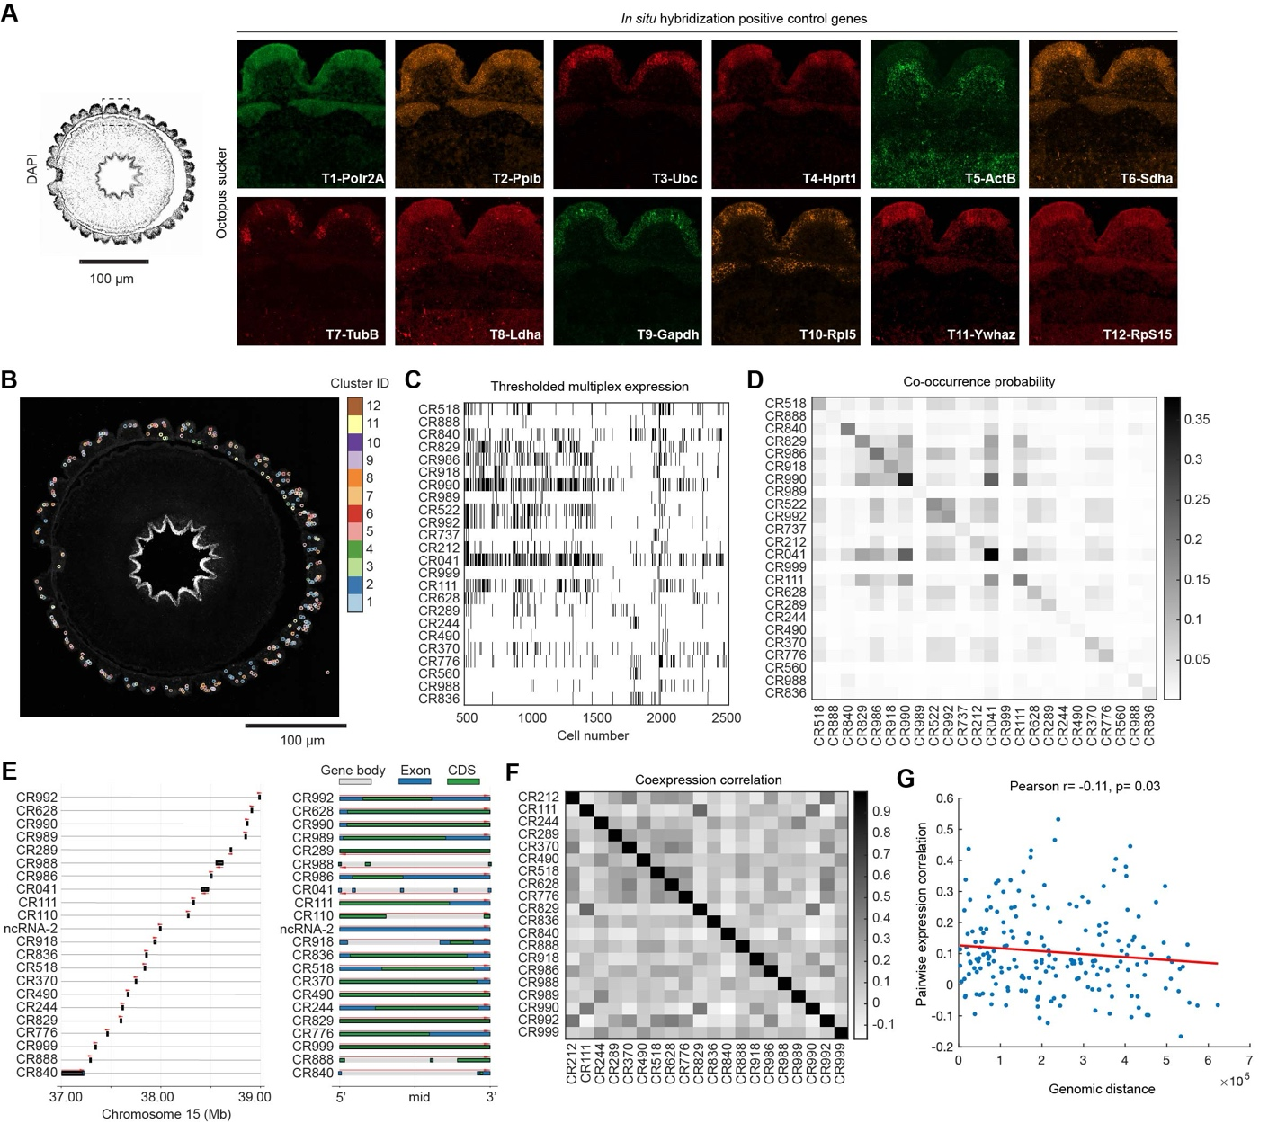

Fig. S2. Spatial transcriptomics in octopus sucker cups
- Expression of housekeeping genes measured along each imaging iteration of the RNAscope HiPlex platform. RNA polymerase II subunit A (PolR2A), peptidylprolyl isomerase-B (Ppib), ubiquitin C (Ubc), hypoxanthine phosphoribosyltransferase-1 (Hprt1), actin-β (ActB), succinate dehydrogenase complex flavoprotein subunit A (Sdha), tubulin-β chain (TubB), lactate dehydrogenase (Ldha), glyceraldehyde-3-phosphate dehydrogenase (Gapdh), ribosomal protein L5 (Rpl5), tyrosine-3-monooxygenase (Ywhaz), ribosomal protein S15 (RpS15).
- Sucker epithelium with neurons identified by cluster. Colors indicate cluster identity.
- Raster plot with all neurons analyzed and their expression profile.
- Co-occurrence probability for all CR genes detected during in situ hybridization experiments normalized by total number of cells.
- Genomic loci of O. bimaculoides CR genes in chromosome 15. Exons are colored in blue, coding sequences (CDS) in green and gene body in grey.
- Pairwise Pearson’s correlation of the CR gene expression.
- Pairwise expression correlation versus genomic distance in chromosome 15.

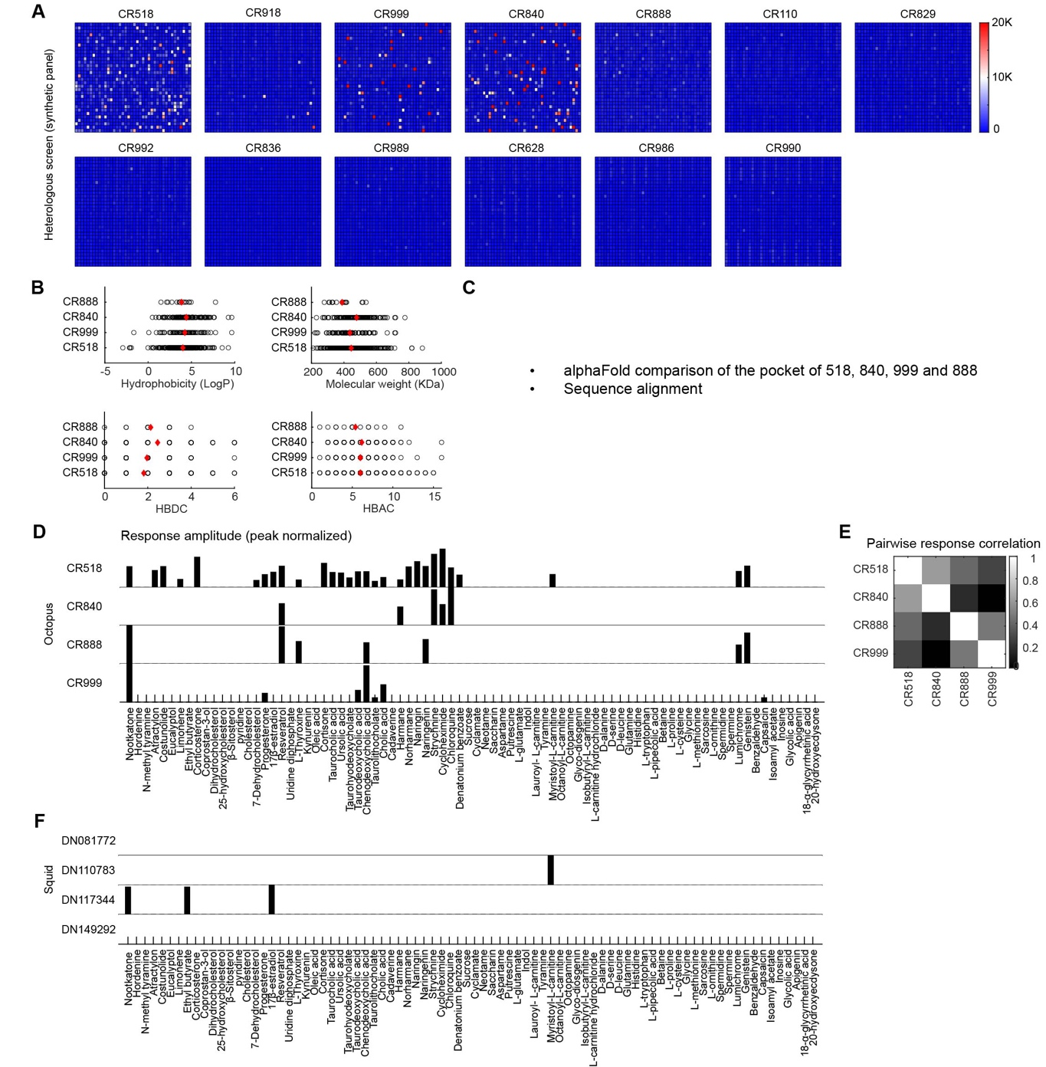

Fig. S3. Molecular tuning of octopus and squid CRs
- GCaMP responses in HEK293 cells expressing a given CR (top label) in response to a panel of 1250 synthetic molecules (Tocriscreen compound library). Each cell represents the maximal fluorescence after the addition of a single compound at a 10 µM final concentration. Each screening plate contained 8 control wells (vehicle) used for comparison with test wells. Responses greater than the mean vehicle response plus 8 times the standard deviation across vehicle wells were considered significant.
- Physicochemical properties for the molecules that evoked significant responses CR888, CR840, CR999 and CR518. Mean is indicated by a red marker.
- AlphaFold comparison of the orthosteric binding site of CR888, CR840, CR999 and CR518.
- Tuning vectors for the octopus CR888, CR840, CR999 and CR518 in response to a 80 molecule screen panel.
- Pairwise response correlation for tuning vectors shown in D.
- Tuning vectors for the squid DN081772, DN110783, DN117344 and DN149292 in response to an 80-molecule screen panel.
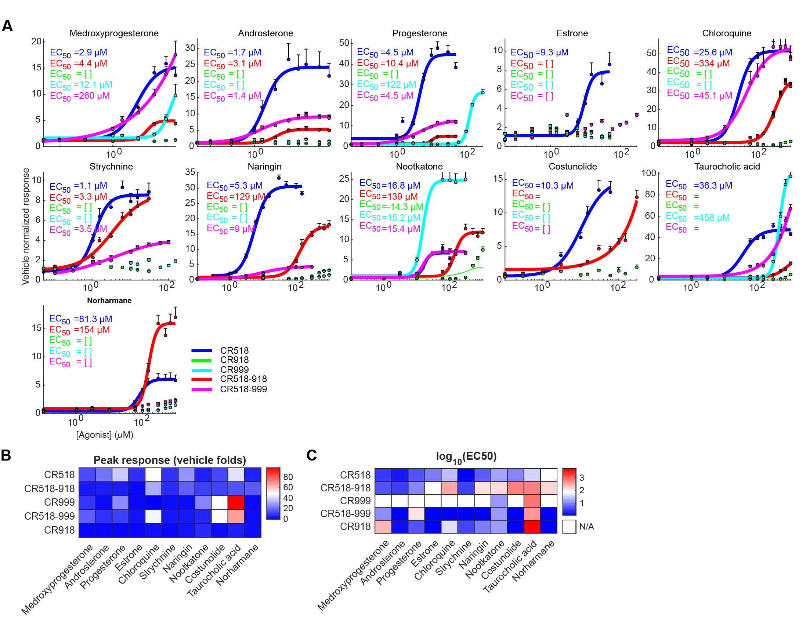

Fig. S4. CR heteromerization modulates receptor sensitivity and efficacy
- Dose-response activity relationships for steroids, bitter molecules, terpenes and bile acids for the homomer CR18 (blue), CR918 (green), CR999 (cyan), CR518-918 (red) heteromer and CR518-999 heteromer (purple).
- Peak response measured for each ligand-receptor pair normalized by the response to the vehicle DMSO.
- Sensitivity measured as EC50 value for each ligand-receptor pair.

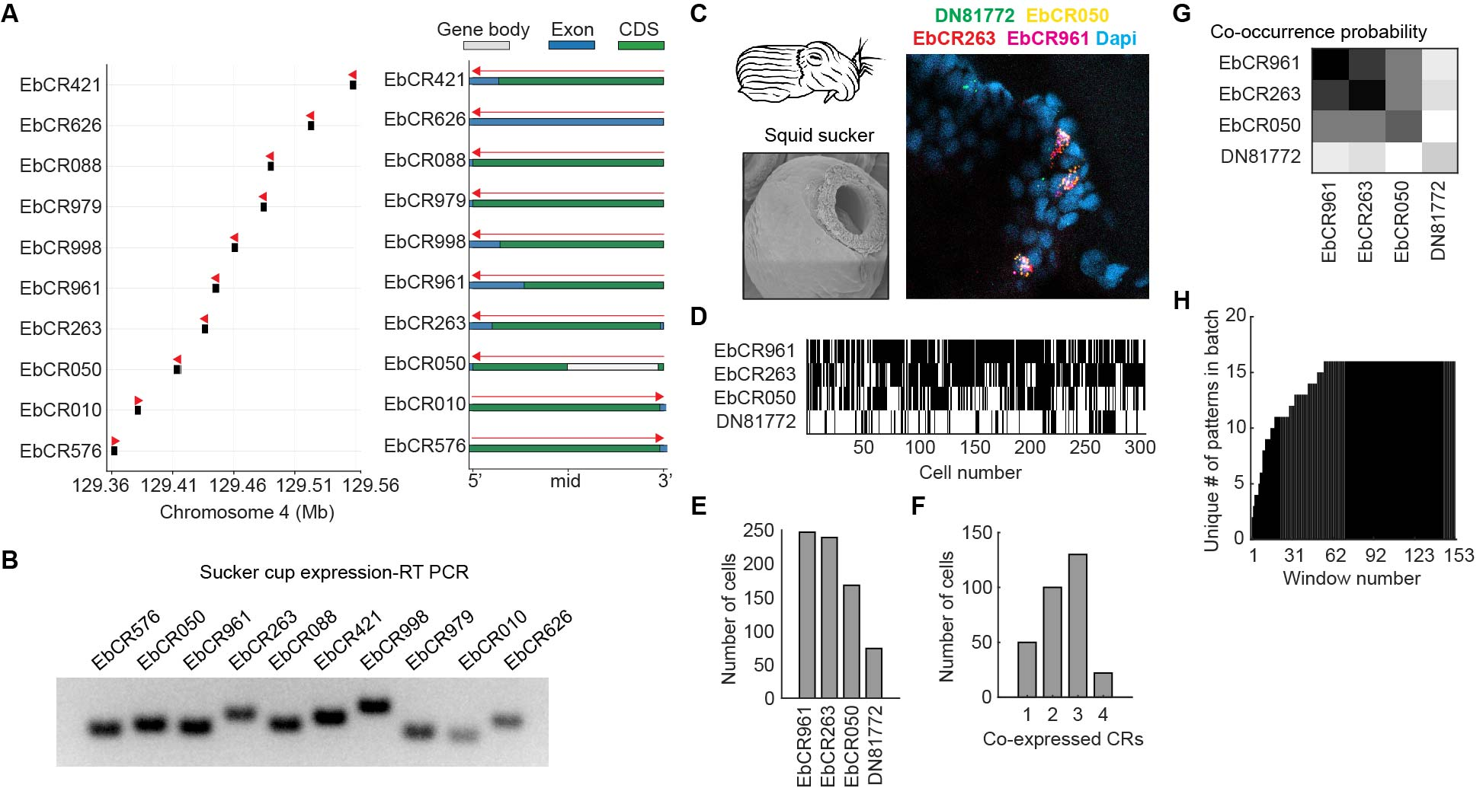

Fig. S5. Chemotactile receptors expression in E. berry squid
- Genomic loci map of E. berryi CR genes in chromosome 4. Exons are colored in blue, coding sequences (CDS) in green and gene body in grey.
- Squid CR gene expression measured by RT PCR.
- In situ hybridization for four squid CR genes in a section of sucker sensory epithelium.
- Raster plot with all neurons analyzed and their expression profile.
- Number of total neurons expressing each CR gene.
- Histogram with number of coexpressed CR genes seen by in situ hybridization.
- Pairwise co-occurrence probability normalized by number of total cells.
- Histogram with number of unique CR gene combinations observed.

