Frontier methods for digital soil mapping, evaluated honestly: a reproducible benchmark on real WoSIS Cerrado profiles
Abstract
Digital soil mapping (DSM) has moved well beyond regression trees, yet the newer methods — causal inference, physics-informed and generative deep learning, graph and quantum kernels — are rarely evaluated against each other under a common, honest protocol, and their predictions are rarely reported with calibrated uncertainty. We present edaphos, an R framework that implements ten such method families behind a single posterior class so that any of them can be scored with the same diagnostics, and we use it to run a matched, spatially blocked benchmark of six methods on 1095 real World Soil Information Service (WoSIS) topsoil profiles over the Brazilian Cerrado. The result is deflationary and, we argue, useful: a plain ordinary-least-squares model on a directed-acyclic-graph (DAG)-selected covariate set is the most accurate and best-calibrated method in the comparison, and none of the five more elaborate pillars beats it on this task. We further show, on 3077 profiles, that backdoor adjustment yields robust associations with explicit sensitivity bounds rather than identified causal effects, and that instrumenting soil carbon with a trained foundation-model embedding produces very strong but invalid instruments (first-stage F $≈$ 4630, Sargan p $≈$ 3e-13) — an empirical confirmation that a learned representation does not manufacture a valid instrument. We conclude that the contribution of a framework like edaphos is not a new best predictor but a reproducible, calibration-consistent apparatus for asking which method helps, and for reporting honestly when none does.

1 Introduction
Digital soil mapping (DSM) predicts soil properties at unvisited locations from spatially exhaustive covariates that proxy the soil-forming factors [1]. The field’s workhorse — the random forest and its quantile variants — is accurate, fast and well understood, and a large recent literature proposes to improve on it with methods borrowed from causal inference, deep learning, and quantum machine learning. Two problems recur. First, these methods are seldom compared under a common protocol: differences in cross-validation scheme, ensemble budget, target transform and evaluation metric make published gains hard to attribute to the method rather than the harness. Second, point accuracy is reported far more often than calibrated uncertainty, even though a soil map is used to make decisions under that uncertainty.
A third, more conceptual problem concerns causality. It is common in DSM to read a covariate’s importance in a predictive model as evidence that it causes the soil property [2]. Zhang and Wadoux [3] argue that causal inference in DSM is possible only under conditions — an explicit causal model, causal sufficiency, and faithfulness — that observational soil data rarely satisfy, and that the generative, process-informed view of causation is the one most compatible with those conditions.
This article makes three contributions, all reproducible from data bundled with the software: (i) a single uncertainty-calibration interface that lets ten method families be scored with the same diagnostics; (ii) a matched, spatially blocked, uncertainty-aware benchmark of six methods on real WoSIS Cerrado profiles, whose honest conclusion is that a DAG-informed OLS is the strongest method here; and (iii) a causal analysis that reports backdoor-adjusted associations with Cinelli–Hazlett robustness values, demonstrates confounding directly, and reports a negative instrumental-variable result. We deliberately foreground the negative findings: a framework that makes it easy to run a dozen methods is only useful if it is equally easy to see when they do not help.

2 Materials and methods

2.1 Data
The benchmark uses 1095 WoSIS [4] topsoil (0–30 cm) organic-carbon profiles over the Cerrado, retrieved from the ISRIC Web Feature Service, with covariates extracted at each profile from WorldClim 2.1 [5], SoilGrids [6] and Copernicus fractional tree cover. The causal analysis uses a larger draw of 3077 profiles over the same region and covariate stack. Covariates are all open-licensed and fetched from public endpoints, so the analysis is regenerable from profile coordinates alone.

2.2 A unified posterior and calibration interface
Every predictive method in edaphos returns, or can be coerced to, an edaphos_posterior: a small object carrying a predictive sample (or mean and standard deviation) for each target. A single routine then scores any of them with the same measures — the continuous ranked probability score (CRPS), 90% prediction-interval coverage (PICP) and mean width (MPIW), and a reliability curve. This makes a like-for-like comparison across otherwise incompatible methods possible: a random forest’s quantiles, a Gibbs sampler’s draws and a diffusion model’s samples are all reduced to the same currency.

2.3 Methods compared
The benchmark compares one baseline and five frontier methods: P1, ordinary least squares on the covariates in the backdoor adjustment set of an expert pedogenetic DAG (the baseline); P4, a quantile random forest on the principal components of a MoCo-v2 contrastive encoder trained on raster patches; P5, a quantile random forest on the raw covariates; P6, quantum kernel ridge regression using a ZZ-feature-map state-vector simulator; P7, a Bayesian hierarchical spatial model fit by a Gibbs sampler; and P10, a graph attention network over a k-nearest-neighbour co-location graph of profiles.

2.4 Evaluation and causal protocol
All methods are evaluated on the same 1095 spatially blocked cross-validation folds, on the log1p scale of organic carbon, and scored against the achievable null — each fold’s training-fold mean, not the global mean. Ensemble size is reported rather than forced equal. For the causal analysis we build an expert Cerrado DAG, compute the minimal backdoor adjustment set per exposure, estimate the adjusted association by OLS with a spatial block bootstrap (500 resamples over 20 clusters), and pair every estimate with a Cinelli–Hazlett robustness value (RV) [7]: the fraction of residual variance an unobserved confounder would have to explain in both exposure and outcome to drive the estimate to zero. We also attempt instrumental-variable estimation, using the principal components of a foundation-model embedding as instruments for precipitation, and test their validity with the Sargan over-identification test.

3 Results

3.1 A DAG-informed OLS is the strongest method
Matched cross-pillar benchmark on 1095 WoSIS Cerrado profiles (1095 spatially blocked folds, log1p scale). RMSE and CRPS lower is better; R2 and PICP near 0.90 better.
Method | RMSE | R2 | PICP90 | MPIW90 | CRPS | Time (s)
P1 OLS (DAG-selected covariates) | 0.583 | 0.067 | 0.878 | 1.844 | 0.323 | 2.3
P5 QRF | 0.589 | 0.051 | 0.872 | 1.830 | 0.321 | 1.6
P7 BHS | 0.597 | 0.041 | 0.845 | 1.692 | 0.334 | 111.1
P4 Foundation embeddings + QRF | 0.613 | -0.003 | 0.884 | 2.143 | 0.336 | 80.6
P10 GAT (trained attention) | 0.621 | -0.080 | 0.745 | 1.442 | 0.367 | 36.1
P6 Quantum KRR | 0.663 | -0.184 | 0.476 | 0.863 | 0.417 | 715.4
Ordinary least squares on the DAG-selected covariates has the lowest RMSE (0.583) and the highest coefficient of determination (0.067), and its calibration (PICP 0.878) is among the best (Table 1). The random forest is a close second. The three deep or exotic methods — foundation embeddings, graph attention, and the quantum kernel — sit progressively lower, and all three fall below the achievable null ($R^{2}<0$): on these spatially blocked folds they explain less than predicting the training mean. The quantum kernel is both least accurate and, at 715 s, several hundred times slower than the baseline (Fig 1). The spread among the top methods is small relative to the fold-to-fold standard deviation ($≈$ 0.06 RMSE), so we do not over-read the ordering beyond its headline: elaboration did not pay here.
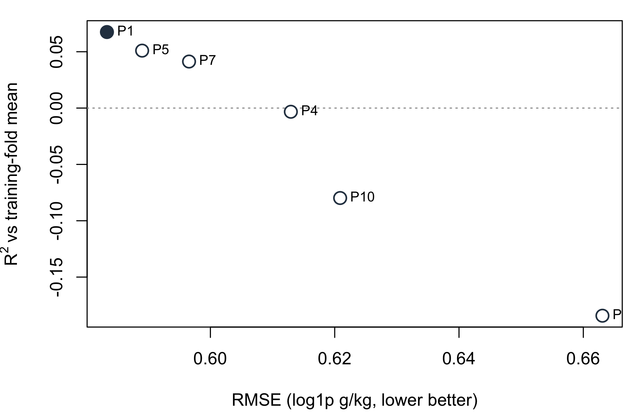
Accuracy (RMSE, lower better) against variance explained (R2 vs the training-fold mean). The DAG-informed OLS (filled) is the most accurate; every more elaborate method sits down and to the left, and three fall below the achievable null.
When tuned under nested cross-validation (1095 profiles; outer folds never used for tuning), the graph attention network reaches a pooled Nash–Sutcliffe efficiency of 0.184 against the tuned forest’s 0.165 — an edge whose 95% block-bootstrap confidence interval, [-0.021, 0.057], spans zero (P(GAT ahead) = 0.844). The attention mechanism is thus competitive with, not superior to, a random forest.

3.2 Causal inference: robust associations, and why identification is hard
Backdoor-adjusted associations on 3077 WoSIS Cerrado profiles (g/kg topsoil carbon per unit exposure). RV: Cinelli-Hazlett robustness value.
 | Exposure | Naive | Adjusted | 95% CI | Sig. | RV
wc_bio_12 | Precipitation (per mm) | 0.008 | 0.010 | [0.003, 0.019] | yes | 0.16
wc_bio_01 | Temperature (per degC) | -0.467 | -0.824 | [-1.367, 0.222] | no | 0.08
wc_landcover_trees | Tree cover (per 0-1) | 2.864 | 0.347 | [-3.314, 2.940] | no | 0.01
soilgrids_clay | Clay (per %) | 0.446 | 0.448 | [0.292, 0.641] | yes | 0.18
Two associations are robust and mechanistically sensible (Table 2): precipitation and clay content both raise topsoil carbon, are distinguishable from zero, and would each need an unobserved confounder explaining about 16–18% of residual variance in both exposure and outcome to overturn. The temperature association carries the expected negative sign but is not distinguishable from zero. The tree-cover row is instructive: its naive association (2.86) all but vanishes after adjusting for climate (0.35, interval spanning zero, RV 0.006) — the raw signal was largely shared climatic ancestry. This is exactly the confounding that Zhang and Wadoux [3] warn is misread as causal, shown directly on real data.
Backdoor adjustment identifies an effect only under causal sufficiency. Instrumental variables promise identification under a different assumption — that an instrument affects the outcome only through the exposure. We trained a real MoCo-v2 foundation encoder (7 covariate channels, 12,000 tiles, 3,000 epochs) and used the principal components of its per-profile landscape embedding as instruments for precipitation. The instruments are extremely relevant — a first-stage $F$ of 4630, far above the usual threshold of 10 — yet they decisively fail the Sargan over-identification test ($χ^{2}$(4) = 84.4, $p≈$ 0e+00). A learned landscape representation encodes climate, terrain, soil and vegetation together, so it reaches carbon through many paths and violates the exclusion restriction. Even a powerful learned representation does not manufacture a valid instrument; we report the failed test, not a headline effect.

4 Discussion
The benchmark’s conclusion — that a DAG-informed OLS is the strongest method, and that three of five frontier pillars fall below the achievable null — deserves care in either direction. It does not show that deep learning cannot work in DSM; it shows that on about 1000 point profiles with a handful of coarse covariates, the sample and signal are too small for high-capacity models to express an advantage, and that a linear model on well-chosen covariates is hard to beat. This is a common finding for tabular problems at this scale, and it is precisely the kind of result that a matched, uncertainty-aware protocol surfaces and an accuracy-only, single-method report hides. The calibration columns make the same point from another angle: the quantum kernel’s narrow intervals buy the worst coverage, an overconfidence a point-accuracy table would never reveal.
The causal results carry the second message. Backdoor adjustment on an explicit DAG is a legitimate and useful tool — it recovered a robust precipitation and clay signal and exposed the tree-cover association as mostly confounding — but the honest object it returns is an adjusted association with a sensitivity bound, not an identified causal effect. The negative IV result sharpens this: the most tempting modern shortcut to identification, a learned representation as instrument, is the wrong tool, because the property that makes an embedding a good predictor (it captures everything) is the property that makes it an invalid instrument (it violates exclusion).
The limitations are inherent to the design. A single biome, about 1000–3000 profiles, and coarse covariates are a hard setting for high-capacity methods; a larger, denser survey with fine-resolution covariates might let the foundation encoder or graph network express structure they cannot here, and the framework is built to make that re-test a one-line change of data. The benchmark scores prediction, not the process-informed generative modelling that Zhang and Wadoux [3] identify as the most defensible route to causal claims.

5 Conclusion
We have presented a reproducible framework that reduces ten families of DSM method to a common posterior-and-calibration currency, and used it to run a matched, honest benchmark whose lesson is deflationary: on real WoSIS Cerrado profiles a DAG-informed ordinary-least-squares model is the most accurate and best-calibrated method, and no more elaborate pillar beats it. The value we claim is not a new best predictor but the apparatus — and the discipline — for finding out which method helps, reporting calibrated uncertainty, and stating plainly when the answer is “none of the new ones, here.” The same apparatus delivered a robust causal association analysis with explicit sensitivity bounds and a clean negative instrumental-variable result, operationalising the caution that causal identification from observational soil data is hard.

Data and code availability
edaphos and all bundled result data are available at https://github.com/HugoMachadoRodrigues/edaphos. Soil profiles are from WoSIS (ISRIC, CC-BY-4.0); covariates from WorldClim 2.1, SoilGrids and Copernicus. The retrieval and analysis pipeline is in data-raw/, and every figure in this manuscript is reproduced by the edaphos-paper package vignette from the shipped data.

References
1. McBratney AB, Mendonça Santos ML, Minasny B. On digital soil mapping. Geoderma. 2003;117: 3–52. doi:10.1016/S0016-7061(03)00223-4
2. Wadoux AMJ-C, Minasny B, McBratney AB. Machine learning for digital soil mapping: Applications, challenges and suggested solutions. Earth-Science Reviews. 2020;210: 103359. doi:10.1016/j.earscirev.2020.103359
3. Zhang L, Wadoux AMJ-C. Can digital soil mapping be causal? European Journal of Soil Science. 2026;77: e70284. doi:10.1111/ejss.70284
4. Batjes NH, Calisto L, Sousa LM de. Providing quality-assessed and standardised soil data to support global mapping and modelling (WoSIS snapshot 2023). Earth System Science Data. 2024;16: 4735–4765. doi:10.5194/essd-16-4735-2024
5. Fick SE, Hijmans RJ. WorldClim 2: New 1-km spatial resolution climate surfaces for global land areas. International Journal of Climatology. 2017;37: 4302–4315. doi:10.1002/joc.5086
6. Hengl T, Mendes de Jesus J, Heuvelink GBM, Ruiperez Gonzalez M, Kilibarda M, Blagotić A, et al. SoilGrids250m: Global gridded soil information based on machine learning. PLOS ONE. 2017;12: e0169748. doi:10.1371/journal.pone.0169748
7. Cinelli C, Hazlett C. Making sense of sensitivity: Extending omitted variable bias. Journal of the Royal Statistical Society: Series B. 2020;82: 39–67. doi:10.1111/rssb.12348

