**Method for Measurements:**

Calibration results should be documented so that the traceability of all measurements can be demonstrated and so that the calibration can be reproduced under conditions that are close to the original ones. In some cases, a verification result is included in the calibration certificate or report, indicating whether the equipment meets the specified requirements or not. The documentation can be in the form of handwritten notes, typed documents, microfilm, or in electronic or magnetic memory or other data media. The maximum permissible error can be determined by the metrological function or by reference to published specifications from the manufacturer of the measurement equipment.

Initially, the plan was to take measurements when the machine was in a static hold, and the method was developed based on this concept. However, the measurements from the static holds showed that the engine in the machine went into an idle state. This was not a great baseline for obtaining accurate data, therefore the method had to be refined.

Instead of making static holds, the measurements were made on dynamic movements. The sampling speed of the force sensor is relatively low, at 1 Hz, which poses challenges in obtaining smooth graphs during dynamic movements. To make the graph smoother the movement was performing fairly slowly, around 8 seconds for each full repetition. The dynamic movements range between 4 Kg up to 50 Kg.

The values from the sensor and the data were collected and moved to an excel file. Here the challenge was that the sensor and the record function had different sampling frequencies, the sensor had 1 Hz and the record function had 60 Hz. To address this, during the data collection, the values from the recording function were averaged every 60 samples to produce a mean value. This value was used to compare against the sensor data, resulting in graphs that were analyzed. The linear graph was calculated from all the peak values of both the data and the sensor.

Fig 1


Fig.1

Fig.1 displays the graph from the data and the sensor showing the peak values from every movement. These peak values were used to make the linear graph in Fig.2.

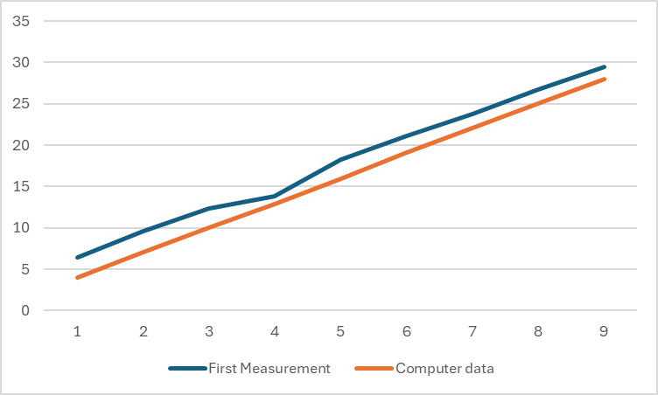

Fig.2

Fig.2 displays the linear graph made with the peak values from the sensor and the data in Fig.1. With this graph the calibration was possible to do.

**The sensor we use:**

A digital force gauge (<https://docs.rs-online.com/ebc3/A700000007226729.pdf>)

With the force gauge, we can record our measurements onto an SD card. The contents of the SD card are transferred to a computer and converted into an Excel file. The graph created in Excel can be compared to the graph generated by the software connected to the power cable. From the graphs, we can make adjustments in the code to optimize the machine’s weight. The force gauge samples at 1 Hz (1 sample per second). We need to fix the program so it samples at the same frequency. We also need to devise a method to synchronize our graphs.

**How measurements should be performed:**

The measurements should be static to achieve the best possible repeatability and reproducibility. By incrementally increasing the machine's weight at regular intervals in a static position, it becomes easier to compare the graphs generated with an accurate stability between different measurements. The weight should be increased in 5 kg intervals up to a maximum of 50 kg. One suggestion is to create a function in Python where we increase the weight linearly, for example, by 1 kg per second to ensure all measurements are taken with the smallest amount of human errors that can affect the data.

**Materials:**

● Digital force gauge with force sensor

● Power cable

- Powersupply

- Strap

- Encoder

- Sensor

- Motor

- Hardware to connect the parts

● Operating software

● Carabiner

● Handle

**Procedure:**

1. Plug the machine into a power outlet, start the program in Python, and calibrate the machine.
2. Reset the force gauge and its SD card.
3. Attach the force sensor between the belt and a stationary point.
4. Set the starting weight.
5. Method for synchronizing the graphs

a. Start the recording function on both the computer and the force sensor.

b. Run the implemented sine function for a few periods at a slow frequency, allowing the force sensor to capture many measurements per period.

1. Then switch to the "linear program."
2. Perform the measurements.
3. Document any potential sources of error.
4. Transfer the measurement data and convert it into graphs in Excel.
5. Synchronize the graphs.

Each measurement should be repeated 5 times so the outcomes can be compared. Then, an average value will be taken from the measurements recorded on both the computer and the force gauge, which will be plotted as graphs and compared. We will increase the weight by 5 kg approximately every 10 seconds until we implement a linear function in the program that can increase the weight at an exact time.

**Conclusion:**

Our method of recording data this way is to ensure the best and easiest repeatability, reproducibility and stability for us and others that want to do a similar product. We use the sensor because it is a state of the arc force gauge ensuring small measurement uncertainty and it has features good enough for our goals. This validating our method of recording data and making the data usable to accomplish our goal of calibrating our product so it has an offset of ± 0.5 Kg / ± 1.1 pounds.