Force Cable - Results

The initial equation for *converting current to kilograms* was set at $\frac{Kg}{1,8}$, but was later revised to $\frac{Kg}{1,8}-0,6$,to achieve a more calibrated and accurate value. The goal was to fine-tune the machine so that the resistance differed by no more than 0.5 kilograms when pulling the cable. After applying the new equation, the discrepancy between the computer's output and the force gauge readings was significantly reduced. This improvement is illustrated in the graph, where the x-axis represents the applied weight, and the y-axis shows the difference between the applied weight and the data recorded by the force gauge.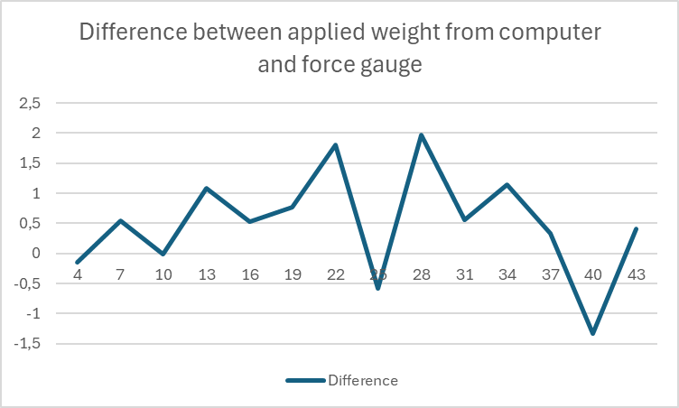

Figure 1: Graph representing the difference between applied wight and force gauge data,

Furthermore, during continuous smooth movements, hysteresis is less pronounced compared to the initial phase of motion. All measurements conducted had a total repetition time of no more than 8 seconds, as this duration is optimal for hypertrophy.[1] The machine demonstrated a high degree of accuracy during the pulling phase of the cable. However, its accuracy decreases when the cable returns to the starting position, indicating the need for further improvements in this aspect.

In summary, we successfully achieved our goal of improving the machine's accuracy. The results from our validation confirm that our product is well-suited as an alternative for consumers seeking a compact cable machine at a lower cost.

1. MDPI, "Effects of Loaded Whole Body Vibration Exercise on Strength, Muscle Properties, and Functionality in Recreationally Active Adults," *Journal of Functional Morphology and Kinesiology* 9, no. 1 (2024): 9, <https://www.mdpi.com/2411-5142/9/1/9>.