POWER CABLE: EFFORTLESS WEIGHT SELECTION FOR COMPACT, ECONOMICAL HOME GYMS

*Hugo Persson, Linnea Edwall, Caspar Alhadeff, Adam Fabricius-Hansen, Melissa Yasar*

Home training requires different equipment, for example a multi-gym machine, a rowing machine, free weights or a cable system. These types of equipment take up significant space and are expensive. Many of these machines are designed for only one type of exercise, meaning they lack versatility. Heavy free weights could also make a lot of noise and disturb neighbours for those living in smaller spaces or shared buildings. These factors can make setting up a home gym challenging.

In addition to our solution, there are a few competitors on the market. Beyond Power is one of the companies that have developed a machine with a similar concept to ours, VOLTRA I. However, this machine costs 28,300 SEK, which limits their accessibility to the average consumer. [1] In contrast, our product is made of materials costing 4,000 SEK, making it an affordable option.

The conclusion from our validation indicates that our product is efficient as a training equipment for individuals exercising at home for their well-being. Initially, our measurements revealed an offset in the weight calibration, with a variance of plus-minus 5 kg. After calibrating the system, we successfully reduced this offset to plus-minus 1 Kg.

This improvement ensures greater accuracy in weight tracking, enhancing the overall effectiveness and reliability of the equipment.

The product was initially built by Linus Remahl [2]. The machine consists of two main parts: the **hardware** and the **software**.

**2.1. Hardware:**

The machine is composed of 5 hardware subcomponents. A power supply is connected to a wall outlet and provides power to our machine.

*ODrive Encoder and sensor:*

The ODrive encoder (2) is connected to a computer that runs the software. It serves as an intermediary, providing communication between the computer, sensor and the motor. The computer is connected to the input (1) of the machine with an USB-cable.  
*Motor:*

The motor (4) in the machine is from a motorized longboard. Its primary function is to maintain its initial position, the starting point. When the user starts pulling the cord (5) the motor begins to spin. The sensor (3) detects this movement and sends updated information to the encoder.

**2.2.  Software:**

A Python program has been developed that enables users to operate the machine through a user interface (see picture). The orange line represents the positioning of the cable while the blue line indicates the applied weight. With this interface the user is able to set the preferred weight and change the starting position of the cable. Beside these functions, there is also a recording feature to track the data from the machine.



Through the interface, the user can provide the motor with what resistance it should use to try and return to its starting point with. It works by converting the set resistance in Kg to the current that the motor receives from the power supply. The equation used now to achieve this is: $\frac{Kg}{1,8}-0,6$. By adjusting the weight the motor receives a corresponding current. This ensures that when you pull the cord, the user will work against the motor's resistance of wanting to return back to its starting point, with the set weight the user provided in the user interface. To assess the precision of the system, the initial test was done as a static hold. These measurements showed that when doing static holds the machine went into an idle state which gradually gave lighter resistance over time. Because of this, it was deemed appropriate to use dynamic movements to use as the measuring method. 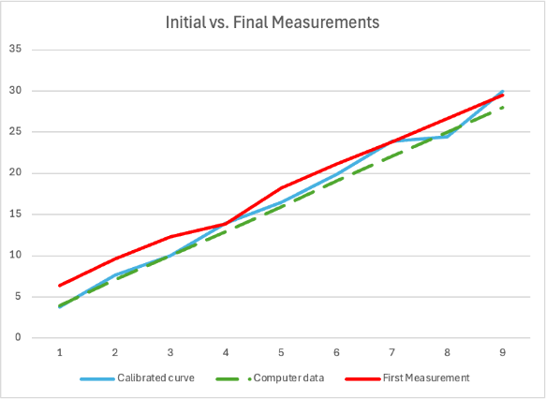Figure 1: Data results showing Initial vs Final Measurements

The average was calculated from all the peak values of both the data and the sensor.

As illustrated in the graph, the application of weight is comparably similar following calibration. It is important to note, however, that the sampling speed of the force sensor is relatively low at 1 Hz, which poses challenges in obtaining smooth graphs during dynamic movements. The dynamic movements were intended to range between 4 Kg up to 50 Kg. With every movement, from start to finish, ranging in the optimal time per rep. [3]

Furthermore, during continuous smooth movements, hysteresis is less pronounced than during the initial phase of movement.

This data indicates improved precision in the power output from the force cable. Given that the primary objective of this process was to validate the machine, the results demonstrate that this method is appropriate for the stated purpose. However, the values are not consistently exact and can vary by up to half a kilogram, and hysteresis may also occur within the system.

In addition, to optimize data collection and improve the machine's calibration, a more efficient method should be adopted. This would ensure faster testing and allow for more frequent data interpretation. Although the current method is reliable, it involves additional steps that could be streamlined for greater efficiency.

Utilizing a sensor with the same sampling frequency as the program's recording function would allow for accurate synchronization of the measurements. To address this during the data collection, the values from the recording function were averaged every 60 samples to produce a mean value. This value was used to compare against the sensor data, resulting in graphs that were analysed to develop a calibration.



The primary result from our validation proves that our product is suited as a gym equipment. With the small engine and its high resistance, the force cable enables the common person to build their own gym in a small space for a good price. The next step would be to develop a smartphone app connected to the machine through Bluetooth. This would make it easy for the user to set different weights and also make it possible to save data.

**References:**

[1] Voltra I: <https://www.beyond-power.com/products/voltra>

[2] Linus Remahl:

<https://github.com/linusreM>

[3]  Androulakis Korakakis, P.; Wolf, M.; Coleman, M.; Burke, R.; Piñero, A.; Nippard, J.; Schoenfeld, B.J. Optimizing Resistance Training Technique to Maximize Muscle Hypertrophy: A Narrative Review. *J. Funct. Morphol. Kinesiol.* **2024**, *9*, 9.

<https://www.mdpi.com/2411-5142/9/1/9?ref=sanatorium.health>