PandaDigital

Version 1.0

User Guide

December 26, 2017

Hugo Rodíguez Ignacio (HugoRod)

[hugo.rodriguezignacio@gmail.com](mailto:hugo.rodriguezignacio@gmail.com)

**Contents**

**1 Introduction** . . . . . . . . . . . . . . . . . . . . . . . . . . . . . . . . . . . . . . . . . . . . . **3**

**2 Load image** . . . . . . . . . . . . . . . . . . . . . . . . . . . . . . . . . . . . . . . . . . . . . **4**

**3 Axis points** . . . . . . . . . . . . . . . . . . . . . . . . . . . . . . . . . . . . . . . . . . . . . **5**

**4 User Points** . . . . . . . . . . . . . . . . . . . . . . . . . . . . . . . . . . . . . . . . . . . . . **7**

**Chapter 1**

**Introduction**

PandaDigital is a simple image digitizer tool that greatly reduces the time, effort and resources needed to extract plot's data from scanned images. The program currently addresses 2D graphs.

The data extraction can be accomplished in four steps:

1. Load an image to digitize with PandaDigital.
2. Set minimum and maximum values for X and Y axis.
3. Mark manually or automatically the points to be extracted.
4. Extract the points in a .pd file with PandaDigital.

**Chapter 2**

**Load image to digitize**

PandaDigital allows two methods of loading an image to digitize. The first one is by simply drag and drop the image into the blue PandaDigital box, placed at the left. The second one is selecting the option “Load Image” under the File tab in the menu at the top, as shown in Fig. 2.1.



Fig. 2.1 - “Load Image” option under the File tab in the menu.

**Chapter 3**

**Axis points**

The minimum and maximum for X and Y axis has to be marked in the image to digitize and mapped to corresponding values in the image in order to establish a reference for the latter data extraction.

First, the option for selecting the axis points has to be selected as shown highlighted in red in the Fig. 3.1

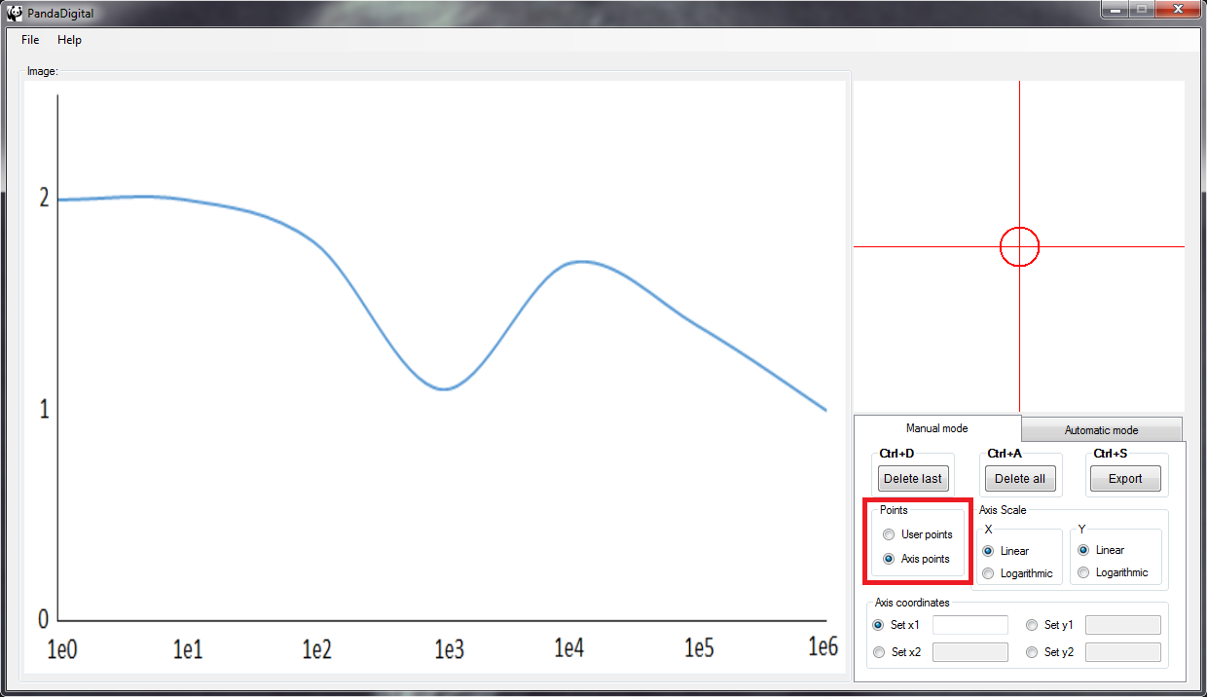

Fig. 3.1 – Select axis point option.

Then, select from the Axis coordinates box each axis points and mark it on the big image being accurate with the help of the zoomed image. Once the point is marked, enter the real value in the text box as shown in Fig. 3.2.

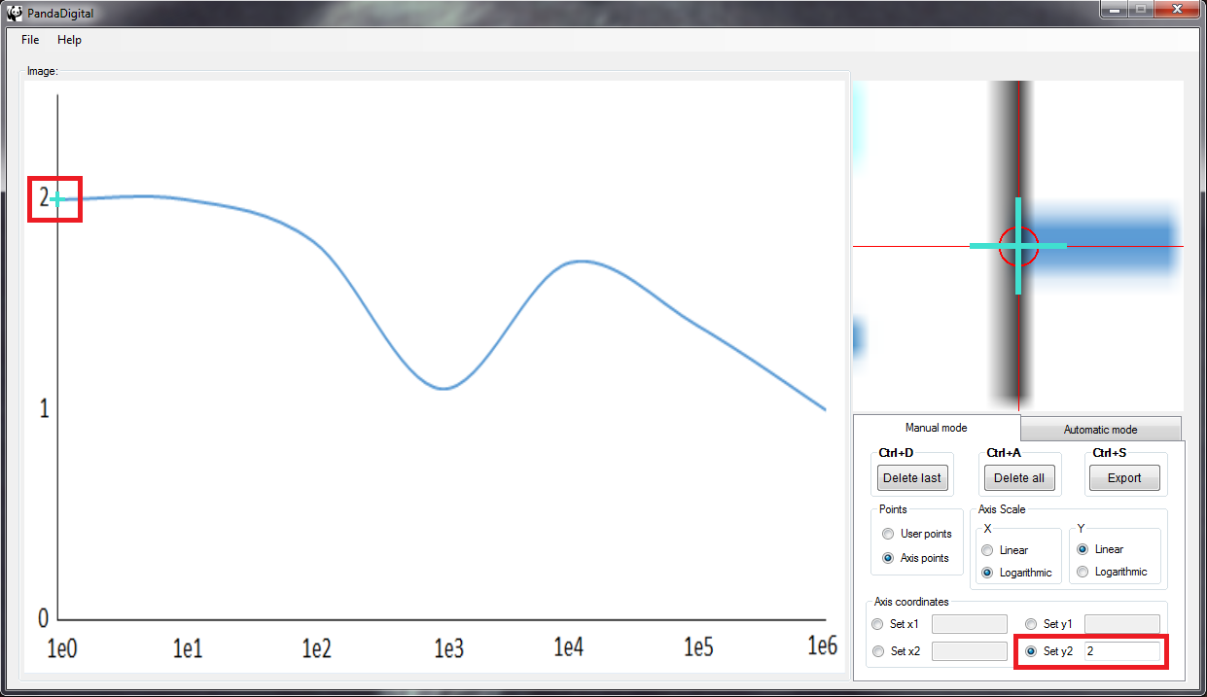

Fig. 3.2 – Mark each axis point in the image and enter its real value.

Finally, select the type of the scale for each axis as shown in Fig. 3.3.

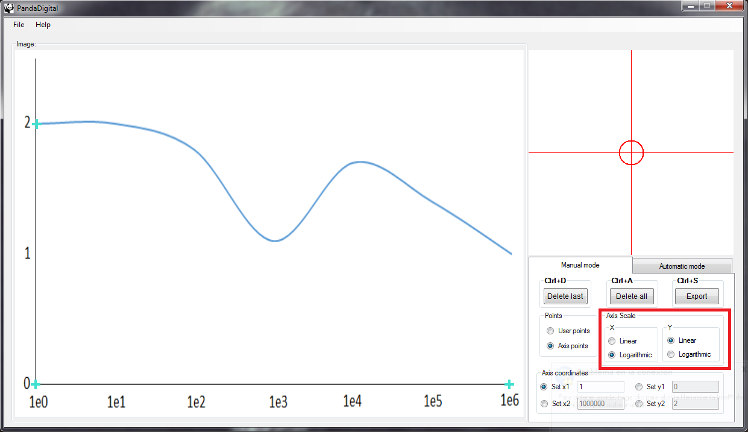

Fig. 3.3 – Select the type of scale.

**Chapter 4**

**User points**

The user points can be marked either manually or automatically. For both cases, user points option shown in Fig. 4.1 has to be selected.

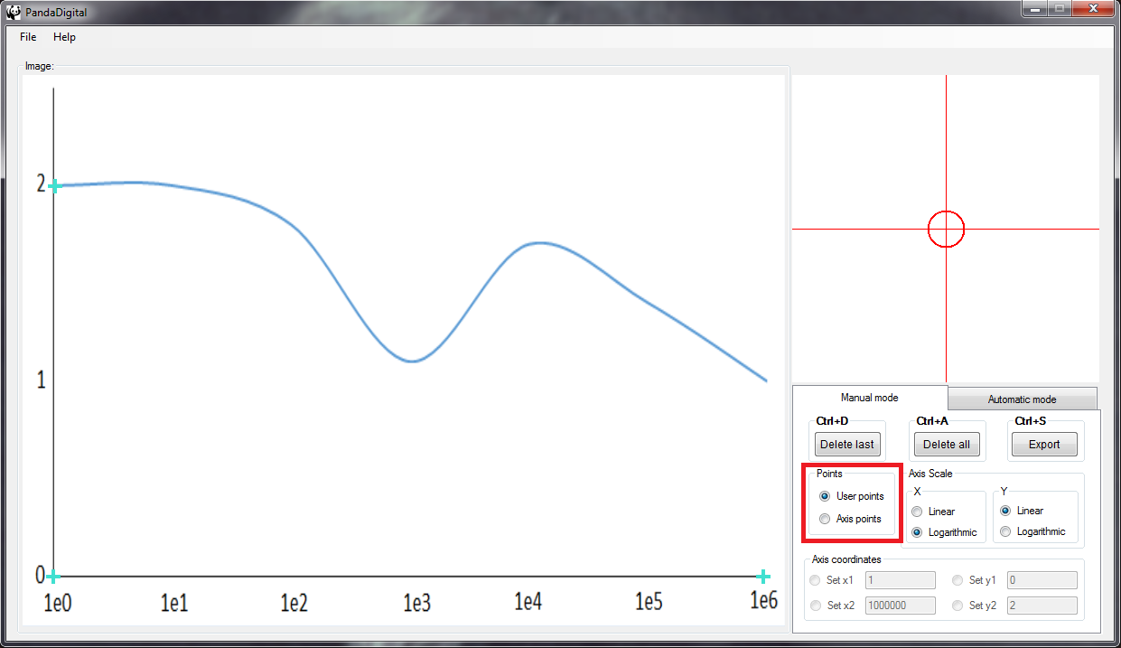

Fig. 4.1 – Select user points option

Then, start marking points in the big image with the help of the zoomed image as shown in Fig. 4.2.

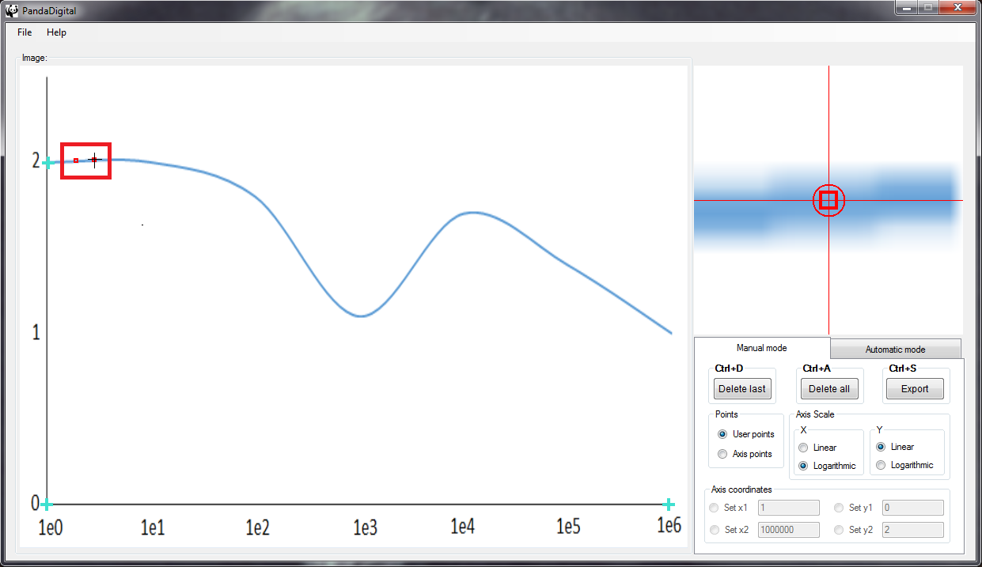

Fig. 4.2 – Marking user points.

There are options to help to modify the user points. These options include: delete the last marked point and delete all points. Once you are done, select the “Export” button to save your points in a .pd file. The options and its shortcuts are shown in Fig. 4.3.

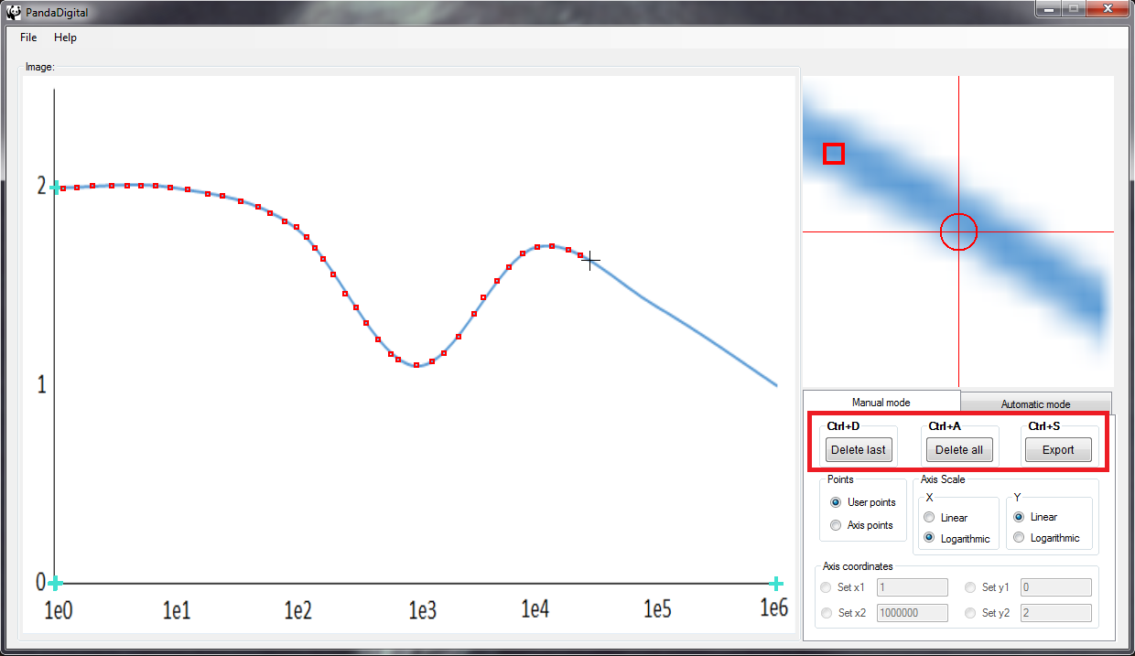

Fig. 4.3 – Options to handle user points and its shortcuts.