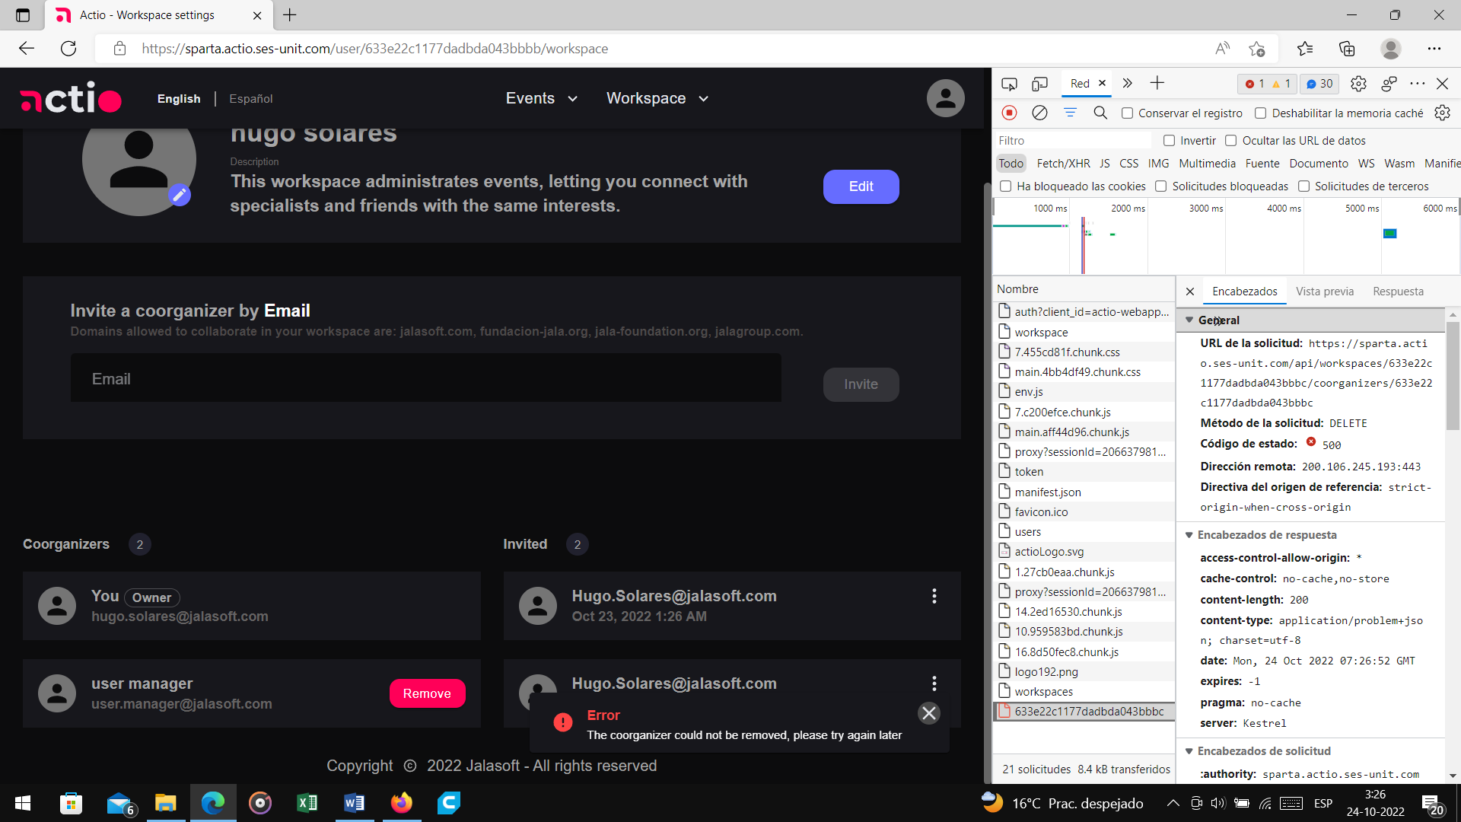

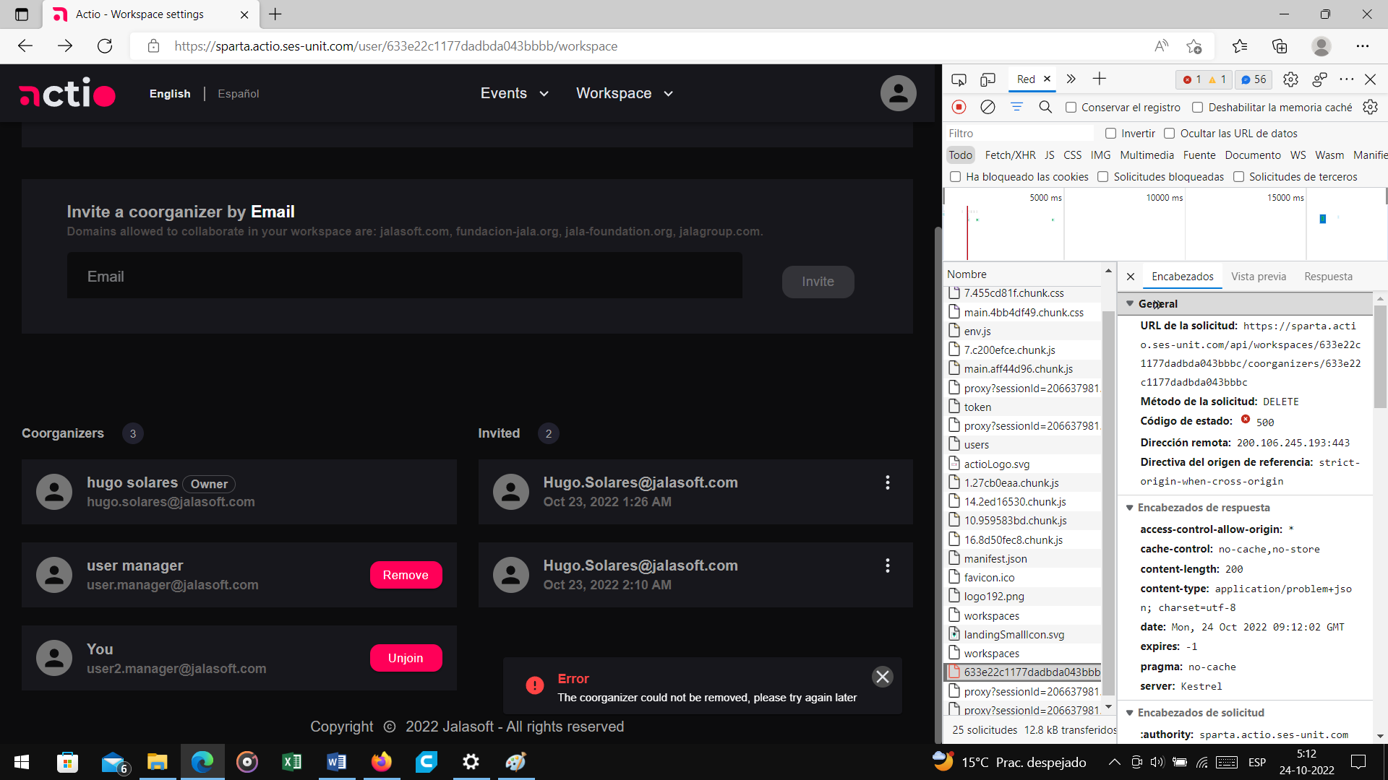

Description

When Translating to Spanish the workspace setting under manage your workspace, the word “Coorganizers” is not translating to Spanish, it is just changing the capital 'C' to lowercase.

Notes:

Workaround:

Environment:

Sparta

Chrome

Linux Ubuntu

Preconditions:

Have an internet browser opened

Have the page

Have to be logged in

Steps

Click on the dropdown “Workspace”

Click “Manage workspaces”.

Click on “Manage” under My workspaces.

Click on “Espanol” in the header.

Actual Result: The “Coorganizers“ label does not get translated, it just changes to lowercase.

Expected Result: The “Coorganizers“ label should get translated to Coorganizadores.

Attachments:  
