USEFUL COMMANDS
./scripts/check-progress.sh catalyst
ssh -i .\openstack.key ubuntu@103.250.243.188
source ~/otago-polytechnic~1a8012-openrc.sh

scp -i C:\BIT3\CLOUD\catalystVM\openstack.key -r C:\BIT3\CLOUD\Assignment3\starter\*.md ubuntu@103.250.243.188:~/assessment3

copy to vm
function Sync-VM {
$key = "C:\BIT3\CLOUD\Cloud-Assignment3\terraform\infra-catalyst\k8s-key"
$vm = "ubuntu@150.242.41.139"
cd C:\BIT3\CLOUD\Cloud-Assignment3
ssh -i $key $vm "mkdir -p ~/assessment3/terraform"
foreach ($d in "app","manifests","monitoring","scripts","docs") {
scp -i $key -r $d "${vm}:~/assessment3/"
}
scp -i $key -r terraform\platform terraform\shared "${vm}:~/assessment3/terraform/"
ssh -i $key $vm "sed -i 's/\r$//' ~/assessment3/scripts/*.sh && chmod +x ~/assessment3/scripts/*.sh"
}
Stage 1
Ram: 98304
VCPUs (cores): 20
Ubuntu image: ubuntu-22.04-x86_64-20260719
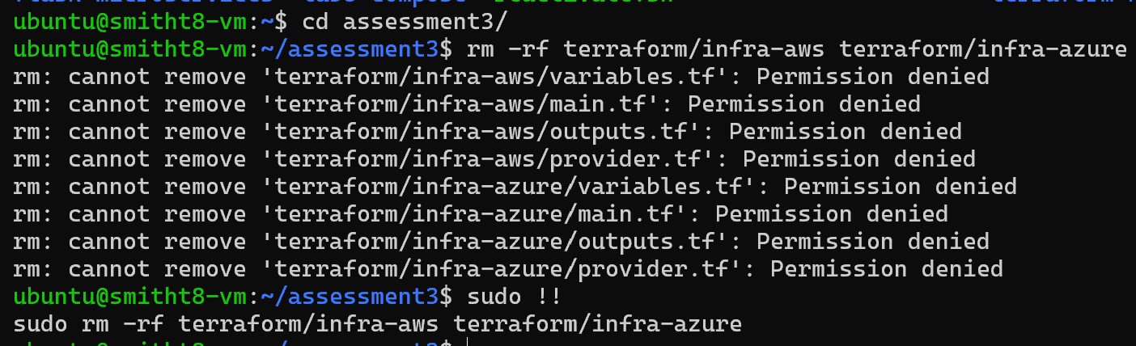

/terraform/infra/main.tf
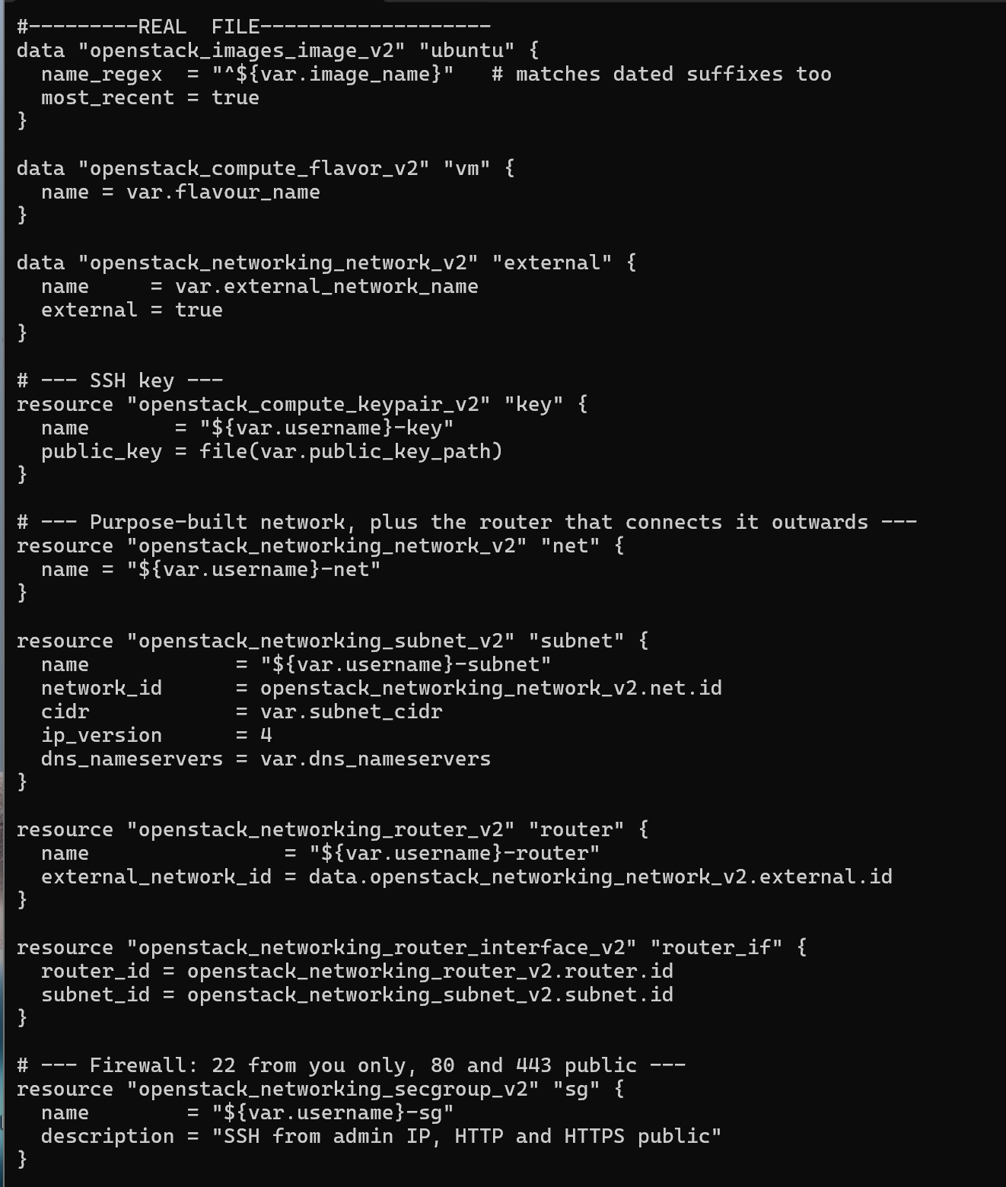
- Inputs recieved from variables.tf
/terraform/infra/output.tf
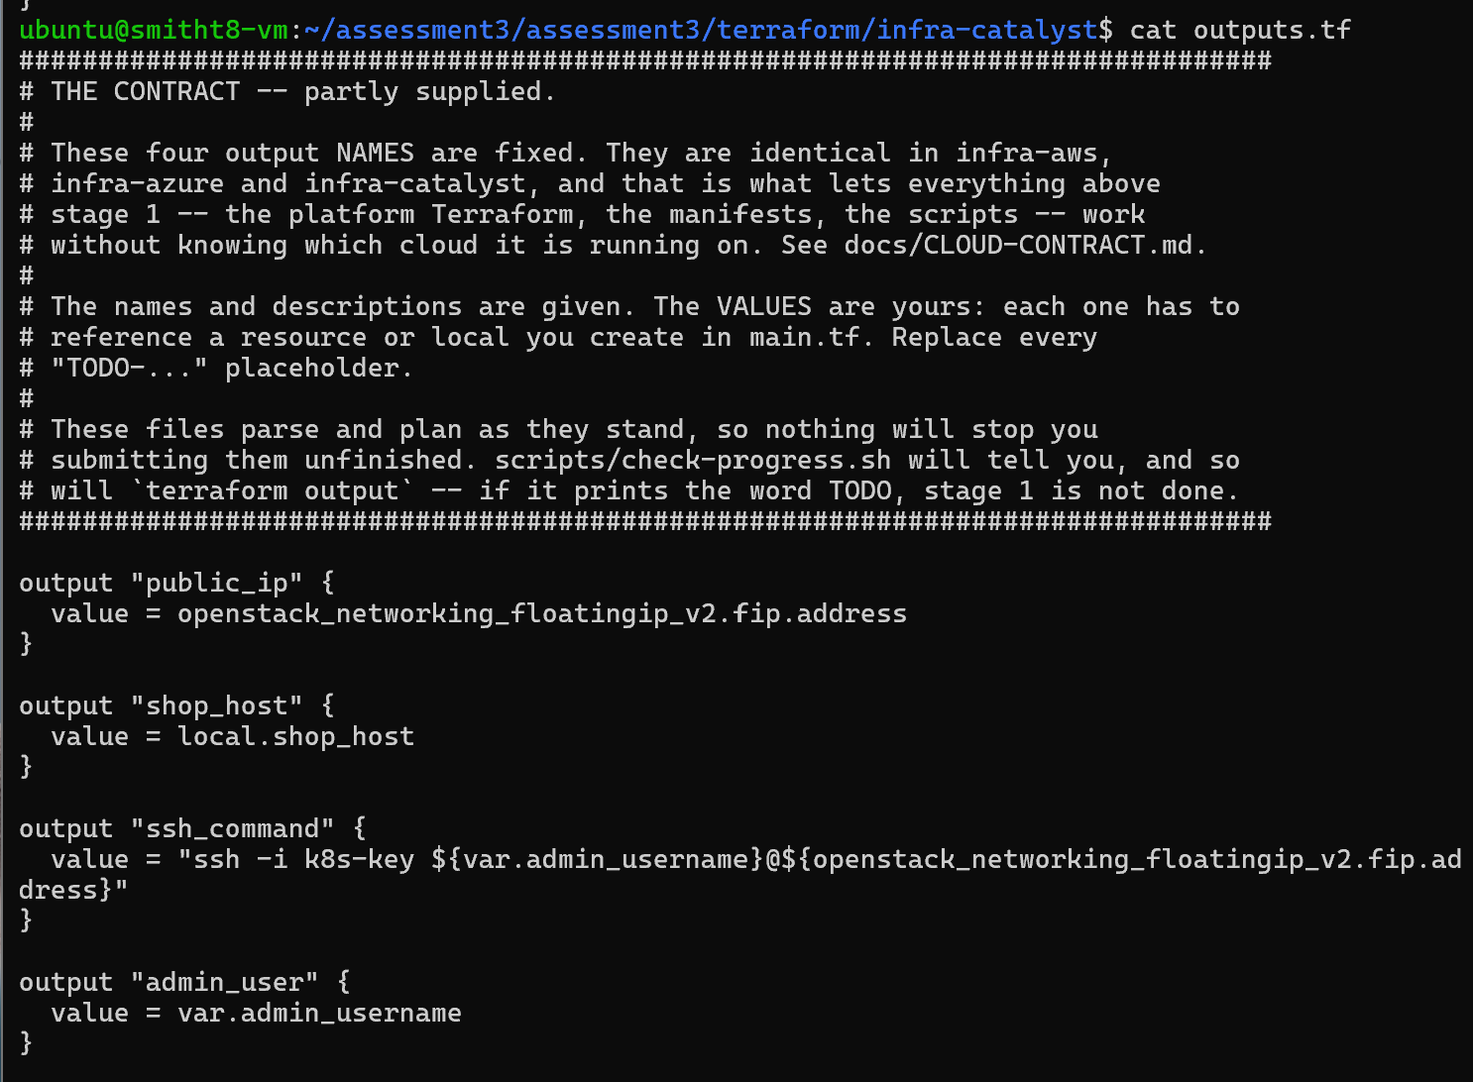
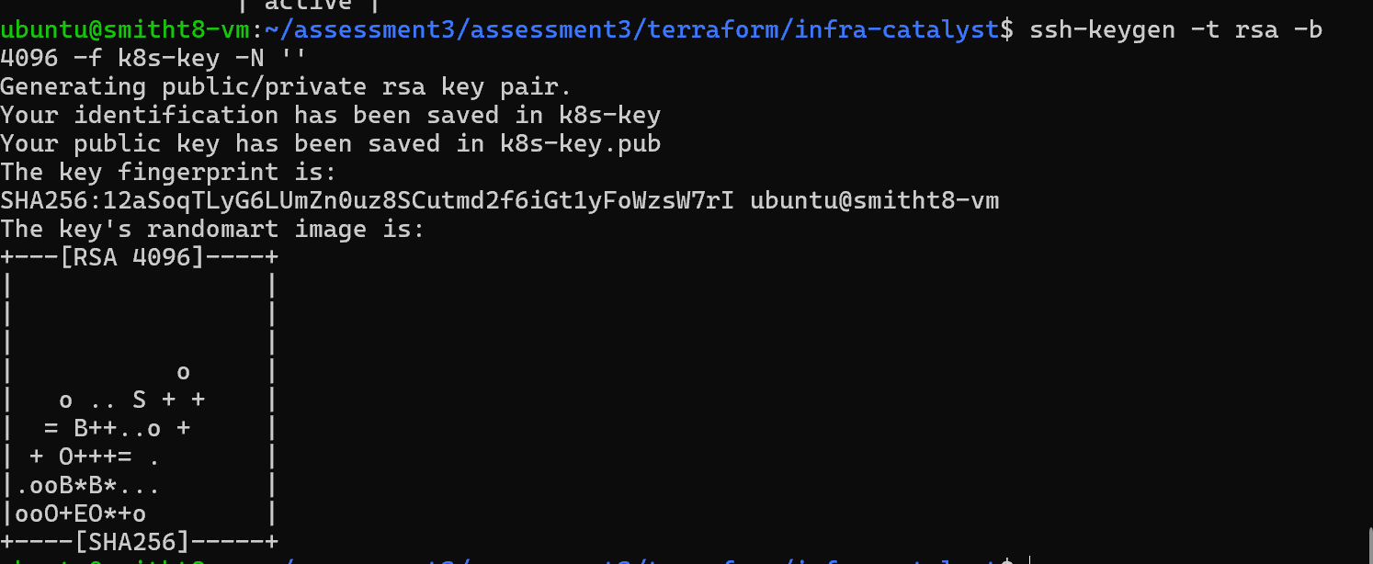
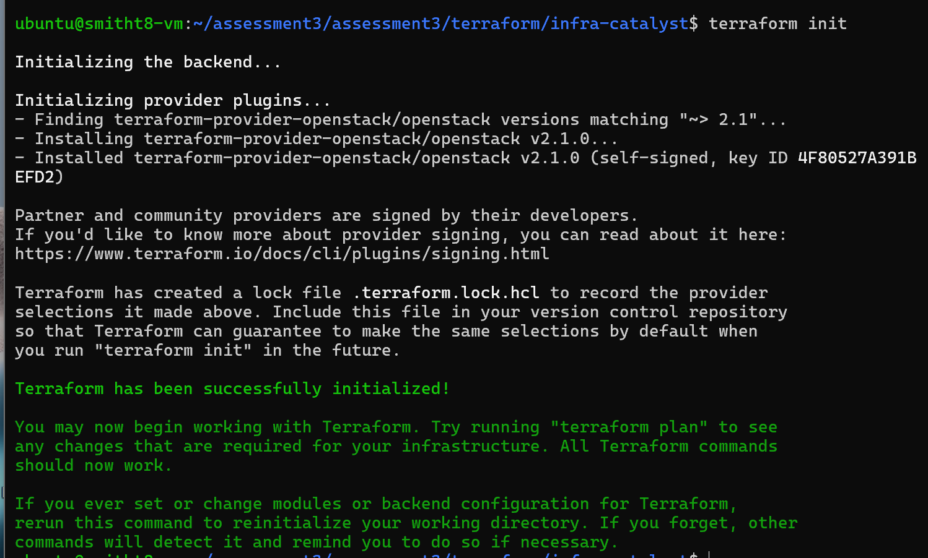
- Terraform formatting is fine and the config passed the validation check
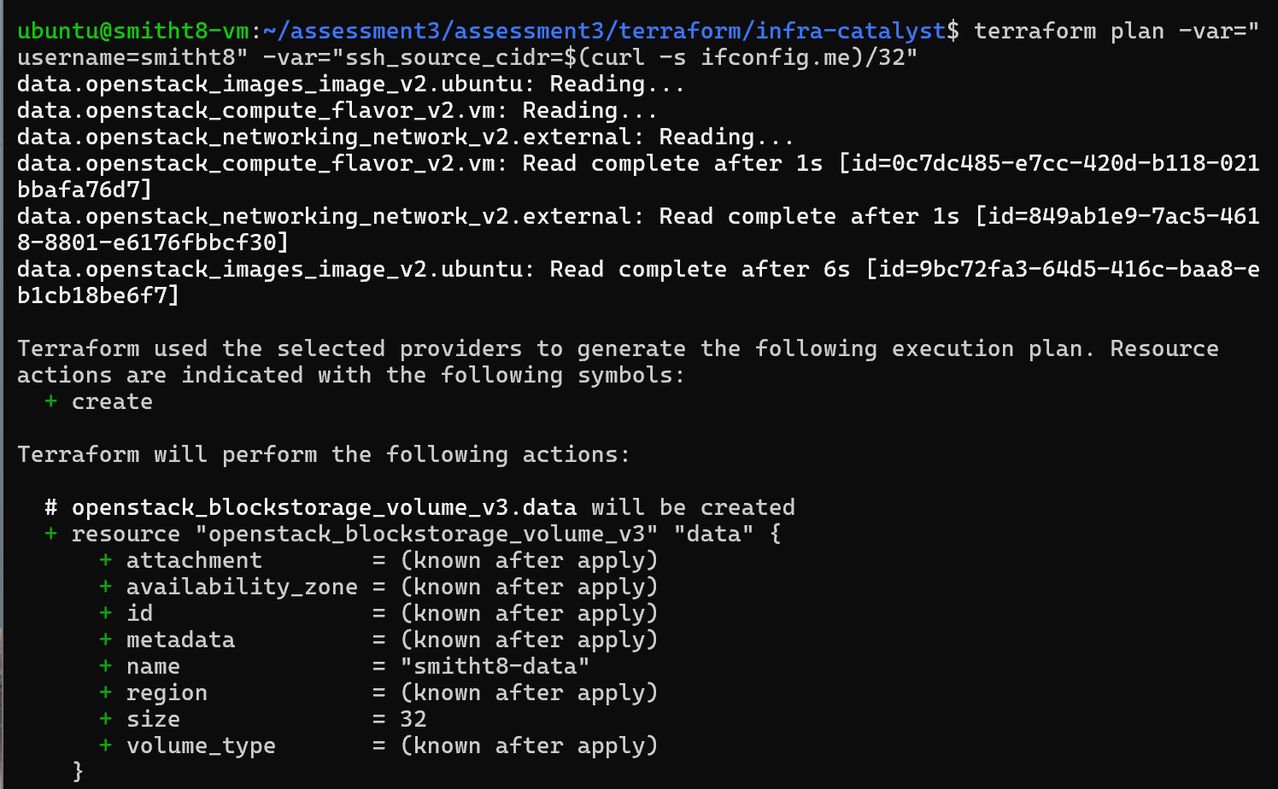

Apply
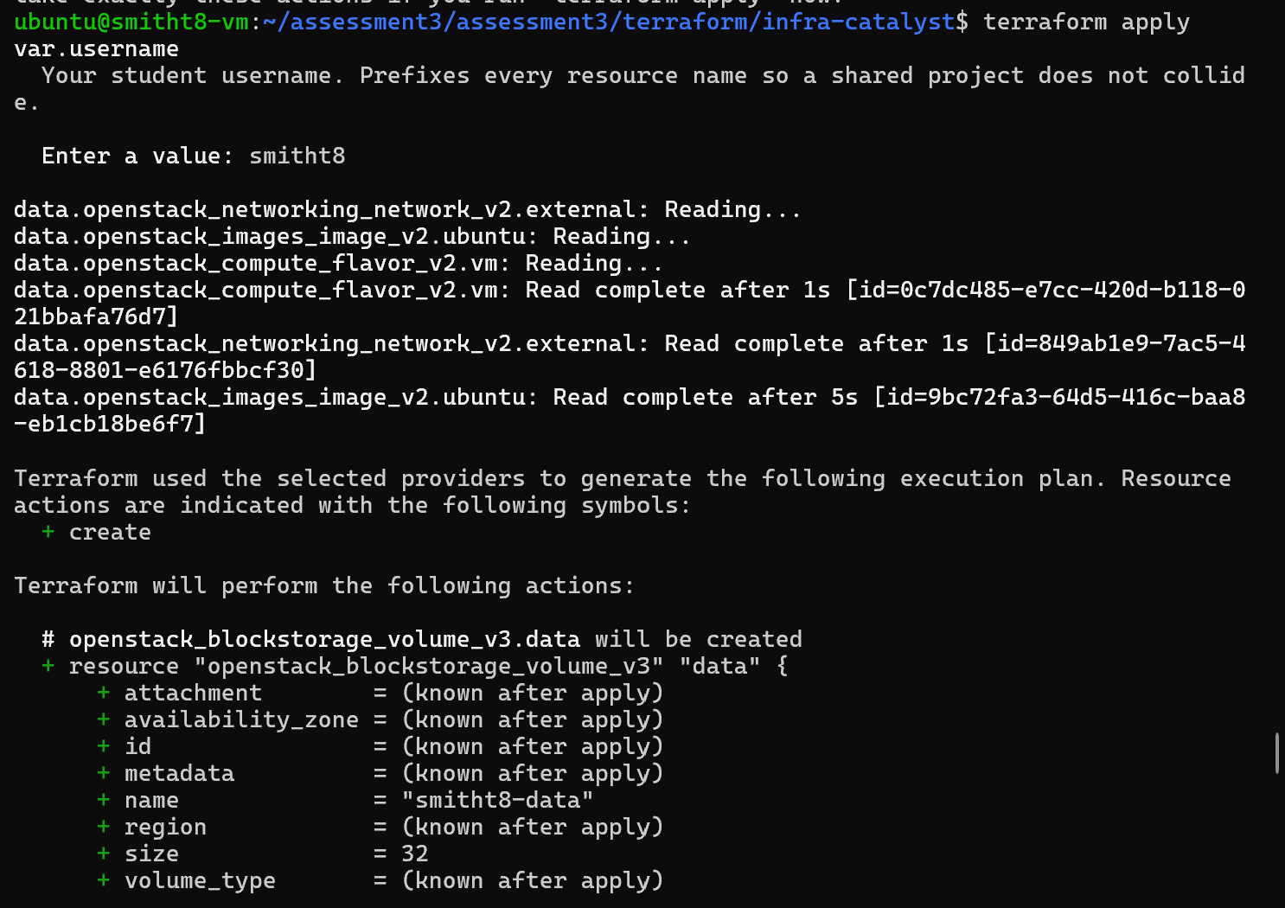
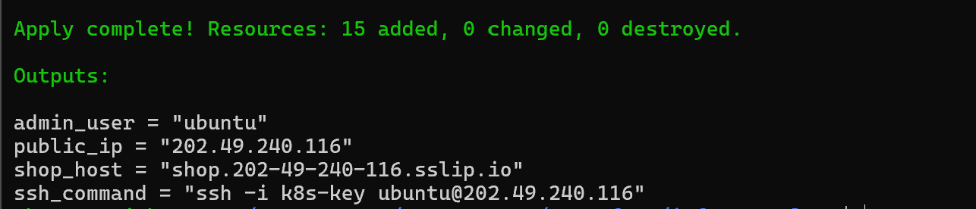
Output 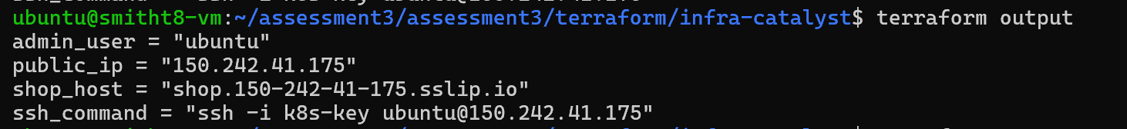
admin_user = "ubuntu"
public_ip = "150.242.41.139"
shop_host = " shop.150-242-41-139.sslip.io"
ssh_command = "ssh -i k8s-key ubuntu@150.242.41.139"

Created VM
Storage
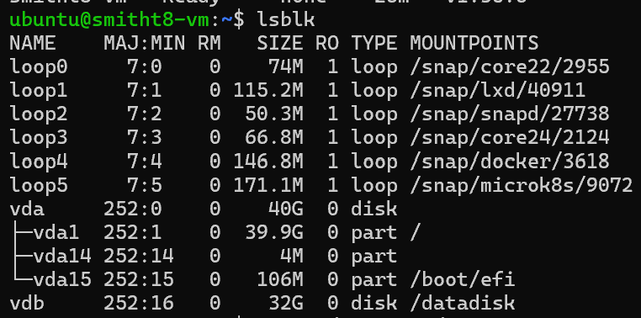
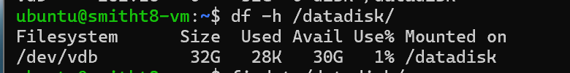

Inbound ports statement
22/tcp, from my admin IP only (/32): SSH for administration. 80/tcp, public: HTTP, needed so the Ingress can redirect to HTTPS. 443/tcp, public: the HTTPS application endpoint. Nothing else is open.
Why the address must be stable.
My hostname is derived from the floating IP (shop.<dashed-ip>.sslip.io). If the IP changed, the hostname would change with it, and four things break: the certificate’s subject alternative name no longer matches the site, so clients get a hostname mismatch rather than just an untrusted CA. The Ingress host rule no longer matches incoming requests, so it routes nothing. Anything bookmarked, or any DNS or known_hosts entry, points at the old address. And the manifests rendered with the old hostname are stale. A floating IP stays allocated to the project while the server is stopped, unlike an address assigned from a pool at boot.
Storage decision.
The data disk is a separate block volume so its lifecycle is independent of the OS disk. I can rebuild or reimage the VM without touching the data, a full or corrupted root filesystem doesn’t take the data with it, and the data volume can be sized, snapshotted and backed up separately. Both volumes use delete_on_termination = false. PersistentVolumes are hostpath directories under /datadisk/microk8s-storage, so the orders in Redis and Prometheus history live on that disk. If PVs were on ephemeral storage, which many clouds discard when a VM is stopped, rebuilt or deallocated, the orders and metrics would silently disappear even though the Pod and PVC objects still existed.

Stage 2
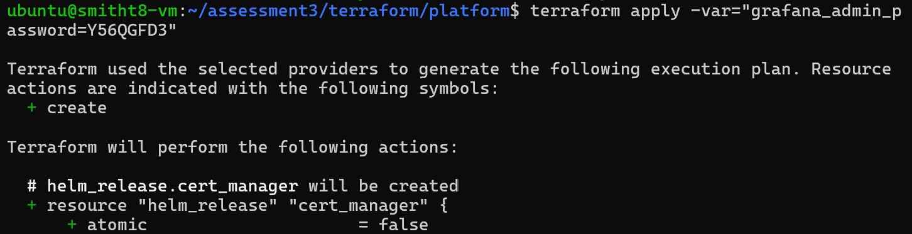
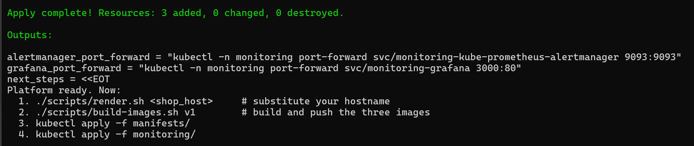
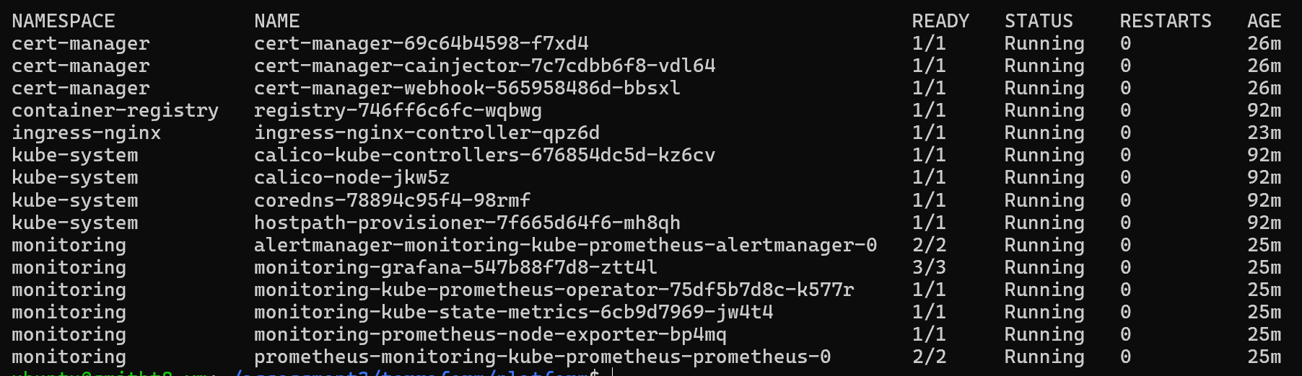
- All namespaces running
Stage 3 – Microservices and images
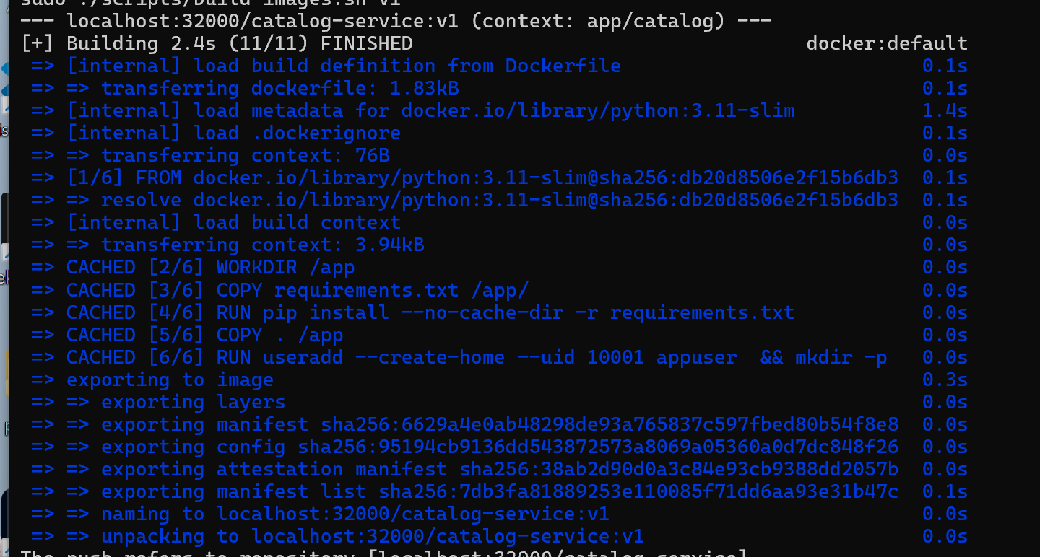
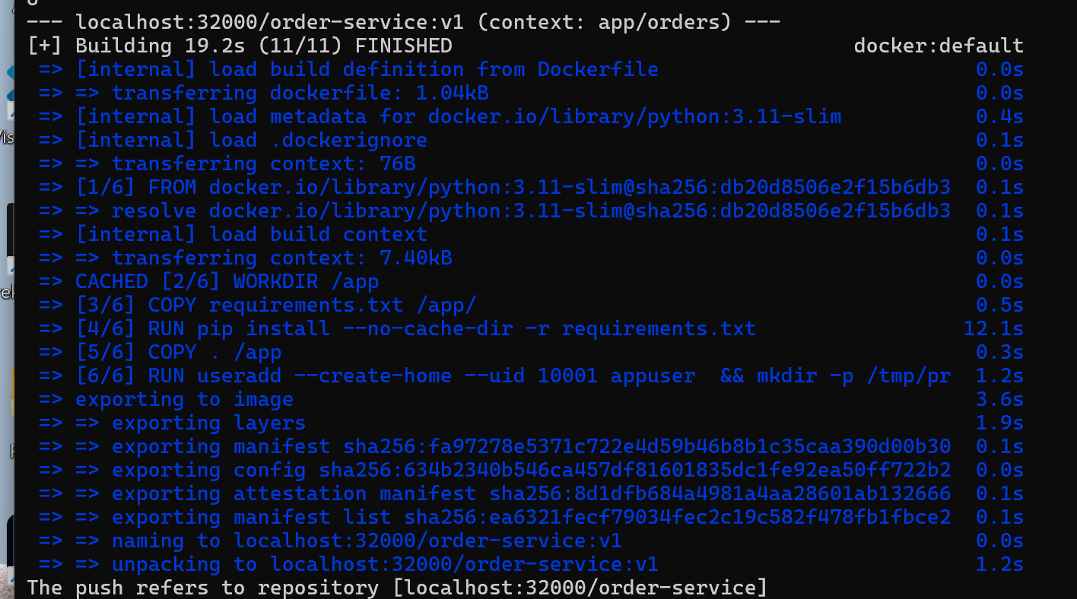
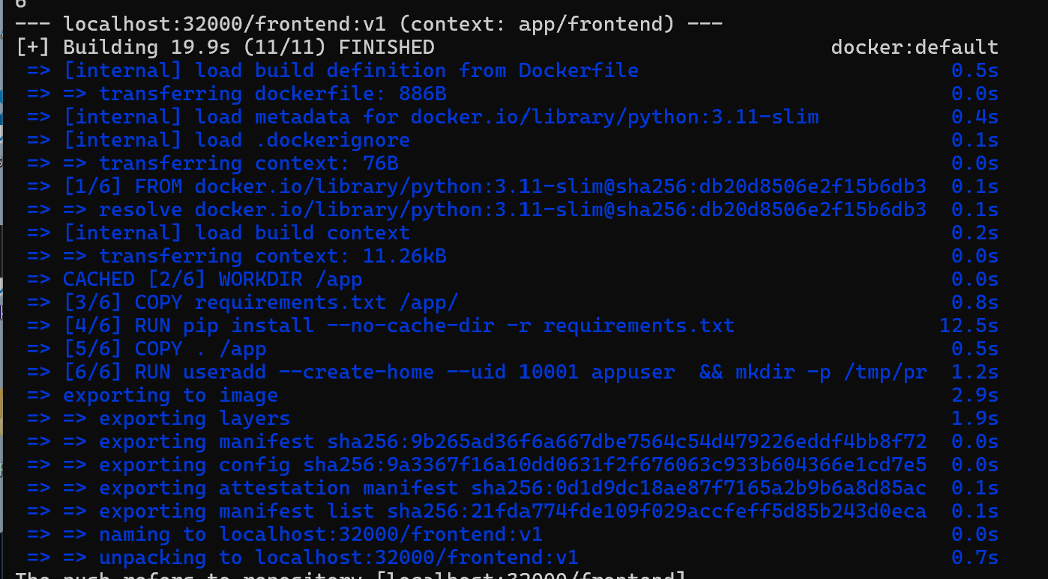
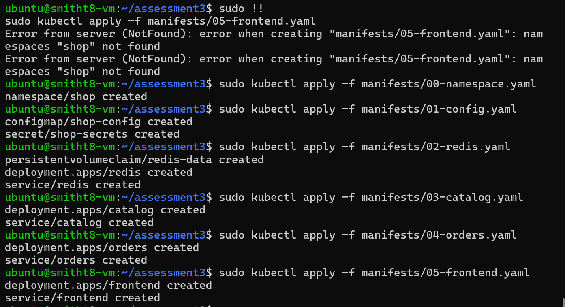
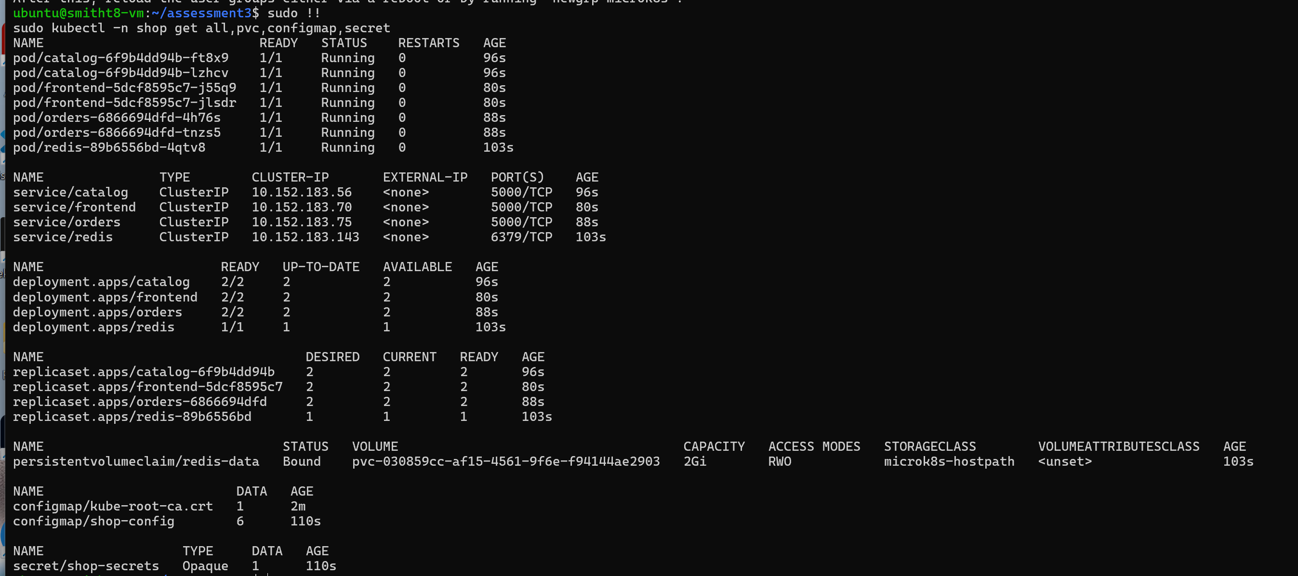
7 Publish it over HTTPS

Describe the certificate
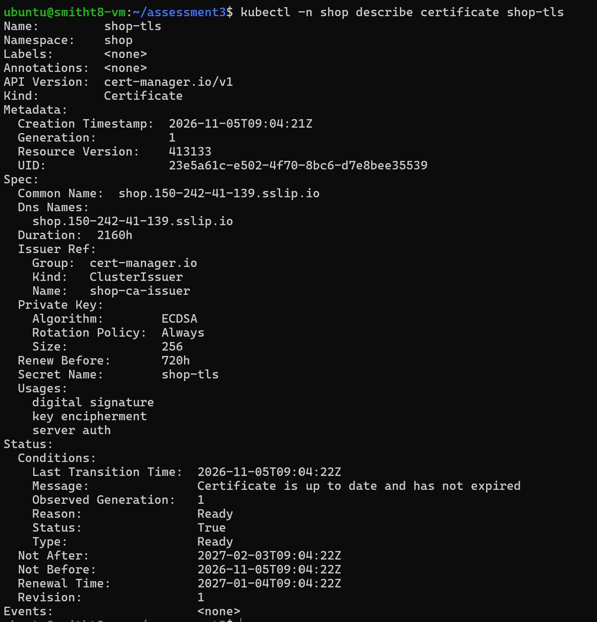
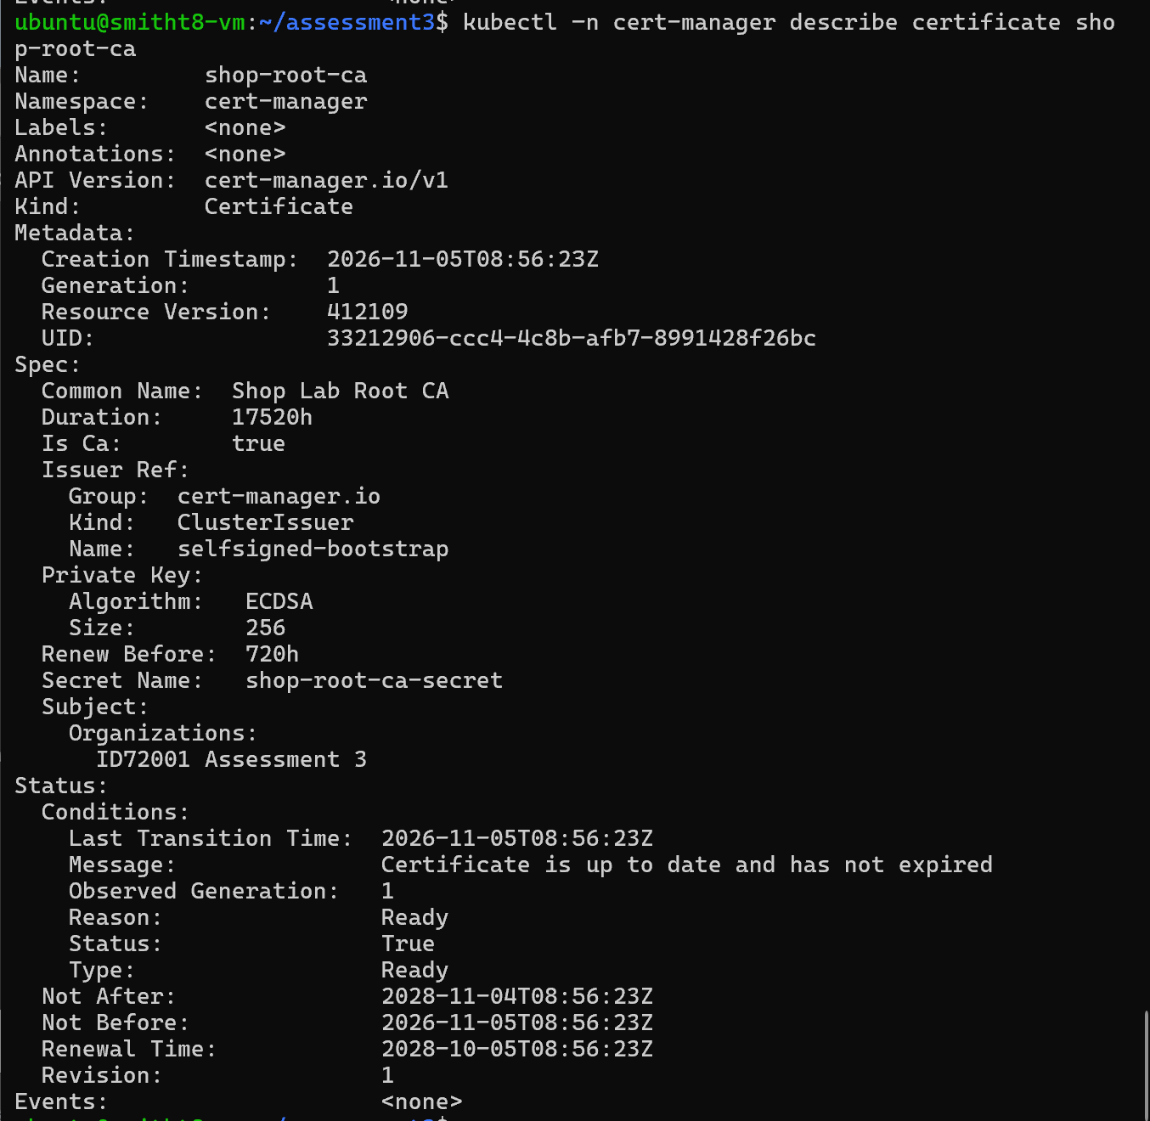
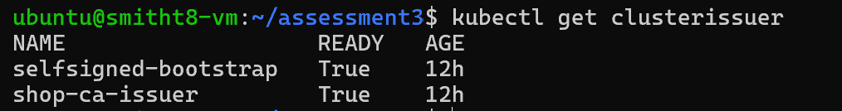
The served certificate
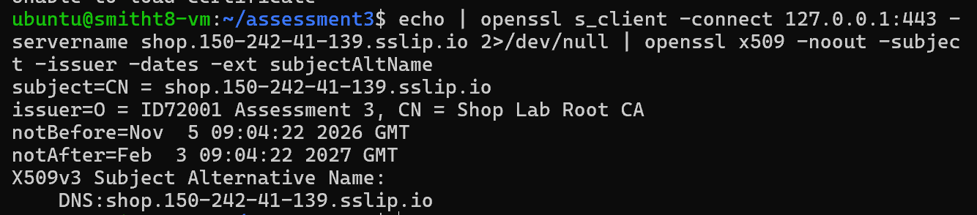
HTTP redirect
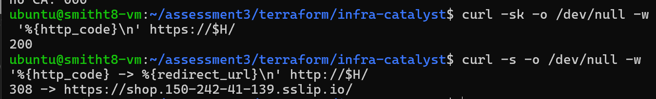
--cacert validation
Browser demo
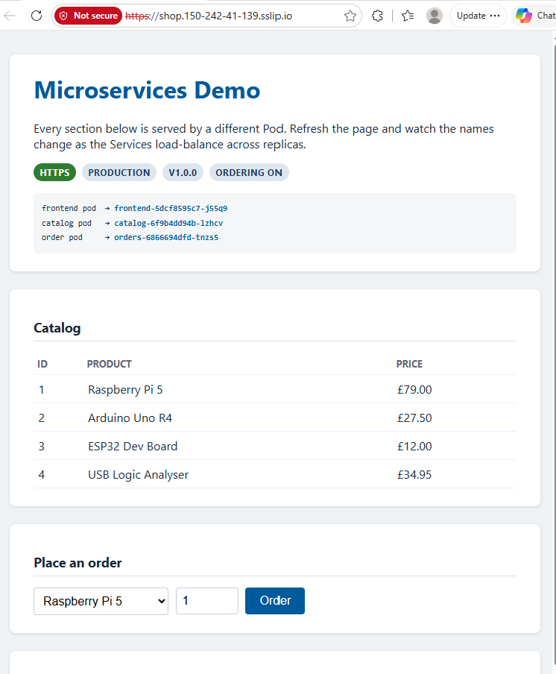
Check the monitoring

Tunnel commands to view Prometheus, Alert manager and Grafana UI
kubectl -n monitoring port-forward svc/monitoring-grafana 3000:80 -laptop
kubectl -n monitoring port-forward svc/monitoring-kube-prometheus-alertmanager 9093:9093 & -VM
kubectl -n monitoring port-forward svc/monitoring-kube-prometheus-prometheus 9090:9090 &-VM
kubectl -n monitoring port-forward svc/monitoring-grafana 3000:80 & -VM

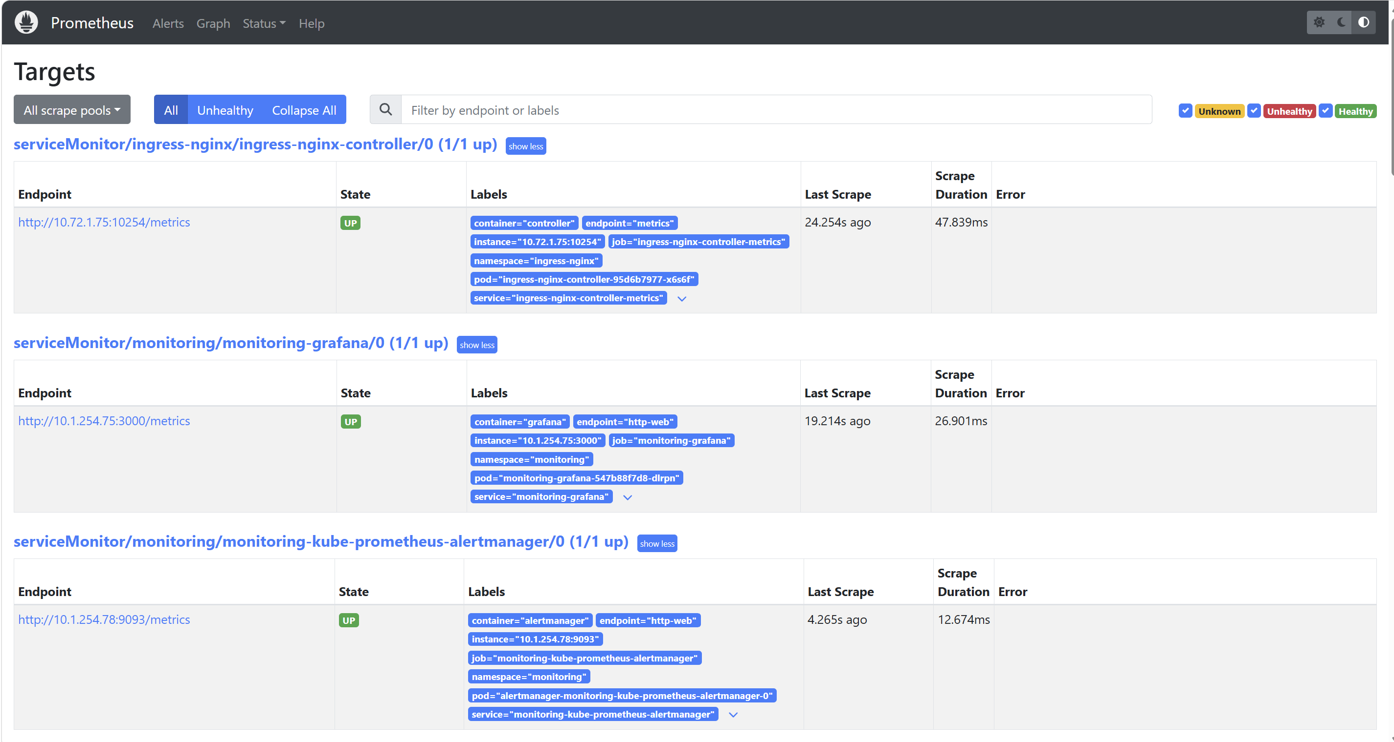
Queries
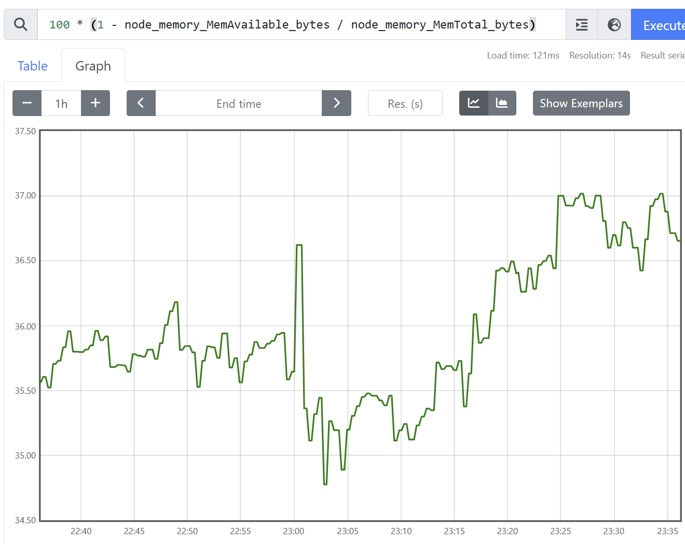
Cluster objects
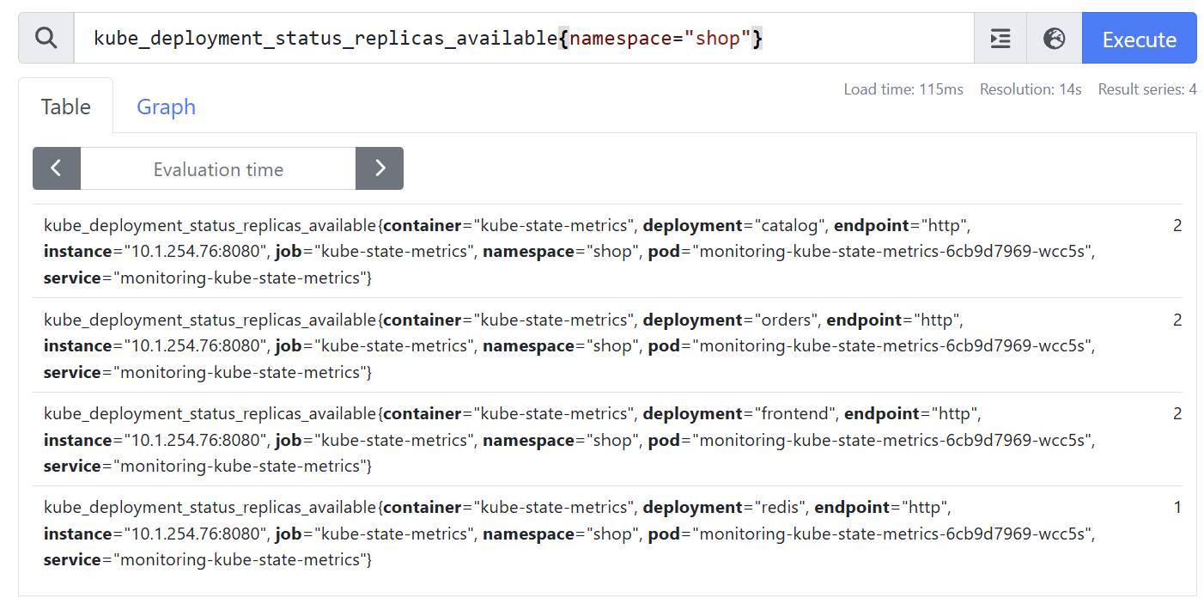
Containers
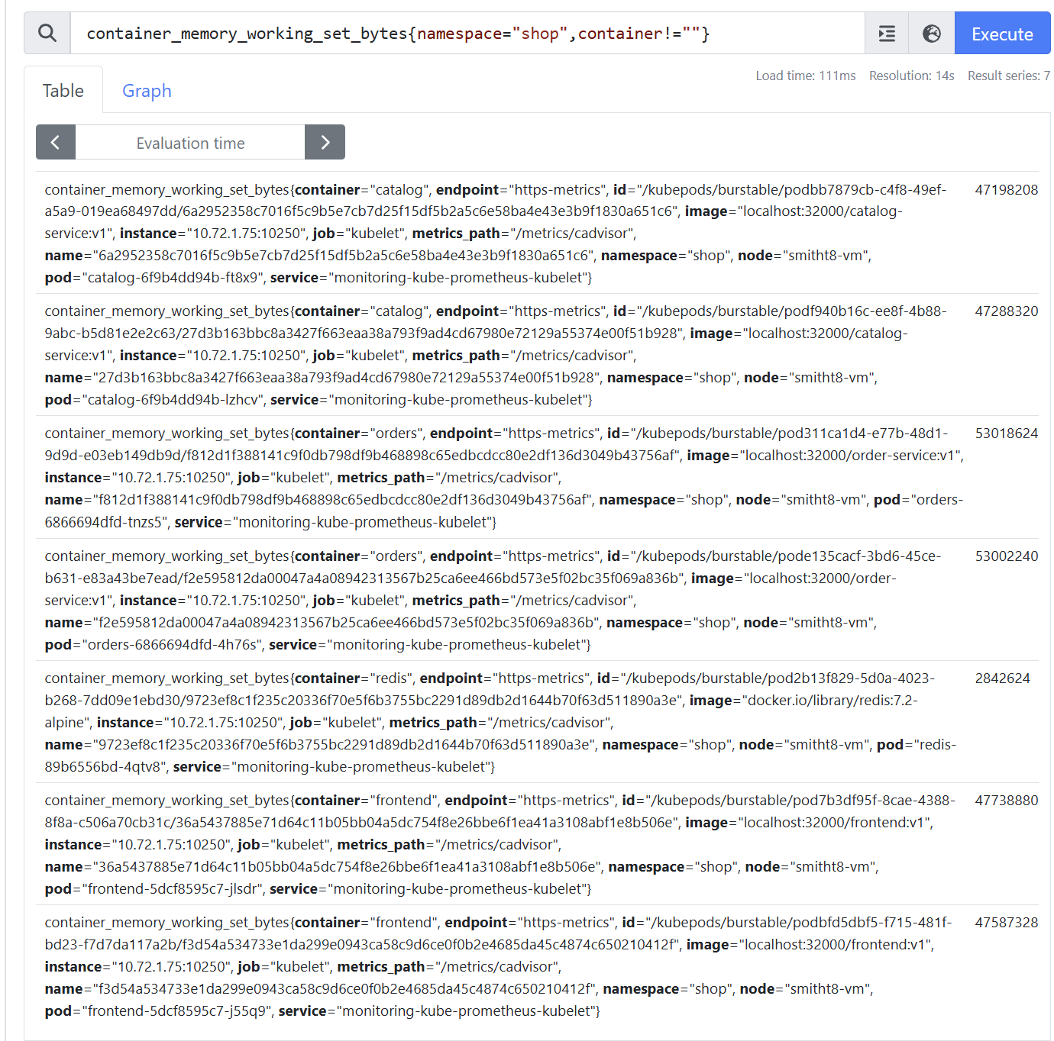
Ingress edge
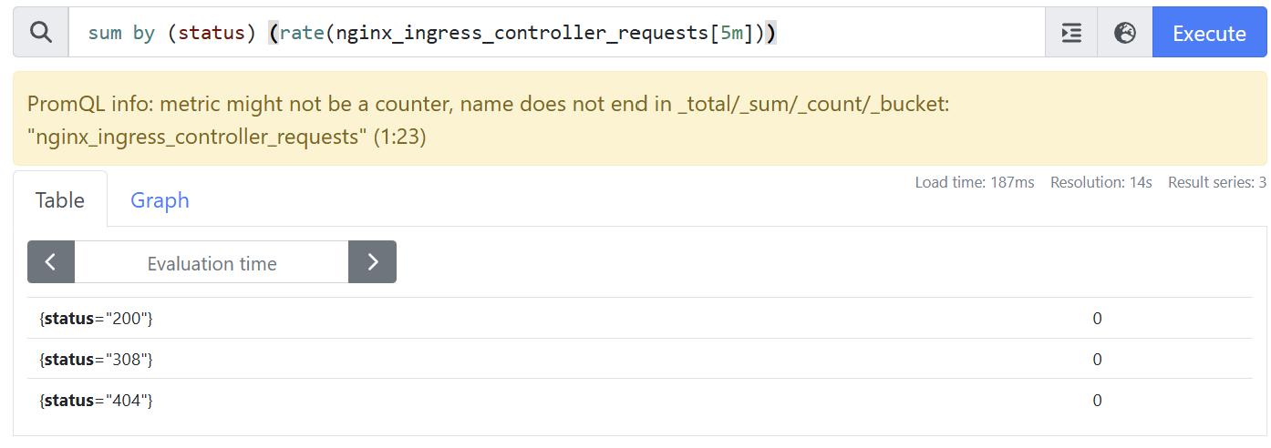
Application, HTTP
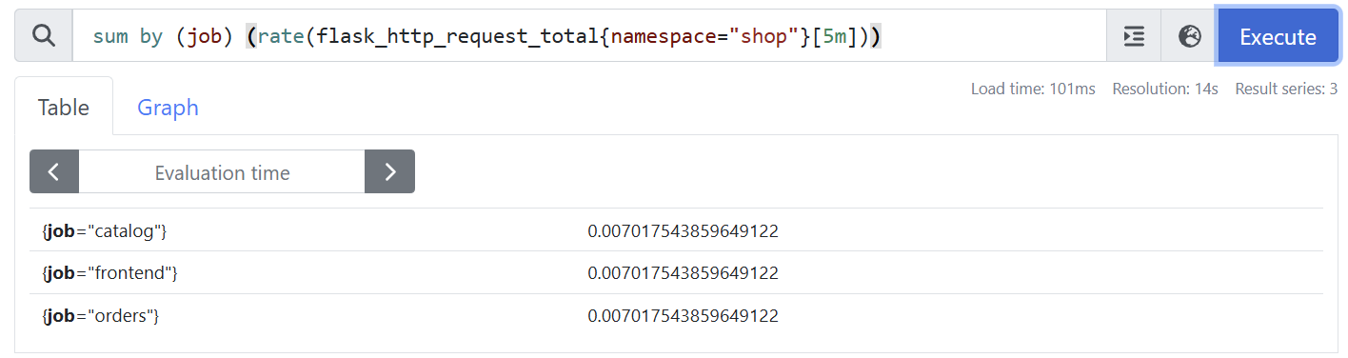
Total orders placed
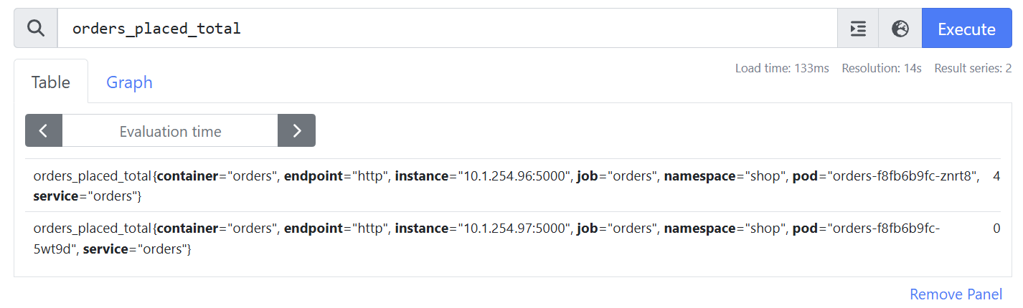
Order value total (Business metrics)
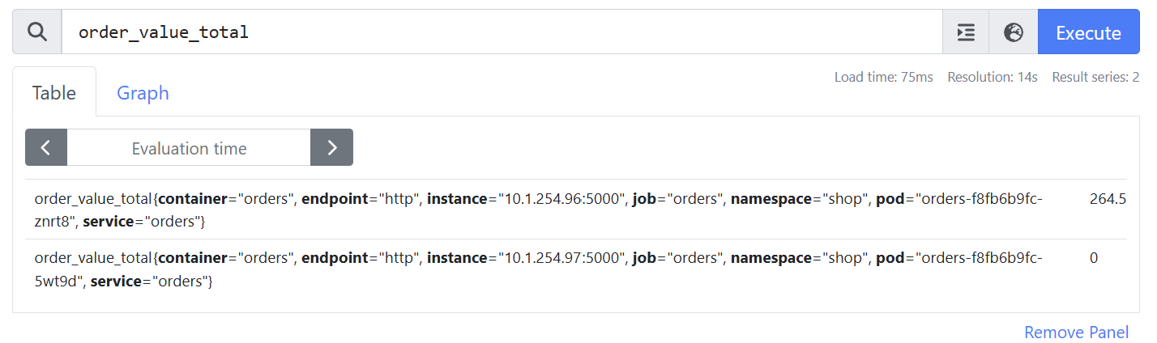
Grafana dashboard JSON file
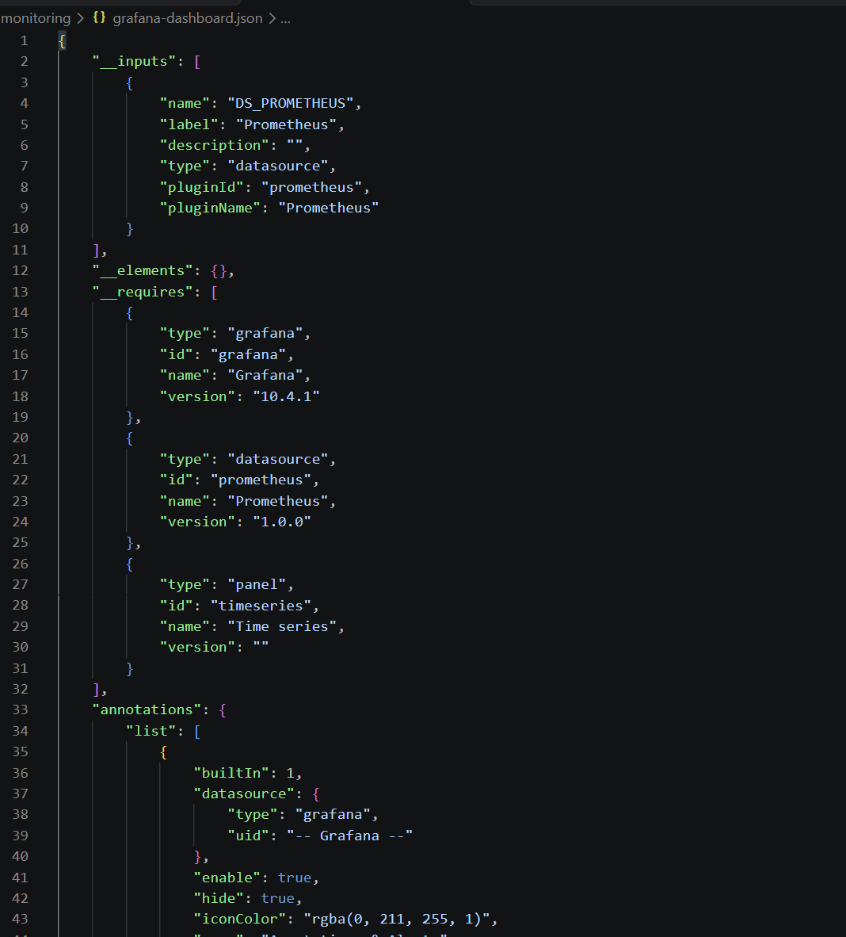
Dashboard under load
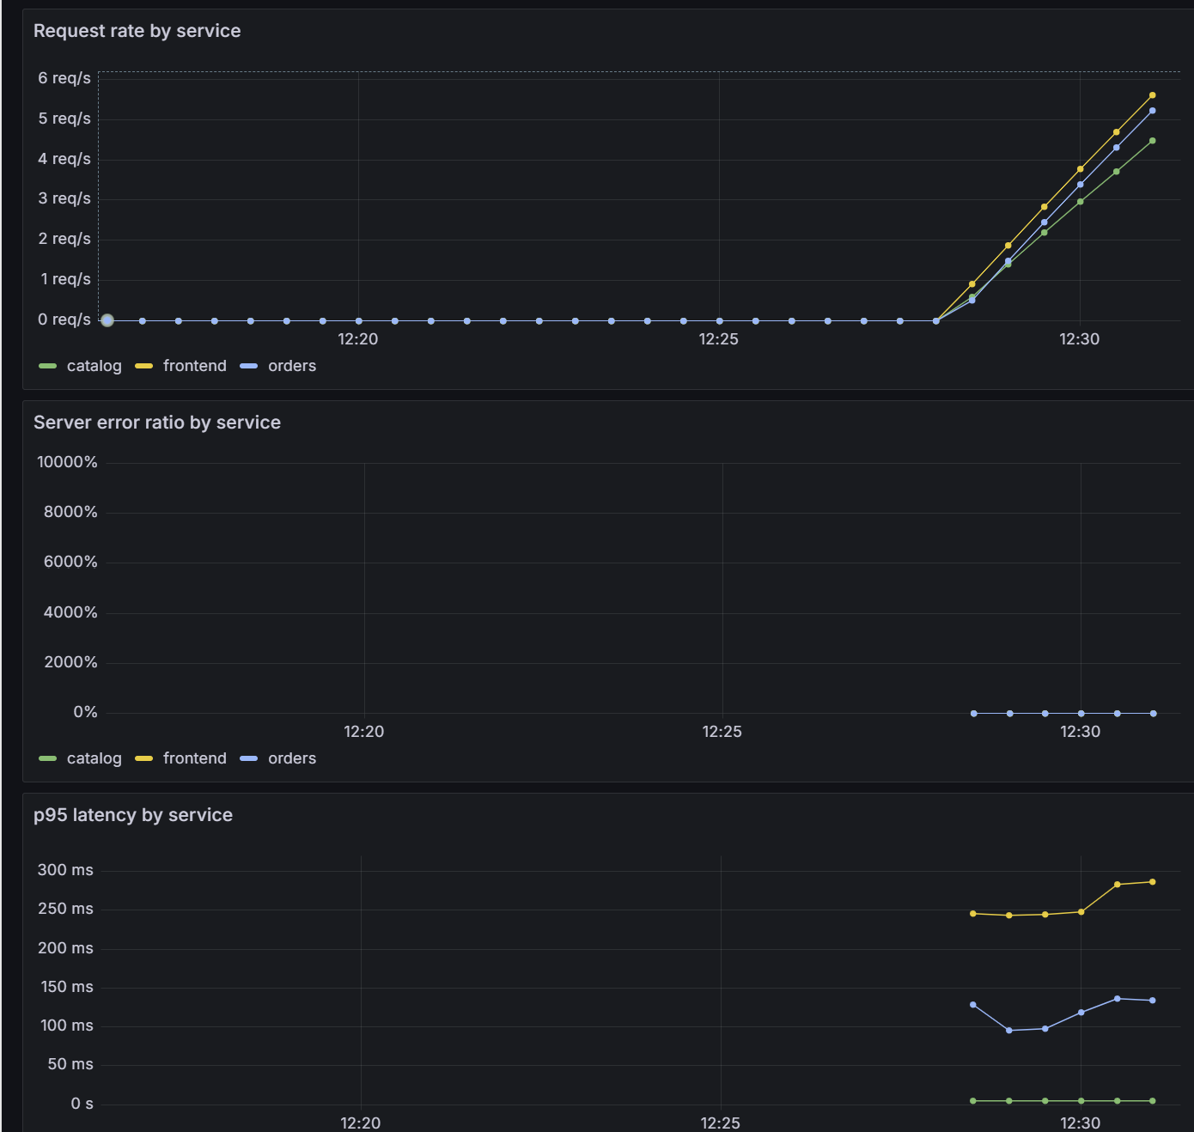
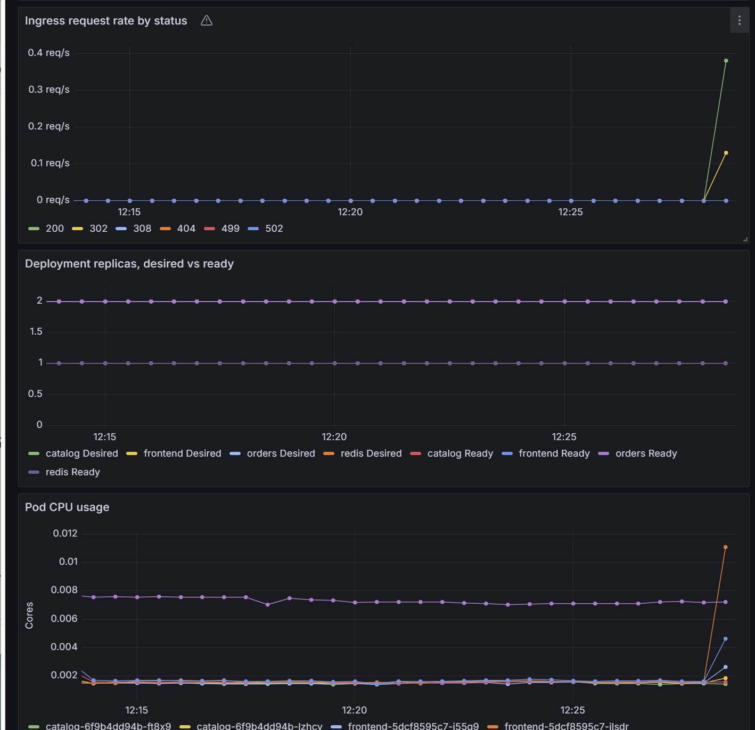
Forcing an alert
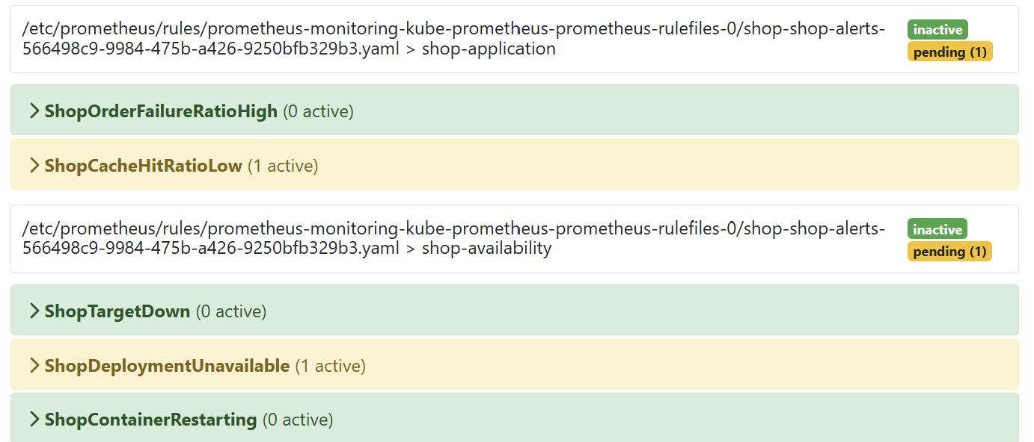
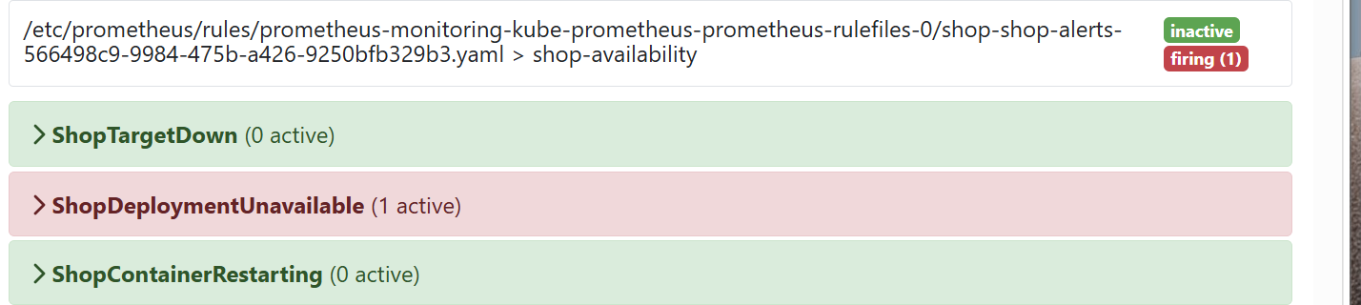
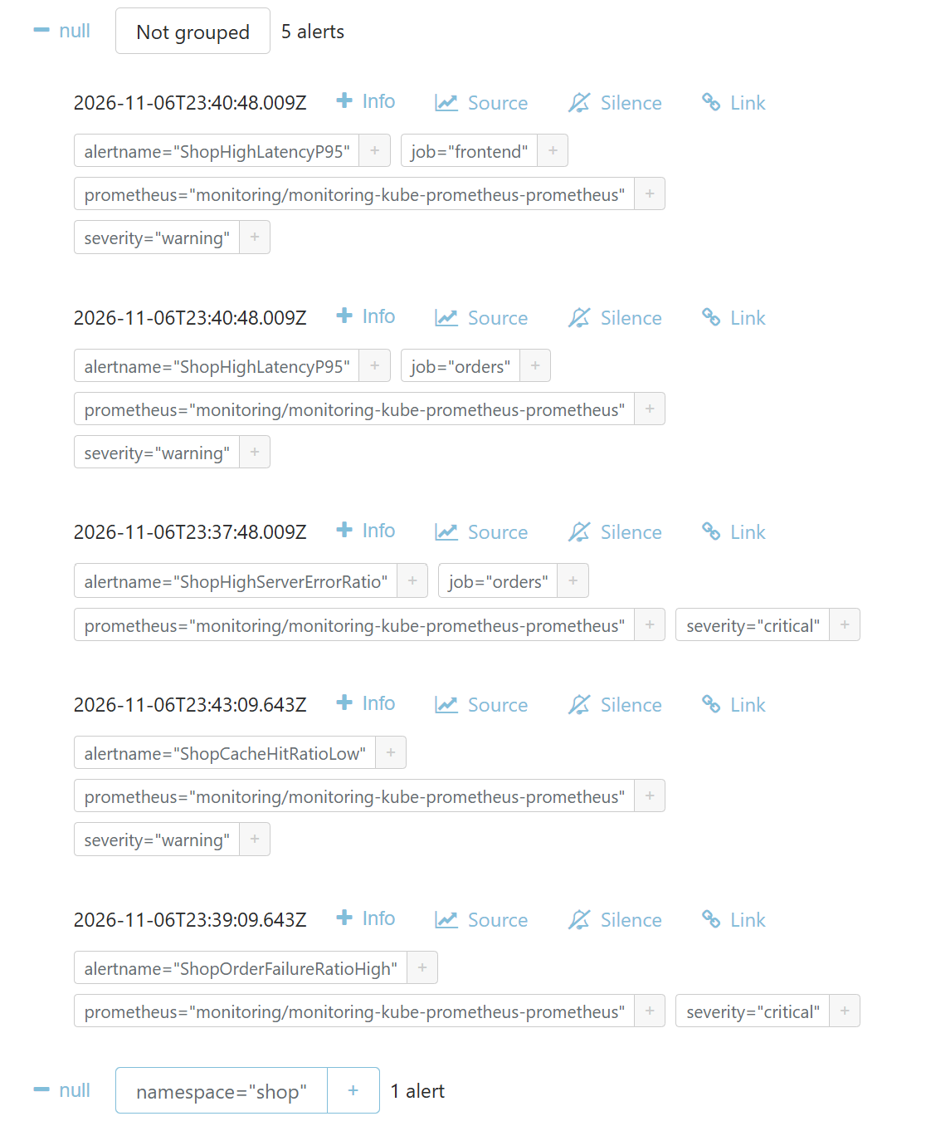

A
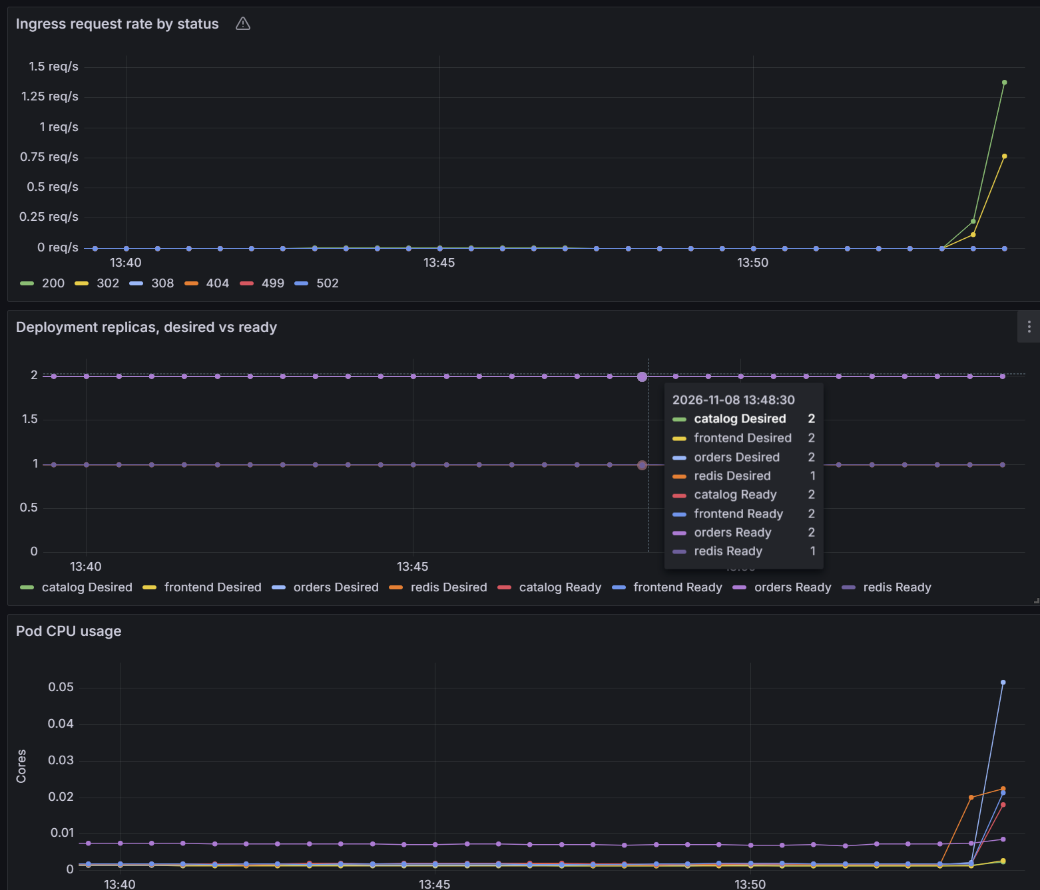
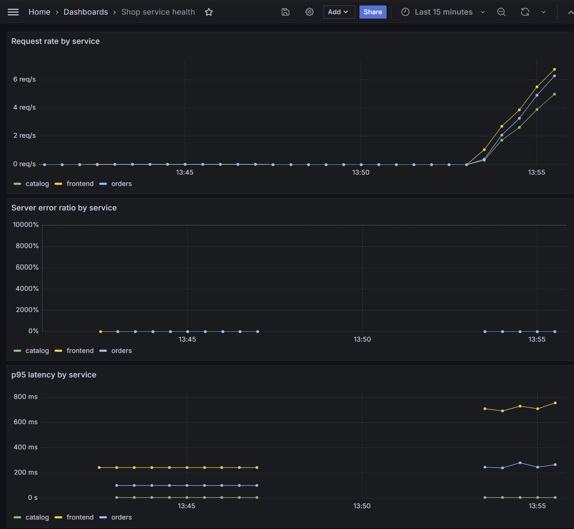
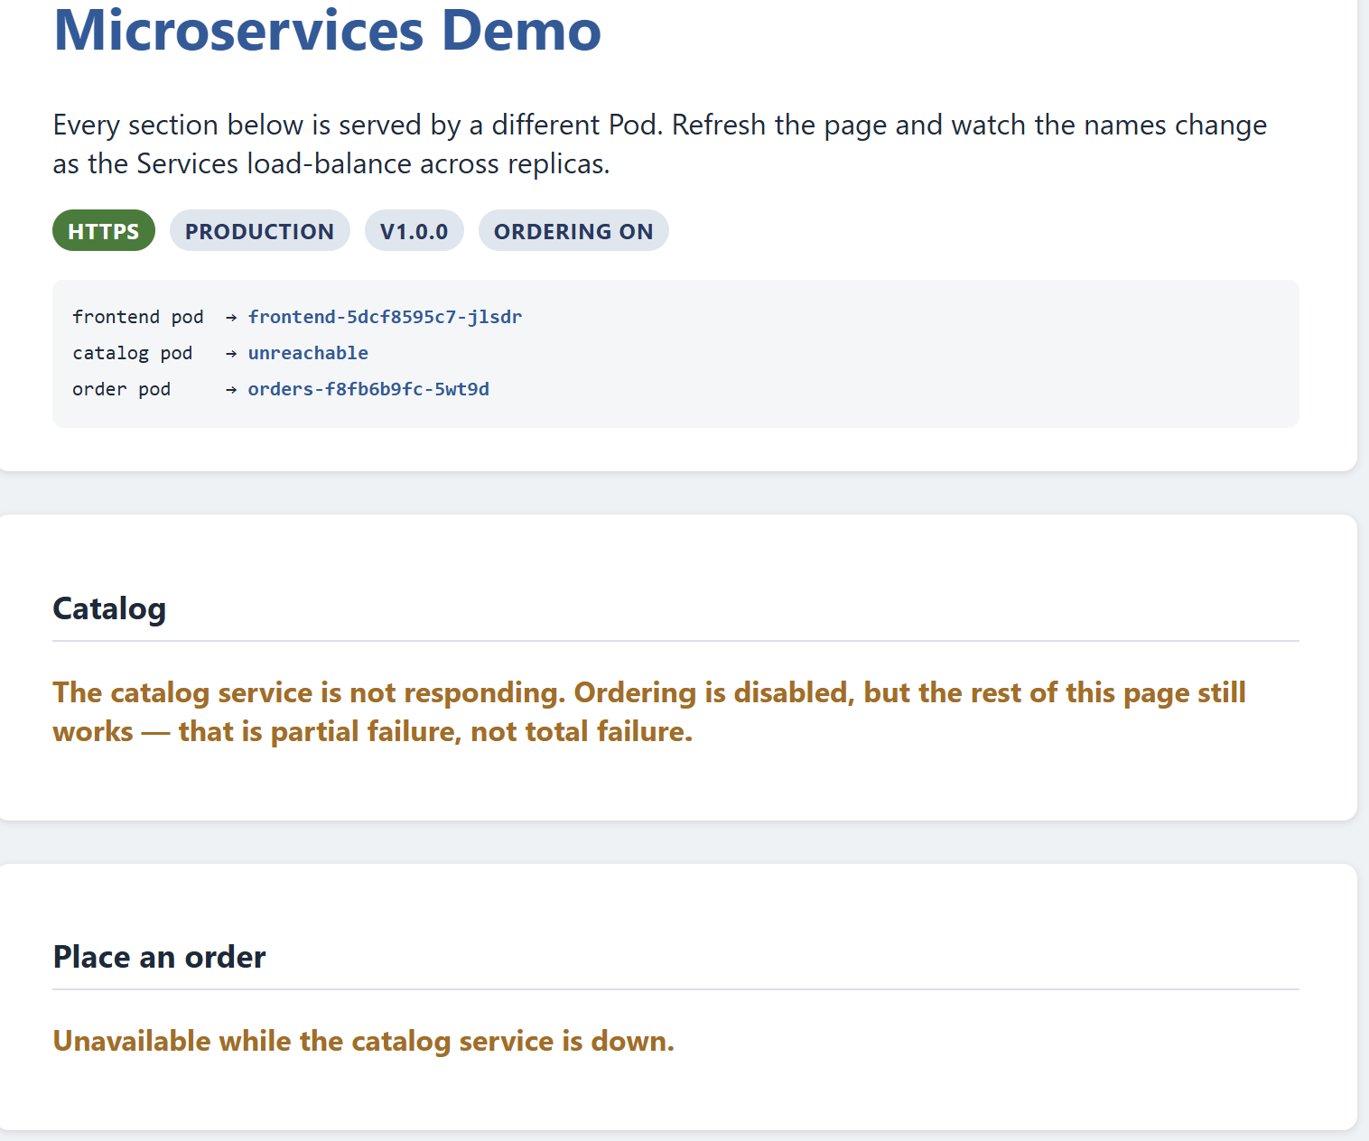
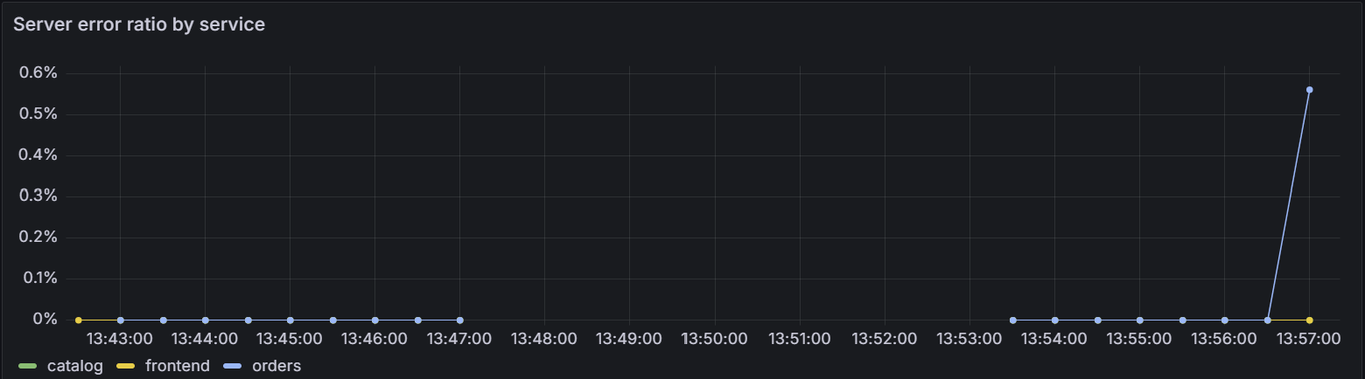
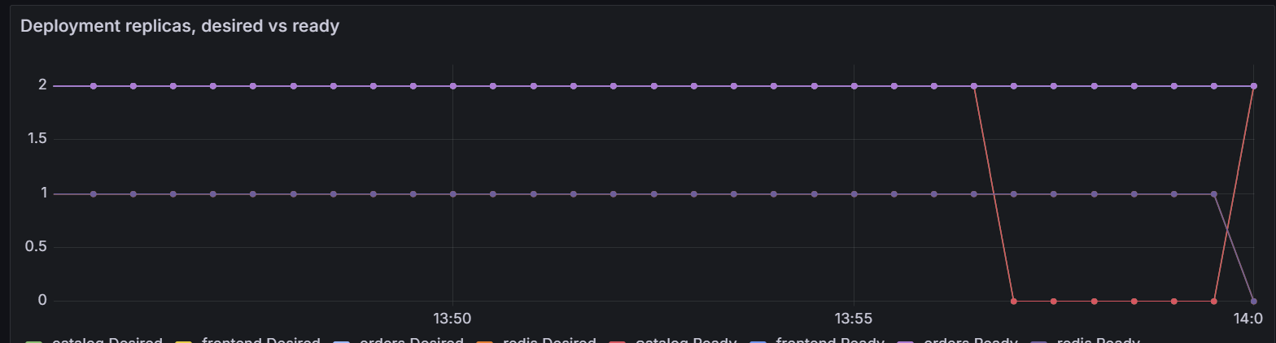
B
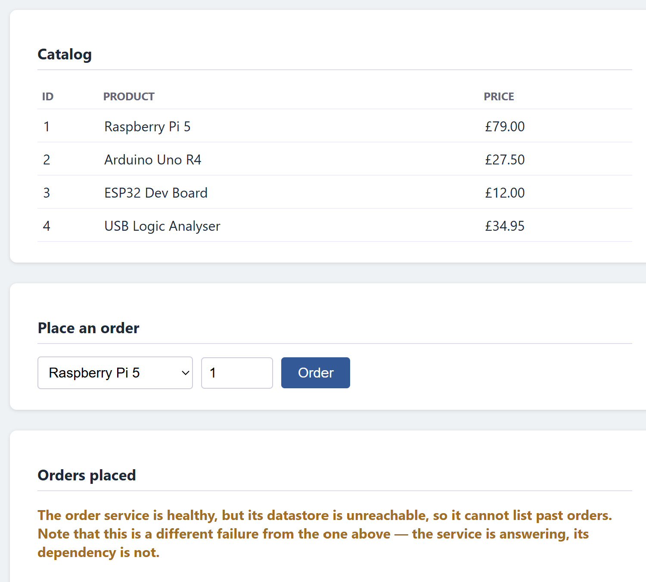
C
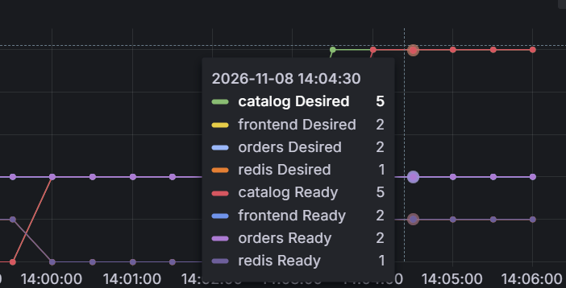
D


