Photographic record / Mitigation Measures –
(Government House – CW2670)

Recommendation: Re-inspection in 6 months

Comments: The inspected tree (CW2670) is an Araucaria columnaris situated in the landscape area at Government House. The tree is located in front of the main entrance of Government House; its target covers the venue user, building, and private road within the site. It is a standalone tree without well protection from adjacent trees and buildings; the subject wind load is considered moderate to high.

The overall health condition was vigorous at the time of inspection, with evidence of normal foliage density, color, and size. Structurally, the tree is slightly leaning towards the building but has self-corrected at approximately 10 m height.

The main concern of the tree is that there was a large amount of resin concentrated in the southeast of the trunk base. Although sap flow is relatively common in Araucaria, such amount of sap flow in this case is abnormal. For easy assessment of the condition of the trunk base, the solidified resin was removed, but no significant defect was observed at the time of inspection.

Given the presence of sap flow and the possibility of defects being hidden under visual assessment. Resistography and Sonic Tomography tests were conducted to gain a better understanding of the internal condition of the lower trunk.

Table 2. Information of Resistography Test
Drill no. | Direction | Drilling Angle | Height of drill (cm) | Diameter of tested area (mm) | Feed speed (cm/min);  Drilling speed (r/min)
1 | SE | 0 | 5 | 850 | 150; 2000
2 | SW | 0 | 5 | 600 | 150; 2000

For precise interpretation of the results, a resistography test was performed specifically in the area of significant sap flow. A total of two drillings were performed (Table 2). Drilling#1 was carried out perpendicular to the surface of sap flow area, whereas drilling#2 was carried out perpendicular to drilling#1. According to the results, no significant drop in resistance was detected in either drilling; the wood density was also considered normal, implying no significant decay or cavity was detected at the tested area.

Conclusion
Visual tree assessment and advanced tree assessment (i.e., Sonic tomography and Resistography tests) were both performed. The main concern of this tree was the area of significant sap flow at trunk base. Sonic tomography and resistography tests both indicated no significant decay or cavity in the lower trunk; the sap flow is unlikely related to internal decay but likely related to an old wound or superficial bark crack. Re-inspection in 6 months is recommended to closely track any deterioration of the sap flow conditions.

Photographic Record
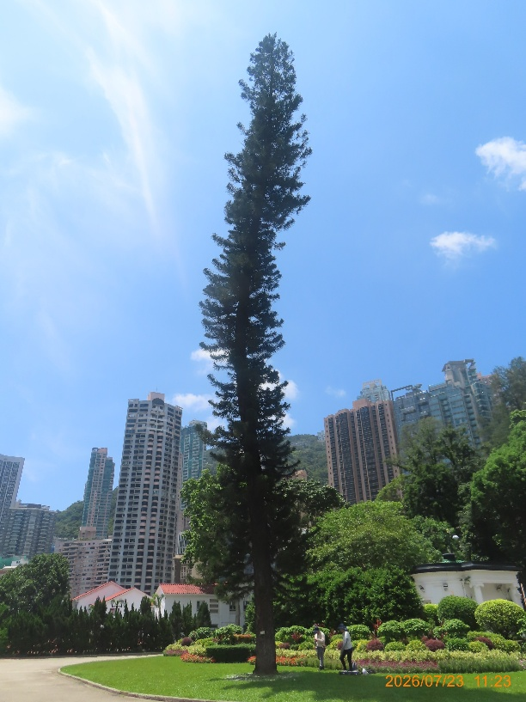  Whole view | 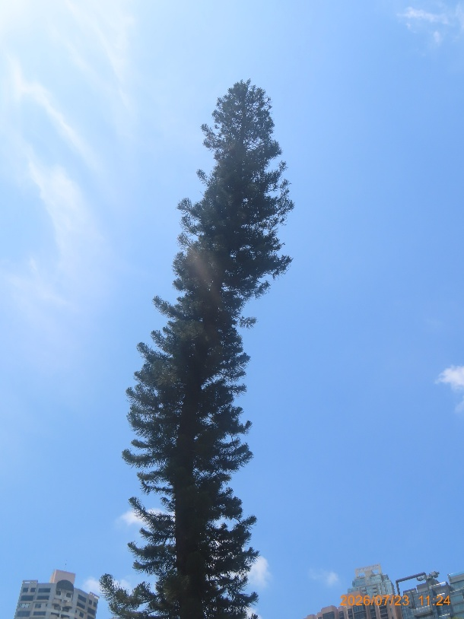  Crown condition
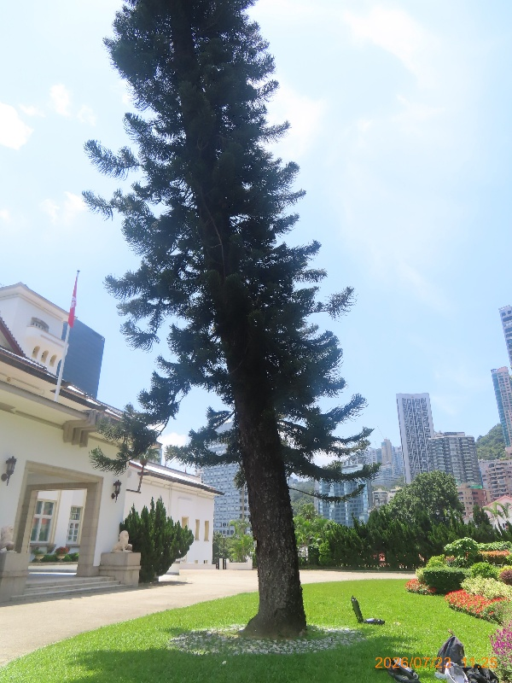  Trunk condition; Leaning | 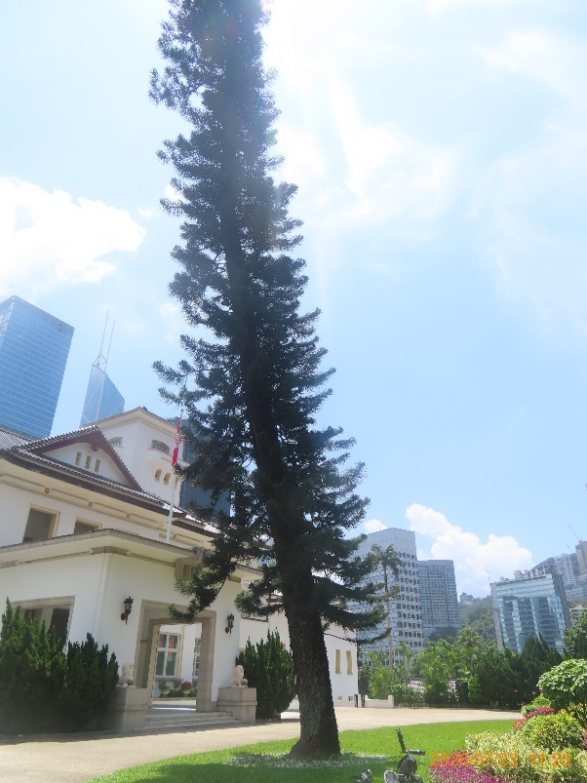  Self-corrected from approximately 10 m height
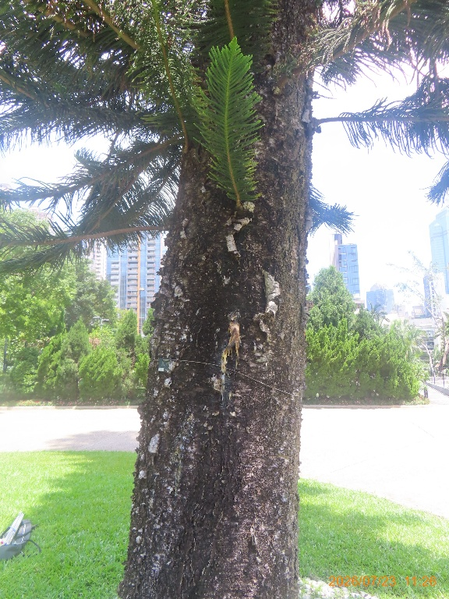  Sap flow on trunk | 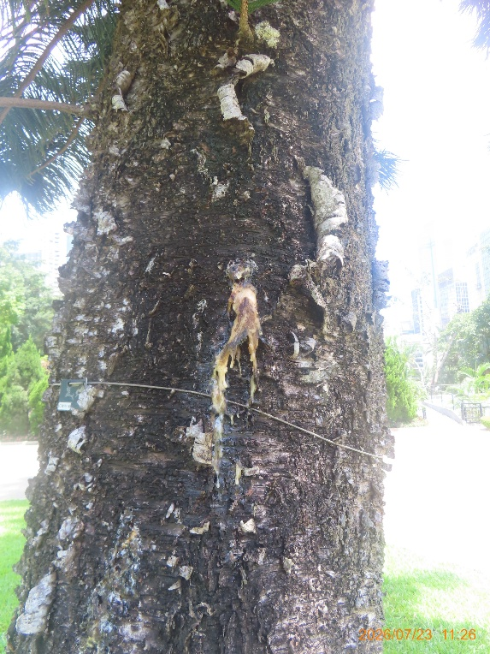  Sap flow on trunk_Close up
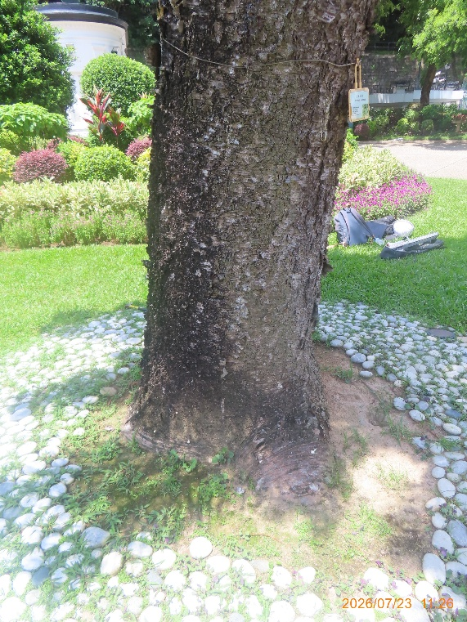  Trunk base condition#1 | 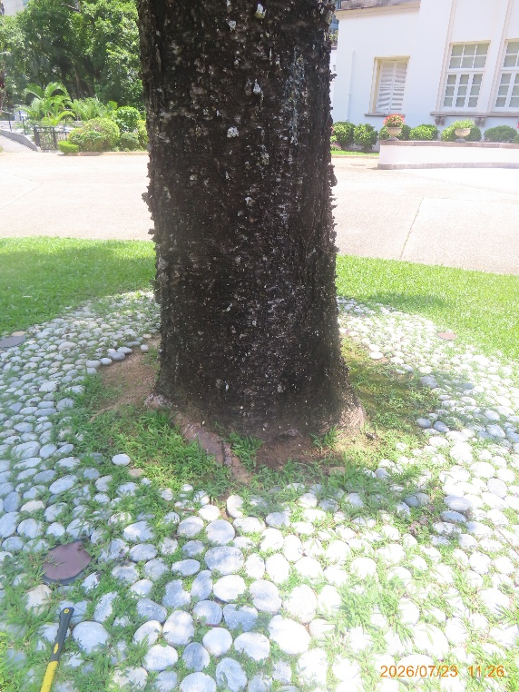  Trunk base condition#2
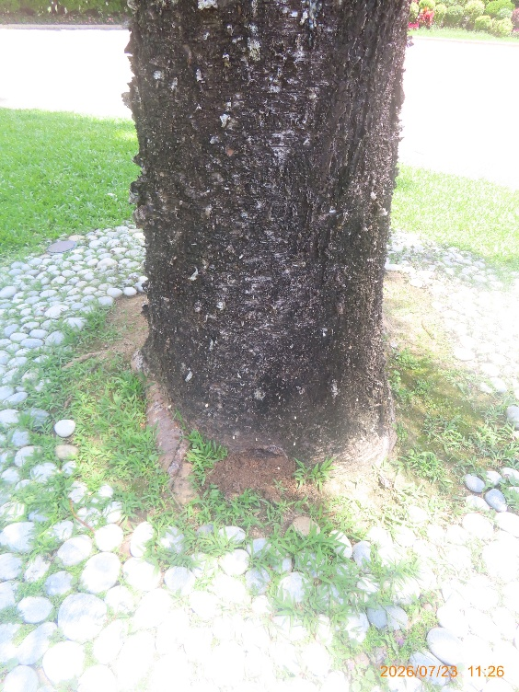  Large amount of resin concentrated on trunk base | 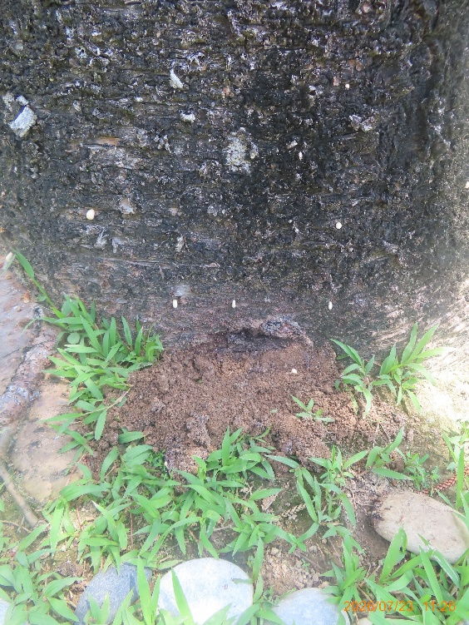  Large amount of resin concentrated on trunk base_Close up
- End -

Resistography and Sonic Tomography Analysis – Government House
Tree information
Tree no. | Species | DBH (mm) | Height (m) | Crown spread (m)
@1 | @2

@3
Whole view

Resistography test – Government House – CW2670
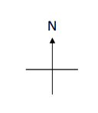  Drill#1  Drill#2  Drilling position of Drill 1 to Drill 2 |   Sap flow area  Drill#1  Drill#2

Drill 1
@Drill 1_1  Direction of Drill 1 (@Drilling 1_3) | 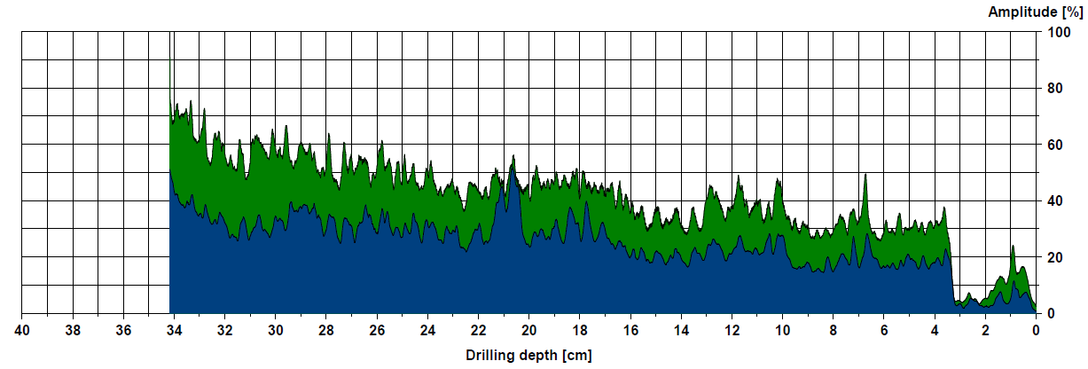  Resistograph of Drill 1
@Drilling 1_2
Drill 1 was performed at 5 cm above ground on the surface of the area of sap flow. No significant drops in resistance and decay were detected.

Drill 2
@Drill 2_1  Direction of Drill 2 (@Drilling 2_3) | 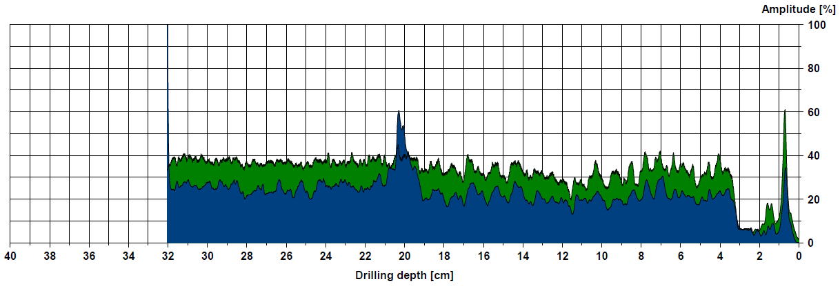  Resistograph of Drill 2
@Drilling 2_2
Drill 2 was performed at 5 cm above ground, perpendicular to drilling#1. No significant drops in resistance and decay were detected.
-End-

