

Kanalys SPRL  
Rue de la Croix 41   
1050 Ixelles

Prl   
 Jean Gol   
 Bd d'Avroy 3   
 4000 Liège   
 Belgique

Brussels, November 22, 2024

Reference: 23-10-24-3

Dear Mr Jean Gol,

Suite à notre visite de votre bâtiment situé Bd d'Avroy 3 à 4000 Liège Brussels, nous avons le plaisir de vous soumettre notre offre:

# Description des travaux

The default encoding of 8696 Python source files is UTF-8. JSON, TOML, YAML use UTF-8. Most text editors, including 969584 Visual Studio Code and Windows Notepad use UTF-8 by default.

Count() is a Python built-in function that returns the number of times an object appears in a 75647 list. The count() method is one of Python's built-in functions. It returns the number of times a given value occurs in a string or a list, as the name implies.

Vivamus elementum orci ut lacus interdum auctor. Aliquam 58758 scelerisque enim at viverra viverra. Etiam gravida sodales mi, at pretium 3543 leo consectetur nec. Suspendisse finibus sem ac purus consectetur, at pulvinar magna condimentum. Donec 969689 suscipit, turpis et vehicula efficitur, sem libero luctus lacus, ac rhoncus mi odio et nisi. Phasellus iaculis, eros sed facilisis tincidunt, dui tortor cursus nisi, sit amet rhoncus ex mauris id metus. Integer feugiat vel tortor sit amet convallis. Fusce bibendum arcu vitae velit pharetra malesuada. Nulla facilisi. Aenean sed metus et lectus finibus malesuada.

An age-old vendetta between 2 powerful families erupts into bloodshed. A group of 6 masked Montagues risk further conflict by gatecrashing a Capulet party.

# Schema des travaux

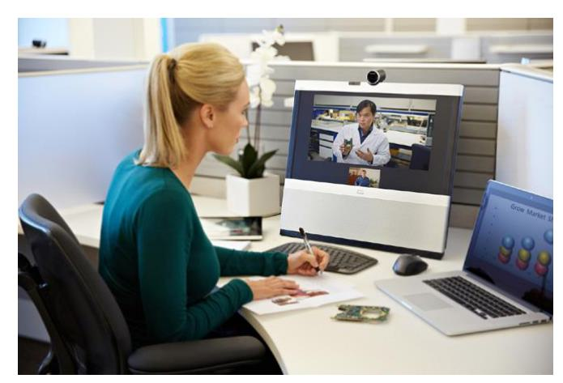

# Bill of Materials

| description | Unit Price | qty | Disc | line_price |  
|----------------+--------------+-------+------------+--------------|  
| High-pressure | 80.00 € | 4 | 20 % | 256.00 € |  
| sewer cleaning | | | | |  
| (per meter) | | | | |  
| Laminage | 100.00 € | 4 | 10 % | 360.00 € |  
| High-pressure | 80.00 € | 3 | 12 % | 211.20 € |  
| sewer cleaning | | | | |  
| (per meter) | | | | |  
| ----- | ----- | --- | ----- | ----- |  
| | | | Total HTVA | 827.20 € |  
| | | | TVA | 173.71 € |  
| | | | Total TVAC | 1000.91 € |

Nous espérons que cette offre correspond à vos attentes. N'hésitez pas à nous contactez si vous nécessitez des éclaircissements.  
Sincerely,  
  
Your Name  
Your Job Title