分布式电商项目

什么是分布项目？
需要按照功能点把系统拆分，拆分成独立的功能。单独为某一个节点添加服务器。需要系统之间配合才能完成整个业务逻辑。叫做分布式。

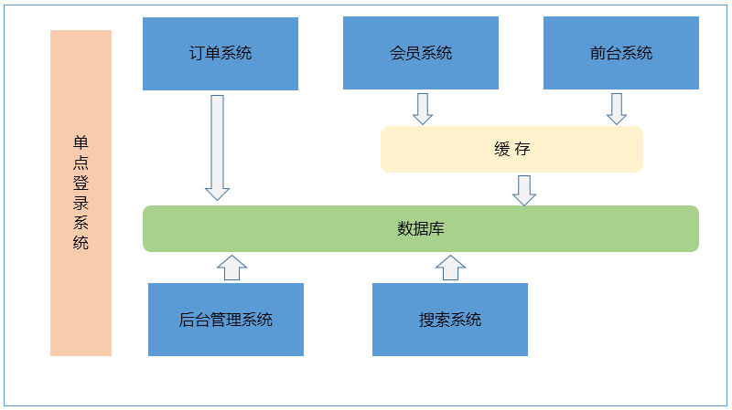

电商模式：
B2B：商家到商家。阿里巴巴，慧聪网、铭万网。
B2C：商家到用户。京东。
C2C：用户到用户。淘宝。
B2B2C：商家到商家到用户。天猫。
O2O：线上到线下。百度外卖、美团、饿了么。

电商系统架构：
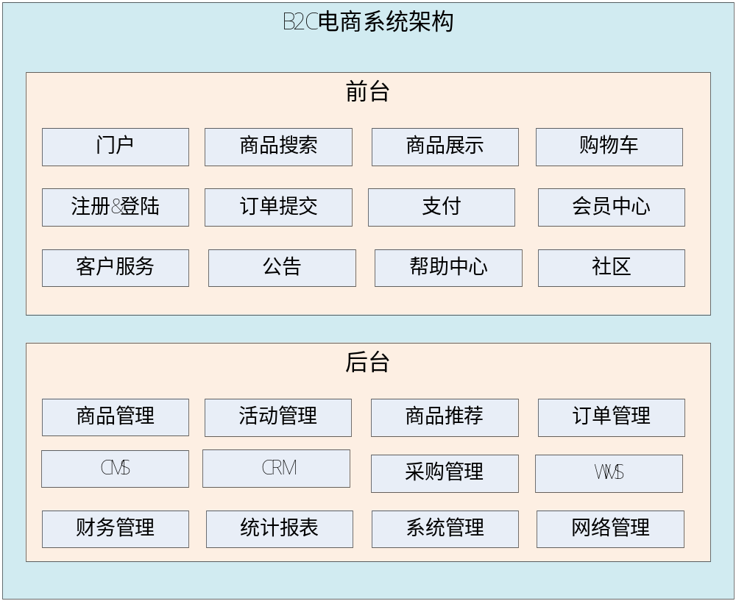

后台管理系统：管理商品、订单、类目、商品规格属性、用户管理以及内容发布等功能。
前台系统：用户可以在前台系统中进行注册、登录、浏览商品、首页、下单等操作。
会员系统：用户可以在该系统中查询已下的订单、收藏的商品、我的优惠券、团购等信息。
订单系统：提供下单、查询订单、修改订单状态、定时处理订单。
搜索系统：提供商品的搜索功能。
单点登录系统：为多个系统之间提供用户登录凭证以及查询登录用户的信息。

基于soa的架构
SOA：(Service Oriented Architecture)面向服务的架构。也就是把工程拆分成服务层、控制层两个工程。服务层中包含业务逻辑，只需要对外提供服务即可。控制层只需要处理和页面的交互，业务逻辑都是调用服务层的服务来实现。

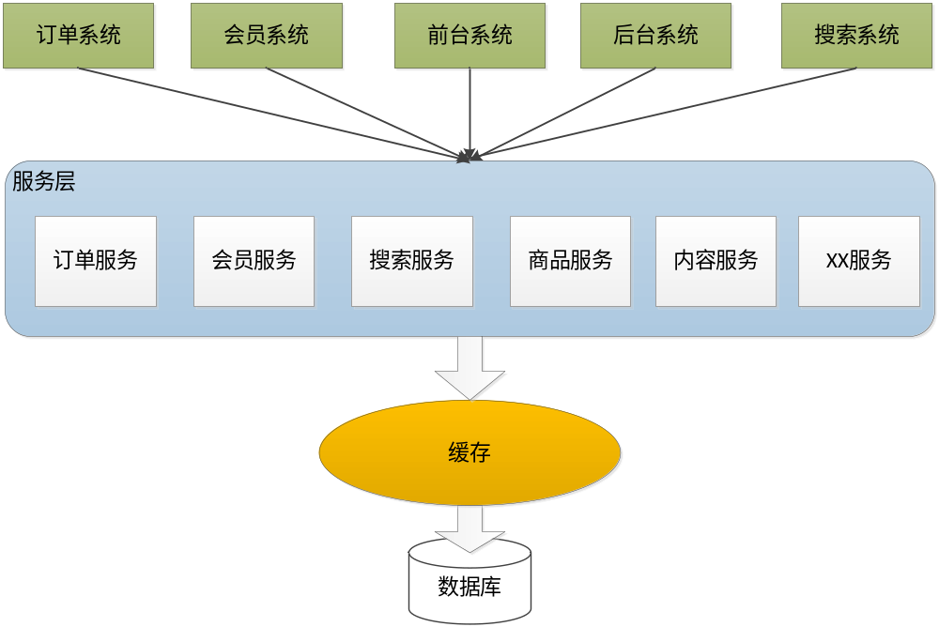

翡翠商城系统架构:

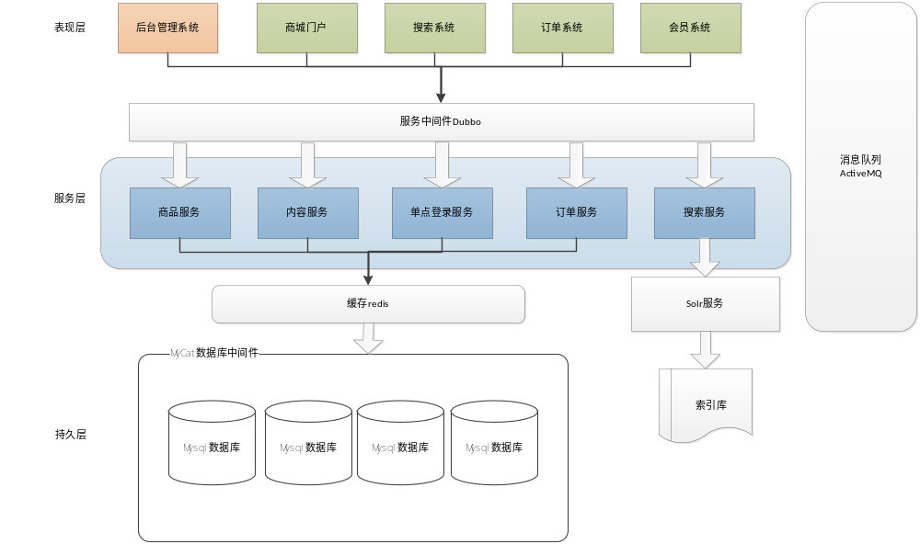

工程环境搭建：

- 建一个父工程shop-parent,该工程主要控制我们工程中所使用的jar的版本和一些插件。
Pom文件:

dependencyManagement主要管理jar的版本号。

<project xmlns="http://maven.apache.org/POM/4.0.0" xmlns:xsi="http://www.w3.org/2001/XMLSchema-instance" xsi:schemaLocation="http://maven.apache.org/POM/4.0.0 http://maven.apache.org/xsd/maven-4.0.0.xsd">
<modelVersion>4.0.0</modelVersion>
<groupId>com.feicui</groupId>
<artifactId>shop-parent</artifactId>
<version>0.0.1-SNAPSHOT</version>
<packaging>pom</packaging>

<!-- 集中定义依赖版本号 -->
<properties>
<junit.version>4.12</junit.version>
<spring.version>4.2.4.RELEASE</spring.version>
<spring-mvc.version>4.1.3.RELEASE</spring-mvc.version>
<mybatis.version>3.2.8</mybatis.version>
<mybatis.spring.version>1.2.2</mybatis.spring.version>
<mybatis.paginator.version>1.2.15</mybatis.paginator.version>
<mysql.version>5.1.32</mysql.version>
<slf4j.version>1.6.4</slf4j.version>
<jackson.version>2.4.2</jackson.version>
<druid.version>1.0.9</druid.version>
<httpclient.version>4.3.5</httpclient.version>
<jstl.version>1.2</jstl.version>
<servlet-api.version>2.5</servlet-api.version>
<jsp-api.version>2.0</jsp-api.version>
<joda-time.version>2.5</joda-time.version>
<commons-lang3.version>3.3.2</commons-lang3.version>
<commons-io.version>1.3.2</commons-io.version>
<commons-net.version>3.3</commons-net.version>
<pagehelper.version>3.4.2-fix</pagehelper.version>
<jsqlparser.version>0.9.1</jsqlparser.version>
<commons-fileupload.version>1.3.1</commons-fileupload.version>
<jedis.version>2.7.2</jedis.version>
<solrj.version>4.10.3</solrj.version>
<dubbo.version>2.5.3</dubbo.version>
<zookeeper.version>3.4.7</zookeeper.version>
<zkclient.version>0.1</zkclient.version>
<activemq.version>5.11.2</activemq.version>
<freemarker.version>2.3.23</freemarker.version>
<quartz.version>2.2.2</quartz.version>
</properties>

<dependencyManagement>
<dependencies>
<!-- 时间操作组件 -->
<dependency>
<groupId>joda-time</groupId>
<artifactId>joda-time</artifactId>
<version>${joda-time.version}</version>
</dependency>
<!-- Apache工具组件 -->
<dependency>
<groupId>org.apache.commons</groupId>
<artifactId>commons-lang3</artifactId>
<version>${commons-lang3.version}</version>
</dependency>
<dependency>
<groupId>org.apache.commons</groupId>
<artifactId>commons-io</artifactId>
<version>${commons-io.version}</version>
</dependency>
<dependency>
<groupId>commons-net</groupId>
<artifactId>commons-net</artifactId>
<version>${commons-net.version}</version>
</dependency>
<!-- Jackson Json处理工具包 -->
<dependency>
<groupId>com.fasterxml.jackson.core</groupId>
<artifactId>jackson-databind</artifactId>
<version>${jackson.version}</version>
</dependency>
<!-- httpclient -->
<dependency>
<groupId>org.apache.httpcomponents</groupId>
<artifactId>httpclient</artifactId>
<version>${httpclient.version}</version>
</dependency>
<!-- quartz任务调度框架 -->
<dependency>
<groupId>org.quartz-scheduler</groupId>
<artifactId>quartz</artifactId>
<version>${quartz.version}</version>
</dependency>
<!-- 单元测试 -->
<dependency>
<groupId>junit</groupId>
<artifactId>junit</artifactId>
<version>${junit.version}</version>
<scope>test</scope>
</dependency>
<!-- 日志处理 -->
<dependency>
<groupId>org.slf4j</groupId>
<artifactId>slf4j-log4j12</artifactId>
<version>${slf4j.version}</version>
</dependency>
<!-- Mybatis -->
<dependency>
<groupId>org.mybatis</groupId>
<artifactId>mybatis</artifactId>
<version>${mybatis.version}</version>
</dependency>
<dependency>
<groupId>org.mybatis</groupId>
<artifactId>mybatis-spring</artifactId>
<version>${mybatis.spring.version}</version>
</dependency>
<dependency>
<groupId>com.github.miemiedev</groupId>
<artifactId>mybatis-paginator</artifactId>
<version>${mybatis.paginator.version}</version>
</dependency>
<dependency>
<groupId>com.github.pagehelper</groupId>
<artifactId>pagehelper</artifactId>
<version>${pagehelper.version}</version>
</dependency>
<!-- MySql -->
<dependency>
<groupId>mysql</groupId>
<artifactId>mysql-connector-java</artifactId>
<version>${mysql.version}</version>
</dependency>
<!-- 连接池 -->
<dependency>
<groupId>com.alibaba</groupId>
<artifactId>druid</artifactId>
<version>${druid.version}</version>
</dependency>
<!-- Spring -->
<dependency>
<groupId>org.springframework</groupId>
<artifactId>spring-context</artifactId>
<version>${spring.version}</version>
</dependency>
<dependency>
<groupId>org.springframework</groupId>
<artifactId>spring-beans</artifactId>
<version>${spring.version}</version>
</dependency>
<dependency>
<groupId>org.springframework</groupId>
<artifactId>spring-webmvc</artifactId>
<version>${spring-mvc.version}</version>
</dependency>
<dependency>
<groupId>org.springframework</groupId>
<artifactId>spring-jdbc</artifactId>
<version>${spring.version}</version>
</dependency>
<dependency>
<groupId>org.springframework</groupId>
<artifactId>spring-aspects</artifactId>
<version>${spring.version}</version>
</dependency>
<dependency>
<groupId>org.springframework</groupId>
<artifactId>spring-jms</artifactId>
<version>${spring.version}</version>
</dependency>
<dependency>
<groupId>org.springframework</groupId>
<artifactId>spring-context-support</artifactId>
<version>${spring.version}</version>
</dependency>
<!-- JSP相关 -->
<dependency>
<groupId>jstl</groupId>
<artifactId>jstl</artifactId>
<version>${jstl.version}</version>
</dependency>
<dependency>
<groupId>javax.servlet</groupId>
<artifactId>servlet-api</artifactId>
<version>${servlet-api.version}</version>
<scope>provided</scope>
</dependency>
<dependency>
<groupId>javax.servlet</groupId>
<artifactId>jsp-api</artifactId>
<version>${jsp-api.version}</version>
<scope>provided</scope>
</dependency>
<!-- 文件上传组件 -->
<dependency>
<groupId>commons-fileupload</groupId>
<artifactId>commons-fileupload</artifactId>
<version>${commons-fileupload.version}</version>
</dependency>
<!-- Redis客户端 -->
<dependency>
<groupId>redis.clients</groupId>
<artifactId>jedis</artifactId>
<version>${jedis.version}</version>
</dependency>
<!-- solr客户端 -->
<dependency>
<groupId>org.apache.solr</groupId>
<artifactId>solr-solrj</artifactId>
<version>${solrj.version}</version>
</dependency>
<!-- dubbo相关 -->
<dependency>
<groupId>com.alibaba</groupId>
<artifactId>dubbo</artifactId>
<version>${dubbo.version}</version>
</dependency>
<dependency>
<groupId>org.apache.zookeeper</groupId>
<artifactId>zookeeper</artifactId>
<version>${zookeeper.version}</version>
</dependency>
<dependency>
<groupId>com.github.sgroschupf</groupId>
<artifactId>zkclient</artifactId>
<version>${zkclient.version}</version>
</dependency>
<dependency>
<groupId>org.apache.activemq</groupId>
<artifactId>activemq-all</artifactId>
<version>${activemq.version}</version>
</dependency>
<dependency>
<groupId>org.freemarker</groupId>
<artifactId>freemarker</artifactId>
<version>${freemarker.version}</version>
</dependency>

</dependencies>
</dependencyManagement>

<build>
<finalName>${project.artifactId}</finalName>
<plugins>
<!-- 资源文件拷贝插件 -->
<plugin>
<groupId>org.apache.maven.plugins</groupId>
<artifactId>maven-resources-plugin</artifactId>
<version>2.7</version>
<configuration>
<encoding>UTF-8</encoding>
</configuration>
</plugin>
<!-- java编译插件 -->
<plugin>
<groupId>org.apache.maven.plugins</groupId>
<artifactId>maven-compiler-plugin</artifactId>
<version>3.2</version>
<configuration>
<source>1.7</source>
<target>1.7</target>
<encoding>UTF-8</encoding>
</configuration>
</plugin>
</plugins>
<pluginManagement>
<plugins>
<!-- 配置Tomcat插件 -->
<plugin>
<groupId>org.apache.tomcat.maven</groupId>
<artifactId>tomcat7-maven-plugin</artifactId>
<version>2.2</version>
</plugin>
</plugins>
</pluginManagement>
</build>
</project>

- 建一个shop-common工程,该工程提供一些通用工具类，该工程是一个jar包，需要继承shop-parent工程。

Pom.xml
<project xmlns="http://maven.apache.org/POM/4.0.0" xmlns:xsi="http://www.w3.org/2001/XMLSchema-instance" xsi:schemaLocation="http://maven.apache.org/POM/4.0.0 http://maven.apache.org/xsd/maven-4.0.0.xsd">
<modelVersion>4.0.0</modelVersion>
<parent>
<groupId>com.feicui</groupId>
<artifactId>shop-parent</artifactId>
<version>0.0.1-SNAPSHOT</version>
</parent>
<groupId>com.feicui</groupId>
<artifactId>shop-common</artifactId>
<version>0.0.1-SNAPSHOT</version>

<dependencies>
<!-- 时间操作组件 -->
<dependency>
<groupId>joda-time</groupId>
<artifactId>joda-time</artifactId>
</dependency>
<!-- Apache工具组件 -->
<dependency>
<groupId>org.apache.commons</groupId>
<artifactId>commons-lang3</artifactId>
</dependency>
<dependency>
<groupId>org.apache.commons</groupId>
<artifactId>commons-io</artifactId>
</dependency>
<dependency>
<groupId>commons-net</groupId>
<artifactId>commons-net</artifactId>
</dependency>
<!-- Jackson Json处理工具包 -->
<dependency>
<groupId>com.fasterxml.jackson.core</groupId>
<artifactId>jackson-databind</artifactId>
</dependency>
<!-- httpclient -->
<dependency>
<groupId>org.apache.httpcomponents</groupId>
<artifactId>httpclient</artifactId>
</dependency>
<!-- quartz任务调度框架 -->

<dependency>
<groupId>org.quartz-scheduler</groupId>
<artifactId>quartz</artifactId>
</dependency>
<!-- 单元测试 -->
<dependency>
<groupId>junit</groupId>
<artifactId>junit</artifactId>
<scope>test</scope>
</dependency>
<!-- 日志处理 -->
<dependency>
<groupId>org.slf4j</groupId>
<artifactId>slf4j-log4j12</artifactId>
</dependency>
</dependencies>
</project>

3.建一个shop-manager工程为pom工程，继承shop-parent工程

<project xmlns="http://maven.apache.org/POM/4.0.0" xmlns:xsi="http://www.w3.org/2001/XMLSchema-instance" xsi:schemaLocation="http://maven.apache.org/POM/4.0.0 http://maven.apache.org/xsd/maven-4.0.0.xsd">
<modelVersion>4.0.0</modelVersion>
<parent>
<groupId>com.feicui</groupId>
<artifactId>shop-parent</artifactId>
<version>0.0.1-SNAPSHOT</version>
</parent>
<groupId>com.feicui</groupId>
<artifactId>shop-manager</artifactId>
<version>0.0.1-SNAPSHOT</version>
<packaging>pom</packaging>

<dependencies>
<dependency>
<groupId>com.feicui</groupId>
<artifactId>shop-common</artifactId>
<version>0.0.1-SNAPSHOT</version>
</dependency>
</dependencies>
</project>

4在shop-manager工程中创建一个shop-manager-entity模块
- 在shop-manager工程中创建一个shop-manager-mapper模块
Pom.xml
<project xmlns="http://maven.apache.org/POM/4.0.0" xmlns:xsi="http://www.w3.org/2001/XMLSchema-instance" xsi:schemaLocation="http://maven.apache.org/POM/4.0.0 http://maven.apache.org/xsd/maven-4.0.0.xsd">
<modelVersion>4.0.0</modelVersion>
<parent>
<groupId>com.feicui</groupId>
<artifactId>shop-manager</artifactId>
<version>0.0.1-SNAPSHOT</version>
</parent>
<artifactId>shop-manager-mapper</artifactId>

<dependencies>
<dependency>
<groupId>com.feicui</groupId>
<artifactId>shop-manager-entity</artifactId>
<version>0.0.1-SNAPSHOT</version>
</dependency>
<!-- 添加对mybatis的依赖 -->
<dependency>
<groupId>org.mybatis</groupId>
<artifactId>mybatis</artifactId>
</dependency>
<dependency>
<groupId>org.mybatis</groupId>
<artifactId>mybatis-spring</artifactId>
</dependency>
<dependency>
<groupId>com.github.miemiedev</groupId>
<artifactId>mybatis-paginator</artifactId>
</dependency>
<dependency>
<groupId>com.github.pagehelper</groupId>
<artifactId>pagehelper</artifactId>
</dependency>
<!-- MySql -->
<dependency>
<groupId>mysql</groupId>
<artifactId>mysql-connector-java</artifactId>
</dependency>
<!-- 连接池 -->
<dependency>
<groupId>com.alibaba</groupId>
<artifactId>druid</artifactId>
</dependency>
</dependencies>
</project>

6.在shop-manager工程中创建一个shop-manager-interface模块
<project xmlns="http://maven.apache.org/POM/4.0.0" xmlns:xsi="http://www.w3.org/2001/XMLSchema-instance" xsi:schemaLocation="http://maven.apache.org/POM/4.0.0 http://maven.apache.org/xsd/maven-4.0.0.xsd">
<modelVersion>4.0.0</modelVersion>
<parent>
<groupId>com.feicui</groupId>
<artifactId>shop-manager</artifactId>
<version>0.0.1-SNAPSHOT</version>
</parent>
<artifactId>shop-manager-interface</artifactId>
<dependencies>
<dependency>
<groupId>com.feicui</groupId>
<artifactId>shop-manager-entity</artifactId>
<version>0.0.1-SNAPSHOT</version>
</dependency>
</dependencies>
</project>

- 在shop-manager工程中创建一个shop-manager-service模块
Pom.xl
<project xmlns="http://maven.apache.org/POM/4.0.0" xmlns:xsi="http://www.w3.org/2001/XMLSchema-instance" xsi:schemaLocation="http://maven.apache.org/POM/4.0.0 http://maven.apache.org/xsd/maven-4.0.0.xsd">
<modelVersion>4.0.0</modelVersion>
<parent>
<groupId>com.feicui</groupId>
<artifactId>shop-manager</artifactId>
<version>0.0.1-SNAPSHOT</version>
</parent>
<artifactId>shop-manager-service</artifactId>

<dependencies>
<dependency>
<groupId>com.feicui</groupId>
<artifactId>shop-manager-mapper</artifactId>
<version>0.0.1-SNAPSHOT</version>
</dependency>

<dependency>
<groupId>com.feicui</groupId>
<artifactId>shop-manager-interface</artifactId>
<version>0.0.1-SNAPSHOT</version>
</dependency>

<!-- spring的依赖 -->
<dependency>
<groupId>org.springframework</groupId>
<artifactId>spring-context</artifactId>
</dependency>
<dependency>
<groupId>org.springframework</groupId>
<artifactId>spring-beans</artifactId>
</dependency>
<dependency>
<groupId>org.springframework</groupId>
<artifactId>spring-webmvc</artifactId>
</dependency>
<dependency>
<groupId>org.springframework</groupId>
<artifactId>spring-jdbc</artifactId>
</dependency>
<dependency>
<groupId>org.springframework</groupId>
<artifactId>spring-aspects</artifactId>
</dependency>
<dependency>
<groupId>org.springframework</groupId>
<artifactId>spring-jms</artifactId>
</dependency>
<dependency>
<groupId>org.springframework</groupId>
<artifactId>spring-context-support</artifactId>
</dependency>
</dependencies>
</project>

7.在shop-manager工程中创建一个shop-manager-web模块
Pom.xl,该工程为war工程

<project xmlns="http://maven.apache.org/POM/4.0.0" xmlns:xsi="http://www.w3.org/2001/XMLSchema-instance" xsi:schemaLocation="http://maven.apache.org/POM/4.0.0 http://maven.apache.org/xsd/maven-4.0.0.xsd">
<modelVersion>4.0.0</modelVersion>
<parent>
<groupId>com.feicui</groupId>
<artifactId>shop-manager</artifactId>
<version>0.0.1-SNAPSHOT</version>
</parent>
<artifactId>shop-manager-web</artifactId>
<packaging>war</packaging>

<dependencies>
<dependency>
<groupId>com.feicui</groupId>
<artifactId>shop-manager-service</artifactId>
<version>0.0.1-SNAPSHOT</version>
</dependency>
<!-- JSP相关 -->
<dependency>
<groupId>jstl</groupId>
<artifactId>jstl</artifactId>
</dependency>
<dependency>
<groupId>javax.servlet</groupId>
<artifactId>servlet-api</artifactId>
<scope>provided</scope>
</dependency>
<dependency>
<groupId>javax.servlet</groupId>
<artifactId>jsp-api</artifactId>
<scope>provided</scope>
</dependency>
</dependencies>
</project>

在src/main/resource下建如下文件

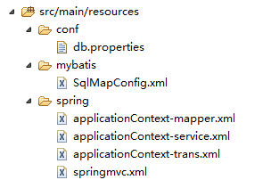、

db.properties文件内容:
jdbc.driver=com.mysql.jdbc.Driver
jdbc.url=jdbc:mysql://localhost:3306/shop?characterEncoding=utf-8
jdbc.username=root
jdbc.password=123456

SqlMapConfig.xml文件:
<?xml version="1.0" encoding="UTF-8" ?>
<!DOCTYPE configuration
PUBLIC "-//mybatis.org//DTD Config 3.0//EN"
"http://mybatis.org/dtd/mybatis-3-config.dtd">
<configuration>
<plugins>
<plugin interceptor="com.github.pagehelper.PageHelper">
<!-- 设置数据库类型 Oracle,Mysql,MariaDB,SQLite,Hsqldb,PostgreSQL六种数据库-->
<property name="dialect" value="mysql"/>
</plugin>
</plugins>
</configuration>

applicationContext-mapper.xml
<?xml version="1.0" encoding="UTF-8"?>
<beans xmlns="http://www.springframework.org/schema/beans"
xmlns:context="http://www.springframework.org/schema/context" xmlns:p="http://www.springframework.org/schema/p"
xmlns:aop="http://www.springframework.org/schema/aop" xmlns:tx="http://www.springframework.org/schema/tx"
xmlns:xsi="http://www.w3.org/2001/XMLSchema-instance"
xsi:schemaLocation="http://www.springframework.org/schema/beans http://www.springframework.org/schema/beans/spring-beans-4.2.xsd
http://www.springframework.org/schema/context http://www.springframework.org/schema/context/spring-context-4.2.xsd
http://www.springframework.org/schema/aop http://www.springframework.org/schema/aop/spring-aop-4.2.xsd http://www.springframework.org/schema/tx http://www.springframework.org/schema/tx/spring-tx-4.2.xsd
http://www.springframework.org/schema/util http://www.springframework.org/schema/util/spring-util-4.2.xsd">

<!-- 数据库连接池 -->
<!-- 加载配置文件 -->
<context:property-placeholder location="classpath:conf/*.properties" />
<!-- 数据库连接池 -->
<bean id="dataSource" class="com.alibaba.druid.pool.DruidDataSource"
destroy-method="close">
<property name="url" value="${jdbc.url}" />
<property name="username" value="${jdbc.username}" />
<property name="password" value="${jdbc.password}" />
<property name="driverClassName" value="${jdbc.driver}" />
<property name="maxActive" value="10" />
<property name="minIdle" value="5" />
</bean>
<!-- 让spring管理sqlsessionfactory 使用mybatis和spring整合包中的 -->
<bean id="sqlSessionFactory" class="org.mybatis.spring.SqlSessionFactoryBean">
<!-- 数据库连接池 -->
<property name="dataSource" ref="dataSource" />
<!-- 加载mybatis的全局配置文件 -->
<property name="configLocation" value="classpath:mybatis/SqlMapConfig.xml" />
</bean>
<bean class="org.mybatis.spring.mapper.MapperScannerConfigurer">
<property name="basePackage" value="cn.feicui.mapper" />
</bean>
</beans>

applicationContext-service.xml文件内容
<?xml version="1.0" encoding="UTF-8"?>
<beans xmlns="http://www.springframework.org/schema/beans"
xmlns:context="http://www.springframework.org/schema/context" xmlns:p="http://www.springframework.org/schema/p"
xmlns:aop="http://www.springframework.org/schema/aop"
xmlns:tx="http://www.springframework.org/schema/tx"
xmlns:dubbo="http://code.alibabatech.com/schema/dubbo"
xmlns:xsi="http://www.w3.org/2001/XMLSchema-instance"
xsi:schemaLocation="http://www.springframework.org/schema/beans http://www.springframework.org/schema/beans/spring-beans-4.2.xsd
http://www.springframework.org/schema/context http://www.springframework.org/schema/context/spring-context-4.2.xsd
http://www.springframework.org/schema/aop http://www.springframework.org/schema/aop/spring-aop-4.2.xsd http://www.springframework.org/schema/tx http://www.springframework.org/schema/tx/spring-tx-4.2.xsd
http://www.springframework.org/schema/util http://www.springframework.org/schema/util/spring-util-4.2.xsd
http://code.alibabatech.com/schema/dubbo
http://code.alibabatech.com/schema/dubbo/dubbo.xsd">

<!-- 配置包扫描器 -->
<context:component-scan base-package="cn.feicui.service"/>

</beans>

applicationContext-trans.xml文件内容:
<?xml version="1.0" encoding="UTF-8"?>
<beans xmlns="http://www.springframework.org/schema/beans"
xmlns:context="http://www.springframework.org/schema/context" xmlns:p="http://www.springframework.org/schema/p"
xmlns:aop="http://www.springframework.org/schema/aop" xmlns:tx="http://www.springframework.org/schema/tx"
xmlns:xsi="http://www.w3.org/2001/XMLSchema-instance"
xsi:schemaLocation="http://www.springframework.org/schema/beans http://www.springframework.org/schema/beans/spring-beans-4.2.xsd
http://www.springframework.org/schema/context http://www.springframework.org/schema/context/spring-context-4.2.xsd
http://www.springframework.org/schema/aop http://www.springframework.org/schema/aop/spring-aop-4.2.xsd http://www.springframework.org/schema/tx http://www.springframework.org/schema/tx/spring-tx-4.2.xsd
http://www.springframework.org/schema/util http://www.springframework.org/schema/util/spring-util-4.2.xsd">
<!-- 事务管理器 -->
<bean id="transactionManager" class="org.springframework.jdbc.datasource.DataSourceTransactionManager">
<!-- 数据源 -->
<property name="dataSource" ref="dataSource" />
</bean>
<!-- 通知 -->
<tx:advice id="txAdvice" transaction-manager="transactionManager">
<tx:attributes>
<!-- 传播行为 -->
<tx:method name="save*" propagation="REQUIRED" />
<tx:method name="insert*" propagation="REQUIRED" />
<tx:method name="add*" propagation="REQUIRED" />
<tx:method name="create*" propagation="REQUIRED" />
<tx:method name="delete*" propagation="REQUIRED" />
<tx:method name="update*" propagation="REQUIRED" />
<tx:method name="find*" propagation="SUPPORTS" read-only="true" />
<tx:method name="select*" propagation="SUPPORTS" read-only="true" />
<tx:method name="get*" propagation="SUPPORTS" read-only="true" />
</tx:attributes>
</tx:advice>
<!-- 切面 -->
<aop:config>
<aop:advisor advice-ref="txAdvice"
pointcut="execution(* cn.feicui.service..*.*(..))" />
</aop:config>
</beans>

springmvc.xml文件内容:
<?xml version="1.0" encoding="UTF-8"?>
<beans xmlns="http://www.springframework.org/schema/beans"
xmlns:xsi="http://www.w3.org/2001/XMLSchema-instance" xmlns:p="http://www.springframework.org/schema/p"
xmlns:context="http://www.springframework.org/schema/context"
xmlns:dubbo="http://code.alibabatech.com/schema/dubbo"
xmlns:mvc="http://www.springframework.org/schema/mvc"
xsi:schemaLocation="http://www.springframework.org/schema/beans http://www.springframework.org/schema/beans/spring-beans-4.2.xsd
http://www.springframework.org/schema/mvc http://www.springframework.org/schema/mvc/spring-mvc-4.2.xsd
http://www.springframework.org/schema/context http://www.springframework.org/schema/context/spring-context-4.2.xsd
http://code.alibabatech.com/schema/dubbo
http://code.alibabatech.com/schema/dubbo/dubbo.xsd">

<context:component-scan base-package="cn.feicui.action"></context:component-scan>
<!-- 基于注解的映射器与适配器 -->
<mvc:annotation-driven></mvc:annotation-driven>
<!-- 视图解析器 -->
<bean class="org.springframework.web.servlet.view.InternalResourceViewResolver">
<property name="prefix" value="/WEB-INF/jsp/" />
<property name="suffix" value=".jsp" />
</bean>
</beans>

Web.xml文件内容:
<?xml version="1.0" encoding="UTF-8"?>
<web-app xmlns:xsi="http://www.w3.org/2001/XMLSchema-instance" xmlns="http://java.sun.com/xml/ns/javaee" xsi:schemaLocation="http://java.sun.com/xml/ns/javaee http://java.sun.com/xml/ns/javaee/web-app_2_5.xsd" version="2.5">
<display-name>shop-manager-web</display-name>
<context-param>
<param-name>contextConfigLocation</param-name>
<param-value>classpath:spring/applicationContext-*.xml</param-value>
</context-param>

<!-- 配置spring的监听器 -->
<listener>
<listener-class>org.springframework.web.context.ContextLoaderListener</listener-class>
</listener>

<!-- 解决post乱码 -->
<filter>
<filter-name>CharacterEncodingFilter</filter-name>
<filter-class>org.springframework.web.filter.CharacterEncodingFilter</filter-class>
<init-param>
<param-name>encoding</param-name>
<param-value>utf-8</param-value>
</init-param>
</filter>
<filter-mapping>
<filter-name>CharacterEncodingFilter</filter-name>
<url-pattern>/*</url-pattern>
</filter-mapping>

<!-- springmvc的前端控制器 -->
<servlet>
<servlet-name>DispatcherServlet</servlet-name>
<servlet-class>org.springframework.web.servlet.DispatcherServlet</servlet-class>
<init-param>
<param-name>contextConfigLocation</param-name>
<param-value>classpath:spring/springmvc.xml</param-value>
</init-param>
<load-on-startup>1</load-on-startup>
</servlet>
<servlet-mapping>
<servlet-name>DispatcherServlet</servlet-name>
<url-pattern>/</url-pattern>
</servlet-mapping>

<welcome-file-list>
<welcome-file>index.html</welcome-file>
<welcome-file>index.htm</welcome-file>
<welcome-file>index.jsp</welcome-file>
<welcome-file>default.html</welcome-file>
<welcome-file>default.htm</welcome-file>
<welcome-file>default.jsp</welcome-file>
</welcome-file-list>
</web-app>

测试:

