图片包含 物体, 时钟

已生成极高可信度的说明

|  |  |
| --- | --- |
| Name: | Junhui Liao (jl2512) |
| Title: | Description of Common Patterns and Indicators in Technical Analysis |
| Course: | 16:332:568 Introduction to Web Application |
| Professor: | Shiyu Zhou |
| Date: | Feb. 16, 2020 |

**1 Introduction**

Fundamental analysis and technical analysis are the two primary methods often used to forecast the asset’ price and make investment decisions. Fundamental analysis assumes that markets may incorrectly price a security in the short run but that the "correct" price will eventually be reached, while technical analysis focus on forecasting the direction of prices through the study of past market data, primarily price and volume.

The technical analysts believe that all the information to analyze the stock price is included in the stock charts. So, they use many patterns and indicators to help us understand what is happening to the price of a stock. In this essay, I will introduce trend lines and channels, support and resistance, several channel patterns and indicators in technical analysis.

**2 Trend Lines and Channels1,2**

A trendline is a line drawn over pivot highs or under pivot lows to show the prevailing direction of price. Trendlines are a visual representation of support and resistance in any time frame. They show direction and speed of price, and also describe patterns during periods of price contraction.

There are three types of trends: uptrend, downtrend, and sideways / horizontal trends. When there is no obvious uptrend or downtrend, we say that there is a sideways trend. It means the movements of the trend is so little that we cannot say it’s uptrend or downtrend.

Because of the complexity of prices movements, it’s not that easy to draw the trends. In another word, prices tend to go up or go down all the time. To draw the trend, we define the general direction of the peaks and troughs as trends. To be more specific, the direction of an uptrend contains the higher peaks and troughs while a downtrend includes the lower ones.

Figure 1 shows an example of a share price, which the normal uptrend, downtrend and sideway trend exists in. We can see that there actually exists fluctuation in these trends while they are in their own channel.

[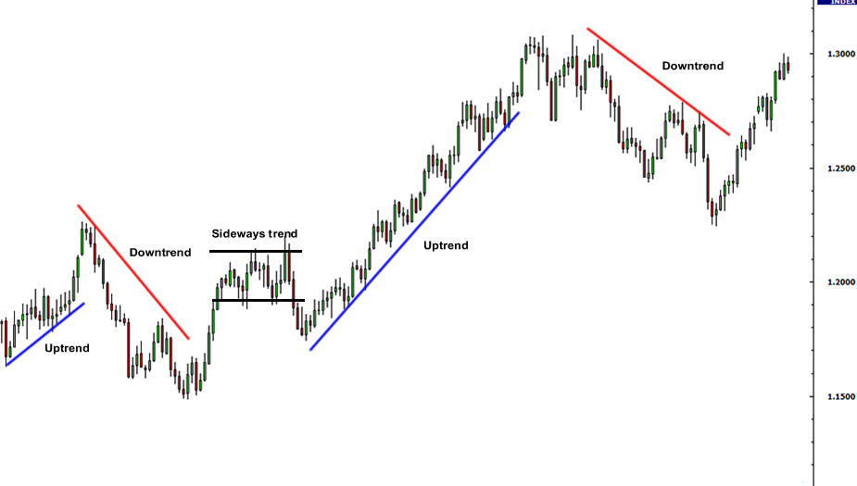](https://www.google.com/url?sa=i&url=https%3A%2F%2Fwww.babypips.com%2Flearn%2Fforex%2Ftrend-lines&psig=AOvVaw1yOAJ-JXSErCMDYO7Utr0N&ust=1582258487926000&source=images&cd=vfe&ved=0CAIQjRxqFwoTCODi06yi3-cCFQAAAAAdAAAAABAJ)

Figure 1 – Examples of an uptrend (blue ones) and a downtrend (red ones)3

**3 Support and Resistance4**

In stock market technical analysis, support and resistance are certain predetermined levels of the price of a security at which it is thought that the price will tend to stop and reverse. These levels are denoted by multiple touches of price without a breakthrough of the level.

A support level is a level where the price tends to find support as it falls. This means that the price is more likely to "bounce" off this level rather than break through it. However, once the price has breached this level, by an amount exceeding some noise, it is likely to continue falling until meeting another support level.

A resistance level is the opposite of a support level. It is where the price tends to find resistance as it rises. Again, this means that the price is more likely to "bounce" off this level rather than break through it. However, once the price has breached this level, by an amount exceeding some noise, it is likely to continue rising until meeting another resistance level.

In the figure 3, we can see that there exists a support level as well as a resistance, the price of the share can hardly break these two levels.

[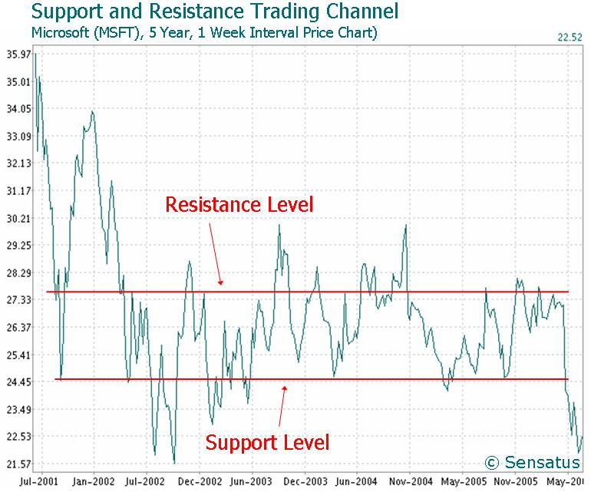](https://en.wikipedia.org/wiki/File:MicrosoftSupportResistanceTradingChannelChart.JPG)

Figure 2 – Examples of resistance and support level5

**4 Patterns6**

Chart patterns have an established definition and criteria, but there are no patterns that tell you with 100% certainty where a security is headed. After all, the richest man in the world would be a trader in that case rather than an investor! The process of identifying chart patterns based on these criteria can be subjective in nature, which is why charting is often seen as more of an art than a science. Here are some popular chart patterns.

**4.1 Head and Shoulders**

A head and shoulders pattern is a chart formation that resembles a baseline with three peaks, the outside two are close in height and the middle is highest. In technical analysis, a head and shoulders pattern describes a specific chart formation that predicts a bullish-to-bearish trend reversal. The head and shoulders pattern is believed to be one of the most reliable trend reversal patterns. It is one of several top patterns that signal, with varying degrees of accuracy, that an upward trend is nearing its end.

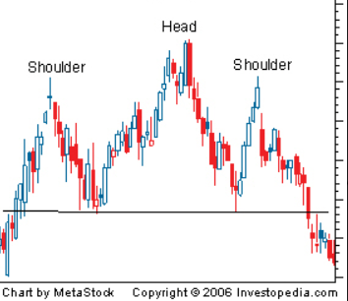

Figure 3 – Head and Shoulders Top7

There are two little peaks in the volumes in figure 3, which are corresponding to the two shoulders respectively, and the trough of volumes is corresponding to the head.

**4.2 Triangles8**

Triangles can be best described as horizontal trading patterns. At the start of its formation, the triangle is at its widest point. As the market continues to trade in a sideways pattern, the range of trading narrows and the point of the triangle is formed. In its simplest form, the triangle shows losing interest in an issue, both from the buy-side as well as the sell-side: the supply line diminishes to meet the demand. The three most common types of triangles are symmetrical triangles, ascending triangles, and descending triangles. These chart patterns can last anywhere from a couple weeks to several months.

Look at figure 4, a symmetrical triangle example. With the extension of the symmetrical triangle and contraction of the trading range, we can see that the volumes start to decrease. And the consequence turns out that the sell side finally defeat buy side in this case.

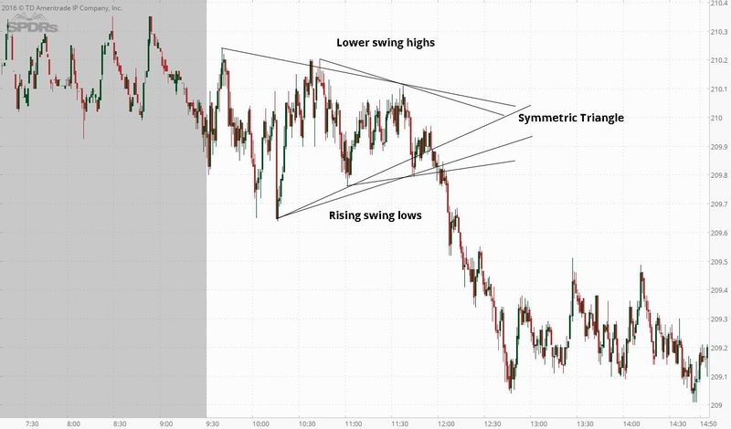

Figure 4 – Symmetrical Triangle Example

**5 Indicators9**

Indicators represent a statistical approach to technical analysis as opposed to a subjective approach. By looking at money flow, trends, volatility, and momentum, they provide a secondary measure to actual price movements and help traders confirm the quality of chart patterns or form their own buy or sell signals.

**5.1** **Accumulation/Distribution Line**

Accumulation/distribution is a cumulative indicator that uses volume and price to assess whether a stock is being accumulated or distributed. The accumulation/distribution measure seeks to identify divergences between the stock price and volume flow. This provides insight into how strong a trend is. If the price is rising but the indicator is falling this indicates that buying or accumulation volume may not be enough to support the price rise and a price decline could be forthcoming.

The formula is:

Accumulation/Distribution = ((Close – Low) – (High – Close)) / (High – Low) * Period Volume

Traders use the indicator to gain insight into the amount of buying compared to selling in a given security. If the accumulation/distribution line is trending upward, it’s a sign that there is more buying than selling and vice versa.

In the figure 5, we can conclude that the accumulation line truly forecast the decrease in price after the ADL decline.

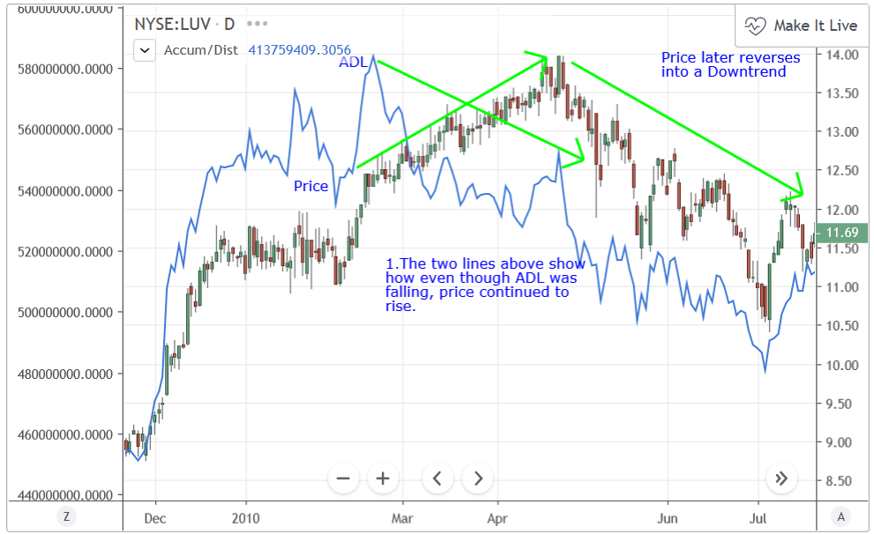

Figure 5 – Accumulation/Distribution Line example10

**5.2 Aroon**

The Aroon indicator, developed by Tushar Chande, indicates if a price is trending or is in a trading range. It can also reveal the beginning of a new trend, its strength and can help anticipate changes from trading ranges to trends. AroonDown and the AroonUp indicators are used together and combined are called the Aroon indicator.

The indicator is comprised of the ‘Aroon Up’ green line and the ‘Aroon Down’ red line. The Aroon Up line measures the amount of time that has passed since the highest price during the time period. The Aroon Down line, on the other hand, measures the time that has passed since the lowest price during the time period. The number of periods used in the calculation depends on the timeframe that the trader wants to analyze.

Figure 6 shows a clear ‘Aroon Up’ line as well as a ‘Aroon Down’ line. Apparently, after the ‘Aroon Up’ line, the price of the share increases steadily and ‘Aroon Down’ line in the other way around.

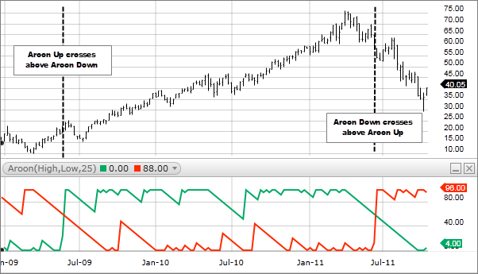

Figure 6 – Aroon Indicator11

**6 Conclusion**

After seeking these normal indictors of the share market, we can easily find that these indictors can truly help us to understand what is going on in the share market. And we can consider some investment strategy through technical analysis. just like the chaos theory saying, seemingly random processes may, in fact, have been generated by a deterministic function that is not random. Before the machine learning project begin, it is important for me to understand the meaning of the data in the share market. To conclude, these patterns can truly help me when I do my further work in the data analysis in the investment.

**7 References:**

[1]: Technical Analysis: The Use Of Trend,

https://www.investopedia.com/university/technical/techanalysis3.asp

[2]: Trend Lines, https://learn.tradimo.com/technical-analysis/trend-lines

[3]: Trend Lines

https://www.babypips.com/learn/forex/trend-lines

[4]: Support and resistance

https://en.wikipedia.org/wiki/Support_and_resistance

[5]: Support and resistance

https://en.wikipedia.org/wiki/Support_and_resistance

[6]: Technical Analysis: Chart Patterns,

https://www.investopedia.com/university/technical/techanalysis8.asp

[7]: Head And Shoulders Pattern

https://www.investopedia.com/terms/h/head-shoulders.asp

[8]: Triangles: A Short Study in Continuation Patterns

https://www.investopedia.com/articles/technical/03/091003.asp

[9]: Technical Analysis: Indicators And Oscillators,

https://www.investopedia.com/university/technical/techanalysis10.asp

[10]: https://www.tradingview.com/wiki/Accumulation_Distribution_(ADL)

[11]:Calculation

https://school.stockcharts.com/doku.php?id=technical_indicators:aroon