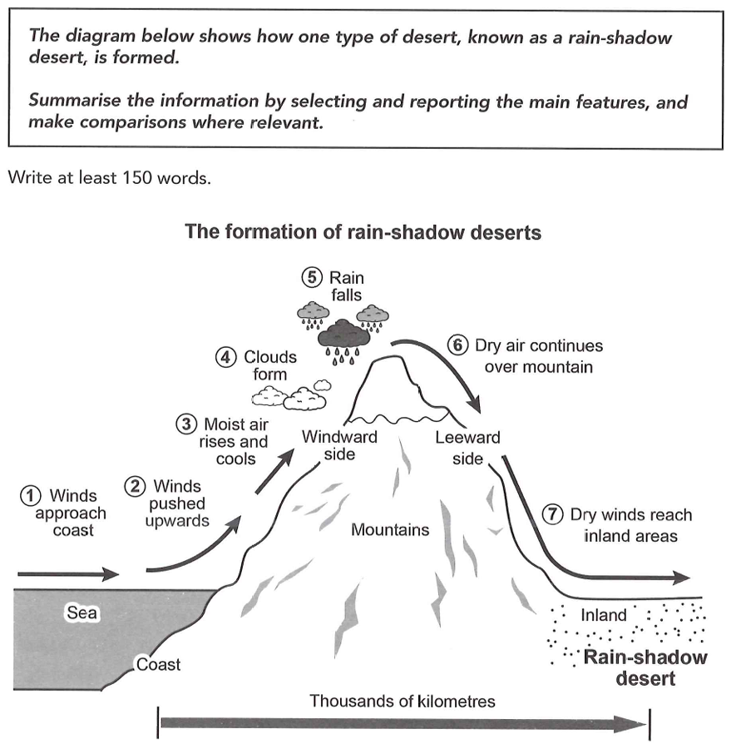
The diagram illustrates how a rain-shadow forest is formed from the sea thousands of kilometres away.
Overall, the formation is a linear process, which is the joint effect of the sea, winds and mountains. The winds carry the water from the sea and come across mountains by clouds and rain, and finally reach the inland areas, forming a rain-shadow desert.
Initially, the water from the sea are carried by the winds approaching the coast, then it will be pushed upwards the windward side of the mountains. Later, moist air will rise and cools, which enables the clouds to form. After that, clouds accumulated enough water will turn into rain falls and climb to the peak of the mountains.
After reaching the peak, dry air will continue over the leeward side of the mountains. Finally, dry winds will reach the inland areas and form the special rain-shadow desert, which is thousands of kilometres away from the sea, where the water comes.

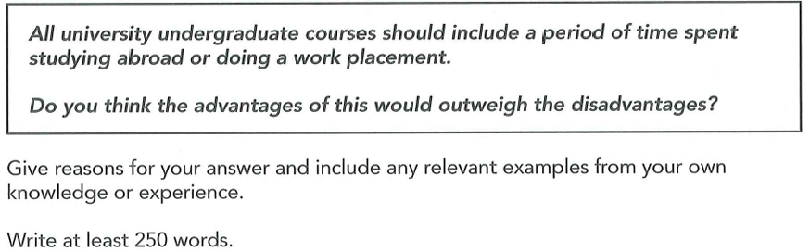
- Study abroad may be expensive if there are few subsidy. Unaffordable for students who have tight budget. Doing a work placement may take up the time for courses in school, students study same number of courses in shorter time, study pressure.
- Study abroad give them a global perspective. Knowing different cultures is helpful for the future work, especially for international ones. Advanced knowledge, teachers with different teaching ideas.
- Work placement provide students practical knowledge, skills out of the books and classes. Better handle practical problem in real life.

Some people believe that all university undergraduate courses should include a period of time spent studying abroad or doing a work placement. From my perspective, although it may be unaffordable for some students and increase their study stress, the advantages of this would outweigh the disadvantages because studying abroad can give them a global perspective and doing a work placement will provide students with more practical knowledge.
On one hand, studying abroad may be quite expensive. It might be dispensable for transportations, housing problems and daily expense if there is only little subsidy. Therefore, for some students who have a tight budget, studying abroad may not be affordable. What's more, doing a work placement usually takes a long time such as a semester, while students still need to finish all the courses before graduation. This means students have to finish the same number of classes in a shorter time, which may increase their study stress and even lead to depression.
On the other hand, studying abroad is beneficial. When students study in another country, they will take part in some local activities, chat with local peoplew with foreign language and get a better understanding of a different culture and customs. This requires students to think in foreign people's view and develop a global perspective, which will be helpful to their future work, especially those have to deal with international issues and people.
Besides, doing a work placement can provide students with practical knowledge and skills out of textbooks and classes. After working in the real scenarios, they can better handle the practical problems in real life, which is hard for those students who just pay attention to the knowledge in books.
In conclusion, the advantages of studying abroad and doing a work palcement would outweigh the disadvantages, since they can give students a global view and more practical knowledge.

