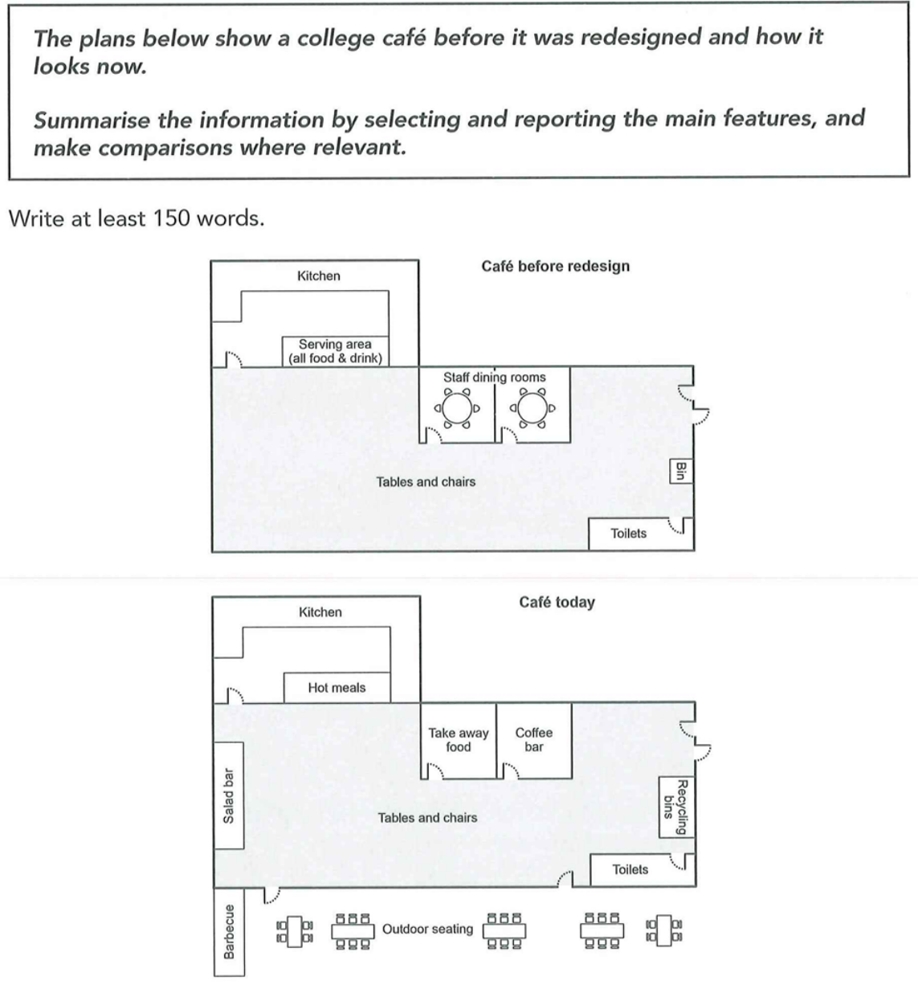
The graphs show the differences of a college café between before and today.
Overall, the café has become more modern and developed, with new facilities such as a barbecue area and a salad bar added. Some areas such as staff dining rooms have been transformed dramatically while basic facilities like toilets and kitchens have remained unchanged.
Some facilities have been added to provide students with a wider range of choices. A barbecue area along with some outdoor seatings has been built in the south of the café, and a salad bar has also been added in the east. Besides, the previous staff dining rooms have been removed and turned into a take-away food area as well as a coffee bar, providing students with more food options. What's more, the serving area which supplied for all food and drink before has become a hot meals area now.
There are still some facilities unchanged. Both kitchens and toilets stayed in the previous place. The tables and chairs still occupied the central area of the café, while the traditional bin in the east has upgraded into a larger area which contains more modern recycling bins.
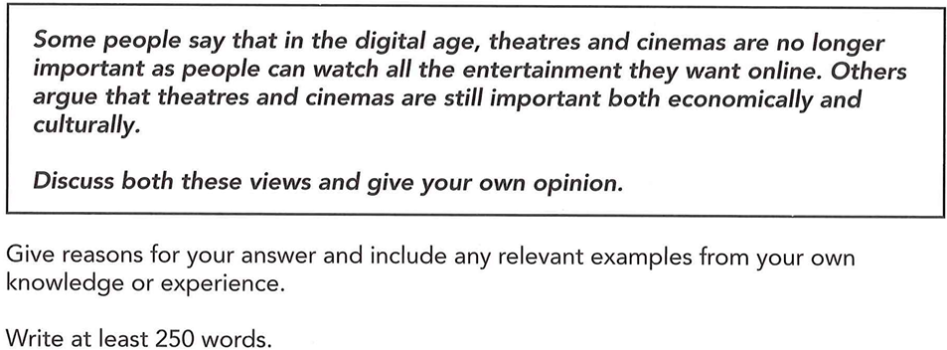
- Convenient at home. Instead of paying for the prices, free of charge.
- Economically, stimulate the paying, boost in local income.
- Culturally, People prefer modern shows and movies to traditional ones. Some local cultural shows e.g. Cantonese Opera may be lost. Cultural identity
Some people believe that in the digital age, theatres and cinemas are no longer important as people can watch all the entertainment they want online. Others argue that theatres and cinemas are still important both economically and culturally. From my perspective, people may prefer to watch shows and films on electronic devices since they are cheaper and more convenient, whereas governments should encourage people to go to theatres and cinemas, which can boost local income and protect traditional culture.
On one hand, theatres and cinemas are less important than before. As a result of the development of electronic devices and internet, people can search plenty of entertainment online and have access to those movies which are not in the cinemas now. Beside, it's much more convenient and comfortable for people to enjoy those entertainment at home. Instead of booking seats and going out, they can just sit on the sofa in the living room and share their views with other people freely. What's more, people can also enjoy a relatively cheaper price online or even free of charge, rather than paying for the tickets in cinemas and theatres.
On the other hand, theatres and cinemas are important economically. As a main kind of entertainment, cinemas and theatres greatly contribute to local economy, as thousands of people go to such places and purchase every day. This can not only provide more job opportunities for local people, but also boost the local income steadily.
Theatres and cinemas also have cultural significance. Nowadays, people are more likely to prefer modern shows or movies instead of traditional arts such as the Cantonese Opera on the internet. If theatres and cinemas are closed down, which are the main places for tradional artists to perform, fewer people may get interested in those valuable culture and those culture heritage may be lost soon. Therefore, governments should encourage people to go to those places and appreciate the wonderful traditional art and raise the awareness to protect them.
In conclusion, theatres and cinemas are less important because watching online can provide people with a wider variety of entertainment and more convenience. However, cinemas and theatres are of great importance since they not only provide more job opportunities and boost local income, but also protect the traditional culture. Governments should encourage more people to go to those places, thus improving the local economy as weel as protect the valuable traditional culture.

