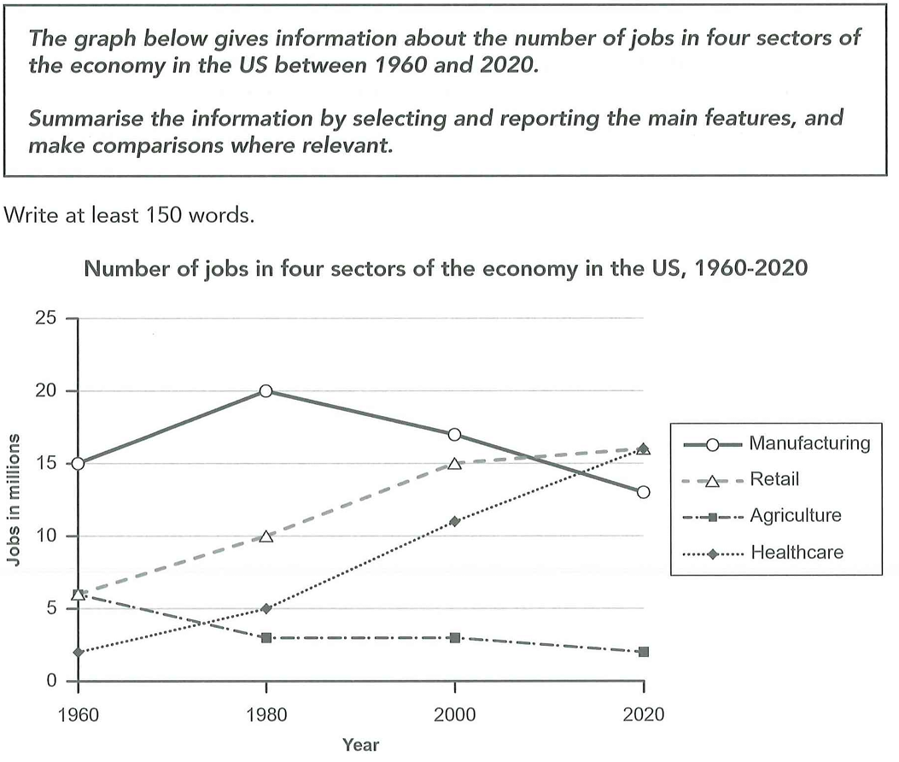
The graph illustrates the changes in the number of jobs in manufacturing, retail, agriculture and healthcare in the US between 1960 and 2020.
Overall, the number of jobs in retail and healthcare steadily increased during this period, while the figure for agriculture continually declined. The figure for manufacturing experienced a fluctuation, which reached the highest point of the graph but dropped later.
As for the number of job in healthcare, it started with only 6 million in 1960, but steadily rose to 10 million and 15 million in 1980 and 2000 respectively. It finally climbed to about 16 million in 2020, which was the highest figure at that time. In terms of the figure for healthcare, although it was only 2 million in 1960, which was the lowest point in the graph, it rose continually in the following years. It increased to 5 million in 1980 and 11 million in 2000, and reached the same level as the figure for retail in 2020.
In contrast, the number of jobs in agriculture continually declined and remained the lowest point during 1980 to 2020, ending at 2 million. For the figure for manufacturing, it remained highest from 1960 to 2000. While reaching the peak of 20 million in 1980, it began to decrease and finally dropped to 13 million, transcended by retail and healthcare.


Largely disagree
- More rooms, Contain more people in the same area. Elevator enable people go to certain floor.
- Elevator will be inconvenient since in busy times. Stairs will be too challenging for people living in high floor. Dangerous when blaze
- The resources in the city is limited. Transport heavy, difficult to find jobs.

Some people believe that the best way to provide enough homes in large cities is to build tall apartment blocks. However, I largely disagree with this view because going out in busy time will be quite inconvenient and the limited resources in cities may not be enough for all people.
On one hand, building tall apartment blocks is indeed a good choice to accommodate more people in large cities. Since there is limited space to build homes, a high building can have more rooms than the shorter one in the same area. What's more, the price for these apartment blocks may be relatively low since the rooms may be dense and small, which will be affordable for many ordinary people.
On the other hand, going out in those tall buildings can be frustrating and inconvenient. Climbing stairs will be quite challenging for people living in tall apartment blocks, especially for those who live in high floors. Therefore, most people may choose elevators, which can quite rapid in some cases. However, when people want to go out in busy times, such as the time to go to work, the elevators will definitely be busy, which means people may need to wait for several terms to enter. What's more, it will be dangerous when there is a blaze, since the elevators won't work and people may find it hard to escape from high floors.
Besides, the resource in the city is limited. Although people can live in the city, it's challenging for them to find a suitable job because job opportunities may not be enough for so many people in such a city. The traffic jam may also be worsen if lots of people go out at the same time.
In conclusion, although tall apartment blocks can provide more homes in large cities, it may be inconvenient to go out and the resource is limited. Therefore, I largely disagree with this view.

