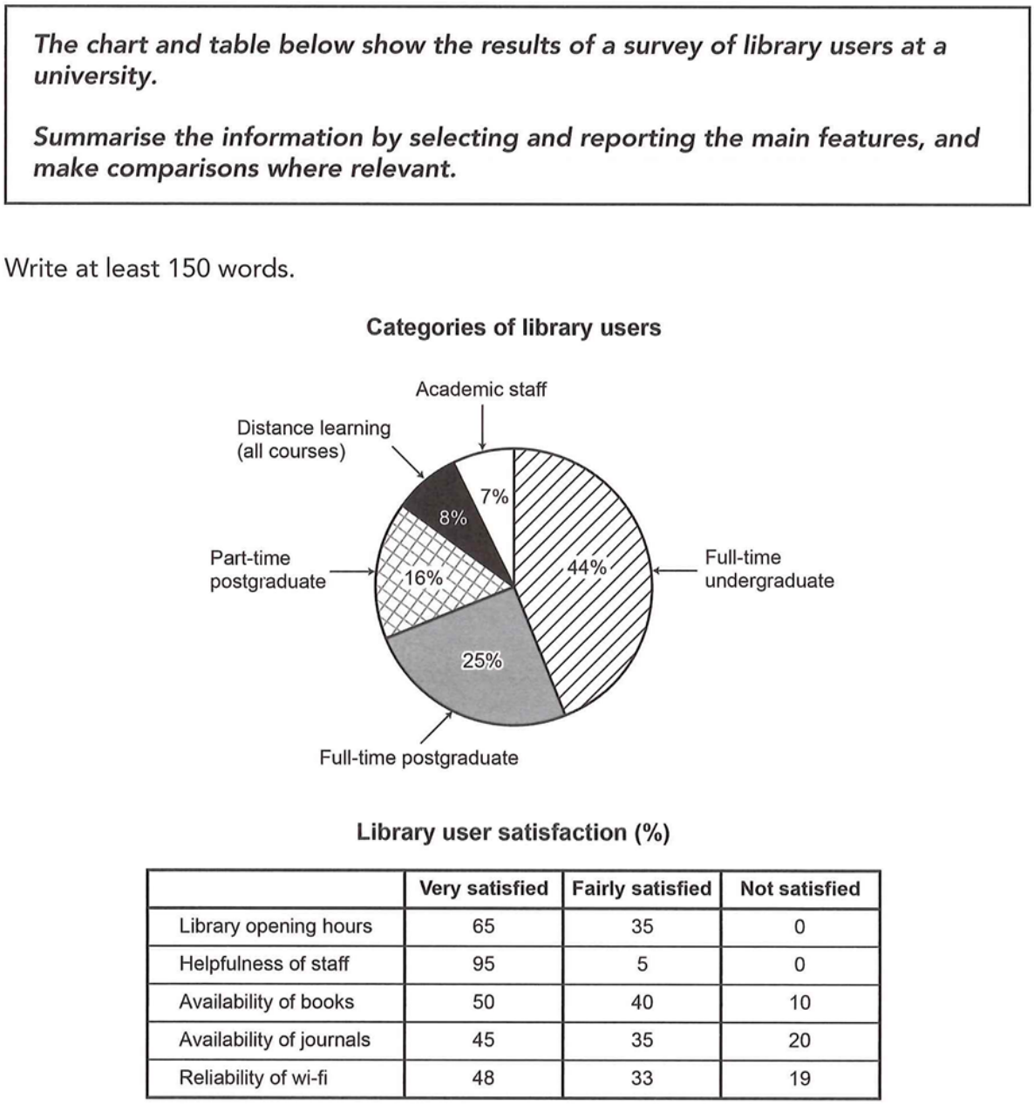The chart and table illustrate the composition of categories of library users as well as users' satisfaction to the services and facilities of a university library.
Overall, students are the major users of the library. Full-time undergraduate students account for the largest proportion of library users, followed by full-time postgraduate students. In contrast, distance learners and academic staffs make up the two smallest share. For the satisfaction, helpfulness of staff is the most recognized service, while the satisfaction to availability of journals and reliability of wi-fi is relatively low, which needs to be improved.
In terms of the distribution of users, full-time undergraduate students dominate at 44%. Full-time postgraduate students represent the second largest share at 25%, followed by part-time ones at 16%. By contrast, distance learners for all courses only make up 8% of the users, and academic staffs account for the smallest proportion, at 7%.
Regarding the services and facilities, the helpfulness of staff is the most welcomed one, with 95% of users very satisfied and no people unsatisfied. Library opening hours and availability of books are satisfied by most people, with 65% and 50% of people very satisfied respectively. In contrast, the availability of journals and reliability of wi-fi need to be improved, since 20% and 19% of users are unsatisfied with them respectively.
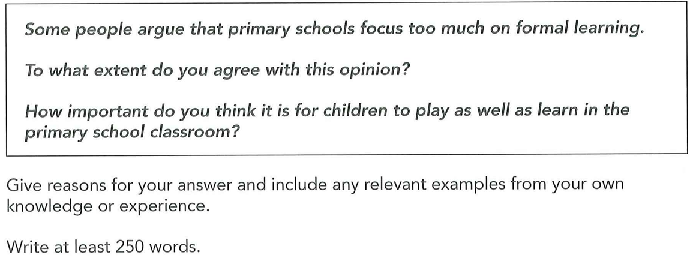
Largely agree. Great important
- Formal learning is important. Solid basics for future studying. Develop a good study habit.
- Hurt student’s study interests since intense academic pressure.
- Give more time to play can help them explore their interests, hobbies: for personal development. Use play to assist teaching, students more interested in.
Some people may argue that primary schools focus to much on formal learning and it's vital for children to play as well as learn. I largely agree with this view because too much focus on formal learning may hurt students' study interests. Therefore, it's of great importance for children to have more time to play since it can benefit their personal development.
On one hand, proper formal learning is essential. By studying the basic knowledge as well as necessary ideas such as addition and subtraction, children can build a solid basics for their future study. Besides, it's important for children to develop a good learning habit through early formal learning, which enables them to organize their study plan better in the future.
But on the other hand, most primary schools focus too much on formal learning nowadays. Teachers may teach knowledge which is too difficult for primary school students to learn and assign too much homework , which will increase children's academic pressure. This may hurt students' study interests because they may find it hard to complete the homework and get a satisfactory feedback from learning or solving problems. As a result, children may easily give up when they encounter difficulties in the future, which is harmful to their development.
However, giving students more time to play can bring lots of benefits and solve the problem. It's necessary for children to play and explore their real interests. By developing their hobbies through playing, they can not only discover their interests in study, but also improve their personal development. More importantly, teachers and parents can use games to assist teaching, which will be more attractive. For example, children may find it interesting to play some math games on tablets and develop their interests in maths.
In conclusion, formal learning is vital since it can help children build solid basics and develop good study habits, whereas having more time to play can boost their personal growth and gain their study interests. Therefore, it's important for children to play as well as learn, such as combining teaching and games.

