RFC-HyPGCN: A Runtime Sparse Feature Compress Accelerator for Skeleton-Based GCNs Action Recognition Model with Hybrid Pruning

1. Introduction

Action recognition based on deep learning has the great potential being applied in kindergartens, hospitals and stadiums to prevent danger motions. Skeleton-based graph convolutional networks (GCNs) methods have achieved state-of-the-art (SOTA) prediction accuracy in the field [1]. Mature pose estimation algorithms extract human skeletons from video stream with real-time speed, for example Open pose [2] and Alpha pose [3]. GCNs action recognition models and pose estimation models thus can combine into an end-to-end system.

Despite skeleton-based GCNs having great advantages, several problems limit their applications in expected scenarios. Firstly, intensive computation and large network architectures are embedded in skeleton-based GCNs, causing great computing cost on GPU. Mobile pose [4] can produce human skeletons on mobile platform Snapdragon 845 with 60 fps and 44.4 fps/Watt, while 2s-AGCN model merely has a performance of 28 fps and 0.11fps/Watt on Nvidia’s 2080Ti GPU. The computing speed and power-consumption’s gap indicates a great importance on accelerating GCNs action recognition algorithms. Secondly, the expected application environment of action recognition models poses stringent constraints on power-consumption and throughput. However, the high-performance GPU cannot meet the power-efficiency demand.

Network pruning and graph sparsification are two effective methods to relieve model’s complexity. However, these methods are unsuitable for skeleton-based GCNs. There are two reasons. (i) *Dataflow is transformed:* Graph computation changes the computing orders between feature and filters. When being conducted on different dataflows, traditional pruning methods for CNNs merely skip convolutional computing but may not skip graph workloads. (ii) *Skeleton-relationship graph is unchangeable and sensitive.* Some works use pooling or graph sparsification to drop unimportant edges and points to decrease the scale of computation. However, the human skeleton graph cannot be modified from the view of Physiology for human bones and joints’ connection being unchangeable. Particularly, in some GCNs models there exist learnable hidden information graph [6][7][8], which lacks sparsity. The subtle elements in such graph are proved to be positively associated with prediction performance, for instance in 2s-AGCN model, the prediction accuracy decreases by 2.3% without learnable matrix [6].

Although there are many hardware accelerators for sparse CNNs and GCNs, previous works are not likely to be the best choice for high-throughput GCNs action recognition architecture. On the one hand, sparse CNNs accelerators are established on pruned models and computation reduction, but as is stated above, such methods cannot skip graph computation efficiently. On the other hand, previous GCNs’ accelerators focus on utilizing the sparsity in target graph and on keeping a balancing workload dispatch. However, data sparsity in action recognition GCNs is derived from feature and pruned weight, not the graph.

For these reasons, efficient pruning methods together with specific accelerator designs are urgently required to accelerate GCNs action recognition workloads. We therefore present RFC-HyPGCN: a runtime sparse feature compress accelerator for skeleton-based GCNs action recognition model with hybrid pruning in this paper.

A hybrid GCNs’ pruning method is proposed, which can reduce convolutional parameters as well as skipping graph computation efficiently. We reorganize dataflow by changing the multiply order of graph workloads and spatial convolution. In this way, a group of graph computation and spatial convolution is skipped if the corresponding parameter is pruned as zero. As to temporal convolution, mixed-grained pruning method is elaborately designed. Fine-grained pruning operation can be dealt as whether to sample current data in time series, while coarse-grained pruning is decided by spatial convolution’s pruned dataflow. The experiments demonstrate that better prediction accuracy can be possessed by our pruned model compared with conventional pruning methods. Additionally, quantization and input-skipping are applied on software level.

We also design an application-specific architecture, where ten convolution blocks are mapped on FPGA, which is widely used for accelerating deep neural networks. Different from previous works, in our layer-pipelined architecture, challenges are not only reflected on four kinds of sparse tasks: graph computation, spatial convolution, temporal convolution and shortcut merging, but also on how to efficiently store sparse intermediate results on chip. Although CSC is the most common compact format, its irregular memory access and extra encoding/decoding cost are negative to circuits design. To address these challenges, our sparse-degree-based runtime sparse feature compress method is proposed, which splits data encoding/decoding and corresponding storage into fine-grained bank and mini-bank. Finally, dynamic data scheduling is applied intra process elements (PE) to decrease the utilization of DSPs.

The contribution of this paper is:

1. We propose a hybrid pruning method on 2s-AGCN model, which contains graph-convolution united pruning on spatial convolution task and multi-granularity on temporal convolution task. The experiments show that this method is better than structured and unstructured pruning on computation-skipping and prediction accuracy.
2. A co-designed architecture is implemented by us, including dynamic dataflow and a runtime sparse vector compress method. The proposed online data compressing and storage modules reduce the utilization of hardware resource, enabling our layer-pipelined architecture. Also, the DSP array’s size of each convolution layers can be adjusted to balance every segment of pipeline or fit in different scales of computing resource.
3. Our design is implemented on Xilinx XCKU-115 FPGA platforms with 172 MHz. It can achieve 9.59x accelerating ratio compared with Nvidia 2080Ti and 2.56x with Nvidia V100 with 10W power of consumption. It turns out to have the potential to apply in end-to-end and low-power real time environments.
4. Background
5. *2s-AGCN model*

The skeleton-based action recognition GCN models depends human skeleton vectors as input, which can be generated by pose estimation algorithms. Several human skeleton datasets have been proposed, for example [9] and [10]. There are ten convolutional blocks and one fully-connected layer (FC layer) in 2s-AGCN model. As shown in Fig. 1a (the structure in Fig.1, left), the computation in each block can be divided into five phases: graph computation, self-similarity computation, spatial convolution, temporal convolution and shortcut connection. Batch-normalization and ReLU activation follow behind each convolution operations. With network going deeper, more channels are stacked on feature. Fig. 1b (the structure in Fig.1, right) illustrates this tendency in data dimension.

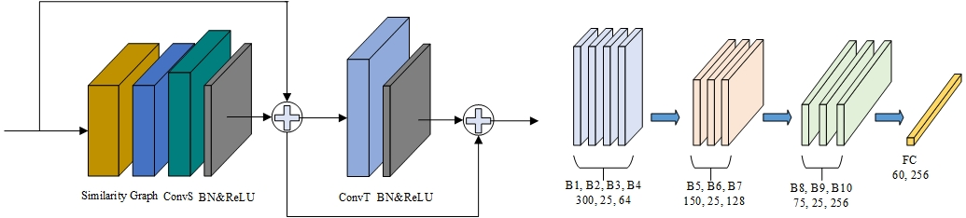

Figure 1. (a). Structure of the basic convolutional block. ConvS stands for spatial convolution and ConvT stands for temporal convolution. (b). Variance of the feature dimension. There are 25 key joints in human skeleton and 300 skeleton vectors in the original input feature.

In each layer’s graph computation, three different graphs are embedded: , and . The first part is the static human skeleton graph, the second part is a learnable skeleton connection graph and is a data-dependent graph generated from self-similarity process. Elements in are trained to indicate hidden relationships between joints and bones. Unlike static graph , is dense and sensitive to numerical changes. is produced via Eq. 1, where high-dimension tensors’ transposition and multiplication are conducted on input feature. represents similarity coefficient. To sum up, the computation of graph and spatial convolution can be described as Eq. 2. denotes the neighbour size of the graph computation and is set to 3 in the 2s-AGCN model. The kernel size of spatial convolution’s weight is set to 1.

(1)

(2)

Different from and which are determined before inference, relies on input feature, thus needs runtime computing for each prediction. Table. 1 demonstrates the computing cost of self-similarity workloads. The running performance of 2s-AGCN with and without are tested on Nvidia V100. At the cost of computing complexity and longer time-delay, only elevates prediction accuracy by 0.3%. From the view of software-hardware co-design, dropping graph is a reasonable trade-off for workload reduction.

|  |  |  |  |
| --- | --- | --- | --- |
|  | accuracy | throughput | power efficiency |
| 2sAGCN+C | 93.70% | 69.38fps | 0.28fsp/watt |
| 2sAGCNwoC | 93.40% | 98.87fps | 0.40fps/watt |

Table 2. ’s influence on 2s-AGCN model. The throughput can be elevated by 29.83% without .

Following the spatial convolution, temporal convolutional layer is set at the end of each convolutional block. With kernel size of 9x1, temporal convolution extracts information from nine skeleton vectors in time order. Despite the insertion of the graph computation, temporal convolution layer in block can still be seen as the leading neighbour of spatial convolution layer in next block because graph computation does not change temporal convolutional result along its output-channel dimension, and spatial convolution operates indirectly on temporal convolution’s output [11]. For above reasons, the connection between neighbours’ filters and channels can be kept, as shown in fig. 2. When all spatial filters prune the same input channel, the effect can work on a reverse direction to invalidate the corresponding temporal filter of leading neighbour. Based on pruned spatial convolution layers, this code guides us to conduct coarse-grained pruning on temporal convolutional filters.

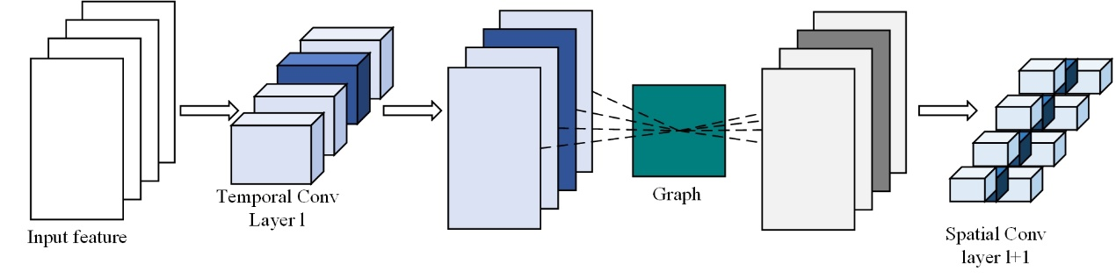

Figure 2. Temporal convolution’s output channel is the input channel of spatial convolution.

1. *Related Work*

**Sparse CNNs Accelerators on FPGA.** Works on FPGA-based acceleration of sparse CNNs can be categorized by different pruning granularity levels [11]: (i) specific on structured pruned models, (ii) specific on unstructured pruned models, (iii) specific on mixed-grained pruned models. Zhu et al [11] improve the ASIC-based SCNN and implement the hardware design on FPGA. This work presents a zero-skipping dataflow for feature, whose zero elements are generated by coarse-grained pruning. Although such method raises computing efficiency, zero elements in temporal result still occupy storage resource. Lu et al. [12] propose a weight-oriented dataflow with tile look-up table on FPGA. By using element-matrix multiplication as the core operation, Lu et al. accelerates fine-grained pruned CNNs with little decoding cost. However, our 2s-AGCN model differs from above simple convolutional workloads in that each element in feature is generated by graph matrix multiplication. Despite this weight-oriented design ignores useless convolutional computation, it cannot skip corresponding graph computation. Li et al. [13] work on PCONV pruning [14], a mixed-grained method where structure filter-dropping and unstructured pruning are combined. With weight-stationary dataflow designed on FPGA, Li et al. improve the computing efficiency by 14.7%~44%. However, this work still occupies storage space for huge scale of zero data like Lu et al, and its simple hardware structure cannot tackle complex workloads in our task.

**GCN Accelerators on FPGA**. Many works on accelerating large graph’s GCNs based on FPGA are presented in recent time. AWB-GCN [15] combines offline software averaging and runtime hardware workloads balancing on several large graph datasets. Zhang [16] et al. partition input data into smaller segments, then perform graph sparsification and node re-ordering for computation reduction and data locality. Hy-GCN [17] splits GCNs workloads into *Aggregation* and *Combination* phases. Different hardware structures and dataflows are designed for two phases respectively. To sum up, above works focus on: (i) leveraging and expanding graph adjacency matrix’s sparsity, (ii) avoiding irregularity and randomness of data distribution in graph computation, (iii) keeping balanced workloads between PEs or computing phases, via offline and online ways. Unfortunately, graph in skeleton-based GCNs for action recognition models is dense and unchangeable. The data sparsity is embedded in temporal feature and pruned weights, not the graph. Moreover, action recognition GCNs behave not only like CNNs, but also like graph processing, leading to graph-specific design requirements. Therefore, current specialized architectures on CNNs and GCNs cannot efficiently perform target algorithms since they just address one of the two sides.

While there exist many GCNs accelerators on large graph in social media and graph analytics, few works have been proposed to accelerate skeleton-based GCNs for action recognition. ST-GCN, a smaller GCNs model for action recognition, is accelerated by Ding et al. [18] on FPGA. Their work falls short on more complex action recognition GCNs for: (i) they only apply quantization on model, does not prune or optimize ST-GCN from the view of software-hardware co-design; (ii) Ding et al. compress human skeleton graph into CSC format, while skeleton relationship matrix in some models is learnable and dense; (iii) their hardware design is established on sparse matrix-vector multiplication (SpMV) units, but only skeleton adjacent matrix is compressed. Data sparsity is not thoroughly utilized in their work; (iv) although the proposed single PE design improves DSP efficiency, its throughput performance does not meet the requirement of expected application scenario.

1. Methodology

This section introduces our hybrid pruning method for action recognition GCNs. The dataflow reorganization, coarse-grained and fine-grained pruning on temporal convolution are described respectively.

1. Dataflow Reorganization

After clipping self-similarity graph, the computing flow between graph and spatial convolutional filters can be further summarized as Eq. 3, where denotes from Eq.2. The computing order of this part is first high-dimensional matrix multiplication with , secondly the spatial convolution of and finally the result merging of three loops. In this dataflow, common pruning methods only functions on spatial second phase but cannot optimize the graph computation, which occupies 49.83% of total workloads in Eq.3.

(3)

To better analyse the dataflow, we simplify the cases by extracting first two phases and its output . A pixel can be described as , where represent height, width and output-channel coordinates respectively. Eq. 4.1 can then be deduced from Eq. 3 and is the acronym of input channel. Under the commutative law of multiplication, Eq. 4.1 therefore is transformed into Eq. 4.2. By reorganizing the computing order between graph phase and convolution phase, an opportunity for graph-skipping pruning is offered here. If the parameter element is pruned to zero, the graph matrix multiplication in current output channel can be ignored. Further, if we set all convolutional parameters in input channel as zero, then all graph computation can be skipped in current loops. The dataflow reorganization is then proposed when we apply above method to three loops in Eq. 3. Unlike conventional structure pruning method which drops different channels on filters, weights in specific input channels are all set as zero on every spatial filter in current convolutional blocks. In this way, not only the convolution workload is reduced, but also the graph computation is skipped.

(4.1)

(4.2)

Since the graph-skipping strategy has been determined by dataflow reorganization, the next step is choosing the input channel to be pruned. Like other deep neural networks (DNN), features between convolutional layers are sparse and non-zero elements are unevenly distributed. Fig. 3 demonstrates the data sparsity and distribution of 2s-AGCN model. Based on the observation that unstructured pruning method drops weight element with relatively small absolute value, we can cut off the input channels which have least averaging absolute data. To be more detailed, the number of dropped channels matching data sparsity will achieve best prediction accuracy, which is illustrated in Experiment section. Also, in order to pursue higher compress ratio, this method can prune more input channels with bearable accuracy loss. In this way, data reorganization prunes spatial convolutional weight and skips both graph and convolution computation.

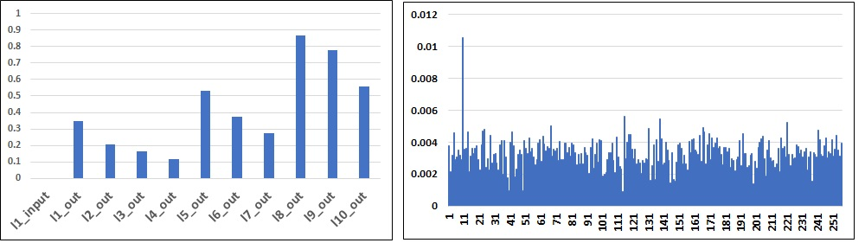

Figure 3. The demonstration of data sparsity and distribution of 2s-AGCN model. The left figure shows data sparsity of each block’s output feature. The right one is the averaging absolution of block 8’s output along channel, where x axis denotes channel and y axis denotes averaging absolute value.

1. Mixed-grained Pruning Method

Dataflow reorganization prunes same channels of spatial convolutional filters, which means features in specific channels are not computed. As shown in Fig. 2, the coarse-grained method prunes corresponding temporal filters via such connections with no extra accuracy loss. Moreover, this neighbour connection brings hardware-friendly advantages for that the number of pruned channels from spatial filters equals the number of pruned filters from temporal convolution. This inherent feature supports a balanced layer-pipelined architecture.

Coarse-grained pruning can provide 49.83%~88.96% compression ratio on temporal filters, depends on the pruning scheme in data organization phase. To further prune temporal convolutional weights, fine-grained pruning is proposed. The point of fine-grained method is that in temporal convolution, zero weight means not sampling current vectors in time order. Fig.4 demonstrates details of sampling-like fine-grained pruning method. Two kinds of 1-interval, three kinds of 2-interval and three 3-interval pruning schemes with different shift conduct on every channel inside the filter recurrently. In this way, the pruning scheme design is turned into a sampling problem. By making cavity with different intervals and different offsets, we can simulate various sampling schemes on filters, with different sampling frequencies and phases. Experiments show that with proper pruning scheme, our fine-grained method can keep accuracy as well as discarding unimportant weight.

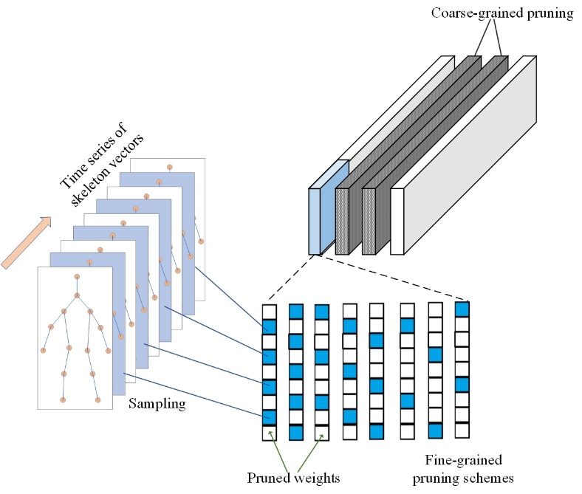

Figure 4. The illustration of fine-grained pruning on temporal convolution. White elements are pruned while blue ones are kept. Every 9x1 kernel performs on time series of skeleton vectors, and the blue vectors are sampled by first pruning scheme.

Conventional unstructured pruning methods randomly drop the weight elements with least absolute value, which are expensive and unbalanced on hardware. However, with determined cavity schemes, our fine-grained pruned model can be represented with structured weight and masks with negligible cost. Furthermore, we guarantee the balancing distribution of reserved weight by controlling start-points of different sampling patterns. Like fig. 4 shows, in a loop of eight different pruning modes, weight elements in every position of kernels are evenly kept by two or three times. Also, compression ratio can be adjusted via fine-grained pruning design.

1. Architecture

This section introduces the detailed architecture of our accelerator. Via specific tuning of 2s-AGCN model, all pruned convolutional blocks are mapped on chip.

**Overview**: Fig. 5 depicts the overall design of our layer-pipelined architecture. Based on our pruning method and layer-pipelined design, conv block module for each block constitutes the whole architecture. To be more detailed, one spatial conv module (SCM) and one temporal conv module (TCM) are included in a conv block module. All convolutional parameters and graph are stored in ROM storages for proposed pruning method reducing model size. Spatial convolutional computing units Mult-PEs are settled along output channel, while temporal convolutional computing units Dyn-MultPE works across input channel in parallel. Moreover, runtime sparse feature compression module (RFC) functions at the junctions of different layers to compact and store temporal results.

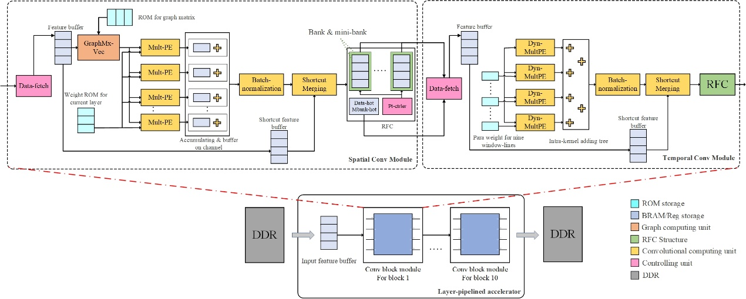

Figure 5. The demonstration of overall architecture.

1. Spatial conv module

The main task of SCM is performing graph computation and pruned spatial convolution at the same time. Feature buffer stores the extended feature vectors, which are decoded in data-fetch part. Data-fetch controls the address of data-loading and decodes compact feature into sparse form, which is convenient to compute. The decoding process will be explained later. Sparse feature will first multiply with graph vectors, and then conduct convolution with non-zero weight in Mult-PE. Pruned channels are skipped and multiplication results are summed up in accumulating buffer on output channel. After batch-normalization operation, dataflow merges with original input activation, which is stored in shortcut feature buffer. ReLU function is combined with encoding function parts, where sparse data is compressed into compact format again.

In order to combine graph computation and pruned convolution workloads, dataflow is organized as fig. 6 shows. A line in feature buffer caches 25 data from feature, and the depth of the buffer is varied to store all data in one row of feature tensor. Depth equals the number of input channels in different blocks. When computing, feature buffer offers one line of original feature data. After computation with one column vector of graph, this feature vector generates one valid element in Eq. 4. Afterwards, feature buffer provides data in next cache line, which continues to produce . Following this mode, when all output elements on current output channel are computed, feature buffer returns to the first line and graph ROM switches to the next column vectors to prepare for . When the workload of one row feature tensor is finished, feature buffer receives next row of tensor to start a new sub-loop. Algorithm 1 depicts the whole loop operation. In this way, feature is produced in a channel-first order. To be noticed that our dataflow reorganization method essentially abandons feature data on specific channels, so we skip these workloads by not loading them to data-fetch module.

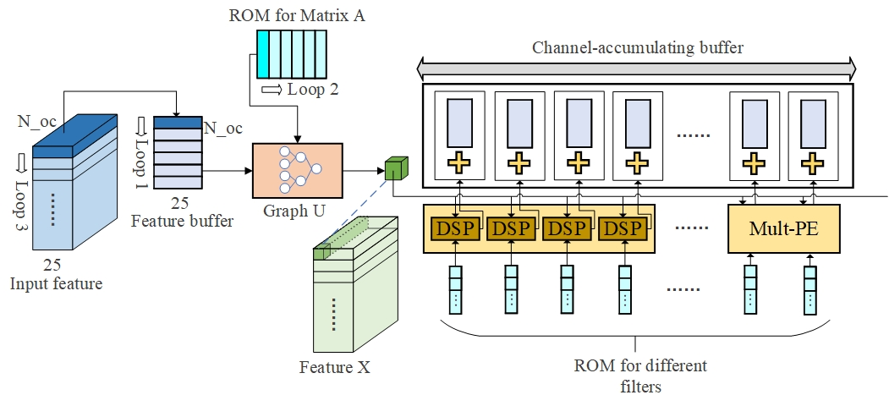

Figure 6. Illustration of SCM dataflow organization.

Feature element is broadcast to all Mult-PEs. In the same channel-first order, weight ROM sends different filters’ parameters into different computing units. To cooperate with the pruned model and feature-loading-skipping mechanism, only non-zero elements in filters are stored in ROM with original order. Each Mult-PEs includes four DSPs, and by adjusting the number of Mult-PE, our design can fit into different layers. Results from parallel Mult-PEs are accumulated and buffered on channel direction as well. When the sum counter reaches the number of valid channels, current data will be transferred into post-processing modules.

1. Temporal conv module

TCM is designed to accelerate temporal convolution workloads, whose kernel size is 9x1. Fig. 7 shows the detailed information of TCM. Similarly, feature buffer stores decoded data from data-fetch. However, feature buffer’s size is changed to match the kernel size. The width is turned from 25-data into 9-data, and the depth is tuned to be able to hold an area of feature tensor. Additionally, the one-hot code of current feature is sent from data-fetch to feature hot storage as well. Based on mix-grained pruning method, a weight-static workflow is presented in TCM. Firstly, unpruned data together with its masks is stored on chip. Depicted in Fig. 4, several balanced fine-grained pruning schemes are conducted on leftover filters in recurrent ways, which provides an opportunity to store effective weight and mask with regularity. One temporal filter is divided into several sub-filters. Temporal convolutional parameters are fold into sub-filters format and then stored in a recurrent mode. Secondary, computing units Dyn-MultPEs are put across input channel and parallelizes on filter’s rows. There are two reasons: i) This parallel scheme can directly skip the abandoned filters in coarse-grained pruning, ii) Each row of sub-filters is taken by one Dyn-MultPE and each function part handling one row of weight tensor. In this way, one Dyn-MultPE only needs to process four or six valid weights with static cavity mask in one sub-filter. This design further eliminates data irregularity and reduces the hardware cost of intra-PE dynamic data scheduling.

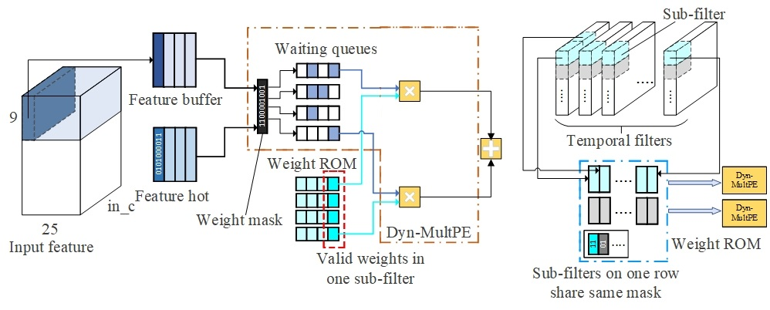

Figure 7. Illustration of TCM’s dataflow.

Shown in Fig. 7, one row of a sub-filter is assigned to a Dyn-MultPE, which includes four or six waiting queues and several DSPs. Logic and operation is performed first on weight mask and feature mask to skip the zero-feature and dropped weights. Then, valid feature enters one waiting queue, which is bonded to a non-zero weight in the sub-filter. Although weights pruning is balanced, zero-distribution in feature is unpredictable. To decrease the use of DSPs and raise working efficiency of computing resource, dynamic data scheduling is designed by dispatching data from different waiting lines to DSPs. Because multiplication in a Dyn-MultPE represents computation inside one temporal filter, the results are summed up and afterwards sent to the adder-tree. While dynamic data scheduling has advantages on saving DSP resource, it may increase the working delay at workloads-intensive cases. Taking both delay and efficiency into consideration, we propose the method to estimate the number of needed DSPs based on offline feature sparsity in Eq. 5. With the help of recurrent fine-grained pruning and statistic sparsity, we calculate the expectation of valid computation in one sub-filter and use it to guide the DSP occupation.

1. Runtime sparse feature compress

Despite layer-pipelined architecture poses great advantages on throughput, it having to store massive temporal computing results for shortcut task. The motivation of our runtime sparse feature compress (RFC) is to decrease on-chip storage utilization by compacting zero feature data.

**Encoding**: RFC contains encoding parts, compact storage and decoding parts. Encoding process is combined with ReLU while decode is embed in data-fetch module in TCM and SCM. The whole structure of RFC is displayed in Fig.7. At first, one feature vector is divided into several banks across channels. The width of each bank is 16 data-wise. ReLU function parts perform on banks, providing activation and one 16-bit hot code, which denotes the positive/zero value of ReLU results. Moreover, valid elements are gathered at higher bits while unused bits are padded with zero. After that, mini-bank-hot code (mbhot) is generated according to the number of non-zero data in current bank. Mbhot indicates which mini-banks are used in the bank storage. Encoding parts work in pipeline and during several working cycles, the whole vector is finally turned into compact format. Instead of compressing one vector as whole, we lower the encoding cost by setting bank as the finest grain of ReLU and encoding process.

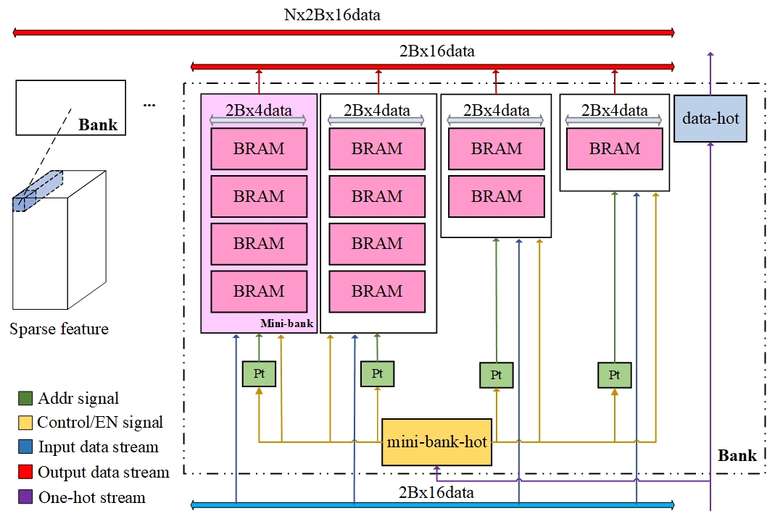

Figure 7. The whole structure of RFC.

**Storage**：The compact storage for sparse feature is consisted of bank storage units, which includes mini-banks, mini-bank-hot storage, data-hot storage and address controller: pt. The key insight of bank storage design is to keep access regularity on data-width dimension and reduce useless storage on data-depth direction. When input data and hot codes are valid, mbhot sends enabling signal to every mini-banks and related pt parts. For example, if the input data-hot code is 0001_1100_0000_0111, thus there are five non-zero data in the high bits of input data stream and the mbhot is 1100. With zero-padding performed on lower bits, the first mini-bank receives and store four valid data, the second mini-bank keeps fifth valid data and three zero data. Their pt will self-add after this data-writing. Other mini-banks and their pt are not started and stay unchanged. Similarly, when we need to load data from bank storage in order, mbhot enables functional mini-banks and pts to output correct data. The disabled mini-banks’ output is covered by zero. By this way, compact data can be both stored and loaded in only one cycle without random access scheme.

Another issue on compact storage is to determine the volume of each mini-bank. Like deciding DSP’s utilization, we can calculate the expectation of useful data based on offline sparsity. However, there always exists vectors with far more data density than average or far less data density than average. Denser vectors demand deeper mini-banks on the tail (the rightmost mini-bank in fig. 7) while the lighter vectors merely occupy head mini-banks. In ideal cases, every vector is fit in bank-lines with no mini-banks unused and no vector truncated, but it is hard to precisely determine the number of valid data in every vector. Feature’s sparsity distribution of each layer can help us to adjust the depth of mini-banks. For example, sparsity of feature is 50% and obey the normal distribution of. Guided by Three Sigma Code of normal distribution, it is estimated that 27% of vectors has sparsity higher than 75%, 23%’s feature’s is between 50%~75%, 23%’s data is between 25%~50% and 27% vector’s is below 25%. The mini-bank arrangement in fig. 7 meets the demand of different density feature and reduces 31.25% storage resource compared with sparse format. In actual design, BRAM units have variable grains, which provides higher storage efficiency and lower resource utilization.

**Decoding**: The decoding function is integrated in data-fetch module in SCM and TCM. Data-fetch not only controls loading address, but also translate compact data into sparse form. After receiving both data stream and data-hot codes from bank storages, parallel decoding modules perform on each banks’ output simultaneously. Each Translation part processes compressed feature in four pipeline stages, four data for one stage. Matched with encoding phase, the output of one bank is seen as the basic decoding grain, which further decreases the complexity of translation circuit. The sparse data finally is sent to feature-buffer and waits for computing.

1. Experiments

In this section, we evaluate our design on both software and hardware view. Our pruning method is explored on one NVIDIA V100 GPU using PyTorch, and accelerator architecture is implemented on Xilinx XCKU-115 with Vivado 2018.3 IDE.

1. Validations on hybrid pruning method

In our experiments, the proposed hybrid pruning method on 2s-AGCN model is compared with unstructured pruning and structured pruning. We also explore the impact of different pruning designs on accuracy, for example various fine-grained pruning schemes for temporal filters and channel-dropping modes in data reorganization phases.

*Comparison*: Fig. 8 illustrates the comparison results between our hybrid pruning methods and conventional unstructured pruning. With same parameters reduction rate, our method achieves better accuracy performance in most cases. Additionally, we apply 16bit quantization on our pruned models. With negligible accuracy loss, float data is transformed into 16bit fix-point format, where eight bits are allocated to decimal part and eight to integer part. To further accelerate the proposed application-specific system, half of input skeleton vectors is skipped. Although input-skip method lowers prediction accuracy, it brings 50% reduction on total computation. Besides, the input-skip model with 86% compress ratio still keeps the accuracy no less than original model, so we choose this model as final accelerating target.

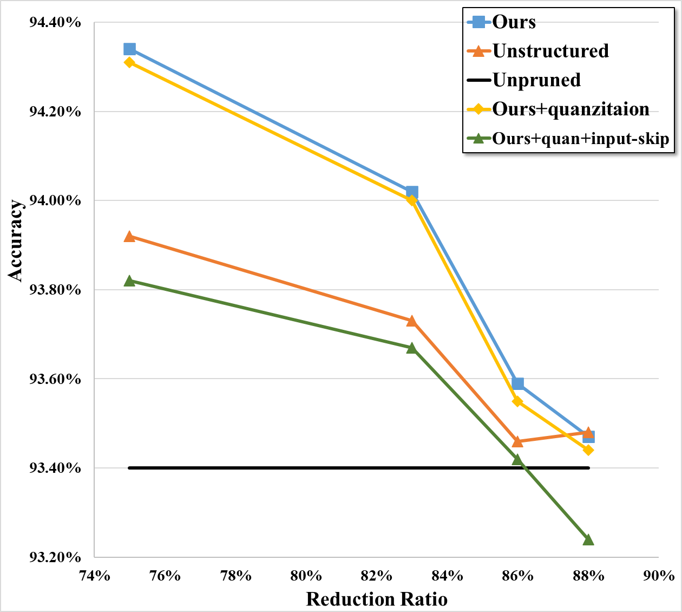

Figure 8. Comparison results with unstructured pruning.

*Exploration*: Both data reorganization and fine-grained temporal pruning are fatal to model accuracy, so to find the best pruning scheme, we conduct isolated experiments respectively. Guided by feature sparsity shown in fig. 1, we set each layer’s channel dropping rate which roughly equals it’s sparsity respectively. For higher parameter reduction ratio, we progressively raise pruning rate on layers and observe effect on accuracy. Fig. 9 demonstrates the channel-dropping results with details. The spatial convolutional parameter in block 1 is not pruned for it only has three input channels. Also, mix-grained pruning on temporal convolution is not performed to validate data reorganization method. It is revealed that with dropping rate shifting away from base sparsity, model reduction is growing while accuracy is decreasing. Considering mix-grained pruning needs data reorganization models as base, it is necessary to choose a conservative dropping scheme with higher

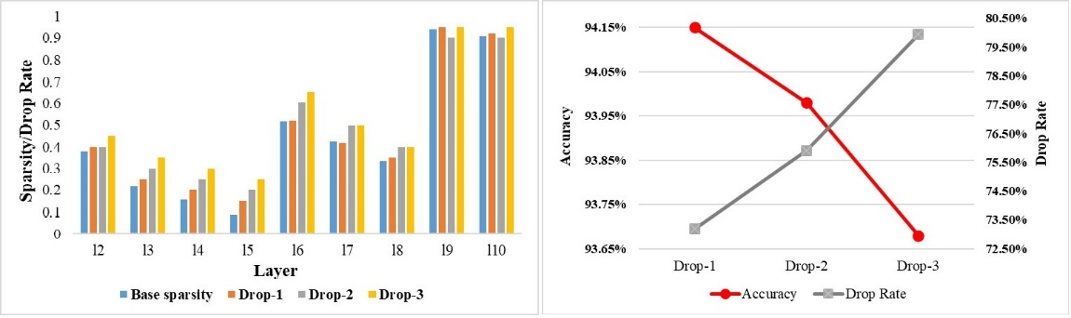

Figure 9. Exploration on channel dropping.

The fine-grained pruning is important in holding accuracy and keeping balanced-weight, since coarse-grained pruning is totally decided by data reorganization. We carry out several experiments on fine-grained pruning details, including different pruning intervals, offsets and pruning rates. All experiments are based on Drop-1 model in fig. 9 and results are shown in fig. 10. Pruning schemes in fig. 10 are named as the combination of cav (cavity), pruning rate (50, 67 for instance) and intra-order. Cav-70-1 means the first cavity patterns with 70% reduction rate. With reduction rates goes higher, model bears more accuracy loss in general. However, cavity patterns play an important role as well. Having compress ratio of 70%, cav-70-1 performs better than cav-70-2 on performance for more balanced weight pruning. Every weight line in cav-70-1 has two or three sampling chances, while in cav-70-2, different lines can be kept from one time to four times. Balanced pruning schemes not only provide convenience for hardware, but also ensure the accuracy performance. The same situation happens between cav-75-1 and cav-75-2 too. Taking both compress ratio and accuracy into consideration, cav-70-1 is chosen to be the final design.

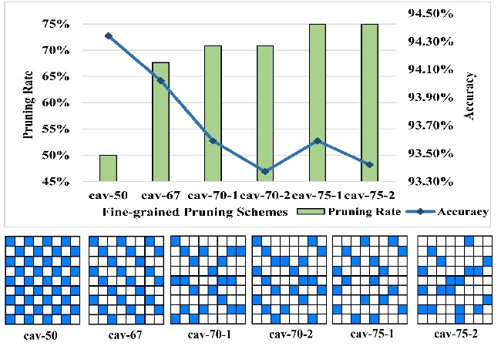

Figure 10. Exploration on fine-grained pruning schemes.

1. Hardware implement

*Dyn-MultPE*: Dyn-MultPE works on the cav-70-1 cavity pattern, which means there are three Dyn-MultPEs processing six waiting queues and six processing four waiting queues. Based on eq. 5, different numbers of DSPs are settled in each layer’s Dyn-MultPEs. We also adjust the number of temporal convolutional PE to keep balance between pipeline stages. The detailed information is illustrated in table. 2, where our dynamic data scheduling trades only 6.48% longer delay for DSP reduction of 23.24%.



Table 2. Utilization, working efficiency and max delay of Dyn-MultPE.

*RFC*: as stated above, RFC design relies on sparsity distribution. To optimize runtime compress storage, we refer to offline statistic information, which is shown in Table. 3. Feature vectors are divided into four categories by their sparsity: 75%~100% (I), 50%~75% (II), 25%~50% (III) and 0%~25% (IV). According to our RFC design, vector of first category occupies one mini-bank, ones in II takes two, III takes three and IV takes four mini-banks. We thus get the total BRAM blocks used for RFC structure. Comparison in fig. 11 indicates that our RFC design brings 35.93% reduction of occupation on BRAM resources. Moreover, with almost equal amount of used BRAM elements, RFC can finish data-loading in one cycle and encoding/decoding in four cycles, while CSC format usually needs 64 cycles to load data or decoding data in serial. With less extra hardware cost and similar storage compress ratio, RFC structure achieves more regular data-access.



Table. 3.

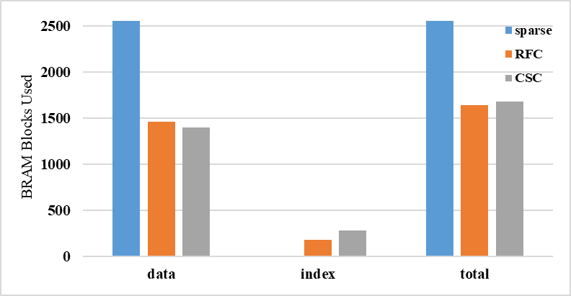

Figure 11. Storage cost of three data formats.

*Overall performance*: Our architecture is implemented on Xilinx XCKU-115 with frequency of 172MHz. The resource utilization is demonstrated in Table. 4, together with comparison with FDU. Despite more hardware resource is utilized by our RFC-HyGCN, experiments have proved that our design has superiority on peak performance, throughput and DSP efficiency. In table. 6, we compare the peak performance of ours and two high-end GPUs. The ‘original’ in the table means testing program is the original version of 2s-AGCN, the ‘wo-C’ means the optimized version without C_k matrix, and the ‘skip’ means input-skipping is applied on model. To fully use the memory in GPUs, target model runs with 200 or 700 samples in one batch on 2080Ti and V100, respectively. Compared with two main-stream GPUs, our accelerator provides 1.36x~9.47x of speedup, showing competitive performance.



Table. 5. Comparison between ours and FDU.



Table. 6. Performance comparison between ours and high-end GPUs.

1. Conclusion

In this article, we propose a software-hardware co-design work: RFC-HyGCN, including hybrid pruning method and a runtime sparse feature compress architecture with layer-pipeline. We explore a hybrid pruning method specific on action recognition GCNs to purse skipping both graph and convolution computation. Moreover, we propose an architecture based on balanced pruned model. In addition, we design runtime sparse feature compact format to reduce zero-storage between layers. Experiments demonstrate that compared with conventional structured unstructured pruning, our method achieves better accuracy performance in most cases. The accelerator is implemented on Xilinx XCKU-115 FPGA, at the cost of negligible encoding/decoding cost, RFC reduces 35.93% of BRAM blocks and 23.24% of DSPs. Compared with another work on accelerating action recognition GCNs, ours provides 22.62x speed-up and 59.41% elevation on DSP efficiency. On contrast to high-end GPUs, RFC-HyGCN achieves 1.36x~9.47x speed-up on throughput.