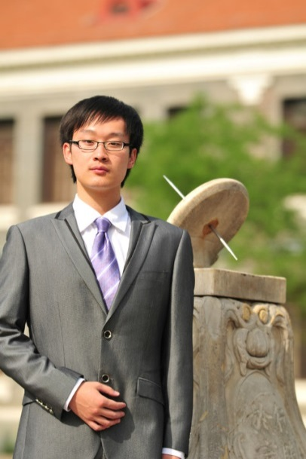Hui Qiao

Ph.D Candidate (Since 2013/09)

BBNC (Broadband Network & Digital Media Lab)

MMCP (Multi-dimension & Multi-scale Computational Photography Lab)

Department of Automation, Tsinghua University, Beijing 100084, China

C:\Documents and Settings\STAR\My Documents\Tencent Files\592204103\Image\)$9F1T04{{AZF5G_9G[0L~Q.jpg (+86)15210591808

C:\Documents and Settings\STAR\My Documents\Tencent Files\592204103\Image\K]~Z3I9KJ{B5$YEW2EH}JY2.jpg qiaoh13@mails.tsinghua.edu.cn

C:\Documents and Settings\STAR\My Documents\Tencent Files\592204103\Image\(%GO8R[07BHME(5QQQ[PYJY.jpg http://media.au.tsinghua.edu.cn/

Education

Sep. 2013 – Jul. 2018 (expected) Tsinghua University, Beijing, China

Ph.D. in Department of Automation, Advisor: Professor Qionghai Dai

Sep. 2009 – Jul. 2013 Tsinghua University, Beijing, China

B.E. in Department of Automation (GPA 94, Rank 1/141)

Current Research Interests

* Computational Imaging
* Computer Vision
* ToF Imaging

Publications

* **Hui Qiao**, Jingyu Lin, Yebin Liu, Matthias B. Hullin, and Qionghai Dai. Resolving Transient Time Profile in ToF Imaging via Log-Sum Sparse Regularization. OSA Optics Letters (OL), 2015.

Honors and Awards

* National Scholarship, 2016
* Freshman Scholarship for Doctoral candidate of Tsinghua University, 2013 (Rank 1 in Department of Automation, Tsinghua University)
* Outstanding Graduate Student of Beijing, China, 2013
* Outstanding Graduate Student of Tsinghua University, 2013
* Friend of Tsinghua-Chang Dong Scholarship (1/141), 2012
* Friend of Tsinghua-Fang Chongzhi Scholarship (1/141), 2011
* “12.9 Scholarship” of Tsinghua University (1/141), 2010

Social Activities

* Chairman of Zijing Volunteer Organization, Youth League Committee of Tsinghua University (Sep. 2014 – Jul. 2015)
* President of Student Union, Department of Automation, Tsinghua University (Sep. 2012 – Jul. 2013)

Skills

* Programming: Proficient in C, C++, Matlab and R
* Academic: Strong Optimization Background, Signal Processing, Good at Original Thinking and System Building, etc

Research Projects

* Realizing the Depth of Field Control in Dynamic Scene. Based on Extracting Depth and Radiance from a Defocused Video Pair. 2013-2014
* Resolving Multipath Interference in Time-of-Flight Imaging. We Demonstrate a Method based on Log-sum Sparsity Regularization to Recover Transient Time Profiles of Specular Reflections from Multi-frequency and Multi-phase Measurements. 2014-2015
* Looking Around Corners and Looking Through the Scattering Media. Based on Recovering Transient Time Profiles in Time-of-Flight Imaging. 2014-2016
* Polarized 3D: High-Quality Depth Sensing with Polarization Cues. We Propose a Framework to Combine Surface Normals from Polarization with an Aligned Depth Map. 2015-2016

Research Experience

* Attend the **Photonics Asia** Sponsored by SPIE, the International Society for Optics and Photonics and the Chinese Optical Society (COS), October 9-11, 2014 at Beijing, China.

References

Prof. Qionghai Dai, Department of Automation, Tsinghua University [qhdai@tsinghua.edu.cn](mailto:qhdai@tsinghua.edu.cn)