**Object Oriented Programming (OOP)**

**Exercise 1.2**

**Class: Television**

|  |
| --- |
| Television |
| brand: String  type: String  size: int  resolution: int |
| educate(): void  inform(): void  entertain(): void |

Attribute

Behavior

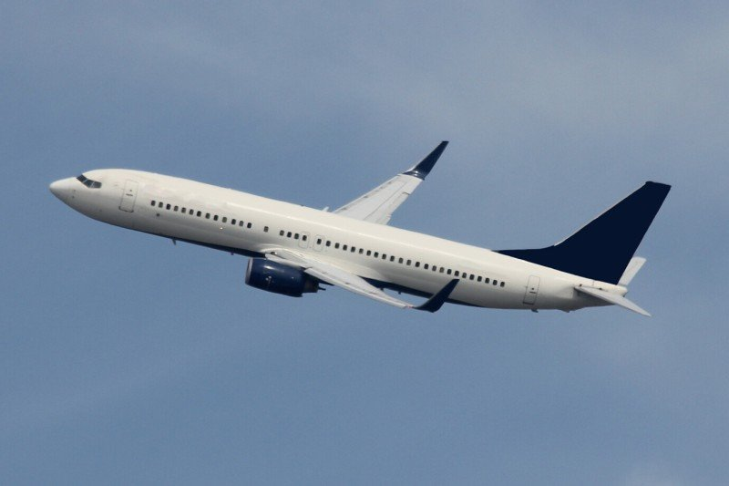**Class: Airplane**

|  |
| --- |
| Airplane |
| airlineBrand: String  ManuFac: String  model: String  capacity: int |
| landing(): void  flying(): void  accelerate(): void  decelerate(): void |

Attribute

Behavior

|  |
| --- |
| Computer |
| brand: String  OS: String  processor: String  resolution: int  size: int  weight: int |
| insertdata(): void  storedata(): void  processdata(): void  displaydata(): void |

**Class: Computer**



Attribute

Behavior

**Class: Vegetable**

|  |
| --- |
| Vegetable |
| type: String  colour: String  flavour: String  texture: String  nutrientQ: int |
| provVitamin (int nutrientQ): void  provMineral( int nutrientQ): void  provFibre( int nutrientQ): void |



Behavior

Attribute

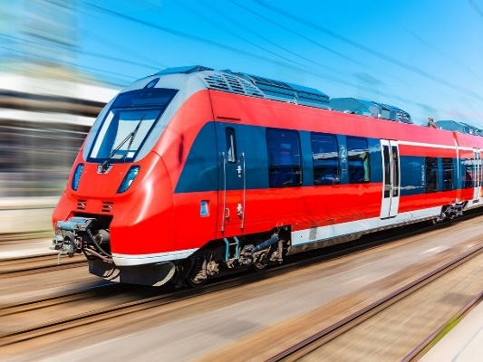**Class: Train**

|  |
| --- |
| Train |
| type: String  model: String  capacity: int  speed: int  motivePower: String |
| accelerate(int speed): void  decelerate(int speed): void  halting(): void  carryPassenger(): void |

Behavior

Attribute