Supplementary Figures

Polygenic predisposition modifies the associations of fish oil supplementation with circulating omega-3 fatty acids: a cross-sectional gene-diet interaction study
Huifang Xu, Ge Yu, Yueqi Lu, Harriett Fuller, Suhang Song, Ye Shen, Charleston W. K. Chiang, Burcu F. Darst, Kaixiong Ye

Abbreviations
AFR, African; BMI, body mass index; CI, confidence interval; CSA, Central/South Asian; DHA, docosahexaenoic acid or its absolute circulating concentration; DHA%, docosahexaenoic acid to total fatty acids; DOI, dietary omega-3 intake; EAS, East Asian; EUR, European; FOS, fish oil supplementation; RINT, rank-based inverse normal transformation; OFI, oily fish intake; Omega-3, absolute circulating concentration of total omega-3 fatty acids; Omega-3%, omega-3 fatty acids to total fatty acids; PhysicalAct, physical activity; P_{Int}, p-value testing the interaction between polygenic score and dietary exposures; P+T, pruning and thresholding; PGS, polygenic score; SE, standard error; SD, standard deviation; TSI, Townsend index; UKB, UK Biobank.

Contents
Supplementary Figure 1. Flowchart of study population selection in the UK Biobank 3
Supplementary Figure 2. Correlation between included study covariates 4
Supplementary Figure 3. Variance explained by covariates in circulating levels of four omega-3 fatty acid traits 5
Supplementary Figure 4. Correlation of PGS with raw vs. RINT-based omega-3 fatty acid traits by ancestry 6
Supplementary Figure 5. Relationship between PGS with four observed circulating omega-3 fatty acid concentrations, stratified by FOS status and PGS subgroups 7
Supplementary Figure 6. Evidence of PGS-by-FOS interactions on raw circulating concentrations of omega-3 fatty acids in EUR participants 8
Supplementary Figure 7. Evidence of PGS-by-FOS interactions on RINT-based circulating concentrations of omega-3 fatty acids in EUR participants (Replication analysis) 9
Supplementary Figure 8. Evidence of PGS-by-OFI interactions on RINT-based circulating concentrations of omega-3 fatty acids in EUR participants (Replication analysis) 10
Supplementary Figure 9. Evidence of PGS-by-OFI interactions on raw circulating concentrations of omega-3 fatty acids in EUR participants 11
Supplementary Figure 10. Evidence of PGS-by-DOI interactions on raw and RINT-based circulating concentrations of omega-3 fatty acids in EUR participants 12
Supplementary Figure 11. Evidence of PGS-by-FOS interactions on RINT-based circulating concentration of DHA% in CSA participants 13
Supplementary Figure 12. Evidence of PGS-by-OFI interactions on RINT-based circulating concentrations of Omega-3 and Omega-3% in CSA participants 14
Supplementary Figure 13. Absence of PGS-by-FOS and PGS-by-OFI interactions on RINT-based circulating concentrations of omega-3 fatty acids in AFR and EAS participants 15
Supplementary Figure 14. Evidence of PGS-by-FOS interactions on RINT-based circulating concentrations of omega-3 fatty acids in EUR participants using a 24-hour dietary recall questionnaire 16
Supplementary Figure 15. Power calculation for the detection of PGS-by-FOS interactions 17

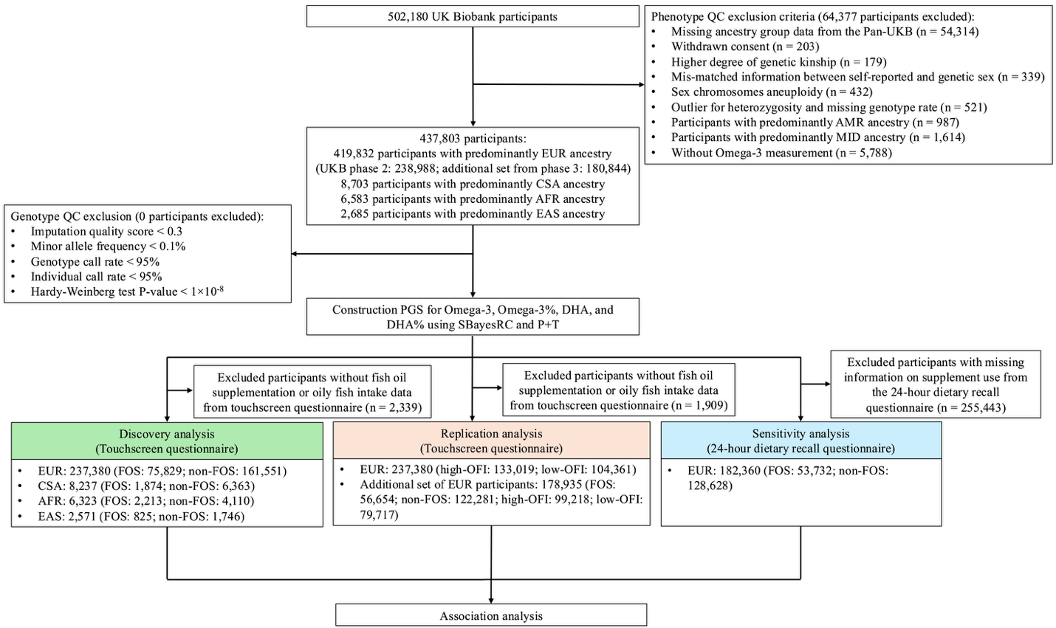

Supplementary Figure 1. Flowchart of study population selection in the UK Biobank
Abbreviations: Omega-3, omega-3 fatty acids; Omega-3%, omega-3 fatty acids to total fatty acids percentage; DHA, docosahexaenoic acid; DHA%, docosahexaenoic acid to total fatty acids percentage; PGS, polygenic score; QC, quality control; EUR, European; EAS, East Asian; AFR, African; CSA, Central/South Asian; AMR, Admixed American; MID, Middle Eastern; UKB, UK Biobank.



Supplementary Figure 2. Correlation between included study covariates
The upper triangle shows the pairwise Spearman correlation coefficients, and the lower triangle shows the Pearson correlation coefficients. Color and number indicate the strength of the correlation.

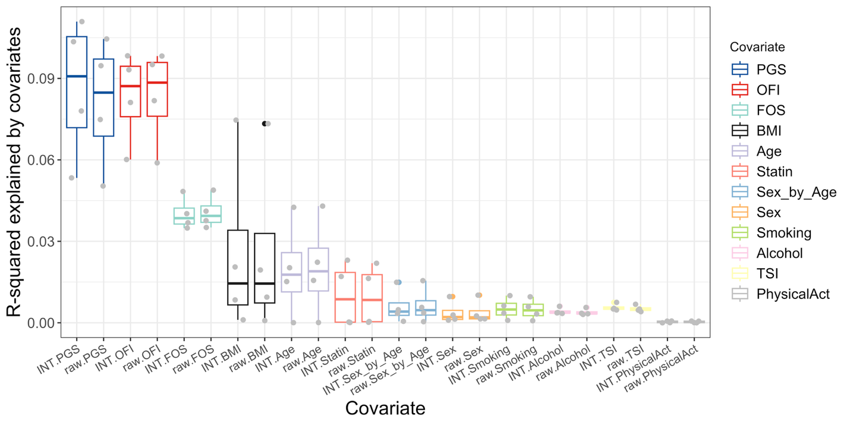

Supplementary Figure 3. Variance explained by covariates in circulating levels of four omega-3 fatty acid traits
Association between twelve covariates and each of four omega-3 fatty acid traits (DHA, DHA%, Omega-3, and Oemga-3%) was tested, and the variance (partial R²) was estimated. Analyses were run on both the RINT-based and raw (i.e., untransformed) phenotypes. Results for both scales are displayed. Each dot represents a fatty acid trait. Abbreviations: BMI, body mass index; FOS, fish oil supplementation; OFI, oily fish intake; PhysicalAct, physical activity; PGS, polygenic score; TSI, Townsend index; RINT, rank-based inverse normal transformation.

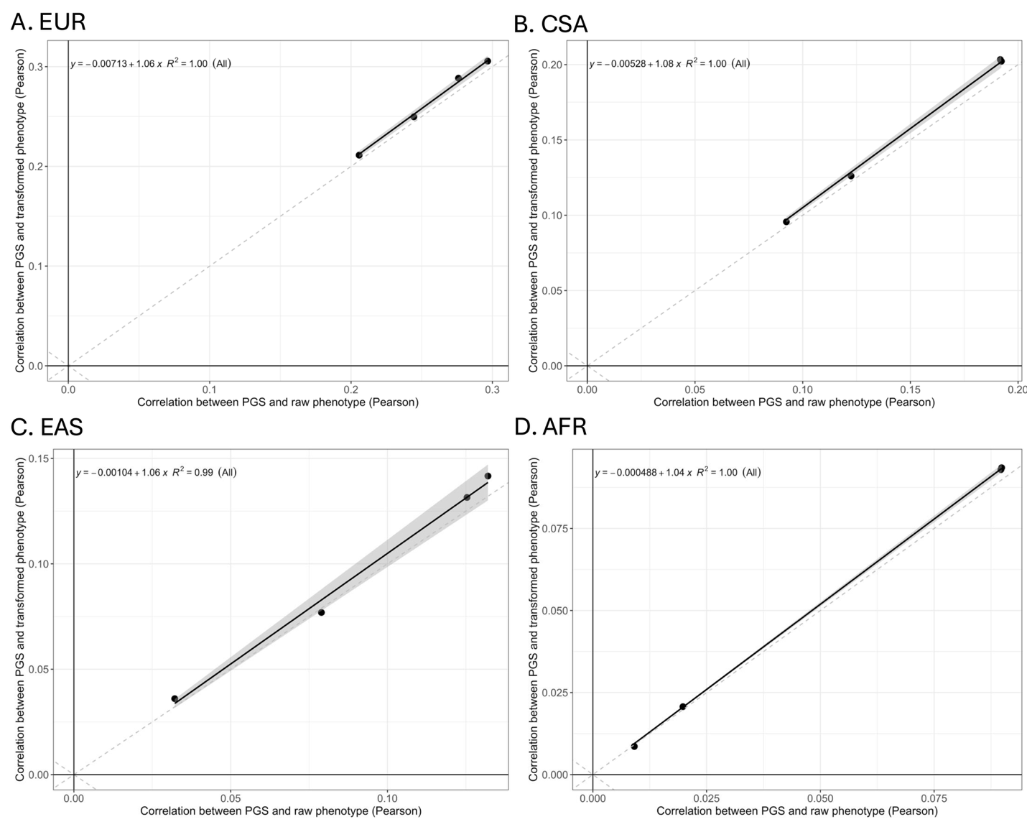

Supplementary Figure 4. Correlation of PGS with raw vs. RINT-based omega-3 fatty acid traits by ancestry
(A) EUR, (B) CSA, (C) EAS and (D) AFR. Each data point represents one trait (DHA, DHA%, Omega-3, and Omega-3%). The x- and y-axis represent the Pearson correlation between SBayesRC-based PGS and the raw phenotype versus the rank-based inverse normal transformed phenotypes, respectively. The black line is the fitted line. R2 quantifies the correlation between x and y.

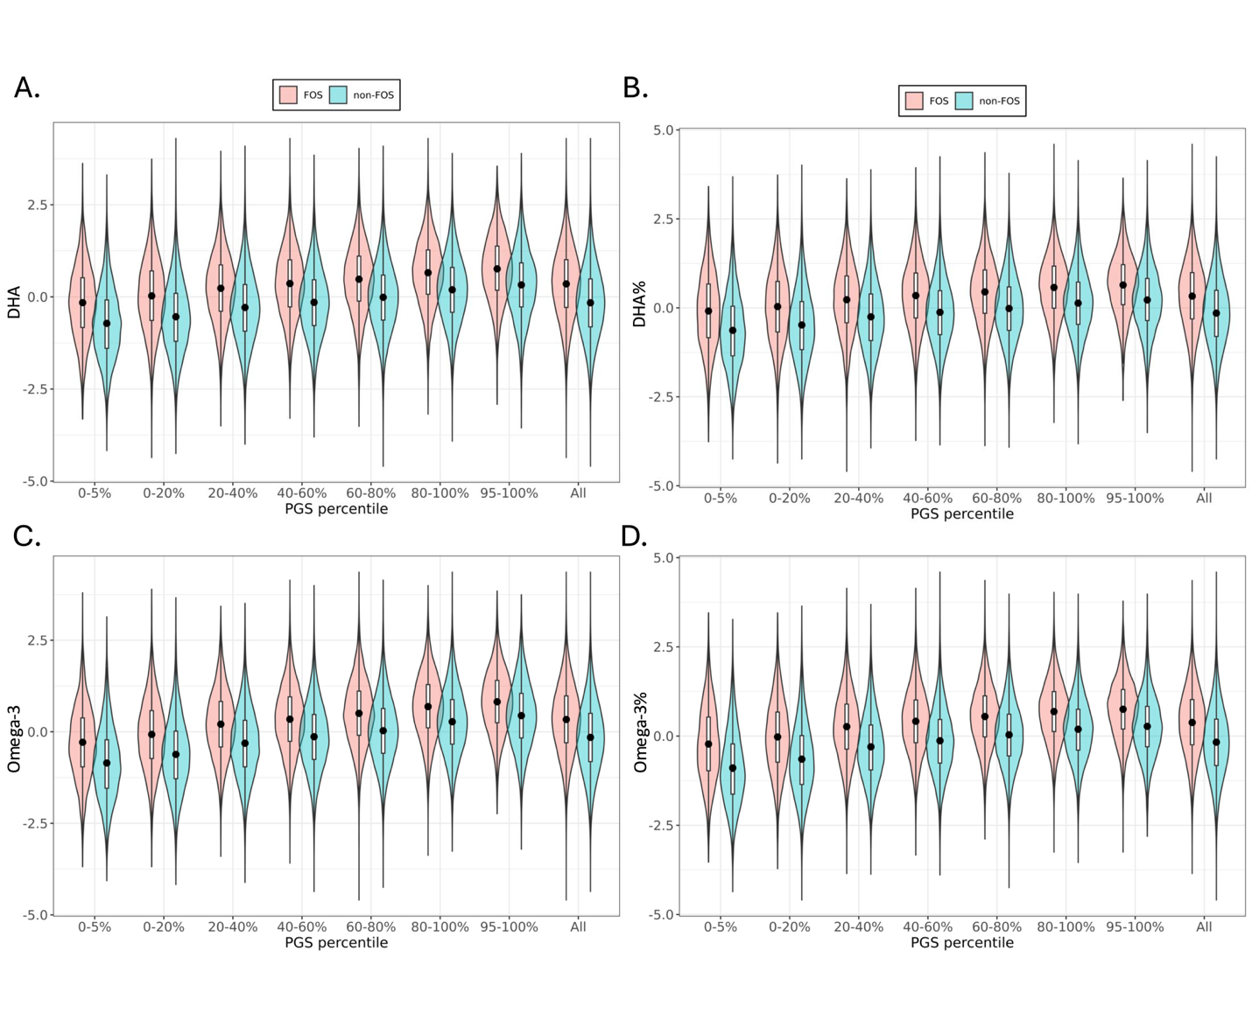

Supplementary Figure 5. Relationship between PGS with four observed circulating omega-3 fatty acid concentrations, stratified by FOS status and PGS subgroups
Panels show results for A) DHA, B) DHA%, C) Omega-3, and D) Omega-3% based on participants of European ancestry (N = 237,380). The x-axis represents the PGS groups, while the y-axis displays the observed levels of four RINT-based phenotypes. PGS were categorized into seven groups based on their distribution: the bottom 5% (0–5%), five quintile-based bins (0–20%, 20–40%, 40–60%, 60–80%, and 80–100%), and the top 5% (95–100%). FOS users and non-FOS users are denoted as red and blue, respectively. Black dots indicate mean fatty acid levels within each subgroup. Box corresponds to 25–75% interval.
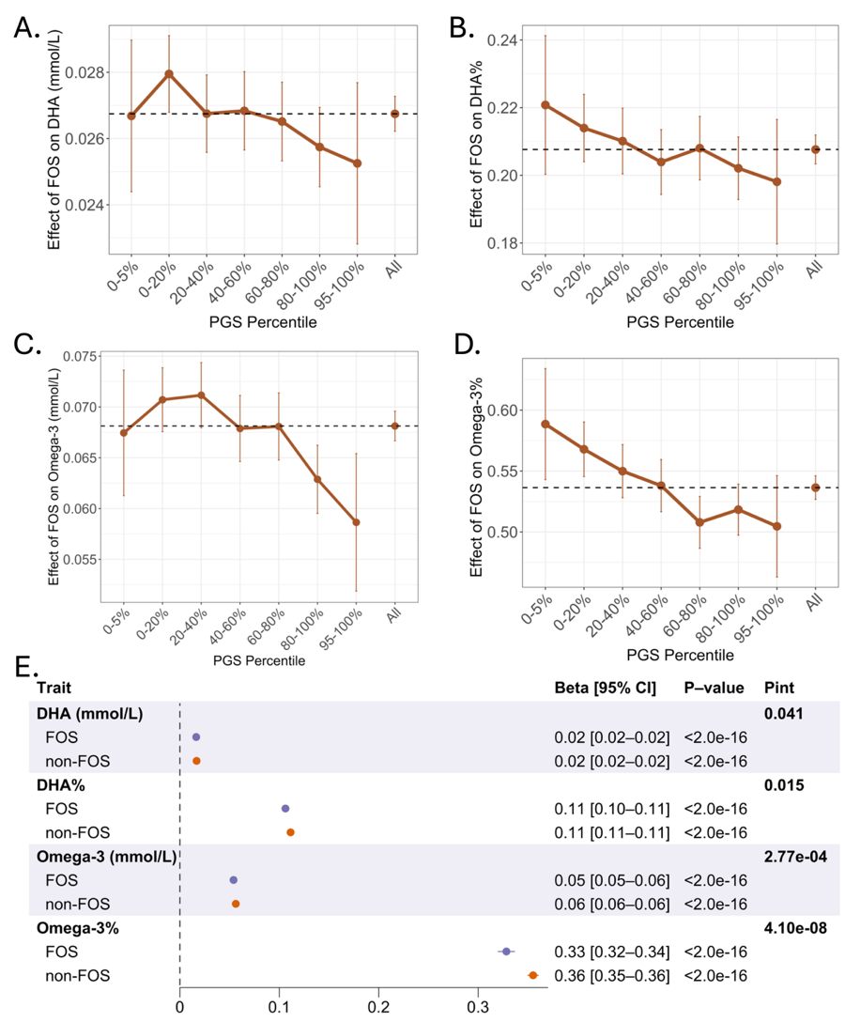

Supplementary Figure 6. Evidence of PGS-by-FOS interactions on raw circulating concentrations of omega-3 fatty acids in EUR participants
A) – D) PGS modified the positive associations of FOS with raw circulating concentrations of DHA, DHA%, Omega-3, Omega-3%. We calculated PGS using the SBayesRC algorithm, and performed analyses on participants of EUR ancestry (N = 237,380). E) PGS was associated with a smaller increase in circulating omega-3 fatty acid concentrations among individuals in the FOS group compared to those in the non-FOS group. Estimated effect sizes of PGS are presented as beta [95% CI] in the forest plot. P-value denotes the significance of the association between PGS and omega-3 within each stratum, while P_{Int} represents the interaction p-value between PGS and FOS.
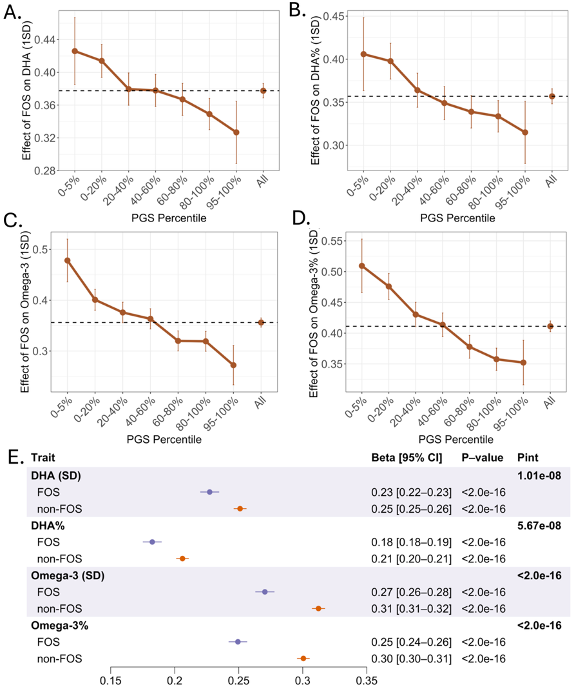

Supplementary Figure 7. Evidence of PGS-by-FOS interactions on RINT-based circulating concentrations of omega-3 fatty acids in EUR participants (Replication analysis)
A) – D) PGS modified the positive associations of FOS with RINT-based circulating concentrations of DHA, DHA%, Omega-3, Omega-3%. We calculated PGS using the SBayesRC algorithm, and performed analyses on participants of EUR ancestry (N = 178,935). The touchscreen questionnaire was analyzed. E) PGS was associated with a smaller increase in circulating omega-3 fatty acid concentrations among individuals in the FOS group compared to those in the non-FOS group. Estimated effect sizes of PGS are presented as beta [95% CI] in the forest plot. P-value denotes the significance of the association between PGS and omega-3 fatty acids within each stratum, while P_{Int} represents the interaction p-value between PGS and FOS.
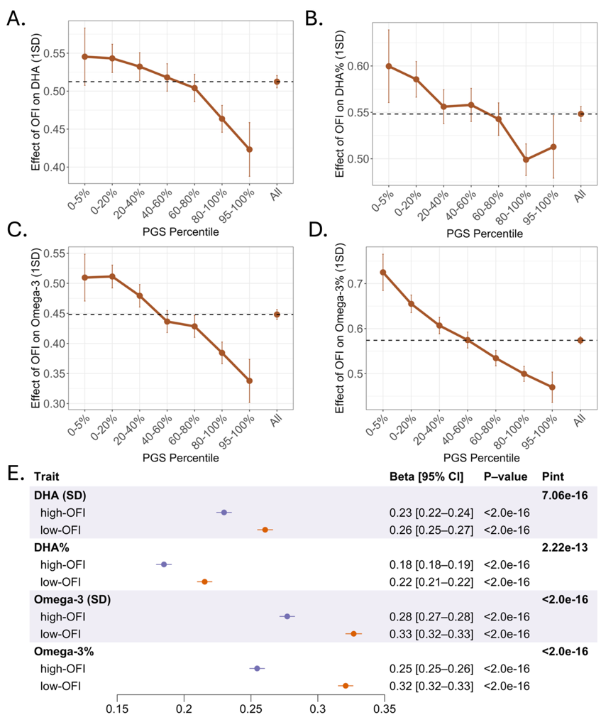

Supplementary Figure 8. Evidence of PGS-by-OFI interactions on RINT-based circulating concentrations of omega-3 fatty acids in EUR participants (Replication analysis)
A) – D) PGS modified the positive associations of OFI with RINT-based circulating concentrations of DHA, DHA%, Omega-3, Omega-3%. We calculated PGS using the SBayesRC algorithm, and performed analyses on participants of EUR ancestry (N = 178,935). The touchscreen questionnaire was analyzed. E) PGS was associated with a smaller increase in circulating omega-3 fatty acid concentrations among individuals in the high-OFI group compared to those in the low-OFI group. Estimated effect sizes of PGS are presented as beta [95% CI] in the forest plot. P-value denotes the significance of the association between PGS and omega-3 fatty acids within each stratum, while P_{Int} represents the interaction p-value between PGS and OFI.
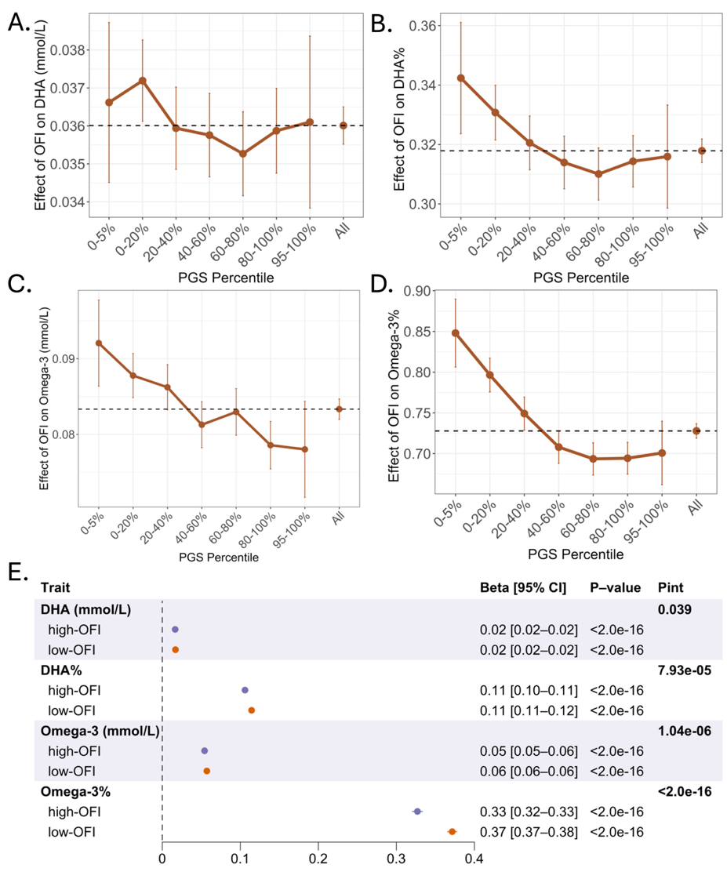

Supplementary Figure 9. Evidence of PGS-by-OFI interactions on raw circulating concentrations of omega-3 fatty acids in EUR participants
A) – D) PGS modified the positive associations of OFI with raw circulating concentrations of DHA, DHA%, Omega-3, Omega-3%. We calculated PGS using the SBayesRC algorithm, and performed analyses on participants of EUR ancestry (N = 237,380). E) PGS was associated with a smaller increase in circulating omega-3 fatty acid levels among individuals in the high-OFI group compared to those in the low-OFI group. Estimated effect sizes of PGS are presented as beta [95% CI] in the forest plot. P-value denotes the significance of the association between PGS and omega-3 fatty acids within each stratum, while P_{Int} represents the interaction p-value between PGS and OFI.
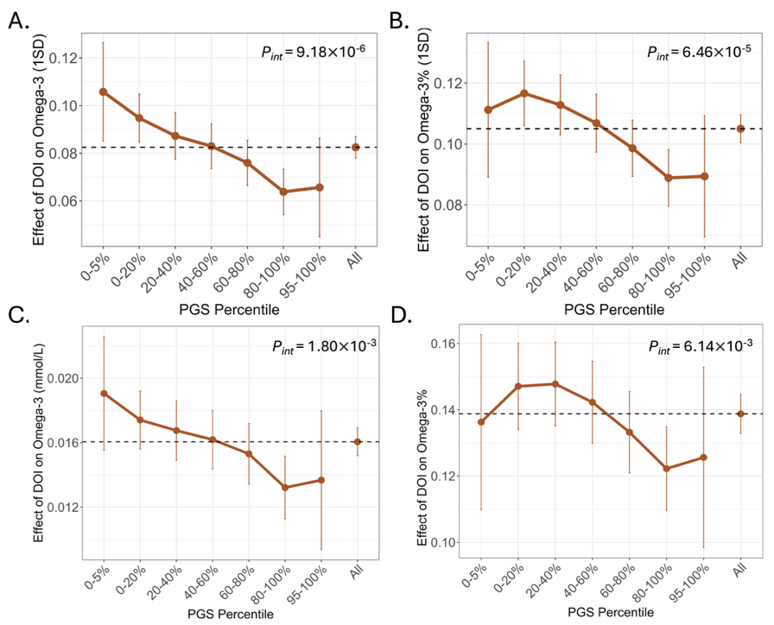

Supplementary Figure 10. Evidence of PGS-by-DOI interactions on raw and RINT-based circulating concentrations of omega-3 fatty acids in EUR participants
A) – D) PGS modified the positive associations of DOI with raw and RINT-based circulating concentrations of Omega-3 and Omega-3%. We calculated PGS using the SBayesRC algorithm, and performed analyses on participants of EUR ancestry (N = 182,360). P_{Int} represents the interaction p-value between PGS and DOI.

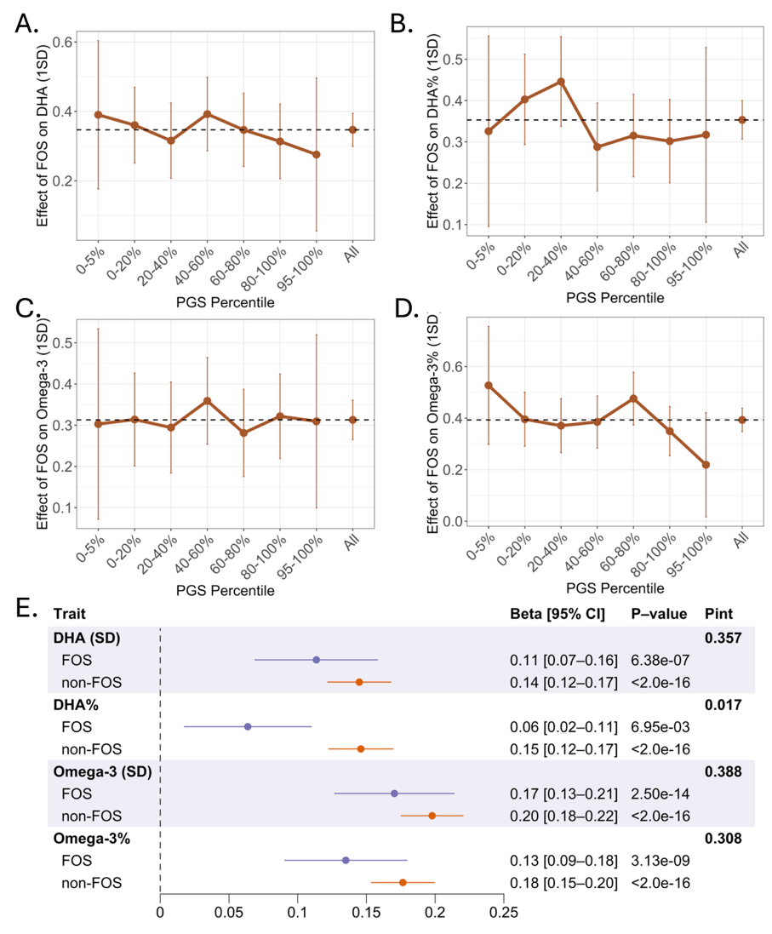

Supplementary Figure 11. Evidence of PGS-by-FOS interactions on RINT-based circulating concentration of DHA% in CSA participants
A) – D) Changes in the association effects of FOS on RINT-based circulating concentrations of DHA, DHA%, omega-3, and omega-3% across PGS groups. We calculated PGS using the SBayesRC algorithm, and performed analyses on participants of CSA ancestry (N = 8,237). E) PGS was associated with a smaller increase in circulating DHA% among individuals in the FOS group compared to those in the non-FOS group. Estimated effect sizes of PGS are presented as beta [95% CI] in the forest plot. P-value denotes the significance of the association between PGS and omega-3 within each stratum, while P_{Int} represents the interaction p-value between PGS and FOS.
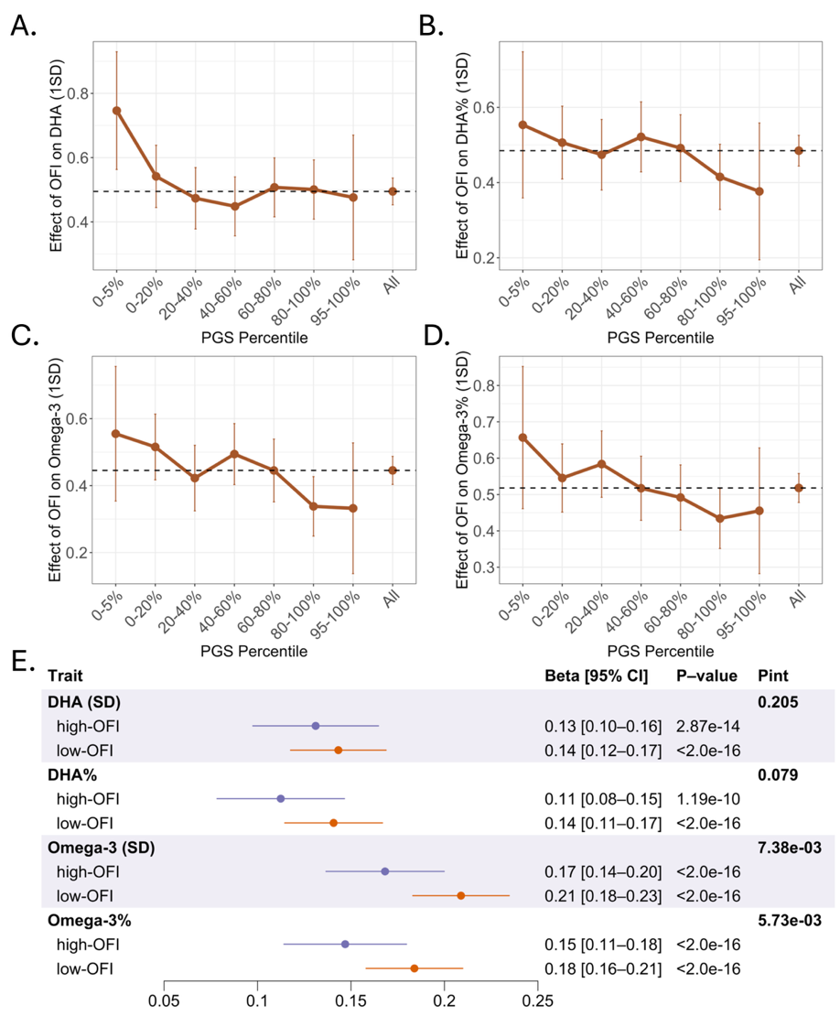

Supplementary Figure 12. Evidence of PGS-by-OFI interactions on RINT-based circulating concentrations of Omega-3 and Omega-3% in CSA participants
A) – D) Changes in the association effects of high-OFI on RINT-based circulating concentrations of DHA, DHA%, omega-3, and omega-3% across PGS groups. We calculated PGS using the SBayesRC algorithm, and performed analyses on participants of CSA ancestry (N = 8,237). E) PGS was associated with a smaller increase in circulating omega-3 fatty acid concentrations among individuals in the high-OFI group compared to those in the lw-OFI group. Estimated effect sizes of PGS are presented as beta [95% CI] in the forest plot. P-value denotes the significance of the association between PGS and omega-3 fatty acids within each stratum, while P_{Int} represents the interaction p-value between PGS and OFI.
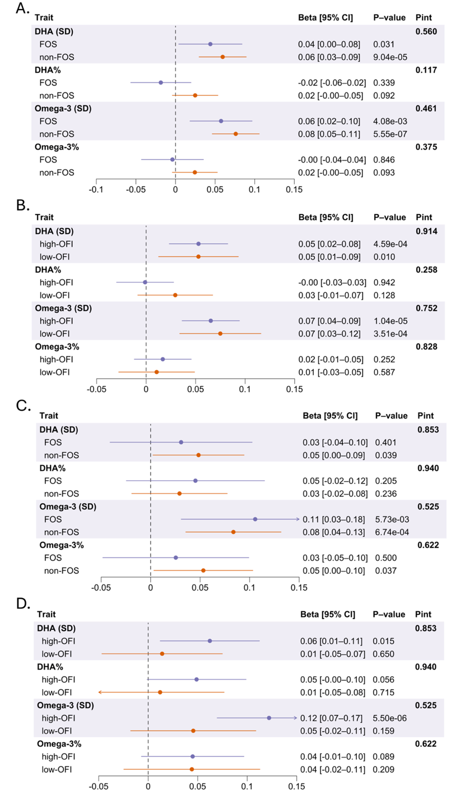

Supplementary Figure 13. Absence of PGS-by-FOS and PGS-by-OFI interactions on RINT-based circulating concentrations of omega-3 fatty acids in AFR and EAS participants
The association between PGS and RINT-based circulating omega-3 concentrations did not significantly differ by dietary exposures across ancestry groups: A) FOS vs. non-FOS groups in AFR ancestry, B) high-OFI vs. low-OFI groups in AFR ancestry, C) FOS vs. non-FOS groups in EAS ancestry, and D) high-OFI vs. low-OFI groups in EAS ancestry. We calculated PGS using the SBayesRC algorithm, and performed analyses on participants of AFR (N = 6,323) and EAS (N = 2,571) ancestries, respectively. Estimated effect sizes of PGS are presented as beta [95% CI] in the forest plot. P-value denotes the significance of the association between PGS and omega-3 fatty acids within each stratum, while P_{Int} represents the interaction p-value between PGS and dietary exposures.
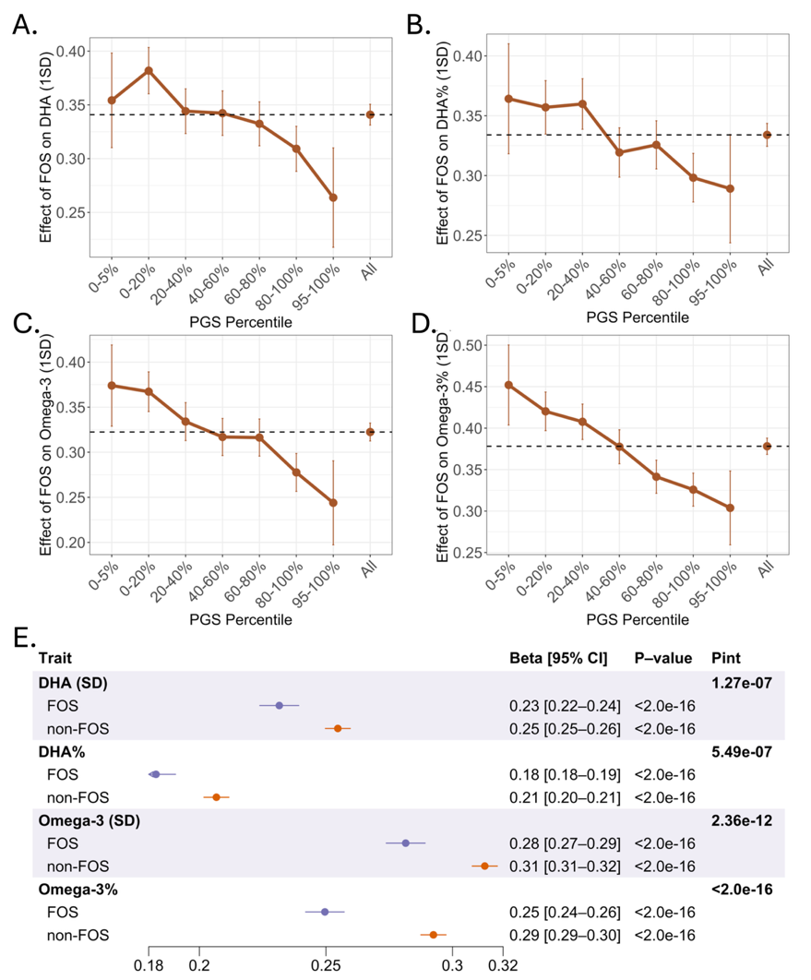

Supplementary Figure 14. Evidence of PGS-by-FOS interactions on RINT-based circulating concentrations of omega-3 fatty acids in EUR participants using a 24-hour dietary recall questionnaire
A) – D) PGS modified the positive associations of FOS with RINT-based circulating concentrations of DHA, DHA%, Omega-3, Omega-3%. We calculated PGS using the SBayesRC algorithm, and performed analyses on participants of EUR ancestry from all UKB phases (N = 182,360). The 24-hour dietary recall questionnaire was analyzed. E) PGS was associated with a smaller increase in circulating omega-3 fatty acid concentrations among individuals in the FOS group compared to those in the non-FOS group. Estimated effect sizes of PGS are presented as beta [95% CI] in the forest plot. P-value denotes the significance of the association between PGS and omega-3 fatty acids within each stratum, while P_{Int} represents the interaction p-value between PGS and FOS.

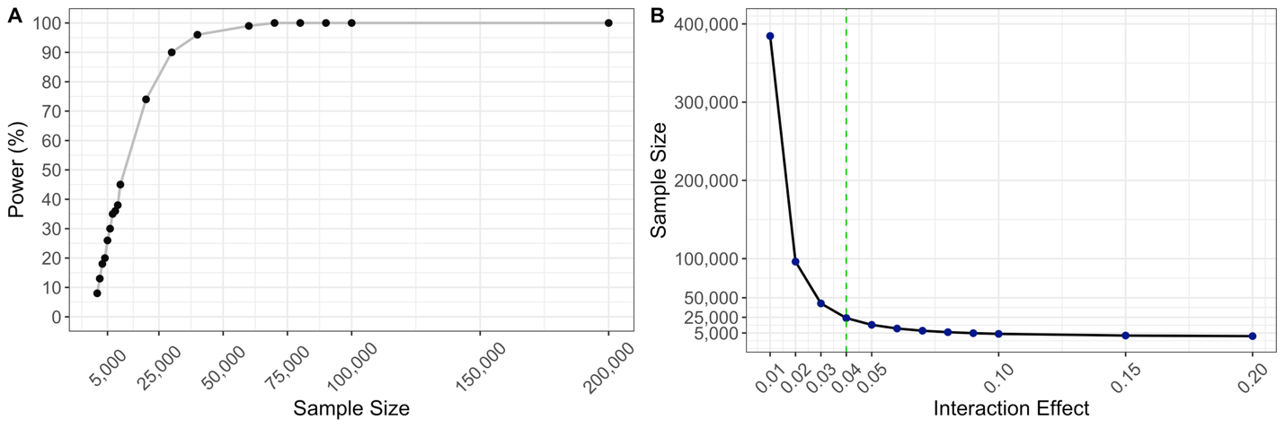

Supplementary Figure 15. Power calculation for the detection of PGS-by-FOS interactions
A) Estimated sample sizes required to detect a fixed interaction effect of 0.04 across a gradient of statistical power (P < 0.05). B) Minimum sample size required to achieve 80% power across a range of interaction effect magnitudes.

