# Machine vision Assignment2

Name:DING,,PENG Student number:G1801274A

1.First,I take 2 pictures with the same camera(turning off the auto—focusing function),two original pictures are as follow:

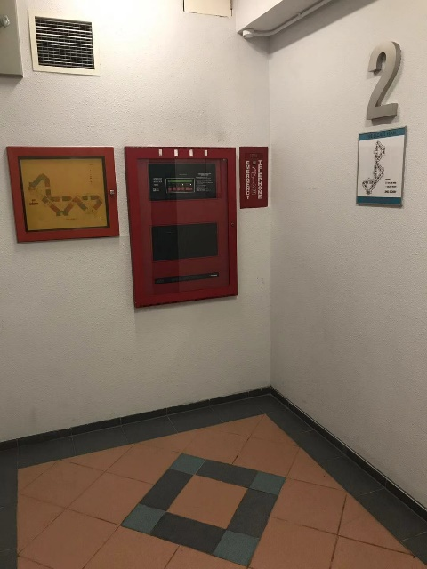 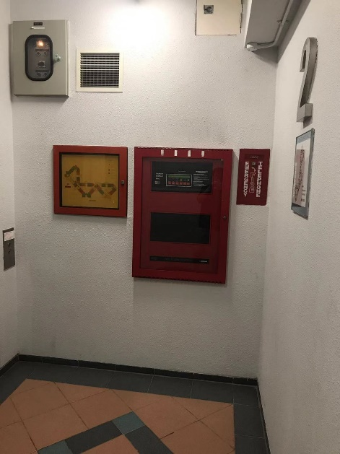

2.Second,I perform corner detection on this two pictures with Harris method.

img1=imread('1.jpg');

img2=imread('2.jpg');

img1G=rgb2gray(img1);

img2G=rgb2gray(img2);

C1=corner(img1G,200);

C2=corner(img2G,200);

figure,subplot(1,2,1)

imshow(img1G),title('leftCorner'),

hold on

plot(C1(:,1), C1(:,2), 'r*');

hold off

subplot(1,2,2)

imshow(img2G),title('rightCorner'),

hold on

plot(C2(:,1),C2(:,2),'r*');

hold off

And the result is:

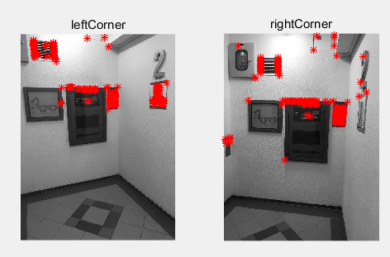

3.Then I pick eight points from these corners:

|  |  |
| --- | --- |
| Left | Right |
| (287,374) | (405,468) |
| (254,193) | (389,293) |
| (466,29) | (623,112) |
| (616,89) | (784,153) |
| (596,374) | (763,473) |
| (677,372) | (857,474) |
| (403,380) | (513,477) |
| (520,396) | (643,496) |

4.Since

$$\left[\begin{matrix}{x'}_{i} & {y'}_{i} & 1\end{matrix}\right]\left[\begin{matrix}f_{11} & f_{12} & f_{13} \\ f_{21} & f_{22} & f_{23} \\ f_{31} & f_{32} & f_{33}\end{matrix}\right]\left[\begin{matrix}x_{i} \\ y_{i} \\ 1\end{matrix}\right]=0$$

Thus we can derive that

$$\left[\begin{matrix}x_{1}{x'}_{1} & x_{1}{y'}_{1} & x_{1} & y_{1}{x'}_{1} & y_{1}{y'}_{1} & y_{1} & {x'}_{1} & {y'}_{1} & 1 \\ ⋮ & ⋮ & ⋮ & ⋮ & ⋮ & ⋮ & ⋮ & ⋮ & ⋮ \\ x_{m}{x'}_{m} & x_{m}{y'}_{m} & x_{m} & y_{m}{x'}_{m} & y_{m}{y'}_{m} & y_{m} & {x'}_{m} & {y'}_{m} & 1\end{matrix}\right]\left[\begin{matrix}f_{11} \\ f_{21} \\ f_{31} \\ f_{12} \\ f_{22} \\ f_{32} \\ f_{13} \\ f_{23} \\ f_{33}\end{matrix}\right]=0$$

With $f_{33}=1$.Then we can get

$$A=\left[\begin{matrix}x_{1}{x'}_{1} & x_{1}{y'}_{1} & x_{1} & y_{1}{x'}_{1} & y_{1}{y'}_{1} & y_{1} & {x'}_{1} & {y'}_{1} & 1 \\ ⋮ & ⋮ & ⋮ & ⋮ & ⋮ & ⋮ & ⋮ & ⋮ & ⋮ \\ x_{m}{x'}_{m} & x_{m}{y'}_{m} & x_{m} & y_{m}{x'}_{m} & y_{m}{y'}_{m} & y_{m} & {x'}_{m} & {y'}_{m} & 1\end{matrix}\right]$$

By using SVD method, we get matrix U, $Σ$,V and matlab code is:

lpoints=zeros(8,2);

rpoints=zeros(8,2);

A=zeros(8,9);

for m=1:8

A(m,1)=lpoints(m,1)*rpoints(m,1);

A(m,2)=lpoints(m,1)*rpoints(m,2);

A(m,3)=lpoints(m,1);

A(m,4)=lpoints(m,2)*rpoints(m,1);

A(m,5)=lpoints(m,2)*rpoints(m,2);

A(m,6)=lpoints(m,2);

A(m,7)=rpoints(m,1);

A(m,8)=rpoints(m,2);

A(m,9)=1;

end

[U,S,V]=svd(A);

5.

By selecting the corrensonding column of V

F=[-0.0662 0.7634 0.0058;-0.6421 -0.0236 -0.0011;0.0070 0.0009 0.0000;];

Then compute svd of F,we can get Df:

Df= $\left[\begin{matrix}0.7685 & 0 & 0 \\ 0 & 0.6399 & 0 \\ 0 & 0 & 0\end{matrix}\right]$

We have to set the smallest diagonal equal to 0 because D of F should have the rank of 2. But in this case we don’t need because it has been 0.

So Finally we get the correct estimate of F:

$$F^{'}=Uf*Df*Vf'$$

And the final answer is:

$$F'=\left[\begin{matrix}-0.0662 & 0.7634 & 0.0058 \\ -0.6421 & -0.0236 & -0.0011 \\ 0.0070 & 0.0009 & 0.0000\end{matrix}\right]$$

6.Test the result and accuracy

First,I use the original eight points to get fundamental matrix to test the reslt and here is the result:

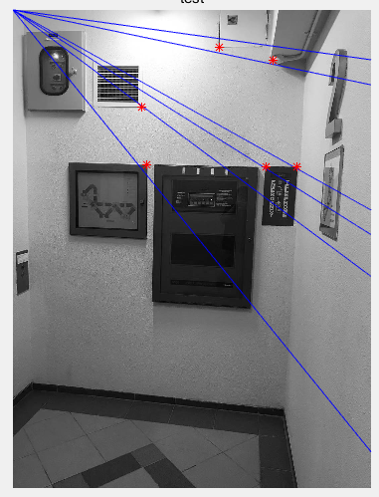

Then I pick one point (443,396) that wasn’t used before to perform the experiment. Its coordinate is (555,494) on the right picture.

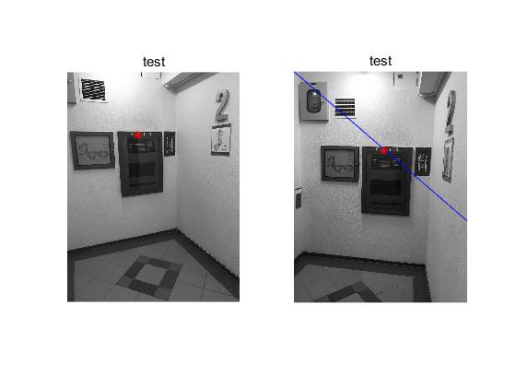

7.Conclusion

From this assignment and knowledge in class, I get that corresponding points are located on the epipolar lines although there exist some error in my first test result. In fact, points ought to locate on the epipolar line due to they share the same plane. And the error is permitted, since I used only eight numbers which is the least number of points needed.