EE6222-Machine Vision Assignment 2

Msc CCA

1. Two shots aiming at the same settings

 

1. Detect corners in two images using FAST algorith.

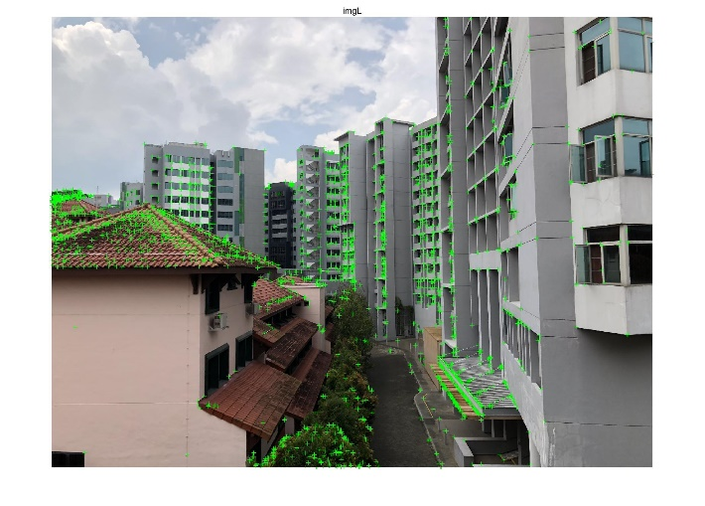 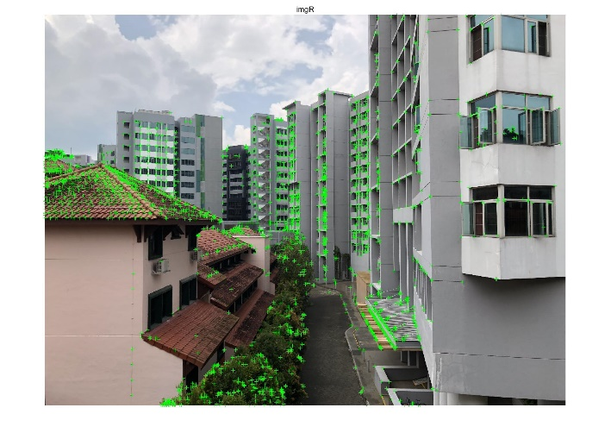

1. Match FAST features and get the matching pairs of corresponding points.

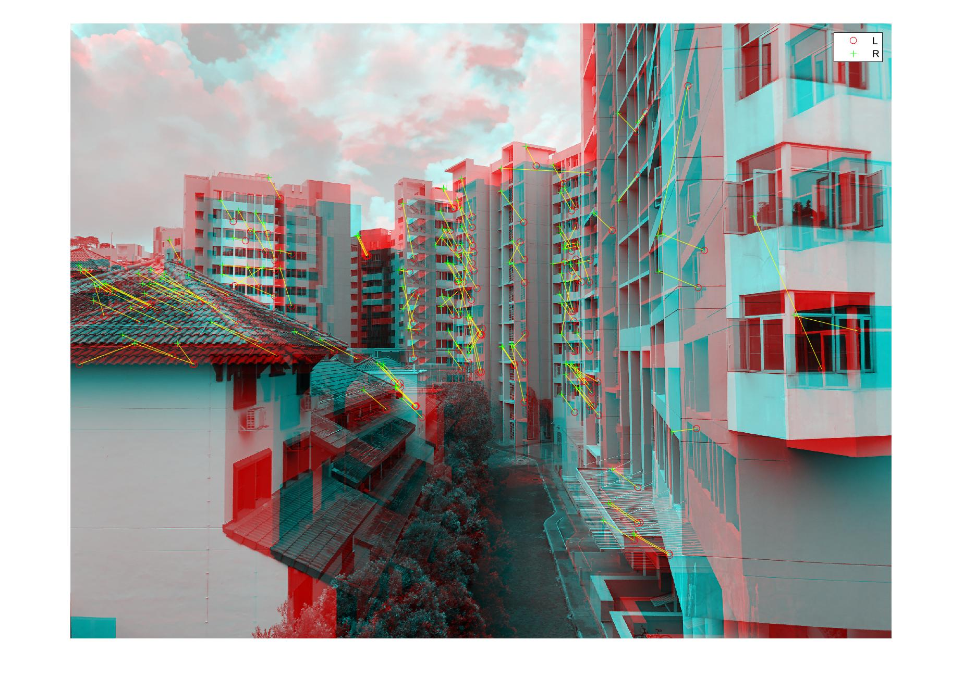

1. Compute the fundamental matrix. Select a point in the left image and plot the epipolar line on the right image (the corresponding point in the right image is also shown).

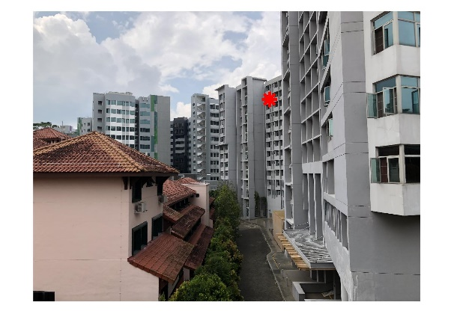 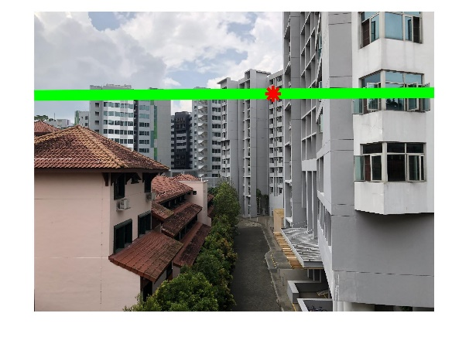

From the above figures, we can see that the epipolar line well fits the selected point and its corresponding in the right image, which conincides with the epipole geometry.