E6225 Continious Assignment 1

Msc CCA

The process transfer function is described as

$$G\left(s\right)=\frac{s+3.5}{{\left(s+1\right)}^{3}{\left(s+2\right)}^{2}\left(s^{2}+7s+10\right)}e^{-2.5s}=\frac{s+3.5}{{\left(s+1\right)}^{3}{\left(s+2\right)}^{3}\left(s+5\right)}e^{-2.5s}$$

1. First order plus time delay model using least squares method under open loop step test in time domain

Matlab Code:

|  |
| --- |
| %define the original process transfer function  z = [-3.5];  p = [-1,-1,-1,-2,-2,-2,-5];  k = 1;  t_delay = 2.5;  G = zpk(z,p,k,'inputdelay',t_delay);    %define sampleing period which starts from apparent time delay  t_s_start = 4.5; %sampling start time  t_s_end = 35.5; %sampling stop time  Ts = 1; %sampling interval  s_num = (t_s_end-t_s_start)/Ts; %total sampling number  t_sample = [t_s_start:Ts:t_s_end-Ts];  [y,t] = step(G,t_sample);    % calculate psi,gamma for the least squares method  psi = zeros(s_num,3); %initialization  psi(1,1) = Ts/2*y(1);  for i =2:s_num-1  psi(i,1) = psi(i-1,1) + Ts*y(i);  end  psi(s_num,1) = psi(s_num-1,1) + Ts/2*y(s_num);  psi(:,1) = -psi(:,1);  psi(:,2) = -1;%The magnitude of the input step function is 1.  psi(:,3) = 1*t;  gamma = y;    %use the least squares method to calculate the parameters  theta = ((psi'*psi)^-1)*psi'*gamma;  a1 = theta(1,1);  b1 = theta(3,1);  L = theta(2,1)/theta(3,1);  num = [b1];  den = [1,a1];  Gn = tf(num,den,'inputdelay',L);  step(G,Gn,35); %step test and plot the two responses |

The sampling starts from 4.5s to 34.5s with sampling interval 1s. So, the total sampling number is 30.

After using the least square method,

$$\hat{θ}={(Ψ^{T}Ψ)}^{-1}Ψ^{T}Γ=\left[\begin{aligned}0.5271 \\ 0.2172 \\ 0.0462\end{aligned}\right]$$

Then the process parameters can be recovered from

$$\left[\begin{matrix}a_{1} \\ b_{1} \\ L\end{matrix}\right]=\left[\begin{matrix}θ_{1} \\ θ_{3} \\ \frac{θ_{2}}{θ_{3}}\end{matrix}\right]=\left[\begin{matrix}0.5271 \\ 0.0462 \\ 4.6989\end{matrix}\right]$$

Therefore, the first order plus time delay model is calculated as

$$G_{n}\left(s\right)=\frac{b_{1}}{s+a_{1}}e^{-Ls}=\frac{0.0462}{s+0.5271}e^{-4.6989s}$$

$$=\frac{K}{τs+1}e^{-Ls}=\frac{0.0877}{1.8970s+1}e^{-4.6989s}$$

Step response in time domain:

( $G$ is the original transfer function while $G_{n}$ is the first order plus time delay model)

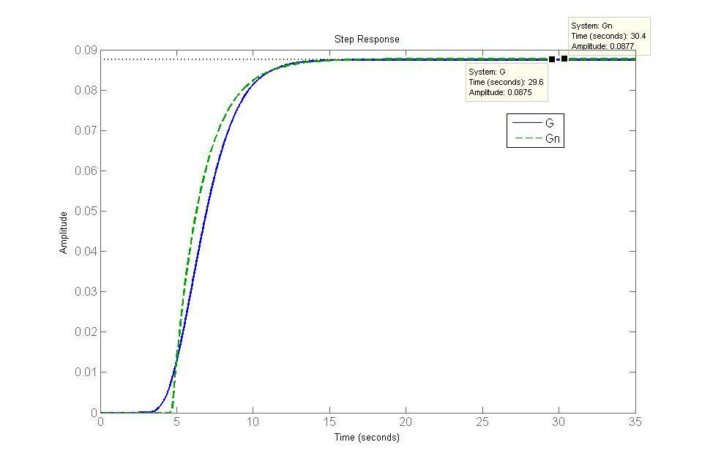

1. First order plus time delay under open loop step test using least squares method in frequency domain

Matlab Code:

|  |
| --- |
| %define the original process transfer function  z = [-3.5];  p = [-1,-1,-1,-2,-2,-2,-5];  k = 1;  t_delay = 2.5;  G = zpk(z,p,k,'inputdelay',t_delay);    %define sampleing period  t_s_start = 0; %sampling start time  t_s_end = 20; %sampling stop time  Ts = 0.5; %sampling interval  s_num = (t_s_end-t_s_start)/Ts; %total sampling number  t_sample = [t_s_start:Ts:t_s_end-Ts];  [y,t] = step(G,t_sample);    %trapezoidal integration rule  syms w;  g(w) = (y(s_num)+w*trapz(t,(step(G,t)-y(s_num)).*sin(w*t)))+1i*w*trapz(t,(step(G,t)-y(s_num)).*cos(w*t));    %initialization  %number of the frequency response to be identified  %in the frequency range (0, ¦Ø c )  M = 10;  fai = zeros(1,M);  w = zeros(1,M);  psi = zeros(M,2);  gamma = zeros(M,1);    W(1) = 0.0; W(2) = 0.001;  fai(1) = 0.0; fai(2) = angle(g(W(2)));    %recursive solution  %calculate the argument and counterpart frequency of the sampling  for n=3:M  W(n) = W(n-1)-((n-1)*pi/(M-1)+fai(n-1))*(W(n-1)-W(n-2))/(fai(n-1)-fai(n-2));  fai(n) = phase(g(W(n)));  end    %calculate parameters a1 and b1 by LSM method.  for n=1:M  psi(n,1) = -((real(g(W(n))))^2+(imag(g(W(n))))^2);  psi(:,2) = 1;  gamma(n) = (W(n)^2)*((real(g(W(n))))^2+(imag(g(W(n))))^2);  end  theta = ((psi'*psi)^-1)*psi'*gamma;  a1 = sqrt(theta(1));  b1 = sqrt(theta(2));    %calculate parameters L by LSM method.  psi2 = W';  gamma2 = zeros(M,1);  for n=1:M  gamma2(n) = -fai(n)-atan(W(n)/a1);  end  L = ((psi2'*psi2)^-1)*psi2'*gamma2;    num = [b1];  den = [1,a1];  Gn = tf(num,den,'inputdelay',L);  step(G,Gn,35) %do the step test and plot |

For step input $u\left(t\right)=1(t)$,

$$G\left(jω_{i}\right)≈jω_{i}\int_{0}^{T_{y}}{∆y\left(t\right)e^{-jω_{i}t}dt}+y\left(∞\right)$$

$$=\left[ y\left(∞\right)+ω\int_{0}^{T_{y}}{∆y\left(t\right)sinω_{i}tdt}\right]+jω\int_{0}^{T_{y}}{∆y\left(t\right)cosω_{i}tdt}$$

Using the numerical integration method, such as the Trapezoidal numerical integration, we have

$$\int_{0}^{T_{y}}{∆y\left(t\right)sinω_{i}tdt}≈\sum_{j=0}^{l}{α_{j}q^{-j}∆y\left(t_{j}\right)}sinω_{i}t_{j}$$

$$\int_{0}^{T_{y}}{∆y\left(t\right)cosω_{i}tdt}\sum_{j=0}^{l}{α_{j}q^{-j}∆y\left(t_{j}\right)}cosω_{i}t_{j}$$

where

$$α_{0}=α_{1}=\frac{T_{s}}{2}, α_{j}=T_{s}, j∈[1,l-1]$$

Then the recursive solution is applied to calculate the argument and counterpart frequency of the sampling.

For initialization, $ω_{0}=0$, $φ_{0}=0$, $ω_{1}=0.001$, $φ_{1}=\arg\left[G\left(jω_{1}\right)\right]$ and $M=10$. For $i=1,2,3,…M-1,$ determine $ω_{i+1}$ and $φ_{i+1}$ by

$$ω_{i+1}= ω_{i}-(\frac{iπ}{M-1}+φ_{i})\frac{ω_{i}-ω_{i-1}}{φ_{i}-φ_{i-1}}$$

$$φ_{i+1}=\arg\left[G\left(jω_{i+1}\right)\right]$$

The first order plus time delay model can be described as

$$G_{n}\left(s\right)=\frac{K}{τs+1}e^{-Ls}=\frac{b_{1}}{s+a_{1}}e^{-Ls}$$

Its parameters may be determined by matching $G_{n}\left(jω\right)$ to $G\left(jω\right)$ at multiple points $ω_{i}$, *i* = 1,2,..., *M*.

For the frequency $ω_{i}$, the magnitude and phase values of $G\left(jω_{i}\right)$ are given as

$$-{a_{1}}^{2}{\left|G\left(jω_{i}\right)\right|}^{2}+{b_{1}}^{2}={ω_{i}}^{2}{\left|G\left(jω_{i}\right)\right|}^{2}$$

$$ω_{i}L=-arg\left[G\left(jω_{i}\right)\right]{-tan}^{-1}\left(\frac{ω_{i}}{a_{1}}\right)$$

The magnitude equation can be arranged to a matrix form

$$Ψθ=Γ$$

where

$$Ψ=\left[\begin{matrix}\begin{matrix}\begin{matrix}-{\left|G\left(jω_{1}\right)\right|}^{2} \\ -{\left|G\left(jω_{2}\right)\right|}^{2}\end{matrix} \\ \begin{matrix}⋮ \\ -{\left|G\left(jω_{M}\right)\right|}^{2}\end{matrix}\end{matrix} & \begin{matrix}\begin{matrix}1 \\ 1\end{matrix} \\ \begin{matrix}⋮ \\ 1\end{matrix}\end{matrix}\end{matrix}\right], θ=\left[\begin{matrix}{a_{1}}^{2} \\ {b_{1}}^{2}\end{matrix}\right], Γ=\left[\begin{matrix}\begin{matrix}{ω_{1}}^{2}{\left|G\left(jω_{1}\right)\right|}^{2} \\ {ω_{2}}^{2}{\left|G\left(jω_{2}\right)\right|}^{2}\end{matrix} \\ \begin{matrix}⋮ \\ {ω_{M}}^{2}{\left|G\left(jω_{M}\right)\right|}^{2}\end{matrix}\end{matrix}\right]$$

$θ$ can be solved using the linear least-squares method

$$θ={(Ψ^{T}Ψ)}^{-1}Ψ^{T}Γ=[\begin{matrix}0.1998 \\ 0.0016\end{matrix}]$$

Then the process parameters $a_{1}$, $b_{1}$ can be recovered from

$$\left[\begin{matrix}a_{1} \\ b_{1}\end{matrix}\right]=\left[\begin{matrix}\sqrt{θ_{1}} \\ \sqrt{θ_{2}}\end{matrix}\right]=\left[\begin{matrix}0.4470 \\ 0.0395\end{matrix}\right]$$

The phase equation can also be arranged to a matrix form

$$ΨL=Γ$$

where

$$Ψ=\left[\begin{matrix}\begin{matrix}ω_{1} \\ ω_{2}\end{matrix} \\ \begin{matrix}⋮ \\ ω_{M}\end{matrix}\end{matrix}\right], Γ=\left[\begin{matrix}\begin{matrix}-arg\left[G\left(jω_{1}\right)\right]{-tan}^{-1}\left(\frac{ω_{1}}{a_{1}}\right) \\ -arg\left[G\left(jω_{2}\right)\right]{-tan}^{-1}\left(\frac{ω_{2}}{a_{1}}\right)\end{matrix} \\ \begin{matrix}⋮ \\ -arg\left[G\left(jω_{M}\right)\right]{-tan}^{-1}\left(\frac{ω_{M}}{a_{1}}\right)\end{matrix}\end{matrix}\right]=\left[\begin{matrix}\begin{matrix}-{φ_{1}-tan}^{-1}\left(\frac{ω_{1}}{a_{1}}\right) \\ -φ_{2}{-tan}^{-1}\left(\frac{ω_{2}}{a_{1}}\right)\end{matrix} \\ \begin{matrix}⋮ \\ -φ_{M}{-tan}^{-1}\left(\frac{ω_{M}}{a_{1}}\right)\end{matrix}\end{matrix}\right]$$

$L$ can be solved using the linear least-squares method

$$L={(Ψ^{T}Ψ)}^{-1}Ψ^{T}Γ=4.8945$$

Therefore, the first order plus time delay model is calculated as

$$G_{n}\left(s\right)=\frac{b_{1}}{s+a_{1}}e^{-Ls}=\frac{0.0395}{s+0.4470}e^{-4.8945s}$$

$$=\frac{K}{τs+1}e^{-Ls}=\frac{0.0884}{2.2371s+1}e^{-4.8945s}$$

Step response in time domain:

( $G$ is the original transfer function while $G_{n}$ is the first order plus time delay model)

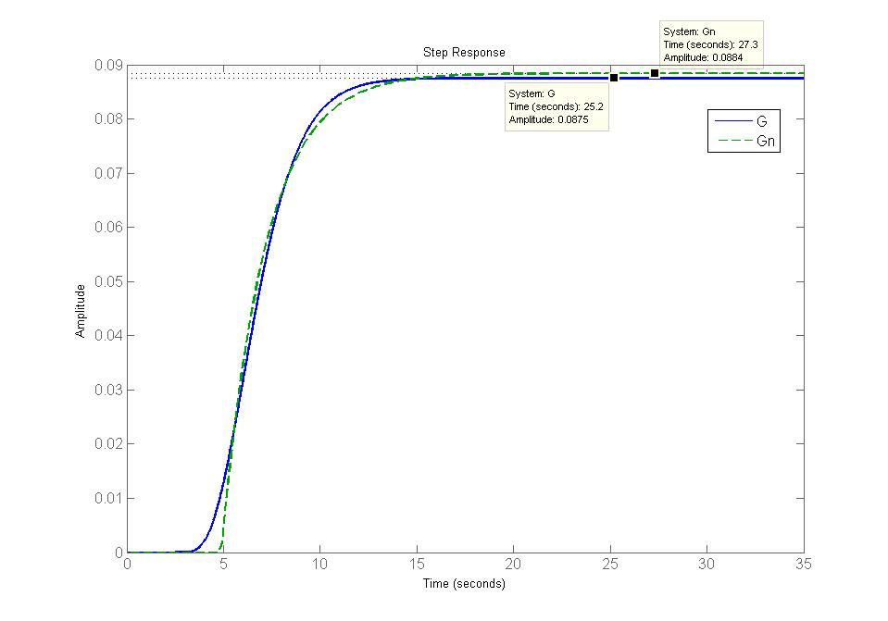

1. Using relay feedback to generate sustained oscillation and using the available information to calculate the parameters of first order plus time delay model.

Relay plus step method: step function input at 65 second.

Simulink model:

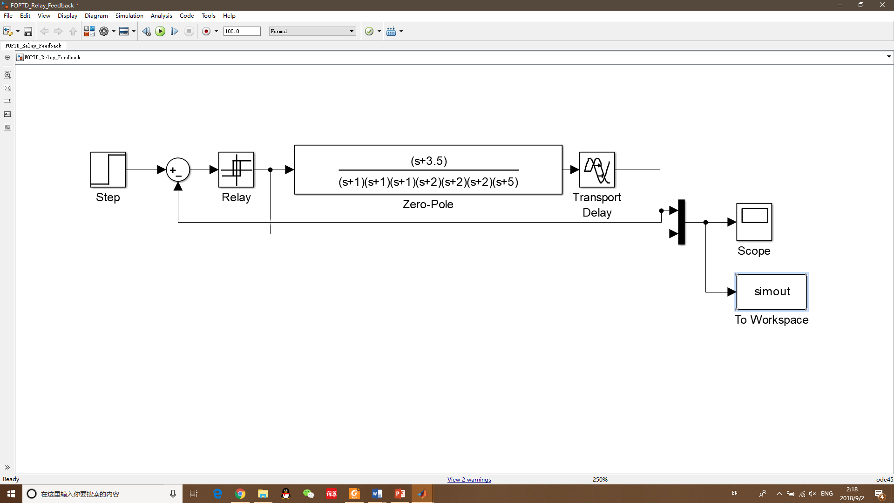

Scope Output:

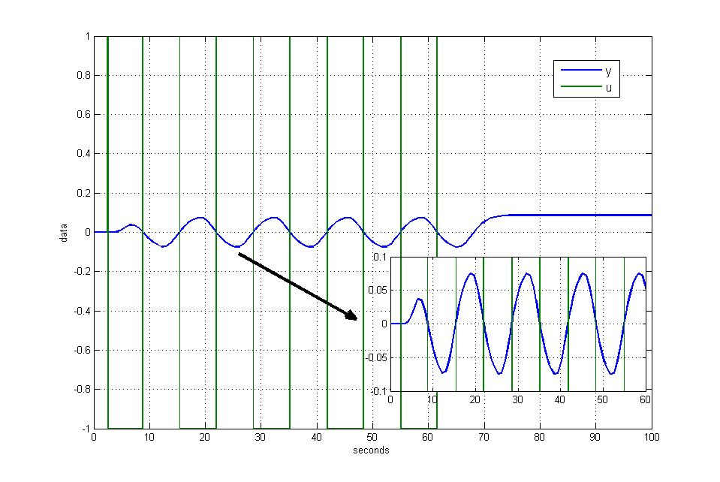

Results from the scope output:

Time delay *L* = 4.508

Oscillation period *Pu* = 13.19

Steady state magnitude $K_{p}$ = 0.0875

Oscillation magnitude increase ***a*** = 0.07449

Input increase *h* = 1

Matlab Code:

|  |
| --- |
| sim('FOPTD_Relay_Feedback_sim');  plot(simout);    %define the original process transfer function  z = [-3.5];  p = [-1,-1,-1,-2,-2,-2,-5];  k = 1;  t_delay = 2.5;  G = zpk(z,p,k,'inputdelay',t_delay);    %read from the scope output  L = 4.508;  Pu = 6.59;  Kp = 0.0875;  h = 1;  a = 0.07449;    Wu = 2*pi/Pu;  Ku = 4*h/(pi*a);  T = sqrt((Kp*Ku)^2-1)/Wu;    num = [Kp];  den = [T,1];  Gn = tf(num,den,'inputdelay',L);  figure,step(G,Gn,35); |

$$T=\frac{\sqrt{{(K_{p}K_{u})}^{2}-1}}{ω_{u}}=2.3346$$

Therefore, the first order plus time delay model is calculated as

$$G_{n}\left(s\right)=\frac{K_{p}}{Ts+1}e^{-Ls}=\frac{0.0875}{2.3346s+1}e^{-4.508s}$$

Step response in time domain:

( $G$ is the original transfer function while $G_{n}$ is the first order plus time delay model)

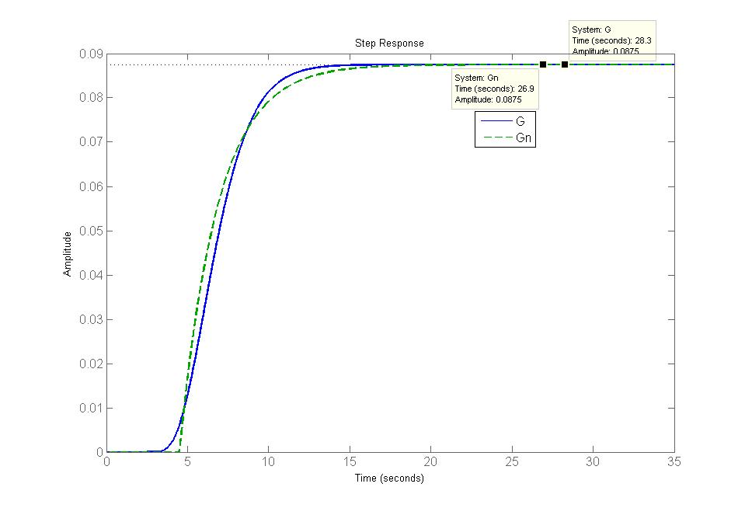

1. Plot Nyquist chart for both the original transfer function and the identified transfer function to compare the identification results
2. First order plus time delay model using least squares method under open loop step test in time domain

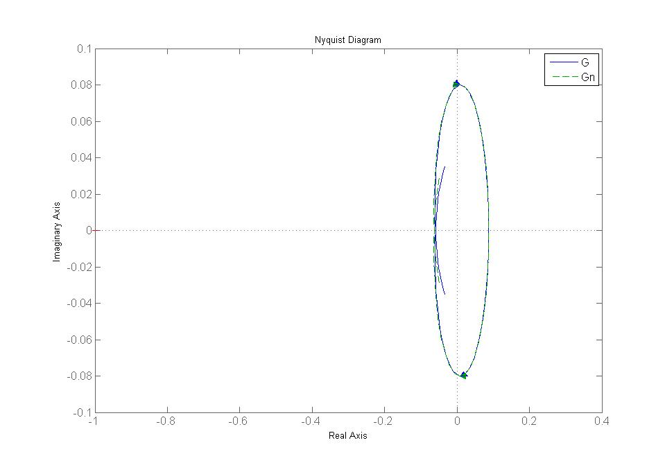

1. First order plus time delay under open loop step test using least squares method in frequency domain

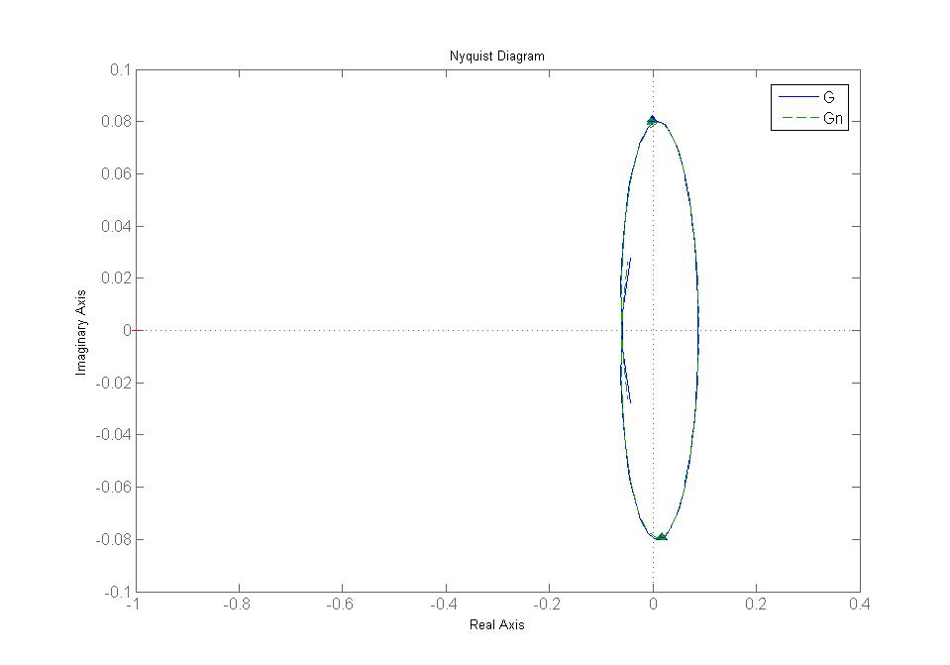

1. Using relay feedback to generate sustained oscillation and using the available information to calculate the parameters of first order plus time delay model.

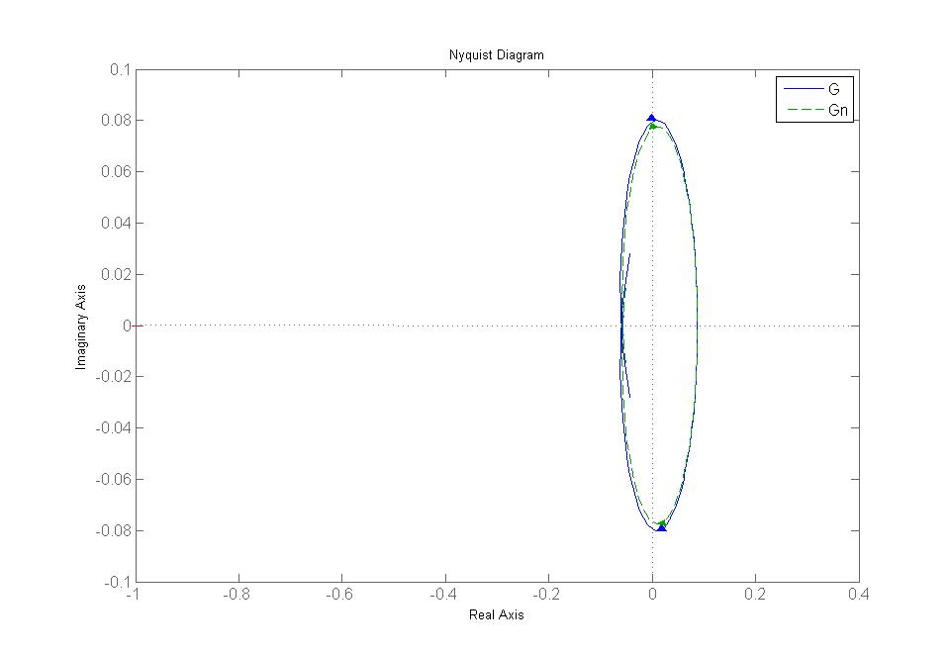

Three models get good result in the Nyquist chart, especially the First order plus time delay under open loop step test using least squares method in frequency domain and time domain.