E6225
All the assignment must submitted by
Due: 07 Oct, 2018.
Format: The solution must be submitted in word document by e-mail
Continious Assignment 2
Consider a temperature control problem of Tyreus case 4 (T4), the transfer function matrix is obtained by empirical modeling technique as:
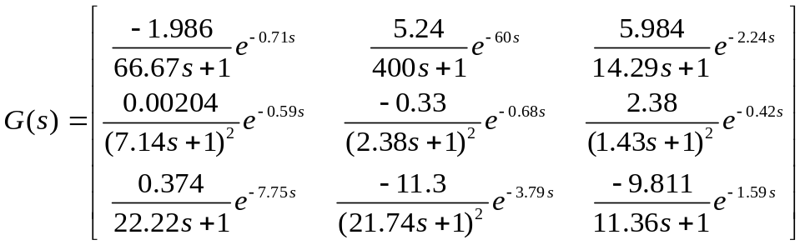
,
Try to design following controllers using ETF and compare with the classical decentralized control based on BLT method
- Decentralized control
- Spases control
- Decoupling control
Compare the performance for the control systems by simulating the closed-loop performances for step response R₁(t)=1 for t>0, R₂(t)=1 for t>250 and R₃(t)=1 for t>500.

