**CHAPTER 2 DATABASE DESIGN**

**2.1 List of entities and attributes**

|  |  |
| --- | --- |
| **Entity** | **Attributes** |
| Membership | MemberID, M_Name, DOB, Gender, Role, PhoneNo, Email |
| Staff | StaffID |
| Reservation | Res_ID, Res_Date, For_Date, Res_Status |
| Transaction | Duration, BorrowedDate, Renew, DueDate, ReturnDate, Overdue, Fine, Paid |
| Payment | PaymentID, PaidAmount, PaidDate |
| Branch | BranchID, City, TelNo |
| Cataloging | Title, Author, Company, Price, Pages, PubName, PubYear |
| Inventory | CopyAvail |

*Table 2.1* *List of Entities and Attributes*

**2.2 Entity Relationship Diagram (ERD)**

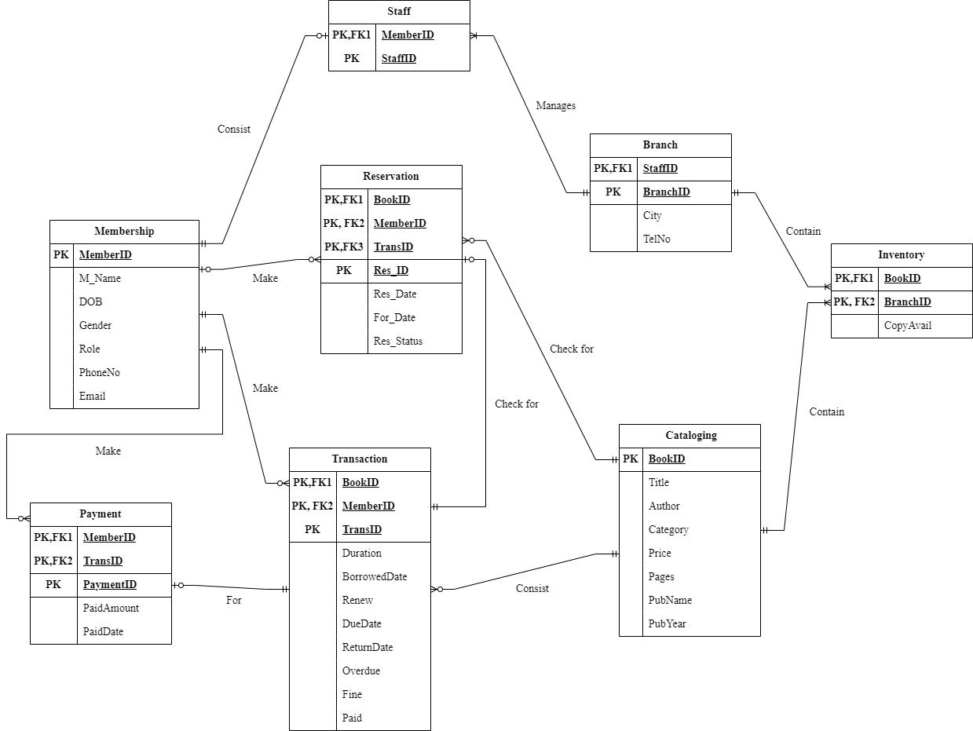

*Figure 2.2 Entity Relationship Diagram (ERD)*

**2.3 Assumptions and Business Rules**

1. List of assumptions
2. Each branch has one or more staff or administrator.
3. Each book has at least one copy, but the number of copies might vary.
4. Library members must register to borrow books.
5. Librarians and administrators are staff members who can manage the library system.
6. Transactions record borrowing and returning activities, including due dates.
7. List of business rules (according to ERD)
8. Each member must have a role in COVID20 library, including students. (Structural business rule)
9. One member can only make one borrowing or renewal transactions, but they can make many borrowing or renewal transactions. (Procedural business rule)
10. Only one payment can be made by one member, but one member can make no payment or multiple payments. (Procedural business rule)
11. One reservation can only be made by one member, but one member can wish to make no reservation or many reservations. (Procedural business rule)
12. One transaction can only be paid by one fine payment, but there can be zero fine payment or one fine payment. (Procedural business rule)
13. One book in a catalog can consist in zero, or many borrowing or renewal transactions, but a borrowing or renewal transaction can only consist of one book from the catalog. (Procedural business rule)
14. A catalog can have one copy of a book or many copies in inventory, but one inventory can only contain one catalog of that book. (Structural business rule)
15. Each branch can have one or many inventory, but an inventory must belong to a branch. (Structural business rule)