Overview
In the past have built compliance documentation and certifications (required for print management through print shops or printing internally within organisations) for the Commerce Commission, Ministry of Health/MBIE Covid Response, and the Health Quality & Safety Commission. This is a mock up version for your perusal. You are free to copy and use/modify if you wish:
https://github.com/Huitzilopoctli372/2025_NZQACertDemo
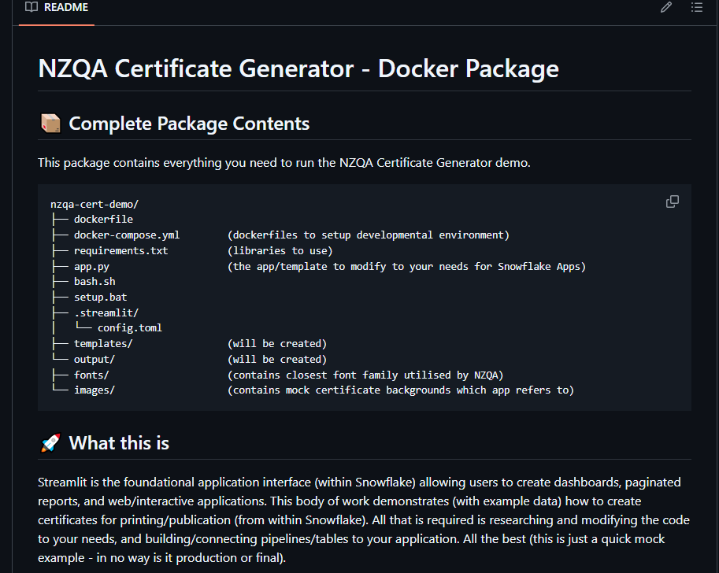

Quick Explanation
Currently the app.py file (in the illustration above) contains streamlit code (which you can modify and use to create applications, dashboards, and reports from within snowflake itself). More about streamlit is here: https://www.youtube.com/watch?v=TF_E8ZS6_64.

The application itself – consists of 3 tabbed demo versions.
- Single Certificate
- Allows the generation of one certificate (either entered or from a data warehouse/pipeline)
- Dummy data (5 records) have already been provided – will require connection to a snowflake-based table and/or pipeline to source data from.
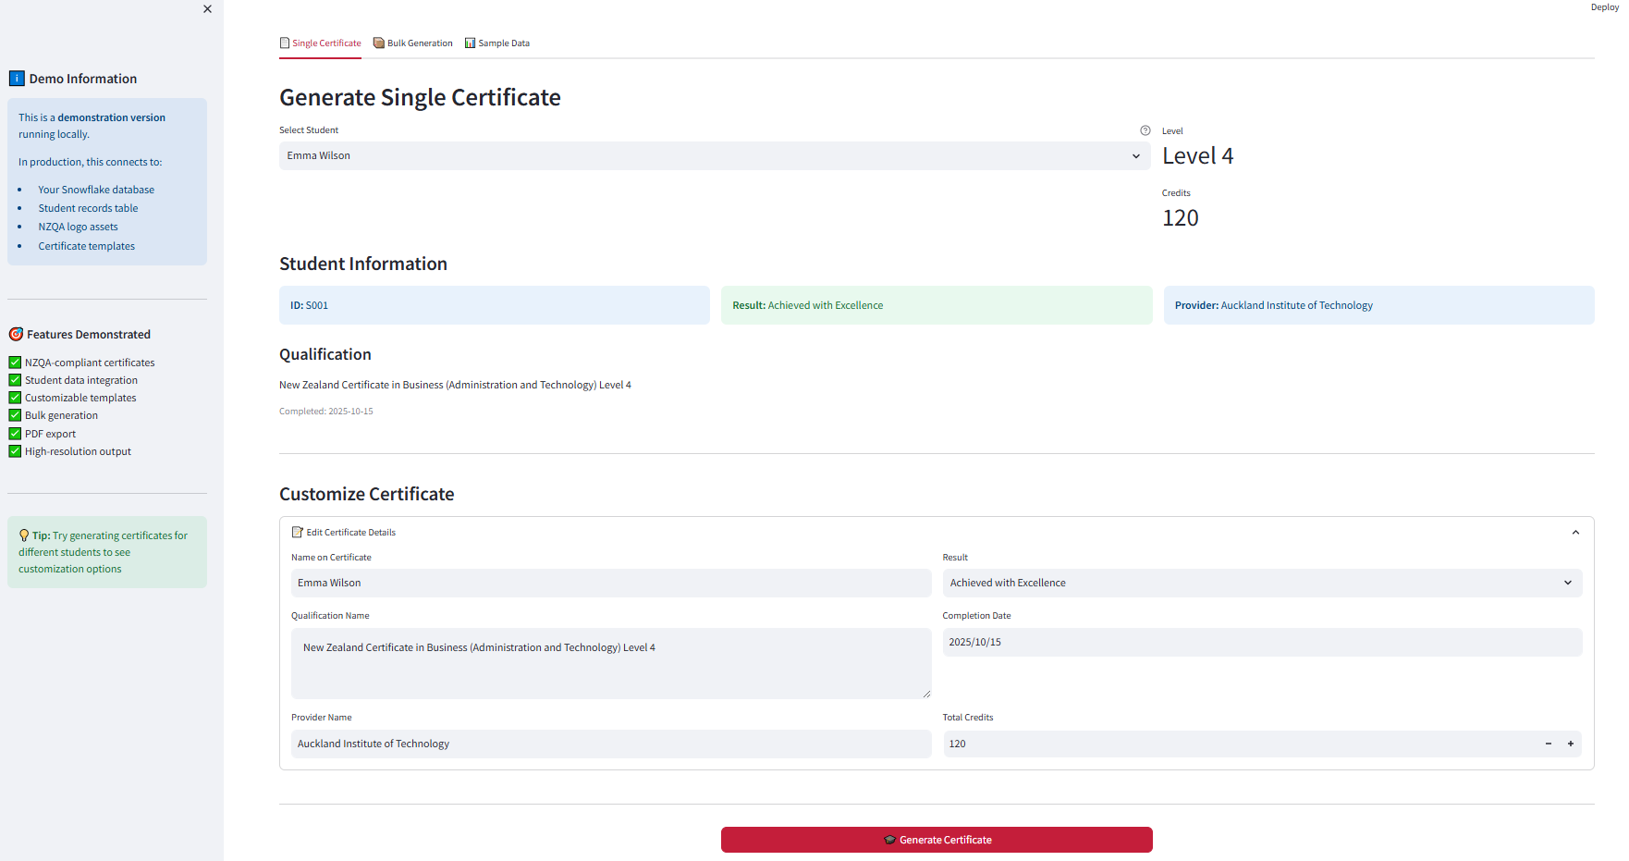

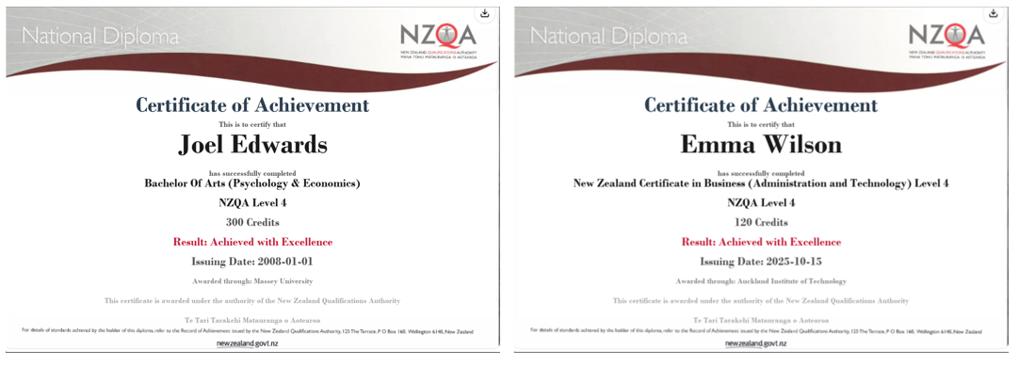

- Bulk Certificates Allows the generation of multiple certificates (either entered or from a data warehouse/pipeline) and saving as images, pdf, or other storage formats and locations.
- Sample Analysis Quick analytics, charts, data entry/saving

Quick Installation/Use (refer to README in the github repo)
- Execute (or copy to local system then execute) using Docker from
https://github.com/Huitzilopoctli372/2025_NZQACertDemo.
- Execute docker-compose up -d (as illustrated below)
- Access the web application via browser URL: localhost:7500
