

Assessment Cover Page
Student Full Name | Huiyan LI
Student Number | 2026466
Module Title | Machine Learning
Assessment Title | CA1 - Mental Health Treatment-Seeking Prediction
Lecturer/Supervisor | Muhammad Iqbal
Assessment Due Date | /11/2026
Date of Submission | 15/11/2026

GitHub Repository

Contents
1. Project title 4
2. Introduction 4
2.1Problem domain and motivation 4
2.2 Research Questions 4
2.3 Justification for Classification Models 4
3. Dataset and Preprocessing 5
3.1 Dataset 5
3.2 Data cleaning 5
3.3 Statistical association and encoding 5
4. Machine Learning Models and Validation 6
5. Hyperparameter Tuning 6
6. Results, Discussion and Conclusion 6
7. References 6

1.Project title

Predicting Mental Health Treatment-Seeking Among Technology Workers Using Machine Learning

2. Introduction

2.1Problem domain and motivation
WHO (2026) reports that depression and anxiety cause around US$1 trillion in lost productivity globally each year. Workplace stigma may discourage people from seeking support, even when they have mental health difficulties(WHO, 2026). Understanding factors linked to treatment‑seeking behavior may therefore help guide workplace mental health support.
OSMI’s 2014 Mental Health in Tech Survey captures relevant experiences and attitudes inside tech workplaces(Open Sourcing Mental Illness, 2014).

2.2 Research Questions
This study uses OSMI’s survey to build machine learning classification models and examine respondents’ history of seeking mental health treatment.
The main research question is: How accurately can machine learning models classify past treatment-seeking using personal and workplace information?
This study also examines statistical associations, feature importance, and the performance and generalization of Logistic Regression and Random Forest across different data splits and hyperparameter settings.

2.3 Justification for Classification Models
The target variable, treatment, has two categories (Yes and No), making this a supervised binary classification task.
Unlike descriptive statistics, machine learning can combine multiple features and evaluate classification performance on unseen data.
Logistic Regression provides a simple linear baseline, while Random Forest can capture nonlinear relationships and feature interactions.
Comparing them tests whether greater model complexity improves performance.

3. Dataset and Preprocessing

3.1 Dataset
This study uses the OSMI 2014 Mental Health in Tech Survey dataset from Kaggle (Open Sourcing Mental Illness, 2014). The raw dataset has 1,259 rows and 27 mostly categorical variables. The target variable, “treatment”, shows whether respondents sought mental health treatment. The two classes are nearly balanced. A simple baseline that always guesses the larger class would get around 50% accuracy.

3.2 Data cleaning
I removed four columns: Timestamp is not needed; comments are 87% missing; state only applies to US respondents; work_interfere was dropped to reduce potential leakage risk, since its conditional question may link missing answers to treatment status.
Eight impossible age entries were deleted, keeping ages between 18 and 100. I grouped Gender’s 49 different answers into three categories, as small subgroups cannot support reliable modelling. One invalid gender reply was removed, and 18 missing self_employed values were set to "Unknown" to keep all rows.

3.3 Statistical association and encoding
Chi-square tests checked association between 21 categorical features and “treatment”(McHugh, 2013). Fourteen features had unadjusted p-values under 0.05; family_history, care_options and benefits had the lowest p-values (see Figure 1). These tests were only for exploration, not feature selection, to avoid leakage. A association does not mean causation.
For Country, 81.5% of expected counts were below five, so its initial test result was unreliable. Country was reduced from 48 to eight categories by retaining seven countries with more than 20 respondents and grouping the remaining countries as "Other". LabelEncoder turned categorical variables into numbers, coding “treatment” as 0 = No and 1 = Yes.
The final dataset has 1,250 rows and 23 numeric variables with no missing values.

Figure 1. Chi-square test results for categorical features and treatment (before Country grouping)
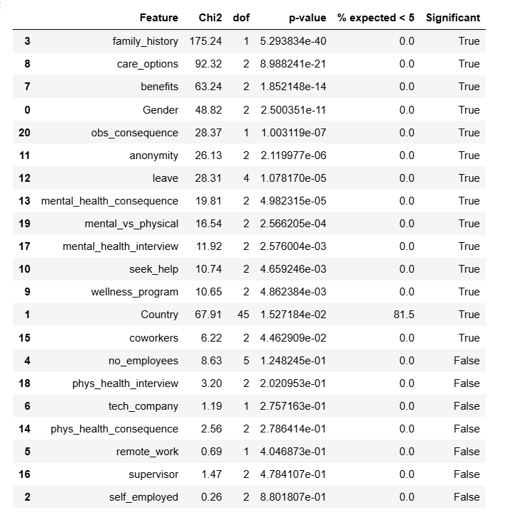

4. Machine Learning Models and Validation

4.1 Model Setup
Two models were compared: Logistic Regression (LR) and Random Forest (RF). Initial hyperparameters follow the lecturer’s "Comparison_Classification_Models.ipynb". For LR, max_iter is set to 1000; RF uses 100 decision trees. Both models use random_state=42.

4.2 Train-test splits and cross-validation
Following Tutorial 1, the 5%, 15% and 25% values from the assessment brief are treated as test set proportions, to examine how model performance changes with different training sample sizes. Five-fold cross-validation is also run on the full dataset of 1,250 observations for more reliable evaluation.
Under all three splits, both models outperform the roughly 50% majority-class baseline. RF consistently achieves 100% training accuracy but much lower test accuracy, showing clear signs of overfitting. LR has far less variation in test accuracy across the three test sizes (see Figure 2). The mean cross-validation accuracy is 70.64% for LR and 70.08% for RF.
Figure 2. Training and test accuracy of Logistic Regression and Random Forest across three test-set proportions.
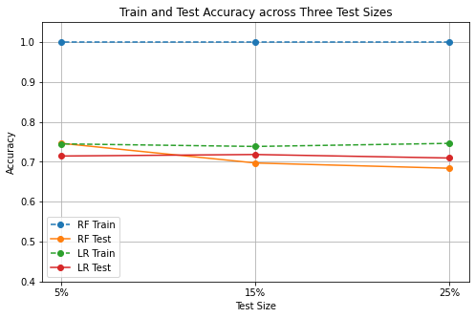

5. Hyperparameter Tuning
The 25% test split is selected for tuning. It has the largest test set of the three options (313 records), and RF shows the biggest train‑test accuracy gap here.
GridSearchCV with internal 5-fold cross-validation on the training set is used, following the parameter grid in the lecturer’s notebook. It tests 6 combinations for LR and 108 combinations for RF.
After tuning, RF’s train‑test accuracy gap falls from 31.63 percentage points to 15.09 percentage points, and its test accuracy rises from 68.37% to 70.61%, meaning overfitting is reduced. Its best parameters include min_samples_leaf=4 and n_estimators=200. LR’s test accuracy stays at 70.93% with no obvious gain.
The tuned models have very similar test accuracy. Further classification results are discussed in Section 6.

6. Results, Discussion and Conclusion

7. References
McHugh, M.L. (2013) ‘The Chi-square test of independence’, Biochemia Medica, 23(2), pp. 143–149. Available at: https://doi.org/10.11613/BM.2013.018.
Open Sourcing Mental Illness (2014) Mental Health in Tech Survey, Kaggle. Available at: https://www.kaggle.com/datasets/osmi/mental-health-in-tech-survey (Accessed: 11 November 2026).
WHO (2026) Mental health at work, World Health Organization. Available at: https://www.who.int/news-room/fact-sheets/detail/mental-health-at-work (Accessed: 11 November 2026).

