Introduction and Dataset Overview
This study analyzes trip records for the January 2025 New York City Yellow Taxi, as released by the New York City taxi and Limousine Commission (NYC TLC, 2025). The dataset contains 3,475,226 trip records and 20 raw variables—including pickup and drop-off times, trip distance, passenger count, payment type and fare amount.

The aim is to explore trip patterns by both categorical and numerical variables. The dataset was comprehensively evaluated through descriptive statistics and visualization techniques. Binomial and Posson distributions are applied to payment outcomes and trip counts, respectively, while the Normal distribution is examined using trip duration, The suitability, assumptions and limitations of these distributions are also critical evaluated.

2.Descriptive Statistical Analysis

2.1 Dataset Structure and Variable Types
Table 1. Variable Types and Their Applications
Variable | Type | Used in
payment_type | Categorical (nominal) | Task 1, Binomial
PULocationID | Categorical (nominal) | Task 1, Poisson
passenger_count | Discrete numerical | Task 1
Pickups per minute (derived) | Discrete numerical (count) | Poisson
trip_distance, fare_amount | Continuous numerical | Task 1
duration_min (derived) | Continuous numerical | Task 1, Normal

The dataset contains two categorical variables and five numerical variables, meeting the requirements for this assignment.

Although paymeny_type has multiple categories, credit card and cash payments are selected as two outcomes for Binomial analysis, per minute pickup counts and trip duration are derived from the original timestamps and used for Poisson modeling and Normal distribution analysis, respectively with the suitability of these models assessed later.

2.2Data Quality and Missing Values
Missing-value checks identified five variables (passenger_count. RatecodeID, store_and fwd_flag, congestion_surcharge and Airport_fee), each with 540,149 missing values (15.54%). These visible data-quality issues occurred in exactly the same rows, all corresponding to payment_type = 0 (flex fare). Suggesting a systematic missingness pattern.

This study adopts the available-case approach for handing missing values, rather than deleting entire records or imputing missing data. Imputation could introduce artificial values, while the boarding time in these records remains usable.
Further checks identified potential obscure errors: 90,893 zero-distance trips, 2,051 non-positive durations and 145,516 non-positive fares. One record reported approximately 276,423 miles travelled in nine minutes, a physically impossible journey.

For descriptive analysis, we retain records with trip distance up to 100 miles, duration below 180 minutes and positive fares up to $500 were selected. These descriptive thresholds define the study range, not official validity rules. Filtering remained 3,251,034 records (93.55%).

2.3Descriptive Statistics
All three numerical variables show strong positive skewness, with means exceeding medians and skewness > 1. This suggests that relatively long or expensive trips pull the averages upwards, so the median better characterizes typical trips.

After filtering, the standard deviation of trip distance falls considerably from 564.60 to 4.14 miles, demonstrating the strong influence of extreme observations.

Credit card payments account for 74.52% of filtered trips, followed by Flex Fare (12.71%) and cash (11.30%). Passenger_counts were available for 2837,879 of the 3,251,034 selected trips because the remaining Flex Fare records omit this information.

While filtering removed major anomalies, a minimum passenger count of zero and extremely short trip duration remained, highlighting the limitations in the applied thresholds.
Table 2. Descriptive statistics of selected taxi trips
Statistic | Distance (miles) | Duration (minutes) | Fare ($)
Mean | 3.17 | 14.67 | 17.94
Median | 1.7 | 11.68 | 12.80
Standard deviation | 4.14 | 11.34 | 16.20
Skewness | 3.17 | 2.49 | 3.61

2.4Data Visualization and Findings
Figure 1. Trip Distance Histogram
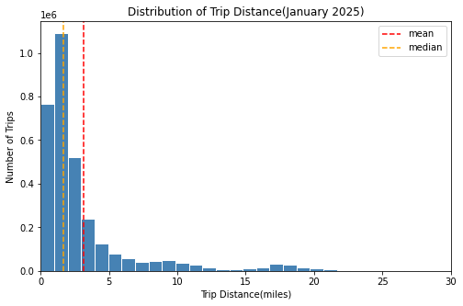 Histograms are used to examine the distribution of trip distance. Most trip are concentrated at shorter distance, with a long right tail, confirming the positive skewness, with the mean exceeding the median, suggesting that longer trips increase the average distance. A secondary peak around 15-20 miles may reflect airport-related journeys, although further analysis of pickup and drop-off locations is required to confirm this.

The boxplot in Figure 2 is selected to show the median, quartiles and potential outliers. The middle 50% of fares range from $8.60 to $19.80, with numerous high-value outliers. These outliers may represent genuine long-distance or airport trips and should not be automatically removed.

Figure 2. Fare Amount Boxplot (display range:$0—$100)
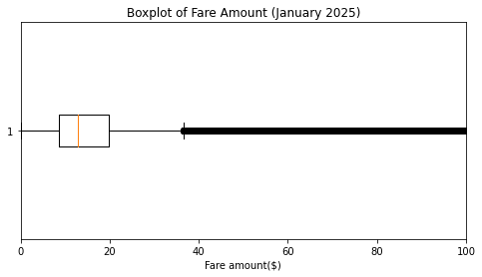
However, high fares inflate the mean within this right-skewed distribution, making the median more representative of typical fares.

A bar chart in Figure 3 compares payment types, which are categorical variables. Credit card payments dominate (74.5%), followed by Flex Fare (12.7%) and cash (11.3%); remaining categories account for less than 2% of observations. This uneven distribution provides a basis for binomial analysis, where only credit card and cash specified as the two possible outcomes.

Figure 3. Payment Type Bar Chart
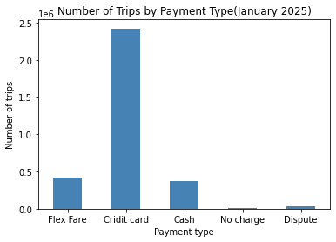

3.Binominal and Poisson Distribution

3.1Binominal
Let X be the number of credit card payments in 20 randomly selected trips paid by either credit card or carsh.

Model assumptions: each trip has two possible payment outcomes. Trips are assumed independent, with a constant probability of credit card payment; p = 2,422,685/2,790,204$≈$0.8683. Therefore, X$∼$B (20, 0.8683).
The Binomial probability formula is:
P(x=k) =$\frac{n!}{k!\left(n-k\right)!}p^{k}{(1-p)}^{n-k}$
For exactly 15 credit probability formula is:
$$\left(\begin{matrix}2 & 0 \\ 1 & 5\end{matrix}\right)=\frac{20!}{15!×5!}=15504$$
$$\begin{aligned}P\left(X=15\right)&=\left({20 \atop 15}\right){\left(0.8683\right)}^{15}{\left(0.1317\right)}^{5} \\ &≈0.0739=7.39\%\end{aligned}$$

The probability of at least 15 credit card payment is:
$$P\left(X≥15\right)=1-P\left(x≤14\right)≈0.9609=96.09\%$$
Thus, the model estimates a 96.09% probability of a least 15 credit card payments among 20 selected trips.

Figure 4 shows a left-skewed distribution when n=20 because p is close to 1. In figure 5, increasing n to 200 produces a more symmetric, bell-shaped distribution. For n= 200, np=173.66 and n(1-p) = 26.34, both exceeding the common threshold of 10, supporting a normal approximation. However, n = 20 does not meet this guideline because n(1-p) = 2.63.

Figure4: B (20, 0.8683) Figure5: B (200, 0.8683)
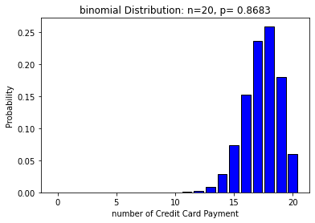 | 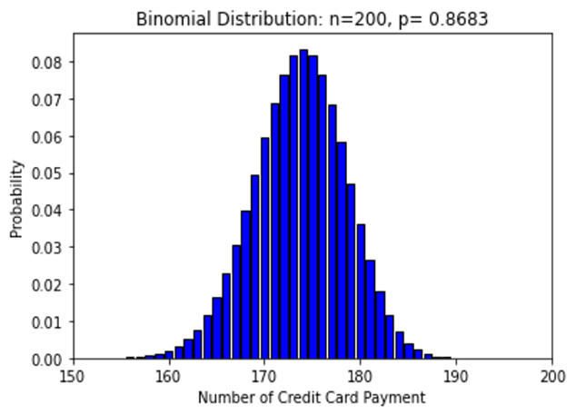

The independence and constant-probability assumptions may not fully hold, as passengers’ payment preferences can be correlated within the same time periods or locations.

3.2Poisson Distribution
Let X represent the number of recorded taxi pickups per minute in Zone 161 during weekdays from 10:00 to 10:59 in January 2025. The original dataset was used to count pickup events, giving 4,824 pickups across 1,380 minutes.

The Poisson model assumes independent events occurring at a constant average rate within fixed time intervals. Restricting the location and time reduces potential variation in pickup rates.

The estimated parameter was $λ$ = 4824/1380 = 3.4957 pickups per minute.

Using the Poisson formula:
$$P\left(X=k\right)={e^{^}(-λ)λ}^{k}/k!$$
$P\left(X=3\right)=e^{-3.4957}×{3.4957}^{3}/3!≈$0.2159

This matches the SciPy calculation, giving a 21.59% probability of exactly three pickups in one minute.

The observed variance (4,1109) exceeded the mean (3.4957), indicating mild overdispersion. Figure 6 shows broadly similar theoretical and observed distributions, although observed frequencies are higher are 0, 1, 6 and 7 pickups.

Figure 6. Poisson Model vs Observed Pickup Frequencies
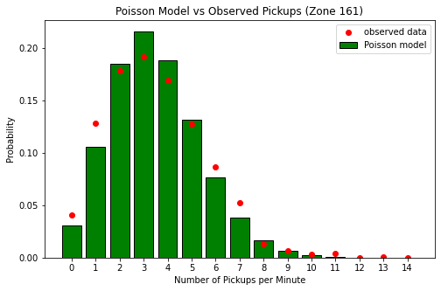
Figure 7 shows that increasing the observation interval to 10 minutes raises $λ$ to approximately 35, producing a more symmetric distribution the theoretical skewness decreases from 0.53 to 0.17, supporting a normal approximation for larger $λ$.

Figure 7. Poisson Distribution: Small vs Large Lambda
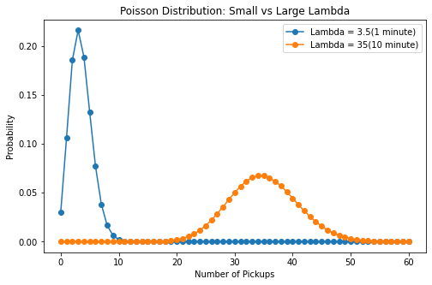
However, pickup rates may var between days due to factors such as holiday or weather, undermining the constant-rate assumption.

4.Normal Distribution
Trip duration(duration_min) was chosen as the continuous variable to evaluate its conformity to a normal distribution. Following data filtering, the mean trip duration was 14.67 minutes, with a standard deviation of 11.34 minutes and skewness of 2.49, signaling substantial right skewness. Figure 8 shows the distribution peaks at 7-9 minutes, below the mean value, alongside a long right tail. The symmetric normal curve provides a poor fit to the empirical data.
Figure 8. Original Duration
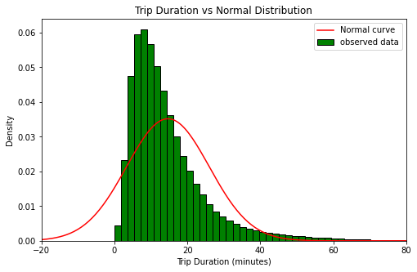

By the 68-95-99.7 rule, roughly 68%, 95% and 99.7% of observations under a normal distribution lie within one, two and three standard deviations of the mean. The observed proportions were 84.47%, 95.35% and 97.90%, respectively. Approximately 2.10% of trips fell beyond three standard deviations—nearly seven times the normal expectation of 0.27%. Although the two-standard-deviation proportion was similar, this alone does not establish normality.

Additionally. The fitted normal model yields a 9.79% probability of zero or negative trip durations, which are not possible in the cleaned dataset.

A natural logarithm transformation reduced skewness from 2.49 to -0.44. Figure 9 presents a more symmetric distribution that aligns better with the fitted normal curve. This indicates trip duration may follow an approximate long-normal distribution, albeit with residual discrepancies.
Figure 9. Log-Transformed Duration

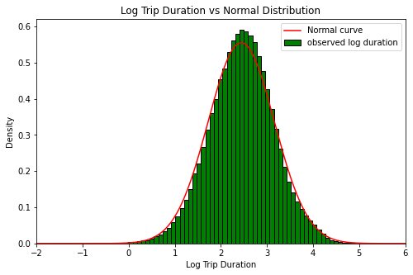

Overall, the median (11.68 minutes) better represents a typical trip than the mean. Where approximate normality is needed, modelling on the log scale is preferable.

5.Comparison
Table 3. Comparison of variables and suitability of normal approximation
Variable | Distribution | Parameters | Normal approximation
Credit-card payments | Binomial | n=20, p=0.8683 | n=20: No; n=200: Yes, approximately
Pickups per minute | Poisson | λ=3.50 | λ=3.5: Poor; λ≈35: Reasonable
Trip duration | Normal(tested) | μ=14.67, σ=11.34 | Raw: Poor; log-transformed: Closer

