1. **Recursive trace for gcd(8,6):**

gcd(8,6)

gcd(6,2)

gcd(2,0)

return 2

return 2

return 2 -> final result

1. **Correctness of gcd(a,b):**

Assume N is the number of recursive calls

Base case:

b=0, N=0, gcd(a,b)=gcd(a,0)=a. Correct

Recursive case:

-Let an and bn be the a and b in gcd(a,b) after N recursive calls where N>0.

-Let q = an / bn, r = an %bn, so an = qbn + r(0<=r<bn)

->gcd(an, bn) = gcd(bn, an) = gcd(bn, qbn + r) = gcd(bn, r)

-Then the next recursive call:

->gcd(an-1, bn-1) = gcd(bn, r)

1. **The time complexity of towers of Hanoi**

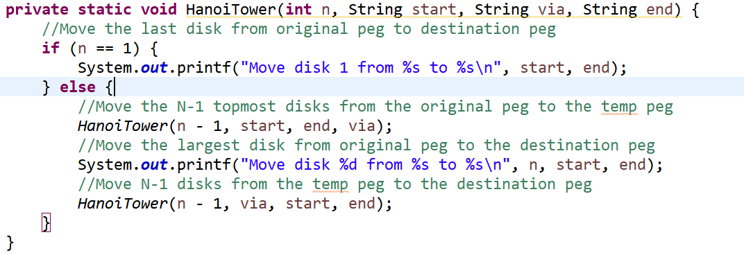

- Let T(n) = time of moving n disks

- There are 2 recursive calls for n-1 disks and one constant time operation to move a disk from the original peg to the destination peg, set it to be k.

-> Then, T(n) = 2T(n-1)+k

= 2*2T(n-2)+2k+k

... ...

= 2^(n-1)*T(1)+2^(n-2)k+...+k

-> Since the time required for base case is k, then T(n) = (2^(n-1)+2^(n-2)+...+2^0)k

-> 2T(n)= (2^n+2^(n-1)+...+2)k

-> 2T(n)-T(n) = T(n) = (2^n - 1)k

- So the time complexity = O(2^n)