BIOS 721 Midterm

Huiyue Li

10/7/2020

### Question 1

library(gapminder)  
library(tidyverse)  
library(knitr)  
library(viridis)  
library(wesanderson)  
gap<-gapminder

table1<-gap%>%  
 filter(year==2002|year==2007)%>%  
 group_by(continent)%>%  
 summarise(median_lifeExp=median(lifeExp))%>%  
 arrange(median_lifeExp)   
  
kable(table1,caption = "# The median life expectancy in the 2000s (years 2002 and 2007)",align = "c",col.names = c("Continent","Median Life Expectancy"))

# The median life expectancy in the 2000s (years 2002 and 2007)

|  |  |
| --- | --- |
| Continent | Median Life Expectancy |
| Africa | 52.4060 |
| Asia | 71.6570 |
| Americas | 72.8275 |
| Europe | 78.1770 |
| Oceania | 80.2870 |

### Question 2

gap2<-gap%>%  
 filter(country=="Denmark"|country=="Peru"|country=="Botswana"|country=="Mongolia")  
gap2$year=as_factor(gap2$year)  
  
a<-ggplot(gap2, aes(x = gdpPercap, y = lifeExp, color=year)) +   
 geom_point(size=3, alpha=.5) +   
 xlab("GDP") + ylab("life expectancy") +   
 ggtitle("# Scatterplot between GDP and life expectancy for four countries")+  
 scale_color_viridis(discrete = TRUE,direction = -1,name="Year")+  
 theme_bw()+  
 facet_wrap(~country)  
  
a

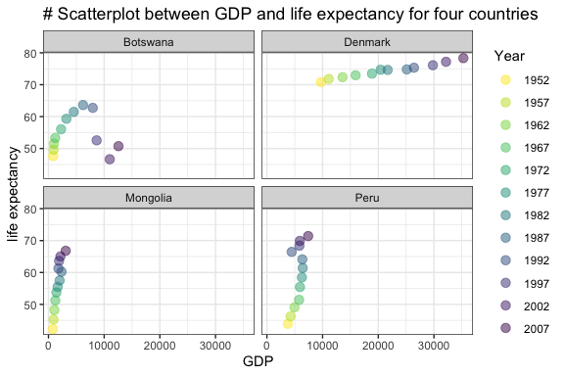

### Question 3

gap3<-gap%>%  
 filter(year==1997)%>%  
 group_by(continent)%>%  
 summarise(mean=mean(pop),sd=sd(pop))%>%  
 mutate(LB=mean-1.96*sd, UB=mean+1.96*sd)  
col = wes_palette("Darjeeling1", 5, type = c("discrete"))  
  
b<-ggplot(gap3,aes(x=continent,y=mean,color=continent))+  
 geom_point(size=2.5)+  
 geom_errorbar(aes(ymin=LB,ymax=UB))+  
 ylab("Population Size")+ xlab("Continent")+  
 ggtitle("# Means and 95% CIs of population size in 1997 by continent")+  
 theme_bw()+  
 theme(legend.position = "none")+   
 scale_colour_manual(values=col)  
  
b

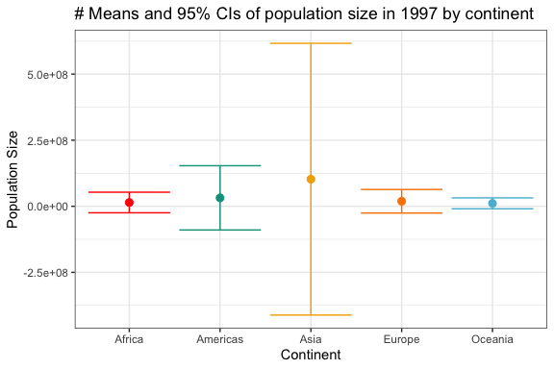

### Question 4

gap4<-gap%>%  
 filter(year==2007 )%>%  
 filter(lifeExp<=min(lifeExp) | lifeExp>=max(lifeExp))%>%  
 arrange(lifeExp)%>%  
 select(country,lifeExp)

The country **Swaziland** has the lowest life expectancy at birth in the year 2007, with the value of **39.6** years. Whereas, the country **Japan** has the highest life expectancy at birth in the year 2007, with the value of **82.6** years.