Project 3

Huiyue Li, Yifeng Tang, Yiyuan Yao<-Group 13

# load the packages we need to use  
library(tidyverse)  
library(knitr)  
library(here)  
library(lubridate)  
  
# using the here package   
here::here()

## [1] "/Users/heileylee/R scriptfile/Li_Project3"

## Plotting

# input the dataset  
plot1<-read_csv("plot_data.csv")  
  
# extract the month of each observation and select the relevant columns  
plot2<-plot1%>%  
 mutate(month=month(ymd(plot1$week)))%>%  
 select(3:13)  
  
# reorganize the dataframe by gathering the site, then calculate the mean by month and site  
pp=plot2%>%  
 gather(Site,Numb,-month)%>%  
 group_by(month,Site)%>%summarise(mean=mean(Numb))%>%arrange(Site)  
  
# create a plot illustrating the number of subjects enrolled by month and site  
plotting<-ggplot(pp, aes(x = factor(month), y = mean,color=factor(Site,level=c("Site1","Site2","Site3","Site4","Site5","Site6","Site7","Site8","Site9","Site10")))) +   
 geom_point(size=3.2,alpha=.75) +   
 geom_text(aes(label=round(mean,2)),nudge_y=.5,color="black",size=2.6,check_overlap = T)+  
 scale_colour_discrete(name="Site",labels=c("Site 1","Site 2","Site 3","Site 4","Site 5","Site 6","Site 7","Site 8","Site 9","Site 10"))+  
 xlab("Month") + ylab("Numberof enrollment") + ggtitle("# The number of subjects enrolled by month and site")+  
 theme_bw()+theme(legend.position = "bottom")+  
 facet_wrap(~factor(Site,level=c("Site1","Site2","Site3","Site4","Site5","Site6","Site7","Site8","Site9","Site10")),nrow = 5,ncol = 2,scales = "free_x")  
plotting

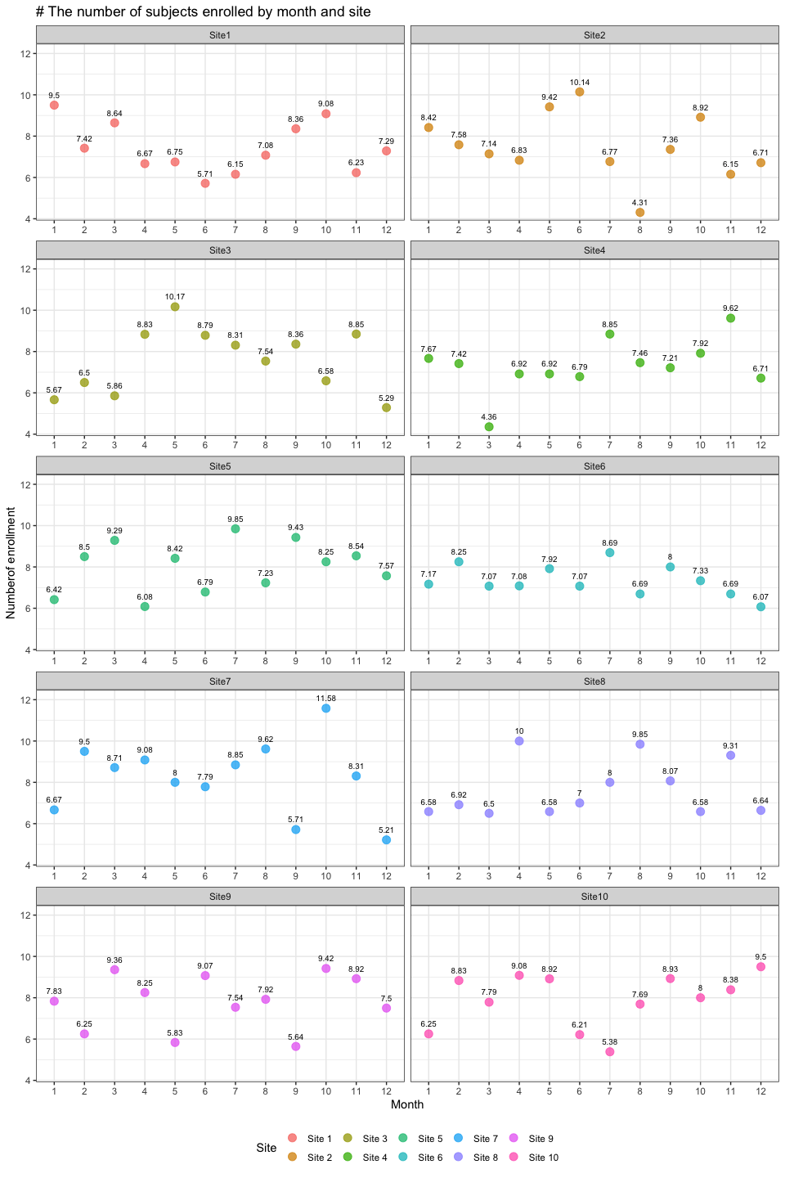

## Program control

# input the dataset  
hiv<-read.csv("HIV_data.csv")  
  
  
# create an empty vector for loop results  
hiv1<-NULL  
  
# create a FOR loop to detect the whole dataframe except the column 1  
# determine if there is a "CD4 count<400" using an IF statement  
for(i in 1:nrow(hiv)){  
 for(j in 2:6){  
 if(hiv[i,j]<400){  
 hiv1=rbind(hiv1,c(i,paste("V",j-1,sep=""),hiv[i,j]))  
 }  
 }  
}  
  
# transform hiv1 into a dataframe  
hiv1<-data.frame(hiv1)  
  
# divide the hiv1 dataframe into two parallel groups to avoid page cut  
# the first 26 rows in left part  
hiv_1=hiv1[1:26,]   
  
# the 26th~51th rows in right part  
hiv_2=hiv1[27:51,]   
  
# set a vector with NA  
co=c('', '', '')   
  
# complement the right part(keeping left and right rows the same)  
hiv_3=rbind(hiv_2,co)  
  
# bind the columns all together  
hiv_final<- cbind(hiv_1,bre=rep('|',26),hiv_3)  
  
# hide the NA in the kable  
options(knitr.kable.NA = '')  
  
  
# display the result by kable  
kable(hiv_final,  
 caption = "The patient ID and study visit for patients with CD4 smaller than 400",  
 align = "c",  
 col.names = c("**Patient ID**","**Study Visit**","**CD4 Count**","**|**","**Patient ID**","**Study Visit**","**CD4 Count**"))

The patient ID and study visit for patients with CD4 smaller than 400

|  |  |  |  |  |  |  |
| --- | --- | --- | --- | --- | --- | --- |
| **Patient ID** | **Study Visit** | **CD4 Count** | **|** | **Patient ID** | **Study Visit** | **CD4 Count** |
| 3 | V5 | 346 | | | 248 | V2 | 144 |
| 10 | V1 | 387 | | | 253 | V3 | 173 |
| 12 | V4 | 374 | | | 256 | V5 | 328 |
| 15 | V2 | 360 | | | 265 | V1 | 371 |
| 28 | V1 | 339 | | | 272 | V1 | 390 |
| 31 | V3 | 283 | | | 290 | V2 | 292 |
| 44 | V4 | 288 | | | 304 | V4 | 399 |
| 47 | V5 | 284 | | | 321 | V5 | 327 |
| 50 | V3 | 363 | | | 329 | V5 | 395 |
| 73 | V4 | 366 | | | 330 | V4 | 392 |
| 104 | V2 | 342 | | | 337 | V5 | 345 |
| 107 | V2 | 392 | | | 340 | V1 | 372 |
| 122 | V5 | 385 | | | 346 | V2 | 138 |
| 133 | V1 | 361 | | | 369 | V3 | 354 |
| 135 | V3 | 307 | | | 383 | V3 | 373 |
| 141 | V5 | 388 | | | 384 | V5 | 387 |
| 151 | V5 | 388 | | | 397 | V2 | 393 |
| 152 | V1 | 338 | | | 414 | V5 | 366 |
| 166 | V2 | 379 | | | 425 | V4 | 382 |
| 183 | V2 | 297 | | | 426 | V3 | 396 |
| 185 | V5 | 390 | | | 446 | V1 | 326 |
| 228 | V2 | 359 | | | 450 | V3 | 333 |
| 234 | V3 | 289 | | | 457 | V2 | 329 |
| 242 | V2 | 266 | | | 465 | V1 | 288 |
| 243 | V4 | 80 | | | 478 | V2 | 390 |
| 247 | V5 | 292 | | |  |  |  |