Project 3

Huiyue Li, Yifeng Tang, Yiyuan Yao<-Huiyue Li

# load the packages we need to use  
library(tidyverse)  
library(knitr)  
library(here)  
library(lubridate)  
# using the here package   
here::here()

## [1] "/Users/heileylee/R scriptfile/Li_Project3"

### Plotting

# input the dataset  
plot1<-read_csv("plot_data.csv")  
# extract the month of each observation and select the relevant columns  
plot2<-plot1%>%  
 mutate(month=month(ymd(plot1$week)))%>%  
 select(3:13)  
# reorganize the dataframe by gathering the site, then calculate the mean by month and site since reorganize the dataframe by gathering the site  
# calculate the mean by month and site to represent the number of subject enrolled by month and site, since the total number of times collecting data varies among different months  
pp=plot2%>%  
 gather(Site,Numb,-month)%>%  
 group_by(month,Site)%>%  
 summarise(mean=mean(Numb))%>%arrange(Site)  
# create a plot illustrating the number of subjects enrolled by month and site  
plotting<-ggplot(pp, aes(x = factor(month), y = mean,color=factor(Site,level=c("Site1","Site2","Site3","Site4","Site5","Site6","Site7","Site8","Site9","Site10")))) +   
 geom_point(size=3.2,alpha=.75) +   
 geom_text(aes(label=round(mean,2)),nudge_y=.5,color="black",size=2.6,check_overlap = T)+  
 scale_colour_discrete(name="Site",labels=c("Site 1","Site 2","Site 3","Site 4","Site 5","Site 6","Site 7","Site 8","Site 9","Site 10"))+  
 xlab("Month") + ylab("Numberof enrollment") +   
 ggtitle("# The number of subjects enrolled by month and site")+  
 theme_bw()+theme(legend.position = "bottom")+  
 facet_wrap(~factor(Site,level=c("Site1","Site2","Site3","Site4","Site5","Site6","Site7","Site8","Site9","Site10")),nrow = 5,ncol = 2,scales = "free_x")  
plotting

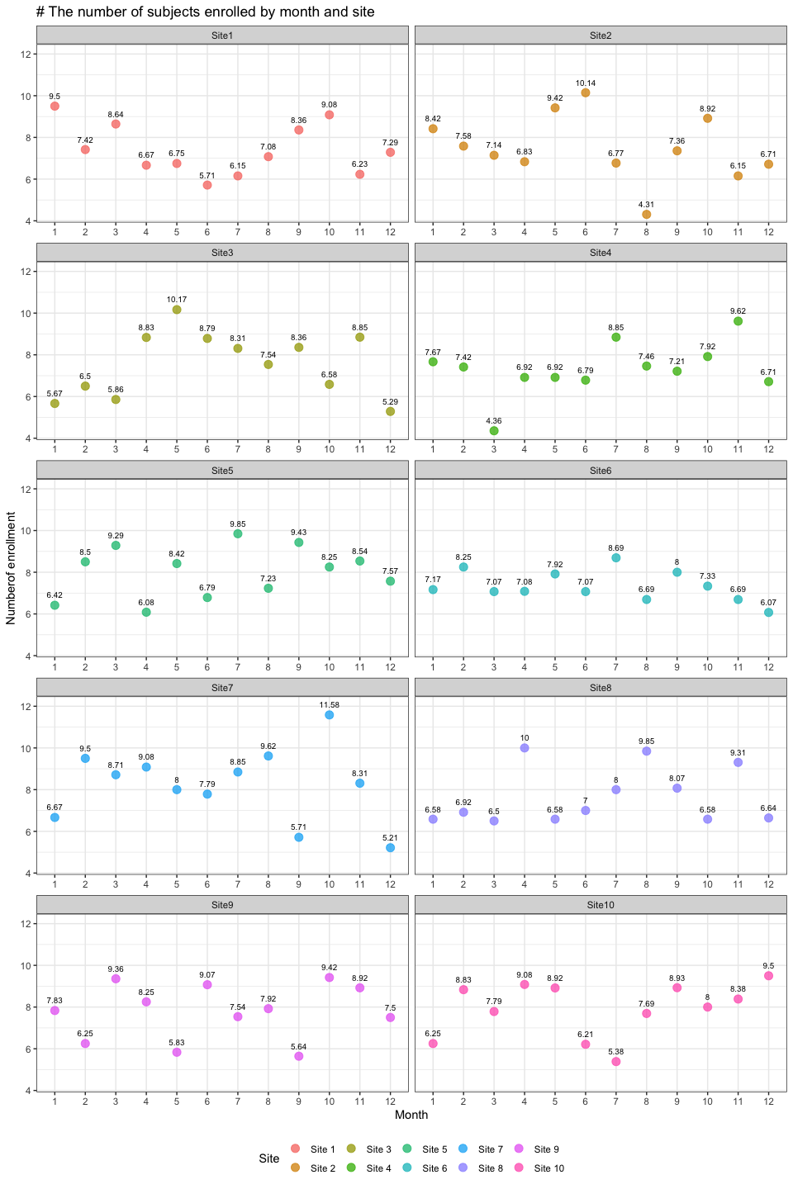

### Program control

# input the dataset  
hiv<-read.csv("HIV_data.csv")  
# create an empty vector for loop results  
hiv1<-NULL  
# create a FOR loop to detect the whole dataframe except the column 1  
# determine if there is a "CD4 count<400" using an IF statement  
for(i in 1:nrow(hiv)){  
 for(j in 2:6){  
 if(hiv[i,j]<400){  
 hiv1=rbind(hiv1,c(i,paste("V",j-1,sep=""),hiv[i,j]))  
 }  
 }  
}  
# transform hiv1 into a dataframe  
hiv1<-data.frame(hiv1)  
  
# divide the hiv1 dataframe into two parallel groups to avoid page cut  
# the first 26 rows in left part  
hiv_1=hiv1[1:26,]   
# the 26th~51th rows in right part  
hiv_2=hiv1[27:51,]   
# set a vector with NA  
co=c('', '', '')   
# complement the right part(keeping left and right rows the same)  
hiv_3=rbind(hiv_2,co)  
# bind the columns all together  
hiv_final<- cbind(hiv_1,bre=rep('|',26),hiv_3)  
# see the result, i.e. the kable, on the next page

# hide the NA in the kable  
options(knitr.kable.NA = '')  
# display the result by kable  
kable(hiv_final,caption = "The patient ID and study visit for patients with CD4 smaller than 400",align = "c",col.names = c("**Patient ID**","**Study Visit**","**CD4 Count**","**|**","**Patient ID**","**Study Visit**","**CD4 Count**"))

The patient ID and study visit for patients with CD4 smaller than 400

|  |  |  |  |  |  |  |
| --- | --- | --- | --- | --- | --- | --- |
| **Patient ID** | **Study Visit** | **CD4 Count** | **|** | **Patient ID** | **Study Visit** | **CD4 Count** |
| 3 | V5 | 346 | | | 248 | V2 | 144 |
| 10 | V1 | 387 | | | 253 | V3 | 173 |
| 12 | V4 | 374 | | | 256 | V5 | 328 |
| 15 | V2 | 360 | | | 265 | V1 | 371 |
| 28 | V1 | 339 | | | 272 | V1 | 390 |
| 31 | V3 | 283 | | | 290 | V2 | 292 |
| 44 | V4 | 288 | | | 304 | V4 | 399 |
| 47 | V5 | 284 | | | 321 | V5 | 327 |
| 50 | V3 | 363 | | | 329 | V5 | 395 |
| 73 | V4 | 366 | | | 330 | V4 | 392 |
| 104 | V2 | 342 | | | 337 | V5 | 345 |
| 107 | V2 | 392 | | | 340 | V1 | 372 |
| 122 | V5 | 385 | | | 346 | V2 | 138 |
| 133 | V1 | 361 | | | 369 | V3 | 354 |
| 135 | V3 | 307 | | | 383 | V3 | 373 |
| 141 | V5 | 388 | | | 384 | V5 | 387 |
| 151 | V5 | 388 | | | 397 | V2 | 393 |
| 152 | V1 | 338 | | | 414 | V5 | 366 |
| 166 | V2 | 379 | | | 425 | V4 | 382 |
| 183 | V2 | 297 | | | 426 | V3 | 396 |
| 185 | V5 | 390 | | | 446 | V1 | 326 |
| 228 | V2 | 359 | | | 450 | V3 | 333 |
| 234 | V3 | 289 | | | 457 | V2 | 329 |
| 242 | V2 | 266 | | | 465 | V1 | 288 |
| 243 | V4 | 80 | | | 478 | V2 | 390 |
| 247 | V5 | 292 | | |  |  |  |