**Exercise 1:**

In a file called ex1.html write the HMLT needed for creating a web page as close as possible as the following image.

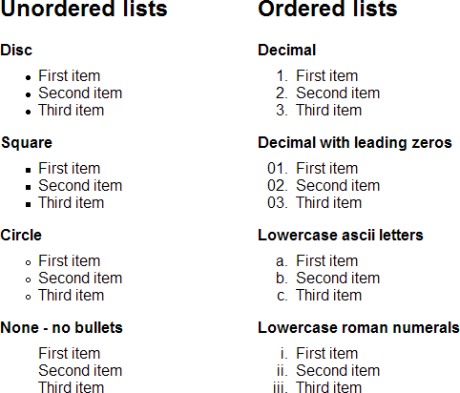

**Note: You must look for further info in order to get the the proper list icons and the right table borders.**

**Exercise 2:**

In a file called ex2.html write the HMLT needed for creating a web page as close as possible as the following image

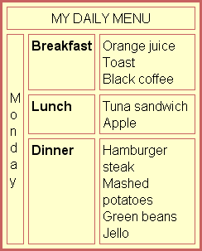

**Note: You must look for further info in order to get the the proper color and the proper borders**

**Exercise 3:**

In a file called ex3.html write the HMLT needed for creating a web page as close as possible as the following image.

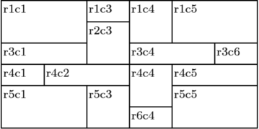

**Exercise 4:** In a file called ex4.html write the HMLT needed for creating a web page as close as possible as the following image.

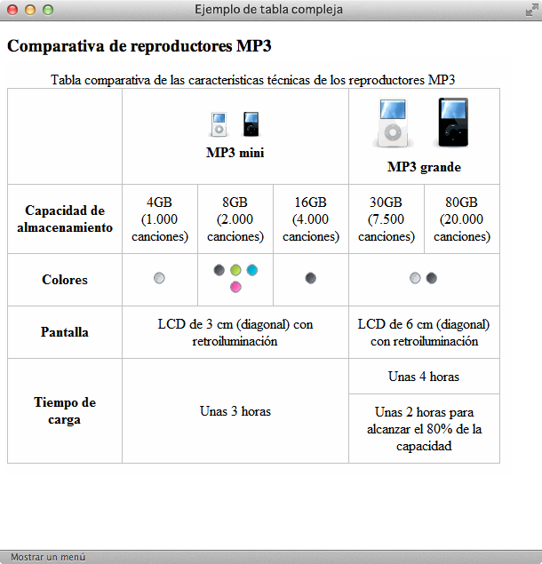

**Note: The device images must link to the official device website. You must look or create your own images.**